Extended Data
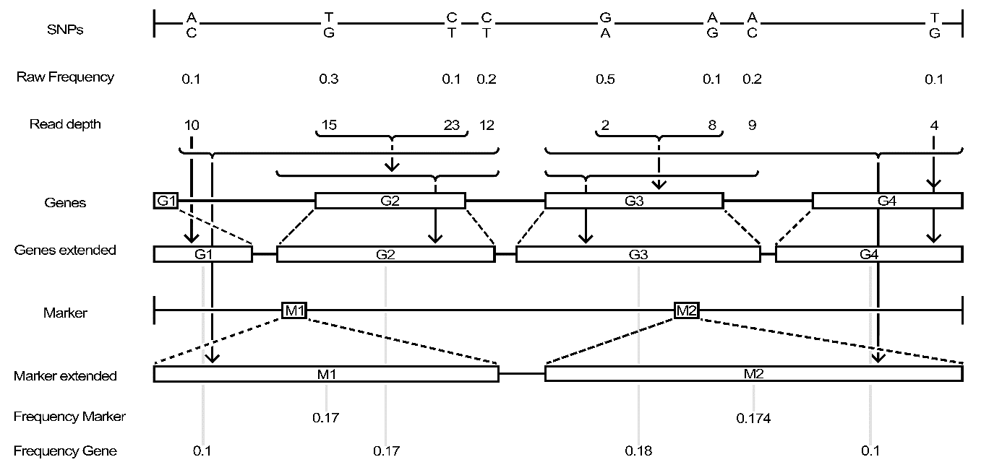 Extended Data Fig. 1. Gene extension algorithm scheme of gene- and marker-based haplotype calculations. The raw SNP based allele frequency (2nd row; “Raw Frequency”) for identified SNPs (1st row) are identified at a given read depth (3rd row; “Read depth”). Annotated genes (4th row; “Genes”) and markers (6th row; “Markers”) are extended in size up- and downstream (“Genes extended”; “Marker extended”) to associate SNPs in the particular region to the genes / markers. By the extension, more SNPs can be annotated to a gene / marker than without (dashed lines and arrows below the 3rd row indicate relationships). Reported frequency in the last two rows of markers and genes are the calculated haplotype frequency for the wild donor parent in the population. The marker and gene-based haplotype calculation is illustrated in the methods section. The figure should only illustrate the model of SNP information aggregation and does not contain real data.

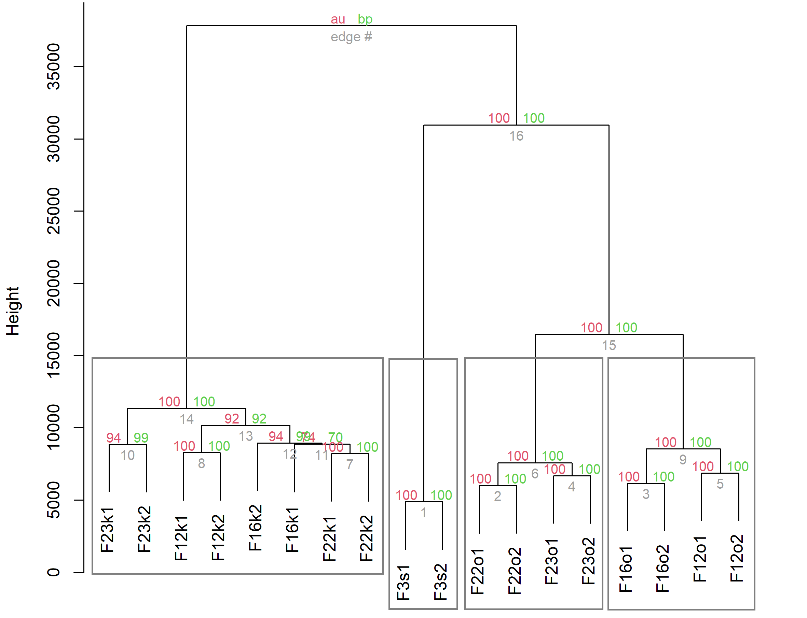
Extended Data Fig. 2. Genetic distance of all pooled samples. The dendrogram illustrates the relation of test samples to one another. The name of the samples is constructed by the generation (F_{3/12/16/22/23}), environment (k – conventional; o – organic), sample (1 / 2). Each node is surrounded by three numbers – the grey number specifies the cluster rank; the red indicates the approximately unbiased (au) calculated p-value, while the green number indicates the bootstrap probability (bp) value. As closer the value is towards 100, as more valid the cluster. On a cut-off level of 15,000, four clusters can be identified: the initial F₃, as well as the early (F₁₂, F₁₆) and the late (F₂₂, F₂₃) organic populations and finally, the conventional populations with all samples in one cluster.

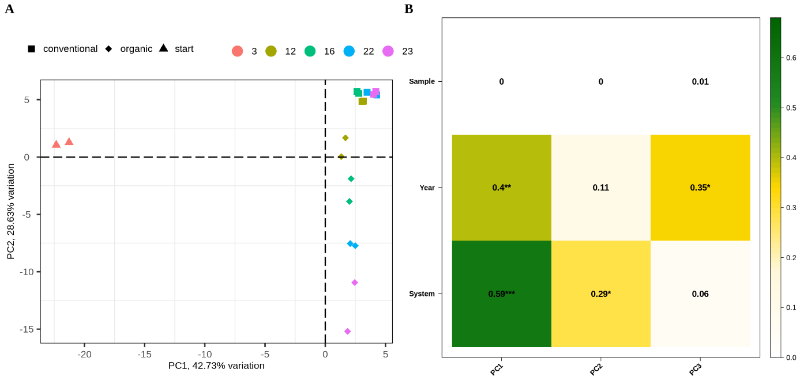
Extended Data Fig. 3. Principal component clustering of all tested generations (including F3). PCA of the 3rd, 12th, 16th, 22nd and 23rd generations with both samples per population (replication), split by shapes for the systems (A). The explanatory effect of the principal components is illustrated in (B), where the first PC explains both the year and the system impact, while the second PC highlights the system (environment) effect and the third PC the year effect. The replications had no effect on the clustering of the samples. (A) The majority of variation is explained by the first PC (42.73%), while the second PC explains 28.63% and the third PC 4.1%. The distance from the 3rd to 12th generation is the biggest in both farming systems, which indicates the greatest changes of the allele frequency in early generations.
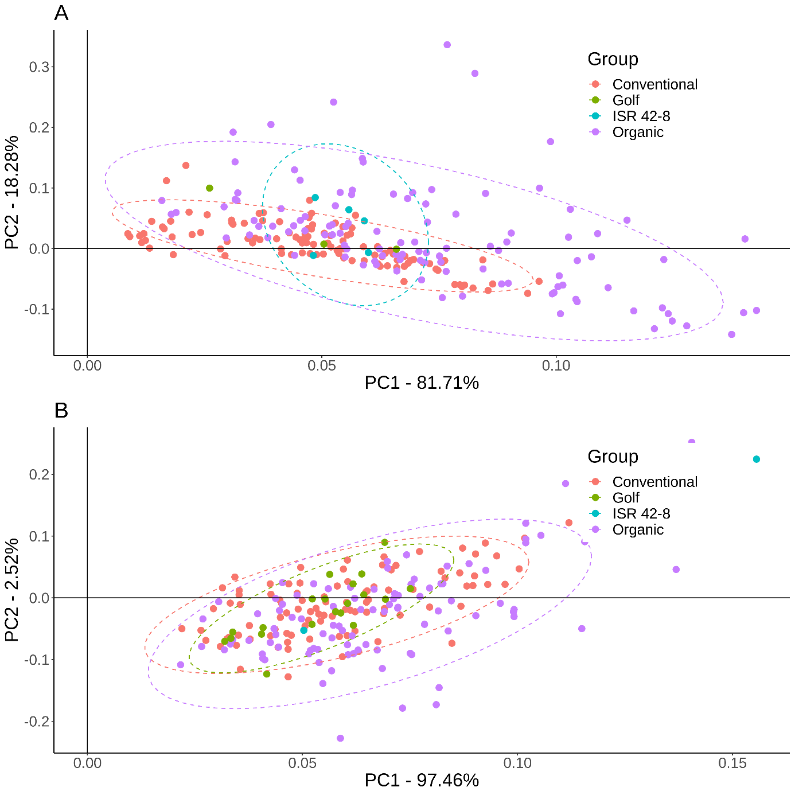 Extended Data Fig. 4. The principal component output of the root morphology assessment in a hydroponic (A) and a field-based environment (B). The first two components are plotted, with the first PC on the x-axis and the second PC on the y-axis. The colours differentiate the conventional (magenta) and organic (purple) systems, and the wild donor (ISR 42-8, turquoise) from the cultivar (Golf, green). Each point represents an individual genotype. In (A), 150 genotypes were tested from the organic and conventional systems, while 100 genotypes each were tested in (B). Dashed ellipses are plotted based on the points if the sample size was sufficient. Both experiments illustrate higher genetic variance in the organic system as compared to the conventional system.
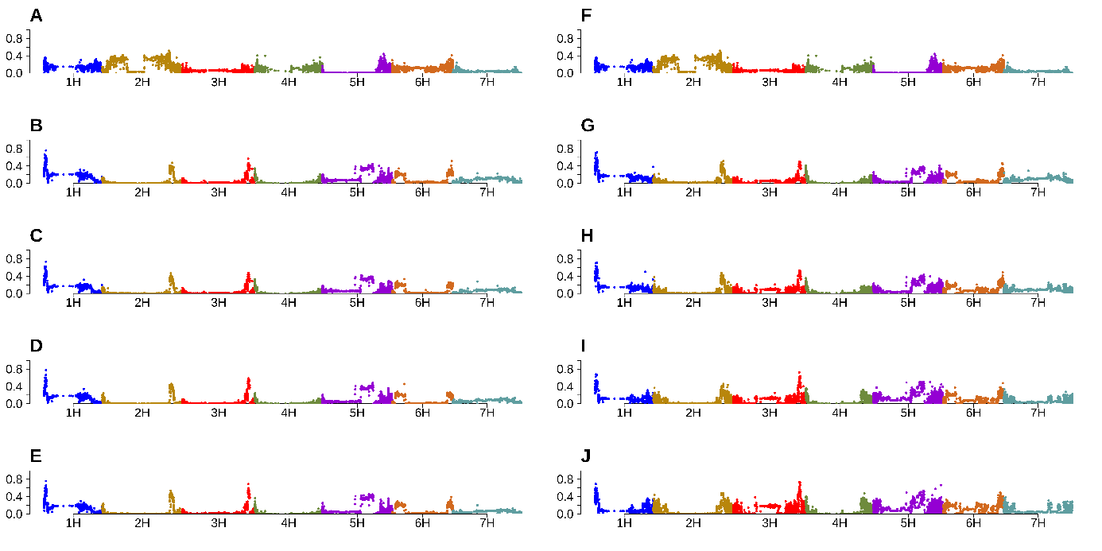
Extended Data Fig. 5: Genome wide wild type allele frequency on a physical map. The left part of the plot represents the conventional system, where each subplot corresponds to one generation. (A) F₃; (B) F₁₂; (C) F₁₆; (D) F₂₂; (E) F₂₃. Analogous to this, the right part illustrates the generations evolved in the organic system. (F) F₃; (G) F₁₂; (H) F₁₆; (I) F₂₂; (J) F₂₃. Both samples per generation and environment were merged in one dataset. The wild type allele frequency of the (y-axis) haplotypes is shown on the physical map, where each of seven barley chromosomes is indicated by different colors (x-axis).

Extended Data Fig. 6. Allele frequency visualization of specified regions on gene level for all sequenced generations, comparing the conventional and the organic system to each other. Additionally, a table with the gene name and potential function are presented for all genes present in the selected region.
[https://michaelschneiderrun.shinyapps.io/allelefreqvariation/]

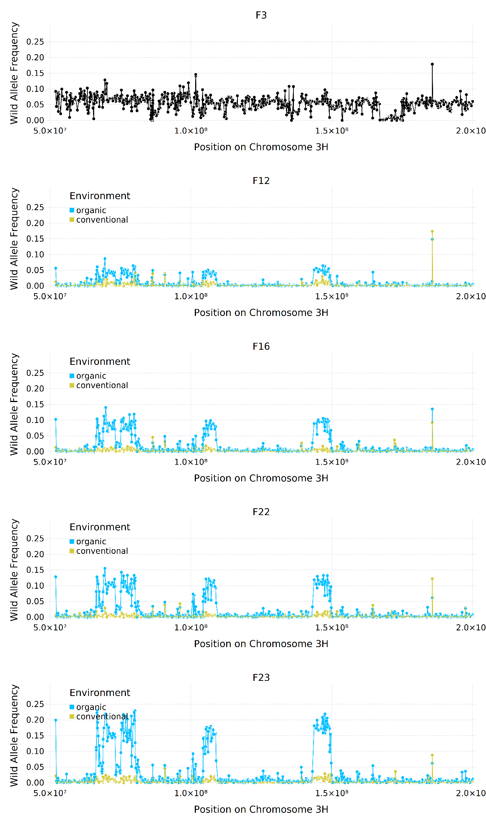
Extended Data Fig. 7. The pericentromeric region around the brittleness loci brt1 and brt2 for each generation of the tested populations. The wild type gene-haplotype based allele frequency is plotted on the y-axis against the physical position on chromosome 3H (x-axis). The blue line is the allele frequency in the organic system, while the yellow line indicates the allele frequency in the conventional system. The dot in the respective colour presents the gene-based haplotype on the particular physical position with the given allele frequency. The generation plotted is given above the subfigure (F3 to F23). Positive selection of 3 to 4 distinct regions in the organic system are observed. The wtAF of brt1 and brt2 loci were negatively selected. The conventional system only shows evidence for WT alleles negative selection.
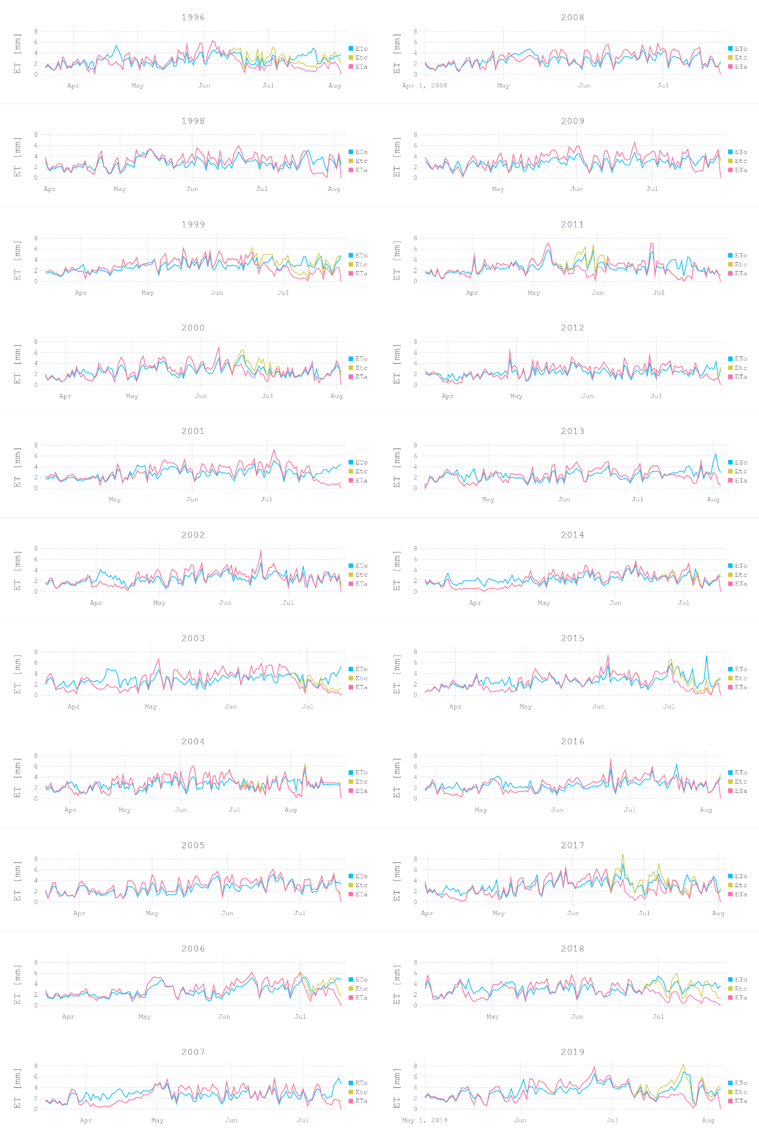 Extended Data Fig. 8. Barley evapotranspiration calculated for each day of the vegetation period from the sawing to harvest date. Facetted by years, the evapotranspiration in l/m² (y-axis) is plotted against the day of the year. The annual plot begins from the sawing day to end with the harvest day. Three graphs are plotted for each ear; ET_{o}, evapotranspiration over grass, basic of the crop specific model; ET_{C}, potential evapotranspiration of barley on a particular day in l/m² if no water shortage; ET_{a}, actual evapotranspiration under field conditions, including periods or days of soil–water limitation. ET_{a} is based on ET_{C}, including a soil–water balance model in the calculations.

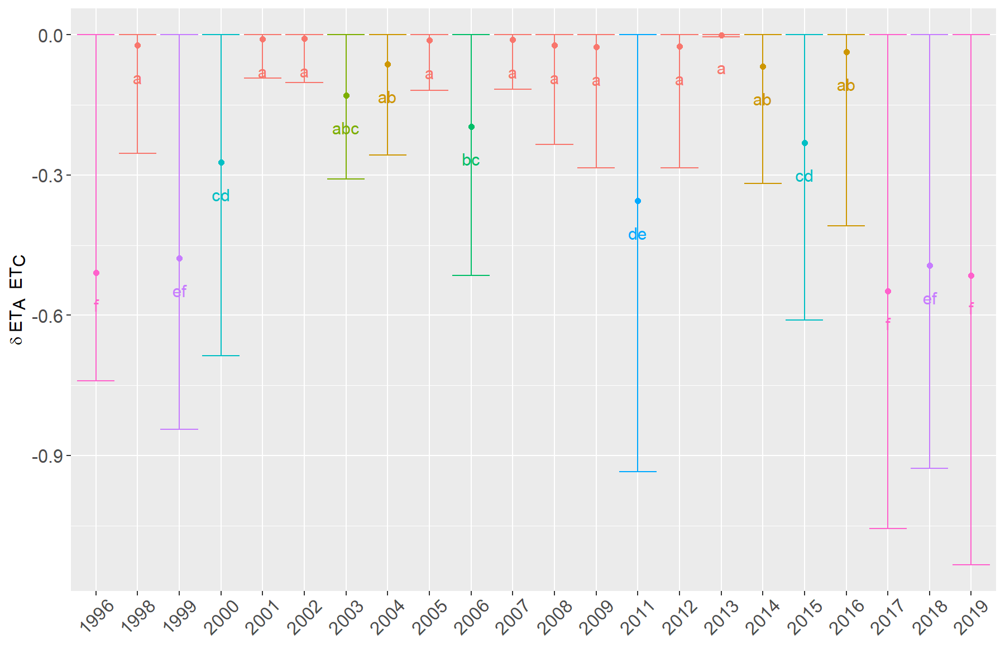 Extended Data Fig. 9. Year-wise clustering of actual to potential evapotranspiration discrepancy. The y-axis illustrates the average variation delta to the actual and potential evapotranspiration for each year (x-axis). Delta is equivalent with the transpiration reduction of the active biomass due to water stress. Grouping (letters) was performed with the HSD.test of the R package agricolae to identify years with similar evapotranspiration patterns. Years with a high impact of drought are illustrated by a high deviation of < 0.3 reduction of the actual evapotranspiration.
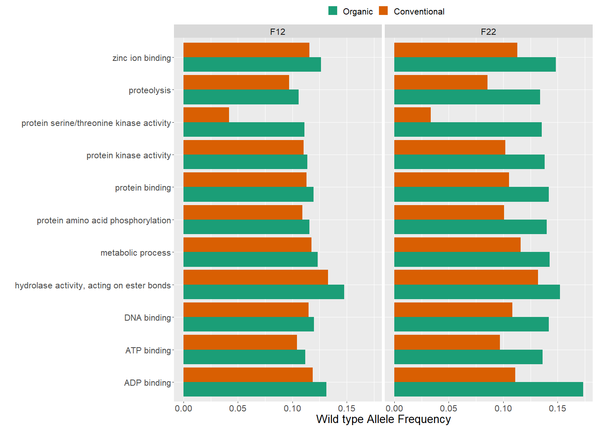
Extended Data Fig. 10. Gene ontology analysis for biotic stress response in the organic population. Significantly variants genes based on the wild type allele frequency variation between the organic and conventional environment in the 12th and 22nd generation are clustered to gene ontologies (y-axis) and the average wild type allele frequency for these is plotted (x-axis). The environments are illustrated by different colours.
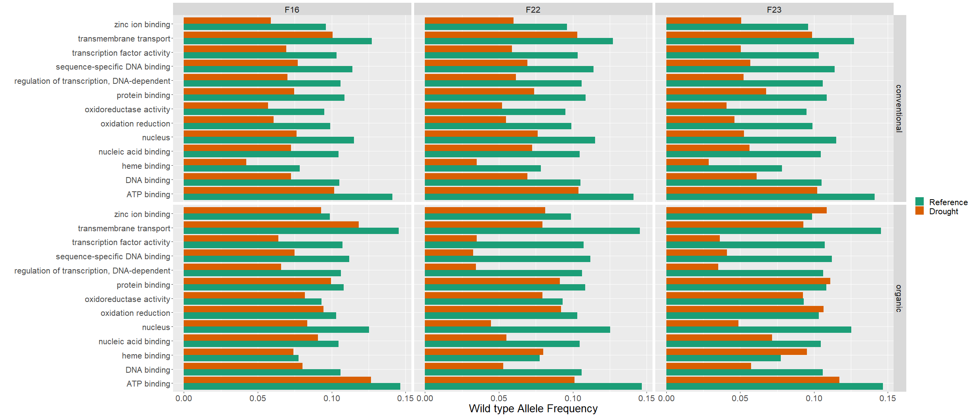
Extended Data Fig. 11. Gene ontology analysis for abiotic stress response to drought in the organic and conventional environment for three generations. Average wtAF (x-axis) plotted for Gene ontology classes identified (y-axis). The 12th generation is used as reference (green bar). 16th, 22nd and 23rd generation present the wtAF after drought impact (drought, orange bar). The generations and environments are faceted.

