Supplementary

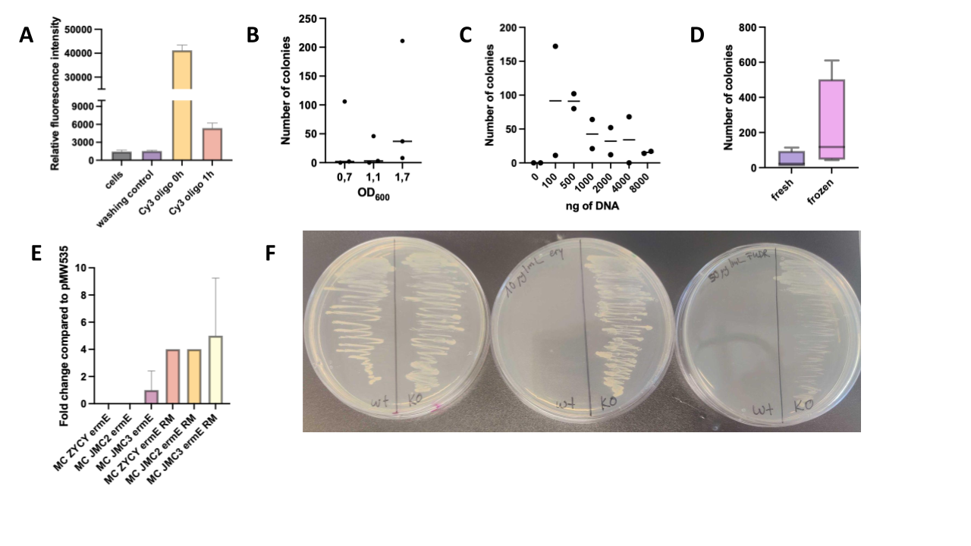
Figure S1: Optimization of electrotransformation in C. acnes A) Fluorescence measurement of cells after transformation with Cy3 oligonucleotide compared to 1 h recovery. B) Number of transformants depending on optical density at time of competent cells preparation. C) Number of transformants depending on different DNA amounts transformed. D) Comparison of fresh cells vs. frozen cells in their transformation efficiency measured in transformants obtained. E) Fold change in transformation efficiency using MC strains (ZYCY, JMC2, JMC3) with (ermE) or without (ermE RM) AGCAGY motif compared to original pMW535 suicide vector. F) Functional testing of KO strain on selective agar plates containing no antibiotic/inhibitor, 50 𝜇g/mL FUDR (inhibitor) or 10 𝜇g/mL erythromycin.

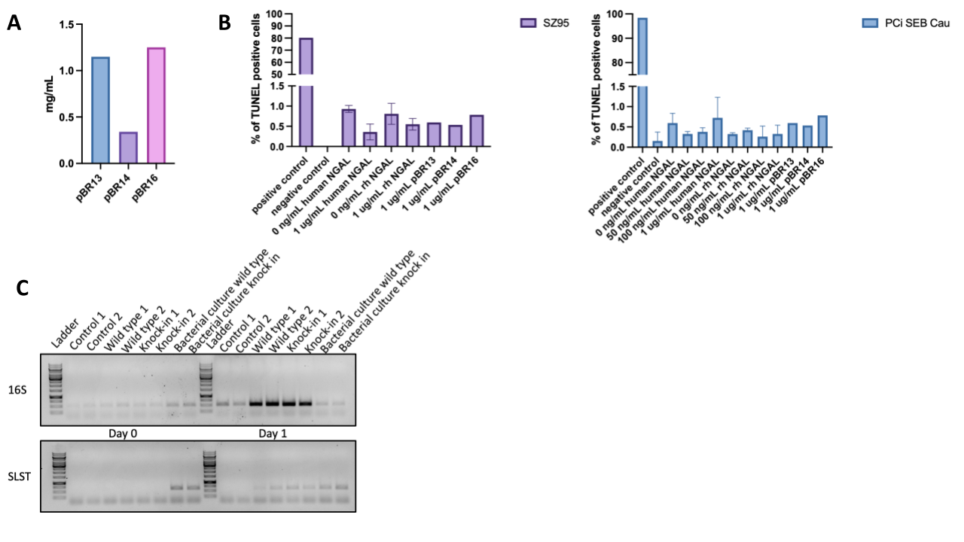
Figure S2: A) Yield of Ni-NTA purified his-tagged NGAL protein from 100 mL bacterial supernatant. B) TUNEL assay of SZ95 and PCi-SEB_Cau incubated with NGAL produced in HEK293 (human), E. coli (rh) or C. acnes (pBR13,14,16) at concentrations ranging from 0 𝜇g/mL to 1 𝜇g/mL.. Percent of TUNEL positive cells were determined by fluorescence microscopy. C) SLST and 16S PCR of mice flora at Day 0 and Day 1 after C. acnes application. SLST primers are C. acnes specific and only amplify if C. acnes is present.

Supplementary Table 1: Sequence of oligonucleotides used in the study.

Oligo name | Sequence
LCN_qPCR_fwd | 5’-AGGGCAAGTGGTACGTCGT-3’
LCN_qPCR_rev | 5’-CGGATCCAGTAGTCGCACT-3’
Junction1_fwd | 5’-AAGACGATGTCGATGAGCGTGT-3’
Junction1_rev | 5’-TGAAGCACAGCTCGACCATCGA-3’
Junction2_fwd | 5’-CAGCTGACACCGACATGCTC-3’
Junction2_rev | 5’-GAAGAAGTGCGACTACTGGATC-3’

