Supplementary Information
for

Targeting and sensitizing MDR cancer by an MMP2 and pH dual-responsive ZnO-based nanomedicine
Qing Zhou^{1,2†}, Li Zhang^{3†}, Yujiao Li^{2†}, Jiao Wang¹, Xiaolu He², Jieyu Zhang², Youbei Qiao⁴, Hong Wu^{4*}, Lin Zhu^{1*}

¹ Department of Pharmaceutical Sciences, Irma Lerma Rangel School of Pharmacy, Texas A&M University, College Station, Texas 77843, United States.
² Department of Clinical Pharmacy, Jinling Hospital, Medical School of Nanjing University, Nanjing 210002, China.
³ Department of Prosthodontics, Nanjing Stomatological Hospital, Medical School of Nanjing University, Nanjing 210002, China.
⁴ Department of Medicinal Chemistry and Pharmaceutical Analysis, School of Pharmacy, Air Force Medical University, Xi'an 710032, China.

†These authors contributed equally to this work.
*Corresponding author. E-mail address: lzhu@tamu.edu (Lin Zhu), wuhong@fmmu.edu.cn (Hong Wu).

Materials, Cells and Animals
Fig. S1 (A) Cellular uptake of the DOX or ZnO/DOX in the DOX-sensitive cancer cells (MDA-MB-231 and HeLa) and DOX-resistant MDR cancer cells (NCI/ADR-RES and MES-SA/Dx5) after 1 h incubation, determined by flow cytometry. (B) Mean fluorescence intensity (MFI) of the flow cytometry data.
Fig. S2 Confocal microscopic images of cellular internalization of the DOX or ZnO/DOX in the MDA-MB-231 and NCI/ADR-RES cells after 1 h incubation. Cell nuclei were stained by Hoechst (blue). The scale bar is 100 μm.
Fig. S3 Uptake of the DOX, ZnO/DOX, or ZnO + DOX mixture after 1 h incubation with the MDR cancer cells (NCI/ADR-RES), determined by flow cytometry. MFI, mean fluorescence intensity.
Fig. S4 Cytotoxicity of the DOX, ZnO NPs, and ZnO/DOX in DOX-sensitive cancer cells (MDA-MB-231 and HeLa) and DOX-resistant MDR cancer cells (NCI/ADR-RES and MES-SA/Dx5). Cell incubation time: 24 h.
Fig. S5 (A) Mitochondrial membrane potential after 1 h or 24 h treatments, determined by the JC-1 assay (flow cytometry). The decrease in the JC-1 aggregate/monomer ratio (Red/Green ratio) indicates the mitochondrial depolarization. (B) Confocal microscopic images of the JC-1 staining after 4 h treatments. The scale bar is 50 μm.
Fig. S6 The C/EBP Homologous Protein (CHOP) levels after 24 h treatments, determined by a CHOP ELISA kit. Cell line: NCI/ADR-RES cells.
Fig. S7 Drug penetration through the MDA-MB-231 and NCI/ADR-RES cell spheroids after 4 h incubation, determined by confocal microscopy (left panel). The scale bar is 200 μm. The right panel is the curves of the normalized mean fluorescence intensity (MFI) vs the distance from the spheroid bottom to the top.
Fig. S8 (A) Synthetic scheme of the PEG-pp-PE. (B) TLC chromatograms of the PEG-pp and PEG-pp-PE. (c) ¹H NMR spectrum of the PEG-pp-PE.
Fig. S9 Mean particle sizes of the ZnO/DPPG/PEG-pp-PE/DOX upon the incubation with HBSS (pH 7.4) or HBSS containing 10% FBS for 72 h. Particle sizes were measured by dynamic light scattering (DLS).
Fig. S10 (A) Digital photographs of the ZnO/DPPG/PEG-PE/DOX and ZnO/DPPG/PEG-pp-PE/DOX with the MMP2 incubation for 12 h. (B) Particle sizes of the ZnO/DPPG/PEG-pp-PE/DOX with/without the MMP2 pretreatment, determined by dynamic light scattering (DLS).
Fig. S11 (A) Cellular uptake of the DOX-loaded ZnO-based NPs in the MDR cancer cells (MES-SA/Dx5) after 1 h incubation, determined by flow cytometry. MFI, mean fluorescence intensity. (B) Confocal microscopic images of the cellular internalization of ZnO/DPPG/PEG-PE/DOX and ZnO/DPPG/PEG-pp-PE/DOX with or without the MMP2 pretreatment after 1 h incubation with the MES-SA/Dx5 cells. Cell nuclei were stained by Hoechst (blue). The scale bar is 100 μm. Data were expressed as the mean ± SD, **p < 0.01; ***p < 0.001.
Fig. S12 Morphology of the NCI/ADR-RES cell spheroids after treatments. The scale bar is 100 μm.
Fig. S13 Cytotoxicity of the DOX-loaded ZnO-based NPs with/without the MMP2 pretreatment after 24 h incubation with the MDR cancer cells (MES-SA/Dx5). Data were expressed as the mean ± SD, **p < 0.01; ***p < 0.001.

Materials. Zinc oxide nanoparticles (ZnO NPs, 10-30 nm) were purchased from U.S. Research Nanomaterials, Inc. (Houston, TX, USA). The water-soluble doxorubicin hydrochloride (DOX) was purchased from LC Laboratories (Woburn, MA, USA). Methoxy polyethylene glycol (2k Da)-succinimidyl valerate (PEG_{2k}-SVA) and 1,2-distearoyl-sn-glycero-3-phosphoethanolamine-N-[amino(polyethylene glycol)-2000] (PEG2k-PE) were purchased from Laysan Bio, Inc. (Arab, AL, USA). 1,2-Dioleoyl-snglycero-3-phosphoethanolamine (DOPE) and 1,2-Dipalmitoyl-sn-glycero-3-phospho-sn-1-glycerol sodium salt (DPPG) were obtained from Avanti Polar Lipids, Inc. (Alabaster, AL, USA). The peptide (pp, GPLGIAGQ) was synthesized by the GenScript USA Inc. (Piscataway, NJ, USA). Triethylamine (TEA), 1-(3-dimethylaminopropyl)-3-ethylcarbodiimide hydrochloride (EDC•HCl), N-hydroxysulfosuccinimide sodium salt (Sulfo-NHS), MMP2, Human Serum Albumin (HSA), ninhydrin spray reagent, molybdenum blue spray reagent, 3-(4,5-Dimethylthiazol-2-yl)-2,5-diphenyltetrazolium bromide (MTT) and dimethyl sulfoxide (DMSO) were purchased from Sigma-Aldrich (St. Louis, MO). Cyanine5.5 NHS ester (Cy5.5-NHS) was purchased from Xi'an Ruixi Biological Technology (Xi'an, China). Chloroform, dichloromethane (DCM), dimethylformamide (DMF) and methanol were purchased from Thermo Fisher Scientific (Rockford, IL, USA). Dialysis tubings (MWCO 3.5kD) were purchased from Spectrum Laboratories, Inc. (Houston, TX, USA). Thin-layer chromatography (TLC) plates (silica gel 60 F254) were purchased from EMD Biosciences (La Jolla, CA, USA). Dulbecco’s modified Eagle’s medium (DMEM), penicillin-streptomycin solution 100×, Hoechst 33258, and trypsin-ethylenediaminetetraacetic acid were from Invitrogen Corp. (Carlsbad, CA, USA). JC-1 mitochondrial membrane potential detection kit was purchased from Biotium (Fremont, CA, USA). Human CHOP ELISA Kit was purchased from MyBioSource (San Diego, CA, USA). CellTiter-Blue® Cell Viability Assay kit was purchased from Promega (Madison, WI, USA). Fetal bovine serum (FBS) and Hank’s balanced salt solution (HBSS) were from Mediatech (Manassas, VA, USA). Agarose was purchased from Amresco (Solon, OH, USA).
Cell lines and culture conditions. The human breast cancer (MDA-MB-231), human cervical cancer (HeLa), MDR human ovarian cancer (NCI/ADR-RES), and MDR human uterine sarcoma (MES-SA/Dx5) were grown in the DMEM medium supplemented with 100 U/mL penicillin, 100 μg/mL streptomycin, and 10% FBS at 37 °C in a humidified 5% CO₂/95% air atmosphere.
Animals. Female BALB/c nude mice (4-6 weeks) were provided by the Animal Center of Nanjing Medical University and feed at the condition of 25 °C and 55% of humidity. The animal experiments were approved by the Animal Care Committee of Jinling Hospital. The tumor-bearing mouse model was established by injection of the NCI/ADR-RES cells into the right rear flank of each female mouse with a density of 1 × 10⁷ cells in 200 μL Matrigel.

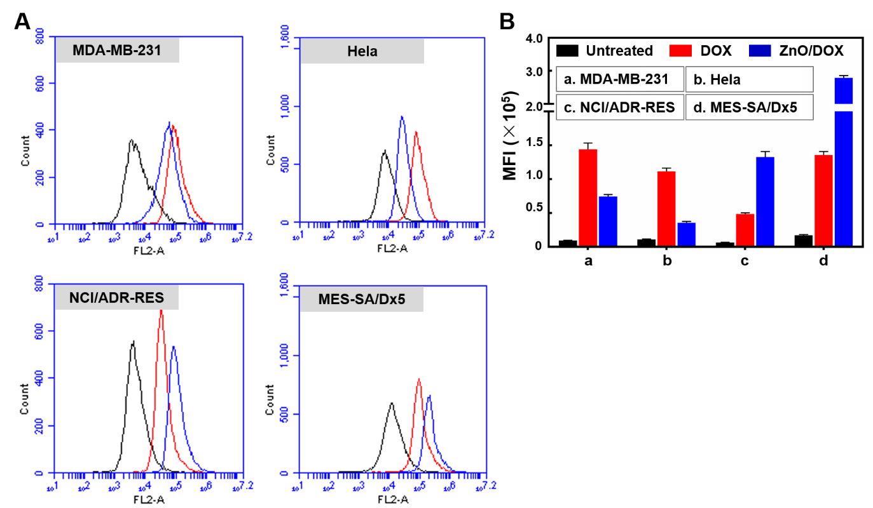
Fig. S1 (A) Cellular uptake of the DOX or ZnO/DOX in the DOX-sensitive cancer cells (MDA-MB-231 and HeLa) and DOX-resistant MDR cancer cells (NCI/ADR-RES and MES-SA/Dx5) after 1 h incubation, determined by flow cytometry. (B) Mean fluorescence intensity (MFI) of the flow cytometry data.

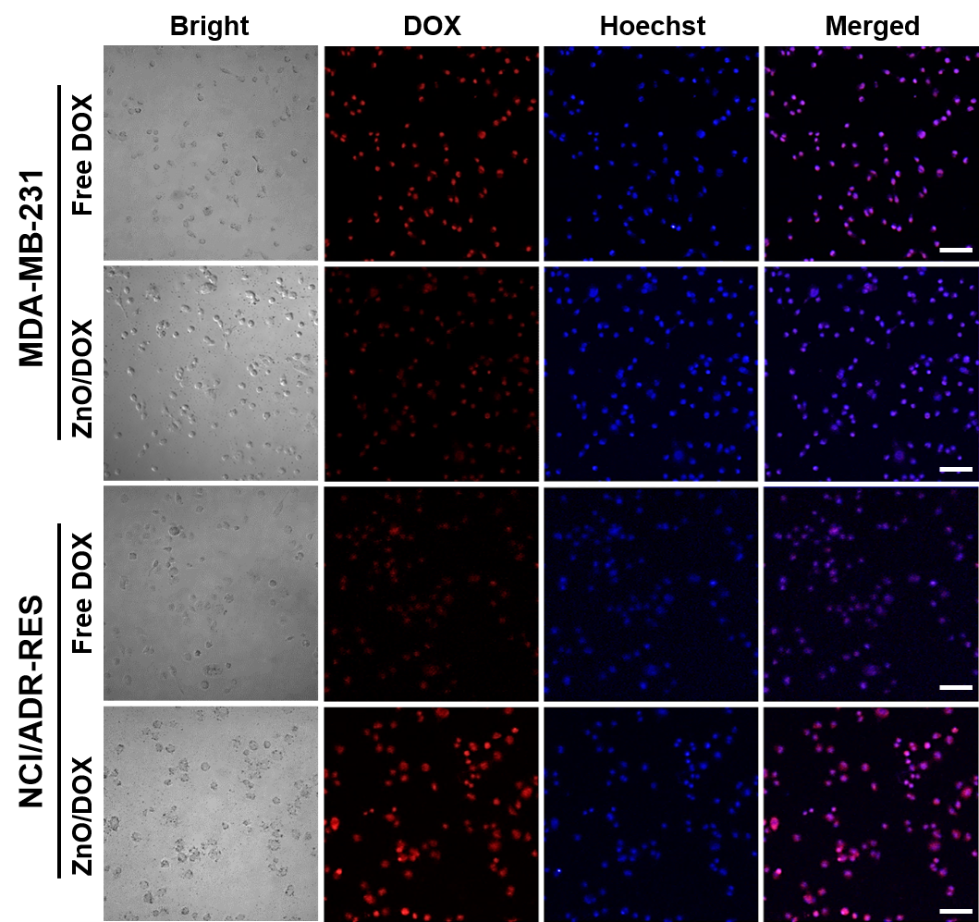
Fig. S2 Confocal microscopic images of cellular internalization of the DOX or ZnO/DOX in the MDA-MB-231 and NCI/ADR-RES cells after 1 h incubation. Cell nuclei were stained by Hoechst (blue). The scale bar is 100 μm.

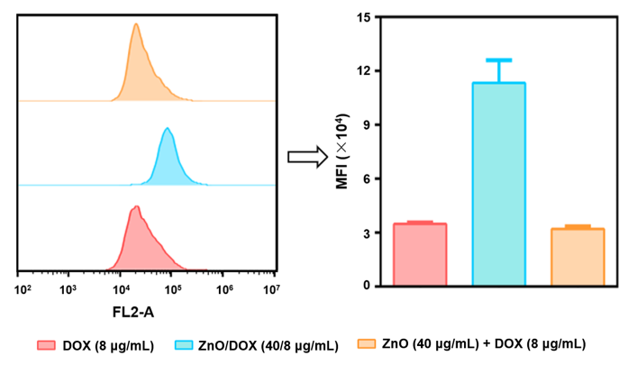
Fig. S3 Uptake of the DOX, ZnO/DOX, or ZnO + DOX mixture after 1 h incubation with the MDR cancer cells (NCI/ADR-RES), determined by flow cytometry. MFI, mean fluorescence intensity.

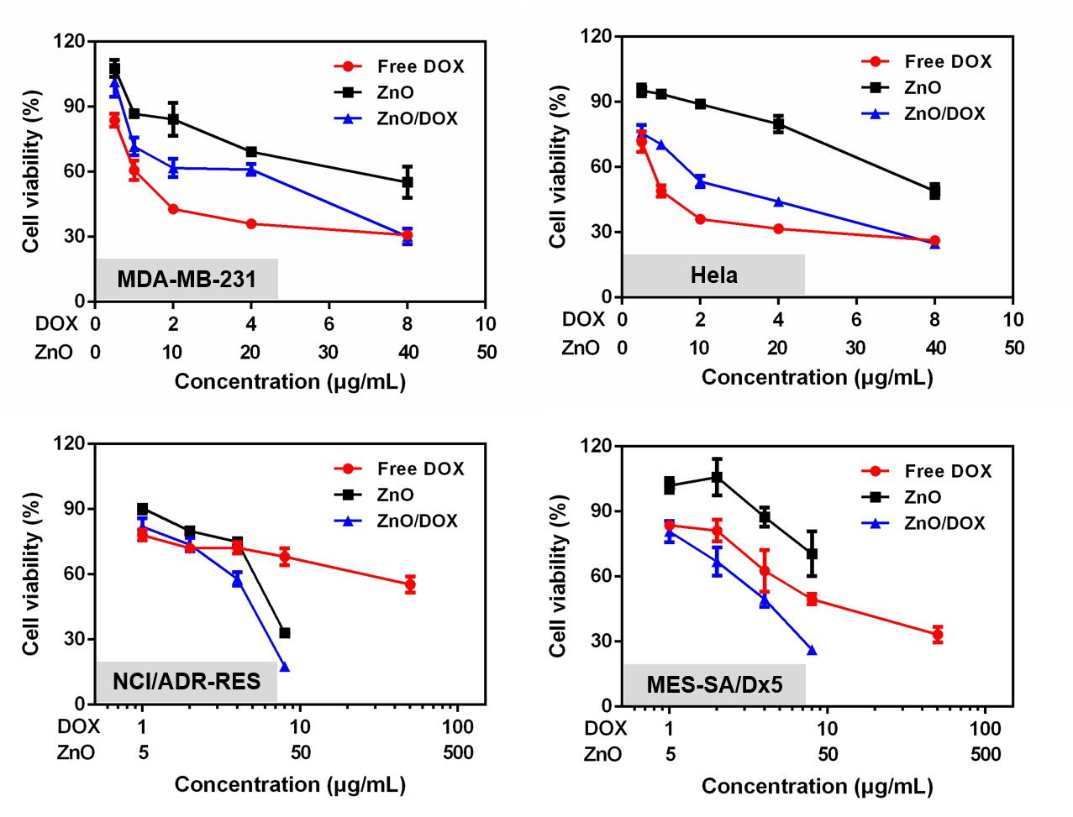
Fig. S4 Cytotoxicity of the DOX, ZnO NPs, and ZnO/DOX in DOX-sensitive cancer cells (MDA-MB-231 and HeLa) and DOX-resistant MDR cancer cells (NCI/ADR-RES and MES-SA/Dx5). Cell incubation time: 24 h.

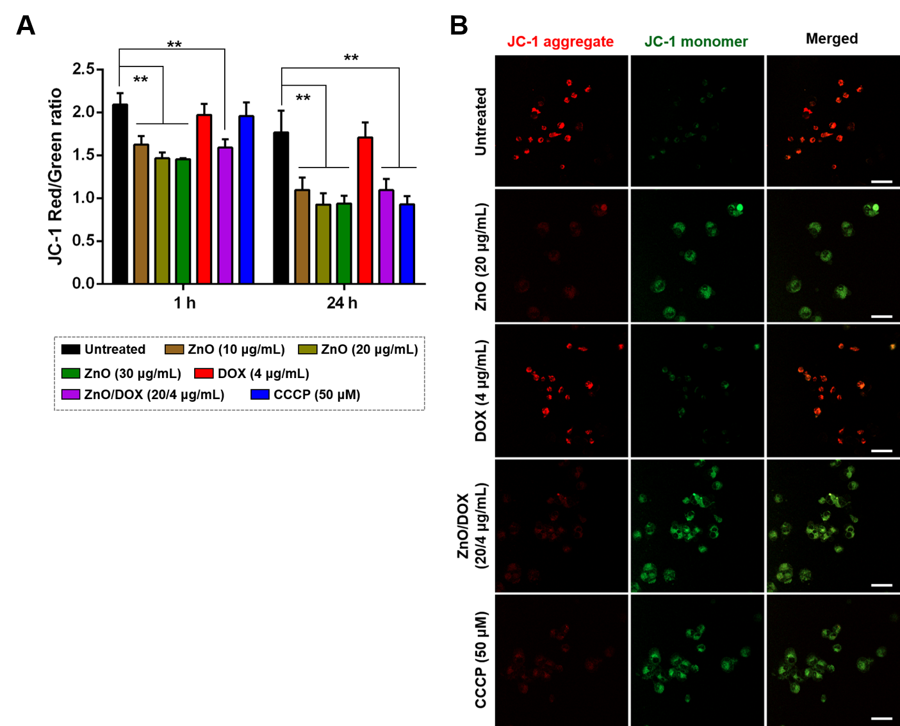 Fig. S5 (A) Mitochondrial membrane potential after 1 h or 24 h treatments, determined by the JC-1 assay (flow cytometry). The decrease in the JC-1 aggregate/monomer ratio (Red/Green ratio) indicates the mitochondrial depolarization. (B) Confocal microscopic images of the JC-1 staining after 4 h treatments. The scale bar is 50 μm.

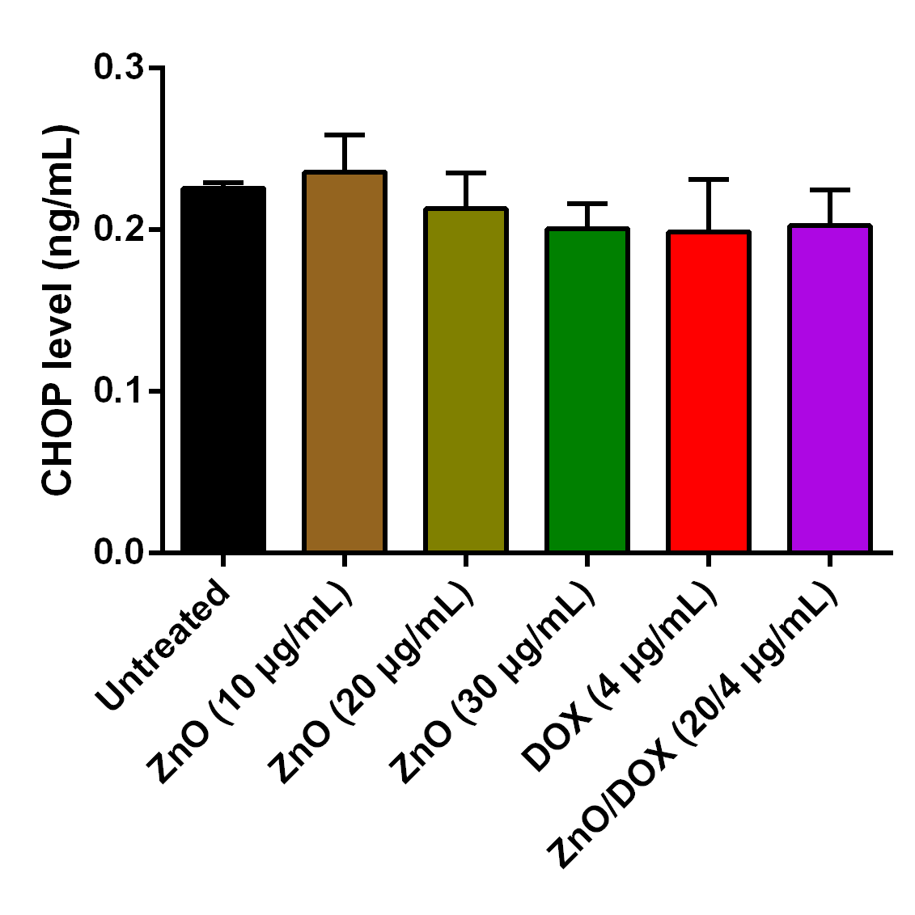
Fig. S6 The C/EBP Homologous Protein (CHOP) levels after 24 h treatments, determined by a CHOP ELISA kit. Cell line: NCI/ADR-RES cells.

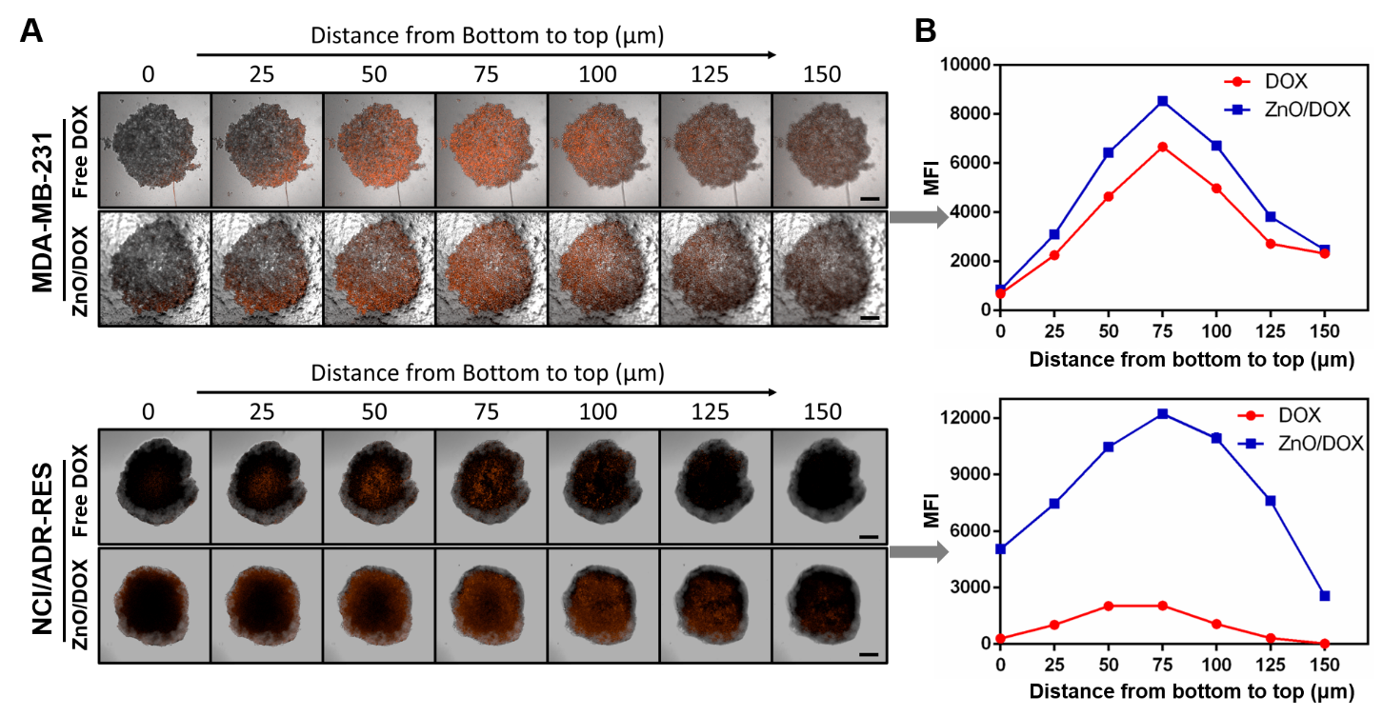
Fig. S7 Drug penetration through the MDA-MB-231 and NCI/ADR-RES cell spheroids after 4 h incubation, determined by confocal microscopy (left panel). The scale bar is 200 μm. The right panel is the curves of the normalized mean fluorescence intensity (MFI) vs the distance from the spheroid bottom to the top.

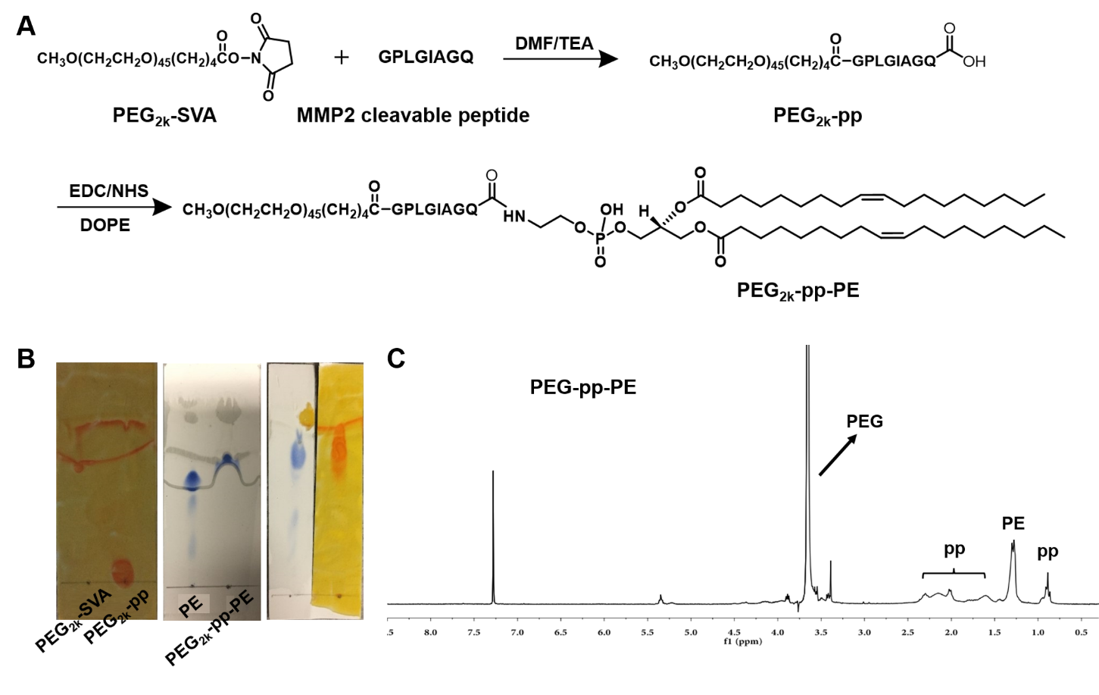 Fig. S8 (A) Synthetic scheme of the PEG-pp-PE. (B) TLC chromatograms of the PEG-pp and PEG-pp-PE. (c) ¹H NMR spectrum of the PEG-pp-PE.

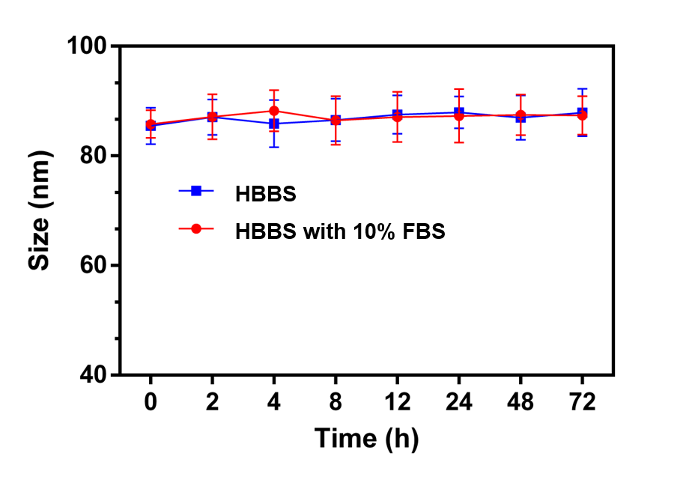
Fig. S9 Mean particle sizes of the ZnO/DPPG/PEG-pp-PE/DOX upon the incubation with HBSS (pH 7.4) or HBSS containing 10% FBS for 72 h. Particle sizes were measured by dynamic light scattering (DLS).

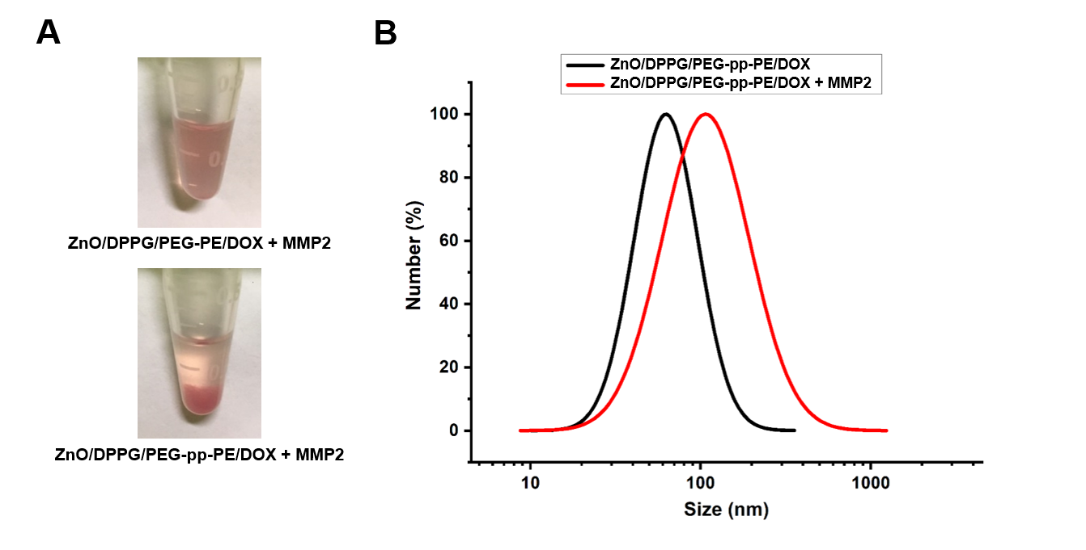
Fig. S10 (A) Digital photographs of the ZnO/DPPG/PEG-PE/DOX and ZnO/DPPG/PEG-pp-PE/DOX with the MMP2 incubation for 12 h. (B) Particle sizes of the ZnO/DPPG/PEG-pp-PE/DOX with/without the MMP2 pretreatment, determined by dynamic light scattering (DLS).

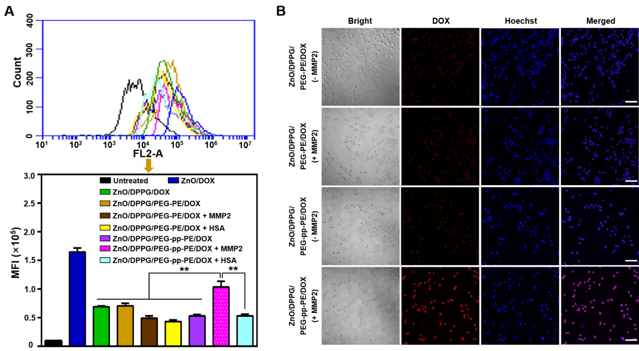 Fig. S11 (A) Cellular uptake of the DOX-loaded ZnO-based NPs in the MDR cancer cells (MES-SA/Dx5) after 1 h incubation, determined by flow cytometry. MFI, mean fluorescence intensity. (B) Confocal microscopic images of the cellular internalization of ZnO/DPPG/PEG-PE/DOX and ZnO/DPPG/PEG-pp-PE/DOX with or without the MMP2 pretreatment after 1 h incubation with the MES-SA/Dx5 cells. Cell nuclei were stained by Hoechst (blue). The scale bar is 100 μm. Data were expressed as the mean ± SD, **p < 0.01; ***p < 0.001.

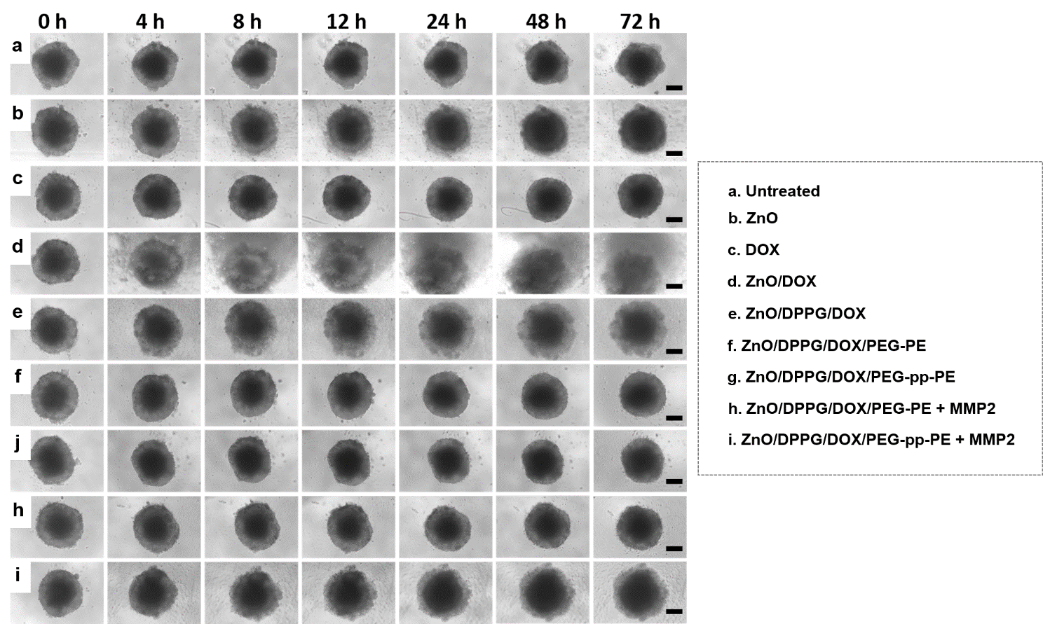 Fig. S12 Morphology of the NCI/ADR-RES cell spheroids after treatments. The scale bar is 100 μm.

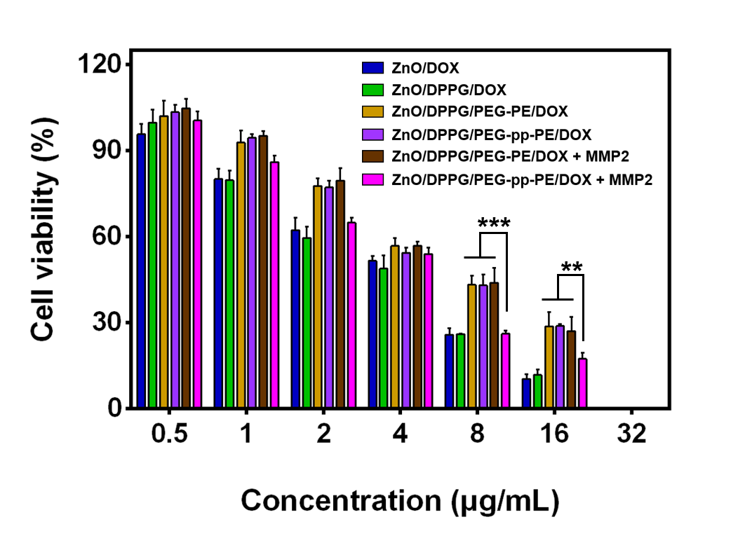
Fig. S13 Cytotoxicity of the DOX-loaded ZnO-based NPs with/without the MMP2 pretreatment after 24 h incubation with the MDR cancer cells (MES-SA/Dx5). Data were expressed as the mean ± SD, **p < 0.01; ***p < 0.001.

