Assessment of low-density polyethylene and poly (ethylene-co-vinyl acetate) capability for the uptake Persistent Organic Pollutants (POPs) in atmospheric passive sampling devices.

Ruben Albeiro Sánchez-Andica*, Estefanía Troches-Mafla, Martha Isabel Paéz-Melo, Jina Martínez-Lara

Grupo de Investigación en Contaminación ambiental por Metales y Plaguicidas (GICAMP), Departamento de Química, Universidad del Valle, Calle 13 No 100-00 PC 760032
* e-mail corresponding author: ruben.sanchez@correounivalle.edu.co

CONTENT
Tables
- Table S1. Chromatographic Conditions and configuration of Mass Spectrometer
- Table S2. Main characteristics of the sampling sites and their respective geographical coordinates
- Table S3. Mass of the polymer, EVA, deposited on the surface of the Glass Fiber Filter (GFF)
- Table S4. Contact angles of drops of three solvents (water, 1,3-propanediol and ethylene glycol) on the surface of the uptaking material used as passive samplers.
- Table S5. Linear range of the POPs and determination coefficients of the calibration curves.
- Table S6. Determination of quality parameters of the analytical method assessed in the extracts of the two uptaking polymers
- Table S7. Partition coefficients EVA-Air (K_{EVA-Air}) calculated from the partition coefficients Octanol-Air (KOA) for each organic pollutant

Figures
- Figure S1. Structures used as supports for the air samplers’ set-up. These contains the uptake polymer materials A) GFF-EVA B) LDPE
- Figure S2. Matrix effect (EM in %) in the chromatographic POPs determination once they have been extracted from GFF-EVA y LDPE polymer materials

Table S1. Chromatographic Conditions and configuration of Mass Spectrometer
Chromatographic Conditions Setup
Injector Temperature (°C) |  | 240 °C
Injection Mode |  | Splitless
Oven temperature ramp |  | 80 °C (1 min), 17 °C/min up to 220 °C (4 min), 4 °C min ¹ up to 270 °C (5 min.)
Mass Spectrometer Setup
Ion source temperature |  | 250 °C
Scan mode |  | MS/MS (MS²)
Ionization method |  | Electron Impact, 70 eV
Maximum excitation energy |  | 0.45 eV
Collision energy |  | 1.05, 1.30
Precursor Ions (PI)
Compound | PI |  | Compound | PI | Compound | PI
PCB 1  α-BHC | 188  181 |  | PCB 101  Lindane | 240.96  180,95 | PCB 187  Aldrin | 393.84  262,91
PCB 5  β-BHC | 222.02  182,95 |  | PCB 87  Heptachlor | 325.9  271,82 | PCB 183  Endosulfan I | 393.81  325,89
PCB 18 | 186.02 |  | PCB 110 | 325.92 | PCB 180 | 393.83
PCB 31 | 256.01 |  | PCB 151 | 359.84 | PCB 170 | 393.82
PCB 52 | 291.92 |  | PCB 153 | 359.87 | PCB 206 | 463.73
PCB 44 | 291.92 |  | PCB 138 | 359.84 | 4,4´-DDE | 246,07
PCB 66 | 291.97 |  | PCB 141 | 359.87 | Dieldrin | 262,95
Endrin | 244,99 |  | Endosulfan II | 240,98 | 4,4´-DDD | 235,04
DDT | 235,1 |  | Methoxichlor | 227,13

Table S2. Main characteristics of the sampling sites and their respective geographical coordinates
Sampling site | Zone | Latitude | Longitude | Description of the zone
Flora | La flora neighborhood – North zone | 3° 29' 25,85" | 76° 31' 16,41" | Station located on the top floor of the parking lot of Éxito, La Flora shopping center. Close to industrial activities. High vehicular traffic.
ERA-Obrero | Obrero neighborhood – Downtown area | 3° 27' 1,51" | 76° 31' 20,16" | Station located within the facilities of the School Republic of Argentina. Near to industrial activities. High vehicular traffic flow
Transitoria-EDB Navarro | Barrio Poblado - Zona oriente | 3°25'1.93" | 76°29'41,05" | Station located at EMCALI's treatment plant
Base aérea | The Cane water park - northeast Zone | 3° 27' 25,66" | 76° 30' 8,29" | Station located near to the Air Base. Close to industrial activities. High vehicular traffic
Pance | Pance – Rural zone or control point | 3° 18' 19,22" | 76° 31' 57,29" | Station located in rural zone. Close to sugar cane crops
Univalle | Meléndez neighborhood – South zone | 3°22'40.48" | 76°32'1.72" | Station located south of the city. Close to sugar cane crops
Compartir | Compartir neighborhood – East zone | 3°25'42.20" | 76°28'0.12" | Station located at EPSA power plant. High vehicular traffic.
Ermita | San Pedro neighborhood - Downtown area | 3°27'19.69" | 76°31'51.57" | Station located in the downtown area of the city. High vehicular traffic.
Cañaveralejo | Cañaveralejo MIO Station - Southwest zone | 3°24'55.40" | 76°32'57.65" | Station located at Cañaveralejo MIO station. High vehicular traffic.

Table S3. Mass of the polymer, EVA, deposited on the surface of the Glass Fiber Filter (GFF)
 | GFF-EVA-L1 (g EVA) | GFF-EVA-L2 (g EVA)
 | 0,0375 | 0,0732
 | 0,0384 | 0,0738
 | 0,0367 | 0,0728
 | 0,0392 | 0,0760
 | 0,0371 | 0,0739
 | 0,0370 | 0,0735
 | 0,0391 | 0,0796
 | 0,0370 | 0,0715
 | 0,0383 | 0,0816
 | 0,3780 | 0,0757
Average | 0,0378 | 0,0752
RSD (%) | 2,4 | 4,2

Table S4. Contact angles of drops of three solvents (water, 1,3-propanediol and ethylene glycol) on the surface of the uptaking material used as passive samplers
Material | Water (H₂O) | 1,3-propanediol (C₂H₆O₂) | Ethylene glycol (C₃H₈O₂)
GFF-EVA-L1 | 117.6±4.9 | 103.8±4.3 | 113.8±4.3
GFF-EVA-L2 | 117.2±1.7 | 105.3±2.9 | 103.1±2.5
LDPE | 93.1±4.4 | 80.6±2.6 | 73.5±1.9

Table S5. Linear range of the POPs and determination coefficients of the calibration curves. These parameters were determined for the analytical determinations with LDPE and GFF-EVA-L1 extracts. Two linear range (and in consequence two r2) were evaluated for some compounds.
Compound | LDPE |  | GFF_EVA-L1
Compound | Linear range (µ/L) | r² | Linear range (µ/L) | r²
PCB-1 | 1-20, 20-140 | 0.9957, 0.9916 | 50-90 | 0.9998
α-BHC | 1-20, 20-120 | 0.9870, 0.9950 | 50-90 | 0.9998
PCB-5 | 1-20, 20-140 | 0.9985, 0.9909 | 50-90 | 0.9999
β-BHC | 20-120 | 0.995 | 10 - 120 | 0.991
Lindane | 1-20, 20-140 | 0.9894, 0.9928 | 50-90 | 0.9994
PCB-18 | 3-20, 20-140 | 0.9919, 0.9953 | 50-90 | 0.9999
PCB-31 | 1-20, 20-140 | 0.9979, 0.9995 | 50-90 | 0.9999
Heptachlor | 1-20, 20-140 | 0.9981, 0.9984 | 50-90 | 0.9937
PCB-52 | 1-20, 20-140 | 0.9979, 0.9925 | 50-90 | 0.9999
Aldrin | 3-20, 20-140 | 0.9950, 0.9956 | 20 - 120 | 0.9833
PCB-44 | 1-20, 20-140 | 0.9962, 0.9942 | 50-90 | 0.9999
PCB-66 | 1-20, 20-140 | 0.9979, 0.9985 | 50-90 | 0.9999
Endosulfan I | 3-20, 20-140 | 0.9881, 0.9984 | 50-90 | 0.9998
PCB-101 | 1-20, 20-140 | 0.9952, 0.9949 | 50-90 | 0.9999
PCB-87 | 1-20, 20-140 | 0.9991, 0.9949 | 50-90 | 0.9999
4,4’-DDE | 1-20, 20-140 | 0.9967, 0.9978 | 50-90 | 0.999
Dieldrin | - | - | 20 - 120 | 0.9917
PCB-110 | 1-20, 20-140 | 0.9968, 0.9953 | 50-90 | 0.9999
PCB-151 | 10-140 | 0.9989 | 50-90 | 0.9994
Endrin | 5-20, 20-140 | 0.9945, 0.9939 | 20 - 120 | 0.9801
Endosulfan II | 20-140 | 0.9985 | 5-120 | 0.9847
4,4’-DDD | 3-20, 20-140 | 0.9980, 0.9956 | 50-90 | 0.9999
PCB-153 | 1-20, 20-140 | 0.9974, 0.9856 | 50-90 | 0.9999
PCB-138 | 1-20, 20-140 | 0.9953, 0.9943 | 50-90 | 0.9999
DDT | 10-120 | 0.9905 | 10-120 | 0.9997
PCB-141 | 1-20, 20-140 | 0.9956, 0.9970 | 50-90 | 0.9999
PCB-187 | 1-20, 20-140 | 0.9982, 0.9978 | 50-90 | 0.9999
PCB-183 | 1-20, 20-140 | 0.997, 0.9956 | 50-90 | 0.9999
Methoxychlor | 3-20, 20-120 | 0.9942, 0.9954 | 50-90 | 0.9998
PCB-180 | 1-20, 20-140 | 0.9970, 0.9805 | 50-90 | 0.9999
PCB-170 | 3-20, 20-140 | 0.9972, 0.9921 | 50-90 | 0.9999
PCB-206 | 20-120 | 0.9993 | 50-90 | 0.9999

Table S6. Determination of quality parameters of the analytical method assessed in the extracts of the two uptaking polymers: Recovery percentage (%R), Relative Standard Deviation RSD (%), Limit of Detection (LOD) and the Limit of Quantification (LOQ)
Compound | GFF-EVA |  |  |  | LDPE
Compound | R (%) | RSD (%) | LOD (µg/L) | LQQ (µg/L) | R (%) | RSD (%) | LOD (µg/L) | LQQ (µg/L)
PCB-1 | 80.6 | 5.9 | 0.5 | 3.0 | 81.9 | 4.6 | 0.5 | 1.0
α-BHC | 73.9 | 9.2 | 1.0 | 3.0 | 113.7 | 7.1 | 0.5 | 1.0
PCB-5 | 106 | 6 | 1.0 | 3.0 | 117.2 | 4.9 | 0.5 | 1.0
β-BHC | 102.7 | 3.7 | 3.0 | 5.0 | 75.9 | 13.8 | 5.0 | 10.0
Lindane | 110.5 | 4.5 | 3.0 | 5.0 | 90.8 | 10.5 | 0.5 | 1.0
PCB-18 | 101.7 | 5.3 | 1.0 | 3.0 | 116.3 | 6.2 | 1.0 | 3.0
PCB-31 | 106.5 | 2.9 | 1.0 | 3.0 | 113.0 | 4.2 | 0.5 | 1.0
Heptachlor | 99.4 | 5.5 | 1.0 | 3.0 | 108.6 | 4.5 | 0.5 | 1.0
PCB-52 | 106.8 | 2.5 | 0.5 | 3.0 | 106.8 | 6.7 | 0.5 | 1.0
Aldrin | 111.3 | 4.2 | 3.0 | 20.0 | 100.6 | 1.6 | 1.0 | 3.0
PCB-44 | 108.1 | 3.7 | 3.0 | 5.0 | 117 | 2.5 | 1.0 | 3.0
PCB-66 | 111.6 | 2.7 | 1.0 | 3.0 | 118.6 | 4.2 | 0.5 | 1.0
Endosulfan I | 118.5 | 10.3 | 3.0 | 5.0 | 100.9 | 4.7 | 1.0 | 3.0
PCB-101 | 103.9 | 4.1 | 3.0 | 5.0 | 114.2 | 5.1 | 0.5 | 1.0
PCB-87 | 107.4 | 3.5 | 3.0 | 5.0 | 114 | 4.9 | 0.5 | 1.0
4.4´-DDE | 121.9 | 1.7 | 0.5 | 3.0 | 105.4 | 7.2 | 0.5 | 1.0
Dieldrin | 100.4 | 2.2 | 3.0 | 20.0 | - | - | - | -
PCB-110 | 111.5 | 2.0 | 3.0 | 5.0 | 108.4 | 3.4 | 0.5 | 1.0
PCB-151 | 103.8 | 2.8 | 1.0 | 3.0 | 99.7 | 11.3 | 5.0 | 10.0
Endrin | 116.3 | 3.8 | 10 | 20.0 | 101.8 | 3.24 | 2.0 | 5.0
Endosulfan II | 115.3 | 11.3 | 3.0 | 5.0 | 120.7 | 5.6 | 10.0 | 20.0
4.4´-DDD | 83.1 | 6.1 | 3.0 | 5.0 | 112.1 | 3.7 | 1.0 | 3.0
PCB-153 | 103.4 | 2.2 | 3.0 | 5.0 | 111.9 | 3.13 | 0.5 | 1.0
PCB-138 | 108.9 | 2.5 | 3.0 | 5.0 | 111.8 | 2.8 | 0.5 | 1.0
DDT | 98.7 | 3.1 | 5.0 | 10.0 | - | - | 5.0 | 10.0
PCB-141 | 109.5 | 2.0 | 3.0 | 5.0 | 100.6 | 2.8 | 0.5 | 1.0
PCB-187 | 107.5 | 1.2 | 3.0 | 5.0 | 99.7 | 3.9 | 0.5 | 1.0
Methoxychlor | 106.8 | 1.4 | 1.0 | 3.0 | 106 | 1.3 | 1.0 | 3.0
PCB-183 | 101.3 | 5.2 | 3.0 | 5.0 | 105.1 | 3.6 | 0.5 | 1.0
PCB-180 | 97.7 | 2.0 | 3.0 | 5.0 | 94.5 | 3.5 | 0.5 | 1.0
PCB-170 | 106.1 | 2.9 | 3.0 | 5.0 | 97.3 | 2.4 | 1.0 | 3.0
PCB-206 | 122.0 | 2.2 | 4.0 | 5.0 | 86.4 | 2.9 | 2.0 | 5.0

Table S7. Partition coefficients EVA-Air (K_{EVA-Air}) calculated from the partition coefficients Octanol-Air (K_{OA}) for each organic pollutant
Compound | LogK_{OA} | LogK_{EVA-AIR} calculated by: |  | LogK_{KEVA-AIR} Average
Compound | LogK_{OA} | Eq. 1 | Eq. 2
PCB-1 | 6.17 | 5.9 | 5.8 | 5.9
α-BHC | 7.82 | 7.8 | 7.4 | 7.6
PCB-5 | 7.05 | 7.0 | 6.6 | 6.8
β-BHC | 7.82 | 7.8 | 7.4 | 7.6
Lindane | 7.82 | 7.8 | 7.4 | 7.6
PCB-18 | 7.54 | 7.5 | 7.1 | 7.3
PCB-31 | 7.8 | 7.8 | 7.4 | 7.6
Heptachlor | 7.39 | 7.3 | 7.0 | 7.2
PCB-52 | 8.18 | 8.3 | 7.7 | 8.0
Aldrin | 9.25 | 9.5 | 8.8 | 9.1
PCB-44 | 8.05 | 8.1 | 7.6 | 7.9
PCB-66 | 8.62 | 8.8 | 8.2 | 8.5
Endosulfan I | 6.41 | 6.2 | 6.0 | 6.1
PCB-101 | 9.23 | 9.5 | 8.8 | 9.1
PCB-87 | 9.37 | 9.6 | 8.9 | 9.3
4,4’-DDE | 9.28 | 9.5 | 8.8 | 9.2
Dieldrin | 8.59 | 8.7 | 8.1 | 8.4
PCB-110 | 8.64 | 8.8 | 8.2 | 8.5
PCB-151 | 10.24 | 10.6 | 9.7 | 10.2
Endrin | 8.59 | 8.7 | 8.1 | 8.4
Endosulfan II | 6.41 | 6.2 | 6.0 | 6.1
4,4’-DDD | 9.59 | 9.9 | 9.1 | 9.5
PCB-153 | 10.78 | 11.2 | 10.3 | 10.8
PCB-138 | 10.51 | 10.9 | 10.0 | 10.5
DDT | 10.38 | 10.8 | 9.9 | 10.3
PCB-141 | 10.38 | 10.8 | 9.9 | 10.3
PCB-187 | 10.95 | 11.4 | 10.4 | 10.9
PCB-183 | 10.95 | 11.4 | 10.4 | 10.9
Methoxychlor | 10.48 | 10.9 | 10.0 | 10.4
PCB-180 | 11.66 | 12.2 | 11.1 | 11.7
PCB-170 | 11.7 | 12.3 | 11.2 | 11.7
PCB-206 | 12.08 | 12.7 | 11.5 | 12.1
Eq. 1: ${LogK}_{EVA-air}=1.148\left({LogK}_{OA}\right)-1.1363$

Eq. 2: ${LogK}_{EVA-air}=0.97\left({LogK}_{OA}\right)-0.19$

K_{OA} values were obtained from the EPI Suite data base from EPA (https://www.epa.gov/tsca-screening-tools/epi-suitetm-estimation-program-interface)

Figures

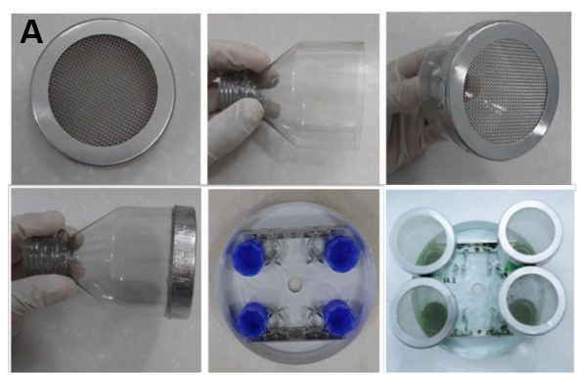
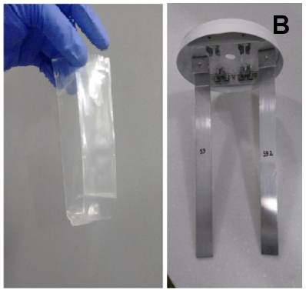
Figure S1. Structures used as supports for the air samplers’ set-up. These contains the uptake polymer materials A) GFF-EVA B) LDPE

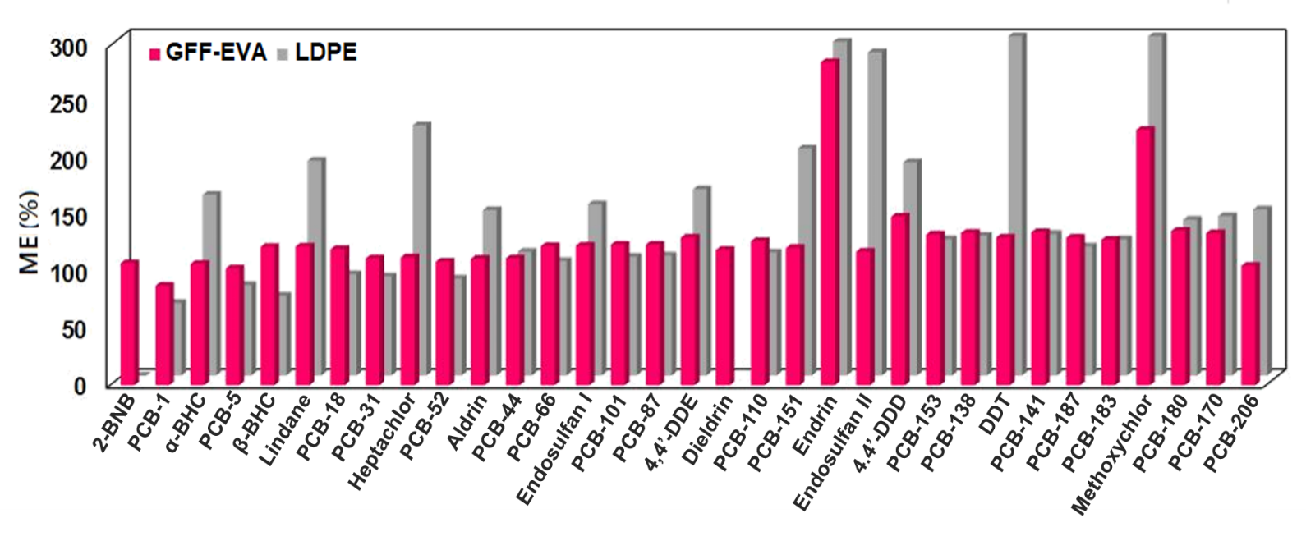
Figure S2. Matrix effect (EM in %) in the chromatographic POPs determination once they have been extracted from GFF-EVA y LDPE polymer materials

