Supplementary Information
Table S1. Table of bioassay total organic carbon (TOC) and O₂ removal rates, respiratory quotient (RQ), nominal oxidation state of carbon (NOSC) for the removed DOM, relative contribution of organoheterocyclic compounds to removed DOM, bacterial growth efficiency (BGE) and the change in total dissolved amino acids in carbon units (TDAA C). Shown in the first three columns are the date of bioassay initiation, the depth that the water was collected from, and the bioassay design where “d” are dilutions of 30:70 3.0 µm:0.2 µm filtrates and “u” are undiluted 3.0 µm filtrate.

Date | Depth | Dilution | TOC | O₂ | RQ | NOSC | Organo-heterocyclic | BGE | ΔTDAA C
 | m |  | µM C d⁻¹ | µM O² d⁻¹ | O2/TOC |  | % | % | µM C
5/5 | 5 | d | - | 0.43±0.03 | - | -0.82±0.02 | 10±1 | 37±3 | -
5/5 | 5 | d | - | 0.43±0.03 | - | -0.90±0.01 | 6±1 | 37±3 | -
5/5 | 5 | u | - | 0.46±0.02 | - | - | - | 31±3 | -
5/5 | 5 | u | - | 0.46±0.02 | - | -0.70±0.03 | 14±1 | 31±3 | -
5/11 | 5 | d | 0.18±0.03 | 0.43±0.03 | 1.36±0.17 | -0.65±0.04 | 10±1 | 32±3 | -0.29±0.09
5/11 | 5 | d | 0.18±0.03 | 0.43±0.03 | 1.36±0.17 | -0.65±0.02 | 11±1 | 32±3 | -0.29±0.09
5/11 | 5 | u | 0.27±0.06 | 0.60±0.02 | 1.56±0.22 | -0.61±0.04 | 10±1 | 31±4 | -0.34±0.10
5/11 | 5 | u | 0.27±0.06 | 0.60±0.02 | 1.56±0.22 | -0.64±0.04 | 15±1 | 31±4 | -0.34±0.10
5/11 | 50 | d | 0.16±0.05 | 0.37±0.03 | 1.15±0.33 | -0.83±0.02 | 7±1 | 45±4 | -0.06±0.02
5/11 | 50 | d | 0.16±0.05 | 0.37±0.03 | 1.15±0.33 | -0.83±0.02 | 7±1 | 45±4 | -0.06±0.02
5/11 | 50 | u | 0.11±0.01 | 0.29±0.03 | 1.04±0.14 | -0.87±0.02 | 6±1 | 56±3 | 0.31±0.09
5/11 | 50 | u | 0.11±0.01 | 0.29±0.03 | 1.04±0.14 | -0.90±0.02 | 6±1 | 56±3 | 0.31±0.09
5/17 | 5 | d | 0.24±0.04 | 0.48±0.04 | 1.24±0.19 | -0.70±0.02 | 13±1 | 26±5 | -0.05±0.02
5/17 | 5 | u | 0.24±0.05 | 0.57±0.02 | 1.62±0.20 | -0.60±0.03 | 11±1 | 28±4 | -0.50±0.15
5/17 | 5 | u | 0.24±0.05 | 0.57±0.02 | 1.62±0.20 | -0.64±0.03 | 13±1 | 28±4 | -0.50±0.15
5/22 | 5 | d | 0.29±0.02 | 0.58±0.04 | 1.38±0.10 | -0.71±0.01 | 11±1 | 23±4 | -0.42±0.13
5/22 | 5 | d | 0.29±0.02 | 0.58±0.04 | 1.38±0.10 | -0.71±0.01 | 11±1 | 23±4 | -0.42±0.13
5/22 | 95 | d | 0.21±0.08 | 0.42±0.04 | 1.11±0.40 | -0.70±0.04 | 12±1 | 29±4 | 0.06±0.02
5/22 | 95 | d | 0.21±0.08 | 0.42±0.04 | 1.11±0.40 | -0.71±0.03 | 10±1 | 29±4 | 0.06±0.02
5/5 | 75 | d | - | 0.38±0.02 | - | -0.67±0.02 | 16±2 | 18±2 | -
5/5 | 75 | d | - | 0.38±0.02 | - | - | - | 18±2 | -
5/5 | 75 | u | - | 0.54±0.02 | - | -0.64±0.01 | 16±2 | 12±3 | -
5/5 | 75 | u | - | 0.54±0.02 | - | -0.72±0.03 | 14±1 | 12±3 | -
5/5 | 125 | d | - | 0.27±0.02 | - | -0.74±0.03 | 12±1 | 32±2 | -
5/5 | 125 | d | - | 0.27±0.02 | - | - | - | 32±2 | -
5/5 | 125 | u | - | 0.43±0.02 | - | - | - | 15±2 | -
5/5 | 125 | u | - | 0.43±0.02 | - | -0.72±0.04 | 11±1 | 15±2 | -

Supp. Fig. 1. O₂, TCO₂ and TOC response to glucose and glutamic acid additions.
In a substrate addition test, the amount of carbon added to the seawater control was similar to the pre-determined amount (4 μM C and 8 μM C), and after 7 days, the amount of TOC removed was relatively similar to the amount added suggesting complete oxidation of added substrate (a). TOC removal and TCO₂ production (b) and TOC and O₂ removal (c) were close to the 1:1 line for nearly all treatments. The complete oxidation of glutamic acid is predicted to have a slightly higher RQ than glucose¹⁴, as suggested by the dotted line RQ = 1.1.

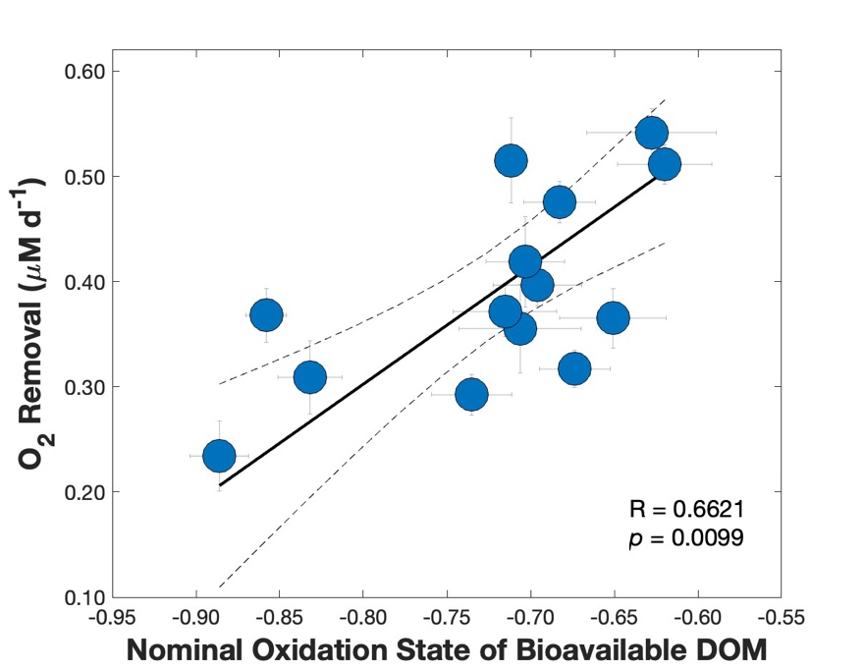
Supp. Fig. 2. The oxidation state of bioavailable dissolved organic matter was correlated with oxygen removal rates.
The nominal oxidation state of bioavailable dissolved organic matter (DOM) was positively correlated with dissolved oxygen (O₂) removal rates. The solid black line and dotted lines represent the Model II linear fit and 95% confidence intervals for the oxidation state and O₂ removal rate (R = 0.6621, p = 0.0099). The lighter lines outside of the symbols represent standard deviations.

N-containing

Supp. Fig. 3. A majority of the organoheterocyclic compounds contained nitrogen.
The relative contributions of organoheterocyclic compounds were positively correlated with the oxidation state of bioavailable dissolved organic matter (as shown in the main text). The majority of the organoheterocyclic compounds (> 70%) contained nitrogen.

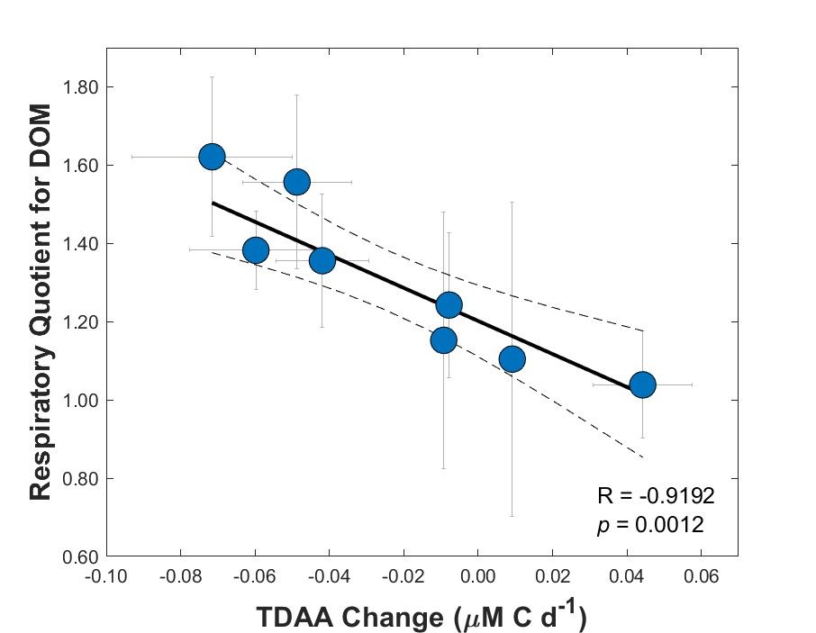

Supp. Fig. 4. The rate of total dissolved amino acid change was correlated with the respiratory quotient for dissolved organic matter.
The rate of total dissolved amino acids in carbon units (TDAA C) change per day between initial and stationary growth phases were significantly negatively correlated with the respiratory quotient (RQ; O₂ uptake vs. respiration of dissolved organic carbon) for dissolved organic matter (DOM) (R = -0.9192, p = 0.0012). Note that negative values in the x-axis indicate removal and positive values indicate production. The solid black line and dotted lines represent the weighted model II linear fit and 95% confidence intervals. The lighter lines outside of the symbols represent standard deviations.

Supp. Fig. 5. Functional group losses identified were from a range of compound types but the majority contained carboxylic groups.
Functional group losses were identified using the chemical proportionality workflow⁷⁷ leveraging Global Natural Products Social networking molecular feature connections. The most commonly recurring molecular offsets included mass offsets related to -CH₂, -C₂H₄, -CH₃CH=O groups (a). Example networks highlight the range in compound types with molecular offsets found in the dataset presented here (b), where diamond shapes refer to compounds with exact library matches, yellow colors refer to compounds where the majority of the bioassays decreased in relative peak areas between initial and equilibrium growth phases and blue colors refer to either no change or an increase in peak areas. The majority of the compounds with a change in peak areas contained carboxylic acids, the majority of which were either amino acid-like or peptide like in composition (c).

