Supplement of
PERFORMANCE EVALUATION OF CORDEX-SEA DATASET
BASED ON MULTI-METRICS AND WEIGHTED ENSEMBLE MEAN

Aminoto et al.
Correspondence to: Perdinan (email: perdinan@apps.ipb.ac.id)

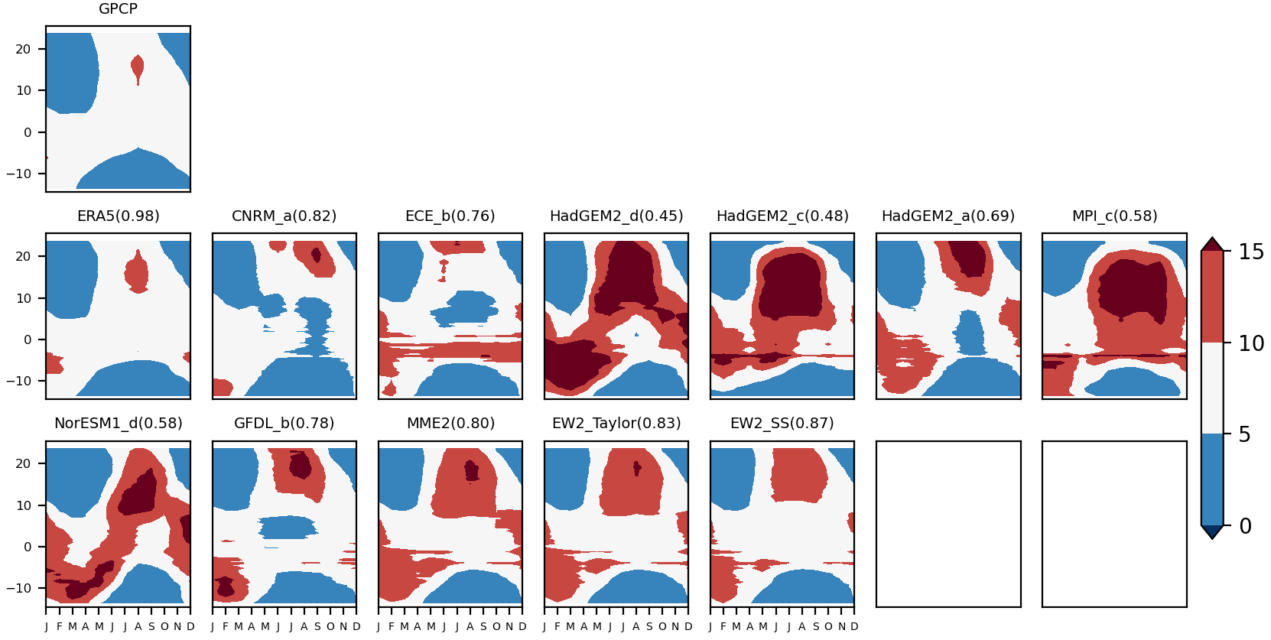
Fig. S1 Zonally averaged annual cycle of precipitation (mm/month) in the SEA region (for new configuration: IPSL not included). The value (Taylor’s skill score) inside the bracket represents the pattern similarity of the model to the reference.

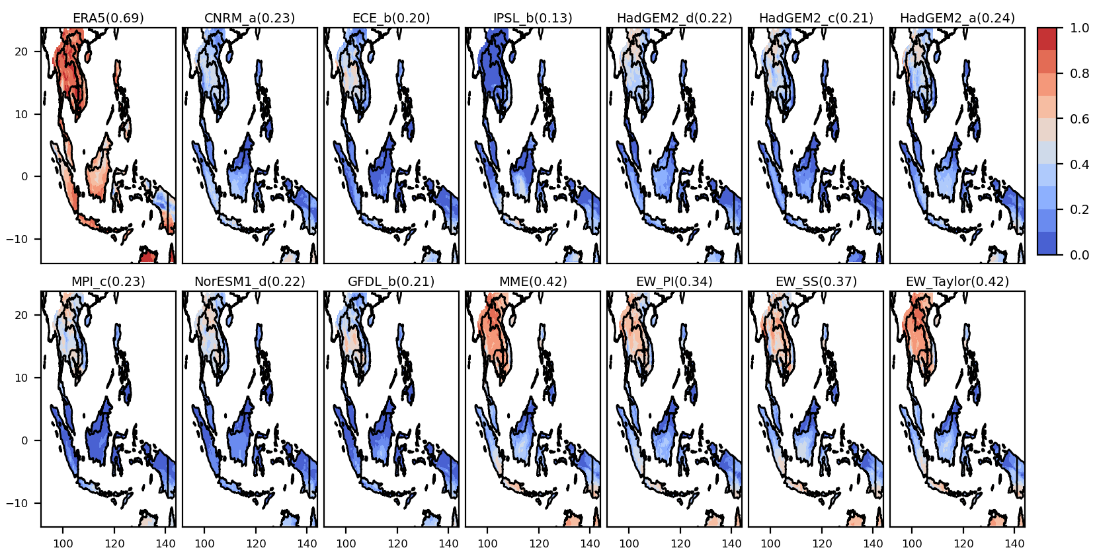
Fig. S2 The distribution of Taylor's skill scores (for monthly data) shows the performance of the model in each sub-region. The value inside the bracket is the mean score.
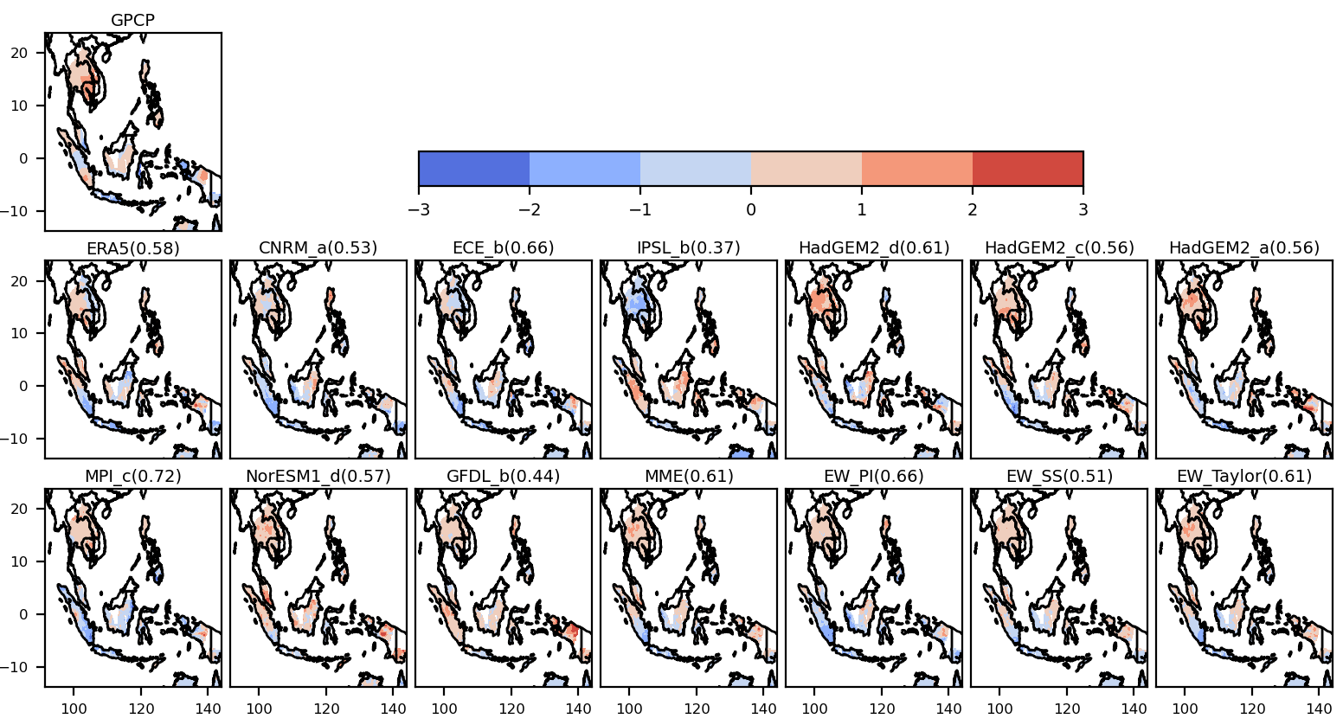
Fig. S3 Spatial distribution of trend evaluation results with Mann-Kendall test on monthly data. A positive z indicates an increasing trend and vice versa. The value inside the bracket represents the similarity pattern to the reference (GPCP).
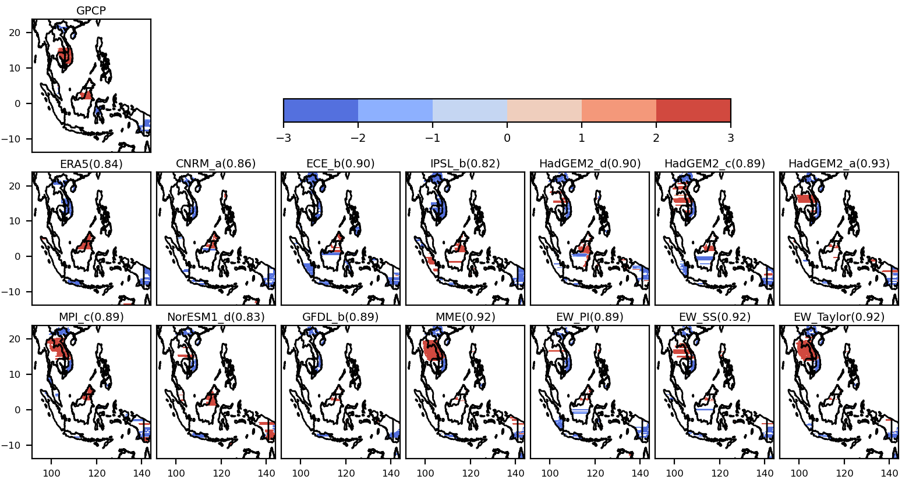
Fig. S4 Spatial distribution of precipitation trend for statistically significant (p-value < 0.05) using Mann-Kendall test. A positive z indicates an increasing trend and vice versa. The value inside the bracket represents the pattern similarity with the reference (GPCP).

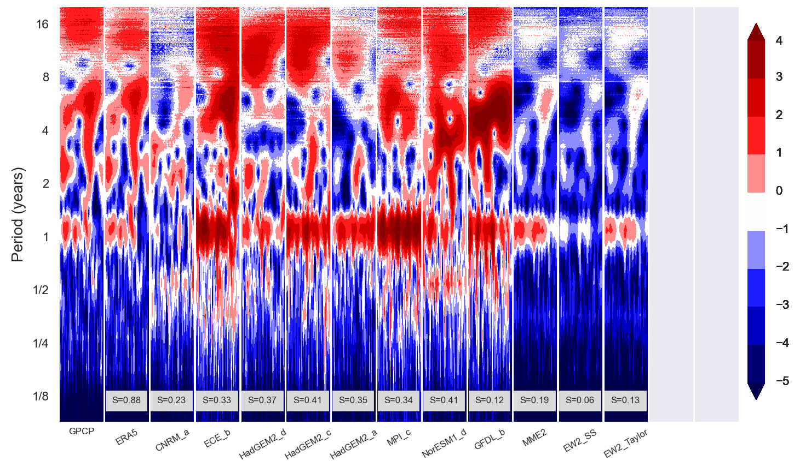
Fig. S5 Wavelet profile of the SEA precipitation variability for new configuration (IPSL_b not included). The S value represents the pattern similarity with the reference (GPCP).

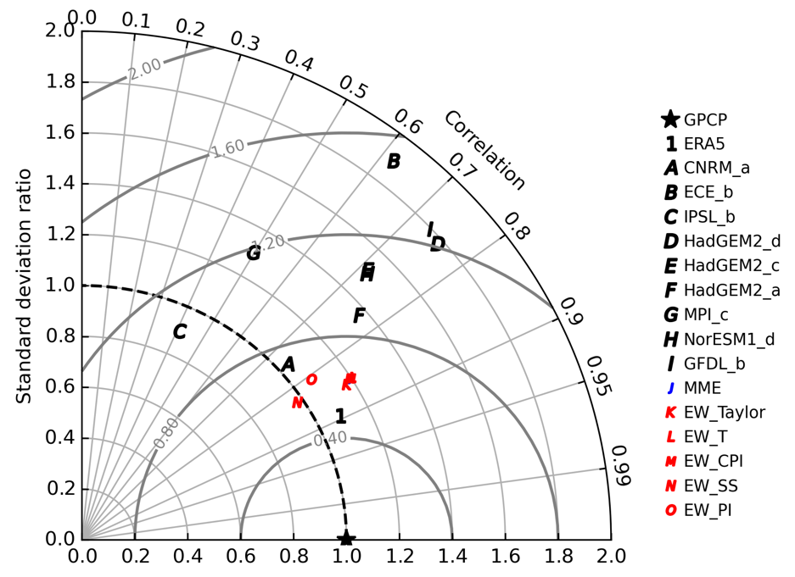
Fig. S6 Taylor diagram (temporal approach) showing the performance of 9 models (A-I), unweighted ensemble mean (J), and weighted ensemble mean with 5 weighting factors: S (K), T (L), CPI (M) , SS (N) and PI (O). Standard deviation ratio and correlation calculation were performed on the temporarily basis.

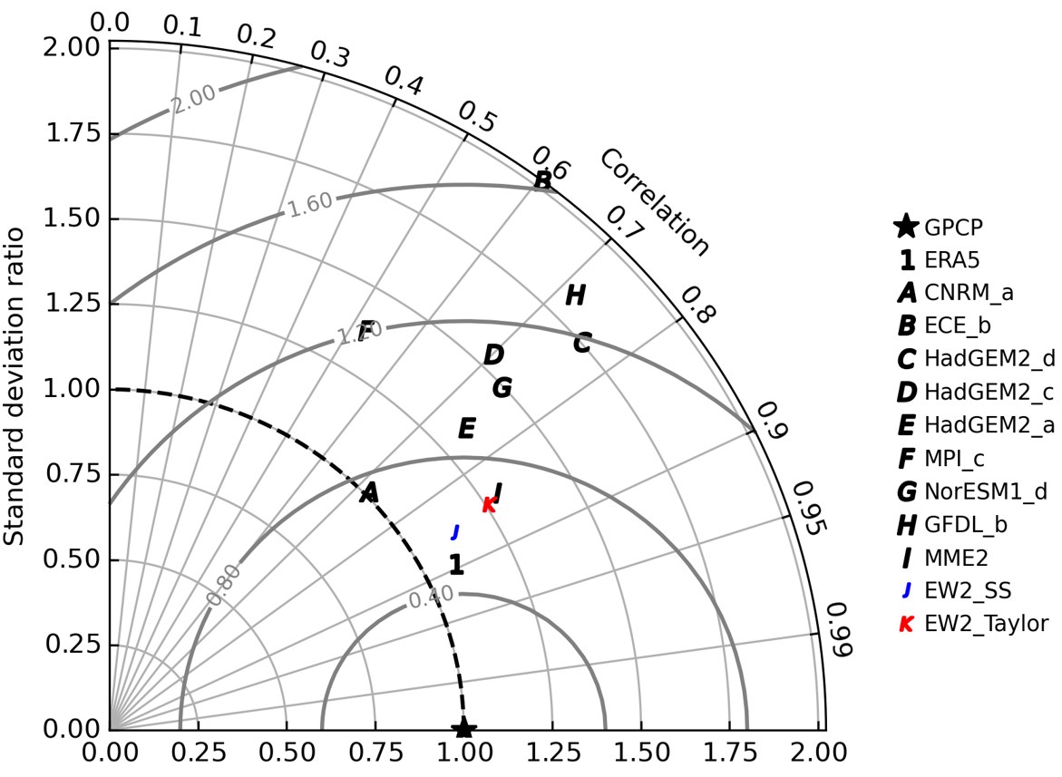
Fig. S7 As in Fig. 6 except for the new configuration (IPSL model and PI metric not included).

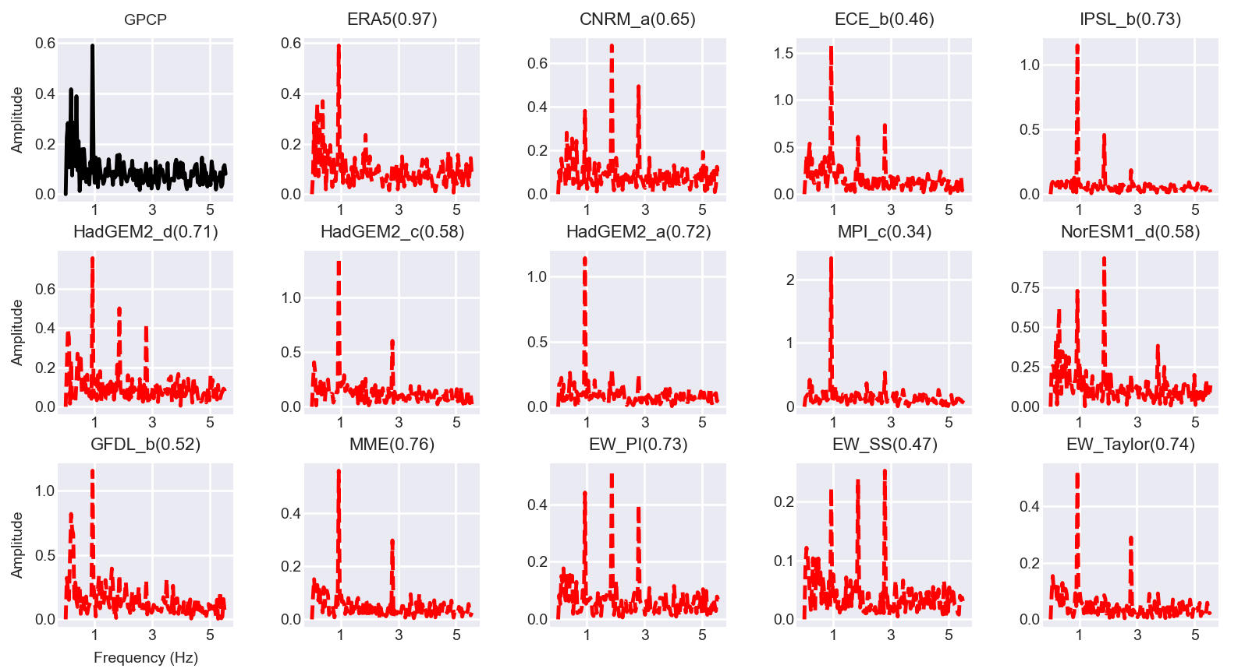
Fig. S8 Plot of FFT for models (red dashed line) vs reference (black line) of the SEA precipitation variability. The value inside the bracket represents the pattern similarity of a model to the reference (GPCP).
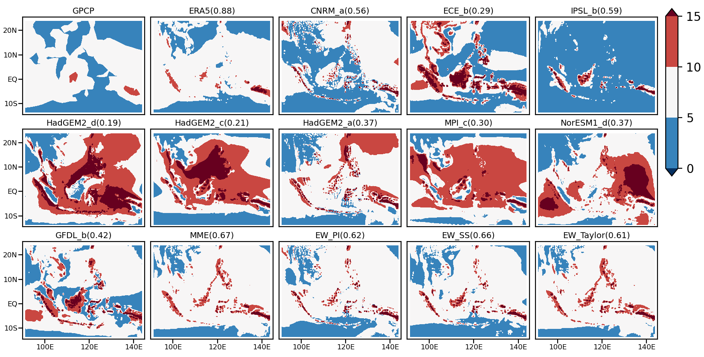

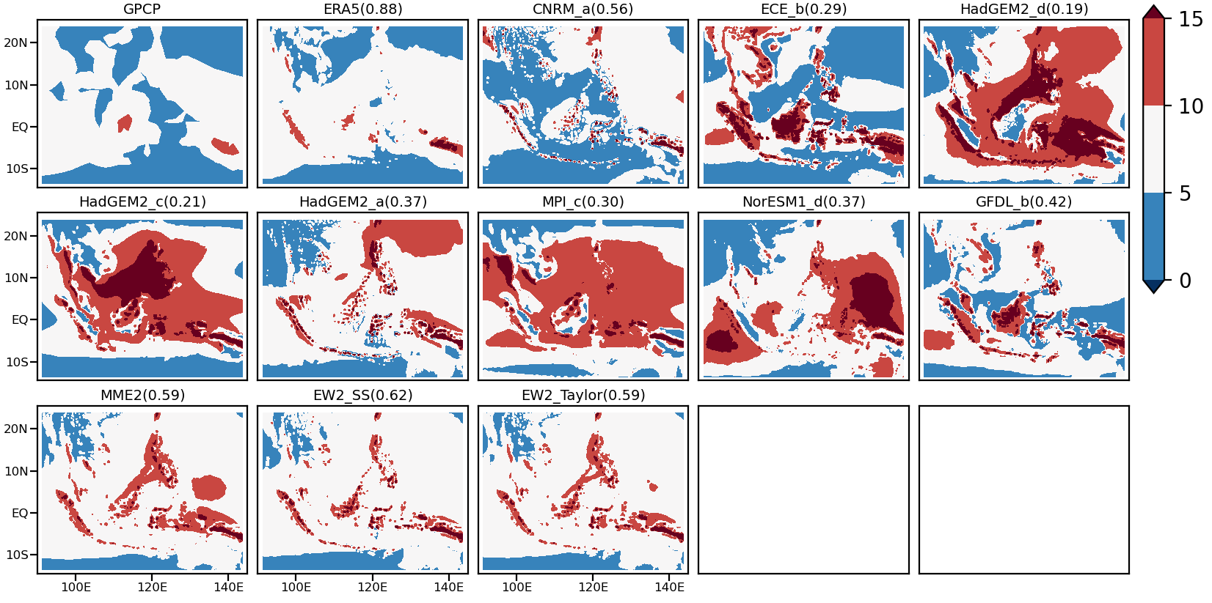

Fig. S9 Mean rainfall from 1981 to 2005 in the SEA region (top), for new configuration: IPSL_b and PI not included (bottom). The value inside the bracket represents the pattern similarity with the reference (GPCP).

