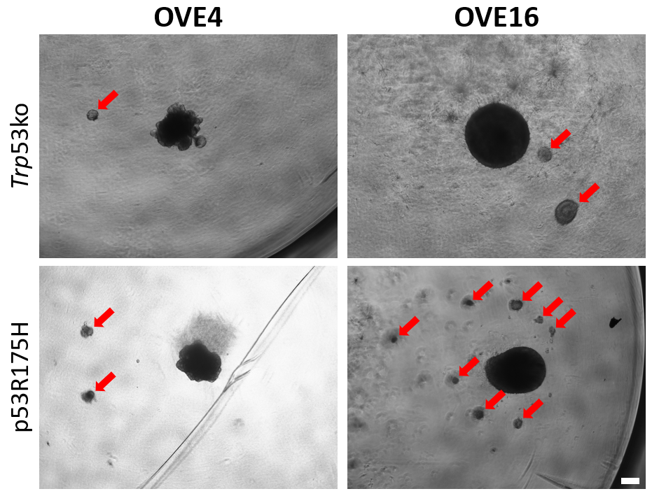

Supplementary Figure S1: Images of OVE spheroids with Trp53 mutation 14 days after embedding in Matrigel. Red arrows indicate satellite colonies. Scale bar represents 200 µm.

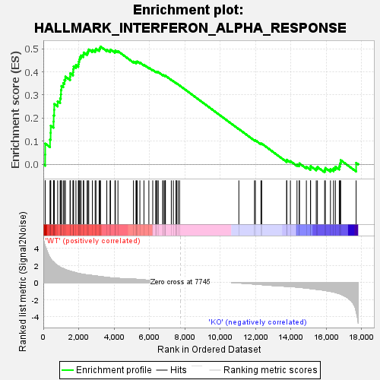
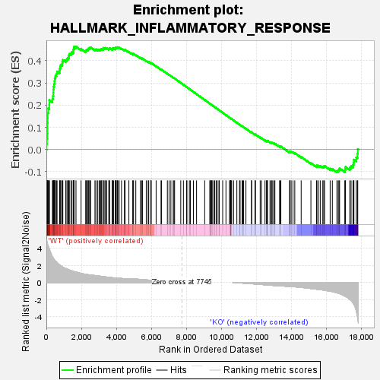
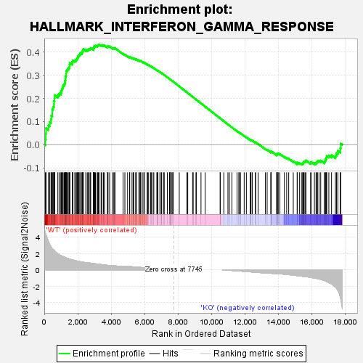
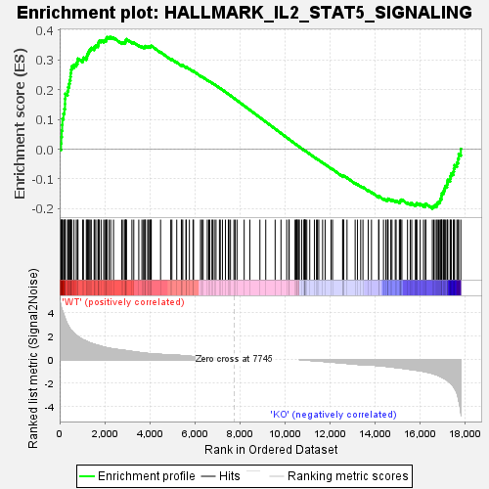
OVE4 parental vs Trp53ko:

OVE16 parental vs Trp53ko:

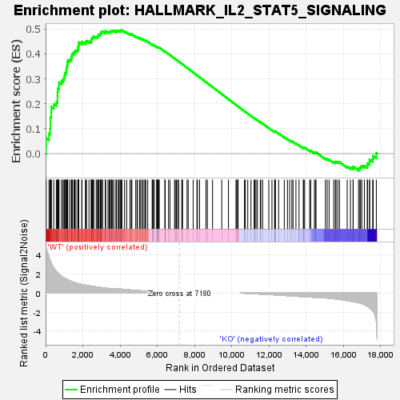
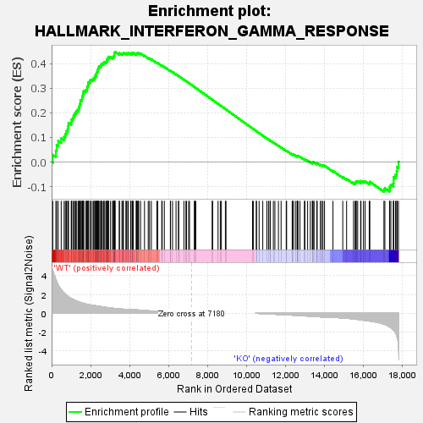
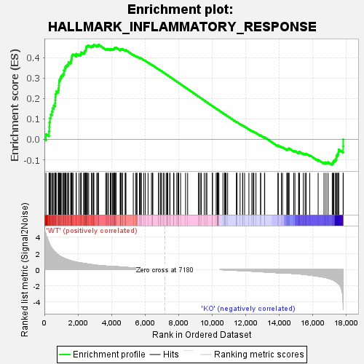
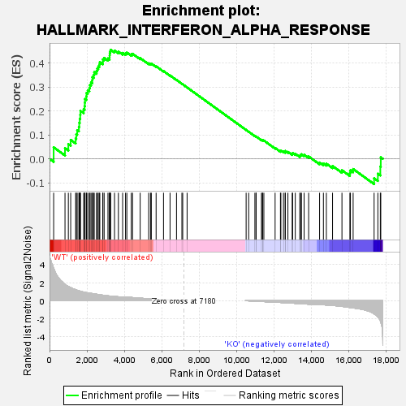

OVE4 parental vs p53R175H:

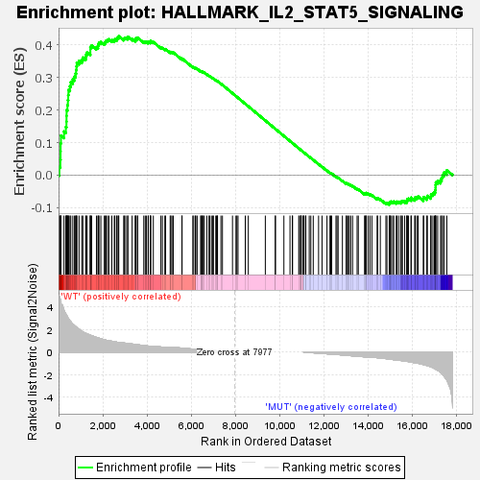
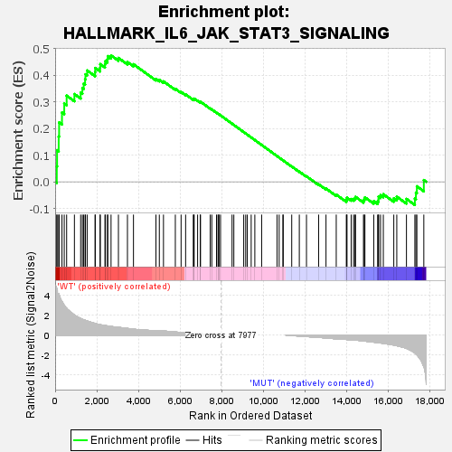
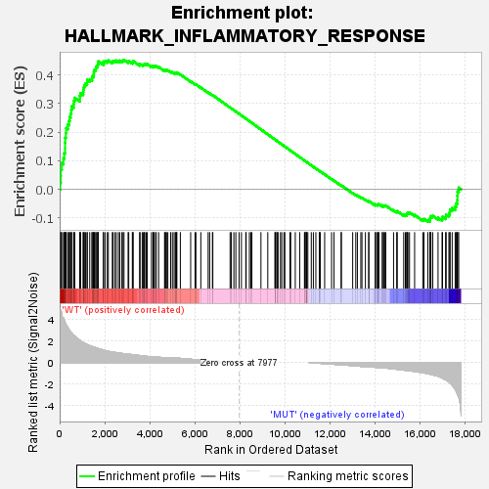
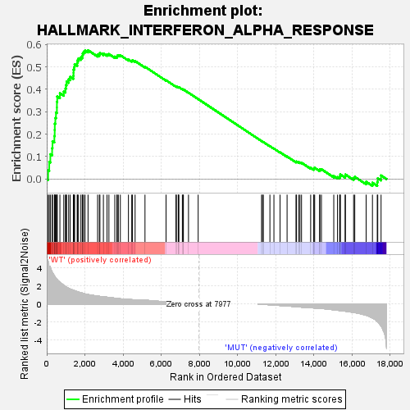
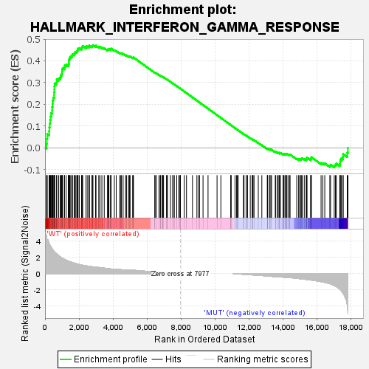
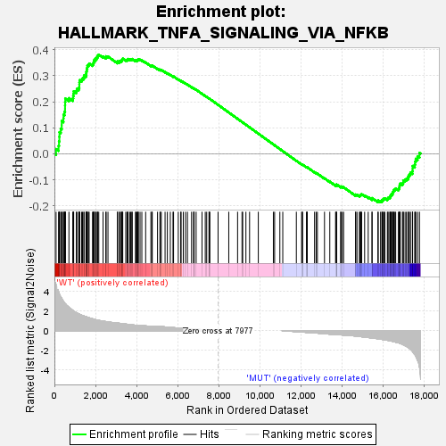

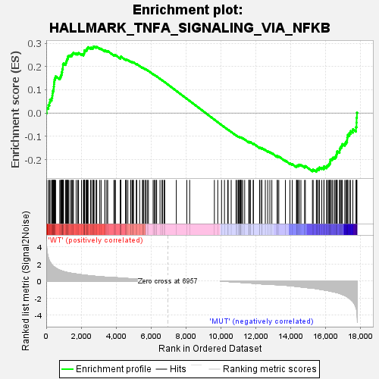
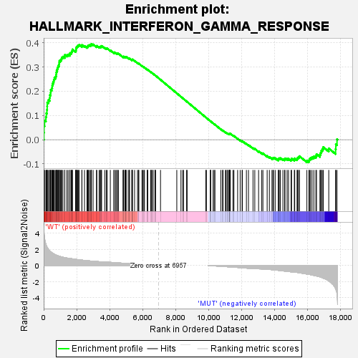
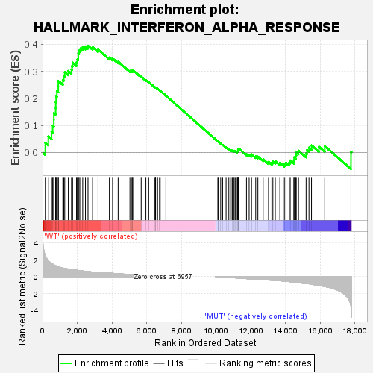
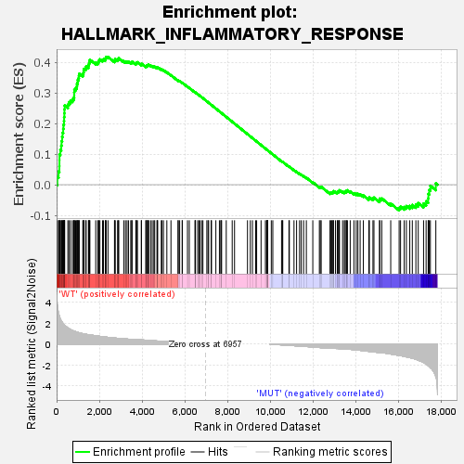
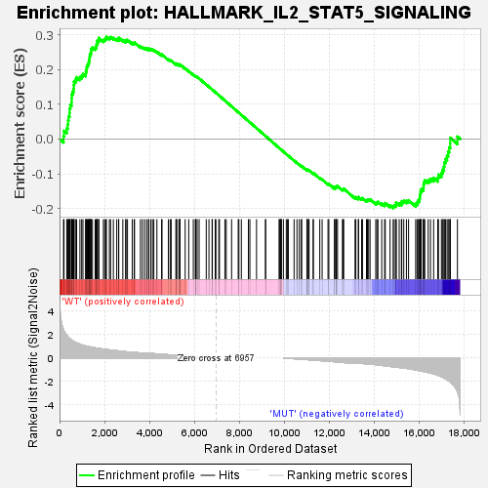
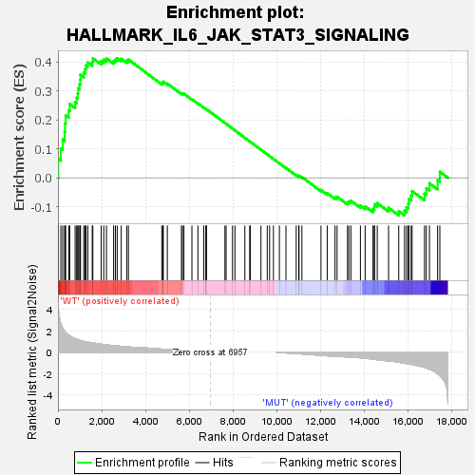
OVE4 parental vs p53R175H:

Supplementary Figure S2: Immune-related hallmark enrichment plots for the parental vs Trp53ko and parental vs p53^{R175H} comparisons (FDR < 0.25).

Gene | Primer Direction | Sequence (5’ to 3’)
Cdkn1a | F | TCGCTGTCTTGCACTCTGGTGT
Cdkn1a | R | CCAATCTGCGCTTGGAGTGATAG
Slc20a1 | F | GCAAATGGGCAGAAGGGTGTCA
Slc20a1 | R | CTTACGGAGGATGAACGCACGA
Timp3 | F | AGGATGCCTTCTGCAACTCCGA
Timp3 | R | GTGTAGACCAGAGTGCCAAAGG
Tnfsf10 | F | GGAAGACCTCAGAAAGTGGCAG
Tnfsf10 | R | TTTCCGAGAGGACTCCCAGGAT
18s rRNA | F | CCATCCAATCGGTAGTAGCG
18s rRNA | R | GTAACCCGTTGAACCCCATT
Supplementary Table S1: Primers used for RT-qPCR validation

