SUPPLEMENTAL MATERIALS: The Evolutionary Impact of Childhood Cancer on the Human Gene Pool

Supplemental Table 1: Categorized level of evidence of constraint for loss-of-function mutations
AD/XLR pCPS genes [n = 62]
Constrained | n = 38 | 61% of total | APC, BAP1, CDC73, CREBBP, CTR9, CTLA4, DICER1, ETV6, EZH2, FBXW7, GATA2, GPC3, IKZF1, MEN1, NF1, NF2, NSD1, PAX5, PHOX2B, PIK3CA, RB1, REST, RET, SETBP1, SMARCA4, SMARCB1, SMARCE1, STK11, TRIM28, TSC1, TSC2, WAS, WT1, PTCH1, SUFU, TRIP13, BRAF, PTPN11
Likely constrained | n = 15 | 25% of total | AIP, ALK, CDH1, CDKN1C, CDKN2A, CEBPA, FAS, PTEN, RUNX1, SH2D1A, TP53, CBL, RIT1, FH, SDHD
Likely not constrained | n = 4 | 6% of total | GPR161, HRAS, SDHB, VHL
Not constrained | n = 5 | 8% of total | IKBKAP, SAMD9, SAMD9L, SDHA, SDHC
AR pCPS genes [n = 23, data missing for one]
Constrained | n = 2 | 9% of total | DIS3L2, MSH2
Likely constrained | n = 1 | 4% of total | MSH6
Likely not constrained | n = 8 | 35% of total | CD27, HAVCR2, ITK, LIG4, TRIM37, USB1, MLH1, BUB1B
Not constrained | n = 11 | 48% of total | ABCB11, ATM, BLM, CD70, NBN, RECQL4, SBDS, BRCA2, FANCA, PALB2, PMS2

Supplemental methods

Methods

Empirical data on the variation of the human pangenome
Single nucleotide variant metadata from 141,456 adult humans published by Karczewski et al. in 2020¹, including their calculations of mutational constraint, was incorporated in this study by downloading their Supplementary Dataset 11. Only canonical gene transcripts were used. In this data, specific metrics on both empirically observed variants and theoretically expected variants are available. Predicted loss-of-function (pLoF) variants observed vs. expected (LOE) scores refer to the specific ratio of observed vs. expected number of pLoF variants. pLoF observed vs. expected upper/lower bound fraction (LOEUF/LOELF) scores refer to the lower and upper fraction of the 90% confidence interval of the LOE score, respectively. In keeping with the literature^{1,2}, a gene was designated as constrained when it showed a LOEUF score lower than 0.35 based on random distribution across the genome. For the purposes of our study, genes with pLoF observed vs. expected (LOE) ratio under 0.35 were designated likely constrained; genes with pLoF observed vs. expected (LOE) ratio over 0.35 were designated likely not constrained; and genes with an observed vs. expected lower bound fraction (LOELF) score higher than 0.35 were designated not constrained (Figure 1). In essence, not constrained refers to genes where the current data does not support that the gene is, or is likely to be, constrained using the 35% LOEUF cut-off. Throughout, higher constraint refers to lower LOEUF score.

Selecting cancer predisposition syndrome genes with pediatric-onset
The paper Selection criteria for assembling a pediatric cancer predisposition syndrome gene panel (2021) by Byrjalsen et al.³ lists a total of 85 genes deemed Category 1 for childhood cancer risk (Supplementary Data 3); i.e. a pathogenic variant (i) in a minimum of five children (aged 0–18 at diagnosis) with (ii) a cancer diagnosis in at least two independent families. These minimum requirements are independent of the prevalence in adult-onset cancer patients³.

In our work, these 85 genes are referred to as the pediatric-onset cancer predisposition syndrome (pCPS) genes. We distinguish between biallelic phenotypes, caused by two pathogenic variants sitting in trans in a gene (i.e. autosomal recessive), and monoallelic phenotypes, caused by one single variant in a gene (i.e. autosomal dominant and X-linked recessive) (Supplementary Data 4).

A separate set of cancer predisposition syndrome (CPS) genes were designated as adult-onset cancer predisposition syndrome (aCPS) genes using the following methodology, also employed in our previous study⁴. Using a list of all CPS genes published by Rahman (2014)⁵, we filtered out all gene/mode-of-inheritance pairs that were designated as associated with pCPS (see above). The remaining 62 genes/mode-of-inheriance combinations were designated as aCPS genes (Figure 2 & 7, Supplementary Data 4)

Combined germline mutational spectrum in patients with childhood cancer
All pediatric pan-cancer studies, published in June 2022 or earlier and including germline sequencing of 100 or more participants were included irrespective of the sequencing strategy (targeted, WES, WGS). Data homogenization was performed with the aim to standardize the categories used for mutational ontology, pathogenicity classification, and diagnosis type. First, the data were loaded into R in their original published format. Next, unconventional nomenclatures were cleaned to ensure that they had uniform names. Then, the ‘rbind()’ function was used to combine data from the following studies: Zhang et al. (2015)⁶, Parsons et al. (2016)⁷, Mody et al. (2016)⁸, Oberg et al. (2016)⁹, Gröbner et al. (2018)¹⁰, Wong et al. (2020)¹¹, Byrjalsen et al. (2020)¹², Fiala et al. (2021)¹³, Newman et al. (2021)¹⁴, Stedingk et al. (2021)¹⁵, and Wagener et al. (2021)¹⁶ (Supplementary Data 5-15). Similarly, gene panels from each study were combined using ‘rbind()’ (Supplementary Data 16-26).

Next, cleaning was performed on the mutational ontology, pathogenicity classification, and diagnosis type categories using the ‘mutate()’ function from the ‘dplyr’ package in R.

Any germline variant reported as either likely pathogenic or pathogenic was considered simply pathogenic. Variants were considered pLoF if the variant ontology was frameshift, nonsense or splice donor/acceptor. Due to the extreme rarity of pLoF variants in these genes among the adult population, the number of pLoF variants found in select genes among children with cancer was extrapolated to a hypothetical 100,000 individuals, making direct comparison possible. Here a quadratic relation was assumed, with the extrapolated sum of unique pLoF variants increasing linearly for each doubling of cases¹.

Mutation propagation simulation
For illustrative purposes, we formulated a simulation of the propagation of a de novo genetic variant. This simulation assumed a stable, infinite human population, with classic Mendelian inheritance, in which all selective pressures other than that associated with the genetic variant are equal. Variants were simulated in numerous iterations across incrementally increasing cancer penetrances (defined as equal to selective pressure). For further details see below under the header “Mutation propagation simulation”.

We developed two functions to simulate the propagation of a de novo mutation with variable fatal penetrance in a population. The first function, “mutation propagation simulation”, simulates one instance of the propagation process. The function takes two arguments: “fatal penetrance of variant” and “generations of propagation”. “Fatal penetrance of variant” is the probability that an individual who carries the de novo mutation dies before reproducing, i.e., the penetrance of the mutation. “Generations of propagation” is the number of inheritances that should be simulated.

The function randomly assigned a survival status to the founding individual based on the penetrance. If the founding individual survives, the number of offspring was calculated based on Poisson distribution set to 2, i.e. presuming a stable population. For each offspring, we randomly assigned a carrier status, at which point carriers were treated identically to the founding individual. Looping through each generation, we calculated the total carriers, total surviving carriers, and total offspring of carriers that will enter the next generation. If there were no offspring from carriers, the variant had died out, otherwise, the loop ran for the full number of prespecified generations. Additional functions iterated over multiple carriers set to variable penetrances.

We used R version 4.0.2 (2020-06-22) for all simulations.

Software and tools
External data was downloaded in .xlsx or .csv format and compiled in sheets, without edits, in a Microsoft Excel workbook. All subsequent data wrangling, analysis, calculations and some visualizations were done using R (version 4.2.2) through RStudio (version 2022.07.1). Non-computational illustrations were made using the browser-based graphical tool BioRender. Illustrations of exon/protein and mutations were made using the browser-based graphical tool ProteinPaint¹⁷ on the PeCan platform. Scripts were written in Rmarkdown and are available on github (link to come, can be obtained upon request to corresponding author). The scripts are preambled by the required packages, which, by name(version number), are; readxl(1.4.1), backports(1.4.1), systemfonts(1.0.4), plyr(1.8.8), lazyeval(0.2.2), splines(4.2.2), TH.data(1.1-1), digest(0.6.31), htmltools(0.5.4), fansi(1.0.3), memoise(2.0.1), googlesheets4(1.0.1), tzdb(0.3.0), penxlsx(4.2.5.1), remotes(2.4.2), modelr(0.1.10), matrixStats(0.63.0), sandwich(3.0-2), prettyunits(1.1.1), colorspace(2.0-3), vest(1.0.3), textshaping(0.3.6), haven(2.5.1), xfun(0.36), callr(3.7.3), crayon(1.5.2), jsonlite(1.8.4), libcoin(1.0-9), Exact(3.2,) survival(3.4-0), glue(1.6.2), polyclip(1.10-4), gtable(0.3.1), gargle(1.2.1), pkgbuild(1.4.0), clipr(0.8.0), Quandl(2.11.0), mvtnorm(1.1-3), DBI(1.1.3), miniUI(0.1.1).1, Rcpp(1.0.9), xtable(1.8-4), gridtext(0.1.5), foreign(0.8-83), bit(4.0.5), proxy(0.4-27), stats4(4.2.2), profvis(0.3.7), htmlwidgets(1.6.0), httr(1.4.4), modeltools(0.2-23), ellipsis(0.3.2), farver(2.1.1), urlchecker(1.0.1), pkgconfig(2.0.3), ultcompView(0.1-8), dbplyr(2.2.1), utf8(1.2.2), labeling(0.4.2), tidyselect(1.2.0), rlang(1.0.6), later(1.3.0), munsell(0.5.0), cellranger(1.1.0), tools(4.2.2), cachem(1.0.6), generics(0.1.3), broom(1.0.2), evaluate(0.19,) fastmap(1.1.0), ragg(1.2.4), yaml(2.3.6), processx(3.8.0), bit64(4.0.5), fs(1.5.2), zip(2.2.2), coin(1.4-2), rootSolve(1.8.2).3, mime(0.12,) xml2(1.3.3), compiler(4.2.2), rstudioapi(0.14,) curl(4.3.3), e1071(1.7-12), gt(0.8.0), reprex(2.0.2), tweenr(2.0.2), broom.helpers(1.11.0), DescTools(0.99.47), stringi(1.7.8), ps(1.7.2), lattice(0.20-45), Matrix(1.5-1), vctrs(0.5.1), pillar(1.8.1), lifecycle(1.0.3), lmtest(0.9-40), ata.table(1.14.6), lmom(2.9,) httpuv(1.6.7), R6(2.5.1), promises(1.2.0).1, gld(2.6.6), sessioninfo(1.2.2), codetools(0.2-18), boot(1.3-28), MASS(7.3-58.1), assertthat(0.2.1), pkgload(1.3.2), withr(2.5.0), nortest(1.0-4), multcomp(1.4-20), expm(0.999-6), parallel(4.2.2), hms(1.1.2), quadprog(1.5-8), class(7.3-20), rmarkdown(2.19,) googledrive(2.0.0), shiny(1.7.4).

Supplemental results

Mutation propagation simulation

Simulating the propagation of a de novo variant
This script was created to explore/illustrate how strong the negative selective pressure on a de novo gene mutation has to be in order to drive mutational constraint of the gene. The simulation assumes an infinite population of humans, in which an average of two offspring per individual survive to reproduce. This means that the population size remains stable. In this hypothetical situation, we can model the relative survival of variants associated with variable risks of childhood death (here defined as penetrance), and this should largely be constant if all other factors remain equal in the population. Factors which undoubtedly have affected human pangenetics such as migration, inbreeding and population bottlenecks are not included in the present simulation. Similarly, genotype-phenotype correlations and gene-environment interactions are not considered. Effectively, these factors are assumed to affect variants equally.
The simulation, available from github, is designed to run any number of generations (function 1). By running function 1 iteratively any number of variants can be simulated for any number of generations (function 2). By running function 2 iteratively any number of penetrances can be simulated for any number of variants across any number of generations (function 3). Functions 4-6 generate plots of the simulation data and the variant survival. The latter plot can be thought of as a KM-like curve that, rather than showing a group of human’s survival across years of life, shows a group of variants' survival across generations, with the event being the extinction of the variant.

Ten sets of 2,000 de novo variants with variable childhood cancer penetrance propagated for 1,000 years (40 generations)
By running a 40-generation simulation in 2,000 iterations for each of the penetrances, 0%, 1%, 2%, 3%, 4%, 5%, 10%, 15%, 20%, 25%, a total of 20,000 variants with increasing penetrance were assessed. The full fates of each variant is given in plots A to J, while the cumulative 1000-year-survival is shown at the top.
As has long been recognized in the field of population genetics, a neutral (i.e. evolutionarily neither harmful or beneficial) de novo variant has a very low chance of surviving or being fixed (i.e. the only genotype in the population), even in small finite populations. This is expected because there is only one carrier to begin with, so if that carrier has no children that both survive to reproductive age and are carriers, the mutation will die out with the founding generation (generation 0; at a mean of two offspring with Poisson distribution this risk is 37%). If the mutation does get passed on to generation 1, the mutation would again be at high risk of extinction, although slighter lower than for generation 0, because some mutations will now exist in more than two individuals. However, the high extinction rate of neutral mutations is irrelevant with regard to constraint as the rate merely dictates the expected number of variants in a gene. Constraint is calculated by observing how many fewer mutations are present in a gene compared to this neutral expectation. Hence the second survival plot show variant survival relative to the neutral (0% penetrance) variants modelled.
From the plots below, we see that, at these parameters, variants with 5% or higher penetrance (selective disadvantage) will have less than 35% of the survival seen for a neutral variant after a millennium of dissemination. In other words, were this hypothetical, highly simplified, model population genetically tested at the 40-generation mark, genes where mutations cause a >=5% selective disadvantage should begin showing strong signs of mutational constraint.

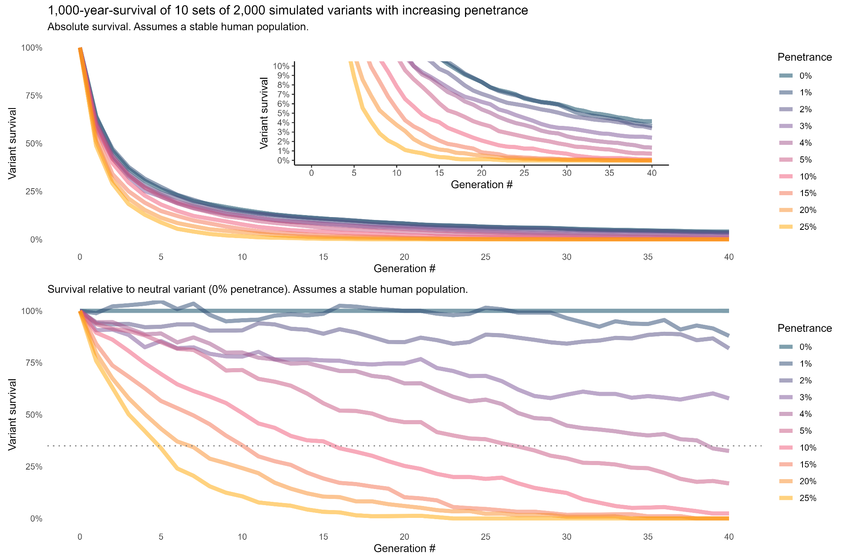
Supplemental Figure 1: Upper plot shows the absolute survival of de novo variants with defined penetrance at variable levels. The lower plot shows the same data relative to the survival simulated for the neutral variants (penetrance 0%). As a whole, the simulation assumes the penetrance (here of childhood cancer) equates to pre-reproductive death, which is equal to selective pressure.

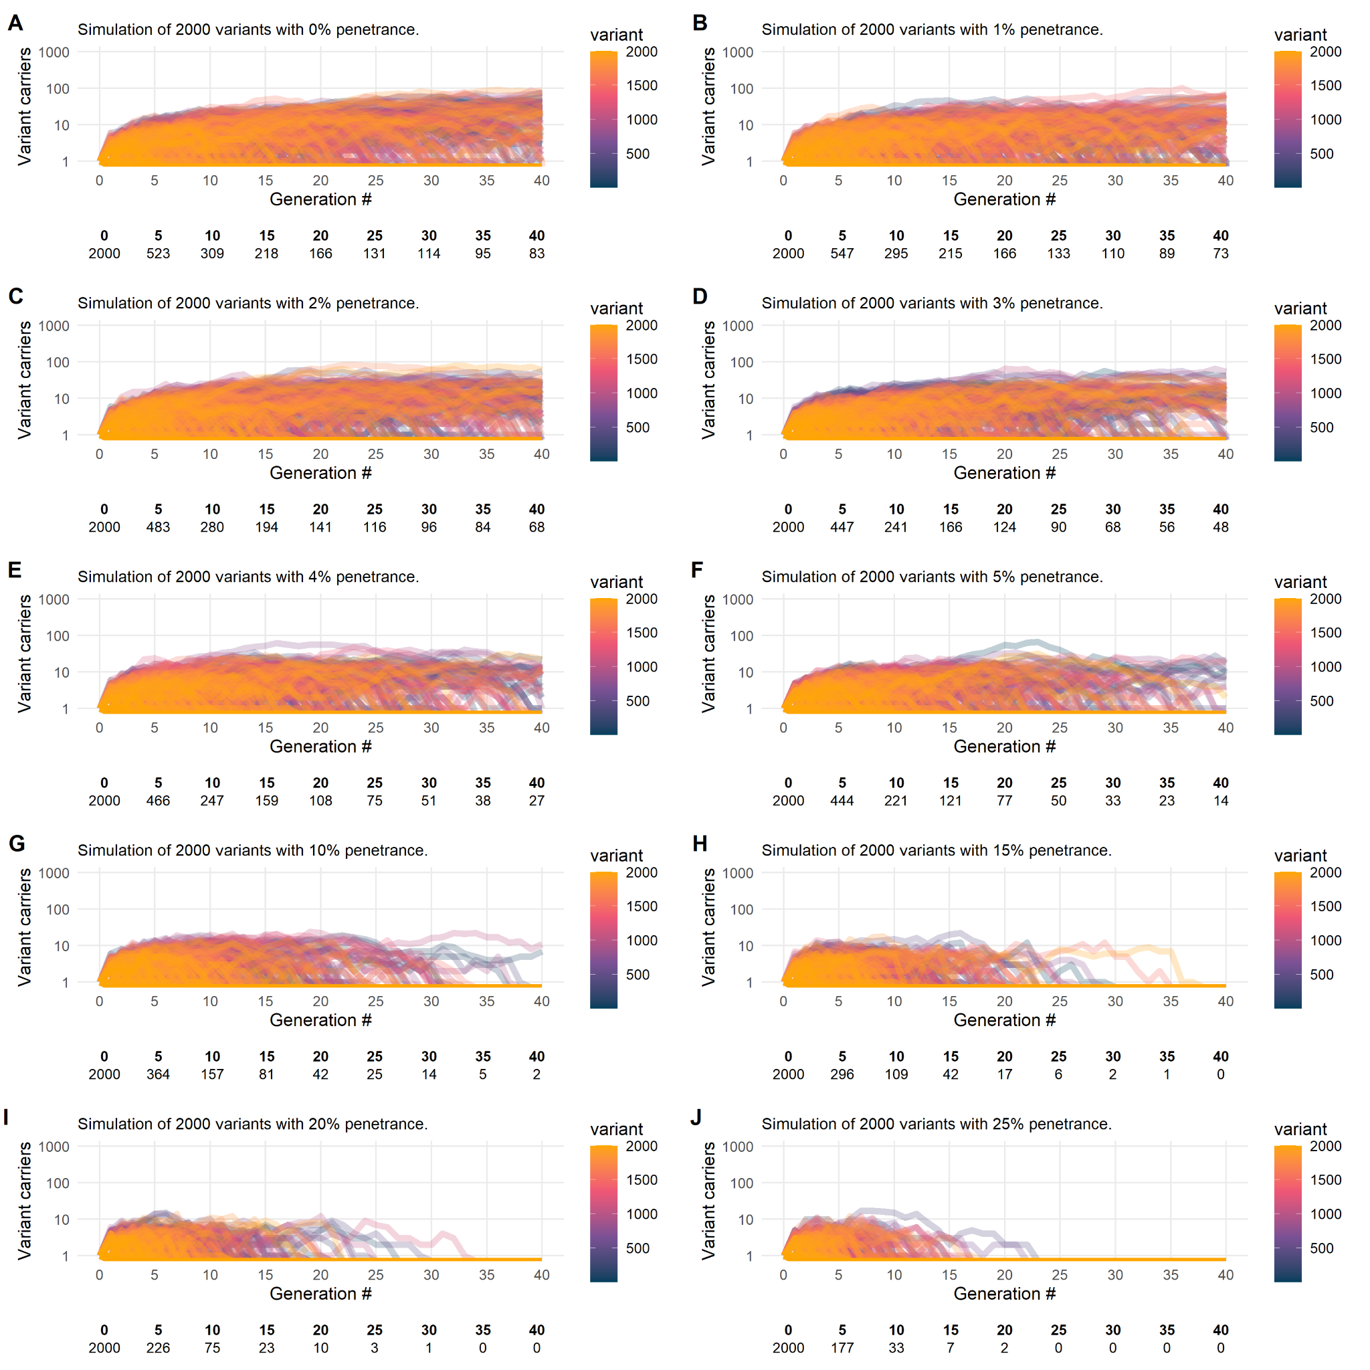
Supplemental Figure 2: Plots A-J: each line shows the fate (number of carriers) of a single variant over 40 generations or approx. 1,000 years. The data tables below each plot show the number of variants that remain "alive" or at-risk in the population; in each simulation 2,000 variants are at-risk at generation zero.

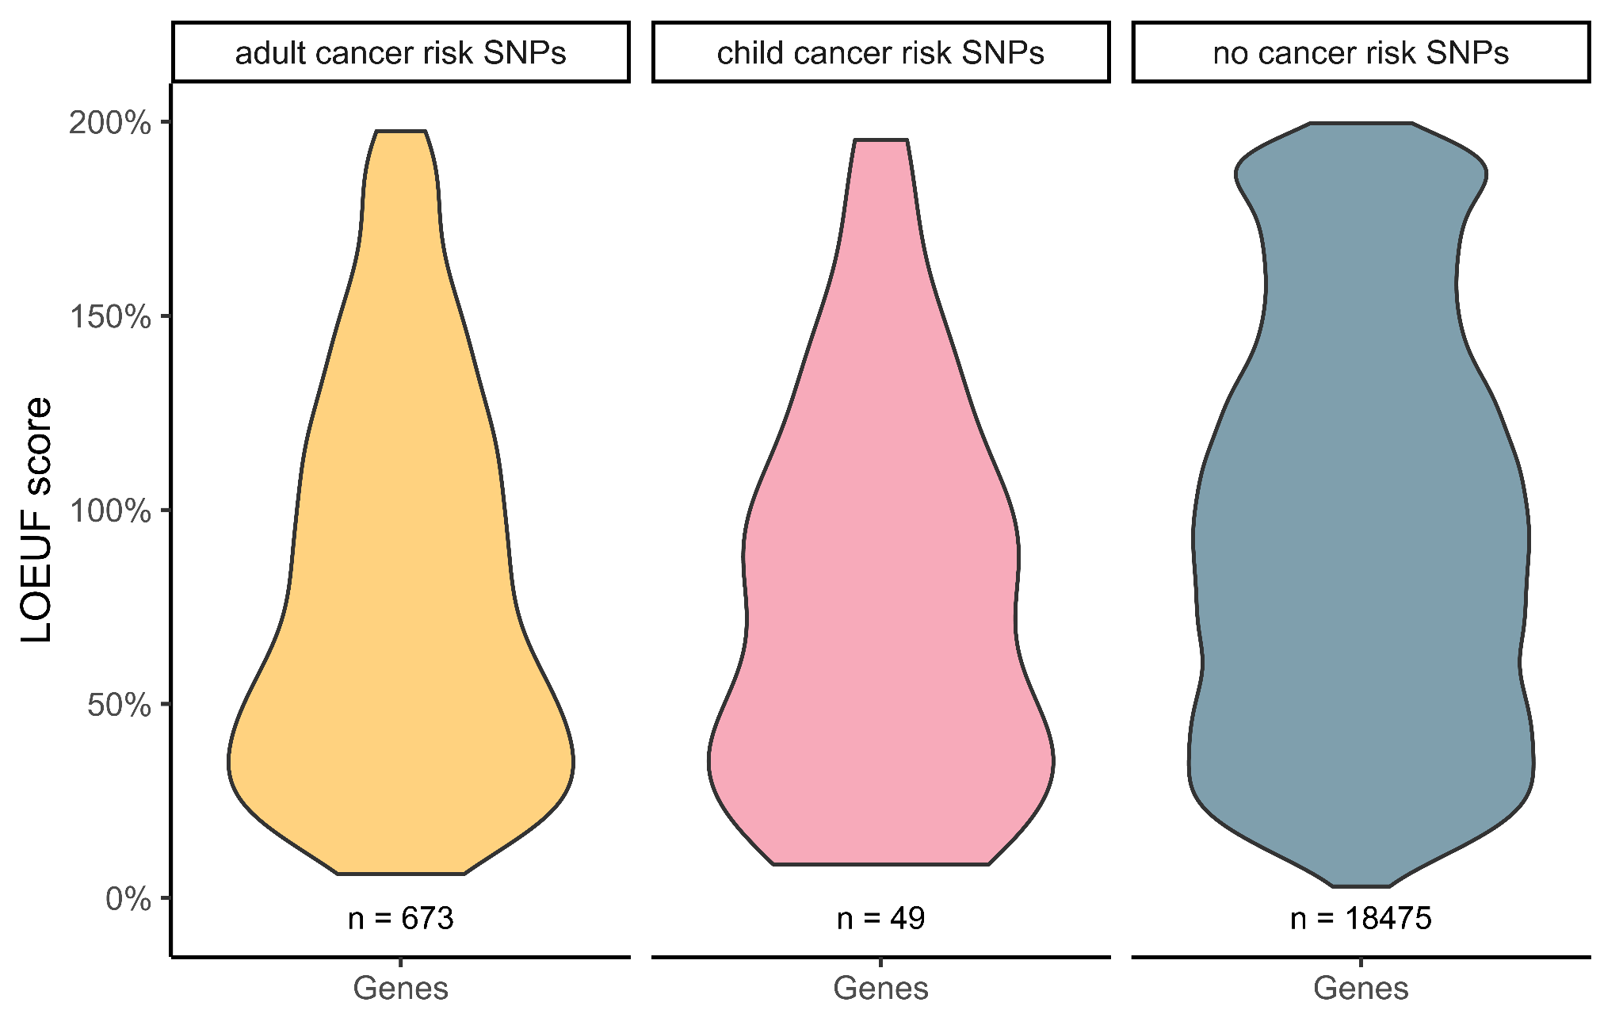
Supplemental Figure 3: The plot represents the distribution of LOEUF scores for sets of genes based on the presence of single nucleotide polymorphisms (SNPs) associated with cancer risk. Violin plots are used to show the distribution of scores for each gene set, with the width of the plot corresponding to the density of data points at each value. Colors indicate gene set. Embedded labels indicate the number of genes (n) for each gene set.

References
1. Karczewski KJ, Francioli LC, Tiao G, et al. The mutational constraint spectrum quantified from variation in 141,456 humans. Nature. 2020;581(7809):434-443. doi:10.1038/s41586-020-2308-7
2. Abramovs N, Brass A, Tassabehji M. GeVIR is a continuous gene-level metric that uses variant distribution patterns to prioritize disease candidate genes. Nat Genet. 2020;52(1):35-39. doi:10.1038/s41588-019-0560-2
3. Byrjalsen A, Diets IJ, Bakhuizen J, et al. Selection criteria for assembling a pediatric cancer predisposition syndrome gene panel. Fam Cancer. 2021;20(4):279-287. doi:10.1007/s10689-021-00254-0
4. Stoltze UK, Foss-Skiftesvik J, van Overeem Hansen T, et al. Genetic predisposition & evolutionary traces of pediatric cancer risk: A prospective 5-year population-based genome sequencing study of children with CNS tumors. Neuro-Oncol. Published online July 29, 2022:noac187. doi:10.1093/neuonc/noac187
5. Rahman N. Realizing the promise of cancer predisposition genes. Nature. 2014;505(7483):302-308. doi:10.1038/nature12981
6. Zhang J, Walsh MF, Wu G, et al. Germline mutations in predisposition genes in pediatric cancer. N Engl J Med. 2015;373(24):2336-2346. doi:10.1056/NEJMoa1508054
7. Parsons DW, Roy A, Yang Y, et al. Sequencing for Children With Solid Tumors. JAMA Oncol. 2016;1200:1-9. doi:10.1001/jamaoncol.2015.5699
8. Mody RJ, Wu YM, Lonigro RJ, et al. Integrative Clinical Sequencing in the Management of Refractory or Relapsed Cancer in Youth. JAMA. 2015;314(9):913. doi:10.1001/jama.2015.10080
9. Oberg JA, Glade Bender JL, Sulis ML, et al. Implementation of next generation sequencing into pediatric hematology-oncology practice: moving beyond actionable alterations. Genome Med. 2016;8:133. doi:10.1186/s13073-016-0389-6
10. Gröbner SN, Worst BC, Weischenfeldt J, et al. The landscape of genomic alterations across childhood cancers. Nature. 2018;555(7696):321-327. doi:10.1038/nature25480
11. Wong M, Mayoh C, Lau LMS, et al. Whole genome, transcriptome and methylome profiling enhances actionable target discovery in high-risk pediatric cancer. Nat Med. 2020;26(11):1742-1753. doi:10.1038/s41591-020-1072-4
12. Byrjalsen A, Hansen TVO, Stoltze UK, et al. Nationwide germline whole genome sequencing of 198 consecutive pediatric cancer patients reveals a high incidence of cancer prone syndromes. PLoS Genet. 2020;16(12). doi:10.1371/journal.pgen.1009231
13. Fiala EM, Jayakumaran G, Mauguen A, et al. Prospective pan-cancer germline testing using MSK-IMPACT informs clinical translation in 751 patients with pediatric solid tumors. Nat Cancer. 2021;2:357-365. doi:10.1038/s43018-021-00172-1
14. Newman S, Nakitandwe J, Kesserwan CA, et al. Genomes for Kids: The Scope of Pathogenic Mutations in Pediatric Cancer Revealed by Comprehensive DNA and RNA Sequencing. Cancer Discov. 2021;11(12):3008-3027. doi:10.1158/2159-8290.CD-20-1631
15. von Stedingk K, Stjernfelt KJ, Kvist A, et al. Prevalence of germline pathogenic variants in 22 cancer susceptibility genes in Swedish pediatric cancer patients. Sci Rep. 2021;11(1):5307. doi:10.1038/s41598-021-84502-4
16. Wagener R, Taeubner J, Walter C, et al. Comprehensive germline-genomic and clinical profiling in 160 unselected children and adolescents with cancer. Eur J Hum Genet EJHG. 2021;29(8):1301-1311. doi:10.1038/s41431-021-00878-x
17. Zhou X, Edmonson MN, Wilkinson MR, et al. Exploring genomic alteration in pediatric cancer using ProteinPaint. Nat Genet. 2015;48(1):4-6. doi:10.1038/ng.3466

