Appendix 1: Notations used in XP E01-015-4 standard to represent functional assembly (CETIM courtesy)
The notations used to represent the functional assembly plans (FAP) are shown in Table A.1 (an example is presented in Fig. 4).

 | Union of a secondary (vertical connection) sub assembly or elementary components on a primary one (horizontal connection) |  | Unfix/Break the attachment (the link)
 | Transformation (machining, marking, etc. = auxiliary operations) |  | Check
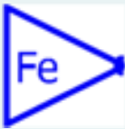 | Feed/Distribution: part feeding |  | Pick/Take or undocking of the end product, a part or a sub-assembly
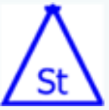 | Stock/Storage of the end product, a part or a sub-assembly | 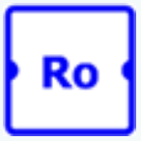 | Rotate/Reversal with horizontal connection
 | Place/Docking of the end product, a part or a sub-assembly | 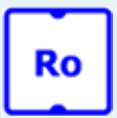 | Rotate/Reversal with vertical connection
 | Move/Transfer with vertical connection |  | Tool/Adding an additional tool
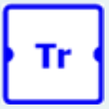 | Translate/Transfer with horizontal connection | 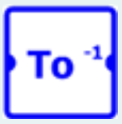 | Tool⁻¹/Removal of an additional tool
Table A.1 Symbolisms used to represent functional assembly plans (FAP)

“Red” symbols represent value-added operations while “blue” symbols represent non-value-added operations.

