Supplementary information

Questionnaire link

https://docs.google.com/forms/d/e/1FAIpQLSd-UaBYGcmxF-fcINtKYkD2lj5HEU4708tat3NtCo4MJH3yKw/viewform?usp=sf_link

Table of breeds and breed categories in sample

Category | Breeds in sample | Number in sample
Beagle | Beagle, Beagle mix | 9
Bully type | American Bully, Staffordshire Bull Terrier, Pit Bull | 26
Designer | Cockapoo, Cavapoo, Chiweenie, Cavachon, Bo-Jack, Springador, Sprollie, Sproodle | 19
Golden Retriever | Golden Retriever, Golder Retriever mix | 10
Labrador | Labrador, Labrador mix | 52
Mountain/sled | Lhasa Apso, Shiba Inu, Husky, Alaskan Malamute, Akita, Burnese Mountain Dog, Leonberger, Newfoundland, Samoyed | 30
Lurcher | Lurcher, Lurcher mix | 13
Other hound | Dacshund, Catahoula, Coonhound, Rhodesian Ridgeback, Bassett Hound | 13
Other working | Doberman, Rottweiler, Karelian Bear Dog, Great Dane, Podenco, Shipperke, Schnauzer, Shar Pei, Boxer, Dalmatian, Poodle | 29
Pointer | Brittany, Hungarian Vizsla, Vizsla, Hungarian Wire Haired, Wire Haired Pointing Griffon | 6
Shepherd/Herding | Border Collie, Anatolia Shepherd, Australian Cattle Dog, German Shepherd Dog, Finnish Lapphund, Australian Kelpie, Belgian Malinois, Huntaway, Spanish Water Dog, Corgie | 80
Sighthound | Greyhound, Italian Greyhound, Spanish Greyhound, Irish Wolfhound, Silken Windhound, Whippet | 28
Spaniel | Spaniel, Spaniel mix | 19
Terrier | Jack Russell Terrier, Yorkshire Terrier, Norfolk Terrier, Terrier mix | 43
Toy | Bichon Frise, Chihuahua, Chinese Crested, Maltipoo, Maltese, Papillon, Pomeranian, Shihtzu, Toy mix | 48
Mix | Any breed mix without primary breed | 65
Unknown | Breed unknown | 7

Table of themes and subthemes from the qualitative data analysis, with example quotes

Themes and subthemes (if applicable) |  | Example extract
Strong bond | Dog considered ‘friend’ or ‘family’ | [We are like] sisters  She is my furry baby  My best friend
Strong bond | Owner identifies as dog’s ‘chosen person’ | She is certainly ‘my’ dog...she waits until I go to bed so she can sleep with me  She’s my sister’s dog...but she’s attached to me and wants to be with me often as I’m her caretaker  She is cautious around most other people but at ease with me
Strong bond | Owner and dog enjoy shared activities | We find joy in going out and about to a park, store or event  We trained together to be a therapy pet team...we also trained for agility and other fun classes. Those classes really build bonds
Strong bond | Owner adapts self for dog’s benefit (i.e. lifestyle changes, effort to change mood) | Whenever I am engaging in activities with my dog I make sure to be calm and centered and if I can’t I take a break  It’s become very important for me to always be aware of my stress levels...whatever is bothering me isn’t worth sending her into a state of anxiety  [We are] close, but because I put a lot of effort in – we are otherwise not a natural fit
Strong bond | Emphasis on perceived closeness of owner and dog | We have a relationship based on love and trust. I adore him  We are on the same wavelength. We are in sync. We just ‘get’ each other. We are ‘in it together’  I owe all of my success to our relationship. He gives me the strength to face the challenges of life and I give him my best in return  She is a cracker...she dotes on me
Dog enhances owner physical wellbeing |  | [My dog gives me] a good reason to be more active  She is very attuned to my physical needs (I have a disability)
Dog enhances owner emotional wellbeing | Dog is attentive if owner cries | She will be agitated and upset if I am crying  If I cry, she will lick my face and sit on my lap
Dog enhances owner emotional wellbeing | Emphasis on owner gratitude for dog | I am proud of the dog I raised and trained  She is why I get up in the mornings...she is trained to help with my anxiety and depression [and] is an amazing help  He’s my shadow and companion and I’m very grateful to have him
Dog enhances owner emotional wellbeing | Shared trauma/history between owner and dog | We rescued each other  We are very close...she trusts me 100% because I rescued her  They’re my babies – I got them after having a miscarriage  I have abandonment and attachment issues due to my childhood, which could affect my dog, as he has similar problems  She has PTSD like me
Dog enhances owner emotional wellbeing | Owner has emotional dependence on dog | He gives me the strength to face the challenges of life  She keeps me stable  She gives me something else to think about. I would be worse without her
Dog is a certified therapy dog |  | She is a trained therapy dog; I take her to school with me once a week  We call her our feel-good dog or comfort dog – a big part of why I thought she would be such a good therapy dog and had her certified for it
Owner perceives a weak bond between themselves and dog | Dog classified as ‘pet’ only | He’s a dog, I am a human  My dog is kennelled with the other dogs and does not come in the house
Owner perceives a weak bond between themselves and dog | Owner emphasis on boundaries to maintain owner-pet relationship | He gets everything a dog could want but he is expected to behave in return  I am the leader of the pack and he looks up to me for guidance and reassurance
Owner acknowledges disadvantages in the human-dog relationship |  | I don’t like his biting problems  Sometimes I wish I could ask her what she wants to do...I want to make sure she is fulfilled...sometimes I feel like I’m disappointing her  [The relationship is] intense – he is my shadow which makes getting things done a bit of a challenge at times...he can be very affectionate but sometimes out of the blue will resource-guard weird stuff...it’s a bit of a rollercoaster
Owner has pragmatic and realistic view of human-dog relationship |  | ...he has some behavioural problems. We’re still training him and I have faith that he will become better  She is a collie...so wanting to follow me about does not indicate anything negative, that’s just how collies are
Dog is responsive to owner mood | Positively | I am a calm person and so he is a pretty chilled dog
Dog is responsive to owner mood | Negatively | If I am upset, he gets very agitated
Dog is responsive to owner mood | Dog ‘mirrors’ owner emotion | She is sensitive to how I’m feeling...I believe she is anxious and nervous because she feeds off my energy
Dog is responsive to owner mood | Dog emotionally dependent on owner | She is scared of being left behind, always follows me and stays close by me...she won’t sleep unless I do or I stay in the same room as her
Dog is responsive to owner mood | Dog responsive to owner anxiety and/or depression | When I’m more anxious, my dog gets more worried and even afraid of me  I have suffered depression on and off for about 10 years…she definitely does get ‘down’ when I am feeling low
Dog is responsive to owner mood | Behavioural or physiological evidence of responsiveness to owner mood | [If] my breathing changes he will move quickly from across the room to see if there is something wrong by putting his nose by mine and inhaling my breath  When I became medicated to treat my mental health issues, her episodes of stomach upset also improved
Dog is unresponsive to owner mood | Owner feels their emotion is not substantial enough to affect their dog | My emotions are mostly self-contained so I don’t think he picks up on them really
Dog is unresponsive to owner mood | Dog is ‘independent’ | She’s a pretty easy-going dog and fairly independent...I’ve had a lot of stress in the last two weeks due to finals and projects...but I have not noticed any changes in her behaviour
Dog is unresponsive to owner mood | Age/type/nature as factors in unresponsiveness to owner mood | He sometimes does not seem to care if I am frustrated as he is 9 months old and tests limits often  I don’t think we have a close emotional bond...greyhounds are more independent and aloof
Owner engages in training dog |  | He’s well-trained and responsive to gentle corrections and encouragement  I have invested a lot of time training him as a puppy which has benefitted both of us
Owner feels guilt and/or pressure as a result of owning dog |  | I think I reinforce her bad behaviour at times  I think I enable bad behaviour by not being strict enough and being too lazy and tired to stick with a training routine
Emphasis placed on high owner expectations of dog in human-dog relationship |  | I feel my dog wants me to be calm and happy...He helps me realise that I am being overly emotional, sad or self-indulgent
Owner and dog share a balanced, collaborative relationship |  | I provide him with love and he provides me with consistency  It is a symbiotic thing partly; I feel calmer and happier when she is around and vice versa  We train for several different dog sports, but during the day I mostly do my own thing and she is nearby  She is the only thing in my life but I try to remember that she is a dog and should be treated like one...I try not to treat her as a substitute for the child I never had or the best friend and partner I don’t have
Owner compares current dog to previous dog(s) or other known dog(s) |  | I can see even more clearly how emotional my connection is with my first dog in contrast to the bond I have with my second dog...I believe my first dog to be a very special dog, and I don’t expect to have the bond I have with her again  I don’t know if I really like him. I really miss my other dog, who died four months ago
Impact of covid-19 |  | Since travel restrictions were lifted, we have been on more adventures...he has honestly been so much happier, which in turn has made me happier  He can be wary of strangers, but I think this is due to lockdown

Normality plots

Histogram, scatterplot and QQ plot for each model. Histograms of standardised residuals check the assumption of normality. Scatterplots check for linearity and to ensure there is no heteroscedasticity. QQ plots show whether residuals are normally distributed.

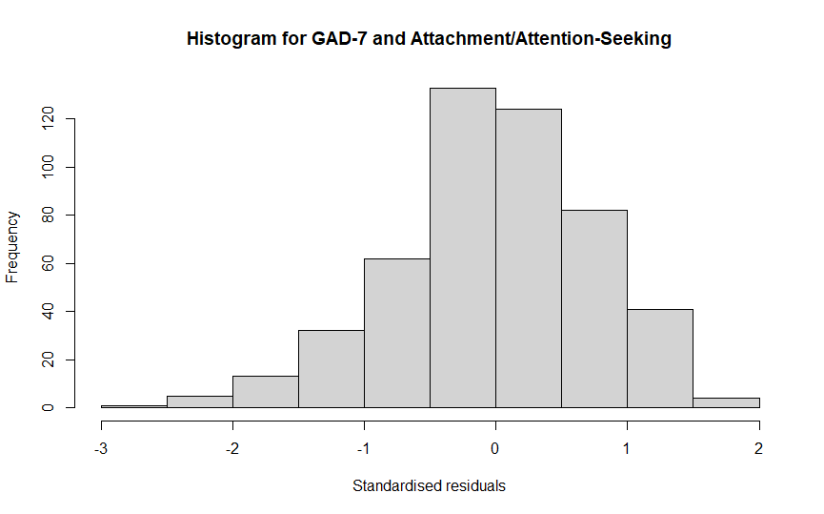
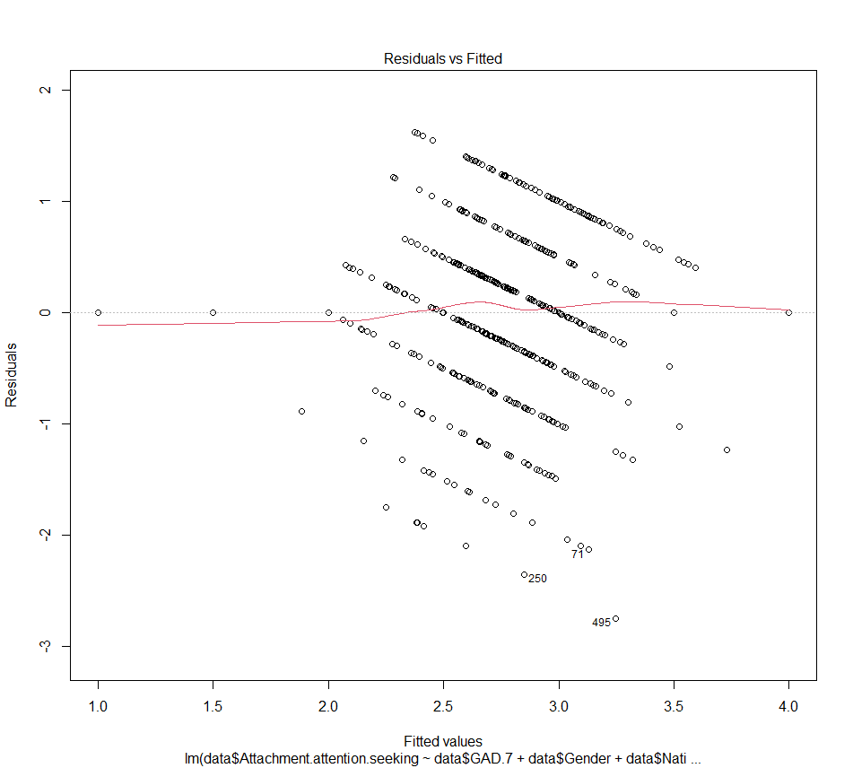
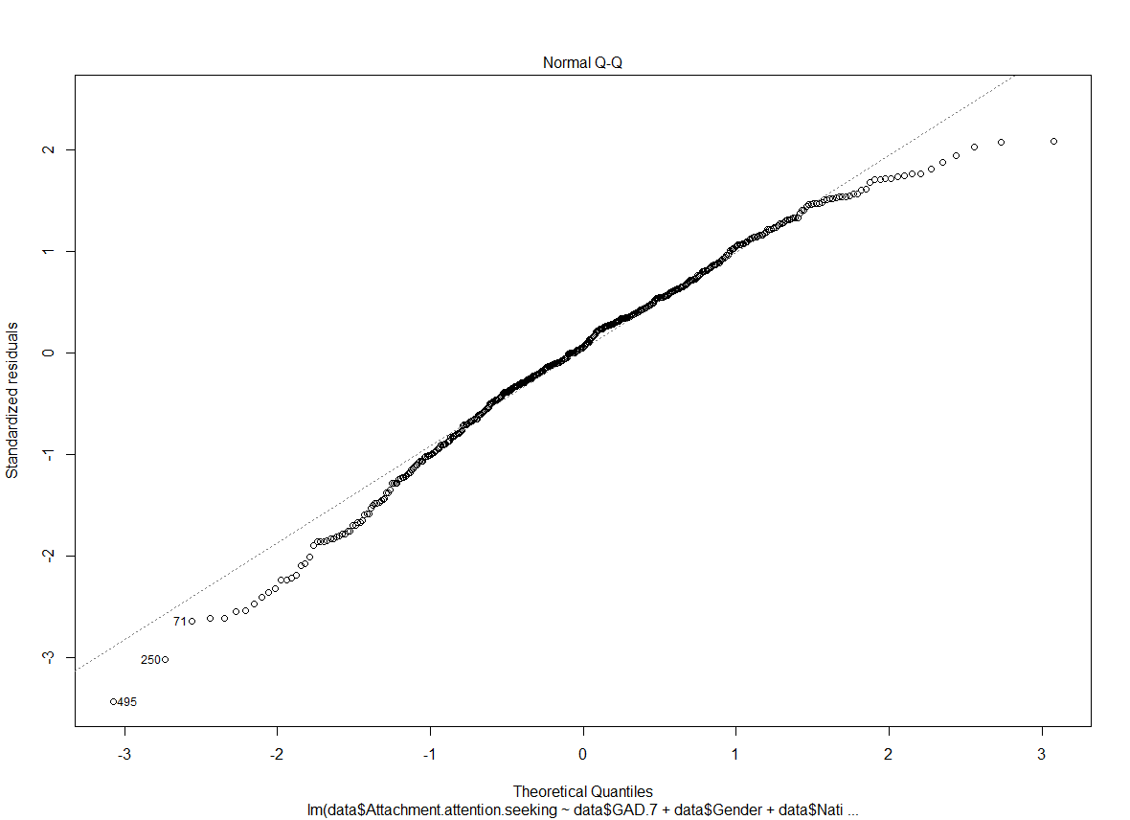

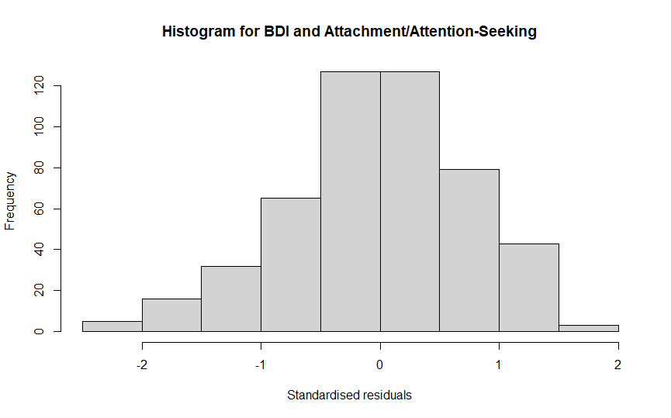
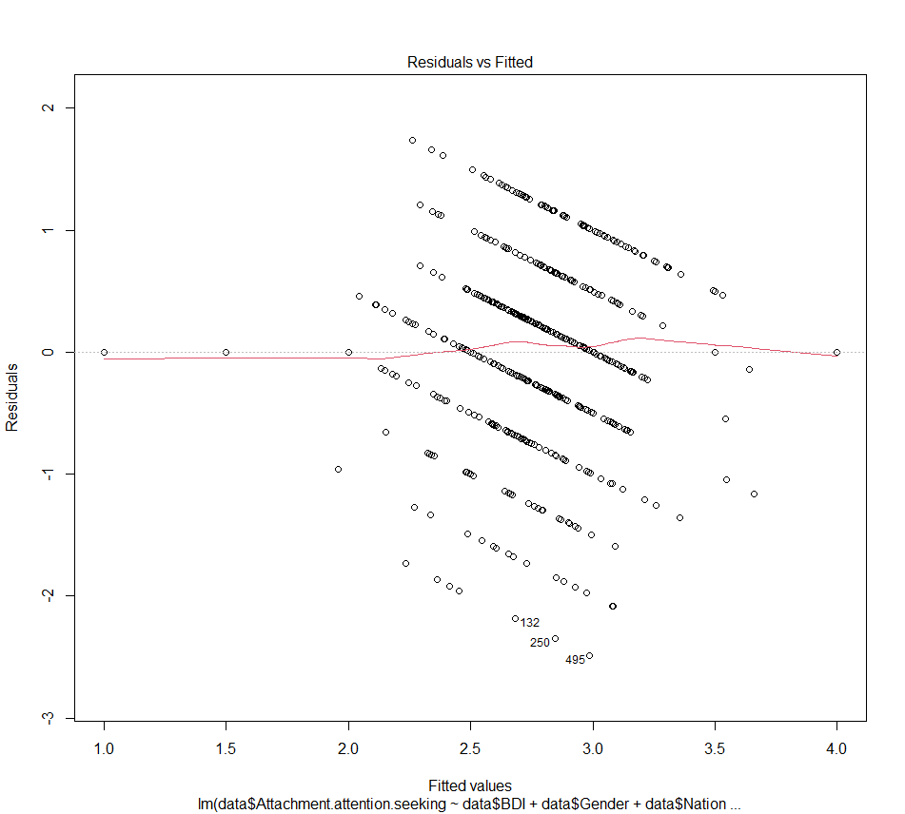

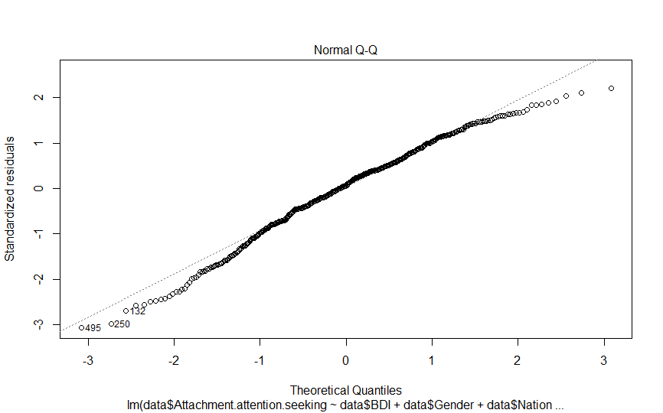

. 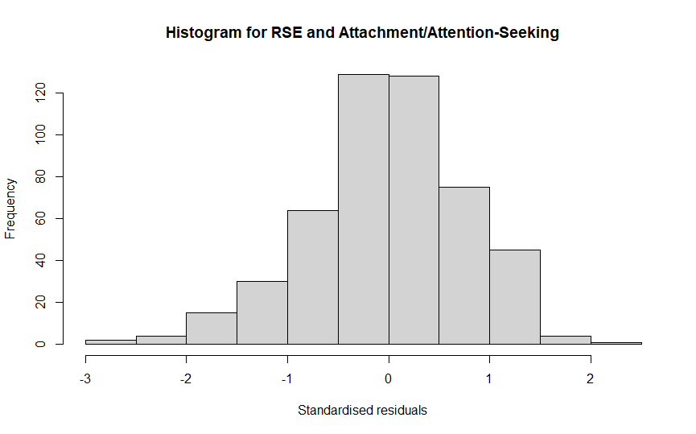

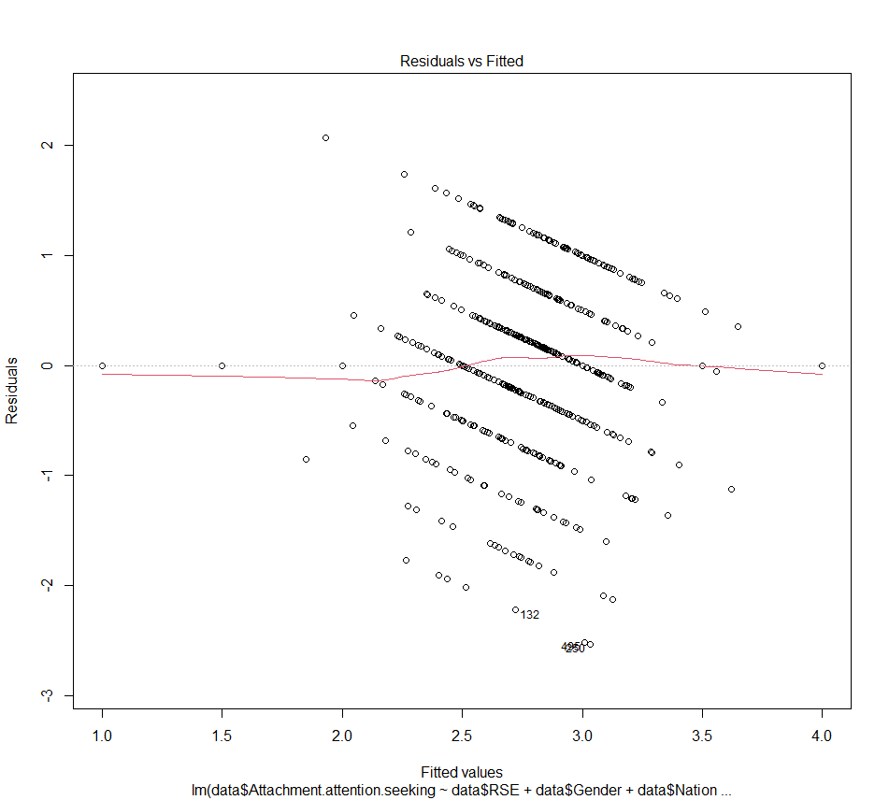
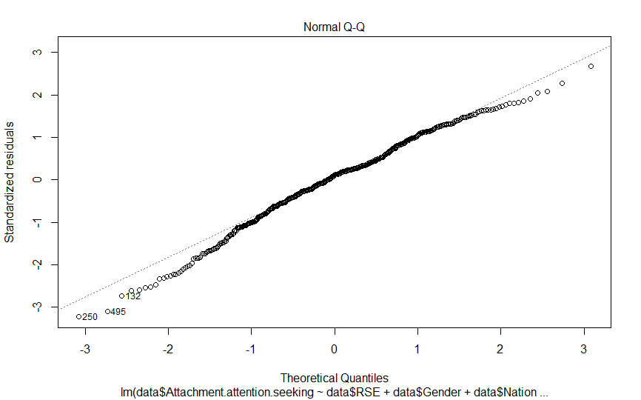
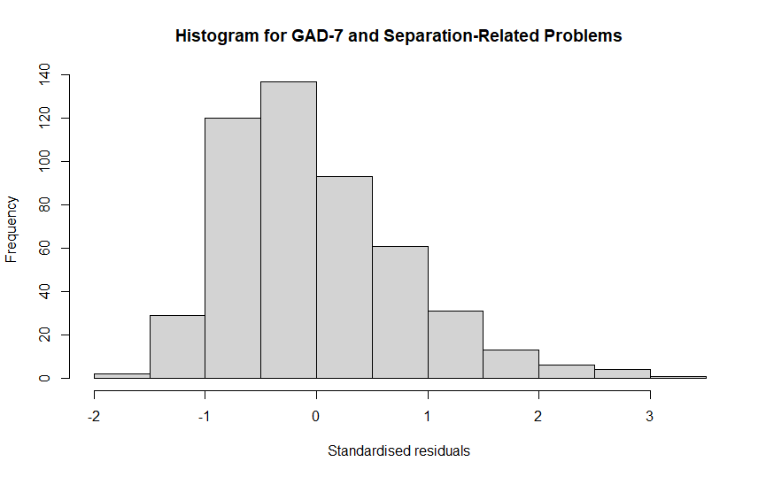
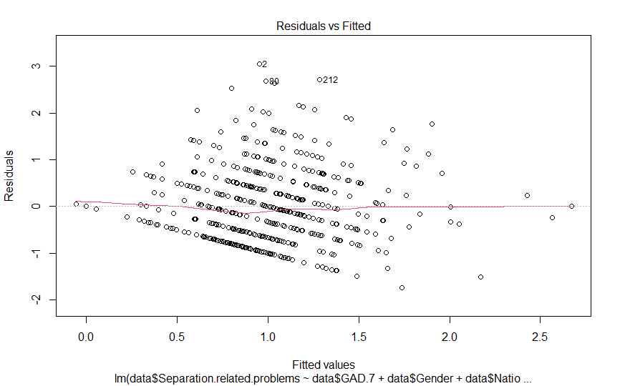
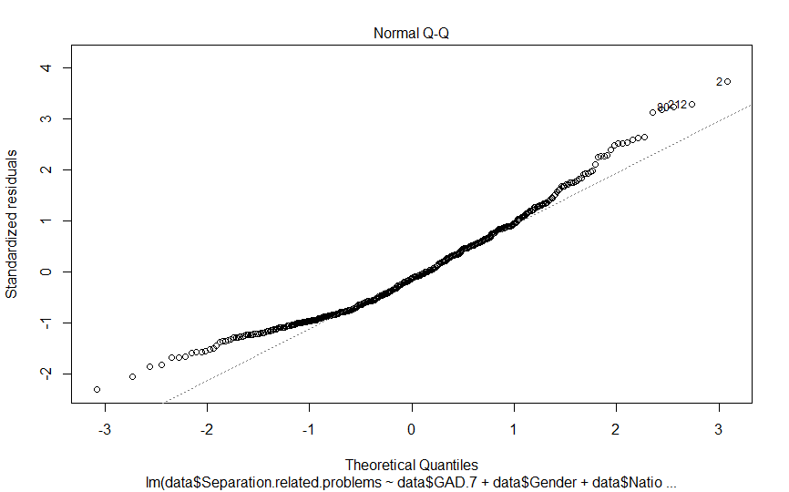

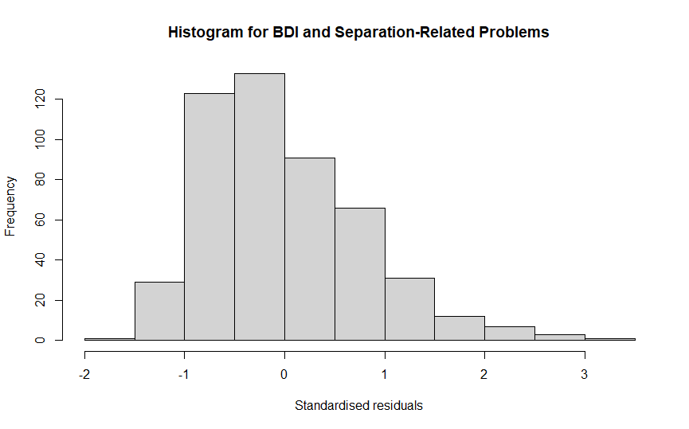
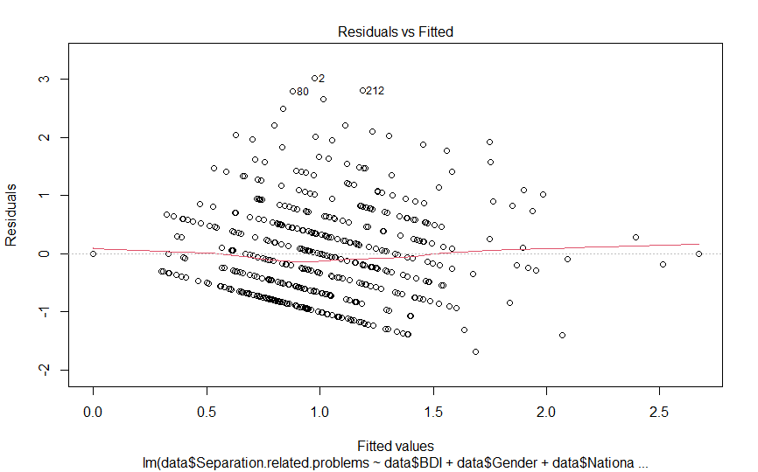

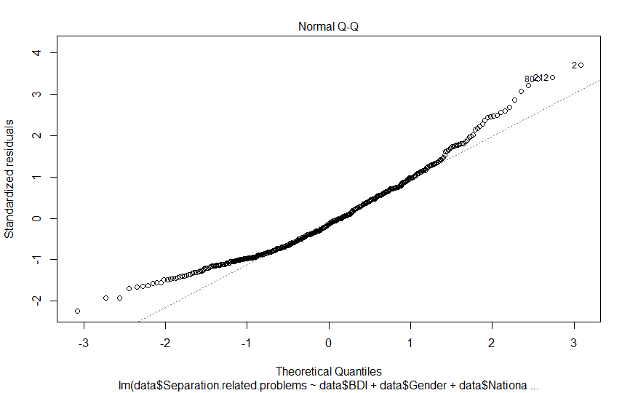

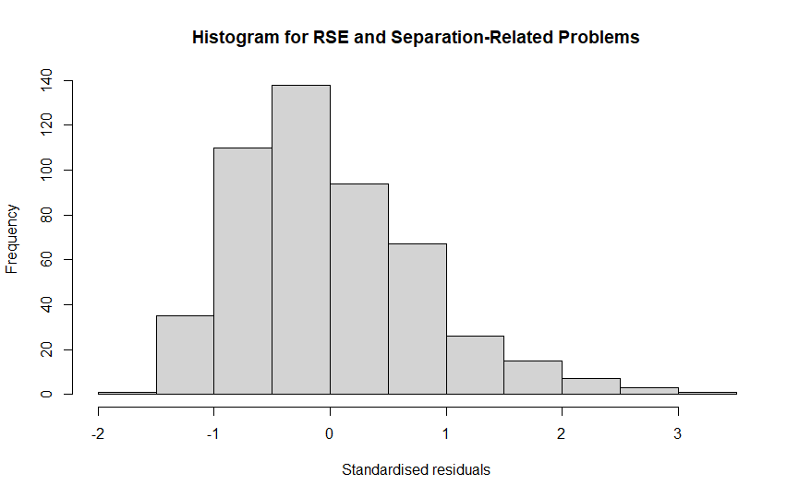
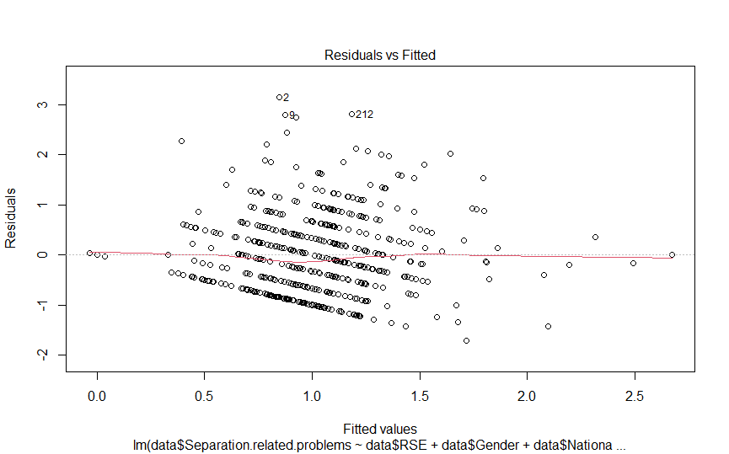

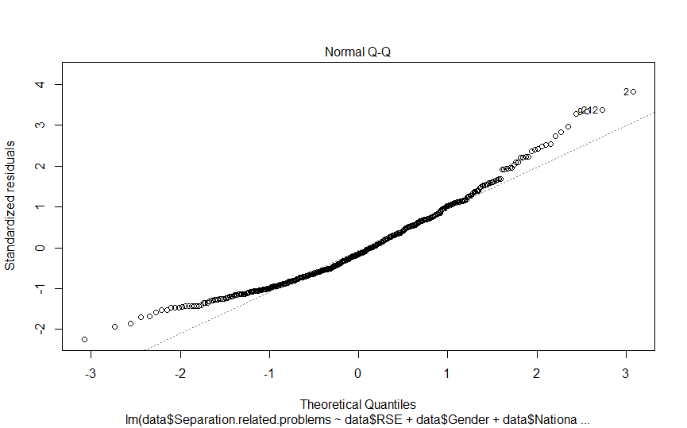
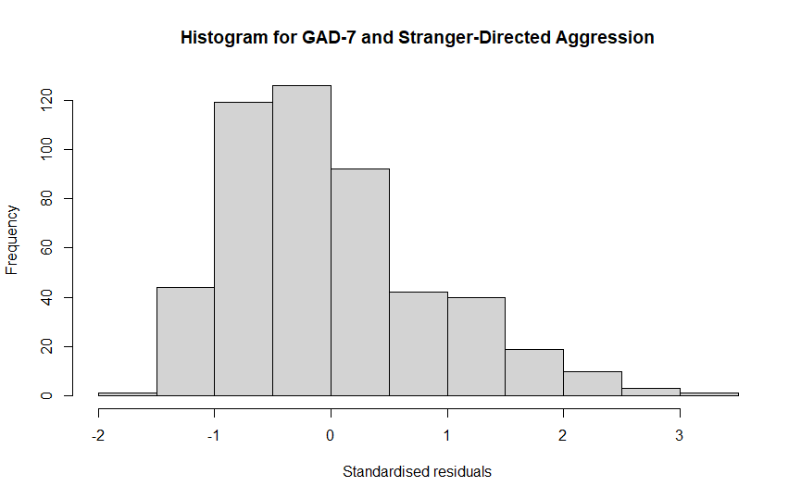
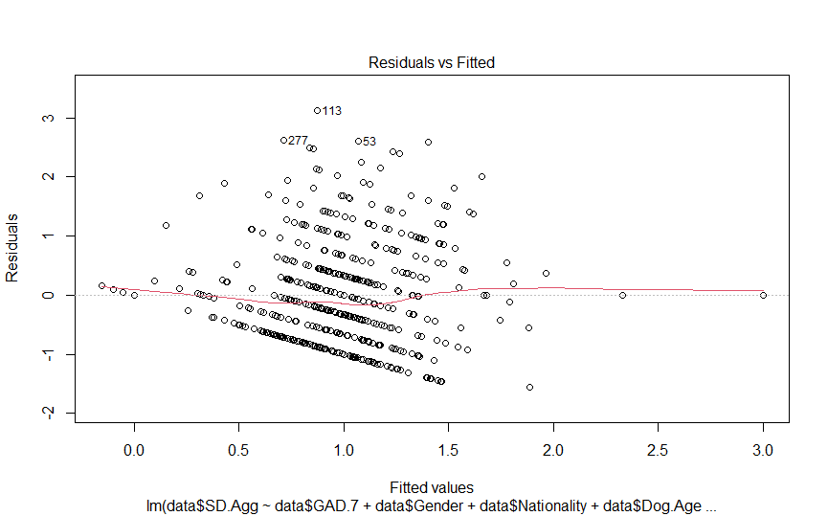
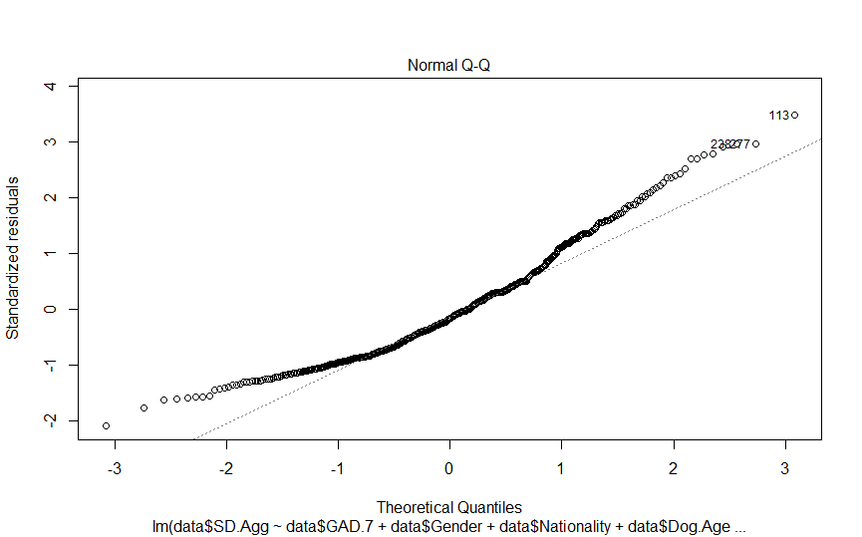

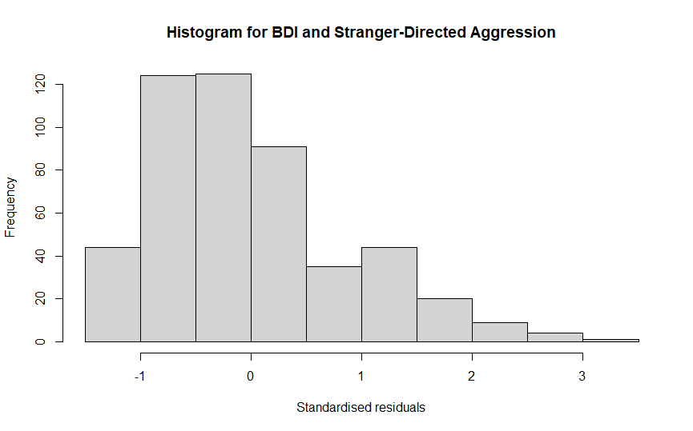
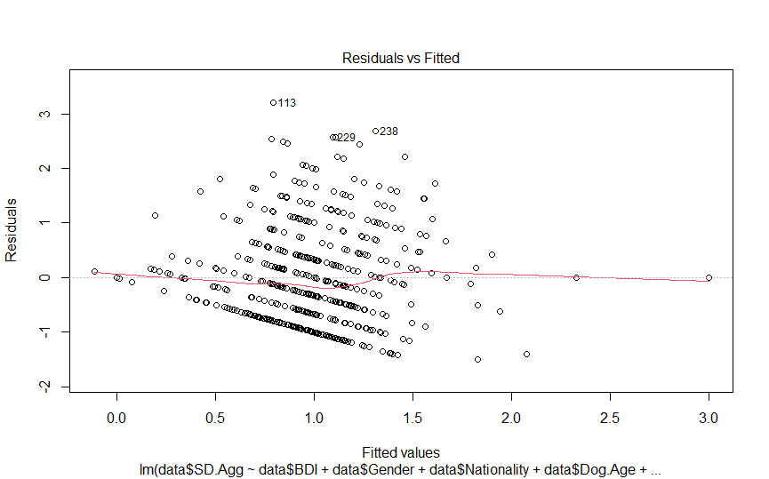

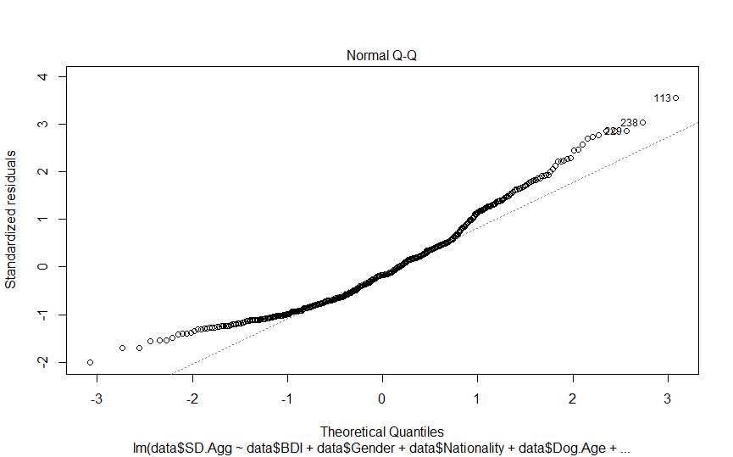
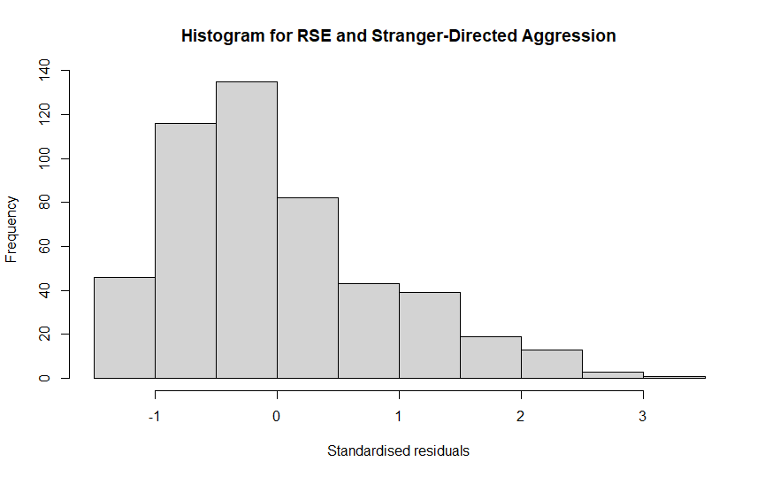

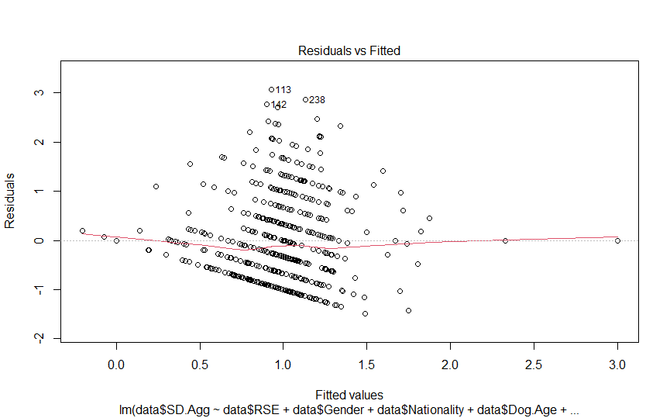
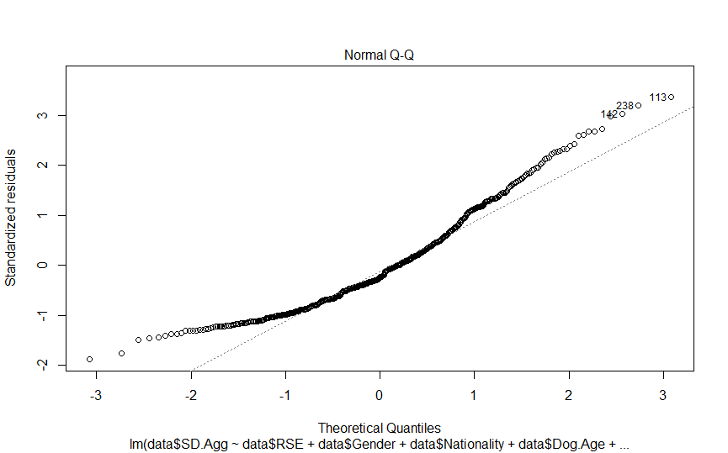

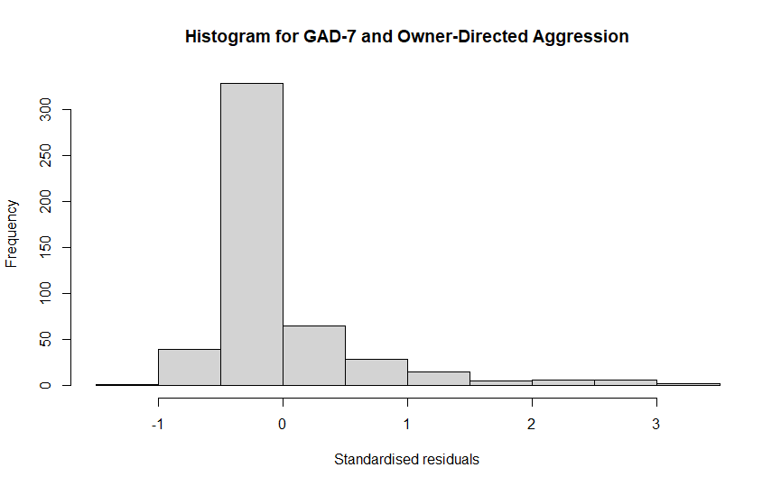
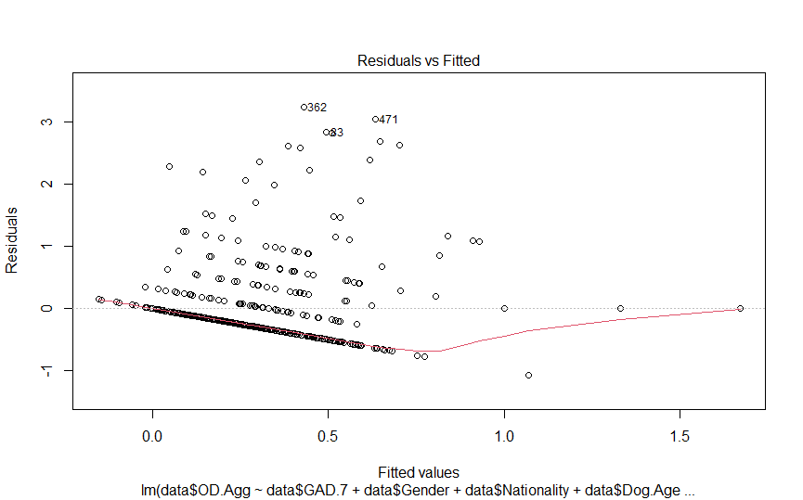
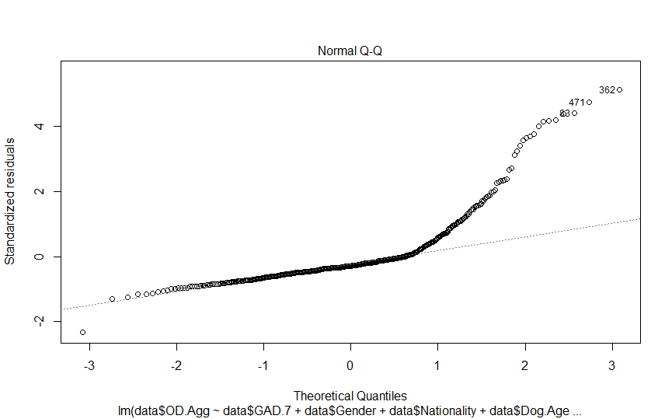
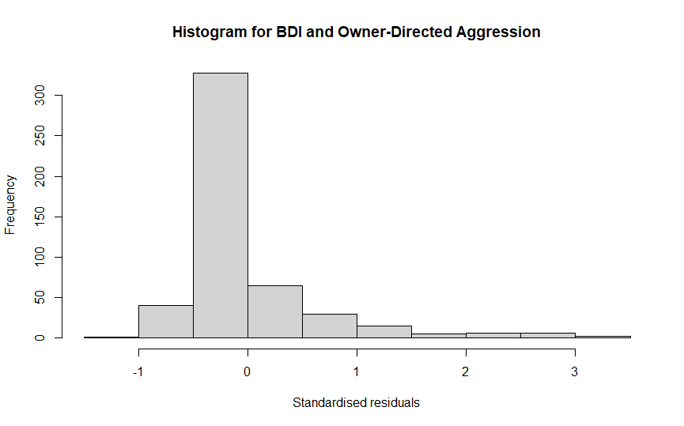
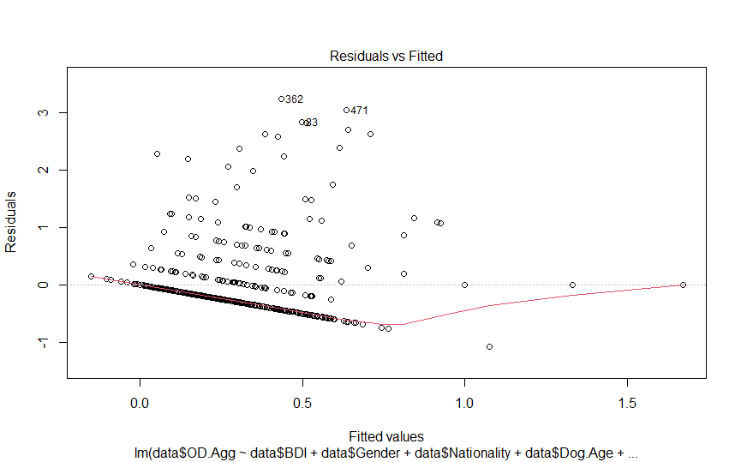
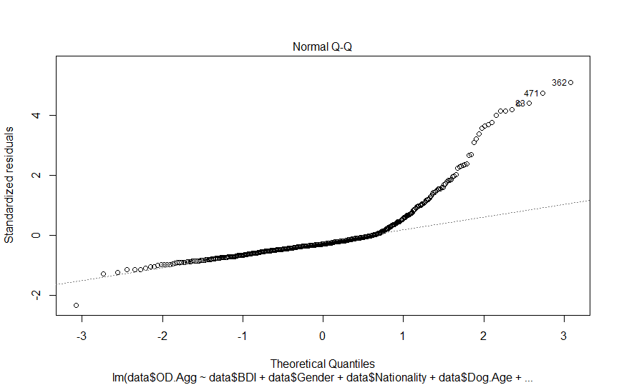
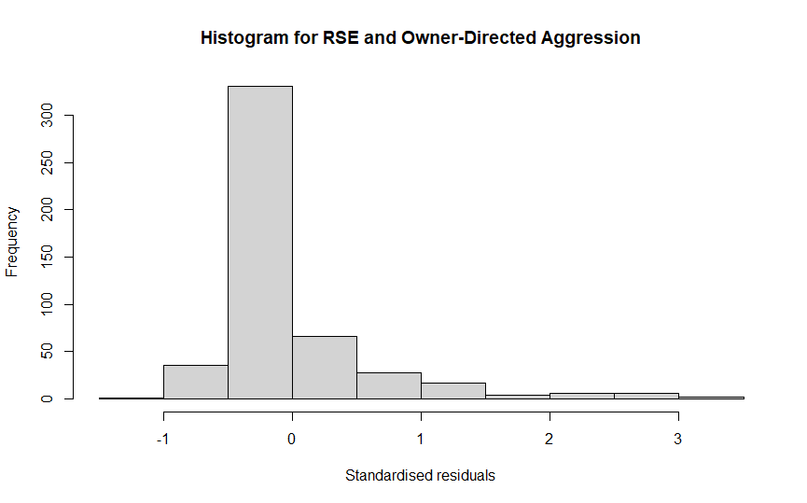
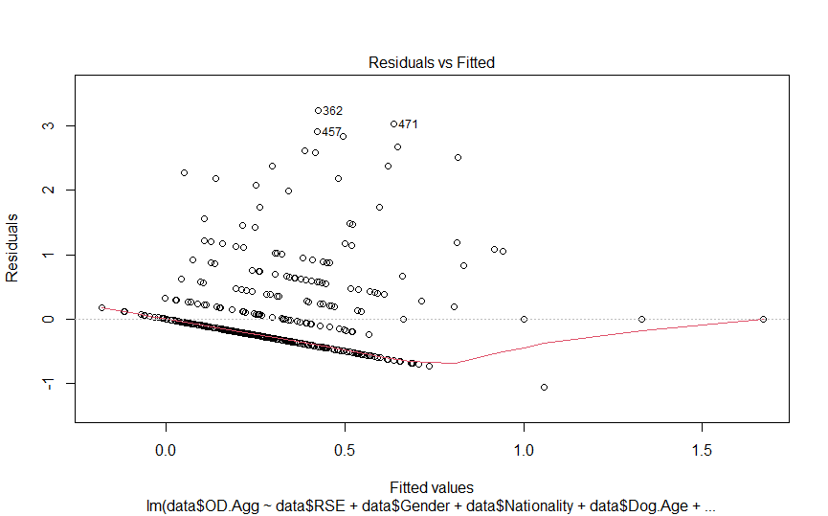
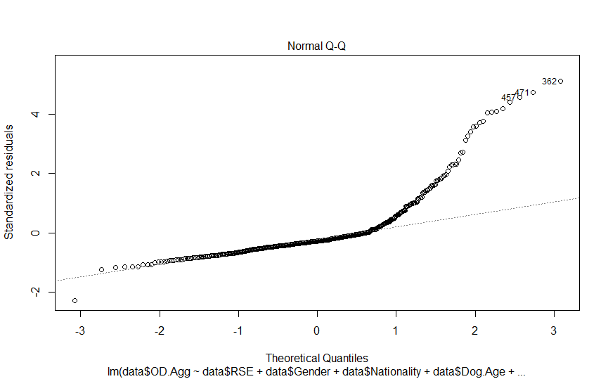
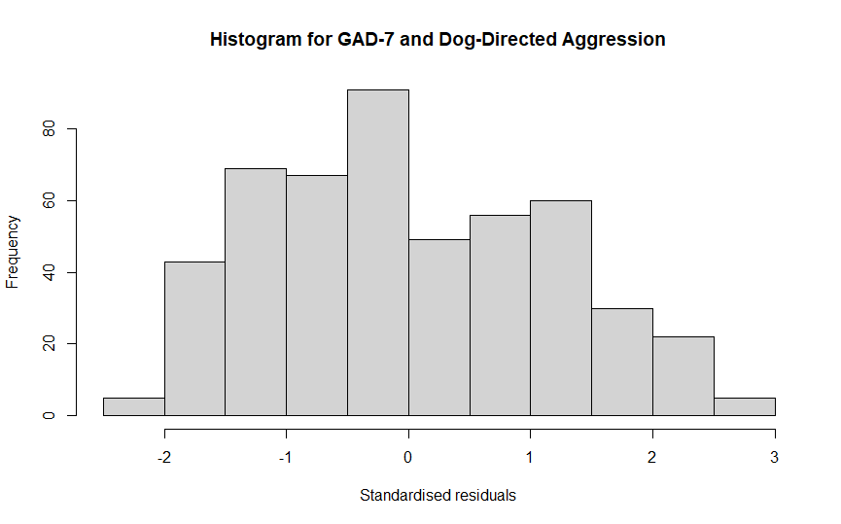
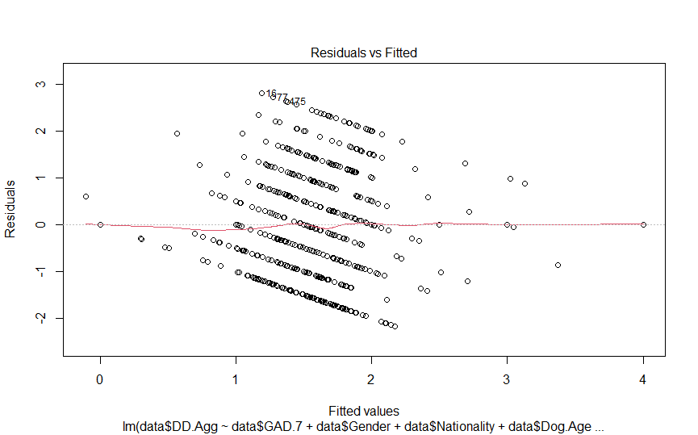
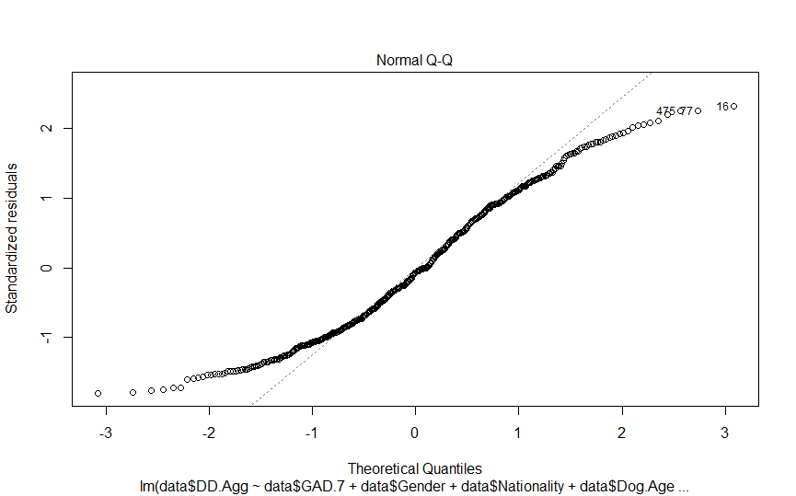
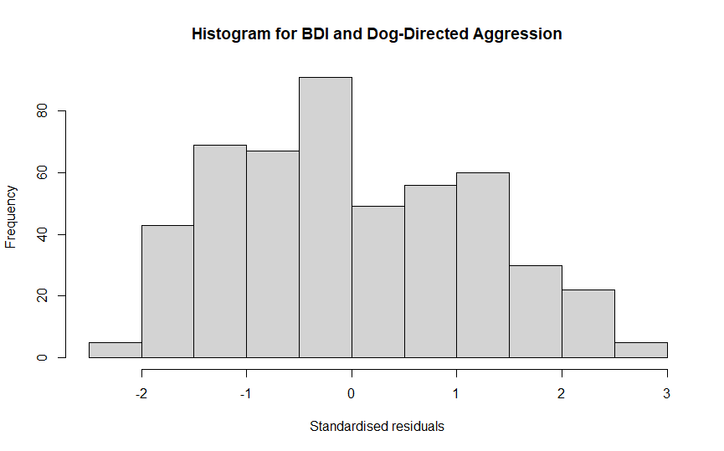
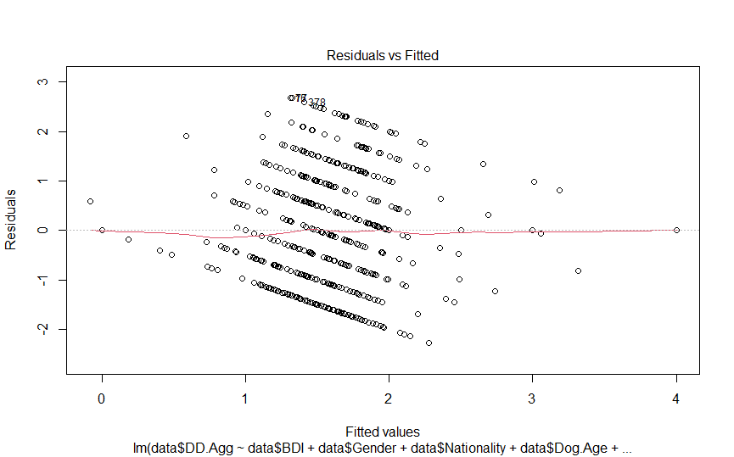
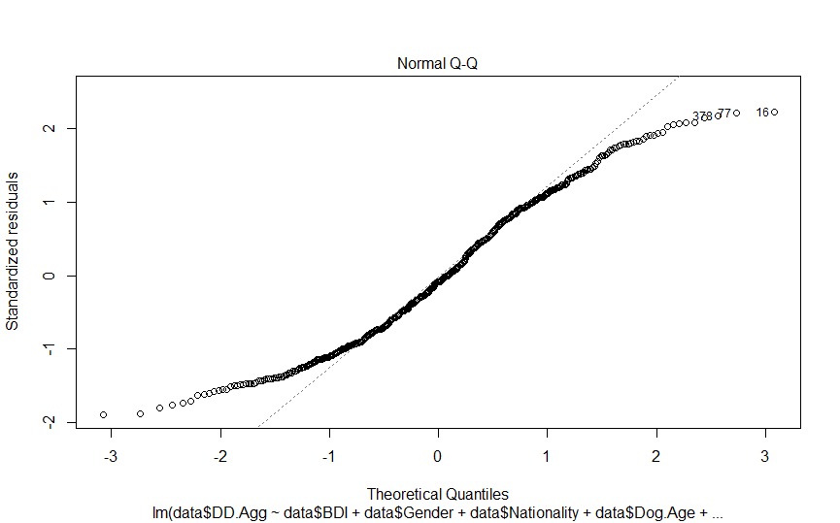
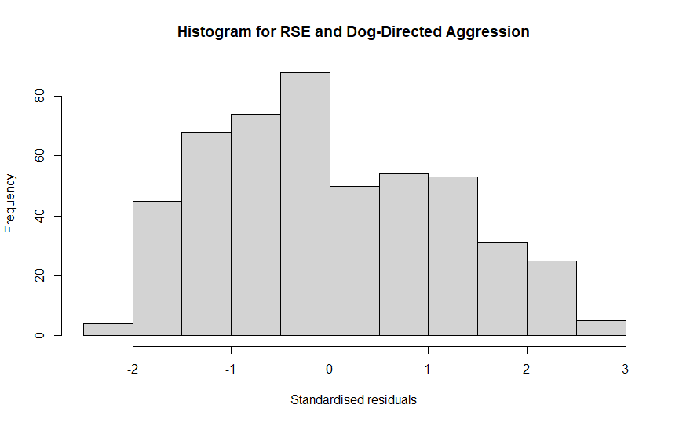
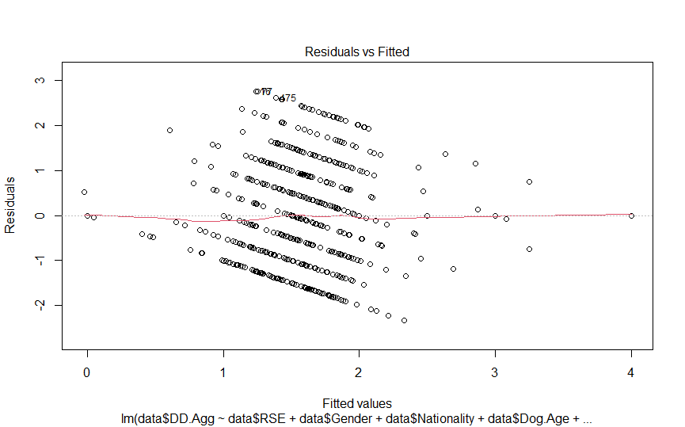
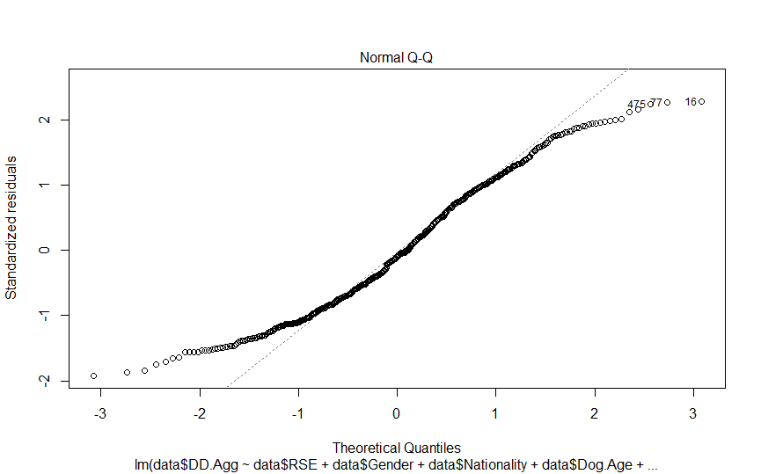
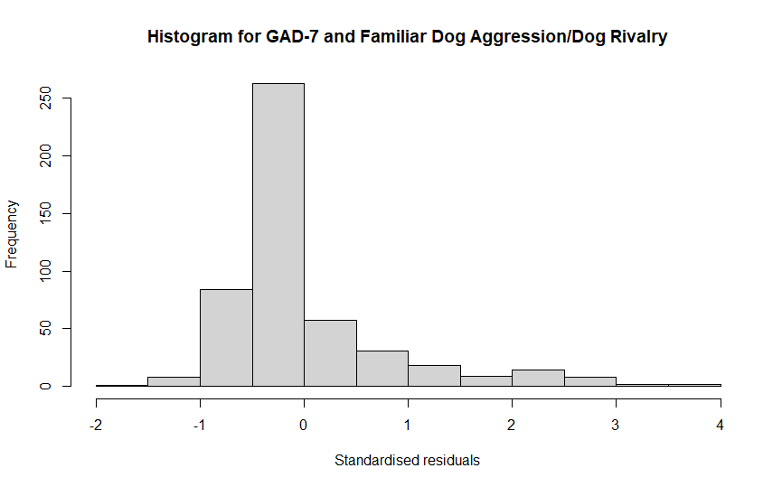
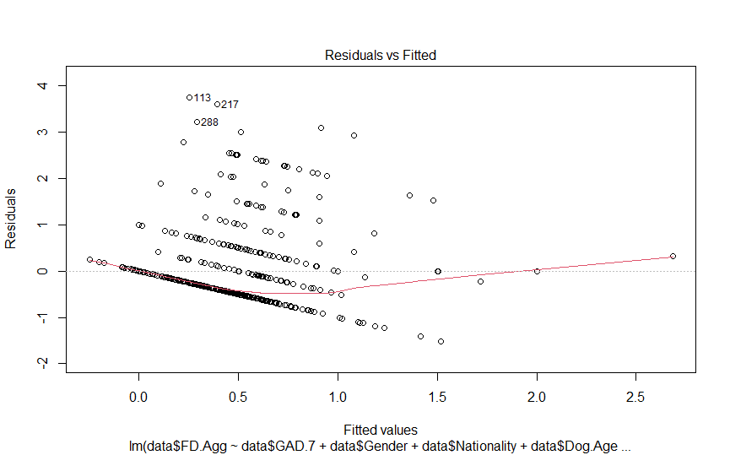
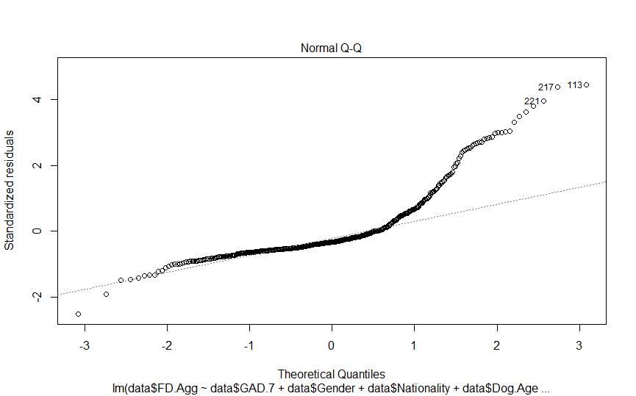
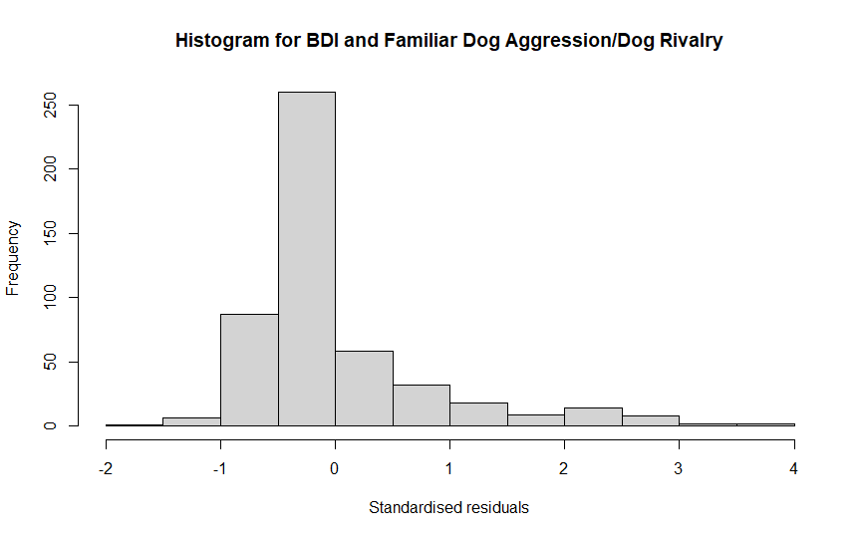
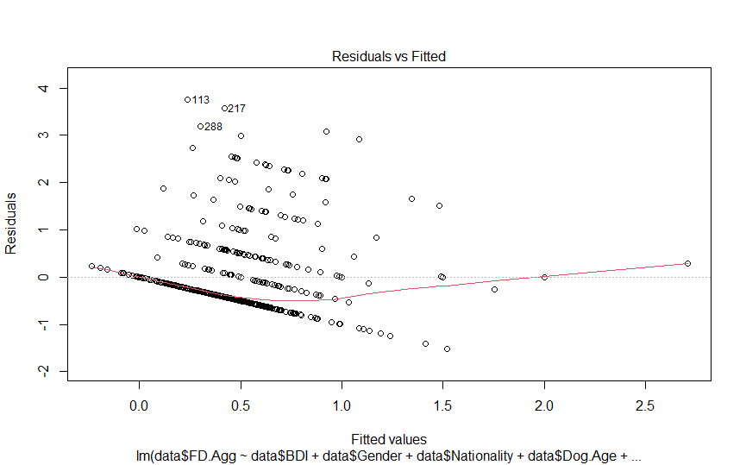
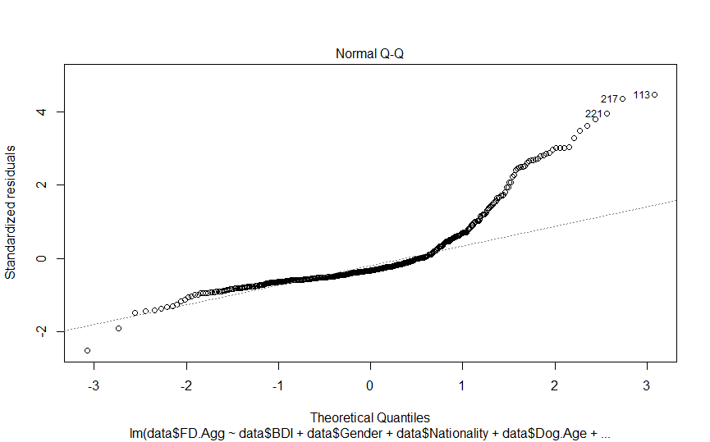
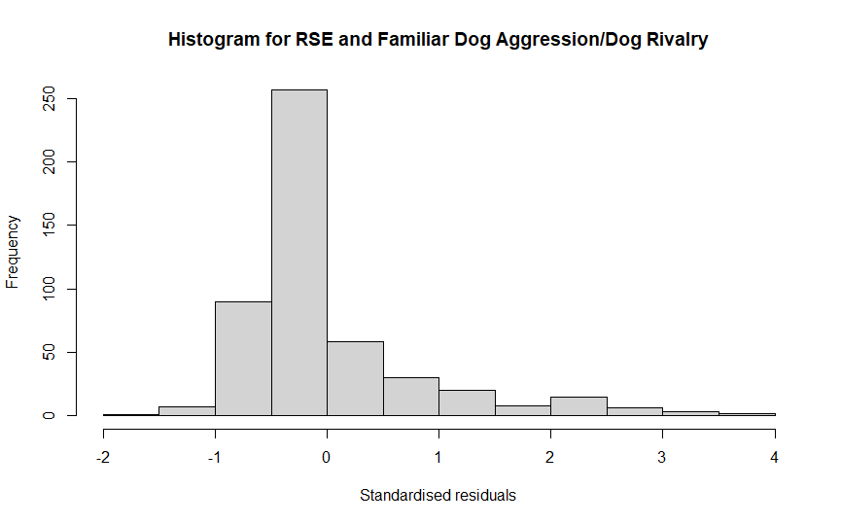
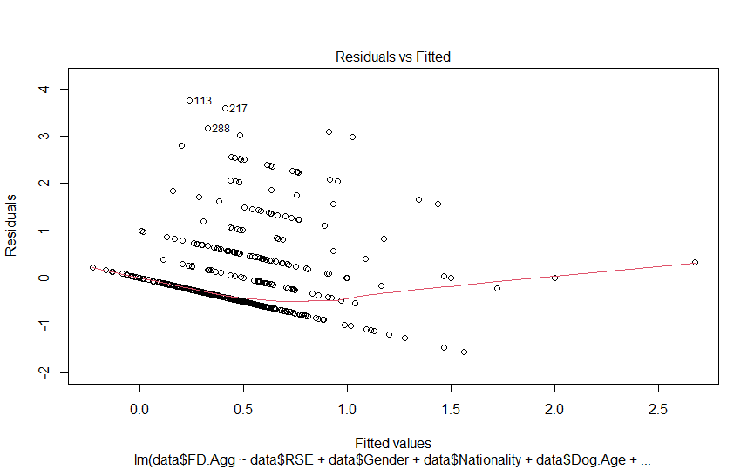
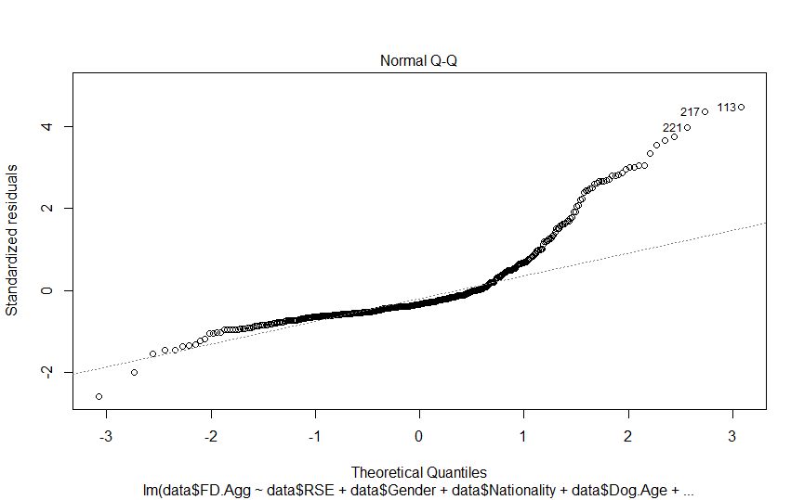
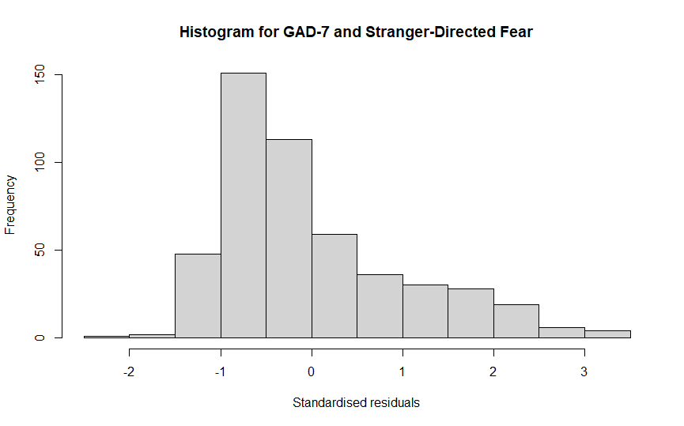
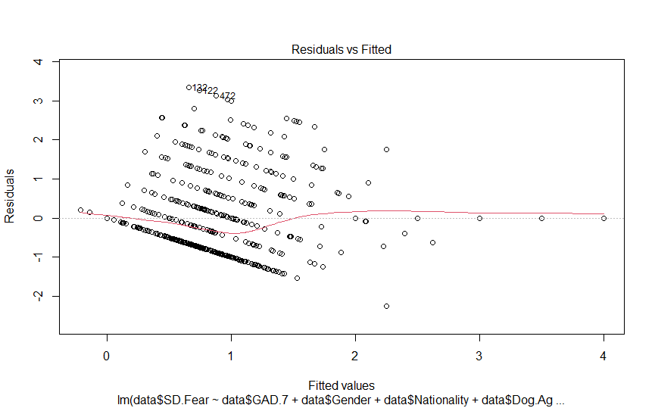
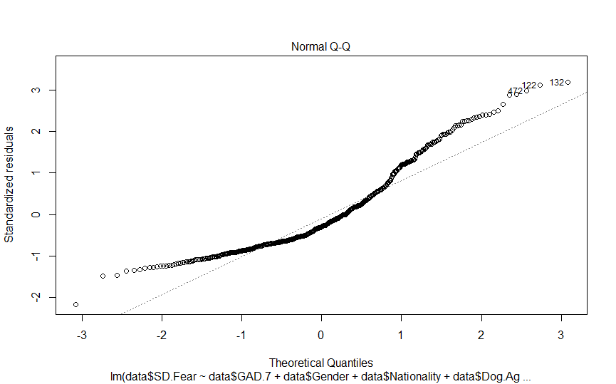

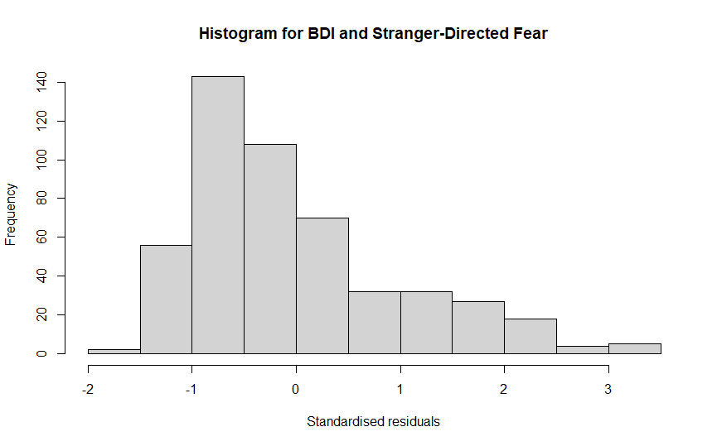

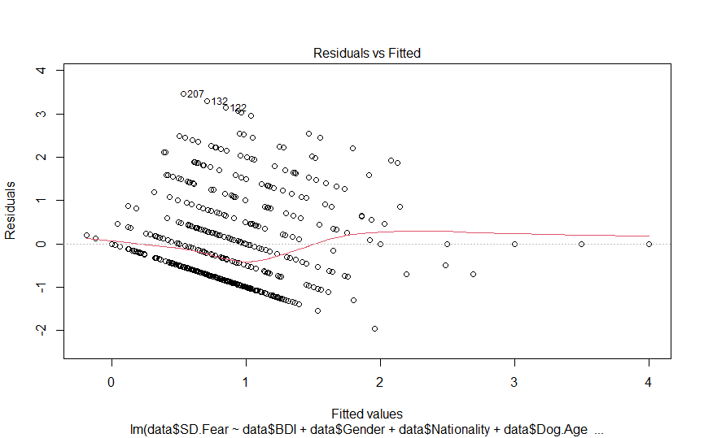
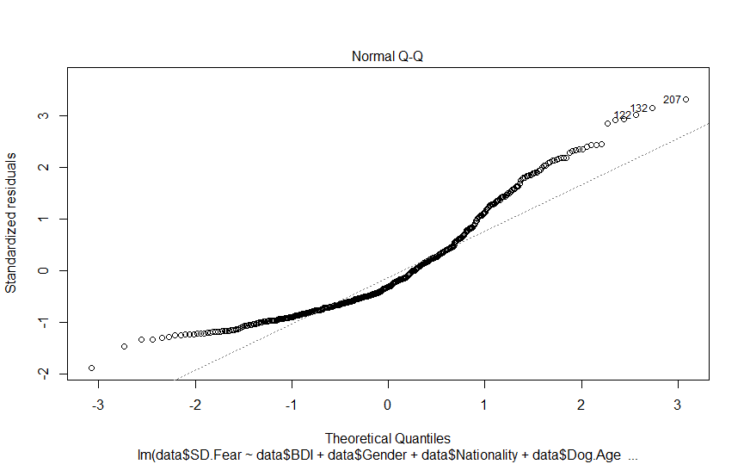
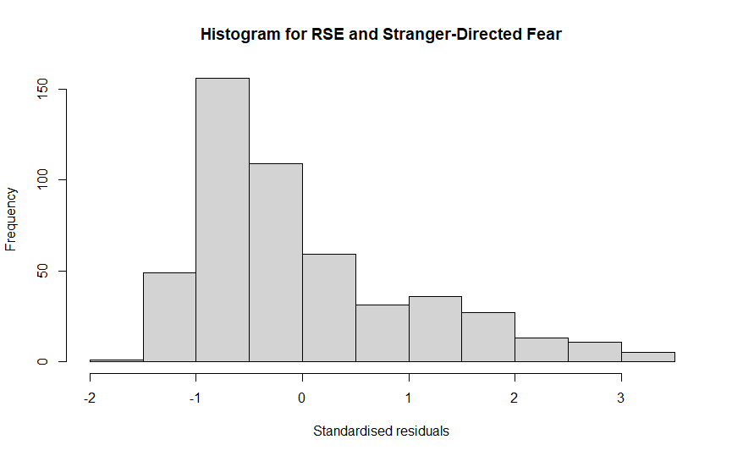
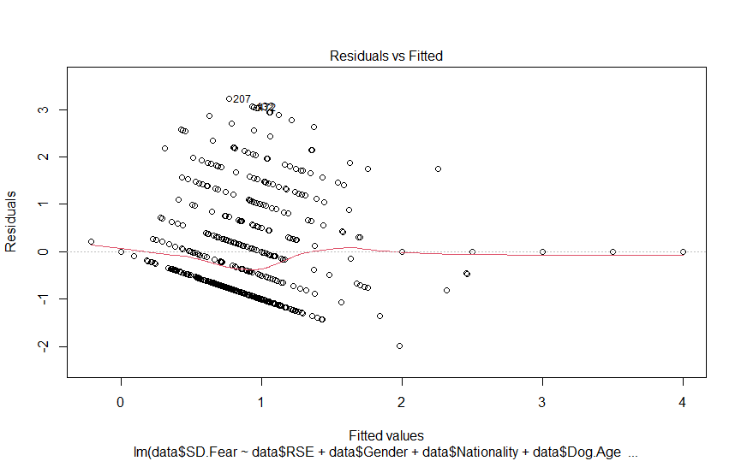
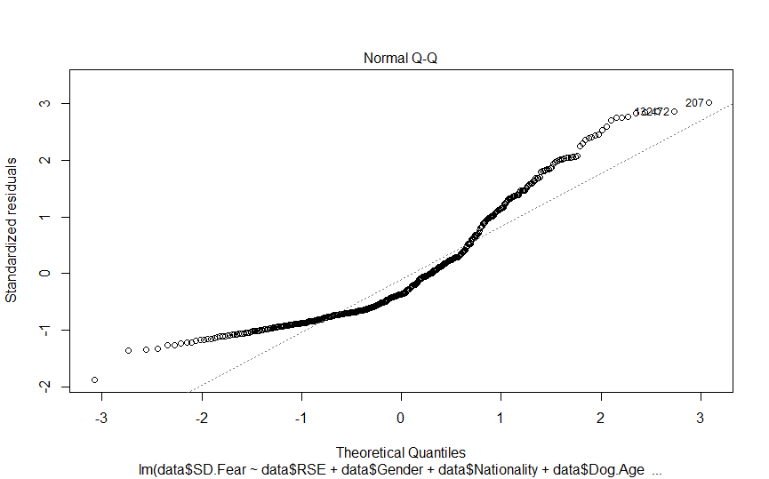
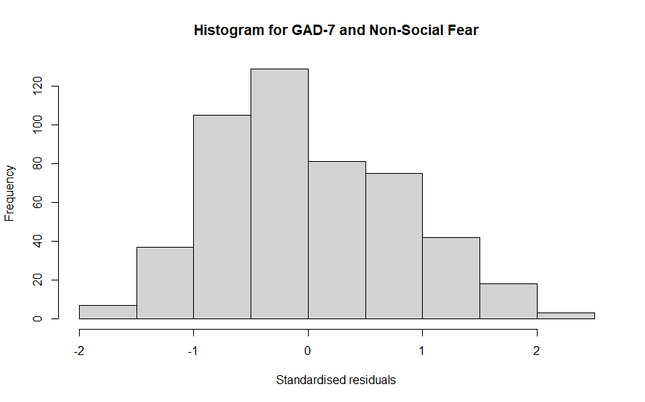

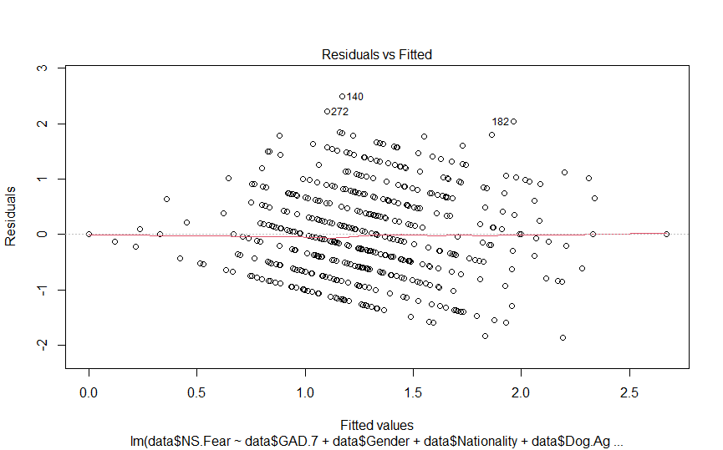
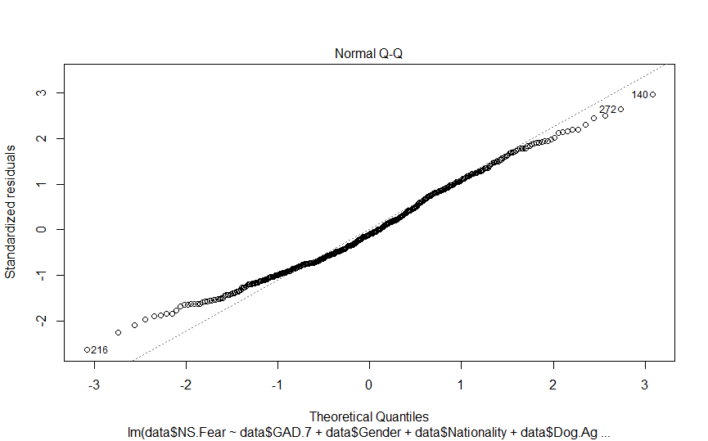
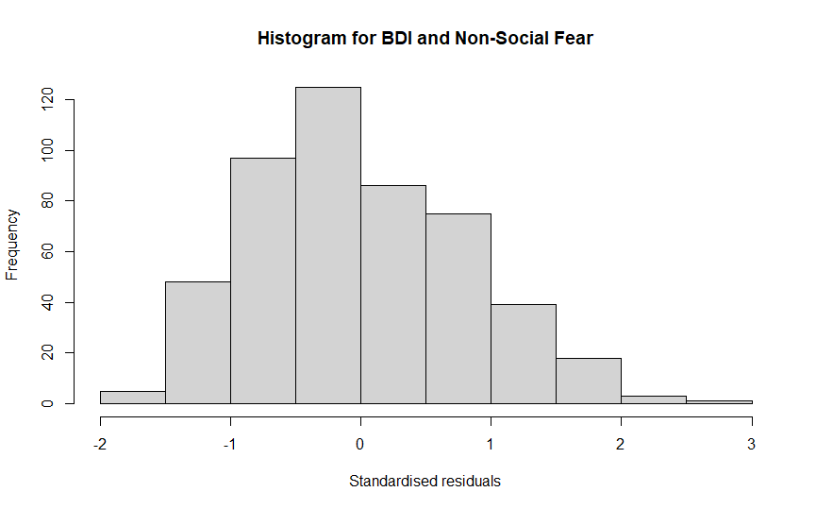
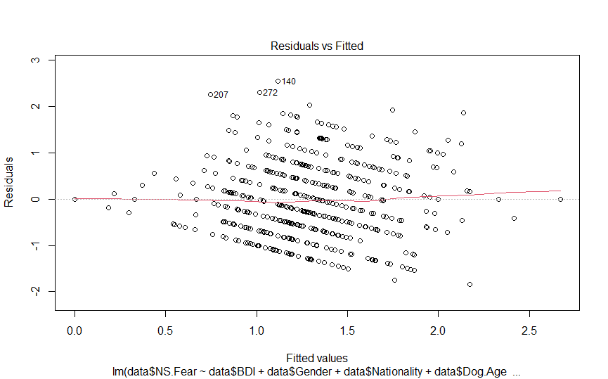
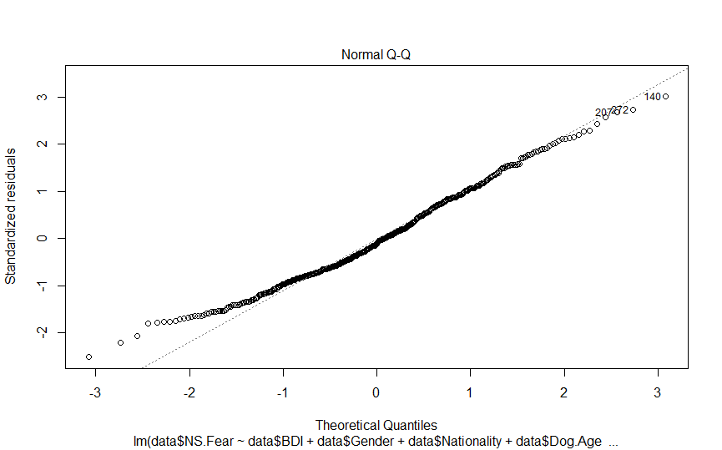

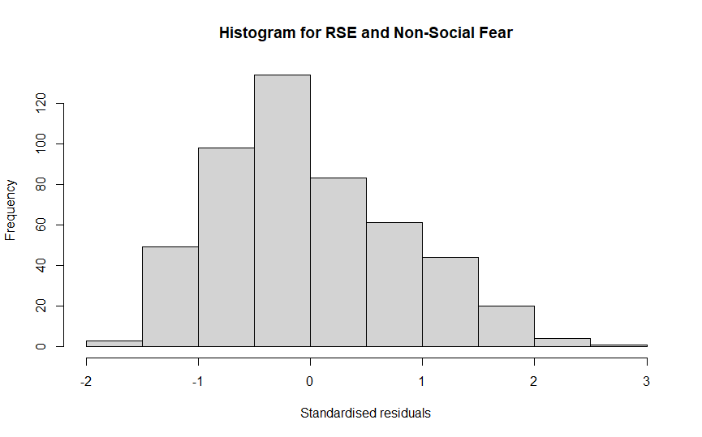
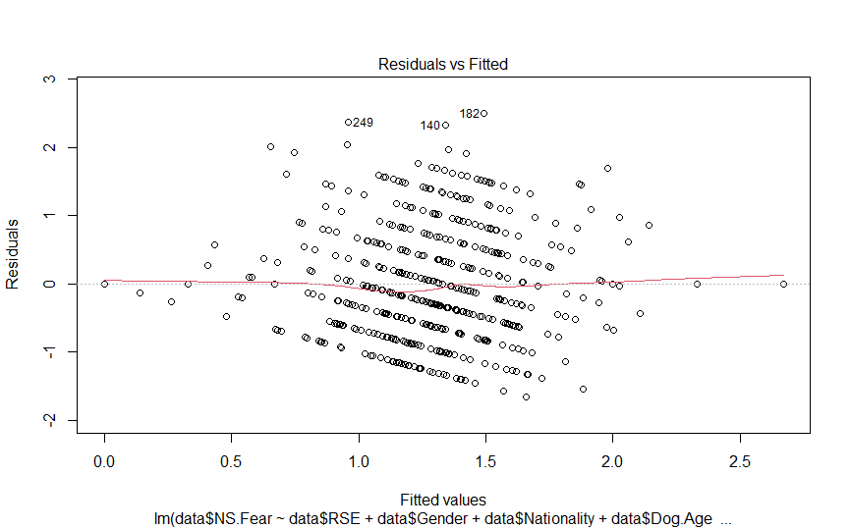
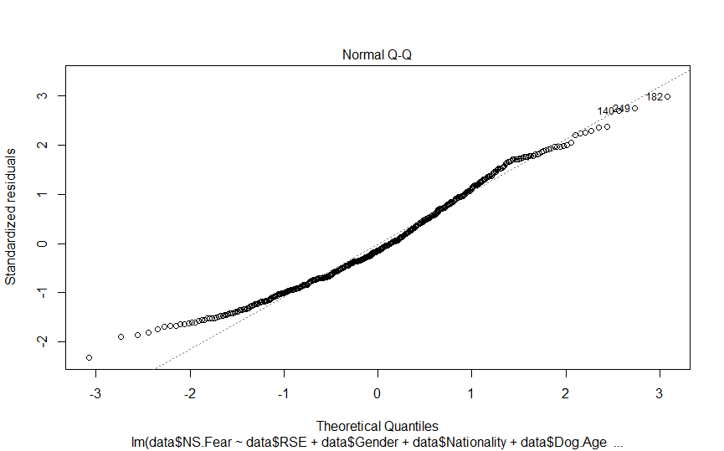

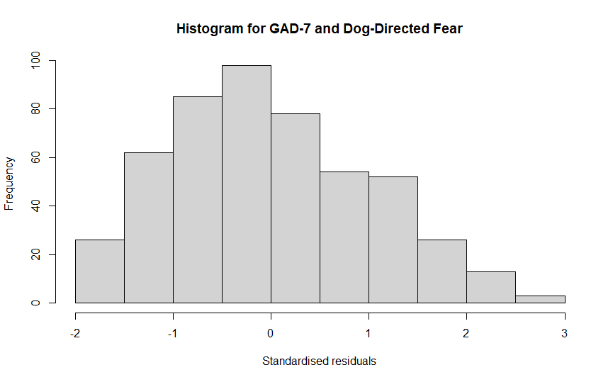
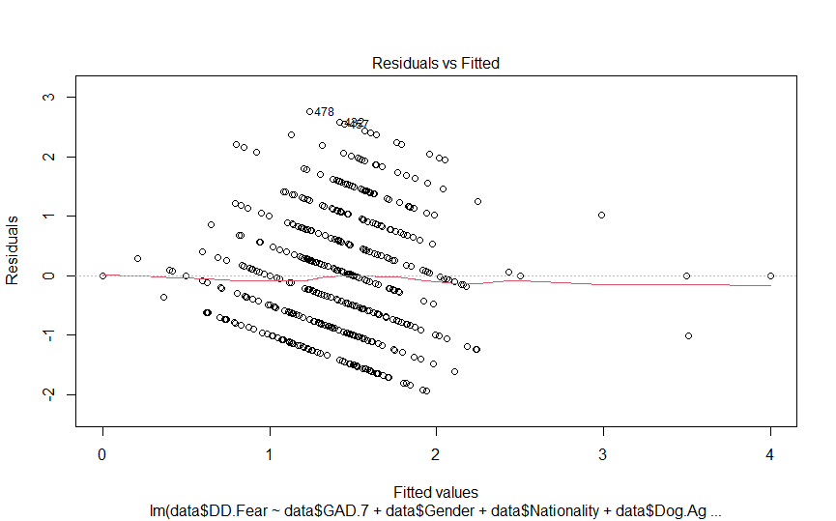
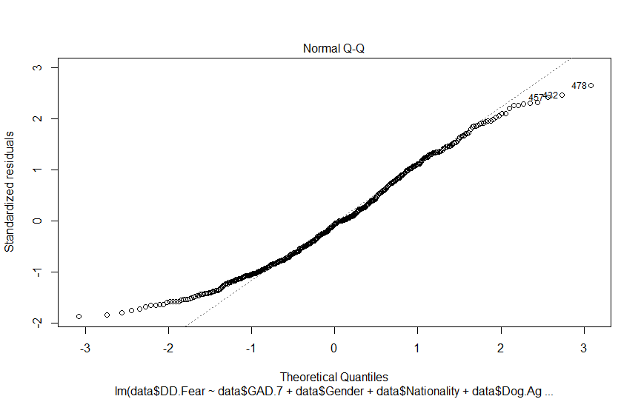
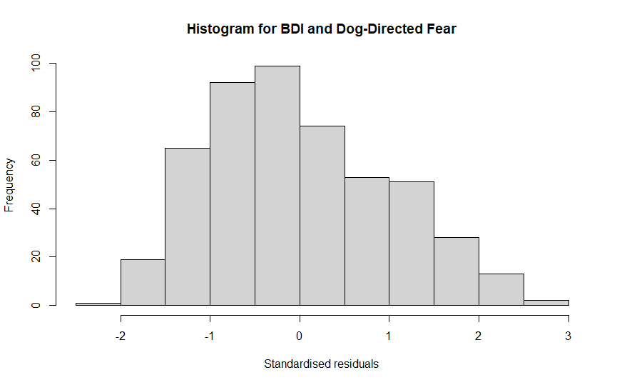
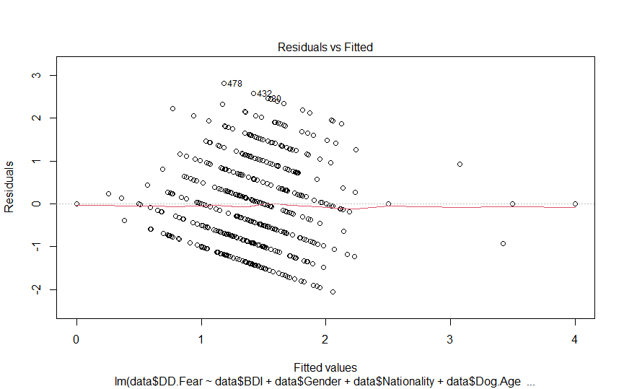
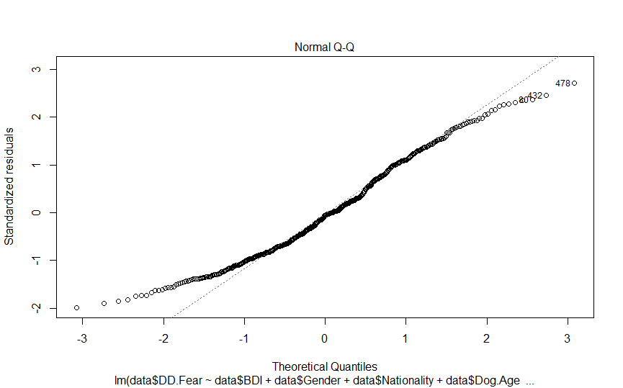
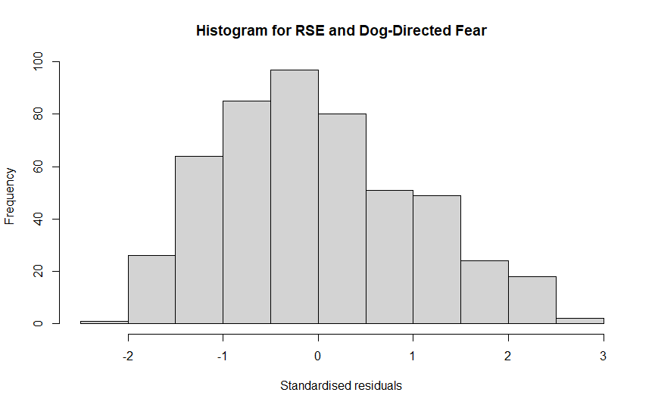
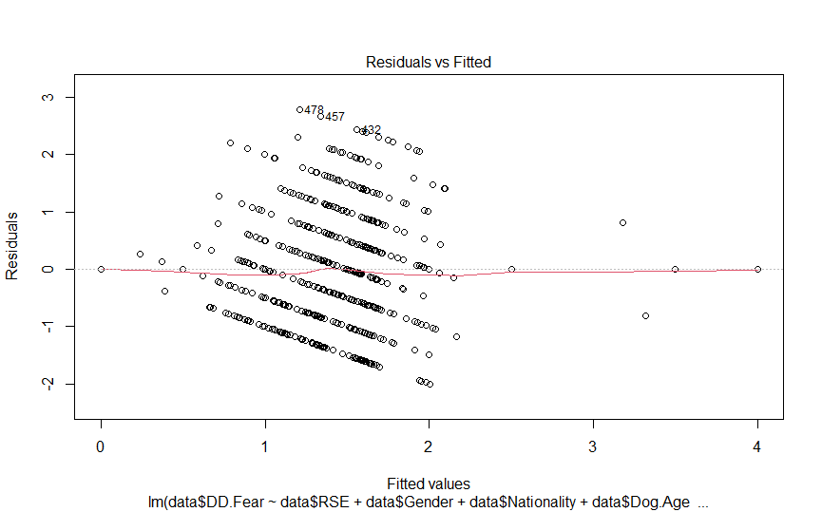
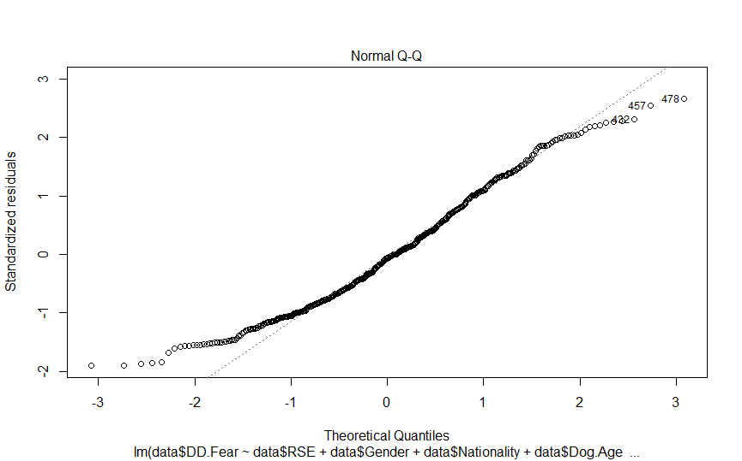

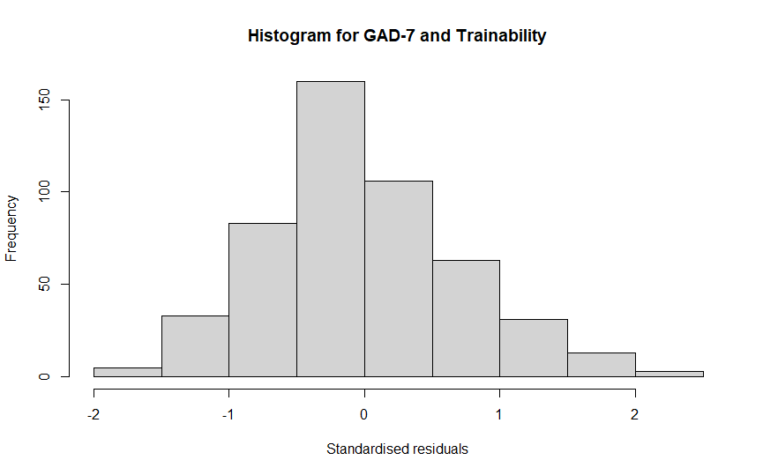
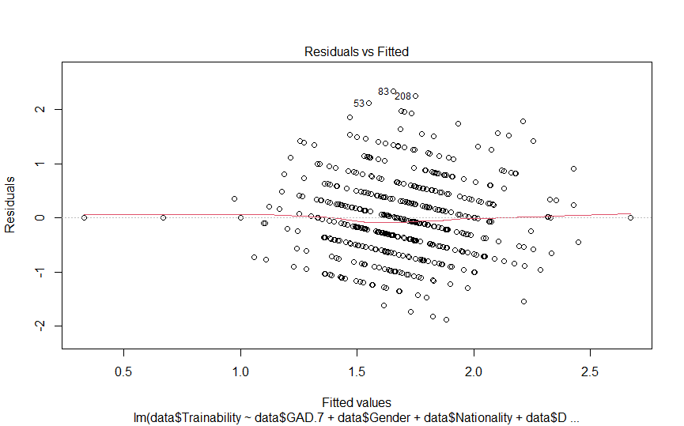
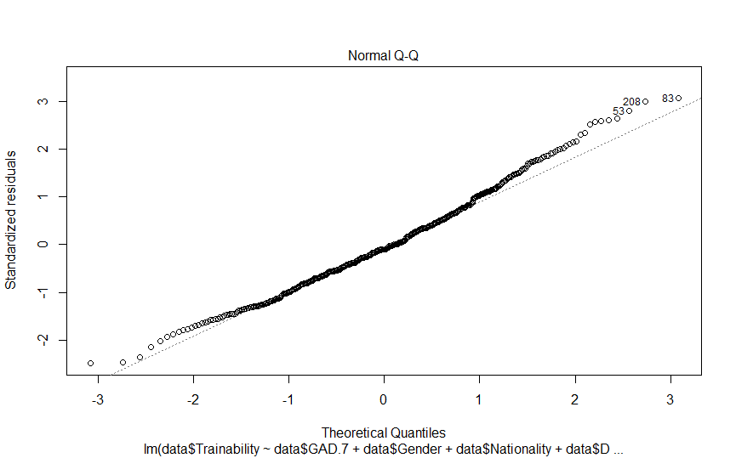
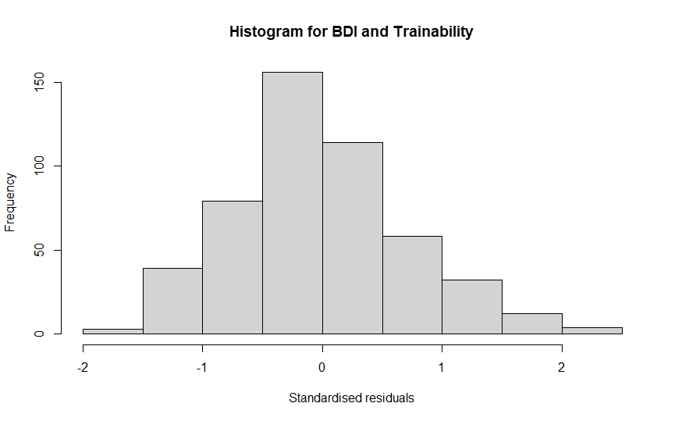
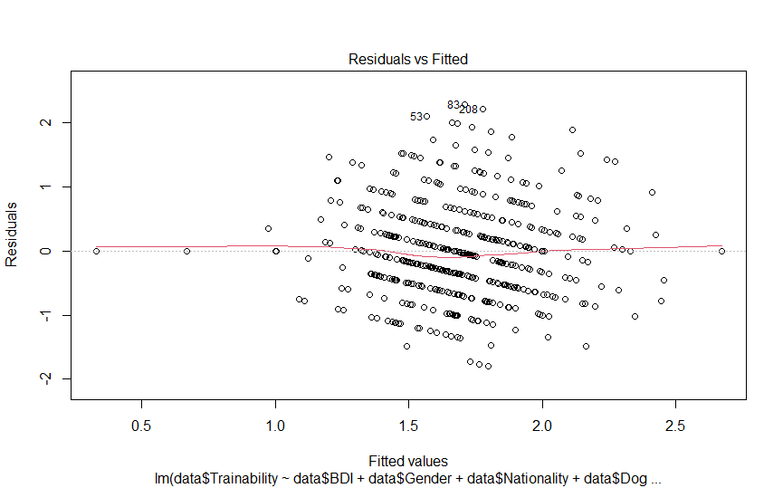
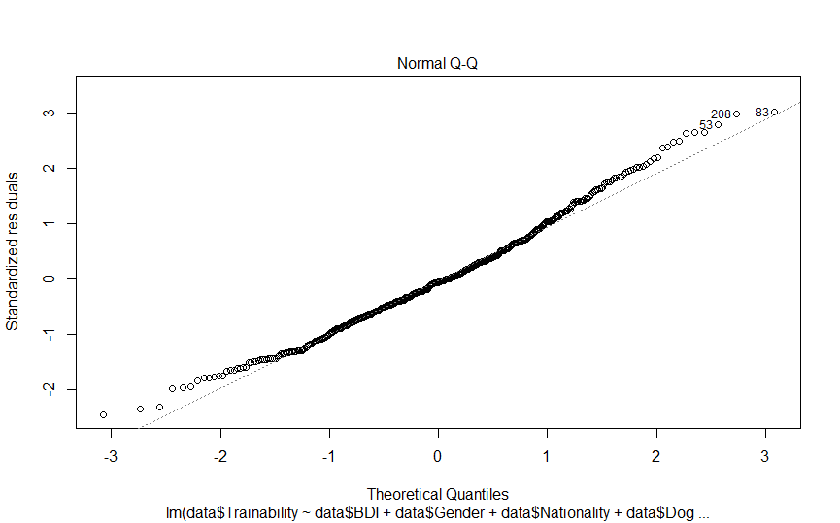
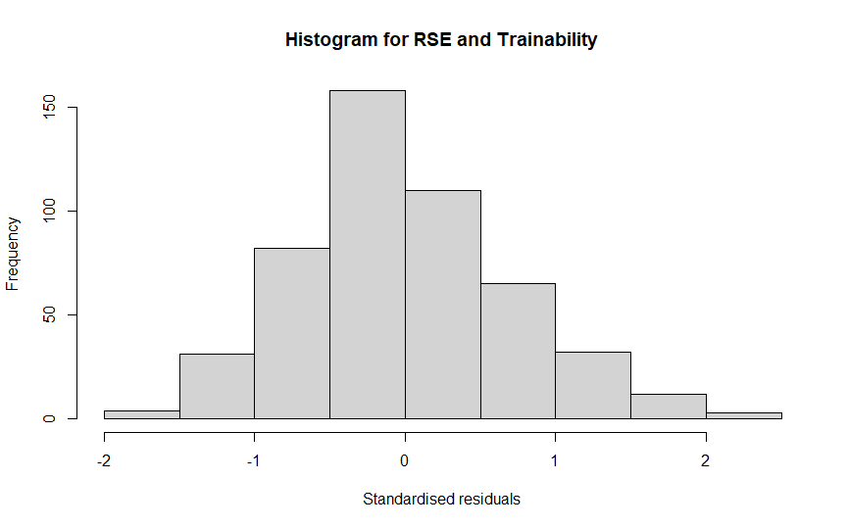
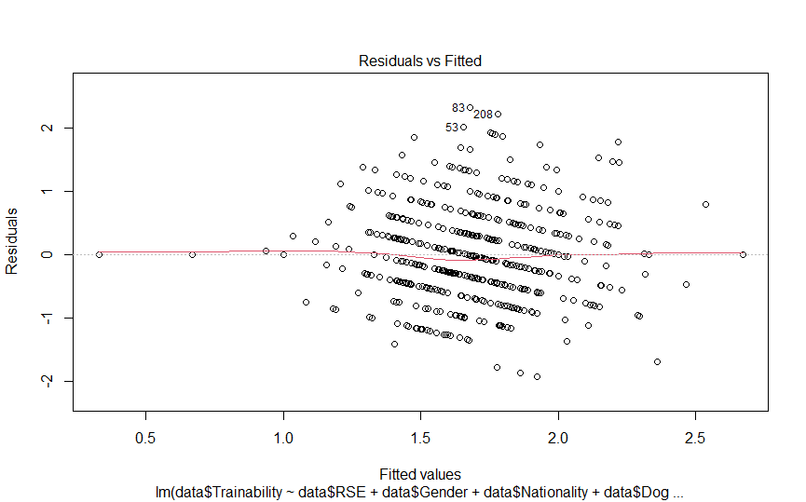
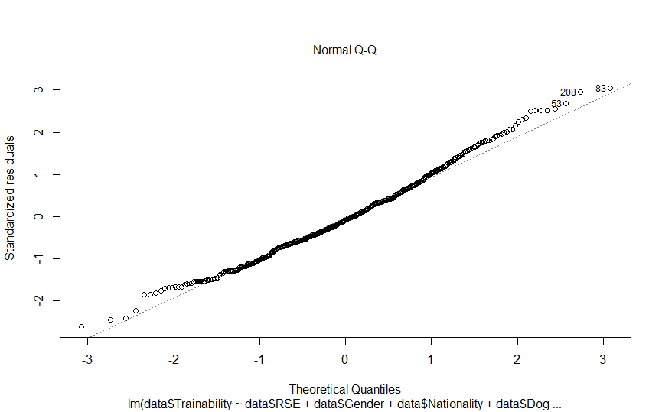

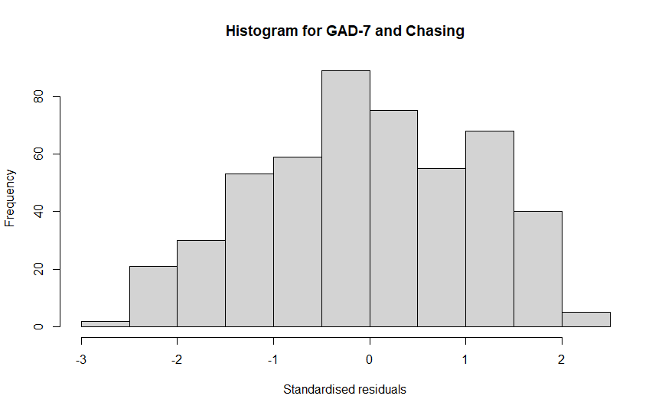
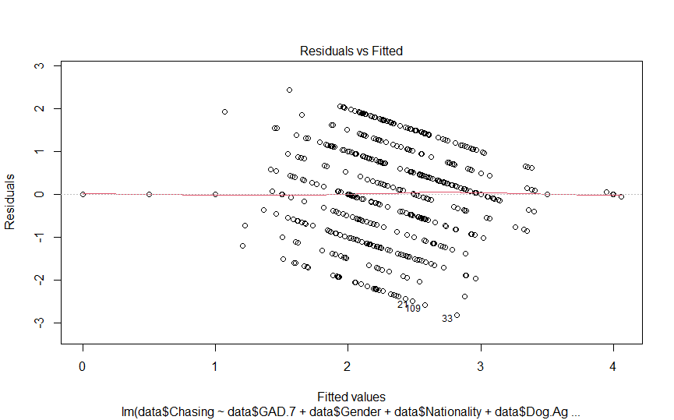
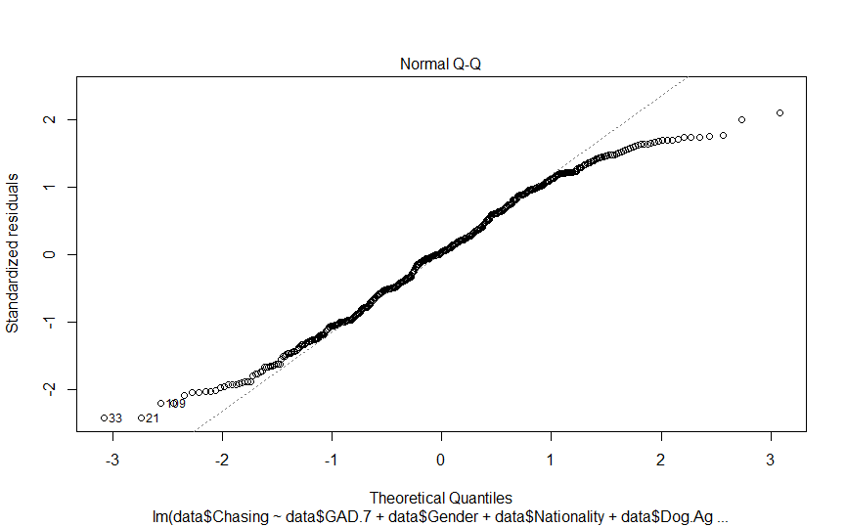
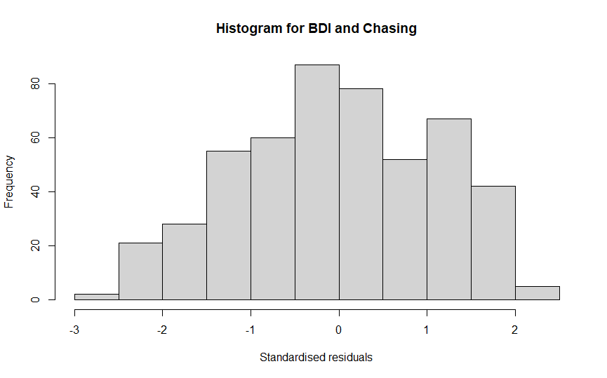
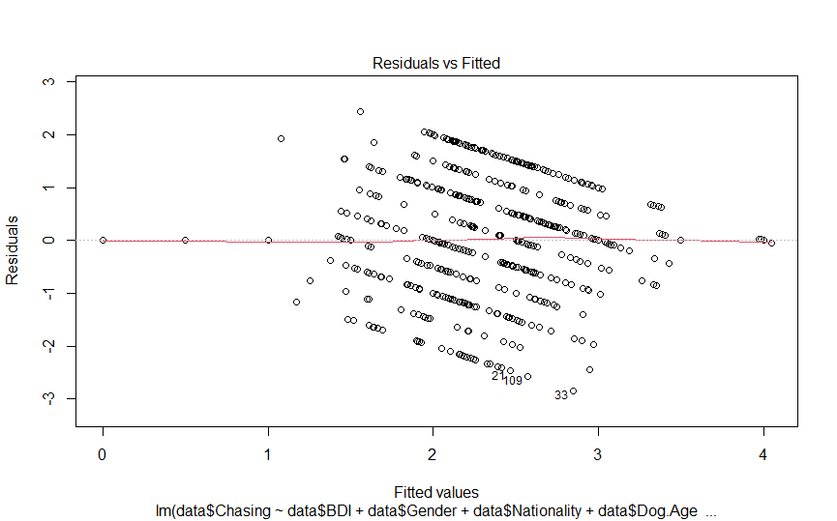
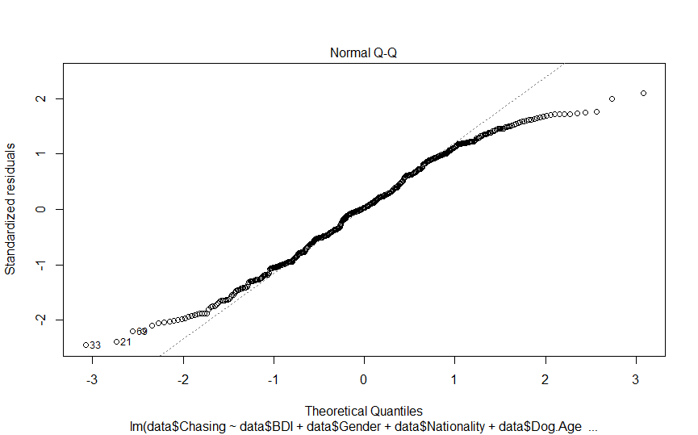
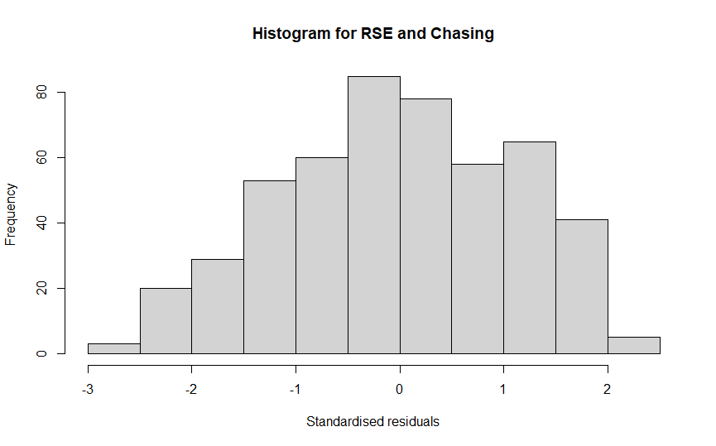
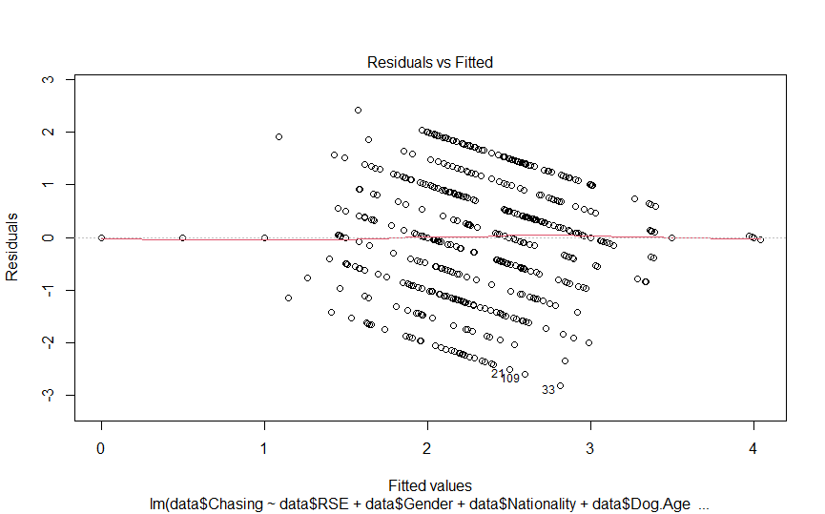
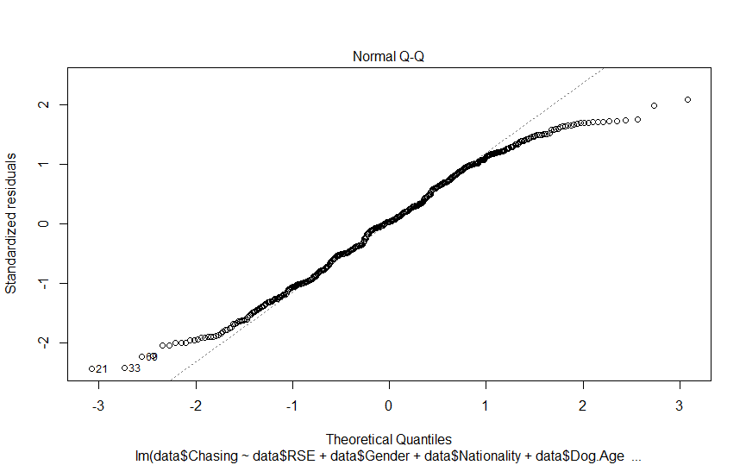

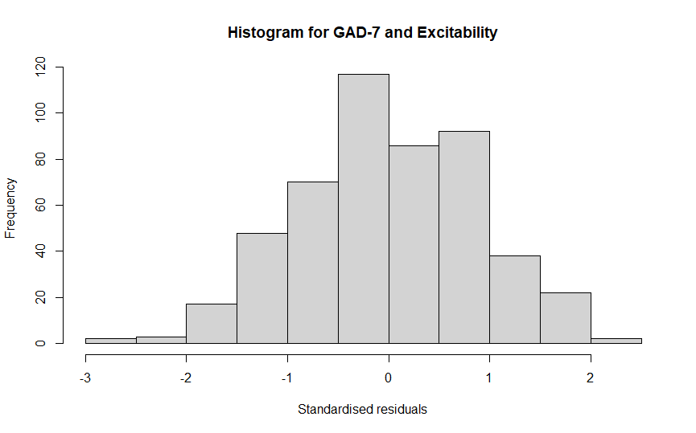
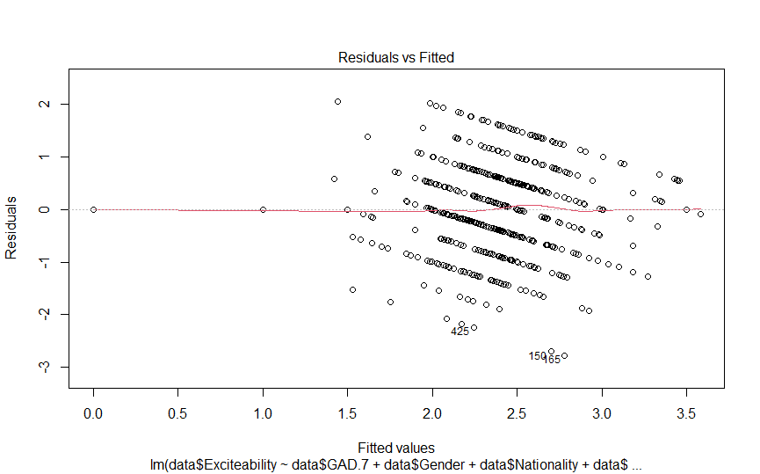
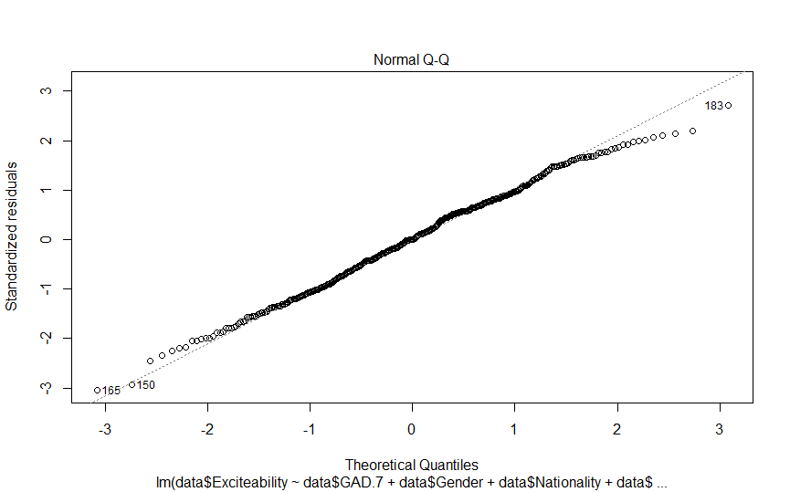
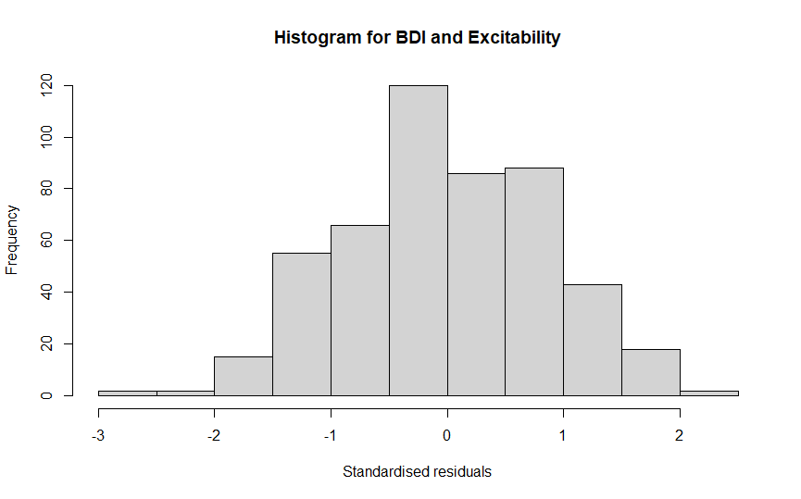
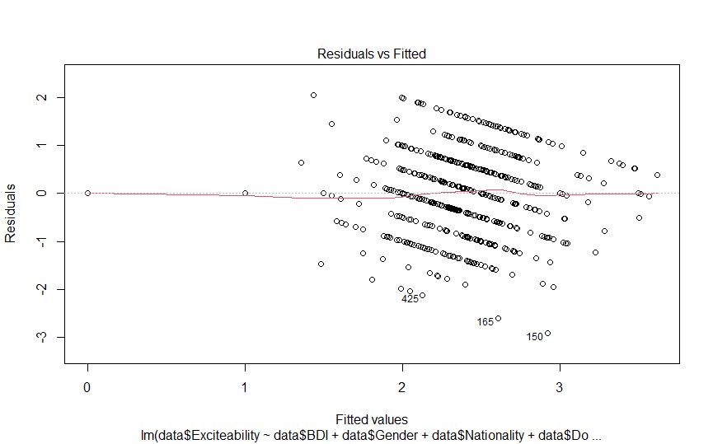
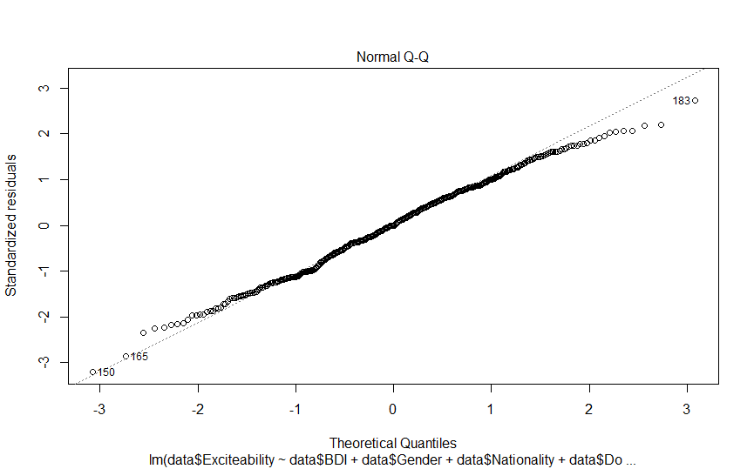

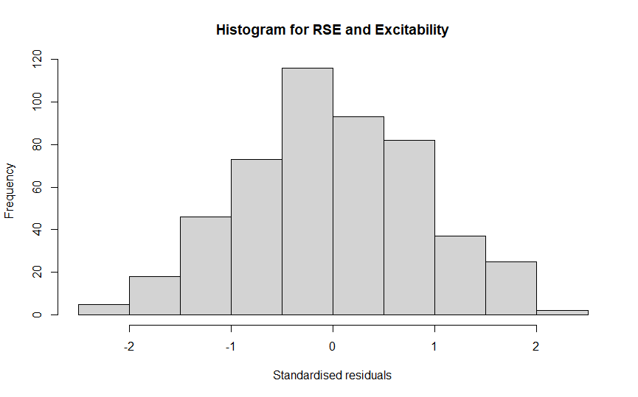
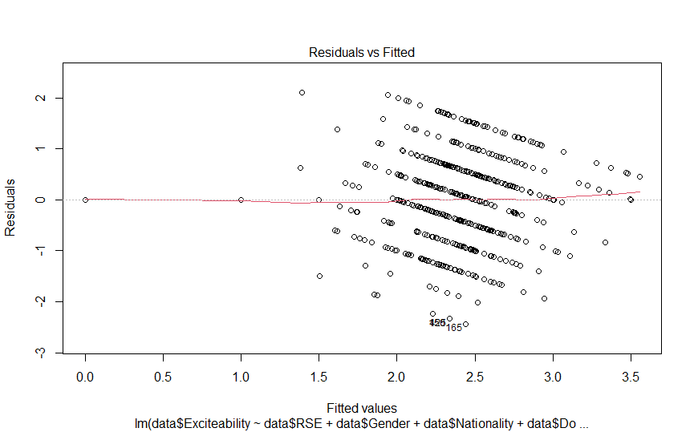
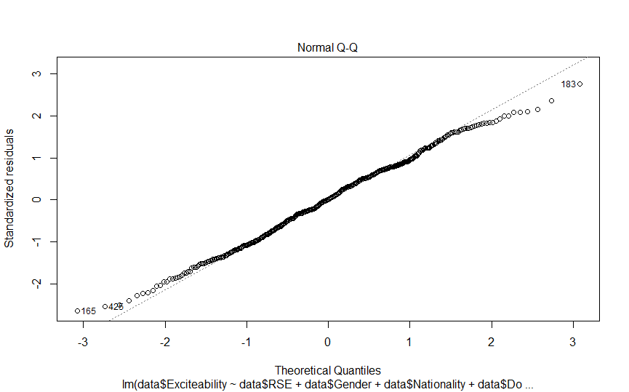

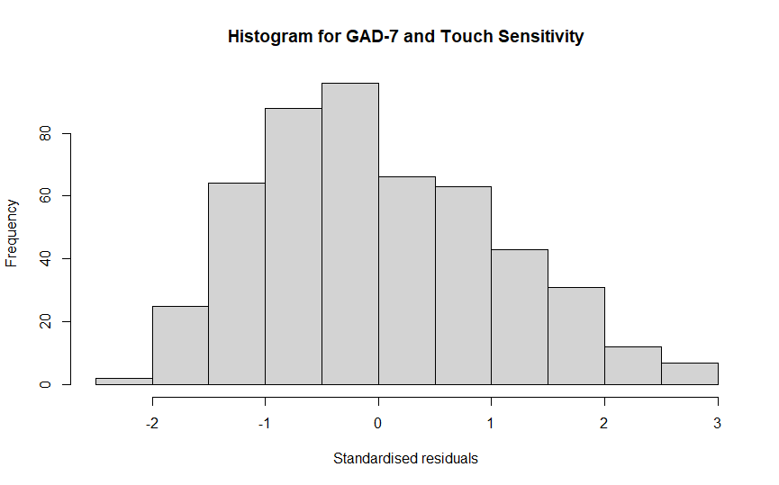
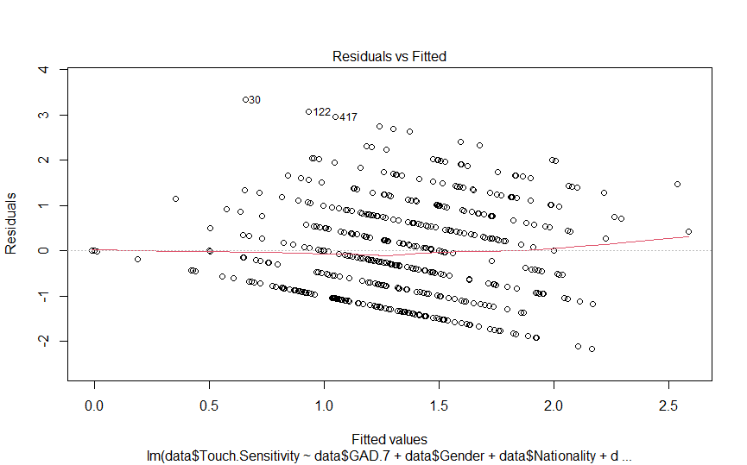
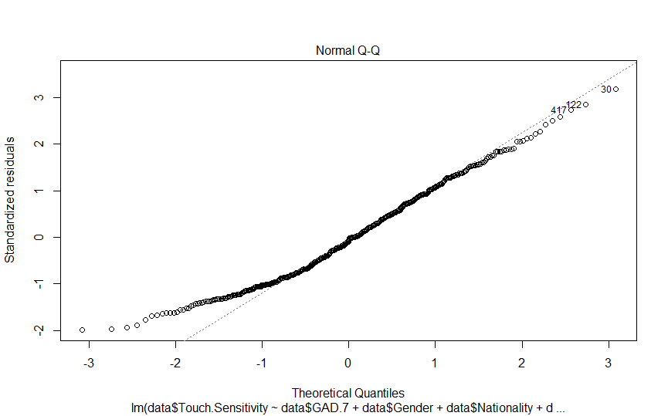

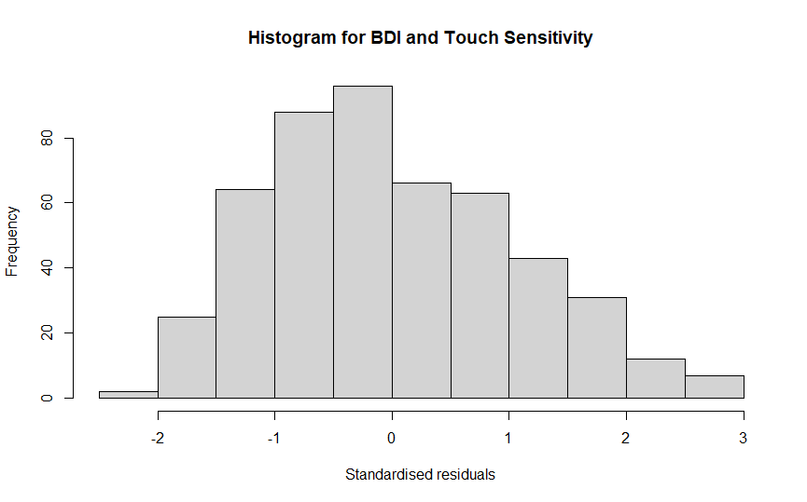
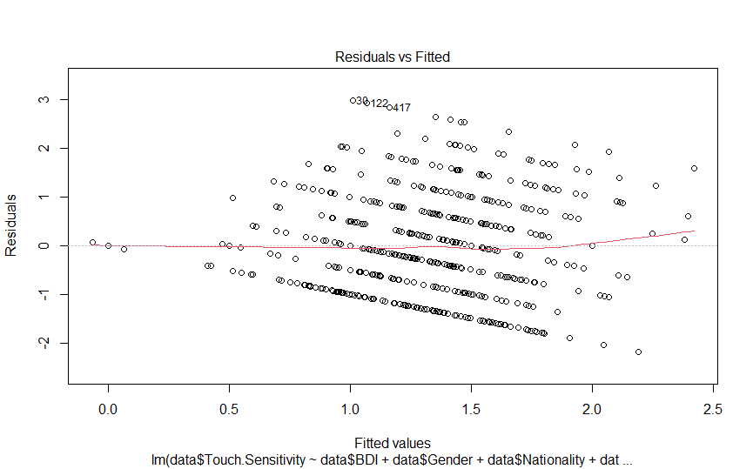
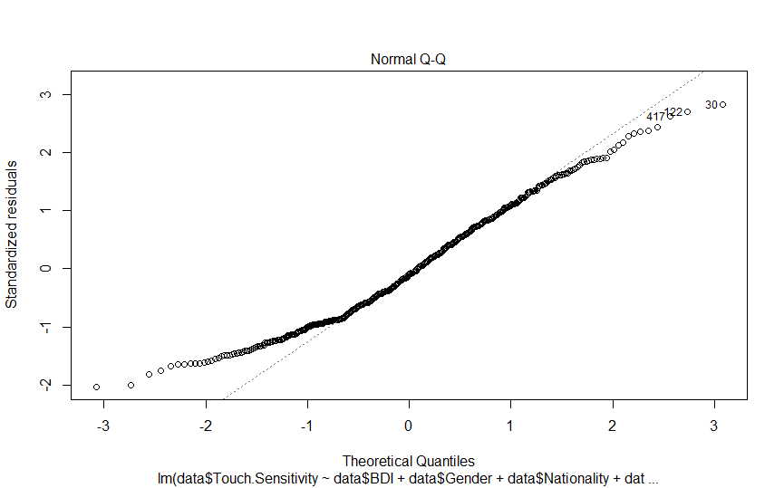
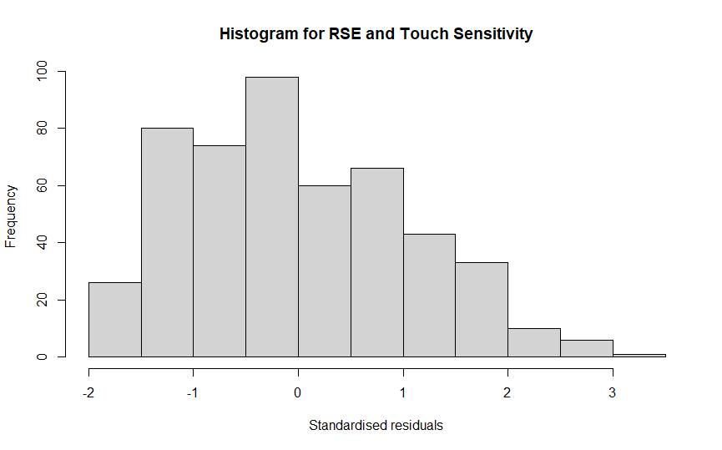
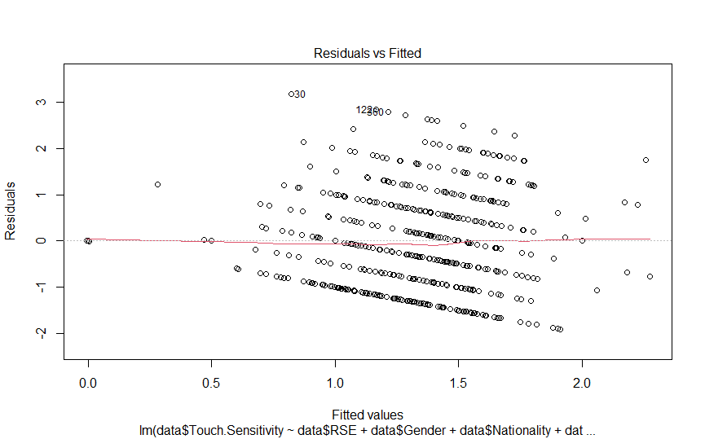
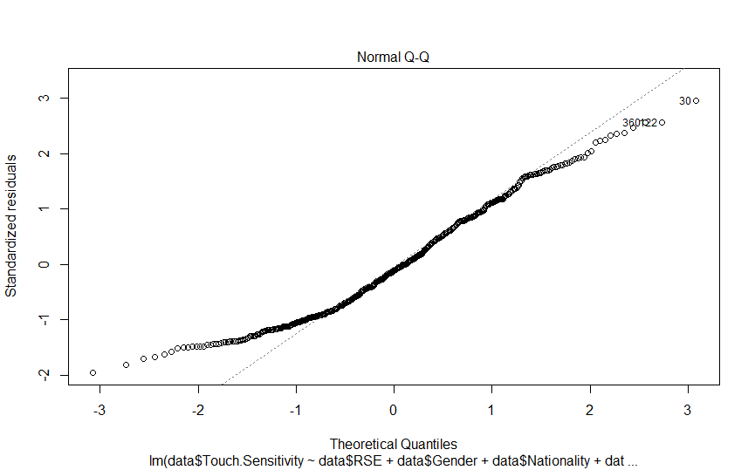
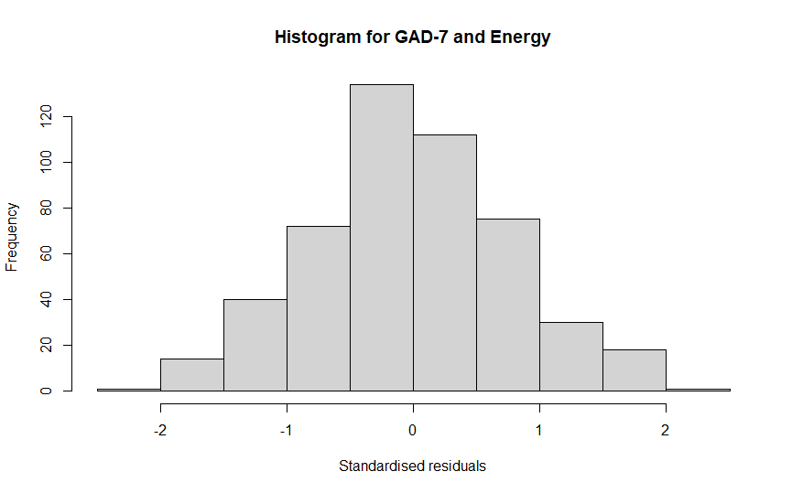
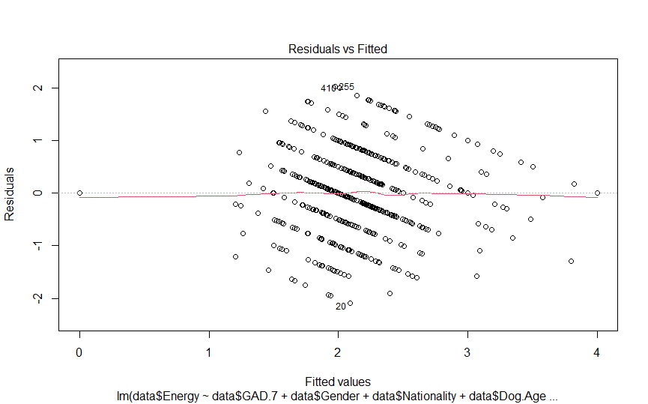
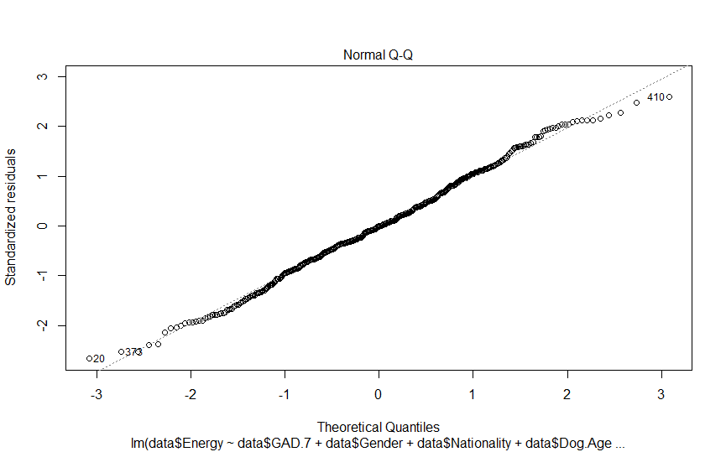
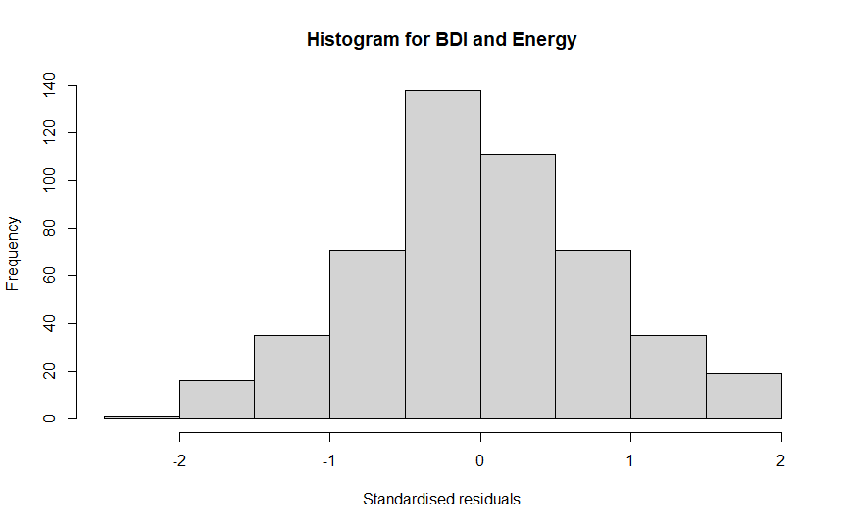
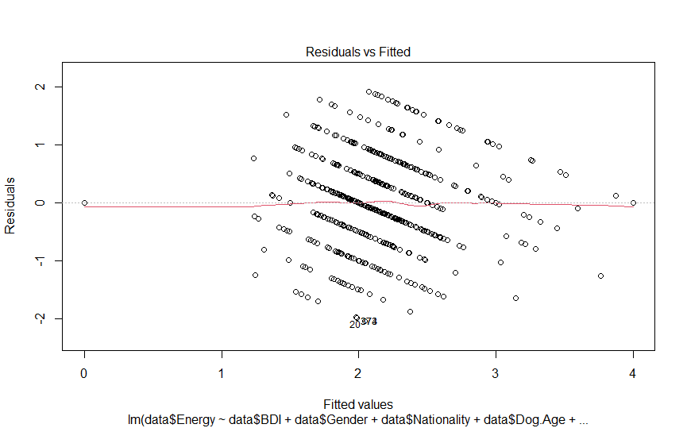
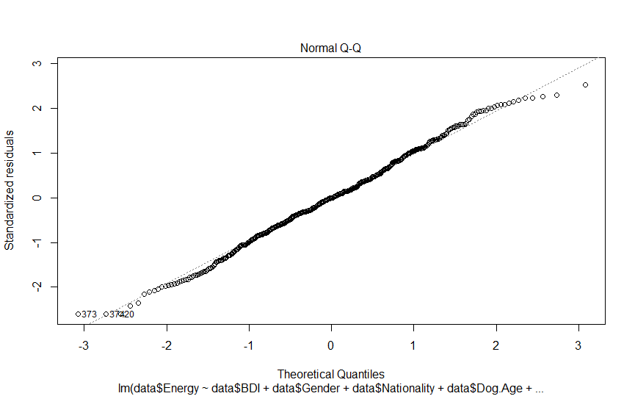
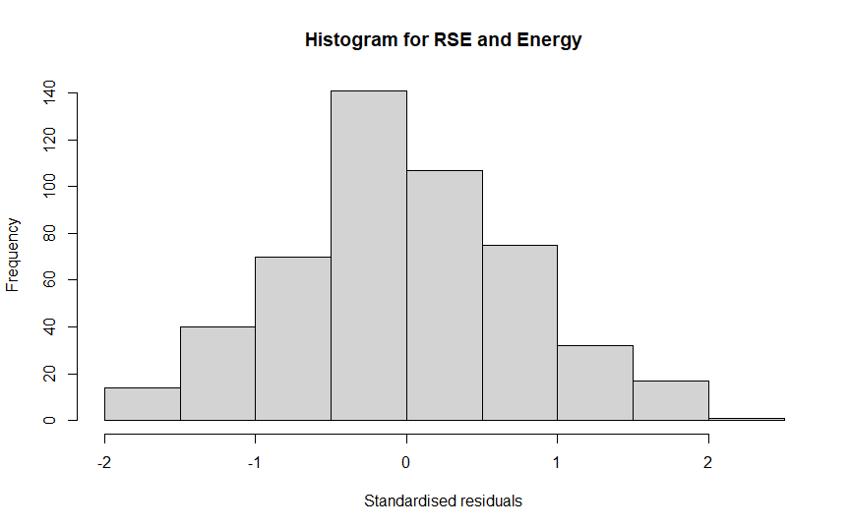
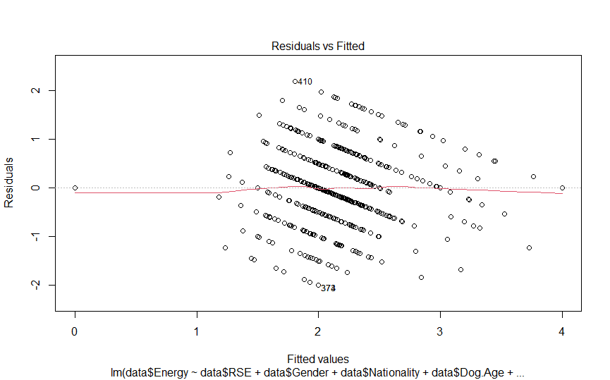
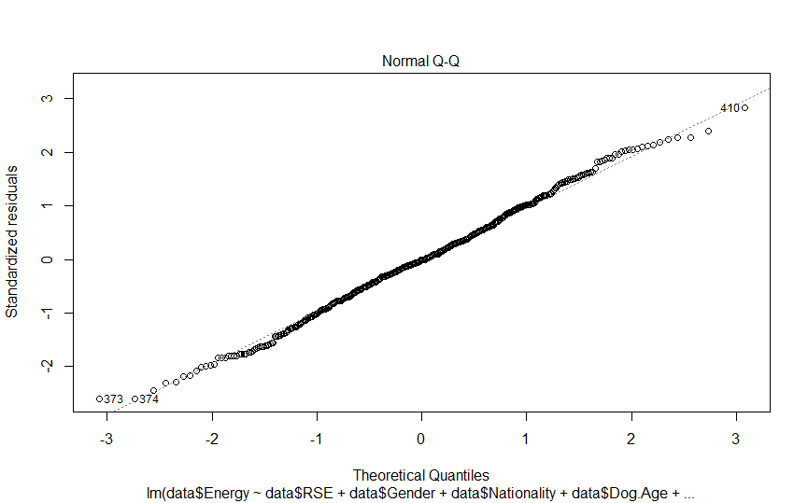

Ethics certificate
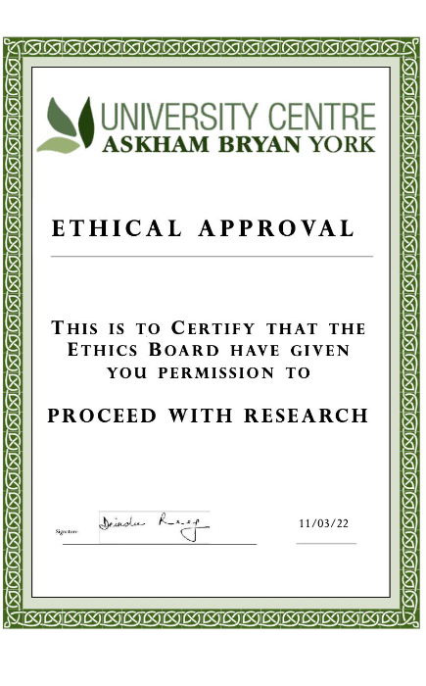

Original qualitative answers extracted from Google Forms
- How would you describe your relationship with your dog? | - To what extent do you think you influence your dog’s behaviour? | - How do you think your dog responds to your emotions?
Communicative, rewarding and peaceful | Significantly | He is certainly very aware of and responsive to my emotions and this is displayed in his body language.
co-dependent, loving, supporting | to an extent, i can see that he can detect my moods | he knows if i'm upset, will comfort me
He is the love of my life | He is too clever for getting too influenced by me | He can feel them
Best friend | Little | Calms down me
Great, she's the family dog but I'm definitely her favourite and I love her. Unfortunatley I can't spend as much time with her as I want because of work and uni but during the pandemic it's been easier to spend time with her. | A lot, I feed her scraps off the table so I'm the reason she begs for food. She's most likely to listen to me/my commands than the other family members. | She knows if I'm feeling sad or down and gives me more cuddles. She's more likely to be excitable if I am too.
I love him, he is part of a family | it influences my mood to significant extend and makes it better | he is strongly responsive to them
She is very important to me. I believe that she trusts me to do the best for her. She makes me very happy. | To a great extent. | She definitely notices changes in my tone of voice.
good, loving | largely | well, she notices if I am upset and comes to cuddle
I love him, he is part of the family | to certain extend yes | strongly because when I am sad he comes to me and tries to make me happy and cuddle
Friends
His registered name is "Better Together" because we are better together. There's no me without him. I owe all of my success to our relationship. He gives me the strength to face the challenges of life and I give him my best in return. I don't know where I would be in life without him by my side. | With 11 years of training and communicating, he anticipates actions based on my body language and knows what to expect in every situation. If I am not around, he does not engage with other members of the household. | He is extremely good at reading me and responding to my emotions. When I am down, he wants to be extra close to me and solicits attention. When I am feeling depressed, he just wants to be near me without asking for anything. When I am excited and energetic, he reflects that energy and wants to play extra hard. He's very attentive.
They are my babies | I don't know, I wind them up sometimes playing with them | One dog is very in tune with my emotions and household members emotions. The other isn't.
I feel I have a very strong relationship with my dog. I think over the past six years that I have had him apart from my children he is the most valuable thing in my life. I live on my own and often he has been the reason I get up in the morning...he is something to care for and has needs only I can fulfill. I feel thankful to have him in my life and appreciate being able to give him a home and a content life.  I talk a lot to my dog and have conversations with him... i think he's like a friend.  Also I need to be well to be able to care for him so he makes more aware to be healthy. | I think I probably influence most of his behaviour although I think he influences mine too so maybe its equal... and thinking about it it's a good job he has the personality and canine needs that i feel i can satisfy for instance i like my own company and sometimes don't want to see anyone or go out very far...well my dog is just as content to sleep all day as he is to do a ten mile walk....i imagine something like a collie or spaniel wouldn't like sleeping all day and would need more stimulation ! | My dog seems to know when I'm feeling sad or anxious and shows this by coming to more and he watches me more too....but equally when I'm feeling happy with a spring in my step he is more happy and energetic.  When we are out on a walk and I'm feeling like chatting to folk or I show signs in my voice that I'm happy to see someone my dog wags his tail and is happy too....but then if we just walk by and don't interact he just passes showing no emotion either.
Loving | Quite a lot | Don’t know.
Great. We do a lot of bonding, play together, lots of training. He’s a pretty happy dog and I’m super proud of him. | I think I influence my dogs behavior a lot. We have spent hundreds of hours doing positive reinforcement training over his life, as well as socialization training. | My dog is sensitive to my emotions. When I’m feeling anxious, he is looking around more at the surroundings. He is more alert, on-edge.
Close knit. I read her pretty well and she’s generally quite responsive to me. | We’re both pretty sensitive. She gets worried if I’m irritated or anxious. | Too much pressure in the environment shuts her down, so she will disengage or show displacement behaviours if people show high emotion around her.
Good | To some degree | At times, he sometimes does not seem to care if I am frustrated as he is 9 months old and tests limits often
He is my heart dog. Great companion and fun competition dog. | Pretty strongly. However, a lot of his temperament and trainablity is genetics. | Moderately and mostly when they have to do with him.
Very good. I adopted her two months ago and she settled in incredibly well to her new home. I spend many hours a day interacting with her, playing and training and we bonded very quickly. | A lot. I feel like just seeing the difference in her behaviour when she is alone with my partner VS with me really goes to show how she could have been a completely different dog with a different "master". | She'll be more calm or more excitable depending on my mood, but not a precise response.
Very close | A little | He stays closer to me when I'm having a hard time. Seems concerned.
Pretty good. He is definitely a “mommas boy” so he generally listens and likes to hang out. | Definitely a good amount. I take note of his behavior and mood, and try to work on techniques to help him relax, settle, etc. he’s always up doing something (adolescent lab brain), so helping give him tools and spaces to help him calm himself.. slow work, but training always is! | He is learning to understand and feed off them. If I get super excited, he’ll become excited, doing spins and butt wags. If I’m mad or upset (especially with him), he immediately knows
Good, I provide him with guidance on how to behave and he is a part of the family. He gets everything a dog could want but he is expected to behave in return. | I think that providing him with socialization to many environment and situations has made him a sound dog. I trained him how I want him to behave in many environments and that absolutely influenced him hugely. | Unless I am yelling he is pretty indifferent.
Loving, family-like, a good relationship | I think I enable bad behavior by not being strict enough and being too lazy and tired to stick with a training routine | She is sorry when I’m mad at her, and is always happy to see me. I don’t notice much of a difference between her behavior when I’m sad or when I’m feeling ok. I don’t think she knows when My depression is worse or better; her behavior is consistent between my good and bad days.
I have had my dog since she was a year old (for about five years). We have a very strong connection and I believe that she was a lot of emotional intelligence. She seems to be able to intuit when I’m not happy, even when I am not showing outward signs. She comforts me by being physically near me and laying parts of her body on top of mine. When I show outward signs of unhappiness, she gets agitated and acts upset or nervous. This sounds silly, but I feel that she has an incredible soul. I have recently (three months ago) adopted another dog, who is boisterous and rambunctious. They get along wonderfully and I love both dogs very much, but I can see even more clearly how emotional my connection is with my first dog in contrast to the bond I have with my second dog. I believe my first dog (about whom I answered this survey) to be a very special dog, and I don’t expect to have the bond I have with her again, even though I know I will have and love many more dogs in my lifetime after she passes. | I worry that I influence her behavior quite a bit—in low periods of my mental health, particularly during periods of incredible stress or anxiety, she has had several flare-ups of GI distress in the middle of the night. When I became medicated to treat my mental health issues, her episodes of stomach upset also improved. I am glad that with the arrival of my second dog, she seems to be less in tune with my low periods and more adjusted and happy overall. She sleeps better now that she plays so much with my second dog. My second dog seems to have diluted my connection between myself and my first dog, which I think is healthier for my first dog, who was already an anxious stray when I adopted her and didn’t benefit from the added pressures of my mental health issues. As a larger and more diverse pack, mood- and personality-wise, we all seem to be doing well. | I think I covered this in my first response: she will lay near or atop me if I am upset or ill, she will be agitated and upset if I am crying, and she will have GI distress when I have insomnia.
Close. We adopted her before Covid and I spent time at home with her before. She likes to be close to me and I feel better when she is nearby. | Very much so. She is dog-aggressive (we have been working on it) and does better when I am calmer. She was even able to meet a neighbors dog on a walk this week and, while she was a bit stressed, she didn’t growl or lunge. I was calm through the entire encounter | Depends on the emotion. She is excited when I am, she is generally happy, but she doesn’t respond to stress or sadness (my father died a few years ago and sometimes I just miss him).
Balanced but very close; we spend a lot of time cuddling, exercising, and training. He goes to daycare & training while I’m at work (playing with other dogs, training, etc). He sleeps with me but is fine being crated if I’m busy. | 80% - my dog looks to me for how to react to any new situation but he still has genetic behaviours (like prey drive, submissiveness to dogs, etc) that I won’t/can’t influence. | He’s very sensitive to emotions & tone. Anxiety when I’m angry, excitement when I’m happy/cheerful, etc
Very close. | When I’m happy, she’s happy. If I’m crying, she tries to make me laugh. When I’m sick, she tones down her normal exuberance. | See above. My girl is very empathetic, not just to me. She tends to modulate her behavior based on the emotions and moods around her, which is why she’s therapy dog trained (note: specific to therapy animals, not service or emotional support animals.) she is retired now because she’s 10.
We have an extremely close bond! | Somewhat. She is great at picking up emotions even when I try to act calm and can sense when I'm fearful, anxious, sad, etc. | Quite well. She cheers me up when I'm sad, she's happy and excited when I'm happy, protective if I'm scared of something/someone.
close | my dog is laid back, like me. | she's responds positively
I still cannot process how much I love him and that it took just a second to fall in love with him. I cannot imagine life without him. He is my baby. | A dog mirrors its owners behaviour. If I am nervous, he will become nervous. I am the leader of the pack and he looks up to me for guidance and reassurance. | He senses them, definitely and will react to them.
New but happy and loving | He maybe senses when I'm nervous or unconfident about a situation. Nog sure though. | No idea.
Good | A lot | Heavily
Happy mostly. Too much barking can be annoying, but corgis like to bark. | At night I am very quiet and he can sense I don’t want him to bark to go out like he does during the day and that keeps him from waking my husband who goes to bed early. | He seems to be calm when we are calm. He did seem to want to comfort my son when he cried. He barks if we act excited.
Symbiotic, she gets to have some good pets and walks and I get a happy face in the morning, snuggles and a good reason to be more active. | Training has helped improve her default behaviors, but anxiety-state behaviors do take a long time to improve on if they ever can be helped. I’d say 70% nurture (influencable) and 30% nature. | To a great extent. If I have any sort of frustration, it is met with with nervous behavior from my dog. Only calm interaction is fruitful with a naturally anxious dog. I don’t know how the dog reacts to sadness etc., I have seen no recognition of this sort of emotion from her yet during 1 year.
She’s the center of my universe, but sometimes I wish I could ask her what she wants to do. She can be a little fickle about going for long walks and doing normal “dog” things. But at the same time, I want to make sure she’s fulfilled and isn’t just a couch potato. Sometimes I feel like I’m disappointing her by not pushing her to be more active. | When I’m anxious, she’s anxious. When I’m relaxed, she’s relaxed. It’s become very important to me to always be aware of my stress levels and control myself when I want to throw a tantrum. Whatever is bothering me isn’t worth sending her into a state of anxiety. | She responds immediately. If I’m experiencing something negative, I can see the stress come over her. Alternatively, when I’m in a good mood and singing or dancing, she’s right there next to me, enjoying the moment. I also respond very actively to her emotions. When I see her entering a stressful situation (unfamiliar area or new people), I try to remain calm to make sure she knows she’s safe.
Strong | Mildly | She is sensitive to my emotions
It is a good relationship and bond. He is my walking buddy and enjoys the sunshine with me. He has taught me patience and brings me joy every day. I think he is pretty happy too. | I bring a little too much positive energy sometimes and it gets him overly excited. | He’s pretty happy go lucky like me.
Overall very strong and positive. I treat him as a companion and have tried to use as much positive reinforcement training as possible. Corrections are done by redirecting his attention, I never physical punishment. He is rather high-energy and easily distracted by new things, and has a bit of reactivity when in and around the home, but learns quickly and is incredibly smart. We train and compete in agility, which is an incredibly rewarding experience for us both. | I think I influence his behavior a good deal. With my direction and cues, he is more likely to behave well, show restraint, and settle down than if left to his own devices. He is a smart dog and will entertain himself if he is bored or ignored for too long. | For the most part, he doesn't respond to my emotions very much. If I'm happy or excited, he does tend to get more energetic, but doesn't seem to respond to any of my negative emotions.
We’re partners. We compete in several dog sports and I feel like we can read each other well and we make a great team | I can be anxious and controlling at times, when I’m stressed she can certainly pick up on it. At times it has likely had a negative influence on her so I make a conscious effort to not let it affect her | She feeds off my happiness and excitement, gives me space when I’m stressed
My best friend | To a great extent | She is very responsive
My relationship with my dog is about as close to perfect as I think a relationship with a dog can be, mostly because my dog is exceptionally merry, even-tempered and easy. He gets along with people of all ages but doesn't pester them. Ditto for other dogs and for the cat. He settles nicely at home but is also an energetic and enthusiastic companion on walks/hikes/runs. Having grown up in the middle of a densely populated city, he is unfazed by sirens, jackhammers, crowds, and so on. In fact, pre-COVID, if there was a parade, protest, marching band practice or similar, he'd try to steer us toward it, like "Let's go check that out." My dog has none of the gnarly problems I see described on r/dogs. If I could change anything about him, it'd be his occasional attempts to take off after bunnies. Seriously, that's it; can't think of anything else. | Hmm. Honestly, on the nature-nurture kind of thing, I lean nature. A breed that's biddable, generally calm, and a dog from a good line go a long way. I think that my major "influence" on my dog's behavior consisted of careful, gentle work during the early socialization window, when he was a wee pup. Day to day, now, I honestly don't know to what extent I influence my behavior, as my behavior is pretty consistent day to day. | My dog certainly responds to obviously expressed joy or excitement by mirroring and participating. Not sure about strong "negative" emotions, as I don't have those very often and, when I do, I try not to interact with my pets. Also, I don't think it's accurate to describe a dog as responding to a person's emotions. Dogs respond to the way people express their emotions, not to the emotions themselves.
My dog is still a baby that's why he has some behavioral problems. We're still training him and I have faith that he will become better. Still, he's very goofy and fun to be with most of the time, that's why he helps me a lot in coping with everything that's happening. When I see him, all my worries go away :) |  | He is sensitive but i dont like his biting problems. When my boyfriend and i fight, he always would want to mediate
exciting, strong | moderately | positively
good | significant | positively
We are on the same wavelength. We are in sync. We just "get" each other. We are very close. We understand each other well. We are both communicators and we communicate well together. We are "in it together". There is a lot of mutual trust between us. We pick up on each other's cues. We enjoy each other's company. We go on adventures together. We discover new things together. We explore and meet people together. We are very, very bonded. There is a lot of trust between us. We enjoy each other and we have fun together. We have a very affectionate relationship with lots of physical touch, pets, massages neck rubs, ear scritches. We can count on each other. We can anticipate each other's next move. We can share down time just hanging out around the house together but also both enjoy going out to cafes, meeting new people, taking trips to wilderness parks, beaches or visiting friends and family. We support and encourage one another but we also love to socalize and share that joy and fun and love!  In some ways we are very similar--we are both confident, extroverted, sociable and curious about the world, we both enjoy novelty, new discoveries and new opportunities; we are both adaptable and flexible and can adjust to change quickly; we are both fairly self-assured deep-down and although we love company we have a degree of independence; and in others we are quite different --my dog is much calmer than I am whereas I tend to be more energetic and frenetic and expressive; my dog is more of a sleepy couch potato at home than I am; my dog tends to be very placid, very even-tempered and fairly bombproof and unflappable, whereas I can be a bit more moody, changeable and prone to anxiety under stress.  My dog is the perfect match for my lifestyle and personality and he is the perfect match for me. I get so much pleasure from petting him, watching him learn and grow and discover, seeing him take joy in his toys or digging a hole or getting a pat from a stranger. I know he is incredibly attached to me but he is not a 'one person' dog; he adores all people, including children, and loves having visitors, spending time with my partner or meeting strangers. He's not jealous or possessive, he feels safe with me and knows I'm there for him and vice versa. He's a source of stability for me and the relationship has been really nurturing and transforming for both of us. | My dog was already very well-trained, calm, confident and friendly when I got him. So I don't think I am the main influence on his behavior; I think most of this is his temperament. However, I do think that I've given him a lot of opportunities to express and engage his positive traits because I've exposed him to lots of wonderful new people, places and things (beach, boat, nature trail, camping, snow, dog-friendly cafes and restaurants or breweries) that he adores and which have helped build and consolidate his confidence and reward his curiosity. I am also very, very in tune with my dog's signals and cues and take them into account. I would say that one area in which I have influenced his behaviour is in adjusting to "life off the track" as a greyhound and that I've done this by being a very calm, reassuring presence who responds thoughtfully to any fears he shows. He used to be very startled by loud noises (his foster thinks this is because he saw and heard other dogs being shot when they were put down) but after a few months of me saying calmly "that's okay, it's just the door banging" he has learned not to be bothered by them. He has only had one true fear and that was stairs inside and he got over that in a few months too. I would say this was a matter of gaining trust and confidence, not training. He is also very praise-driven and loves my approval so he has been very easy to train and listens to me quickly. It only takes a quiet "uh-uh" for him to stop doing something. Even some instinctual things like wanting to chase birds or lunging if a cat is right in front of him have calmed right down until he can ignore these situations (but I still wouldn't trust him in a room with a running cat obviously!) The main way I've influenced him is just by communicating kindly and clearly about what's expected and I've never even raised my voice to him as he is a very sensitive and biddable dog who wants to please. However, even though I did a lot of recall training with him, this is one area where I think I've only had partial success and if something he sees is interesting enough to him he still won't come when called (although he will stop if I say 'wait'). He has a HUGE amount of trust in me and even when severely injured let me handle him and take him to a vet, wagging his tail as I patted him, although in extreme pain. So while we influence each other and I have had an impact on him, I also think I chose a dog that had the right characterisics to succeed and thrive in my home and he really has! | My dog picks up my emotions towards him and his behavior very quickly and reacts accordingly. He once picked up a chicken bone on the street and I forgot to use the "drop it" command and just said "oh no" in a scared, stressed voice and so he just immediately dropped it anyway. He knows when I am "serious" about something (a command or instruction or situation) from my voice and mannerisms, compared with when I am making a suggestion or encouraging something. I would say he is happier when I am happy. He can also be very flexible and adaptable and accepting if I am, say, physically tired or sick. He seems to notice and get that. On the other hand if I am upset about something that has nothing to do with him, like with a boyfriend or family situation and quietly cry, he ignores this; he doesn't know to comfort me or anything. He's attuned to my emotions in relation to him and the world but not overly bothered if I'm having a quiet mood; he just leaves me to it. He generally dislikes too much loudness or expressiveness so will sometimes sigh and leave the room if I am talking too loudly on the phone. If I were really agitated or really low, this would impact on him. If I have a really depressed day and want to hang around in bed he will adjust to this for a while but whine and get me up; he seems to notice it's not usual and need to intervene (to get his walks and pats!) If I got quite withdrawn or non-communicative, I think he would cope really poorly. However, he is quite secure and independent and can have a good time even if I'm not the one driving it. He's different around me when I have my boyfriend or visitors over. He LOVES visitors and will lavish attention on them and even change where he sleeps and what time he wakes to get more company and fun with them. He's very socially driven and communication-oriented. He has never seen me properly angry and I think if he did it would really scare him.
excellent, he takes care of me and I him. He is my buddy | He has a very independent personality, so not much | he definitely gets excited when I am happy about something, but other than that I don't think he recognizes if I am sad, like when watching a sad tv show.
Sensitive. I know what she's going to do before she does. | I'm very confident around animals in general, being quiet and serene and matter of fact helps too. No drama. | As above, My dog and (other non human ) pets respond with behaviours, that reflect the owners personality and emotional response to situations.
We get along well and have a good partnership. We play, train, and go out to do fun things together, but he is very much his own dog in the sense that he is independent. He likes me, but he doesn't need me! | My actions - a lot since I do a lot of engagement work and training with him and constantly reinforce him for good behavior. | I don't think he cares or picks up on it much? He seems pretty neutral.
good | significant | positively
We have a good relationship, she’s very focused on me when we’re doing something but is happy to fluff off on her when we’re home or at the park. | We’re very calm about things in the world, she’s picked up on that and is very confident. | She picks up on excitement, but she’s not particularly concerned if I’m seeming sad. She just does her own thing, or might try and get me to go out for a walk. I don’t think she’s seen me scared, but I suspect she might be defensive.
She's my heart | Alot, she's a well trained dog and I really try my best to help her make good choices though my moods change everything, she knows when I don't have the energy to do what she needs and she will push boundaries | She knows when I need space and will leave me alone
great | to a large extent | greatly understands
Excellent. We are each others best friend. He lights up my day . | Quite a bit but also influenced by other members of the family. | He can feel my emotions and responds accordingly. Quiet and calm if I'm sad , very cuddly and excitable and running around big I'm happy or excited
we are not very affectionate. give each other space but love doing things together | more than I thought before his survey | very much
Close. She is one of my closest friends. | Very little. She has a mind of her own. | She senses when there are problems.
Friendly relationship | Moderately | They recognised facial cues to determine if a person is happy or angry
Close, love him, around each other a lot, would be lost without him | A lot because loudness causes him to shadow-chase | He comforts me
He's like my child rather than my best friend. My partner would describe him as his best friend. I take a lot of time to care for him and make sure he has a good, balanced, happy life. He can be hard work, but I wouldn't change him for the world. | I think when I'm angry or busy he picks up on that and finds it harder to settle or calm himself down. He is an extension of us so if we're in a bad place, he is off kilter too. | Strongly.
Brilliant. We enjoy lots of time together. We have a close relationship with mutual respect, he prefers to be with me but I do not feel he is overly dependant on me. I feel we communicate well with each other, have lots to give each other and generally are a cracking duo  I expect him to be well behaved and generally he is. He is not perfect all the time which I think shows he is able to show his individual character | I think I have a great influence on his behaviour. I think I am a calm and very positive person and he is a bright and balanced dog, mostly calm but can be energetic and excitable. I have invested a lot of time training him as a puppy which has benefitted both of us. It has given him confidence and plenty of stimulation which has avoided any challenging behaviours. I have taken him gundog training regularly which has helped him learn calmness and self control, respecting boundaries. It helps to keep us both mentally and physically fit and has enabled us to develop good communication together. | He is very responsive to emotions. When I am calm and relaxed so is he. If I am worried about something he sits closer to me. If I get anxious about something then he is more unsettled for example approaching a style on a footpath with no dog access, I start to worry about getting him across safely & he will start running about & jumping up at me before we reach the obstacle.  He dislikes raised voices if we humans have a debate about something and will exit to another room or head into his crate. This includes commentary on TV relating to sporting events
Very important to me. She is why I get up in the mornings and the only constant in my life really. She it trained to help with my anxiety and depression is an amazing help. | A little. When she is anxious I am the one to calm her but because she is trained to help me with my anxiety me being anxious does not effect her too much if at all. | When we first got her yes and now she does not respond emotionally but as she is trained to
We have a good bond, she's my sisters dog and only moved in 2 or so years ago but shes attached with me and wants to be with me often as im her caretaker (feeding her, sleeping with her, giving her daily excersize and loving her) | I think I somewhat influence her behavior, shes an adult dog and has already figured out her personality and how she wants to feel in certain situations but she gets hyped up when i'm hyped up, and she gets tired when im lazy. | When I'm sad or having anxiety attacks, she comforts me. (I have been training her for ESA but before training started she would come cuddle up with me if she noticed me crying)
Loving, part of my family | Sometimes | Knows when I am sad
We have a good bond. He can tell when I'm sad and I can tell when he doesn't want to be bothered | My laziness & lack of motivation has led to my dog sleeping on my bed with me more often than usual. | Okay. I think he's able to sometimes understand if I'm having a bad day.
Very positive - we both rely on each other so much and we enjoy spending time together. She is very attached to me - she howls when she hears my car coming home, but she doesn't suffer separation anxiety or get stressed when I'm not home. | I think I reinforce some bad behaviour at times - letting her jump up at me, letting her lick me - which visitors to my house sometimes don't like but she has the habit of doing these things because I let her. She is more likely to respond to me when I tell her to sit than someone else she is less familiar with. | She definitely responds to me when I'm happy, excited, like when we're about to go for a run together and she notices that I'm energetic and she responds to that. If I am quiet or maybe feeing sad, or working from home, she will come and sit right next to me, sometimes on my lap, and try to lick my face.
quite good | I think that dogs reflect our emotions, whenever I am engaging in activities with my dog I make sure to be calm and centered and if I can't I take a break | if I am on edge and anxious she will be too as she looks to me for guidance
 | Greatly. I know she is anxious and nervous because I am. She feeds off my energy. She is very needy and wants my full attention always. She is scared of being left behind always follows me and stays close by me. If she can’t see me she will come looking right away.She won’t sleep unless I do or I stay in the same room as her. If I go to another room while she sleeps, she will wake up within 10-15 minutes & come find me. | She is sensitive to how I’m feeling. I believe she is anxious and nervous because she feeds off my energy. She mirrors my emotions
Loving | We both like cuddles and chill out time | She notices and comes for cuddles
Great helpful | My mood | Effectively
We are very close and she trusts me 100% because I rescued her a deaf dog that was abused and she loves her life now more than ever. She just loves being a therapy dog in a hospital and is a natural at that job. | I'm her whole life and we both are very connected. | She knows me like I know her, both have respect and love each other.
We are a team that respects each other. We find joy in going out and about to a park, store or event. We find joy spendingtime alone at home relaxing | I am proud of the dog I raised and trained. With that pride she is able to be a confident well behaved dog | At times when I need a good cuddle, she is right there. And the times I when I celebrate with a good walk or playtime, she is happy to join in.
We are very close. I have done all of his training for Canine Good Citizen, advanced, & urban as well as therapy dog. I only use positive training so he trusts me implicitly and prefers to be with me to anyone else. He is a very confident, but calm dog & is one of my heart dogs. | He watches me to see if I am asking him to do something. If I give him permission to approach someone, or tell him it is okay if a delivery person is in the drive, he responds appropriately. He will take hand commands from across the yard or across a room. I am a calm person and so he is a pretty chill dog. I have to be careful if I do not like someone as he seems to pick that up and also will not approach or be friendly to someone I like. | He is very in tune to me. If I am watching a sad show and my breathing changes, he will move quickly from across the room to see if there is something wrong by putting his nose by mine and inhaling my breath. This is something he does with many people, almost like he can smell a hormone change or something. If I am upset, he gets very agitate, running about as if to discover why (this has only happened a few times). If I am ill, he is very gentle and attentive. I do not get angry often, but if I do and the person who is involved is nearby, I have to control him by voice or leash.
We are a close team. He's my buddy. | He's well trained and responsive to gentle corrections & encouragement. Simply clearing my throat will remind him of what he's been trained to do, or NOT do. | He'll approach and make physical contact when I'm upset. Conversely, knows tone of voice or laughter that indicates happiness & time to play outside.
I have a wonderful relationship with my dog. We trained together to be a therapy pet team with Pet Partners. We also trained for agility and other fun classes. Those classes really build bonds | With my dog, treats are the biggest motivator. So, if I have treats, he’s paying attention to me on a higher level. | Sometimes he pays attention, and other times he doesn’t.
Very good, I am the primary handler and he respects me and listens to me. However, he prefers my husband. He is more excited to see him and when given the choice he is more likely to want to snuggle with him. | I think of I'm anxious it makes him anxious. | He definitely feeds off other people's emotions.
Awesome ... Fun . rewarding | He is me. Happy energetic rests when needed . loves to please people | Well.. He reads me well
Bonded. | Much of the time. | Very intuitive.
My dog is my constant companion. She works with me most days and we spend the majority of time together. We enjoy engaging in activities together and she has transformed my life. | I think the connection between dogs and their humans is strong and that they look to us for guidance and direction. If I percieve something as fearful, my dog likely also finds that experience to be something to fear. I also influenece how she behaves by ongoing training and expectation setting of behaviors in certain environments. | She is insightful and follows the lead of my emotions. She reacts to not only my emotions but the emotions of an other. My dog often reads a group therapy room and will slide in next to a client who in that moment needs her the most.
Good we share a bond but he prefers my husband as I believe he feels more secure with him | I think I make him weary at times, if for example I'm having a very bad day I feel he seems to be anxious despite never raising my voice at him or doing anything that might upset him I think he just picks up my anxiety. | He becomes more anxious, lip licking yawning etc
We are friends and family. I think we are both worriers so feed off each other's emotions at times. We have a mutual respect and trust, as well as love. | I definitely think my introvert character can influence my dog's behaviour. However she has it in her nature to be wary of strangers. | I don't think she's as in tune with my emotions as some dogs can be with their owners, but there is certainly some response to my stress and worry.
Positive | Somewhat | Usually positively
generally good | greatly | his reactivity definitely worsens when I am feeling bad
complicated | Difficult to know as I've only owned her a year but her separation anxiety is worse with me leaving the house than my parents but I am her primary carer.  My previous dog had no anxieties. | Hard to comprehend when she's very different to my previous dog.
Really good 75%of the time | I’m not sure, sometimes but other times not at all | Well to some but not enough to others
she is my friend but I am in charge of what she does | I make her behave in the way I want her to eg not barking, coming when she is called etc | Not sure , she is a very self centred dog!
He is family. | I don't know. | He comes up for cuddles if I cry and he will sit at my feet and lean against my legs if I'm particularly anxious. If I'm happy he has zoomies and wants to play.
Total love on both sides | Quite a bit, often negatively | He worries when things are bad
I dont feel my dog likes me. | I dont think i do. My dog does what he does to get what he wants in terms of food etc | He doesnt.
We are very close |  | He's quite in tune with me, when I'm panicky or anxious he always sits close and leans onto me.
We have a relationship based on love and trust. I adore him. | Hugely. I have invested hours in training him. He is an intelligent working breed with boundless energy and enthusiasm. Training has provided a focus and outlet for that energy and has helped him learn impulse control, which was completely lacking when he was a pup. | I think he is sensitive to them most of the time, he responds negatively to negative emotions and positively to positive ones. He gets upset at raised voices. If we are laughing he wants to be part of the fun. He's not particularly tuned into subtle emotions. He doesn't notice if I'm feeling a bit fed up for example.
Most of the time very good | Probably quite a lot | Negatively
Loving, respectful, happy | Probably a great deal more than I realize | Comforts me when I need it as after knee surgery
Close, I like to be with her as much as I can | Sometimes she picks up on my anxiety & will be more reactive when out | She is very good at picking up on how I'm feeling & becomes more attention seeking & affectionate
Wonderful!! She is my furry baby. ;-) She is certainly "my" dog. My husband says she will lay in my daughter's bed with the view of the driveway until I come home when I am gone, even though he works from home currently . And she waits until I go to bed so she can sleep with me. (does not sleep with my hubby if I am gone for an overnight; will go to one of the kids instead). She is my cuddle buddy when I sit on the couch. She is also a trained therapy dog; I take her to school with me once a week. | It is a symbiotic thing partly; I feel calmer and happier when she is around and vice versa which I believe helps her feel that way as well. She always seemed to have a sweet calm nature though. We got her when she was 2 months old; she was the runt of 11 litter mates. I was a stay at home mom for the first 5 years of her life, so she quite naturally become very attached to me and I with her. I hypothesize sometimes if being the runt and then being with a human mom at home most of the time helped to really develop that sweet, calmness. The 2 year old rottie we also have now, we got when she was closer to 5 months old, she was raised out in a barn rather than in a house, and was the oldest female of her litter. Their personalities seem very different, though both are loving, smart, loyal dogs. The nature/nurture thing... My dog already had a sweet, calm temperament and we were able to help that blossom even more with how/where we raised her and still treat her. | She has never liked when we play fight/wrestle with the kids; she wants to be by me then. She seems to notice those who are not feeling well and wants to be by them; we call her our feel good dog or comfort dog--a big part of why I thought she would be such a good therapy dog and had her certified for it. She does not like it when my husband raises his voice when discipling the children; again, she wants to be my me. Freyja is her name. She is my napping buddy; she is always happy to relax and chill with me. I really don't know if she responds to my emotions and wants to cheer me up when tense or sad, share in my happiness with me, etc or if she just wants to be with me no matter what!
Good. She gives me something else to think about. I would be worse without her. | Quite a lot - I have had to learn to be less panicky in unexpected situations | Picks up on my emotions. Panics if I do, is very clingy hen I am sad.
Friends | Quite heavily | I don't think she is particularly sensitive to them; she is tuned in to my behaviour, anything that might predict that she is about to be involved in - but I haven't noticed her behaving according to my mood.
close | i live with my parents who share in caring for my dog so I am not the primary caregiver. I think he is not that affected by my limitations but before I came to live back home with my parents he definitely was affected for the worse. It might be good to place a question in the survey about whether the dog owner lives alone or with other humans that the dog might be influenced by. | My emotions are mostly self contained so I don’t think he picks up on them really.
Sisters | A little | A little
Good | None | Stays close by when I feel low
We are a team | Not very much-she is a naturally chilled breed | She is generally pretty laid back
Very close | I dont know | She licks my face if i am crying or sick
Very close. If I’m sitting she is right in my lap | A lot, she acts a lot like me | She gets worried, more anxious and stays extra close
We have a rather solid partnership, we spend most time together and comunicate clearly with eachother | To some degree, when i'm having a panic attack or more ansious, she will shut down a bit and react less to things around her | When i'm more ansious, my dog gets worried and even afraid of me
very close | I don't influence my dogs behaviour | very caring towards me
Well connected | Very much | Not sure. Im usually pretty stable and happy and the dogs are too.
happy conforting | she is responsive to my moods | knows when a cuddle is needed
Like best friends | I do | Very much. He either gets scared when I have panic attacks or comes close to me to help me feel safe and at ease.
Perfect | Always | Happy when I’m happy
Very close. She keeps me stable and stops me from killing myself and self-harming. She sleeps on my bed and loves cuddles. | I think I do influence her behaviour, especially as she’s a rescue who had no training before she came to me. I’m trying to train her to be a good dog. | When I’m anxious she’s more barky and jumpy and when I’m low she seems more subdued. When I’m crying she jumps up and licks my tears and sits on my feet if I’m having a panic attack.
strong but undemanding. comfortable | somewhat when inadvertent; a lot when purposeful as in when training. | I think my emotions affect her at least somewhat, probably more than somewhat. I think this is true for dogs in general.
My dog is like my best friend | Partly | He understands my emotions, can tell when I am unhappy or need comforting by staying close
Bonded, loving, mutual | I feel I am a positive influence, loving and using positive correction if needed for behavior | Very attentive if I am sad, happy when I am happy. I feel my dog wants me to be calm and happy
He is my constant companion. I provide him with love and he provides me with consistency. | My moods, my daily activity, my commands all play a very influential part in my dog's daily life. | He is not quite a sponge. He knows when I need him close and he responds by sitting or lying with me. He helps me realize that I am being overly emotional, sad or self indulgent. He is never judgmental.
She is basically the only real frien i have and often I feel I behave so unfair towards her. She tries her best. But she has some issues we are battling slower than I like and this makes me frustrated | Not sure. See previous. I tend to be not patient enough and want everything now, right now. When it fails, I get frustrated and tend to want to much from her, amounts she can't bear | Fawning a lot. Trying to be the best until the moment she shuts down. With positive ones, well, positively
He feels like a loved family member. I centre a lot of my day to day life around him, more than I would had lockdown not happened. | He's only a puppy so he still needs a lot of input. He's worried in new situations so I do take on quite a protective and calming role, and I plan a lot of experiences for him so he can gradually desensitize to thinks but not become overwhelmed....I hope! | He definitely picks up on people's energy levels, seems to know when people are unwell. People shouting angrily really upsets him. He definitely picks up on emotions in tone of voice.
Good, possible too attached. | Some influence | I think my dog is more anxious when I am more anxious and is excited when I am. I do not feel my dog is any more lethargic if I am.
She and I are very close, and provide each other with a sense of comfort. She’s the reason I go outside and get any exercise at all, and I’m the reason she’s in the states. We rescued each other. | She’s more protective of me than my neurotypical partner, and she keeps an eye out for my episodes and kinda keeps me as normal as I can be. | She’s still learning to read people and respond to things like tone of voice due to her past. As a result she picks up more of my behaviors than my feelings.
Warm bond, loving, trusting | A lot, although he isn’t as obedient as I would like him to be when he is distracted by other dogs | I think he is on edge when I am and when I am relaxed he picks up on that
Loving, positive, caring | To a certain degree. When walking on lead she tends to walk better with me than with other members of my household | She's very intuitive. If there's someone I'm not sure of she becomes more wary
He is my friend and I love him. I feel responsible for him and I want to protect him. It is a bit like having a third child. I want him to be happy and I want to do the right thing by him (training, exercising him, socialising him etc). | To an extent: he is a young terrier mix (mongrel) and is very excitable and energetic. He wants to chase and dig and is not always easy to train (all terrier behaviour features which I think we haven’t particularly influenced). However we are quite a calm family I think and I think the dog is definitely becoming calmer (though that could just be as he gets older). We have tried to be consistent and I think it’s having a positive effect on him (he is making slow but solid progress in his training). He is much loved and I think, in turn, he loves us. | When the children are sad he tries to cheer them up. If anyone is crying he will jump on them and try to lick them. It could be that he is just reacting to an interesting or different human noise that he doesn’t hear often (a child crying) but it is hard not to interpret it as him trying to cheer us up! He definitely gets excited when the family are happy and energetic!
Close, but i am not his favourite (dad is), he listens to me a bit less | A large extent; i believe i make him nervous because i sometimes lean on him for comfort and support | He's intuitive; will watch me closely, sometimes sits with me when i am sad
Very close and loving. She depends on me and is bonded to me. I’ve had her almost her entire life and she will be 13 later this year. | Quite a bit. I know she picks up on my emotions. I’ve always referred to her as my “magic dog”. | It depends on the emotion. She responds in kind.
Strong bond, trusting and loving | When I struggle, he gets less than all of me. He is an introvert while I am an extrovert. He appreciates that hos big sister, a Pyr gets all of the attention. He is a bit of a mama's boy. | He senses anxiety and physical pain that I have but not negatively.
We are pals. He looks to me for food, comfort , security, fun etc; I look to him for comfort, love , to be calmed, to take me out of myself. We are close. He reads my moods and I can usually tell if he is off. | Well he has a wild streak so,times, but generally he behaves as I want him/ trained him. | Very much so. If I am upset, he will come rest his head on me, if I am irritable he will tend to avoid me, if I am laughing he will take that as a sign to play. He is empathetic with several family members and our other dog. He is the best medicine.
I see it as my job to give him everything he needs, and to make his life as good as it can possibly be for him. I get a lot of pleasure from just watching him sleep or go for a good walk when he’s had a tough life before we got him. | Not very much. He is quite set in his ways as he was already 10 when we adopted him. | He is calm when we are calm and I think he takes cues from us when things are to be excited about or when it’s time to relax. I don’t think how I’m feeling mentally really has much of an impact on him though.
Very good. A lot of trust and love for each other. | I don't think she's personally influenced by my emotions. | She doesn't really react to any emotions. The only time I notice her actively reacting is when I'm overly happy and energetic, that's when she  comes to join me to play and cuddle. When I'm really depressed or crying she doesn't really seem to care.
Still developing | I worry my anxiety as a first time owner has rubbed off on her | Think she is less relaxed because I am on edge
My dog is a rescue and very undemanding. She doesn’t ‘play’, she doesn’t seem to expect much. She is undemonstrative but I know she loves me the most - however she’s happy to be left alone too. I think this is conditioning and her personality combined - she’s extremely calm/placid so you need to work to understand her. | She’s stubborn and has a mind of her own - again, personality and conditioning from whatever happened before we got her. So whilst she’s quite trainable - she’s food oriented - she’s also quite capable of just pleasing herself when she wants to. But equally I know I don’t give her as much focus as I ought to, and if I did she might be different. | When I am sad she is sad, definitely. If I am low and don’t want to walk her or interact with her as much as I should she seems depressed and listless. A more demanding dog might demand more walks but she accepts her lot in life - and that makes me feel guilty!
Very strong, close bond. Lot of mimicking and copying behaviors. We do lots of activities like scent work and trick training together, and our bond is very close because of that. I pick up on her signals very well, and I am able to read her body language very clearly. | I think my mood influences her a lot. For example, if we’re out walking and I am feeling anxious she will stick closer, if I am feeling irritated she will often respond to me less, probably because I don’t give as many cues rewards etc. I try to minimise my emotions around her because they can make her anxious at times as she picks up on them so well. | She shows visible signs of trying to comfort. She will respond differently to different emotions. If I cry, she will like my face and sit on my lap. If I am irritated (seldom at her) she will sit near me.
I am her boss and she listens to me. She likes me being around and loves to cuddle. Thus, the relationship boss-dog is clear. | To some extent | When I am afraid then she responds the most "active"
She is my absolute best friend, with unconditional love between the two of us. There for each other through darkest of times. | She knows when I am sad. | When I am sad or struggling she will not leave my side, even to eat or sleep. I have to take her to her bowl to sit with her whilst she eats. Otherwise she just wants to sit with me until she somehow knows I am ok again.
Very close | She has become much more calm and confident while she has been living with us. When she first came to live with us I was very anxious and depressed and she was anxious and scared. | She will come to me if I am upset.  She is sensitive to shouting and will hide if the children are shouting in anger or if they argue.
My dog is my best friend and I am her favourite person | Dog always lies touching me and pouts whenever I move to do something | Dog is very happy when she is having one to one attention. She particularly likes it when I take her out for a walk and leave other dog at home. She settles very quickly at home when I am able to sit with her. She is unsettled until I am able to sit down and relax. If I am annoyed with husband or kids the dog prefers to retreat to her bed. When I am happy and relaxed dog is happy and relaxed. When I cry dog is very concerned, unsettled and brings me toys to play.
Very close and bonded | I have suffered depression on and off for about ten years. I don’t tend to notice the dogs behaviour changes until I am starting to feel well. She definitely does get ‘down’ when I am feeling low. Similarly, she is happy and light when I am well | She gets anxious if i am upset and tries to comfort me with affection. She is excitable when I am in company and good spirits. Is lethargic when I am, she tends to mirror me
Very close -best friends | If I ever feel nervous or anxious, my dog begins pacing or crying or tries to snuggle in to me. | He takes his cues from my emotions.
Attached but strained. I got her to fill a hole from my previous dog who is now deceased. I love her but I often feel more irritated with her behavior than I probably should because I find myself comparing her to the previous dog. Plus my health is not what is way so I am too tired to invest in her training as I did the previous dog. | I'm sure alot | It depends. If I am hurt or sad, she is overly tactile to jumping on me and licking crazy. When I am angry (especially at her) she becomes incredibly aggressive.
We spend most of our time together. I would say it's very strong. I do her grooming, cleaning, and health checks and most of her walks while my partner does the rest. She looks up to me more like a parental figure but my partner more so like a fun uncle (if this makes sense) | Although I'm not sure if actually see any behavioural signs from her, but I'm pretty sure she can sense my mood and tends to personify it. | Can tell if it's a good or bad emotion but she doesn't know how to respond or what exactly it is (broadly happy sad anxious etc)
I love all my dogs. They help me overcome stress and depression. Can't live without them. | They sleep when I sleep. They love to cuddle, other than that never really thought about it. I am older and they are too. | one dog gives me hugs on request but frequently he asks for hugs
My dog is like a son to me. | I think my emotional state has a heavy influence on my dog’s behavior. | My dog mirrors my emotions frequently, especially when I am feeling anxiety.
My dog is like a son to me. | I think my emotional state has a heavy influence on my dog’s behavior. | My dog mirrors my emotions frequently, especially when I am feeling anxiety.
Good- I love her to bits! | Interesting- I’m not sure. But I do know that I can tell if a dog is going to be nice or bark a lot by looking at the owner! If owner smiles- the dog is nice! | I’m not sure. I mean I do believe that emotions go “down the lead”,but I am mostly positive and happy!
close | a lot | strongly
Very bonded | Don’t think I do | Don’t think he does
Very close, always together and sensitive to each other’s needs/moods | I think my moods affect my behaviour, he picks up on the changes and changes his behaviour as well | He definitely picks up when I am anxious and becomes more anxious himself
She is a cracker - obedient, loving, respectful. We play a lot of games. She dotes on me (she is a collie and very pack-focused, so wanting to follow me about does not indicate anything negative - that's just how collies are). Occasionally she is naughty and I tell her off and she looks guilty. Then we make up. | A lot. I am very calm and don't stress/panic/worry about anything, and my dog is the same - calm, confident, fearless.  A previous dog (a family dog when I still lived at parental home) would be calm around me and more anxious around my stressy mother, so her behaviour was definitely influenced by my mother's stressy vibes. | She loves it when we laugh and are happy - she comes over to join in, and often brings a ball - presume she thinks we are in a playful mood (she is right)! If sad, she will snuggle up and (unfortunately) lick my face.
Very close bond, greatly enjoy each other’s company | A lot, the more positive I am the happier the dog is | Perceptive, able to read mood and responds. If having a bad day the dog sticks closer to my side
Urm, he's a dog. I'm human. He's quite fun. | I train him, don't I. So I'm in charge of his behaviour. | He knows if someone's excited, or sad.
Close, but because I put a lot of effort in - we are otherwise not a natural fit | A lot - I think almost all his 'bad traits' have ben influenced by me, to a lesser or greater degree | Strongly. He shows several distress type behaviours if I am sad or upset.
They’re my babies - I got them after having a miscarriage | I work from home (even pre Covid) so I teach them | They’re very intuitive and know when I need a cuddle
She's my best friend and usually the only reason I get up in the morning. I treat myself horribly most of the time but will always take care of my dog the best I can. | I can tell she gets sad when I do. I think I affect her a moderate amount but she is also a rescue who came with anxiety and separation issues. | My dog will mirror my emotions a lot of the time
She is my best friend | Quite a bit we are very in tune | always
Ride or die. | He can tell when I'm very anxious/edgy or depressed. He becomes more clingy when that's the case. He does get scared when I have angry outbursts when I'm very anxious though. | He seems to behave as a caretaker. We are both very hypervigilent, but he will take a break from it and focus on engaging with me when I need it. He's a terrier so he's always hunting, and he's very reactive towards anything outside (people walking, dogs, cats, squirrels, people getting in or out of cars, etc.), but he will sit on me when he knows I'm very upset. I have always called him my amateur compression therapy dog. He's not graceful at it, but if I'm sitting he will sit on my lap. If I'm laying down he will lay on top of me, and often press his face on my face - usually getting hair in my mouth, but like I said, not graceful. He only does this "pressing" when I am in a considerably bad mood.
They’re my babies - I got them after having a miscarriage | I work from home (even pre Covid) so I teach them | They’re very intuitive and know when I need a cuddle
Close. He is with us 24/7 | Somewhat. He is a naturally anxious dog. But when my anxiety goes up, his goes higher. | See above. My attempts to stay calm during stressful situations (i.e., an off-leash dog approaching us), doesn't matter once he gets focused on the impending 'threat.'
We are close and pretty attuned to each other and are able to be separate and then have fun walking, hiking, and going to the park and for some snuggle time at night. | I know that if I get frustrated or angry, she gets anxious and concerned so I try not to do that in front of her. If I do, then I calm myself and then calm her. | I can raise her excitement just in how I ask the question like "want to go for a ride?" I am also able to calm her down if she gets anxious.
Very good, close. | I am pretty easy going and so is she. | She is very in tune to emotions.
Good | Moderately | In a normal way
Fantastic - very in tune with one another | I think there can be quite a bit of influence, especially at competitions/trials you can very much tell how your nerves affect your dog. | Intuitively
Intense - he is my shadow which makes getting things done a bit of a challenge at times. I do love him and do my best for him. He can be very affectionate which is amazing but sometimes out of the blue will resource guard weird stuff he finds like a clothes peg and he has bitten me 2 or 3 times. It's a bit of a rollercoaster because he's still a puppy really. | Very much. He is definitely in tune with tone of voice and body language. When I am in a good mood and have plenty of time for him, he is happy, playful and relaxed. | I don't think he instinctively knows but responds to physical cues. He will moderate his behaviour for example, he will lean against me if I have told him off (not seriously but sometimes he eats things he finds in the park or street) to ask for affection. He sleeps with my husband and I and finds it easy to relax if we are.
Adventure buddy | I think he can pick up when I am nervous or frustrated. If I have ever been unsure or nervous on a hike, he takes over and "leads." He also knows when I am sad and lets me be boring and sits with me. | He observes me and waits for me to be happy again so that I will feed him, walk him, pay attention to him, etc. I believe that he cares about me, but he could just be waiting for me to be better so I will take him places.
Tenuous. I've only been with our dog for 2 months, and she's an 8 month rescue from the arctic circle who suffered from an embedded collar. She likes to be independent and lay on her own and jump on us and play. I can't tell if this aloofness is from the breed, from her past, or from my mental health. | Greatly. I know that I can exude a lot of frustration and I know that reflects in the dogs rambunctiousness. | I think my dog responds strongly to my emotions, but not in a direct way to me. More like she feeds off the energy and becomes a bit unruly or all over the place because she has so much energy and I may not play with her or be frustrated with her in that moment. Again, only had her 2 months so there's a lot of factors at play.
Extremely close bond; unconditional; emotional connection | Somewhat - she seems to read when I am having lazier/unmotivated days and will be more tired gerself | I fully believe she reads my emotions and will be more affectionate when I more sad.
Very bonded, a great team | Moderately so. She notices when I am upset or agitated and tends to want to cuddly very closely. | When I am extremely upset she wants to be in my lap/on top of me. She normally prefers to lie next to me, either not touching or barely touching. To give example, when I saw a dog get hit by a car and die, or a separate time when I gave CPR to a dog who collapsed and he ended up dying; when I arrived home she wanted to be on top of me as I cried.
My lifeline | I don't believe it influences him much as anytime he is anxious I'm usually not. | He worked as my service dog so he was trained to respond to specific tells. He does know when im upset and will be more "on me"
Good, we're buddies. | to the extent I dole out food or play with his toys. Technically I'm sure I influence all of his behaviors, as everything is either reinforcing or punishing in our interactions with the world around us and my dog and I spend most all of our day together. He is in teenage puppy mode, so the pushing boundaries is definitely a thing right now | seems to ignore them or know just when to push my buttons even more, ha. If I act excited/amped up he does feed off of that and also get excited
He is like my son | A lot | Even if he is old (he doesn't hear or see properly) he 'knows' when I feel bad or sad and he (in a dog way) worries
Excellent, she is my little shadow. Sometimes I feel like she is my baby. I talk to her like a person even though I know she can't understand language. I work at making her happy and giving her good experiences. | We have a good training relationship and good two way communication. I think she trusts me when I ask her to do something even if it is uncomfortable. She loves to play games with me and trusts when we go somewhere or do something that I will be doing something fun for her. | If I am irritated about something (unrelated to her) she will check in with me a lot more and touch me with her nose. If I am excited, she gets excited. When I am not feeling well, she is good at being cuddly for me. She does not react too much to crying though.
Relaxed, understanding, and familiar. I got her when she was just a puppy when I was living in Malawi as a US Peace Corps volunteer. She ended up getting distemper at 6 weeks old. Her balance and coordination were severely impacted. She would walk into things, walk straight off the steps and fall off. For a while I thought she was blind. She has some residual nerve damage that makes her a little unstable when she walks. When she was two, I went back to America and brought her along. Due to growing up in a remote village she was never exposed to large crowds, car rides, the vet, and other socializing opportunities. As a result she experiences a lot of fear when we are in these types of situations. She is much happier at home or on walks around the neighborhood. We don’t go out much because it’s less stressful for her. I think someone less understanding of canine development would have tried to force her into social settings. | Some, at least. I’ve known her since she was 2 days old but it’s hard to figure out what aspects of village life impacted her development and how distemper could have influenced her ability to interact with her surroundings which could have influenced her personality. | She’s a pretty easygoing dog and fairly independent. She likes to follow you through the house but she isn’t like, say, a doodle who absolutely must be touching you at all times I order to be happy. She’s always happy to sit next to you and just relax. I’ve had a lot of stress in the last two weeks due to finals and projects in my graduate program but I have not noticed any changes in her behavior, nor have I in the past.
Extremely close bond; unconditional; emotional connection | Somewhat - she seems to read when I am having lazier/unmotivated days and will be more tired gerself | I fully believe she reads my emotions and will be more affectionate when I more sad.
We have a strong bond but I often find it hard to tell if she truly “likes” me. I’m a trainer and I know I have put in a good amount of work to be reinforcing to her so she knows that I am where good things happen. However, she still doesn’t seem to be inherently happy just to be with me, but rather knows to come to me if she needs something. | Probably a lot. | She doesn’t seem concerned when I am upset but I think my depression may make her depressed too.
We are very close, she is my heart dog. We cuddle and also train for dog sports. | Quite a bit, we train for several different dog sports, but during the day I mostly do my own things and she is near by | If I'm angry she gives me space, but generally she will come cuddle extra hard if I'm upset.
Very close. She is cautious around most other people but at ease with me. She seems in tune with my physical and mental well-being. For instance when I have a migraine she stays close to me and is quieter than normal. We do lots of things together. Her favorite is agility. She sleeps snuggled up with me every night. | I know my anxiety affects her. We make a feedback loop with each other. I am not the only one who has noticed this: multiple trainers have commented on it, too. | She’s in tune with even small shifts in my behavior/mood. She looks to me to see if there’s anything to be anxious about, and since anxiety is often my default, she is also fairly anxious. With other people she knows well and likes, she does not display so much anxious behavior (though still some).
Not great. I don't know if I really like him. I really miss my other dog, who died four months ago. this dog is a good, sweet boy, but I don't love him like I loved my old girl. | A lot probably. He has calmed down a lot in our home. I really try not to yell at him because he's really sensitive. | I don't know. I don't think he notices a difference in emotions unless someone is mad.
Good! She’s a sweetheart. She’s very attuned to my physical needs (I have a disability) but can always be distracted by food ;) we are working on her aggression and it seems to be helping. | A lot when dealing directly with her - she gets anxious if I’m anxious when she’s on a leash etc. I don’t feel like I influence her at other times though | She definitely comes and cuddles me when I’m crying. But she doesn’t seem to get upset herself when I’m upset, she’s just more likely to cuddle me.
Loving but hostile a times | A lot  His aggression seems to be heavily influenced by how we act, talk and behave | In a negative and offensive way
Good | Very much | Definitely feels them and tries to avoid negative ones (anger/frustration -not aimed at her)
Our relationship is pretty great. I love him and he trusts me. | I think I do influence his behavior. When I’m nervous he seems to sense it. | He is very attuned to my emotions. When I’m upset he climbs onto me to calm me down.
He's my baby. He's the family dog, but he's mostly mine. I'm his favorite person. He sleeps next to me and I'm his favorite. | I can get him to calm down better than anyone. He listens to me more than anyone else as well. | Definitely responds though, not a much as some dogs given his age and breed. He's still in that puppy stage where he's a self centered beast and the beagle in him is stubborn like you wouldn't believe. But overall he's pretty attuned with me and will respond pretty well to my emotions.
Very close. We spend all day together, especially during the pandemic and I lost my job. She comforts me, walks with me and plays with me. She is calm and provides a nurturing companionship. | Some. She gets hyper when I get excited. | I think she understands to be sweet when I am low, and to be playful when I am high.
Better since we are out of the challenging puppy stage! I love her but still find aspects of dog ownership difficult. | We are making consistent efforts with training which she is usually responsive to. | I have noticed she doesn’t like it if my children are bickering or if there are raised voices in the house.
Loving | Somewhat | Not sure
Very close | I think he does pick up on and mirror my mood. | He is very sensitive and emotional, I think he feels what I feel.
Strong bond. He is very bonded to me, and is constantly aware of where I am. | Very much. When I feel stress or pressure, he acts more nervous. I have tried to show him and my nervousness makes it impossible as he becomes too fearful of the judge to be touched. | When I am stressed or nervous, he is much more fearful.
Joyful | A lot, we have fun. | They are happy when I am enthusiastic and exciting to them
Very good | Mentally not at all or he would be a hot mess. Training and behavior wise a great deal | He does alot of distracting behaviors if im upset (poking me with nose, hand licking etc)
My dogs are like my children. We are very close, they cuddle with me at night, I plan my days around how to keep them taken care of, entertained, etc. | I think my dogs definitely respond to my mood. | My dog is a mirror for my emotions.
Best pals | More than avarage | better than my parents
Very good | Slightly | He doesn't
Good. He's a typical independent husky. Jot keen on being smothered but he will come over when he wants attention. | As an independent and well behaved dog, I don't feel I have much influence. | He is very aware of my emotions
I love the relationship I have with my dog. She has a great bond with me. Love her unconditionally | I’m generally always happy when with her,training her etc. | If I’m tired and just relaxed she likes to cosy up beside me. If I’m busy she’s very lively but can sometimes be too anxious.
Close, it’s just me and him at home | I think I influence him quite a bit | He always reacts to what ever mood I’m in, if I’m a bit down he will sit really close , but if I’m happy and excited he wants to play
Good. We enjoy each other's company, especially when training. | Considerably. She usually walks okay on the lead because I trained her, she rarely chases birds or rabbits because I encouraged a good point, she has learned to sit and wait to have her lead put on. This makes her much easier to live with and therefore much more enjoyable to be with. | She really likes it when I am pleased with her. If I'm unhappy, she looks a bit worried from a distance and then comes closer. If I get amped and excited, she does too.
Co-dependent | Rather a lot. She is very perceptive of mood and physical illness | She looks to comfort people who are unsettled
Terrible | I don’t know. I believe my dog would have issues regardless of my mh issues however, I believe if my mental health issues were better I would be in a better place to take control of his training / behaviour | Scared / Sleeps
Good, but it has become more distant with myself working more. She is also getting older and I have to leave her behind for some activities like longer hikes. She constantly barks when I get home, roll over in bed, open the door, etc. So I feel like I am always disciplining her and not getting too much positive interaction. | I get anxious and so does she. She barks, I yell at her, and it does not help at all | She will mirror all of my emotions
Good | Over excitable | Picks up on them
Very bonded, I worry I don't do enough for and with her. I worry I'm too distracted and/or self absorbed for her best life. I do everything I can to make sure she's safe and happy. I know she loves me. The best thing in the world is when she gets zoomies when I get home from work. | Some. She does not trust my assessment of stranger danger, and her guard dog proclivities are much more pronounced when I am around (or around our house vs. in public). I think she relaxes more when she believes she doesn't have to protect me. And I, evidently, always need protecting. I have seen that if I remain calm, she is more likely to calm down - if not immediately at least within a reasonable time. Certainly more so than if I freak out too. Still, I am clearly the stupid human that does not comprehend what horror is on the horizon. | I know if I'm angry, she withdraws. If I'm angry with her (not often), she disappears. If I'm sad or depressed, she watches me and will sometimes seek my attention. If I'm wound up about something, she is absolutely wound up as well. Not long after I got her (at 18 months), I realized we had all the same issues, frightened of (essentially) the same things. Maturity and a stable home has helped her, at least to a point, and since I've had her I've been encouraged to work on resolving my issues so they are not amplified in her. Granted, a work in progress.
Strained. I feel my depression and current stressors have negatively affected our relationship because I take my anger and irritability out on him. | I think my depression and stress negatively affect him and increase his stress. | He is aware and may be afraid of me.
I love him very much but I get very upset and embarrassed when doesn'r recall or behave as I want. My dog is very attached to me and likes to be with me as much as possible. | Not nearly enough. He feels out of control and I get very frustrated and anxious. Being out of control is scarey for me generally. | The more emotional i get, the less he responds to me.
Parent/child | A lot. He takes a lot of cues from my behavor. | tries to comfort me and himself by getting close to me.
Very good. I've had a few dogs over the years but some are more special than others, as he is. | Not sure, though sometimes do shout when he barks, which I know doesn't help. | Not sure.
She is my soul dog | Not this dog but yes to another in the pack | She is empathic
Good | Not grately | Notices but not hugely
Strong and bonded to both | On bad days strongly | Intuitively
A mixed bag - we’ve only had him for three months and the idea to get him was to help my mental health and loneliness when my partner is at work on evenings. However, because my dog is still young I didn’t fully appreciate how much work he would be so I think at the moment it’s had more of a strain on my mental health than I realised it would. | I think if my dog sees I am upset then he picks up on that energy too | I think if he sees me upset he might feel sad too or become stressed
Brilliant, I love him he loves me ,he's mommy boy | A lot | He knows if I'm I'll or felling off
Amazing | She is able to copy my mood, when I'm happy and excited so is she and when I'm relaxed she is always up for a cuddle. | Very well, copies my emotions and moods.
Good. They are a reason to keep going and the only reason my section was lifted (well, and the lack of beds) | I don't think they change their behaviour to reflect my mood but they get considerably less enrichment and training | I dont
He's my boy, we are very close. | He listens to me and picks up on how I'm feeling | He's very intune with me, if I'm feeling down he's constantly by my side and showing affection.
Good | Minimal- she is generally a happy dog and if I’m down I don’t feel it effects her very much | Unless I am overly distressed doesn’t take any notice
She is a family member, she is my best friend. She's a reason to get up in the morning and leave the house, she needs me. She keeps me company and I have so much love for her it radiates out of me. I'm so thankful for her. | We do training but sometimes I am concerned our emotions can affect the training as we might be more impatient some days or struggle to feel the motivation to train | It feels like she knows when we are upset and like she comes to comfort us
Happy and very friendly. We are always together. | The more attention and love I provide the happier and calmer she gets. | She is highly responsive. If I'm happy she is happy and excited. If I'm sad she is quiet.
I feel we have a good relationship but she is definitely more attached to my mum | If I get excitable then she is but that’s about it | I don’t think she does really
Close. Very responsive to me, very happy to be around me, I did all training and exercising, but I would also acknowledge that I put the dog on edge at times when irritable due to occasional slammed doors or shouting (not at the dog). | Quite a lot. She reads me and I read her and we feed off of each other in that respect. When I'm happy she is happy, when I'm not she seems to give me space. Other than that we have a very good and very clear relationship so that she would easily know what I was asking of her (short clear commands, positive reinforcement etc). | She responds with anxiety when I'm angry or irritable, which has led to her shivering out of fear on more than one occasion, despite our very good relationship otherwise. This in turn makes me feel bad and guilty that I can't control my emotions and that it leads to fear in her. When I'm happy and well she responds to me extremely well as she knows she gets lots of things from me!
She is my whole world | Shes very relaxed, laid back ad easy going. I'm a mess most days so I would say I have little influence on her but she does pick up on my bad stress or upset days | She knows and responds to my bad days. She knows when I'm angry or irritated as she tends to stay away and stays calm. On my upset days she stays close and is very affectionate and on normal or happy days she is very bouncy and loving, relaxes, cuddles and is very much as free as I feel.
Very good, close and loving | A little bit although she seems pretty independent | She doesn't has far as i've noticed
I love my dogs and probably put them before myself. | I do dog agility and my feelings definitely transfer to the dogs behaviour. If I'm feeling off colour my dog snuggles more. I have arthritis and fibromyalgia and my dog seems to sense when I'm struggling and at bedtime snuggles up. The 2 girls do, not the male. | Senses them easily.
Good | If I’m having a bad day then he’s more reactive on lead | He feeds off them
My best pal always there for me. | Probably quite a bit | Very responsive to my emotions
I love my dog more than anything else in the world, we have a bond as we both have terrible anxiety. As I can understand it more than anyone else my dog trusts me in anxious moments more than others. | I think I pass my fears and worries onto my dog. She feels responsible to protect me from others and feels possessive over me. | She tries to console me when I’m upset and stays away when I’m angry or irritated.
Close | I think she senses when I'm stressed and anxious. | She seems to mirrors my stress and anxiety with irritability. She's at her calmest when I'm calm.
Good most of the time | Somewhat | Not as much now as my old dog (I now have a German shepherd - previously I have a cavalier King Charles who always seemed to be more affectionate when I was feeling low)
She is my best friend | I know I do. When I'm happy so is she | She senses when I am upset
Heartwarming | A lot | Mirroring them in some cases. I can’t do much about my everyday anxiety, but in cases when my dogs might be very scared, such a as going to the vet, I take great care to prepare myself so that I can be someone they can rely on.
Symbiotic. Rescued dog to help relieve stress, anxiety, and enhance feelings of security and build feelings purpose. Dog appears to understand his lot in life is better demonstrated by affectionate eye contact, positioning himself near me, and shows feelings of safety and enjoyment by rolling in the grass, greeting me affectionately, and presents as appreciative of toys. Spending time or watching him enjoy himself makes me feel happy, proud, worthy, and appreciated. | I believe my dog was abused by previous owner, evidenced by fear-aggression followed by fleeing from strangers; and ducking away from swift movements (especially from things that swing, like when I put on a belt, or haphazardly toss a shirt somewhere). However, over the year that I have had him, I have witnessed a significant decrease in these behaviors due, I believe, in my efforts to show love and affection and foster senses of security (ex: drop my belt to let him investigate and see it is safe). He has recently been able to be approached by people in neighborhood with no growling nor raised hair on shoulders and back, but does shy away from being touched. | Dog seems to respond to my mood: if tired and worn out from work, dog is generally able to stay calm and reduce efforts to play. When in a positive mood, dog seems more likely to approach me with a toy. I believe he can sense my mood though whatever means dogs do, and tends to mirror me. However, there can be some instances (seldom) where he persists with attempts to play when I don't want to (but I always make an attempt, even if half-hearted or with low enthusiasm).
I am her comfort and she is mine. We rely on each other to handle our anxieties and fears. | I have had some positive influences and have made her more calm overall but it is difficult to overcome the traumas she has endured | My dog lives in the moment and doesn't respond much to my emotions but is excited to just be doing something with me, be it cuddling or playing.
Mommas boy | I think he's very influenced and maybe depressed too | He lays with me or sits in my lap almost 24/7 sleeps with me and doesn't move
Very good! I love her so much. She’s my baby | I think if I’m up and about she’s more inclined to have energy. If I’m sitting on the couch she usually naps. However she does get random bouts of energy and lays by the door waiting to be taken on a walk. | She is very reliable in her emotions and predictable. One time I was having an anxiety attack and she got up from her bed and moved to another part of the room. She doesn’t seem to notice our emotions a lot because she’s a very relaxed dog.
Very good | Only a little | I don't think my dog responds at all to my emotions
Very loyal | Don’t know | Sits by me
My dogs are two of my best friends. Home would not be home without them. | A lot | A lot. I noticed when I am in school and more stressed my dogs are more stressed too
Very close | She picks up on my anxiety when out on walks | She picks up on them and can reflect them when we're out on walks
Best friend in animal form | I think she notices when I'm sad as she doesn't leave my side | has a strong urge to protect me
improving
Loving but I am the boss | Inside the dog picks up on my moods, outside the dog is protective if I am nervous. | If I am sad or stressed the dog will cuddle up to me, Out side the dog stays close to me and will walk slightly in font of me if I am nervous.
Very close, had him in my life since i was 5 | Not too much | Possibly more than i realise
Strong, reliable, supportive | To some degree | Very well, she does seem aware of them
We accept each other as we are | I should be more consistent in correcting her unwanted behaviour | She knows when I'm down
My dog has made me see the beauty in life that I had lost. I feel a deep love with her and we are almost never apart. | If I am sad or unhappy or angry then this has a impact on her. She licks me, jumps all over me etc She is a law unto herself and mostly does not care what I ask of her as she has her own agenda. | She can be fearful when i'm angry which I feel great shame at as i've never hurt her. My voice can be loud and intimidating which i've inherited from my father. If I am happy then she is happy also.
Great. He is very affectionate towards me although I get sad when he is more tail wagging for strangers but his affection for me is in other ways like sleeping on my lap. | Medium | He often does not seem to notice emotional cues like sadness or anxiety but if I’m extra happy he will dial up the happiness and excitement too.
She’s my soulmate, strong connection | If I’m irritable she picks up on it and starts misbehaving more | If I’m sad she’ll sit next to me. She’s tuned in to my energy
Good, we're pals | A lot, I think my traits have rubbed off on him. He particularly reacts to my partner's anxiety which is less well managed. | He goes on alert when he senses one of us is anxious. It's hard to calm him down, we can't explain why we're anxious. My partner doesn't always recognise his own anxiety, so ends up in a cycle where his anxiety triggers the dog to be anxious, then he gets annoyed at the dog's anxious behaviour, which makes both of them feel worse :(
She is my best friend and we are always together | When I am manic, she is more upbeat and energetic with me. We go running together and play more. When I am depressed she cuddles up close and is calmer. She sleeps more. | She seems to know when I am sad and comforts me. It doesn’t make her anxious, just less energetic.
caring, supportive | I think my social anxiety is in some kind part of my dog, in that she also doesnt like strangers very much and is not very interested in them. | She keeps calm, lets me cuddle with her and licks my skin (armor similar).
Sometimes I feel like I am not a good owner to my dog, especially when I have bouts of depressive episodes. I am not able to walk her regularly and feed her on time. I also tend to neglect bathing her when I have these episodes. However, I am surprised how every time I try to harm myself, she seems to understand what is happening and tries to stop me and comfort me. One example is when I wanted to cut myself. As soon as she saw me holding the knife against my neck, she ran towards me and started licking my face. | I feel like I influence her behavior the most when I pet other dogs or cats. She sometimes shows signs of jealousy. Also, I noticed that when I have bouts of depressive episodes, she seems to match my energy. For example, on bad days, I would just sleep in the whole day and she would just lie down with me in bed. | I strongly believe that my dog knows when I am happy or sad. She has displayed a number of times what seems to be a deep understanding of what I am feeling.
Absolute best friend | A lot | Picks up on them easily
I depend on her a lot and she on me. She is very nervous and I have mental health problems and so we’re kind of co dependent and are together a lot. | I think she finds my presence calming. She is often nervous and is a rescue and she has picked me as her person (over my boyfriend) | I think she sometimes wants more pets when I’m upset. Maybe she knows it cheers me up :)
My dog is like my child | All of it | She tries to confort me
It varies. He has a lot of behavioral issues and I often get very frustrated with him. He has caused physical harm to me on multiple occasions, usually as play behavior and not aggression. I wish he could be calmer on days that I don’t feel well. I also know that he’s still a puppy/adolescent, and most of his behavioral issues are because of his age. It will get easier when he’s older. I use positive reinforcement training only, never physical punishment. In general, he does very well with that type of training, but adolescence commonly causes dogs to regress in their training. Even though we have a lot of difficult days, we adore each other. He looks at me with such love and I know that I’m his favorite person in the whole world. I love him so much, and I enjoy how sweet and silly he can be. If I could do it over, knowing that it would be this hard, I would still want to raise him. | Somewhat. German Shepherds are a very sensitive breed, and very in tune with their owner’s emotions. He is a bit more reactive toward strangers and large dogs if I am feeling anxious or tense. When I am having a hard day, it gets him pretty worked up and he will jump on me and pull my hair. But he is still reactive on days that I’m not anxious. It’s only a slight difference. | He is very protective. When I am upset with someone in my family, he will often behave differently around them, mostly ankle biting, not serious aggression. He is more alert in situations when I am anxious, such as walking at night. When he experiences minor stressors, he usually responds well to me petting and comforting him, and can be distracted from whatever is stressful.
Still developing. I try to be a good dog owner for him | I'm not yet sure | Only somewhat
We're extremely close; he's treated me as his designated person/owner for the great majority of our lives together. I've been his main trainer, companion and source of affection even when living apart (university). We're living together again and he's much happier now, and I am too. I'm very tuned into his body language and behavior | It depends on the situation. He's very stubborn and distractable generally, but he knows the rules and tries his best to be good. He's also extremely praise driven and loves people in general so I'm usually the one with the most response from him when it comes to correcting behaviours. | If I'm upset or someone is yelling he tries very hard to break the tension with affection and sometimes gently "defend" or separate me from the situation. If I get frustrated with him trying to walk, for example, he can get even more stubborn, fixated and uncooperative. Anxiety or stress about avoiding certain negative triggers (for his or my sake) can also prompt misbehavior
Best friends | A great deal. | My anxiety, specifically, reflects directly in her anxiety. She starts to shake when I get get very anxious.
I love her. She loves pets and cuddles | Not sure | Good. I was having medical issues last year and she always snuggled with me
Loving | I think I have a calming influence on her | I think she cares about me and responds in certain different helpful ways when I'm in specific moods.
Really good! She's my buddy. | I don't think I influence her behavior much. | The only thing I've noticed is if I start crying at all, she runs away from me haha.
Very close, I’m her safe person. I think she would have had a better life with my ex husband but she has always been more attached to me so I got her. | I know when I’m depressed and barely getting out of bed, she gets no exercise or stimulation. She’s a great napper and cuddler but she gets a lot more anxious and aggressive whenever something goes by the windows if she’s not getting time outside the house and then I feel guilty because I’m not walking her (we don’t have a fenced yard so I just take her out on a 4’ leash to potty). | Yes I think she’s more cuddly when I’m sad and she will keep a little distance if I’m irritable.
She motivates me to take better care of myself and do more for the both of us. Her happiness always makes me smile and instantly uplifts my mood. | I have noticed on days when I want to be less active, she takes notice and will also decide to just cuddle with me and lay down instead. | She notices when I’m sad and bothers me more than usual when that is the case. I think she knows how happy she’s able to make me and how comforting she is.
he is my baby! and he loves me too. he loves to cuddle and give me kisses. he loves everyone but i think im his favorite person. | a bit, hes always happy though | i feel he can tell when im sad. when im sad or down he’ll come around and nudge me more than usual for pets and wants to be very close to me so much so that he pushed me off the couch once because he couldnt get close enough to me! (it was not an aggressive push he just wanted to be near me)
He's me shadow and companion and I'm very greatful to have him. | He's a naturally bouyant boy and I'm not, so I'd say not much. Maybe he does have awareness when I'm sad, though. | In general he's just him. I guess they don't like it if there's a fight or upset amoung humans and take themselves out the space (we have a garden) and they do know when you're sad, but I think he's a far better and stabler little mind then myself.
She has a lot of trust for me and my partner but is very anxious about other people, and sometimes dogs. Never showed a single sign of aggression to us, but sometimes is very to other people. She sometimes mistakes us for other people when me or my partner go on a walk solo - if someone looks like us from a far away she loses her mind and pulls in the direction. I feel like she's bound to us by anxiety, she's very uncomfortable without us nearby. We also have a second dog which is younger, and she also is very upset when the younger dog tries to escape via fence - usually comes whining and barking to us and guides us to the place of escape! It's like she wants everyone together with her at all times. But she also wants her alone time - it's just that we're probably the only humans she likes | I feel like she's picking up on depressive moods and mirroring them for example if I'm at my apartment alone she would be more nervous, or either she easily gets agitated. I have social anxiety and GAD - when I go out for a walk with her during late evenings and night I have a lot of suspicions about people that we run into, I am nervous when someone that looks like trouble is nearby and she also tenses up even when I try to be calm. | I think she can clearly see what mood I'm in, when I'm angry she avoids any contact and tries to not be as much in-your-face. She sometimes reads badly or it's just her thing - when in stress she demands to be rubbed on her belly as this is the only thing that relaxes her. She might forcefully guide my hand to the belly or (when I'd be lying at a couch) for example stand with her front paws on my chest demanding attention which is quite painful for me usually. And not always in the best moment. She's good at picking up things I would never think of, for example she'd hide under the coach (her safe-place) when me and my partner were on a LSD trip once and to be fair we had to act weird. But also during this we actually things got comfortable for her and we went for a long walk around the city and even some crowded places - In retrospect she took on responsibility of guiding us even though there were a lot of distractions (other animals, city noises, cars and trams, other people during night-life) but she was in such a great focus that we didn't need to worry at all. Considering all of these things usually stress her out very hard that was something new to me.
We are close and I feel that we understand each others' body language quite well. He is happy with other people, but he is attached to me in particular and prefers to sit close to me and sleep at my feet. I feel more at ease when he's nearby, and he cheers me up. | My dog definitely is keen on trying to read my expressions and figure out what I'm doing, where I'm going and if he can come too. He gets sad and his curly tail lowers when he realizes I'm leaving, or when I lock him out of a room I'm in. On the other hand I can really hype him up when I am in a fun mood--if I dance he gets playful and jumps around me. | I don't think he responds much to me being sad, but if I'm anxious or scared of something then he is also scared and will alarm bark.
I love my dog, but I know he favours my partner over me. He listens to me and misses me when I'm gone, but when it's me or my partner he'll choose my partner over me (e.g. When we are not in the same room, he won't follow me). | To some extent. Some breed specific behaviour we seem not to be able to control: prey drive, seperation anxiety,... | He does not respond to my emotions at all.
Very loving | I think dogs are in great part influenced by their people | Mimicks them if they linger long enough
Best friend that i would die for | Its on a positive note,he is very energetic and cheerful with other dogs,but he gets overprotective over his toys so I guess there are some pros and cons | I have never been sad when I'm with him,just myb angry when he is not behaving well,but I'm happy he is happier
Ruby (my 8 yo adopted GSD, we adopted her since 2020) is a very independent girl, but she does surprise me when I almost drowned in my negative emotions.  I do feel like I’m being needed by she even just sometimes, and I can’t stop thinking of her when I have to go to office at daytime.  A few times when I nearly committed suicide, she showed extra attentions to me. If without her presence and her caring heart, I wouldn’t be here to answer your questions.  The bound between us is getting stronger, and she started to showing her needy side to me as well, for example like today we went to vet to get her two shots to help with her allergic reactions. She fell asleep on my laps and if I intended to move away, she will immediately ask for belly rubbing and doesn’t let me go. My legs were numb after one hour stay still, but it’s all worthwhile as long as she is happy. | I suppose I have had quite some influence on her.  E.g. she is very reactive with other dogs whilst we walk in the park/street etc, this is most likely due to her overprotective behaviour. She didn’t show any aggression on the first day I adopted her and we met other dogs in the pet store.  We usually play fetch toy at home, and if she ever wants treats she will bring her toys to me and ask for play for exchange of treats.  I will hide some treats in my room waiting for her to explore where they are. If I sit in the dark and she didn’t realise where I am or thought I left home without say bye to her, her curl tail will become droopy and show less attention and interests to the treats on the floor. I was really touched when I first discover this fact.  We play chasing games at home, I let her chasing after me in a circle in different rooms. She immediately figured out where I would go to the next connected room and run back to that room wait for me there. She feels very proud with waving tails to show her happiness.  However, she doesn’t like to be cuddled for more than 10 seconds. Still can’t stand for more than 5 minutes laying on the bed with me. Most of time, she would choose stay alone… | I never expect she would respond to my emotions, especially bad emotions. But she surprised me every single time with her intelligence and caring. Even though I was crying in another room, she would come to lick all my tears off, stay with me for a little while or just simply guard me in the room entry. I guess that’s why people love dogs, and think they can be strongly emotionally attached to each other.  If I’m cheerful and she will definitely be influenced by me, my smile, playful and soft voice.
Fantastic. He's somewhere between being my child and my best friend. We love each other dearly. | A lot. I think he got a lot of his personality from how we raised him when he was young. I give him a lot of attention and he seems to want a lot of attention. He can be stubborn, but he usually listens when I give him commands. I think he learns from me a lot. | He can usually tell when I'm feeling happy or sad. He settles down when my mood is low and snuggles me, and gets excited when I'm excited.
Companion. | Depends on the behaviour. She’s a rescue working cocker & her behaviour may be why we’re probably her 4th home. I cannot stop her chasing pheasants (for hours) except by having her on a lead: like all spaniels, she goes deaf to the whistle. She goes into her crate at night perfectly. She leaves food when told to. | Spaniels have empathy - check the charity Bravehound which puts dogs (especially spaniels) with former service people, for PTSD, waking them when they’re having nightmares etc. (Originally based at Erskine Hospital.) Our dog comes to give comfort if I’m crying, is concerned. She gets excited if we’re laughing.
Best friend/family member. Love her | A lot. | Not hugely
I adore them, they love me for my food, walking and scitchin ability | Very much | strongly
Best friend though she's closer to my partner | Don't as such she's very willful | Doesnt . Very stubborn
He’s an angel and I’m lucky to be blessed with him we love each other | About 75% | He mimics what I do so he probably mimics how I feel as well
Developing. First dog and he’s still a pup but feel we have a bond | Not much at this time. The dog doesn’t respond to different emphasis on commands I give. He will either obey when it suits him. If he does not obey changing my voice doesn’t seem to influence his behaviour. Similarly the general mood of people in the house doesn’t seem to influence his behaviour at this time. | I have not detected much response to my emotions.
Great! | A lot | Our dog is calm and well behaved because he lives in a loving calm peaceful household
She is my friend and companion. | I do notice that when I am really agitated that it’s harder for her to comply with commands. When I first rescued her though her anxiety was through the roof. Now it’s only in some circumstances. She has a very strong prey drive due to being bred for hunting pigs so when she’s picked up a scent she has no ears/forgets her name. That makes me anxious as I worry I’ll lose her to a car or someone abusing her.  If she’s comfortable she’s happy doing her own thing. Otherwise she’s a Velcro dog. Unfortunately I do think I encourage that as I like having her close.  Getting another dog was the best thing for her as she’s been able to experience some of the puppy fun that she missed out on in the first 3 years of her life. | If we’re out she won’t respond to me if I’m agitated. If we’re at home she’s ok as long as she’s getting a cuddle on the couch. If not, she tends to mope around and will start whining.
Very close, I am primary carer / bonded person so he watches me closely and at tunes to my mood | Highly, he's very receptive and mirrors | He is highly attuned, if I am down will try to comfort me and gets down himself. Also reverse happens, detects good mood and is bouncy
Love him to bits. Couldn’t be without him. Great comfort and company. | I’d say lots but only positive but I do spoil him. | I feel he understands mostly.
Very good. A strong bond | Very little. He’s got a glass always half full kinda attitude to life. | Quite well sometimes.
Close, almost like a 3rd child |  | Seems to recognise when people need a cuddle
Love them | All of it, no such thing as a bad dog only owner | I think they pick up on your mood
My closest friend and companion | Some influence | He worries if I display negative emotions and will seek to provide comfort
Co-dependant. My third baby! | Greatly | Mirrororing
Love dogs as if they were children! | To a reasonable extent, subconsciously but sometimes think not at all when trying to get them to obey commands! | Strongly-can see a change when I’m not happy as become more‘clingy’ and needy. Also more boisterous when I’m happy or excited.
Good | When I’m particularly stressed her behaviour worsens | Her behaviour worsens when I’m irritated but mostly she wants to be touching me
Loving | Very much so | All the time
I feel my dog is my shadow, we are very close and she reflects how I'm feeling! Almost to the point where people say she is a part of me, like if I hurt she would also feel it! | To quite a large extent, if I'm anxious she becomes restless and whines, and wont settle unless she's touching me! She's also become very protective and despite never baking she's started baking if anyone comes near the house and it's just the two of us inside!  She's certainly more attached since I've been at home and not working these last two yrs, and gets upset when her routine is changed. | She mimics them, or often she will display what she feels she needs or what I need! So if I'm upset she'll want to be close and have attention and love, which strangely helps us both!
Happy | Not a lot other than packing a suitcase or similar where she is not sure if she will be left behind or not | She is very loving when I am quiet or unwell
Very strong bond. Responds extremely well to me. Sometimes irritates me, but is more that I get frustrated with partner/family letting him away with jumping up etc. So he thinks it’s ok to do to me | 50% | Will respond if I’m excited. Will also comfort at times if I seem down
Good. He's very attached to the family. We think because he had 4/5 homes before we got him (aged 2) | Not much | Rarely apart from if we're arguing he runs between the two of us
he’s my best friend, i love him more than any person haha !! | i influenced my dogs behaviour a lot as i took him to puppy training where we bonded and he learned a lot from me and will follow me about. | he can tell when i’m happy as hell get playful and when i’m sad he will sit with h me, so i think he responds well to my emotions
He's my buddy. I'm his favourite in the house. | Probably quite a lot. | Being annoying
he's my best pal. love walking him and having him around | somewhat, he's his own mind at times and does what he wants | i think he can see/feel when i am stressed or annoyed and will often appproach me.
Very close. Mutual respect and caring. | A lot. She is very perceptive of mood and will behave accordingly. | She will comfort me if I am down. She will avoid any anger and conflict.
Trusting. Not as close as she is with my wife or youngest daughter, but we have strong trust and enjoy walks off the lead through the countryside. | Quite a lot. | She knows where we are panicking about going on holiday, or I'm tense about work.
I am second best to my wife, but definately a major part of his life and enjoyment | Quite a bit - when cross he tries to interject (even when I am just shouting at the Google Home!) | He reacts to excitement (even when he has no idea what is going on) and anger / loud words
He's the best dog ever. I'm second best in the house to my wife. | A large extent, he dislikes changes in routine and its noticeable that changes affect him e.g. kids being at home instead of school makes him restless, even though he has a great relationship with them. | Not so much me, but my wife's mood really affects him. He becomes restless when she is anxious but very affectionate towards her.
Good but she is still quite young with a bit to learn
she never leaves my side and sometimes i feel like she is the only reason i am still here. she always looks for me when i wonder away and wont settle down until she finds me. i let her go into any room im in. i feed her, water her, and let her out. she always lays next to me making sure she is touching me. even if someone else calls her she looks at me and i tell her to go ahead, then she will go to them. i play with her toys with her every day and we sleep in the same bed. sometimes shes at the foot. other times shes on the pillow. sometimes when i game she is tucked under my arm because she wiggles under there or paws at me til i move for her. | i feel like i reinforce the behavior. i let her follow me around and i could teach her not to look for me as much but i let her. i also let her sleep on the bed and let her make me move so she can lay next to me. sometimes she wakes me up wadding up my blankets and i just cover her up instead of telling her to go lay down. i think i reinforce her bringing me toys by playing with her, i don't think that's a bad thing. i definitely give her attention by hugging and petting her when she paws me or throws herself against me when im upset. | When i raise my voice she hides behind me. when i cry she walks up to me with her ears up and lays next to me or throws herself against me so ill pay attention to her. when I'm happy she bounces around and is pretty happy with me. she brings me her toys all the time, it cheers me up but i don't know if it has much to do with how I'm feeling at the time, if there's a pattern i haven't recognized it.
she's my little baby. I adopted her last September after my childhood dog passed away, she helped me get over that grief and has been here for all the hard times since. she's my shadow (she is quite literally a black dog haha), and follows me around the house. she sits with me and likes to take naps in my room. she's like a teddy bear that really enjoys walks, just pure joy. | I don't think I impact her as much since I live in a multi family member household, but on really really dark days where I can't get out of bed, she's there with me, it almost seems like she's moping. most of the time she's very happy and full of life, despite me feeling bad. | on the worst of days, she doesn't leave my side, she sleeps next to me or tries to get me to play with her. she'll raise her paw at me as to say "pet me pet me" and lay on the pillow above my head. on bad days it almost seems like she tries to make me feel better. she ignores our other dog and my other family members and sticks with me, I appreciate her so much.
He is strongly attached to me. Likes a fuss and enjoys a walk or following the bike with me. He will listen to me in preference to the other household members | He will check for where I am when out walking/running. If he doesn't listen to commands/directions and I have to shout the response is immediate. If I am annoyed by something I have read or seen on TV and show it he will be concerned. | He enjoys happy me, less impressed with angered me. If I am sad there are usually cuddles.
Good, he likes me and I like him. | When I'm angry he gets angry, and vice versa. | He knows if I'm upset.
I have a strong relationship with both of my dogs. The relationship with each dog is unique, as their personalities and idiosyncrasies mesh differently with my own personality and idiosyncrasies. Our border collie mix was a shelter dog and took years to fully warm up. He is very attached to me and very aware of my emotions. If I am upset, he is extra clingy and always keeps me in sight. He is very in-tune with how I am feeling and his behavior changes if my emotional state changes. Our GSD is very active and used to be very aloof. It is only in recent years that she has become more cuddly and interested in my emotional state. She does seem to be aware of my emotional state and often demands pets if she feels that I am sad or upset. She also signaled to my husband when I had a seizure by pawing at my face. | Both myself and my husband have a huge impact on our dog's behavior. Positive reinforcement helps them learn the behaviors that we encourage. Both of our dogs want to please us and try very hard model their behavior based on the things we encourage and discourage. | Both of our dogs are very in-tune with our emotions. While they respond differently, it is clear that when we are upset or angry that they want to try to help. Our border collie mix immediately begins trying to get pets or cuddles. He begins to follow us around the house everywhere as well. Our GSD often tries to get us to engage in one of her favorite activities, fetch, when she senses that we are upset. It almost feels like she is trying to get us to do something that makes her feel good.
Good | I think he is nervous about new people because of me | If I am upset I think he gets stressed
Very loving | Extremely
I took her off the street and she is slavishly devoted to me. | A reasonable amount. For example, on trips out hiking/running etc. when we pass other dogs, if I just blast past with confidence she will follow me without getting distracted. Before chasing rabbits, she will look at me to get permission for her to "go". | I'm pretty sure she wants lots of exercise and food rather than an overly emotional me! If my behavior around her is inappropriate, she gets confused.
I think she treats me as part of her pack or family but she doesn't feel like she is the alpha, more like she wants to protect me and make sure I'm okay. She is really good dog. | A little bit. | She rather reacts to certain actions
Good, I feel we have a strong bond and good communication. | When I'm anxious or stressed it definitely affects her. Our communication gets worse and she often stresses out on walks if I'm in the wrong mindset. I guess my body language probably doesn’t communicate the same thing as my verbal commands. | I think she, like most or all dogs, are very receptive to body language and it's a lot clearer than verbal commands and it's difficult to mask or fake positivity and calm when I'm stressed or anxious.
My dog is very attached to me, and doesn’t like being without me. I’m like a magnet for him, as he follows me everywhere. | I have abandonment and attachment issues due to my childhood, which could effect my dog, as he has similar problems.
My dog is one of the only reasons why I smile somedays. I have thought about ending my life before but I can't leave my dog alone. I would describe our relationship to be strong, loving and somewhat dependant. | I don't think I influence his behavior at all | Yes, when I feel sad he usually lays down by my side, wants me to pet him and licks my face.
He's my baby | I try really hard to train him Properly | Yes
We are best friends. We cuddle together, run together, hang out together. | I think he can tell when I am sad/upset. He gets excited when I’m excited. | Mostly ignores but will get excited if I show excitement and will give me a “hug” if I’m crying.
Benny and I have an amicable relationship. He enjoys walks and playtime and hops up next to me whenever I sit down. | Benny responds to my moods, commands, and facial expressions. He loves positive feedback and treats and works hard to please and avoid consequences. | When I am upset at him, he often responds by giving me wide berth at first. Then he tries to gain favor. When I am in a good, energetic mood, his mood often mirrors mine.
Healthy. Mutual trust and confidence built through daily hikes and by seeking out new and challenging experiences. No velcro dog tendencies. | To an extremely large extent. I make sure to carefully control my reactions at all times. When I act like something is no big deal, he believes me. | When I am upset I make a point not to let my dog know. I want him to think I am stable, safe and predictable, though often I feel anything but. Luckily dogs can't read minds, and he has no way to know when I'm faking my zen. I suspect my approach has contributed greatly to his unflappable temperament.
Good. We get along well, and he motivates me to get out of the house to go for walks, runs, and hikes. He doesn’t like being poked or prodded (grooming or vet needs), but he is a joy to be around when I don’t have to see to grooming issues. | He’s become so much calmer since I adopted him. He had major separation anxiety when I adopted him, so I worked with him to help him calm down and be more confident in his home life. He can now chill in another room or the backyard without me without worrying that he’s not in my immediate vicinity. I definitely have had a positive influence on his behavior in that regard. | My dog knows when I’m feeling down and will cuddle with me when he knows I need a cuddle. He also gets excited when I’m excited, even if he’s not sure what I’m excited about.
My dog is rather solitary, so most of the time if she comes to me I tend to give her attention, as it's uncommon. I feel like she doesn't love me enough ( despite being probably the most well liked person by her in the household) and I find myself constantly wish that she would act like a normal dog, without her neurotic tendencies | A lot. When I'm down she certainly seems to be so too. | My dog is trying to be very protective of me when it comes to emotions, as opposed to other people in my home. When I get angry or frustrated she always comes to calm me down
We have fun. I don’t think we have a close emotional bond, she’s more like a cat - greyhounds are more independent and aloof compared to labradors. When I was recovering from surgery recently she seemed very worried though, and didn’t leave my side, which is unusual for her. I love my dog and she keeps me company and gives me a reason to keep going. She makes me feel grounded and gives me a solid routine. If I’m feeling depressed or anxious it’s usually her calmness and steady routine which pulls me up. | I don’t think my mental state impacts her - if I’m crying or upset she doesn’t appear to notice. If I’m clingy one moment and hugging her for comfort she will just sleep and not exhibit any change in behaviour. If I am physically ill and can’t complete my usual routine (usual walkies times) she will appear worried or anxious, not leaving my side and sleeping next to me all day. | She seems largely unaware if I am upset or depressed. If I am angry (if my partner and I are arguing about something minor) she will walk out of the room, leave us to it and go sleep on another dog bed. If I’m crying, upset and hugging her, she will just sit there until she’s lost patience, then wander off somewhere else without this silly human getting her fur wet!!
Wonderful! I love her to bits. She is such a special dog | Somewhat | I think that she knows when I am upset. She tends to snuggle up to me on the bed
We are family- his pack | Quite a lot . He will recognise if we are going to do something out of the ordinary . He understands a number of commands and looks to me for leadership in uncertain situations | He is empathetic
Loving and sacred | Not much | Indifferent
Good. He's just starting to respect rules and boundaries. | To the greatest extent. Other than what's built in; dogs are who raise them. | The husky doesn't seem to care at all.
Good | A lot | In sync.
Very close; never apart, as dog gets upset if left (history with previous owner) | Not much, suspect vice versa. | Very laid-back and happy dog, so anxieties aren't catching.
I am very fond of her and she seems to feel the same about me. She is the only thing in my life but I try to remember that she is a dog and should be treated like one (equal to me but keeping in mind she is a dog). I try not to treat her as a substitute for the child I never had or the best friend and partner I don't have. She is very affectionate. We play together and enjoy walks. I do my best to protect her from my sadness. She is a Romanian rescue and came to me as a foster. I sometimes wonder if I should not have adopted her. I wonder if I did it for me or for her. She is physically healthy now (was very ill when she came) and I research how I can best look after her and really try hard for her but I am aware that she is sat on the sofa with me now and tears are rolling down my face and I don't know how much it affects her. She is sleeping and not visibly distressed. She is a lovely dog. I talk to her a lot and smile at her even when I don't feel like smiling. I stroke her, massage her and tickle her and try to make sure she feels loved and wanted and safe. | Somewhat. She is a dog who shows her fear in a way that it is easy to recognise. I am quite good at reassuring her and making her feel safe. She has made tremendous progress since she has been with me. She is able to go off lead sometimes. She is ok with some household items, eg the washing machine, but is terrified of the hoover. I am quite good at being calm and helping her not to stress about it. It's not really that I am calm, more shut down, but that's better for her I think than being outwardly angry. She trusts me to look after her, for instance if a male dog is bothering her back end she will stay with me and allow me to push them away from her. She is a calm dog who helps me do better for her. I let her 'walk' me. If she stops, I stop. I am not sure if that puts too much responsibility on to her but I like her to take her time to do what she wants to do (sniffing mainly!) I see lots of people walking at their pace and their poor dogs struggling to keep up with them. Or being 'penalised' for stopping and sniffing, ie they then have to run to catch their person up. I think it's because I used to be a mountain biker (I saw your post on STW). I would always be at the back on group rides, they would wait at the top, as soon as I caught up with them we would go again. It really gets you down. You feel like a nuisance and you unintentionally ride slower as you have no motivation to reach the top. I soon started going on my own which was much nicer. Anyhow, I think that is one of the reasons I like to let her go at her pace and do what she wants. | I think she gets stressed and anxious when I get stressed and anxious. I think it's easier for her to be happy/excited if I am like that. I think she mirrors me. I try hard to protect her from my sadness. I try to be 'happy' so we can play squeaky toy. I try to make her feel loved and to give her lots of physical attention like tickles and scratches. I always try to think of her before I react to anything. I am very down which is not great but I do not tend to have explosive anger anymore. I used to shout before she came. Not necessarily at anyone but just out of frustration. Like for instance at the log burner if I couldn't get it to light but i don't anymore because it doesn't help and she might get frightened because she doesn't know it's the log burner I am annoyed with.
Good | A fair amount | Astutely
He's my best mate and I'm his | Not at all. He's a terrier | If I am very unhappy, and it's been a while since I have, it is easy to see he's concerned. If I'm happy he's just his usual happy self
Very good |  | I am a fairly calm person and I think this is reflected in my dog but recently when I suffered a family bereavement he really struggled with my emotions and attempted to mount me and became very clingy
I wish I never had a dog. I didn't want to, in fact, but my SO insisted so much I accepted | My dog is way too much like me. That was one of the reasons why I didn"t want to have one. | She imitates me.
Really well. She's my rock and I love her immensely. | I have noticed as my depression has worsened, her activity levels and overall energy has lessened. I think when I get anxious, she senses that. For example, I don't know how she will react to a dog approaching and get nervous and in turn her behaviour changed. As I became more confident in her, (less anxious) she became more friendly and social to other dogs. | I think she senses mood changes in scent or body language and reacts accordingly. If I'm anxious, she believes what we're coming up to is a threat. If I'm stressed from studying, she will come up to distract me and rest her head on my lap until I acknowledge her. If I'm sad or crying she will usually ignore me but just lay there near me. Sometimes she will look at me, sometimes she will roll over on her side and I take it as a submitting motion. She was a stray off the streets and had a lot of trauma and fear around shopping bags and leads and brooms/mops. So I'm unsure what that behaviour represents when I'm crying and she's avoidant, I never understood it.
Very good. I worked at a doggie daycare when I first got her at 4 months. She came everywhere with me until Feb of this year when I had to change jobs. When I'm not at work she still goes everywhere with me, and we spend a lot of time playing and cuddling. | Pretty heavily. On days I'm grumpier she is grumpier with other dogs. On days I'm happy and having a good time she is upbeat and her tail won't stop wagging. | I think if I'm super sad she doesn't know what to do, but she knows how much I love it when she cuddles with me or asks me to play so she always does that when I'm not feeling well or if I'm upset or angry.
Codependent | She has PTSD like me | She is very empathetic
Very close. He is my best friend and sleeps in my bed with me every night. I love him a lot and would do anything for him. I believe he feels similarly toward me! | I'm not sure. I'm often depressed and low-energy but my dog is almost always very energetic. He doesn't seem to have less energy when I do. So I would say not necessarily so much. | I think he can sense if I'm really down and will try to cuddle with me more. And if I'm happy or excited about something he can definitely tell and will get super excited himself, even if he doesn't know what it's about.
He loves me more than my other family members. It’s my son’s dog but I’m the most attached. | Completely. | When we’re happy he’s happy. He mimics our energy (when we’re energetic, so is he; when we are resting, he rests). When we first rescued him he was always looking to get out. Now he knows we love him and will take care of him and instead of looking to get out he looks to keep others out (protect mode).
Very good - the strongest bond of any dog I’ve owned | Very much but still needs more work | Sometimes
Not great. I got a divorce 4 years ago and after my ex moved out, my dog became extremely depressed and she has never seemed to want to form a new bond with just me since then. | She is pretty old and set in her ways, and I think going deaf, and maybe a little senile. I'm the only person she will listen to commands from, but it can be hit or miss, especially if she is off leash and away from me, she will ignore me completely. However, she is also very low-energy and she usually just loafs around all day. | She is definitely in tune with my emotions, and is much more likely to seek affection from me or bring me a toy if I'm in a good mood. If I'm sad or anxious, she will generally sleep all day and will usually choose to not stay in the same room I'm in. She will also cower quicker to certain things, like if I close a door too suddenly, she will look at me anxiously as though I might be angry and might direct that towards her (even though I have never hit her or anything.)
We are in tune with each other | Very much! He comes to comfort me when he senses a change | He hates when we argue by barking, he protects us when we go to pee, he comforts whomever is upset
Frustrating for both of us, most of the time. | I see my own anxiety reflected back to me in my dog. It comes out in different ways, of course, but he's often either wound up really tight or seems sad. My ADHD (only recently diagnosed) shows up in a lack of household routine which I believe exacerbates his anxiety. | I can see that his reactivity and separation issues are direct results of my own reactions to situations or interactions which have conditioned him over time into these behaviours.
We are strongly bonded, but I wish I could control his energy and excitability so he could be more polite when meeting people. He loves people, but has no self-control when greeting them. | I have trained him to be obedient but also have allowed him to get away with some bad habits. | He gets excited whenever anything unusual happens, including strong laughter or crying.
I have had Him since 4 months old, my dog is everything to me. | Max extent | He knows when I am sad and happy and likewise as well.
I do not want children but I consider her my kid. Her happiness is paramount to me and I plan my downtime around things she likes to do that make her happy. We're likely co-dependent on each other maybe not to a healthy degree as I got her when she was maybe eight weeks and I've worked from home almost the entire time I've had her. We are rarely apart and I find it hard to relax and not feel worried or anxious about her when I have to go somewhere without her. But I do think if she could talk she'd say I'm a very good and doting mom and I'm always hyperaware of changes in her behavior and make sure to follow my vet's recommendations for yearly tests and checkups etc. She makes me get outside when all I want to do is shun the world for days and she's a very sensitive dog who tries to comfort me when I'm crying or having a bad day. I couldn't ask for a better dog. | I think my periods of extreme depression naturally make her less active but that's probably because I'm not engaging with her as much as I should be. I didn't know she was a border collie / highly active dog when I got her but I make it work the best I can and spend some time with her outside every day. I think if she lived on a farm or some place like that she'd be more active and fulfilled possibly but I live in the city. | I've pretty much answered this already unintentionally but if I'm sad and crying she'll bring me a toy and lick my face to try to cheer me up. If I'm yelling in anger or frustration (not at her but due to my job) she likes to stay away and hide in a safe space, lol. I don't blame her and I'm sure to tell her when I calm down that I'm not mad at b her but I know it's bad energy for her and stressful regardless so I try to keep it inside.
Good. He and I do well together. | Highly | He’s a very sensitive creature. If I’m upset or angry he can definitely feel that from me.
My dog and I are very close. We exercise together sometimes two times a day. We love to hike, camp, walk, and go to the dog park. We are experimenting with running together. She loves to snuggle while I watch my evening television shows. She is great at playing frisbee. She likes it when I sing and dance with her. I adopted my dog as a graduation present. I graduated from grad school, and an out-patient mental health program around the same time. I have PTSD, OCD, General Anxiety and Depression. She has helped IMMENSELY with my hyper-vigilance, depression, and she is teaching me about unconditional love. | With my PTSD, I sometimes wonder if my anxiety around new people influence my dog. We go to the dog park all the time and she does GREAT with other dogs. When walking in the neighborhood she is likely to bark at strangers (although we are training hard, and getting better and better). I am also an anxious driver, and my dog is jumpy and loud in the car. She has a good seatbelt to keep her safe. It is unclear if she is anxious in the car, or overstimulated (she is smart and there is so much to see in a car ride). | If I am highly anxious, I notice that she is more active and alert. When I am sad or sick is usually more snuggly. BUT if I am sleeping too much or laying down too much she will nudge me until I get up.
Healthy, under control | Very much, as alpha | With intent
Very good, she’s very attached to me but protective. | I think my anxiety influences her a lot making her more reactive. | I think she worries about me, and I feel guilty that I make her anxiety worse. It’s worth mentioning that we both got bit by another dog together.
The best thing I have. | 100% cause what I do she does. | Hides when I’m anxious or sad. Happy when I’m happy.
She's awesome, I'm so grateful for her. She's my sidekick and loves to go everywhere I go. I'm incredibly isolated but I take her out everyday for an hour to walk in the woods now that the weather is good. | 75% maybe. I mean she has her personality and she's a dog, she came to me at a few months old very, very hyper and high strung, and really smart, so she has always needed constant training and daily exercise. She is a frisbee and fetch dog, but walking her for long periods of time makes her extremely happy. | She gets very, very worried when I am upset. She will try to cover the phone if I sound upset on it. If there is an argument in the house, she will hide in the bathroom. When I'm happy she is thrilled. If I am quiet, she will go rest on her bed. If I cry she will sometimes come over and try to get my attention.
Good | He’s happier when I’m active. | He wants me to feel better.
We have a great bond and lots of fun | I think all dog owners influence dog behavior to q major extent. Dogs feed off of their owners vibes in my opinion | I think my dog will align with my emotions...for example...being calm around a strange dog and he will be calm but if I am anxious he will be anxious
Attached at the hip | Not too much | Being more snuggly with me
I’ve put a lot of effort into training my dog and building a good relationship with him and socialising him with the world but I’ve had a small handful of moments where I’ve snapped at him for doing something wrong (eg digging) and I think it’s permanently hurt our relationship, like he’s wary of me. To be clearly I never hurt him badly, but to a sensitive dog like him even just putting his nose in a hole and giving him a smack is a big deal! | A lot. He’s a border collie so he picks up on my energy and facial expressions and body language near perfectly. If I’m grumpy or irritable I can see him being wary of me. | He’s on point. All the time. He probably knows my emotions better than me!
He's my little boy. Getting old now but he's my baby boy. | No clue | I don't know/Don't pay attention
Friendly | A good deal | He picks up on them
Very close, interested in training, their behaviour, their happiness - prioritise them and their health/activity/stimulation highly | Quite a lot - they are companions for much of the day so I'm aware I can influence their 'happiness' by taking them out for longer, playing with them, training exercises etc. | Crudely but I think they mirror an extreme mood e.g. if I'm noislily happy and energetic, they become excitable
She is my best friend. | A lot. When I am not at home, she sleeps most of the time. When I'm home, she follows me everywhere and follows my routines. | Pretty well. Unfortunately, her solution to most of my emotional outbursts is to bring me a toy to throw.
Great, he is very cuddly | Some | A lot, if I’m crying he is anxious
Extremely close, she is the reason for my happiness | Very much. She is very in tune with me and my emotions | She comforts me by licking my face and cuddling with me
she is very dependent on me, she is a very easy dog | completely | she knows if i am upset or in a mood
Good! He responds well to me, we play, I walk him, feed him, he comes to me if he's afraid/nervous. He cuddles up at night. | I think he is capable of knowing when I'm irritable or anxious and I think it affects his mood. I think he becomes more reserved to me during those times and leans more towards my boyfriend then. | I think he's sensitive to my (our) emotions. I think he's likely to shy away when he sense anger; cuddle up when he senses sadness; and he seems playful and happy when I'm happy.
Outgoing, caring, adventures | Moderate | Is more clingy when I'm clearly upset
I feel we have a good relationship, she is an old girl now so except when food is expected she is very chilled and lies by my feet next to the sofa. She is a dog that's happy on her own too though. | I'm not sure, we are both quite low energy alot of the time but perhaps that is her adapting to us more?? | I don't feel that she does. I've had dogs previously who if I was crying would come over and nudge me but none of the malamutes have been like this.
Very interactive with excellent communication that goes both ways. | At home- 20%. On a walk if off lead- 70%. On lead- 20%. | Very intuitive to my mood, when I mentally relax his body posture changes as well.
Strong, but independent. I'm his preferred person, who he will listen to the most. He comes with me most places, but is happy to stay home. |  | When I am angry, he gets nervous, though he's been trained with R+ exclusively and I have never physically punished him. When I am upset, he is very present and becomes almost needy. When I am full of energy, he is too, and when I am low energy, he is generally happy to snuggle on the sofa with me.
I am very fond of him and he is a big part of my life. | Quite a lot. He is very worried if I am upset. | He is concerned if I am upset and likes to be near me most of the time.
I adore her and I am her closest person. | Somewhat | Not at all
Friends, don't see myself as a owner more that we are friends | Greatly, she almost always listens and does what I want or think she should do | Positively, very affectionate and always wants to play or cuddle
He is the emperor and I am his favourite servant... | I am a total enabler.He gets exactly what he wants when he wants it. | He largely ignores them. When I'm sad he'll lick my face then bring me toys until I play with him.
Best friends | She knows when i’m unhappy and it makes her quiet | she mirrors them
Mainly good | Moderately, not as much as I would like, he's the hardest dog to train I've ever owned | He is very sensitive to them
We have a very good relationship. Because he has been so easy, especially compared to previous dogs, we haven't put the effort in with training and so he has some bad behaviours about a few things. He's so easy to have around though its easy to overlook the little stuff. He just fit in from the start and has never caused any trouble. | I think a lot must be intrinsic to him as he's my 4th dog and completely different to the others. Its so nice having a dog I can trust completely, I loved my previous ones but wouldn't have trusted them with a small child or a chicken. This one if I say don't hurt it, he won't and thats it. Some things are down to me though, I have accidentally taught some bad habits and deliberately taught some good ones. Its difficult to know re emotional and mental health but I suspect he'd protect himself there. When my parents come over he loves my dad but avoids my mum (mum has had schizophrenia, a long time ago now, and can still be quite up and down emotionally). | If I am arguing with someone (even if its just on the phone) he will leave the room and go to bed somewhere out of the way, he doesn't like to be around angry people. I don't think he's as sensitive to emotions as other dogs can be though and that's a good thing, he doesn't really do overly nervous, over protective, aggressive etc. He doesn't let people's emotions influence him too much.
Good, relaxed, happy | Some she's an independent sort | Get concerned about angry people but otherwise not
excellent | a lot, we spend 24/7 together most days, he sleeps in the bed with me and is usually with me in the. But hes also well brought up and socialised so doesnt seem to be unduly upset by things | hes quite a sensitive dog and picks up on emotions easily
Happy | A lot
Good - he's very enthusiastic which can be a bit wearing sometimes! | A lot - he's very sensitive to my moods | A lot - he's sensitive to my moods. He's just been diagnosed with epilepsy which means I am getting a lot less quality sleep currently meaning my temper is shorter and I'm having to work very hard to make sure it doesn't affect him.
Okay. My dog is kennelled with the other dogs and does not come into the house. | A little amount. | I have no idea at all!
Brilliant. She’s very in tune with me and me her. Best dog ive ever owned! | She responds to my moods with astounding sensitivity. If i am agitated, she rushes up to me tail wagging and tries to lick me all over to get me to laugh and change my mood! If i fall over/hurt myself she rushes up to me to ‘help’ by licking me! She takes cues from me most of the time so is really well-behaved as she reads me so well. She’s the most human attached/sensitive dog ive owned.  She’s friendly to everyone, people and animals, playful mostly. Shes only ever cowered and low growled with one person - a neighbour - always the same reaction to this man - she simply didnt like him/his ‘energy’ - we got on with our neighbour, but it transpired he was an awful man, trapping and hunting wild animals, no respect for animals, hates dogs etc....we fell out with him years after her first reaction, after she sensed his ‘malevolent’ energy. I trust her judgement now more than my own! | See above.
Very good. | Depends on the situation, but sometimes it's a lot, which is why I put a lot of effort on being calm, and relaxed when training her. | She's a typical somewhat independent Spitz breed type of dog, she doesn't care much if I cry, but she keeps check on me, and is happy if I'm happy.
Strained | A lot | He is kind and aware
Very good. | Depends on the situation, sometimes it's a lot, which is why I put a lot of effort on being calm, and relaxed when training her while she grew up. | She's a typical somewhat independent Spitz breed, but if I really cry she might come and check on me. She doesn't seem to care if I'm my usual sometimes struggling to keep myself together mood, but if I'm happy she's happy.
Easy. She seems secure and gives me no worries. | Very much. I am her 'comfort zone'. | I have to be careful as she becomes fearful if she scents discord in the house.
Good
Very good. | Depends on the situation, but sometimes it's a lot, which is why I put a lot of effort on being calm, and relaxed when training her. | She's a typical somewhat independent Spitz breed type of dog, she often doesn't show that she responds much on if I'm crying or is moody, but is happy if I'm happy.
Very good relationship, she is the sweetest dog and great company. I love her very much. | If you are a calm relaxed person, I believe she senses it and is calm and relaxed too. | She is very aware of my emotions. I truly believe we have a very unique bond.
We are very closely bonded. I'm her favorite person in a house of four people. | I think I'm pretty laid back and her behavior reflects that. My daily routine is pretty structured and she seems content to snuggle on the sofa or nearby me when I'm doing chores around my home. | She definitely gets excited when I do! When my high school aged daughter was struggling a lot during remote learning, she stayed with her in her room a lot during the day. I think she sensed my daughter needed some extra comfort at that time.
Fun
Very important to me, source of companionship | Little to none | Doesn’t like it when I’m very upset or angry but otherwise little response
Very close; we do most things together. | All the time; he watches me constantly. Especially if I feel grumpy or irritated he can get very difficult to deal with. | He is very sensitive to my emotions.
Good - when I got her she was scared of everything, she trusts me now and ~I~ am her "go-to" person". | I am a very calm person, due to her extreme stress when I got her, she responded well to my calmness, and has in most cases become very relaxed. She does have a dis-trust of strange dogs, although she wants to play with them, she is scared. As I don't react, generally she calms down and relaxed - taking the stress out of meeting other dogs away | She knows if I'm sad or happy. If I'm sad she will try to get close to me for comfort
Very close - she is with me all the time, when possible. She does get a little jealous when the other dog wants my attention - but she isn't nasty with it | Hardly at all - she is the happiest little dog, very independent, very friendly | She is always aware of my emotions. If I'm happy she wants to play and bounce, if I'm down she sits close by.
Good, he is my best friend and he comes everywhere with me apart from work. | He is usually a very well behaved dog, but he is young and bouncy. He sometimes runs over to other dogs on a walk and doesn't listen to me shouting him back which some other owners dont like. He can be wary of strangers but I think this is due to lockdown, he is usually a very confident dog, and im hoping with time he will be confident around strangers too. | He doesnt like it if im cross with him, he is then very submissive. All in all he is a well rounded dog.
We adore each other, she’s loyal and cuddly. I worship the ground she walks on, and I go out of my way to make sure she’s always happy. She’s the most precious thing in my life, and with that comes loyal behaviour from her. | Very much influence each other. | She knows when I’m in need of a cuddle, equally she knows when I’m happy and she becomes more playful.
We have a strong bond | quite a lot, if I am upset or angry or nervous then it can lead to her being either fearful or over aroused, worried | Directly and immediately, she worries and looks for reassurance
She’s sometimes the most annoying responsibility I have in my life currently since she’s still a puppy, but most of the times she’s my favorite person to come home to at the end of the day. | Although I don’t always feel like taking a walk or playing, I do things for her sake because I would feel guilty if I let my desires affect my ability to provide the things a dog needs (walks/exercise, etc). | She notices when I seem sad and if she sees me crying she comes over to check on me or will lick me
Close. Only had him 5 months but he has become very attached to me which I am trying to control to help him when he needs to be alone. He is a very friendly dog towards people so a pleasure but is very dog aggressive unless we can ask to pat the other dog. He then accepts the other dog willingly. He used to be very dog aggressive with his previous owner too. He was given up to rescue as previous owner had to take in her v young granddaughter and dog snared at the little girl so she didn't want to take chances. He has not shown aggression to children when out on walks (though we are v careful). We have always enjoyed walks and got our dog to accompany us. He comes pretty much everywhere with me unless I am going to town. He is left for no more than 2 hours max and not very often. | We are trying to break the reliance he has on me. My partner gives him his evening feed, we share who has him on the lead during walks though I tend to get up first so let him out and he comes to feed the horses with me. I enjoy having him with me. He listens to me and seems to understand the tone of my voice as to whether he is good or needs to stop doing something. | Again he is excited by the tone of my voice when he is good. I don't think he reacts if I am sad (though he actually enjoys a cuddle).
Very good | After over 60 years training dogs, instructing dog training and working my dogs in both competitive obedience and gundog work, quite a bit! | Yes
He is very loving and physically affectionate. I love this about him. It delights me that he wants to sit next to me and sleep next to me (when he is allowed). He is definitely "my" dog, not my husband's - he looks for me when I am not there and cries when I leave. | Less now than when he was a pup, but he does try to do as he is asked. I suspect I may have created some of his less desirable behaviours (like killing chickens) by encouraging prey behaviour when he was young. He certainly pays attention to me. | If I am upset, or if my husband and I have a fight, he will bring me/us shoes - we call it The Shoe Of Peace. If I am very angry he will hide, but he's brave about coming to me when I am angry, I have to have lost it completely before he goes away. If I cry, he comes to comfort me.
brilliant | Very much so. | Very empathetic
Mutually beneficial | Quite a lot, I like to try and make sure she has a good quality of life | She is very perceptive although less now than when she was younger as she has gone deaf in the last year
Mama bear and her cubs | They are trained dogs - can't think of any greater influence than that. :D | If I am stressed, they may become more clingy
He's like my child | I try to always have a positive attitude when dealing with him. He is always happy. | When I get annoyed at him, he will ignore my Come command and just stare at me.
Excellent | In a lot of ways, but she spends the daytime with relatives when I'm at work. | Sometimes
She is one of my best friends, along with my other 4 dogs, they are all different | A lot, I spoil her | She probably picks up on cues I give her and responds in that way
Close and loving | A lot | He seems to understand me
I am very close and attached to my dog, as he has been in my life for a long time. And I fear losing him as he is quite old and completely blind. But I view my dog as very independent and he does not appear to be as attached to me over other family members. | Not a large extent. My dog does whatever he wants. | I believe he responds positively when I am in a good and energetic mood, as he seems to have more vigour as well. But he appears oblivious if I was sad and/or crying, so I cannot tell if he is responding to my emotions or my behaviour due to mood changes.
Best buddies | Quite a lot | I think he’s oblivious, he’s a boy
Very good. I treat him like a baby and he is very spoilt. | Not much. He has a set routine of what he likes to do and will be unsettled if we don't do things at the right time. He's very stuck in his ways. | He can tell when I'm upset, he'll always come sit with me if I feel down.
My best friend and constant companion at home, work, and in the car. We are a team. | He reacts to my moods, my energy level, and my movement. He is calm when I need him to be calm. If I am nervous, he will show more alertness and awareness. | He is intuitive about my emotional state and responds with the same outward emotions. Because I am in perimenopause, he stays with me during episodes of insomnia, sits quietly when I need space to let emotions go, and pushes me to exercise with him when I am in a down mood.
Very close for 14 years | He seems sad when I am depressed | He is sensitive to my anxiety and depression
Excellent, very close | My dog is very in tune with my feelings and picks up on my own fears. | I noticed as a puppy how much in tune my dog was with me, and that much of his behavior mirrored mine. It made me aware that I need to pay attention to my emotions or behaviors to be able to raise a well adjusted dog.
Active, loving, balanced | A lot, she's an amazing mood reader | She adapts. If I'm excited she gets excited, calm she'll be calm (she joins me when I relax on the ground after yoga and the way she lays against me feels like she's trying to capt some of that good calm energy). Annoyed she'll lay low, sad she'll worry and come check on me.
I treat her as a canine, not as a surrogate human | I am aware my emotions would probably affect my dogs behaviour, so am mindful of that. | As above. Dogs/Animals are experts at reading people's intent, emotions and behaviours.
Very close, great "friends", she is very loyal and is with me as much as possible, including a 13 hour train journey when I visit my friend near Skye in Scotland. She is no trouble. | Well, I direct her behaviour to a certain extent. Have to, as in to prevent her being in danger or something like that. | She knows when I'm sad and she is excited when I am. As a lurcher, she is however pretty laid back by nature.
I have a good relationship with my dog, he came with many issues from an unsuitable home and is now a very happy and content dog | I have quite a loud chaotic family but this seems to suit my dog, he gets a lot of exercise with us too and has gone from being terrified of his own shadow and unable to walk on a lead with no recall to friendly, brave, trainable and loving life | He instinctively knows when I need a cuddle and when I'd rather be alone, he's very in tune with how I'm feeling and generally reacts accordingly
It took him over a year to be fully comfortable with us (we adopted him January 2020). But now that he's fully acclimated he is the best. He brings me so much comfort. | We adopted him as an old dog, so I don't think we've influenced him as much. | He knows when I'm sad and is extra cuddly.
We are best buddies. He is always around to comfort me and keep me company. | I think I influence my dog's behavior a lot. He is very attached to me and behaves differently with me than other household members. | I think he knows when I am sad because he will come cuddle with me.
Bonded | None | Quiet
Very close, very bonded. We rescued each other. | I think I make him feel safe and loved, so he is generally relaxed and happy. | If I am sad or not feeling well, he seems to want to comfort me. If I am excited or happy, he responds in kind.
We love each other. She keeps her eye on me and prefers to be inside if I am. My other dog prefers to be outside most of the day. When she can tell I’m getting ready for bed she jumps up on the bed and waits for some belly she neck/head rubs. When my hands stop moving she usually jumps down and sleeps somewhere else. | I think she is more friendly with strangers than I am. | She knows when I’m sad and comes and leans on me and try’s to cheer me up. She gets excited if I’m listening to music and happy and dancing around the living room  I would like to add that I’ve had severe anxiety during covid that I’ve been learning to cope with through talk therapy (ACT), breathing exercises, acupuncture, meditation. I’m a recovering alcoholic who’s been sober 6+ years but was turned off by AA, but have recently found recovery dharma, which is a Buddhist inspired recovery and support program that is so much more enlightened and empowering than I found AA to be. The ability to hear others and share my own vulnerabilities and stories has been great. I felt like AA talked about some power greater than oneself wear as recovery dharma has self accountability and awareness
We are very close. She loves licking me and being pet by me. | I think I have had a positive influence on her. She has learned to listen to commands as well as her attitude feeds off the positive energy in the house | She knows as soon as I am upset or sad and comes to comfort me. When I am happy or excited she reacts to it and is even more excited.
extremely close | her behavior towards strangers is the same whether I am in the room or not (I asked the vet specifically). | She is always close to me, asking for attention, and giving affection regardless of my emotional state.
He wags his tail and yelps with joy when I come home every day, and he gives me comfort and calms me down. He’s affectionate in his own way. | Very much! When learning to train him I realized a lot of his negative reactions to strangers were in response to my worrying about him having one. If I carry on like it’s no big deal, then so does he. | If I am fearful I think he is more aggressive/ defensive. He does not act differently when I’m very sad. When I’m excited and happy he gets happy sneezes and excited butt waggles.
Very attached | A moderate amount | Very in tune
We are very close | I’m as cuddly with him as he is with me | When I shout he gets worried
Perfect. I wish it could last forever | She is her own terrier but she does what I want her to do (mostly) and she is part of the family. | she is there. She understands
Good, positive, happy, respectful | Some of the time. She can sense when I get tense or angry | Shes very affected by my emotions, especially irritation/frustration/anger when she becomes fearful
Very close, he is very much my dog and no one else's. love him to bits | Not enough given he can be obstinately disobedient | He gets upset if i get upset or angry and raise my voice
They don't like me | I should rehome them | they aren't happy
We are a team. We fulfil each others needs. | A great extent | His attachment increases without being clingy.
best buddies | he is sensitive and a harsh word or yelling (even when not directed at him) will upset him. | Average. He reacts strongly if I am angry (see prior answer), but other emotions don't affect him much.
He's a pandemic puppy. I love him, but his high energy level is a challenge for an old man. But we're committed to each other. | Quite a bit. During covid he's had less exposure to other dogs and people than we both would like. | I think he's very attentive to them. Although I'm a generally easy going person, I have some physical limitations that I believe he's particularly attentive to.
I have an amazing relationship with my dog. I also think we need each other as much as each other, which is nice (although maybe I am optimistic on that front and really, he just needs me for food!). I really enjoy his company and I'd say we do equal parts exciting things (like walks and training) and chilling out on the sofa together. I think we work well together - I enjoy training him as much as he enjoys taking part and we like to go to new places and explore together. I like to think he always keeps an eye on me during walks, which makes me think he knows he should at least be within sight and therefore, that we have a connection. He's a very funny dog, which lifts my spirits.  The pandemic has had an effect on us all and I'm glad there's an open question or two as I wanted to add that I think it has also affected my dog quite a lot. He was a bit poorly at the start of the year and then appeared to go through a period of depression almost (although this was not diagnosed and we never sough veterinary advice). I don't know if my behaviour influenced this - I suspect it did - but I actually think that really unexciting walks and him not seeing my friends or family (he loves people so much) or even his doggy pals was a major contributing factor and really had an effect. Since travel restrictions were lifted, we have been on more adventures, to the beach especially, and he has honestly been so, so much happier, which in turn as made me happier. I think what I'm trying to say is that it's a two way street and that when he is happy, I am happy and when I'm feeling low, he seems to recognise that and gets a bit closer sometimes... | To a great extent, absolutely. Myself and my partner have a very calm house and our dog spends a lot of time in a calm state (usually asleep on the sofa or his bed, on his back, legs in the air!). Equally, he knows his routine (and I also like routine) and he knows when it's time for a walk so gets excited (although not over-excited - he doesn't put that much effort in!). On weekends, we tend to go on what we call adventure walks, and I swear he knows, both in the house and when we arrive at wherever we are going. I'm not a stressy person and he isn't a stressy dog. It's very easy to recognise when he is stressed as it's only happened 2/3 times in the 3 years we have had him. Lastly, I think it's really obvious when we're both happy and when training, he always appears very, very proud of himself when he's done something right and I'm sure it's because he does get high praise. | Despite all of the wonderful things I've said in the last two questions, I actually think he's pretty crap at recognising emotions towards the sad end of the scale. He often doesn't acknowledge me crying and his behaviour doesn't appear to change when I'm very sad. I don't know if that's because we are close anyway... I say this but he is equally always there as well as he has serious FOMO and can be quite needy sometimes (head bopping under the arm for a stroke when I'm sat at my desk, for example)! In terms of responding to happiness, I would say he does respond but it's not often. A good example would be when we recently got our vaccine letters and we were jumping around the kitchen like silly fools and he responded by jumping around with us and then we had a little play in the garden.
We are a team. I make sure she is well exercised, fed and comfy and that she knows where she is in the world. She sees herself as looking out for me I think. | When I am ratty (work/life etc) she does the doggy equivalent of rolling her eyes I think but she doesn't like it. She was a rescue from a very bad place and although confident now I think she must remember the bad times occasionally. | If I am upset she comes and snuggles up to me. She is a very good dog.
Best friend | Little - she's very laid back and easy | If I'm stressed or upset at a low level she tends to ignore it but if something has upset me a lot and I'm crying etc then she is beside herself. If I'm injured or ill she wont leave me.
At times supportive and compassionate. His behavior irritates me daily, mostly his need for attention. I love him without limits, when he is calm and behaves as expected. | My ability to give him attention varies a lot. | Sometimes he seems confused and doesn't understand why I'm annoyed or pissed.
I am his slave. | Less than he manipulates mine. | He avoids me if I am in a bad mood.
Ok, I had her as an older dog and don’t feel we have the same bond as I’ve had with dogs from puppies | Not very much! | Not sure she does!
Besties | Massively | He understands my moods
Very good she is my rock | She reacts to how I’m feeling | She is sad and I feel awful for it
Loving and caring | I think my anxiety rubs off on her while out | I think she picks up on them and responds with excitement
close bond | not much | he knows when I am upset as becomes more cuddly
In the household she is the closest to me | I think the way she just lays down is my fault even though she loves playing and running around and I try to play with her but I get so tired | When I’m down she goes comfort me
Good | My failure to train independence as a puppy lead to some separation anxiety that we are constantly working on since | Minimally. She's very independent
Good. We are good friends. On a one to one basis she is very in tune with me. She's a bit of a jekyl and Hyde (this morning she was on her back cuddling with me before deciding she had had enough and snarled at me) but I have learnt how best to manage her when she is stressed. She is a sensitive creature and I am not particularly sensitive or easily phased which seems to work. | I don't think I really do. She's very independent. I know how to manage her behaviour but I don't believe I influence it. | I try to not be too emotional around her. She's a little stress head so it's best to just be calm and matter of fact with her. If I were to raise my voice then she would be frightened. If I were to cry then I expect she would be inquisitive about it. If I act excited then she will mirror that.
Loving, affectionate | He learned his routine from us and anticipates it.
Very close. We are great friends. | Moderately | She picks up on my emotions.
Excellent | Quite a lot probably | Very responsive
Very close. We don't go anywhere without each other. | I don't think I influence her at all. | She doesn't tend to react to any of my emotions.
She is loyal to me and I am loyal to her. We are pretty close. | I think I only influence her behavior when I'm emotionally dysregulated and she gives me biofeedback. When my behavior is regulated, she is her normal friendly and playful self | She is very in tune to my behavior. When I am dysregulated and angry, she watches from about 5 feet away and cautiously wags her tail. When I observe her doing this, the irritation turns to breakdown/crying, she comes close instantly and tries crawling in my lap and licks me all over, which soothes me and helps me back to baseline.
He has been a challenge outside of the home but brings me lots of joy. | It depends on the situation but not a great deal | He doesn't seem to notice a change in my emotions
He is the Bart Simpson to my Marge: my special little guy. | When I am calm, he is more likely to be calm. | When I am upset, he is extra clingy and snuggly.
I love and dote on her, but she is quite aloof in general. She often prefers to do her own thing, and sometimes I refer to her as my roommate | Unclear. The more withdrawn/introverted I become, I notice the same in her | She is uncomfortable with my emotions and doesn’t really know how to comfort me, or humans in general. If I am upset, she will usually look at me for a while and then eventually leave the room. Very rarely she will do something like sit near me or on my feet
Trusting, happy and comfortable | I’ve always tried to be quite chilled out around her and as a result I think she is quite a well rounded dog, despite being a rescue. | She doesn’t seem too concerned!
Affectionate and close | I think she picks up on my mood quite often | If I'm very sad she is concerned and confused. If I'm angry she gets scared. When I'm happy she is also very happy.
Fairly good ,more stress owning a reactive dog than I have experienced in previous dogs | Quiet household which makes visitors very exciting for her , | Seems to know if I need some extra affection
He is a fantastic pet and we take care of each other and give each other comfort. I can read his moods quite well and whenever I am frustrated he can tell and tries to help | A large amount, he seems to have a lot of my good traits (outgoing, enjoys exercise and routine, and empathetic) he also has picked up on some of my bad ones (at times apathetic towards people and dogs, anxiety) | He often enjoys my displays of joy and likes to take part when people get excited but when I get frustrated (such as irritated at an email during WFH) he will try to lick me or lean against me to ease my stress.
Very close | Only a small amount | Pretty independent
Good friends | I'm an insomniac and I think that affects him | We are both very even keel
We're strongly attached to each other and have a positive relationship | To a moderate degree - she's a hound and so tends to be stubborn/difficult to train | She noticed when I'm anxious and tends to get clingy - not sure whether she's anxious due to picking up on my feelings or whether she's trying to be reassuring, but she usually stays close by when I'm having a hard time
Very close, I love him more than anything. He loves to be around me and will push his way into my room to spend time with me when others are present in the house. We play and hike together. He also LOVES to cuddle. He's a very needy boy and loves to be around people. | Not super much. When he was little, I would say a lot more so. He's older now, so he's very set in his ways and is very much a creature of habit. We helped influence a lot of his behaviors when he was younger with training and such, but he is very individualistic and has his own personality. He doesn't act up often, though. | He's either does not notice negative emotions or he is very scared of them. When I or my mother cries, he either doesn't acknowledge it or he runs away because he's scared that we're mad at him. When I'm happy or excited, he gets very excited.
He is the first dog I have ever had. I can’t imagine life without him. | I can influence correct behavior, give commands but not much influence beyond that. | My dog licks my tears when I cry.
Best friend | Very much, although he is fairly independent | I think he definitely gets more agitated or anxious if I’m feeling agitated or anxious. I don’t think he’s affected very much by my sadness, like he doesn’t usually try to comfort me or check in on me if I’m crying. But he gets wound up if I’m upset
Best friends | A lot | A lot. If I am upset she is more cuddly.
They are my entire world. | My father was abusive to us both but since he died I’ve done my best to treat him right. I think I’ve helped him a lot to become more confident in himself, he is not scared of almost any of the things that used to terrify him (vet, car rides, walks). But also some of his behaviour is innate. I’m autistic and uncomfortable with strangers, whereas being a husky he’s always loved meeting people and it makes his whole week if he’s met new friendly people. Some ways we are very similar; I tire very easily from loud or busy places and have to spend the next day inside, and so does he. He likes to sleep most of the time and be extremely active for about an hour a day but if he were not a husky I think he would be even less active and more like me. | As a puppy he would jump all over me when I was sad until I stopped crying, then he would grab a toy and throw it up and catch the other end until I laughed. Now that he’s older he only does that if someone else caused it (ie. if I had a fight with a family member). If he can’t see the exact cause he will go and lie down somewhere far away. I think it makes him uncomfortable. If I am happy is very happy and relaxed.
We are very close and have a strong bond | I try to stay calm in order to keep her calm and reassured. When I'm agitated or stressed out, I think she senses it | I think she can sense when I'm agitated or stressed out. Also when I was sick, she was very attentive, gentle and concerned about me
Very loving and fun. Lots of cuddles and exercise together. | He is very sensitive to the general 'vibe' in the house and will mostly act accordingly.  Ex. When we are relaxed and have sleep in he does not (always) beg for walks etc. | He is very sensitive to my emotions and picks up on them quickly. When I am crying or anxiousfor example, he tries to comfort me.
comfortable, we've been together his whole life and we fit well together and have a good bond that has changed as he's gotten older. I do my best to enrich his life with things he likes to do (walking in the woods, smelling lots of things, food puzzles). He is up for doing activities but equally okay to just be sleeping near me while I'm working or on the computer. I know how he will react in the majority of situations with a high level of confidence. | I think obviously the amount of attention/interaction and activities we do together help to make our bond stronger and to stimulate him enough so that when he is left home alone or we're at home and not giving him attention that he has had enough where he is ready to sleep or relax. I am not sure if my mood influences his behavior. When I went through a bad break up like 10 years ago I did feel like he was more cuddly when I was sad but I could have been projecting because I wanted something/someone to care about me. I think it works more in reverse in that things that make him happy make me happy. Even if I'm in a bad mood it makes me laugh and be happy to see him so thoroughly enjoying his walk or when he plays with his toys or our new puppy. I think if I had different ways of managing my stress (like if I was more likely to yell when stressed) he probably would not understand what was happening and could be anxious. He has some bad arthritis now and even though he just keeps acting normal but slower I feel sad for him to see his struggle with activities that used to be easy for him. | I feel like when I'm upset that he sticks close. I know when I laugh that he will wag his tail and seems happy but I also tend to laugh when he's doing something that's already fun for him so I could have just made a positive association to my laugh!
Excellent | Not hugely except I suppose he’s happy I love him 😍 | Yes, a bit
Close! She is my best girl- I got her when I was 21 and don’t know how I would have survived my 20s without her. She often knows my moods/emotions better than I do. | I know she picks up on my stress and anxiety. I can tell that she’s a bit more stressed when I am. She breathes heavily and wants to be active or be petted. | I always say that she is going into “service dog mode when I’m really stressed or when my ptsd is triggered. She is a rescue with no formal training, but she always paws at me when I’m ousted and won’t leave my side or stop trying until I pet her and calm down. As she’s gotten older, I think my stress causes her to be a bit more upset than it did when she was younger. But she is always privy to my moods and always there to calm me.  We often go on walks when I’m stressed, so she’ll sometimes walk toward the garage before I even am aware of my mod. Labs are great dogs!
Amazing. Just as a best friend | I think my mood affects her. If I am afraid on a walk of something then she will be more on guard, whereas if I am relaxed she is more relaxed. | She is sensitive to them and responds in kind

