Supplementary Material
Supplementary Table 1. Details of the data sources used in this study. 2
Supplementary Table 2. SNPs outliers in MR-PRESSO analysis 3
Supplementary Figure 1. The scatter plots for the relationship of depression with traits of sarcopenia. 4
Supplementary Figure 2. The scatter plots for the relationship of traits of sarcopenia with depression. 5
Supplementary Figure 3. The forest plots for the relationship of depression with traits of sarcopenia. 6
Supplementary Figure 4. The forest plots for the relationship of traits of sarcopenia with depression. 7
Supplementary Figure 5. The funnel plots for the relationship of depression with traits of sarcopenia. 8
Supplementary Figure 6. The funnel plots for the relationship of traits of sarcopenia with depression. 9
Supplementary Figure 7. The leave-one-out analysis for relationship of depression with traits of sarcopenia. 10
Supplementary Figure 8. The leave-one-out analysis for relationship of traits of sarcopenia with depression. 11

Phenotype | consortium | samples sizes | source
Depression(exposure) | 23andMe+PGC+UK biobank | 2,113,907 | https://www.ncbi.nlm.nih.gov/pmc/articles/PMC6522363/bin/EMS80873-supplement-Supplementary_Table_1.xlsx
Depression(outcome) | PGC+UK biobank | 500,199 | http://dx.doi.org/10.7488/ds/2458
Grip strength | UK Biobank+the US Health and Retirement Study and others | 256,523 | https://www.ebi.ac.uk/gwas/publications/33510174
ALM | UK biobank | 450,243 | https://gwas.mrcieu.ac.uk/datasets/ebi-a-GCST90000025/
Walking pace | UK biobank | 459,915 | https://gwas.mrcieu.ac.uk/datasets/ukb-b-4711/

Supplementary Table 1. Details of the data sources used in this study.
PGC: Psychiatric Genomics Consortium; ALM: appendicular lean mass;

Supplementary Table 2. SNPs outliers in MR-PRESSO analysis.
Exposure | Outcomes | No. of SNPs | MR-PRESSO outliers
Depression | Grip strength | 95 | NA
Depression | ALM | 79 | rs3213572、rs2509805、rs10149470、rs1045430、rs10774600、rs1095626、rs12967855、rs13084037、rs143186028、rs1568452、rs1956373、rs301799、rs62188629、rs7198928、rs7659414、rs78337797
Depression | Walking pace | 81 | rs1448938、rs10789214、rs10890020、rs12624433、rs12967143、rs12967855、rs17641524、rs198457、rs2509805、rs301799、rs61902811、rs7198928、rs9592461
Grip strength | Depression | 13 | NA
ALM | Depression | 570 | rs12188208、rs12962050、rs1730028、rs2025609、rs2070598、rs2717008、rs2978362、rs301807、rs4852257、rs7107356、rs7543202、rs772222、rs9266244
Walking pace | Depression | 49 | rs10750025、rs10883618、rs11039324、rs2602731、rs2645979
Outliers were removed before mendelian randomization analysis;
ALM: appendicular lean mass;

Supplementary figure 1. The scatter plots for the relationship of depression with traits of sarcopenia.
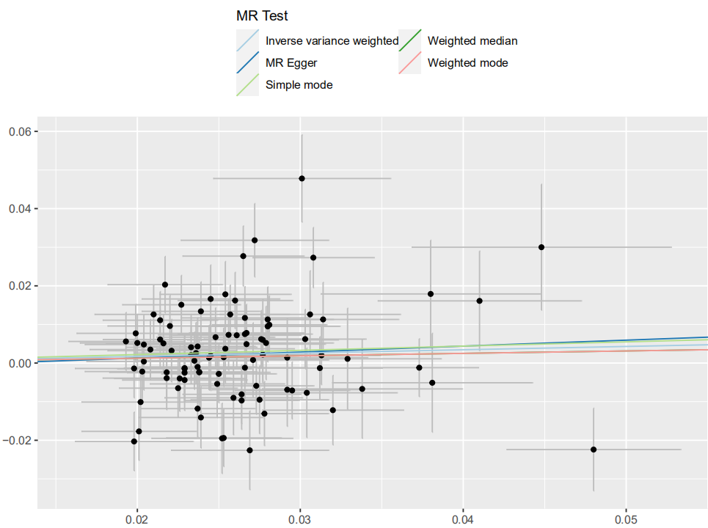
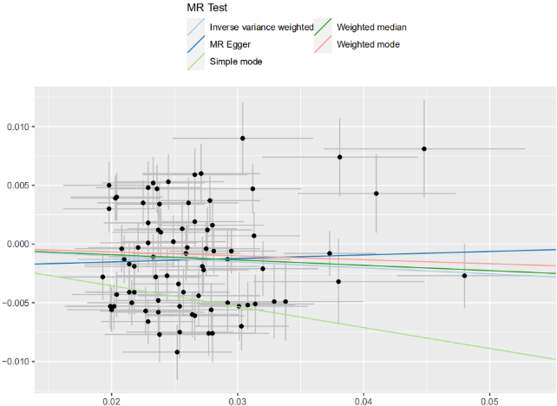
Depression on walking pace
Depression on ALM
Depression on grip strength

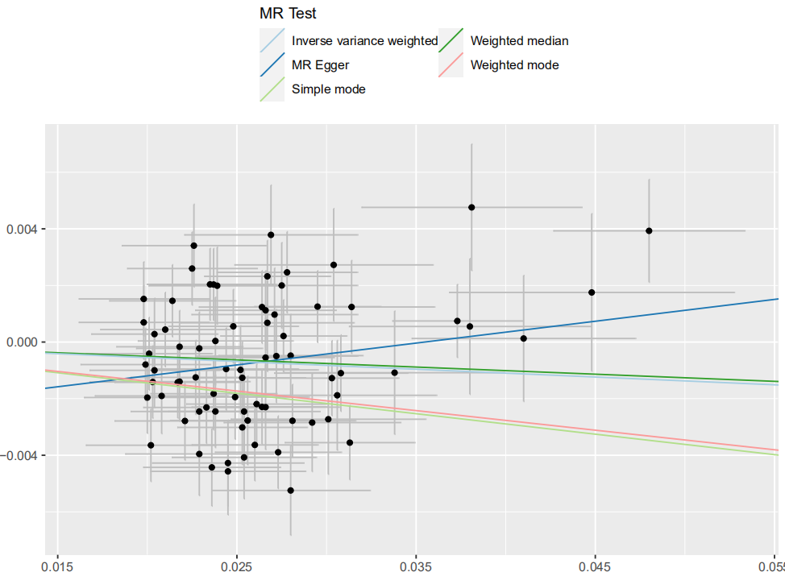

Supplementary figure 2. The scatter plots for the relationship of traits of sarcopenia with depression.
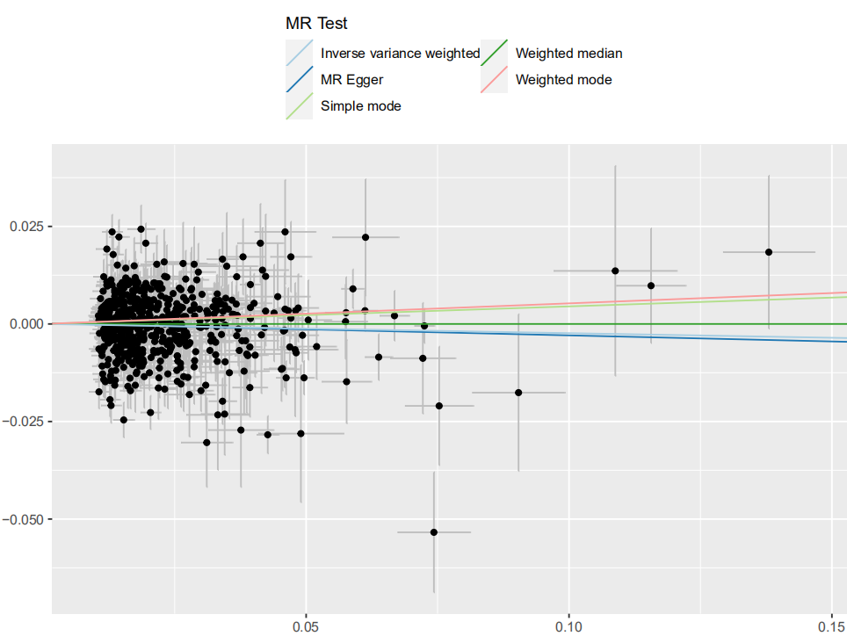
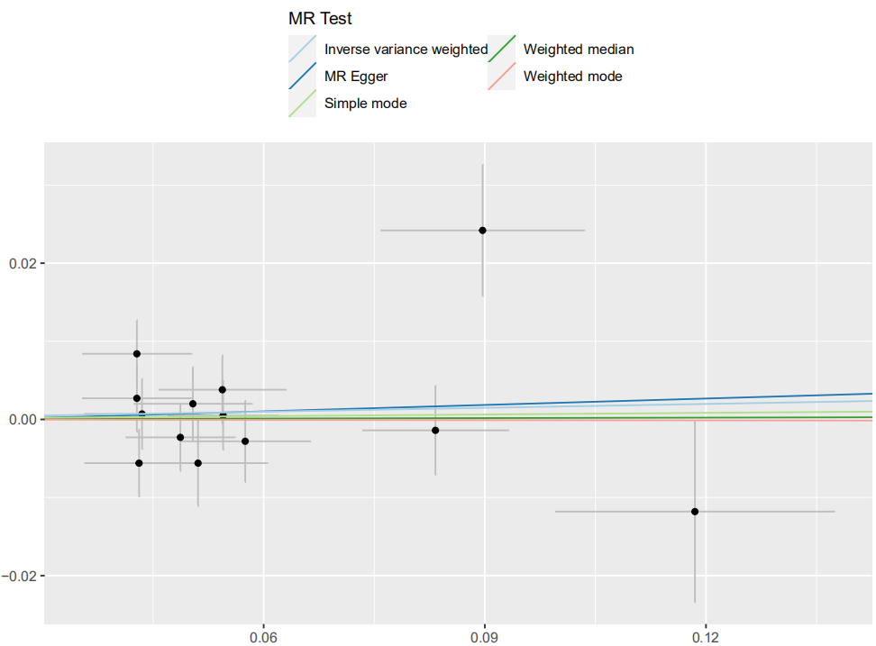
ALM on depression
Grip strength on depression

Walking pace on depression

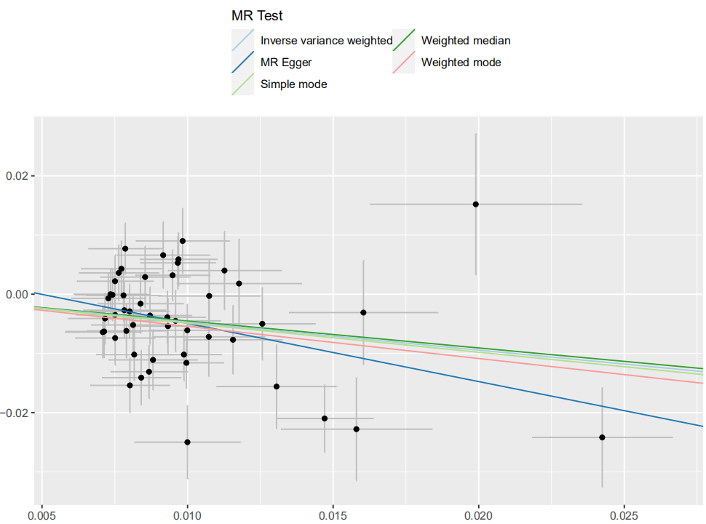

Supplementary figure 3. The forest plots for the relationship of depression with traits of sarcopenia.
Depression on grip strength
Depression on ALM

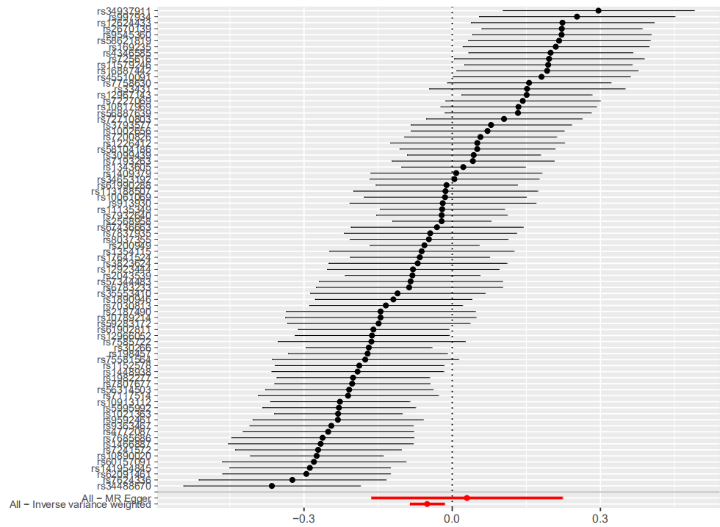
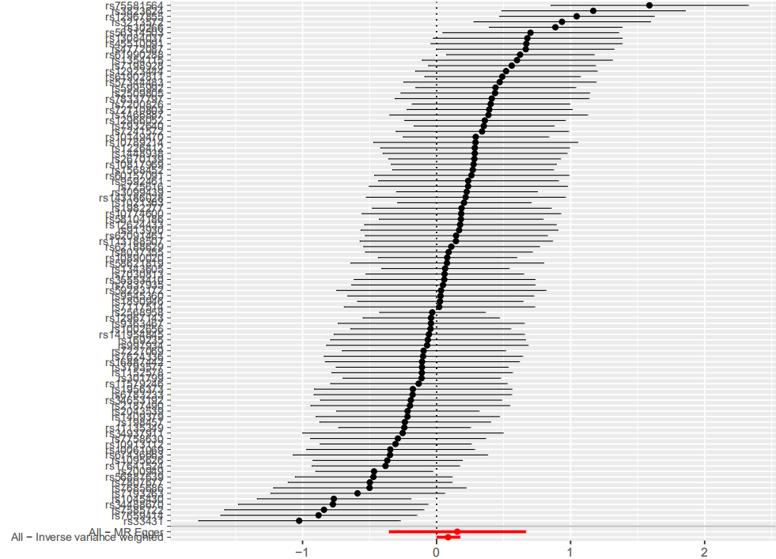

Depression on walking pace

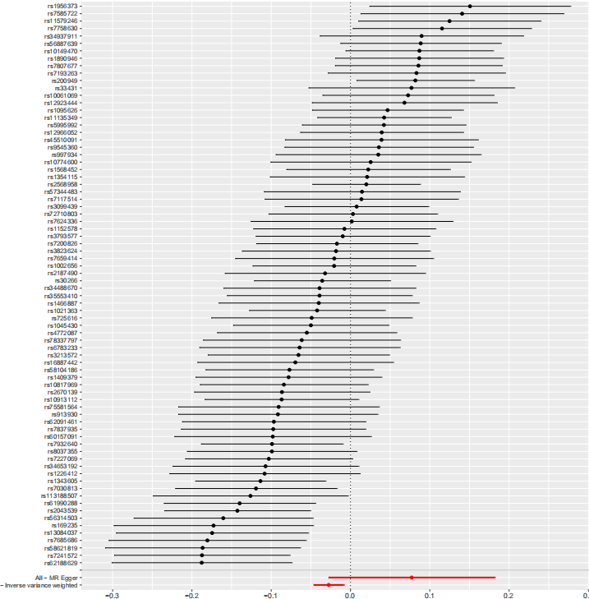

Supplementary figure 4. The forest plots for the relationship of traits of sarcopenia with depression.

Walking pace on depression
Grip strength on depression

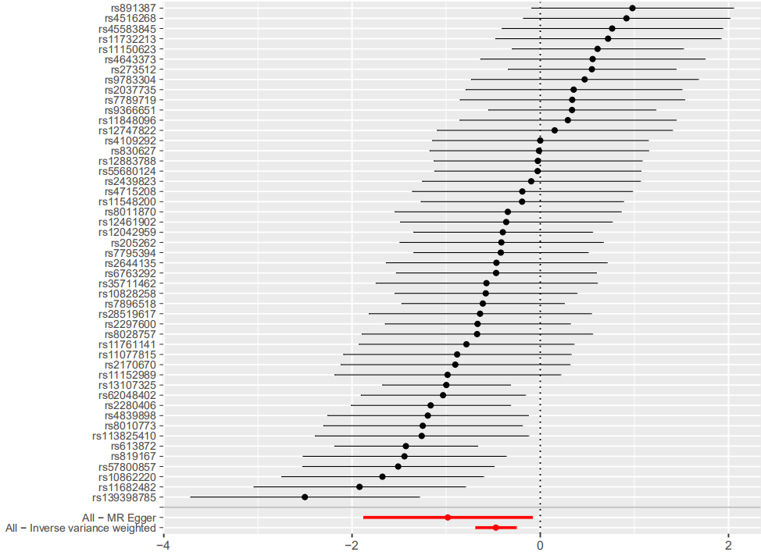
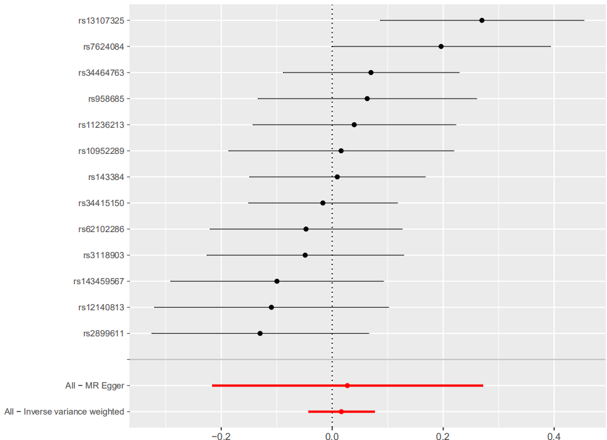

ALM on depression

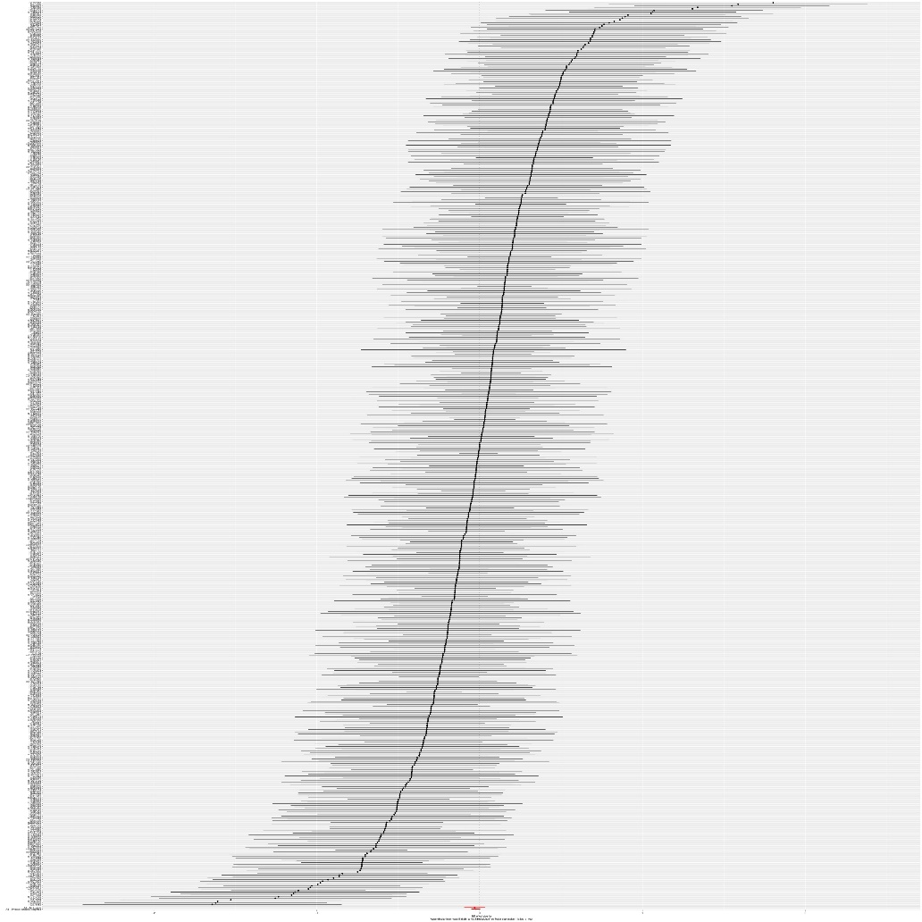

Supplementary figure 5. The funnel plots for the relationship of depression with traits of sarcopenia.
Depression on grip strength
Depression on ALM

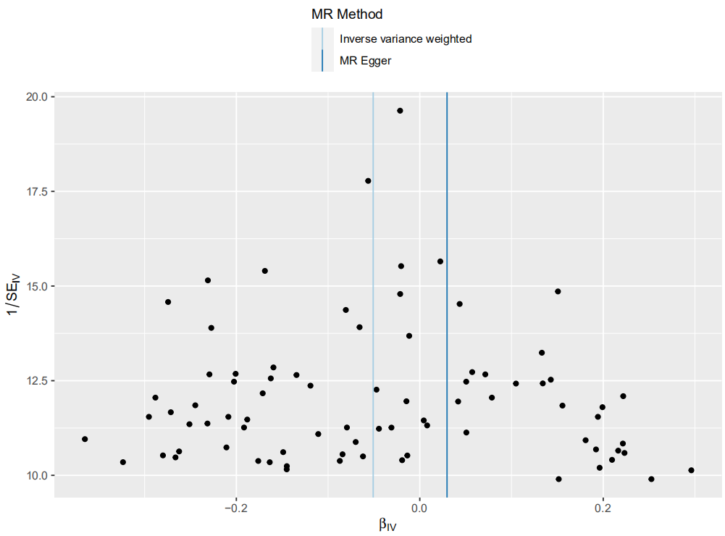
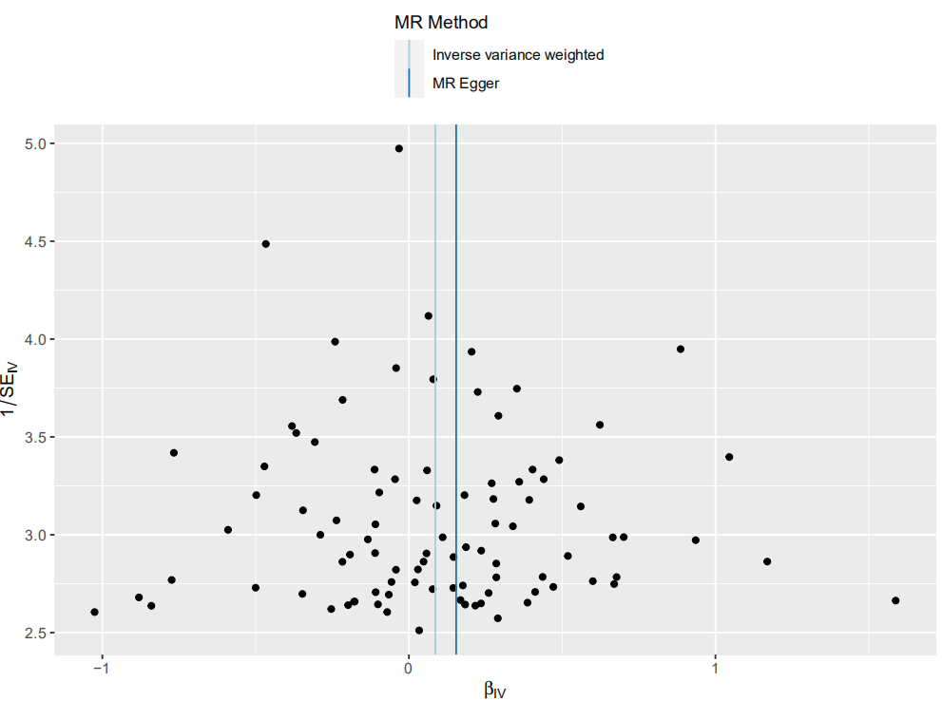

Depression on walking pace

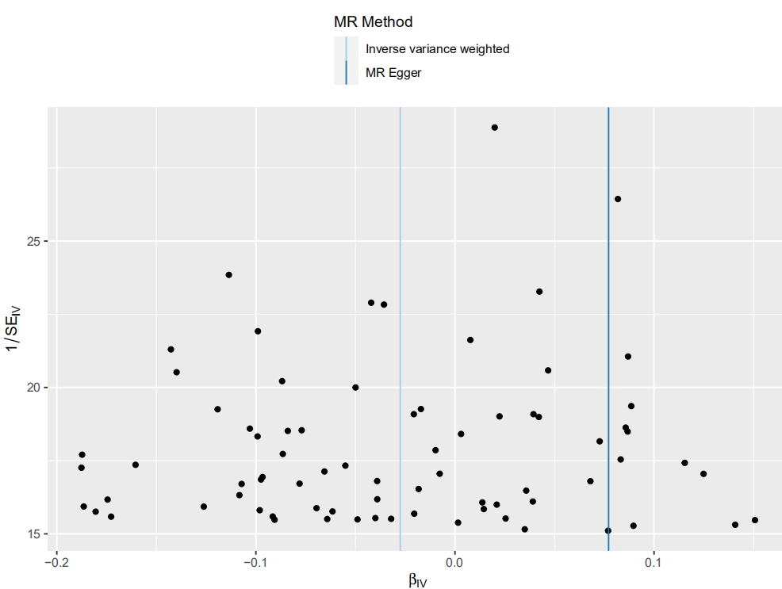

Supplementary figure 6. The funnel plots for the relationship of traits of sarcopenia with depression.

Walking pace on depression
Grip strength on depression

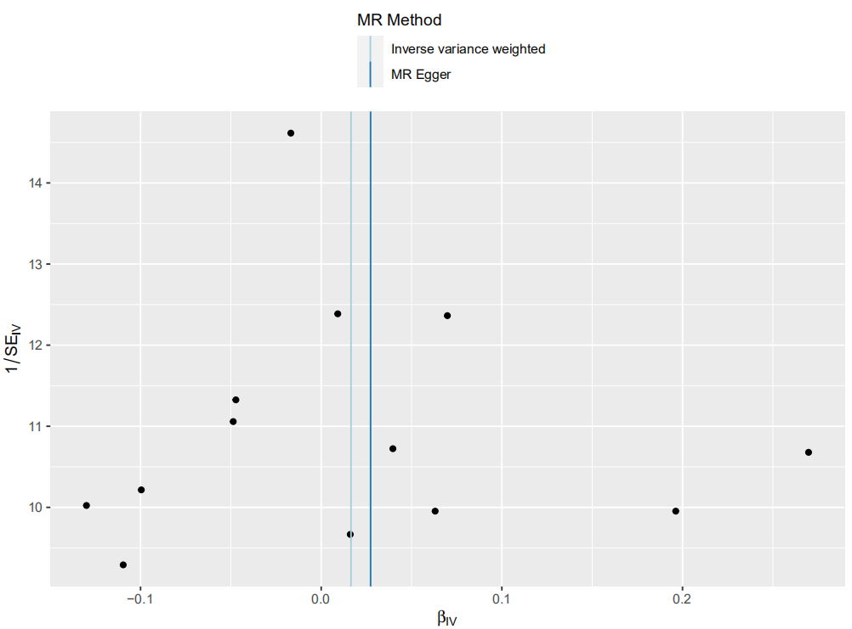
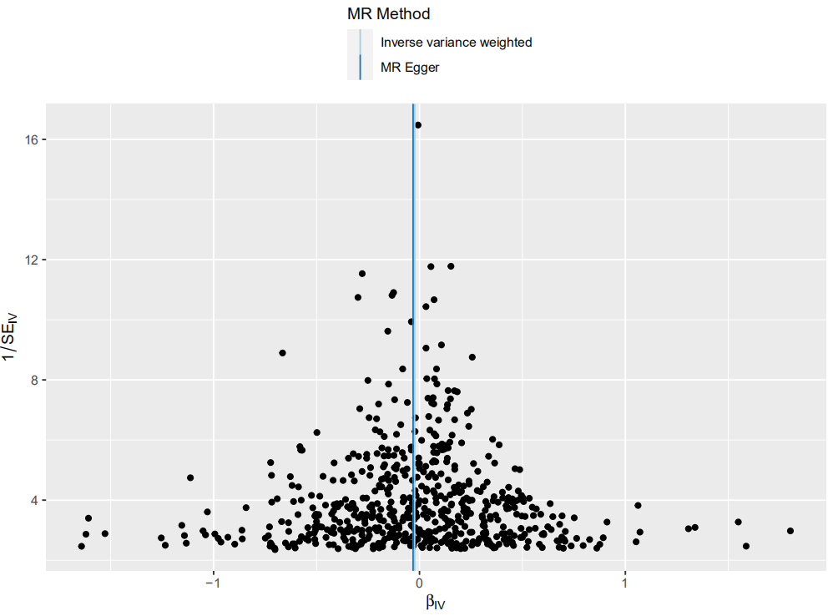

ALM on depression

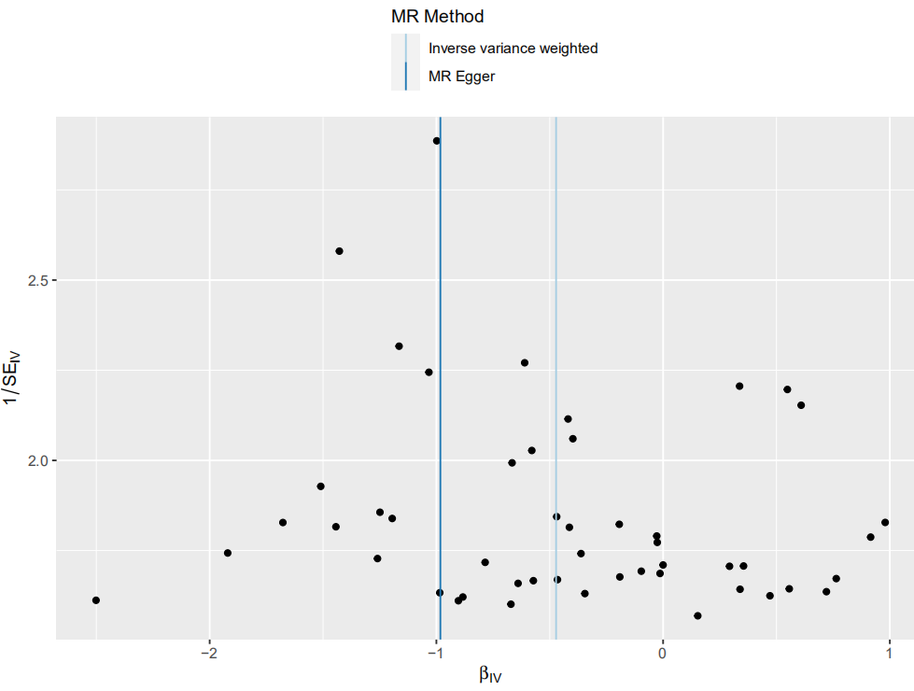

Supplementary figure 7. The leave-one-out analysis for relationship of depression with traits of sarcopenia.

Depression on ALM
Depression on grip strength

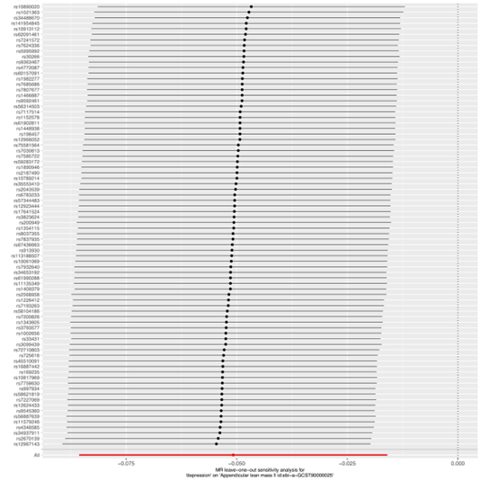
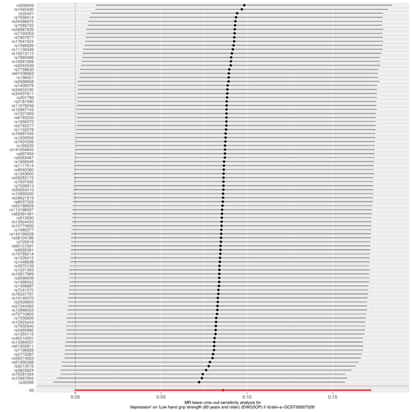

Depression on walking pace

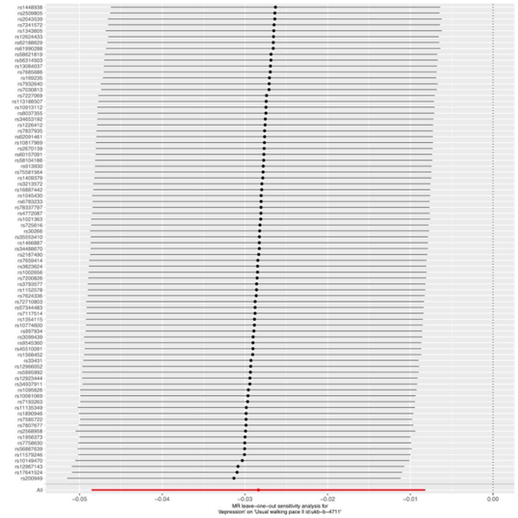

Supplementary figure 8. The leave-one-out analysis for relationship of traits of sarcopenia with depression.
Walking pace on depression
Grip strength on depression

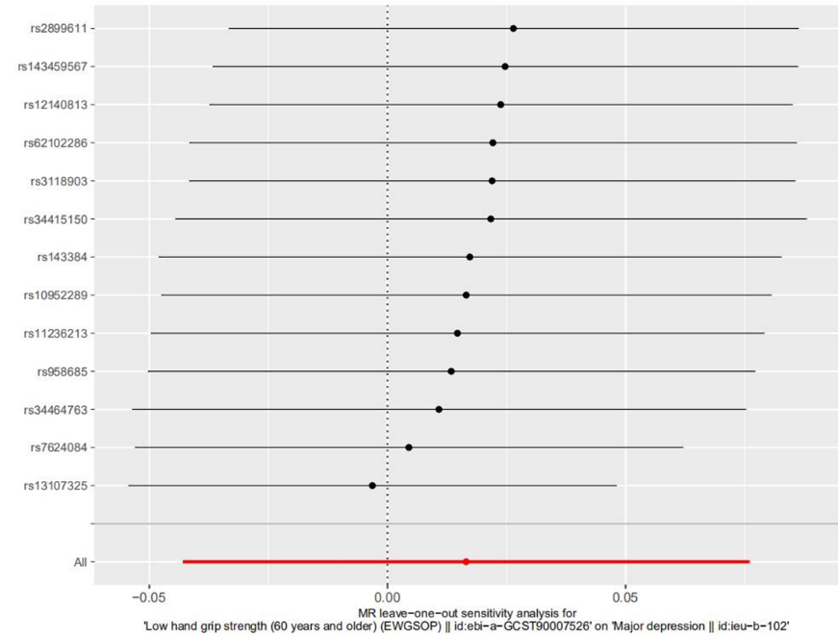
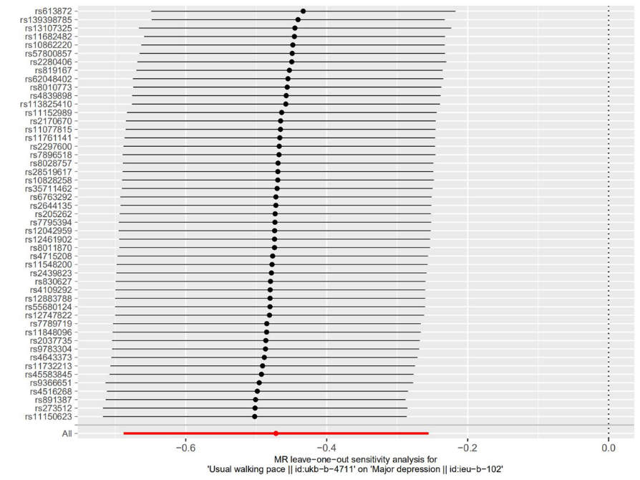

ALM on depression

