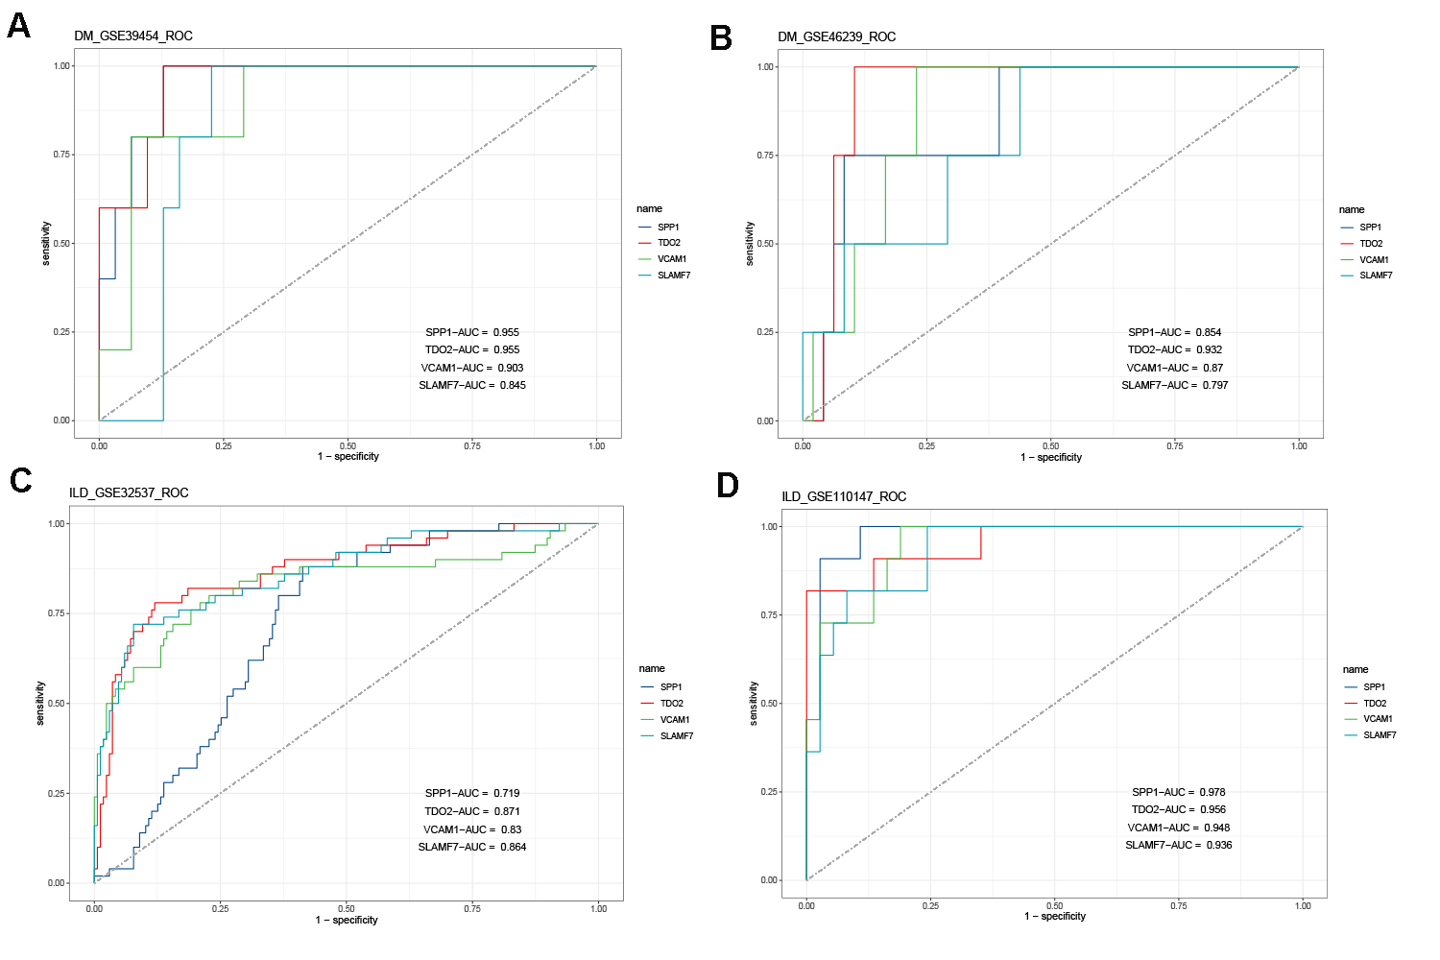

Fig. S1 ROC showing the sensitivity and specificity of the common DEGs for the diagnosis of DM (A,B) and ILD (C,D).

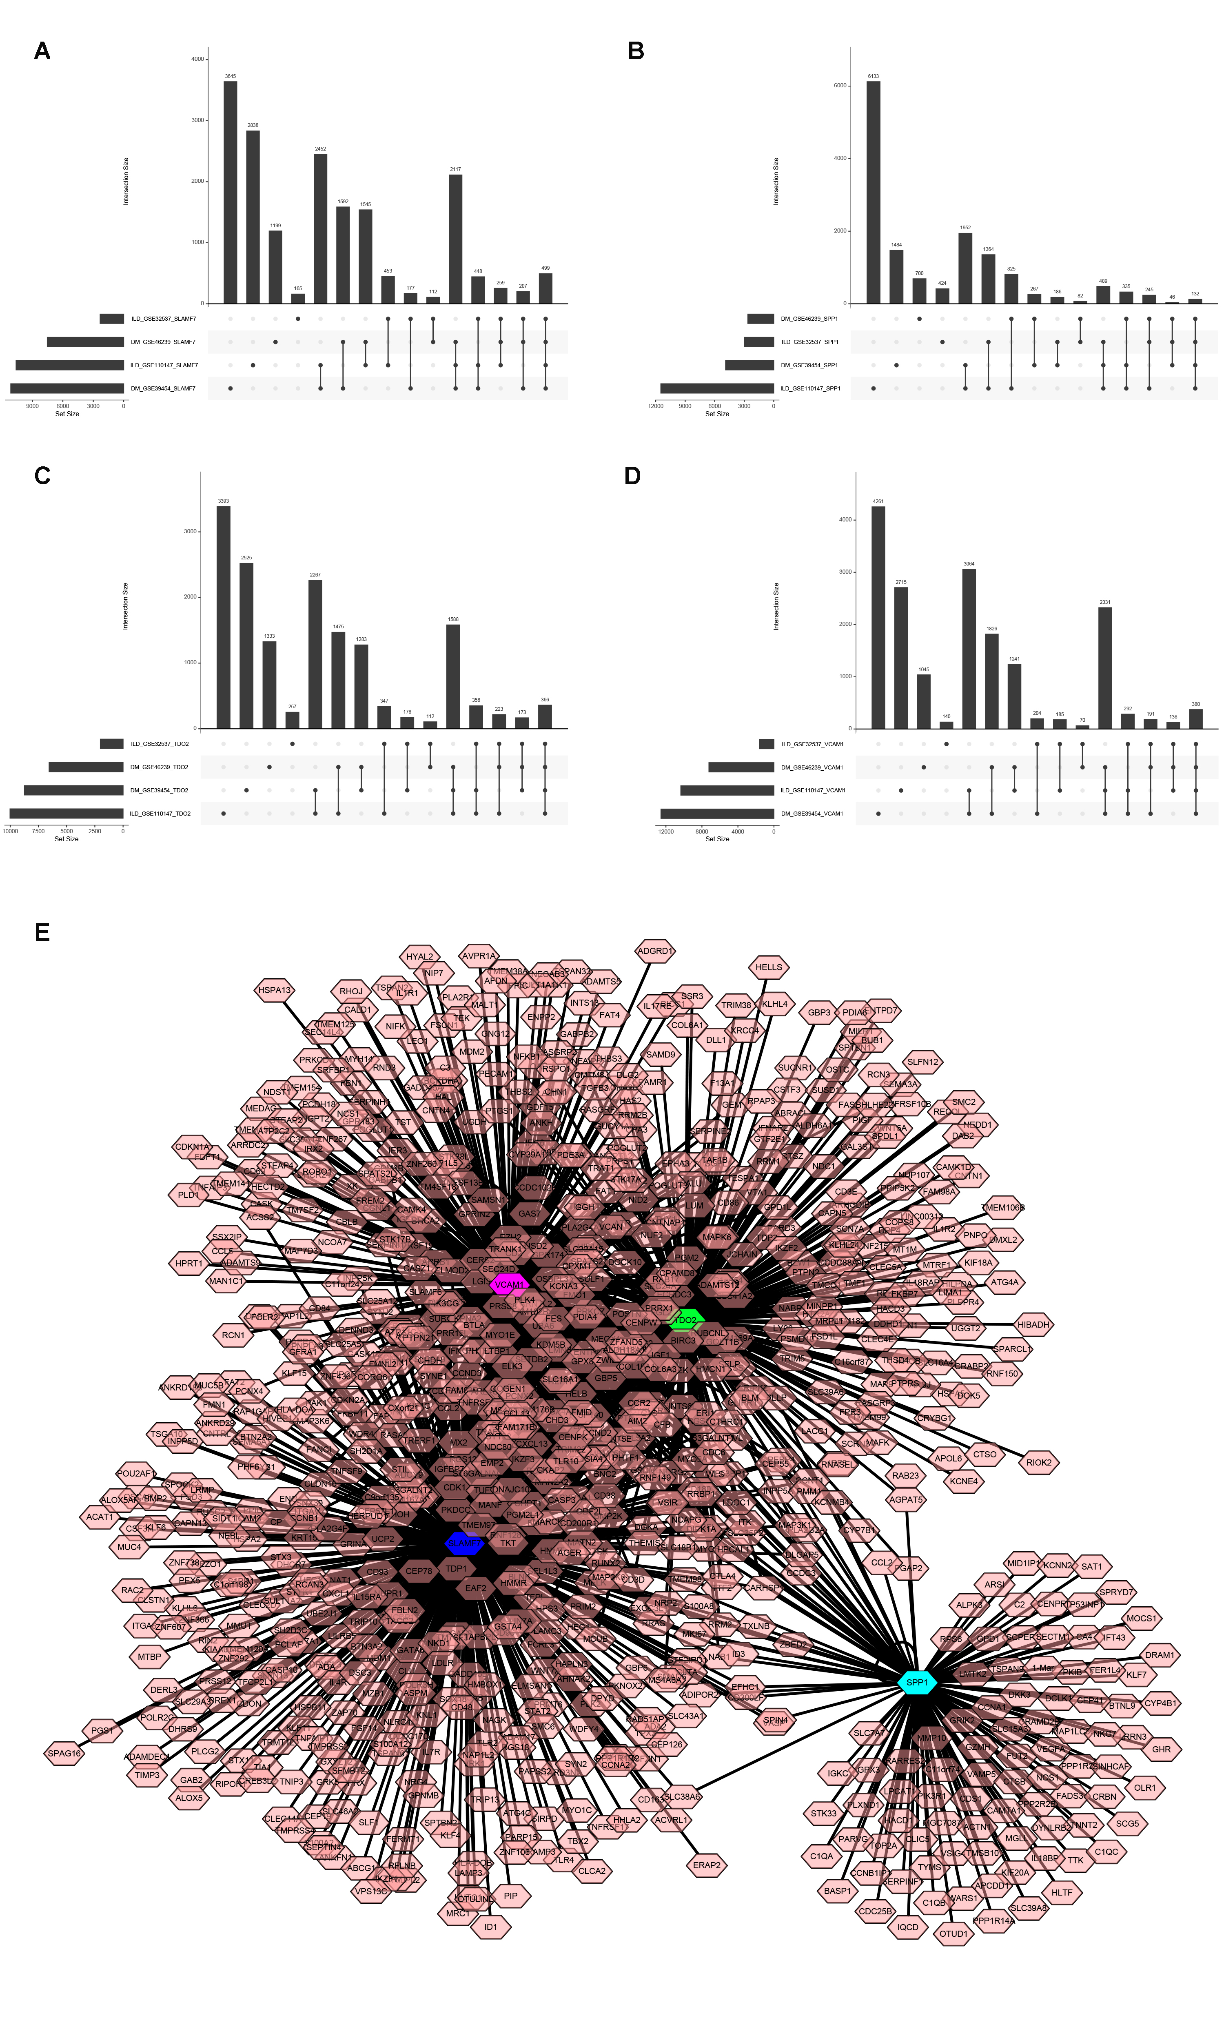
Fig. S2 (A,B,C,D) Veen diagrams showing that each common DEGs-associated genes in the four datasets. (E) Regulatory networks of the common DEGs.
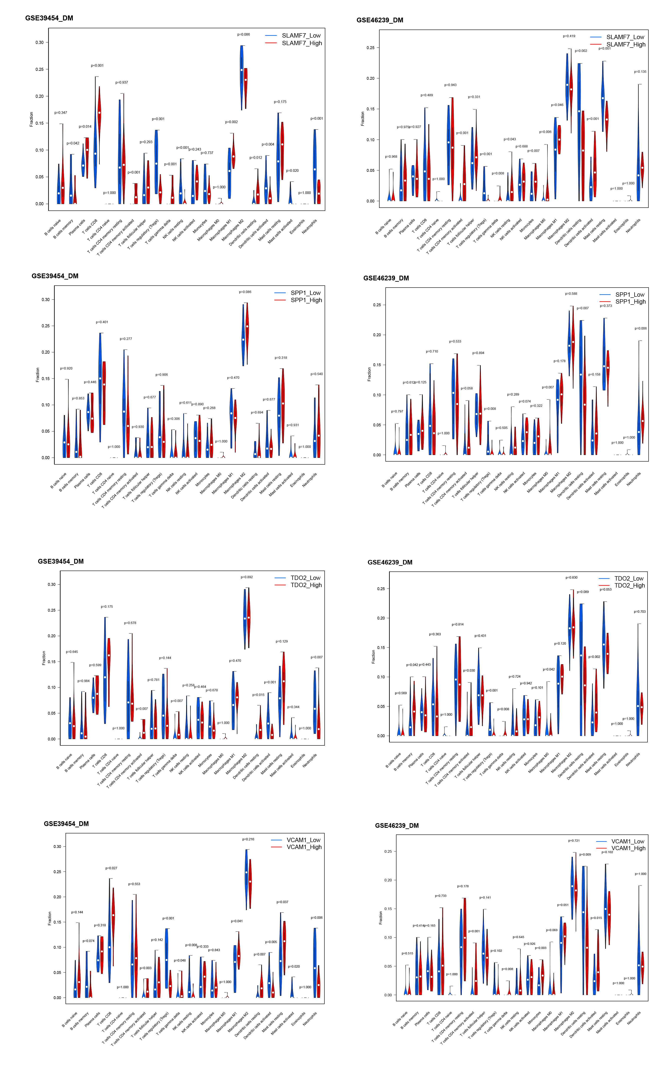
Fig. S3 Relationship between the expression levels of common DEGs and 22 immune cell infiltration in the DM.
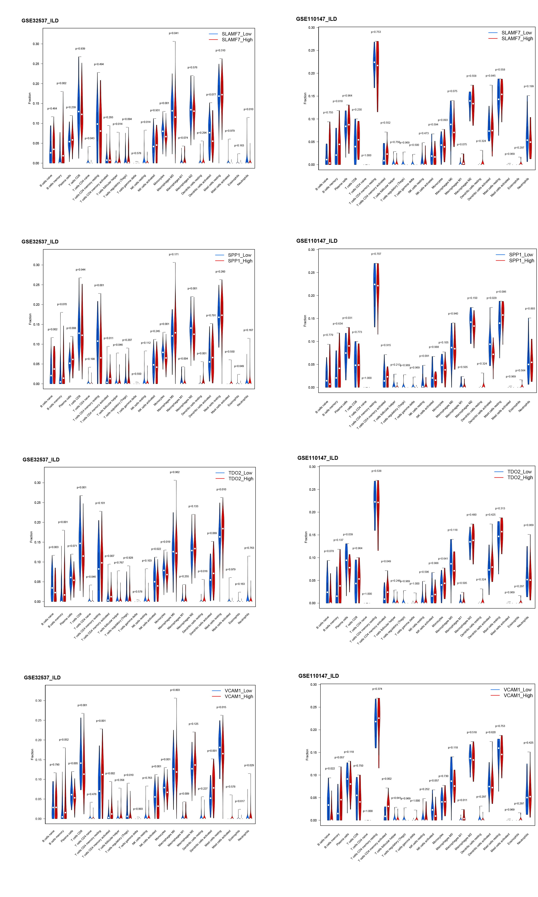
Fig. S4 Relationship between the expression levels of common DEGs and 22 immune cell infiltration in the ILD.

