Supplemental Information for
An efficient and reproducible Agrobacterium-mediated genetic transformation method for the ornamental monocotyledonous plant Ornithogalum dubium Houtt.
Pankaj Kumar Tripathi, Dana Ayzenshtat, Manoj Kumar, Hanita Zemach, Iris Yedidia, and Samuel Bocobza*
Institute of Plant Sciences, ARO Volcani Center, P.O. Box 15159, Rishon LeZion 7528809, Israel
*Samuel E. Bocobza; bocobza@volcani.agri.gov.il; ORCID ID: 0000-0002-8138-4426

Supplemental Tables:
Supplemental Table S1: Media used for O. dubium explant transformation
MS: Murashige-Skoog medium including vitamins (cat. no. M0222.0050, Duchefa, Netherlands).
Media | Composition
Callus induction medium  (CIM) | MS; 0.1 mg/l NAA; 1 mg/l BA; 1 mg/l CARB; 1 mg/l sodium metasilicate;  30 g/l Sucrose; 7 g/l Plant agar; pH 5.8
Pre-selection medium | MS; 0.1 mg/l NAA; 1 mg/l BA; 30 g/l Sucrose; 7 g/l Plant agar; 0.5 mg/l TIC; pH 5.8
Selection medium | MS; 0.1 mg/l NAA; 1 mg/l BA; 30 g/l Sucrose; 7 g/l Plant agar; 0.5 mg/l TIC; pH 5.8; 80 mg/l Kan
Rooting medium | MS; 0.5 mg/l NAA; 30 g/l Sucrose; 7 g/l Plant agar; 0.5 mg/l TIC; pH 5.8
Propagation medium | MS; 30 g/l Sucrose; 8 g/l Plant agar; pH 5.8

Supplemental Table S2: Hormonal combinations used for rooting in O. dubium transformed tissues.
MS: Murashige-Skoog medium including vitamins (cat. no. M0222.0050, Duchefa, Netherlands).
Hormone concentrations | No. of explant used | No. of rooting | % of rooting
MS x1; 0.1 mg/l NAA;  30 g/l Sucrose; 7 g/l Plant agar; 0.5 mg/l TIC; pH 5.8 | 20 | 2 | 10
MS; 0.3 mg/l NAA;  30 g/l Sucrose; 7 g/l Plant agar; 0.5 mg/l TIC; pH 5.8 | 20 | 3 | 15
MS; 0.5 mg/l NAA;  30 g/l Sucrose; 7 g/l Plant agar; 0.5 mg/l TIC; pH 5.8 | 20 | 12 | 60
MS; 1.0 g/l NAA;  30 g/l Sucrose; 7 g/l Plant agar; 0.5 mg/l TIC; pH 5.8 | 20 | 7 | 35

Supplemental Table S3: List of oligonucleoprimers used in the present study
Primers used for PCR and cloning
Name of primer | Primer Sequence (5’-3’)
SlACTIN_F | CCAACAGAGAGAAAATGACCCAGATTATG
SlACTIN_R | AACGGAACCTCTCAGCACCAATGG
RFP_F | ATGGCCTCCTCCGAGGACGTCATC
RFP_R | TCAGGCGCCGGTGGAGTGGC
35S_F | GCGCCGTCTCGCTCGGGAGACTAGAGCCAAGCTGATCTCCTTTGCC
35S_R | CAACACAAAGTGATCAAACTGAAACTTACTCGACTAGAATAGTAAATTGTAATGTTGTTTG

Supplemental Table S4: Effects of kanamycin concentrations on the survival of O. dubium calli
Kan concentration  (mg/l) | WT
0  12  25  50  80  100  150  200 | 26.33±2.08  18.34±1.52  17.67±1.53  16.33±2.51  14.33±2.52  4.33±1.52  1.00±1.00  0

Supplemental Figures

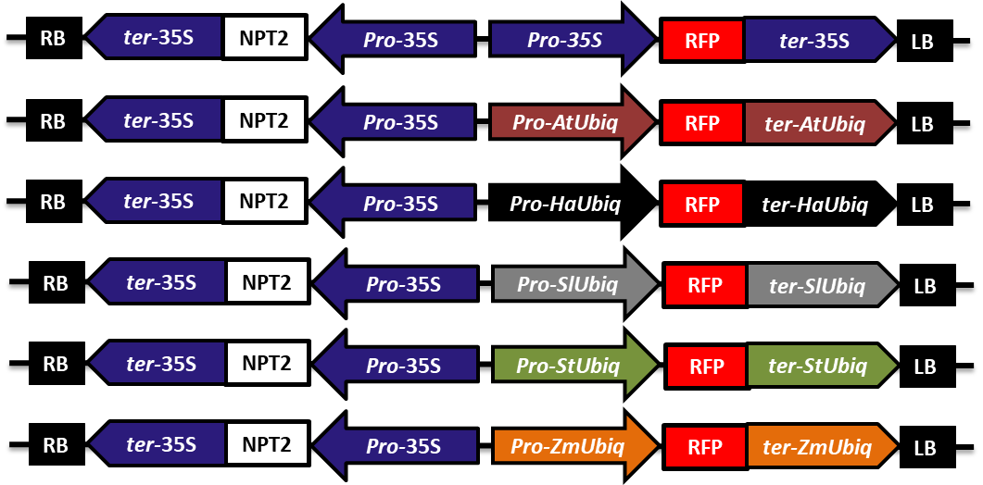
Supplemental Figure S1: Schematic representation of the constructs used in this assay, consisting of the CaMV-35S and different UBIQUITIN10 promoters and terminators to control the NPT2 and RFP genes (Kumar et al., 2021).

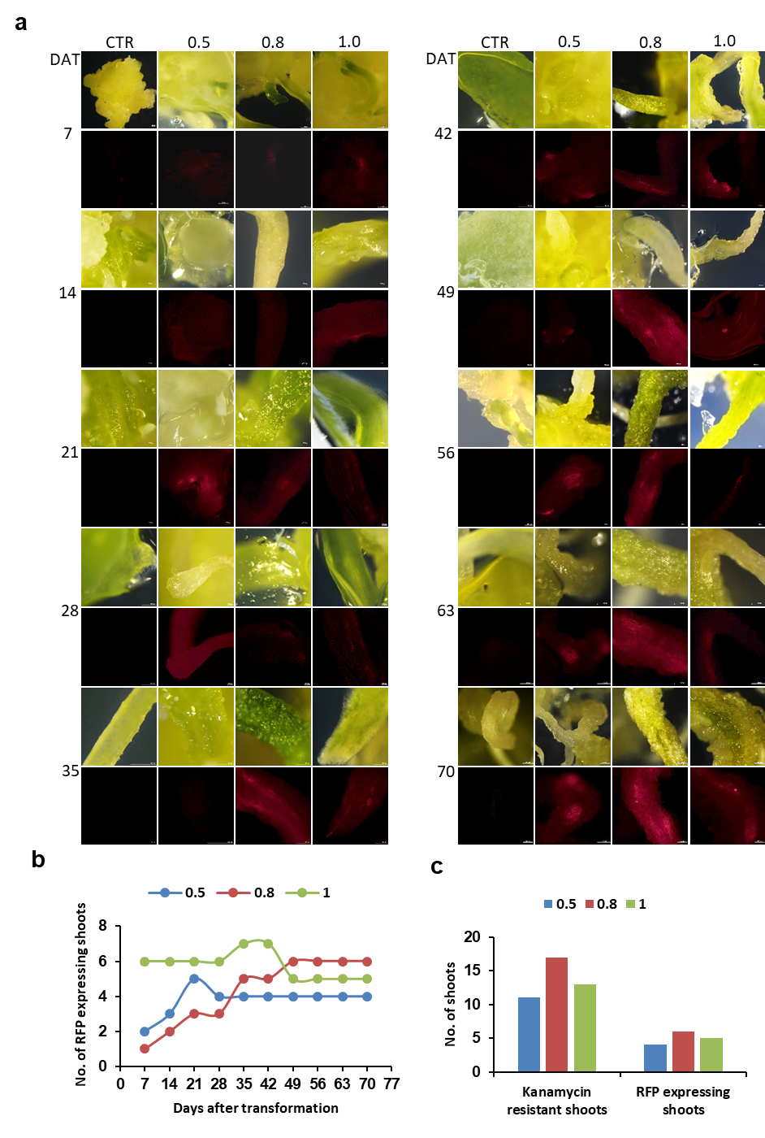
Supplemental Figure S2: Transformation of O. dubium using Agrobacterium at different OD₆₀₀.
a RFP fluorescence observed during the regeneration process of O. dubium plants transformed using the construct depicted in Figure 3 and Agrobacterium strains EHA105 at different cell densities (O.D₆₀₀ 0.5, 0.8 & 1.0)
b Number of RFP fluorescent shoots detected during ten weeks following transformation
c Number of Kan-resistant and RFP fluorescent shoots detected after ten weeks
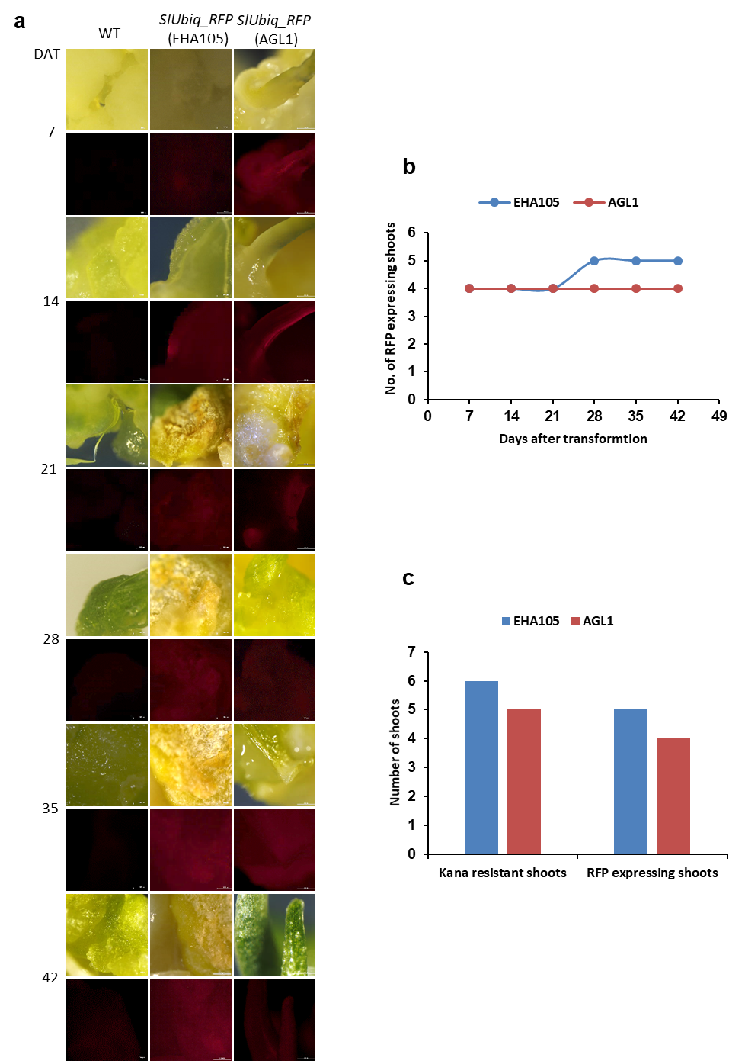
Supplemental Figure S3: Transformation of O. dubium using two different Agrobacterium strains (EHA105 and AGL1)
a RFP fluorescence observed during the regeneration process of O. dubium plants transformed using the construct depicted in Figure 3 and Agrobacterium strains EHA105 and AGL1
b Number of RFP fluorescent shoots detected during six weeks following transformation
c Number of Kan-resistant and RFP fluorescent shoots detected after six weeks

