Supplementary Tables
Supplemental Table 1. Independent variables prepared for each province
Variables |  | Value | Variable Unit
V1 | Percentage of population |  | %
V2 | Unemployment rate |  | %
V3 | Percentage of migrated persons |  | %
V4 | Percentage of educated persons |  | %
V5 | Percentage of sheep |  | %
V6 | Percentage of cows |  | %
V7 | Percentage of goats |  | %
V8 | Percentage of GDP |  | %
V9 | Elevation |  | Meters
V10 | Mean NDVI from March 2017 to March 2018 |  | Grayscale (0-255)
V11 | Precipitation in January 2018 |  | Millimeters
V12 | Precipitation in February 2018 |  | Millimeters
V13 | Precipitation in March 2017 |  | Millimeters
V14 | Precipitation in April 2017 |  | Millimeters
V15 | Precipitation in May 2017 |  | Millimeters
V16 | Precipitation in June 2017 |  | Millimeters
V17 | Precipitation in July 2017 |  | Millimeters
V18 | Precipitation in August 2017 |  | Millimeters
V19 | Precipitation in September 2017 |  | Millimeters
V20 | Precipitation in October 2017 |  | Millimeters
V21 | Precipitation in November 2017 |  | Millimeters
V22 | Precipitation in December 2017 |  | Millimeters
V23 | Maximum temperature in January 2018 |  | ° C
V24 | Minimum temperature in January 2018 |  | ° C
V25 | Maximum temperature in February 2018 |  | ° C
V26 | Minimum temperature in February 2018 |  | ° C
V27 | Maximum temperature in March 2017 |  | ° C
V28 | Minimum temperature in March 2017 |  | ° C
V29 | Maximum temperature in April 2017 |  | ° C
V30 | Minimum temperature in April 2017 |  | ° C
V31 | Maximum temperature in May 2017 |  | ° C
V32 | Maximum temperature in May 2017 |  | ° C
V33 | Maximum temperature in June 2017 |  | ° C
V34 | Minimum temperature in June 2017 |  | ° C
V35 | Maximum temperature in July 2017 |  | ° C
V36 | Minimum temperature in July 2017 |  | ° C
V37 | Maximum temperature in August 2017 |  | ° C
V38 | Minimum temperature in August 2017 |  | ° C
V39 | Maximum temperature in September 2017 |  | ° C
V40 | Minimum temperature in September 2017 |  | ° C
V41 | Maximum temperature in October 2017 |  | ° C
V42 | Minimum temperature in October 2017 |  | ° C
V43 | Maximum temperature in November 2017 |  | ° C
V44 | Minimum temperature in November 2017 |  | ° C
V45 | Maximum temperature in December 2017 |  | ° C
V46 | Minimum temperature in December 2017 |  | ° C

Supplemental Table 2. Spatial autocorrelation report of FMD incidence.
Moran's Index: | 0.000788
Expected Index: | -0.034483
Variance: | 0.004781
z-score: | 0.510115
p-value: | 0.609971

Supplemental Table 3. Coefficients and p-values of the OLS model for dependent variables. The variables with (*) are the most significant factors among dependent variables. The parameter $b_{0}$ is explained in equation (1).
Variable | Coefficient | P-value
$$b_{0}$$ | -2.98655 | 0.45210
The percentage of sheep * | 1.58503 | 0.01001
The percentage of goats * | 0.844726 | 0.04510
The percentage of population | 0.438214 | 0.32792
Precipitation in January | -0.0811962 | 0.42434

Supplemental Table 4. Coefficients and p-values of the SLM model for dependent variables. The variables with (*) are the most significant factors among dependent variables. The parameter $b_{0}$ and $ρ$ are explained in equation (1).
Variable | Coefficient | P-value
$$b_{0}$$ | 0.0287 | 0.99480
The percentage of sheep * | 1.49632 | 0.00365
The percentage of goats * | 0.790592 | 0.02788
The percentage of population | 0.360996 | 0.37318
Precipitation in January | -0.126036 | 0.18958
$$ρ$$ | -0.232249 | 0.35185

Supplemental table 5. Estimation results of the MGWR
Variables | Mean | St.Dev | Min | Max | Bandwidth
Intercept | -0.025 | 0.001 | -0.026 | -0.024 | 3617.950
The percentage of sheep | 0.316 | 0.265 | -0.006 | 0.860 | 389.320
The percentage of goats | 0.335 | 0.440 | -0.136 | 1.897 | 169.740
The percentage of population | 0.021 | 0.000 | 0.021 | 0.021 | 3618.040
Precipitation in January | -0.178 | 0.001 | -0.179 | -0.177 | 3618.130

Supplementary Figures
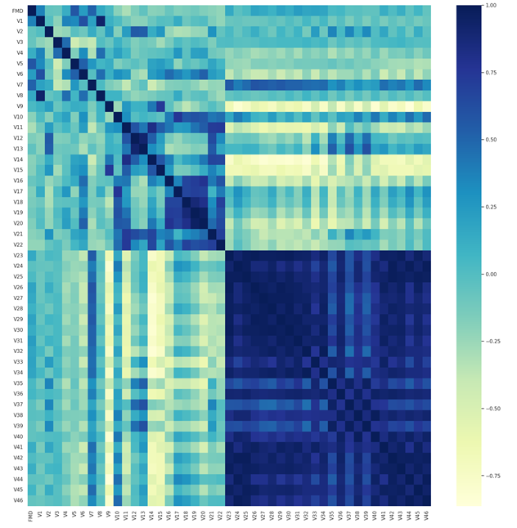Supplemental Figure 1. Pearson correlation matrix. The variables which had correlation more than |0.3| for dependent variable were selected in the first step. See supplemental Table 1 to find the name of variables (from V1 to V46).

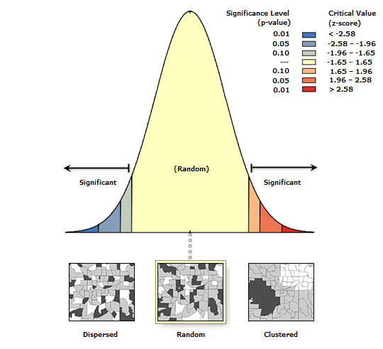
Supplemental Figure 2. Given the z-score of 0.5101, the pattern of FMD incidence in Iran does not appear to be significantly different than random.
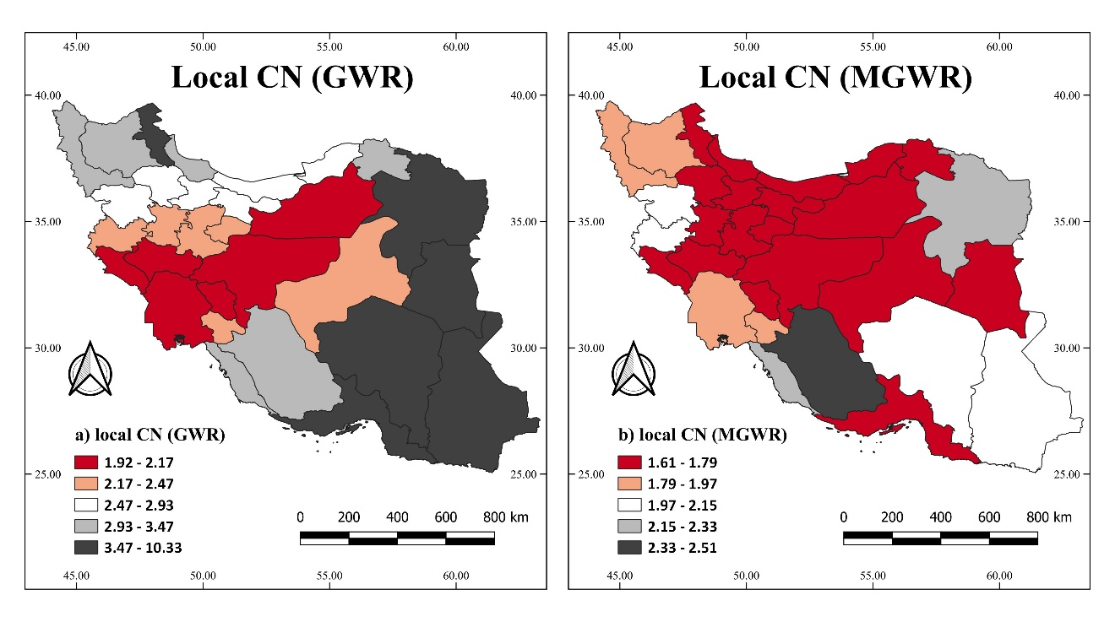
Supplemental Figure 3. Diagnostic tests of the local collinearity for the GWR (left) and the MGWR (right)

