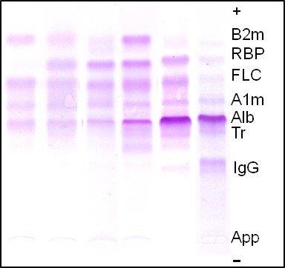
Supplementary Figure 1: Illustrative profiles of urinary protein electrophoresis: 1,2,3,4: patients with tubular dysfunction, 5 and 6: patients with tubular dysfunction associated with a glomerular profile. 1m: alpha-1-microglobulin, Alb: Albumin, App: Sample application on gel, ARDS: Acute respiratory distress syndrome, 2m: beta-2-microglobulin, FLC: Free light chains, IgG: immunoglobulin G, RBP: Retinol binding protein, Tr: Transferrin

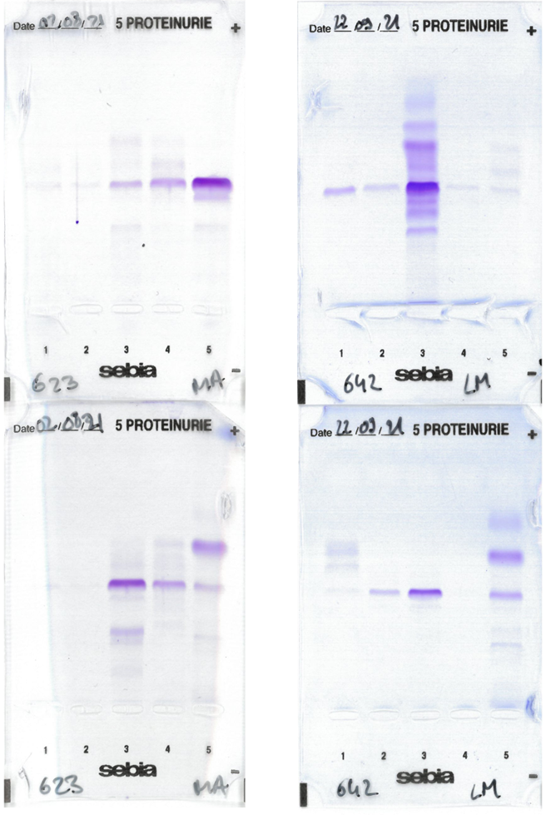
Supplementary Figure 2: Full gels of urinary protein electrophoresis

