Table 1.
The alternative concepts for the syringe subsystem
Design | Description
Concept 1  Loader of 5 ml syringes  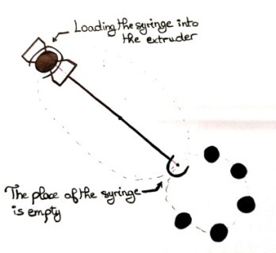 | The first concept is to use a loader of 5 ml syringes. The idea is to print the hip prosthesis using several 5 ml syringes. It is a charger of four syringes of 5 ml or more, once mixing in the first syringe is completed, the system will make an automatic change to print with the second syringe and so on.
Concept 2  Single syringe  Printing with a 20ml syringe  S= 20ml  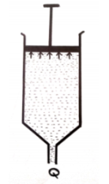 | The second concept is to use a single syringe of 20 ml. This one allows printing large parts.
Concept 3  Loader of 20 ml syringes  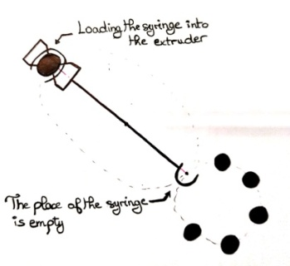 | The idea in this concept is to use a loader like the first concept but with 20 ml syringes to minimize the time to change the syringe.
Concept 4  Printing with a syringe 5ml, 20ml, or more) filled from a reservoir  S= 20ml  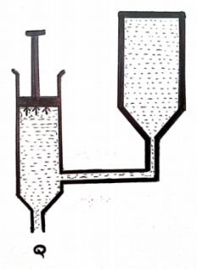 | For this concept, to print pieces of 20 ml or more, a tank containing the soft material will be used with the syringe.
Concept 5  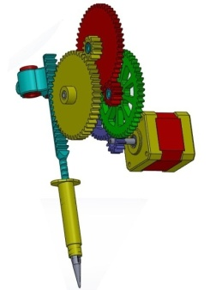 | The initial state: its extruder mechanism consists of a rack-and-pinion system that directly pushes the syringe plunger and transmits the necessary force to operate it. It is driven by a motor and gears set to reduce the speed of rotation and multiply the torque. The rotary movement is ensured by the stepping motor (M) and it is assigned to the toothed wheel.

