Supplementary Information
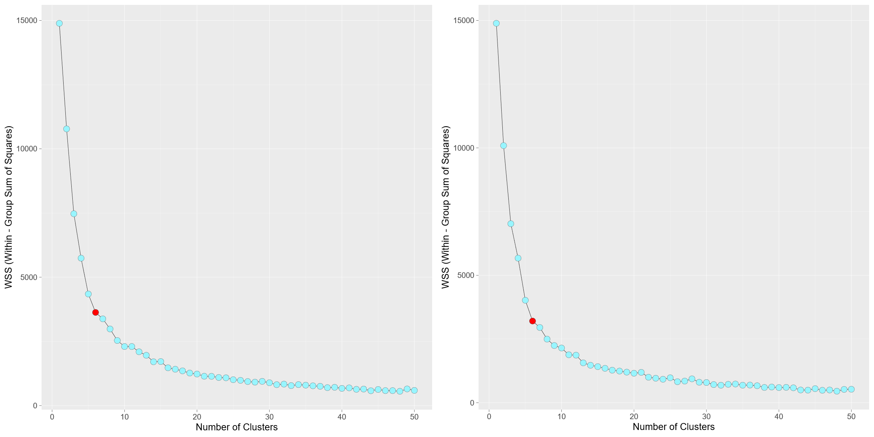
Figure S1. Within Group Sum of Squares (WSS) versus number of clusters for (a) extreme rainfall, (b) seasonal rainfall with selected number of clusters (6) pointed as red color
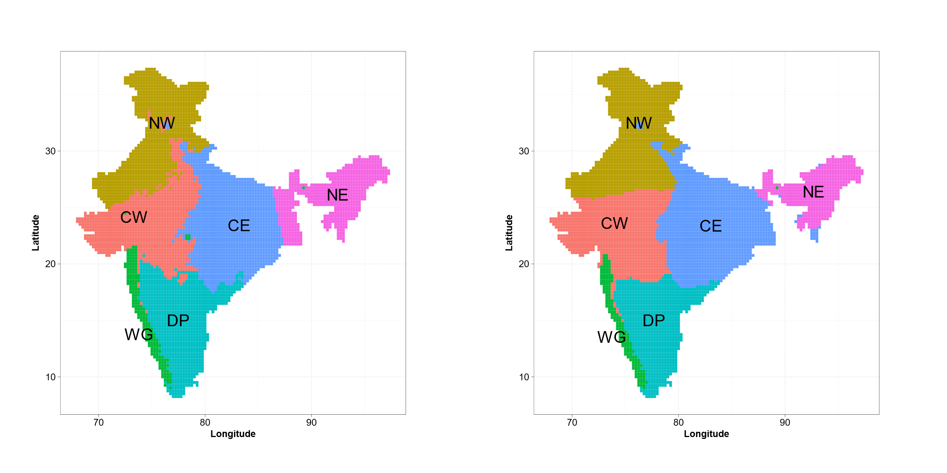
Figure S2. Spatial clusters identified from the clustering method of Bracken et al., (2015) for (left) extreme rainfall, (right) seasonal rainfall for the period 1901-1950
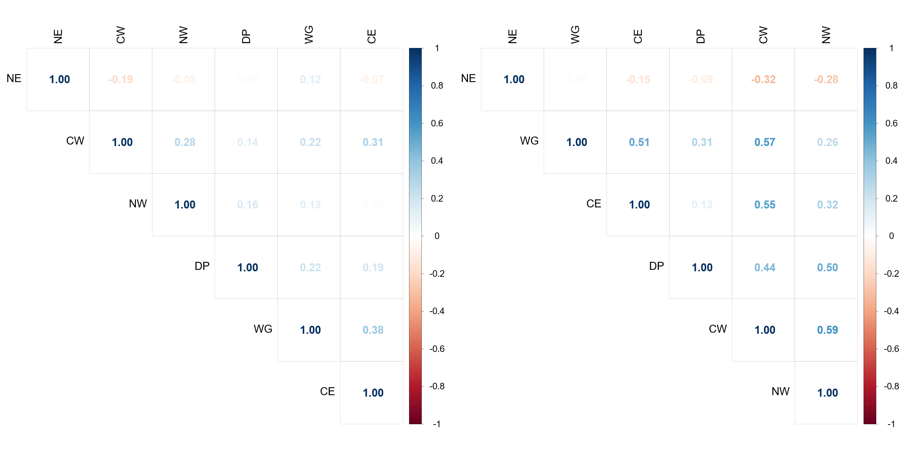
Figure S3. Panel of correlation among clusters for (a) extreme rainfall, (b) seasonal rainfall
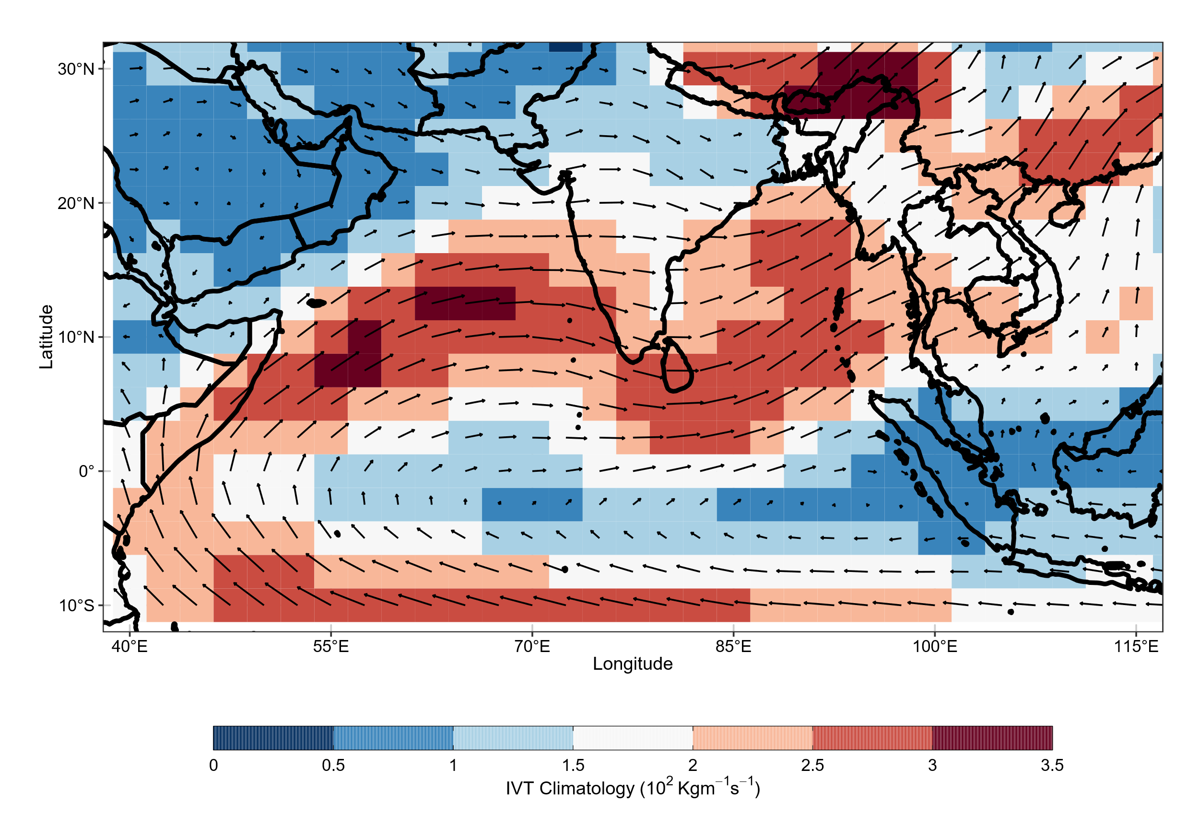
Figure S4. Spatial map of IVT for climatology for the period 1951-2017
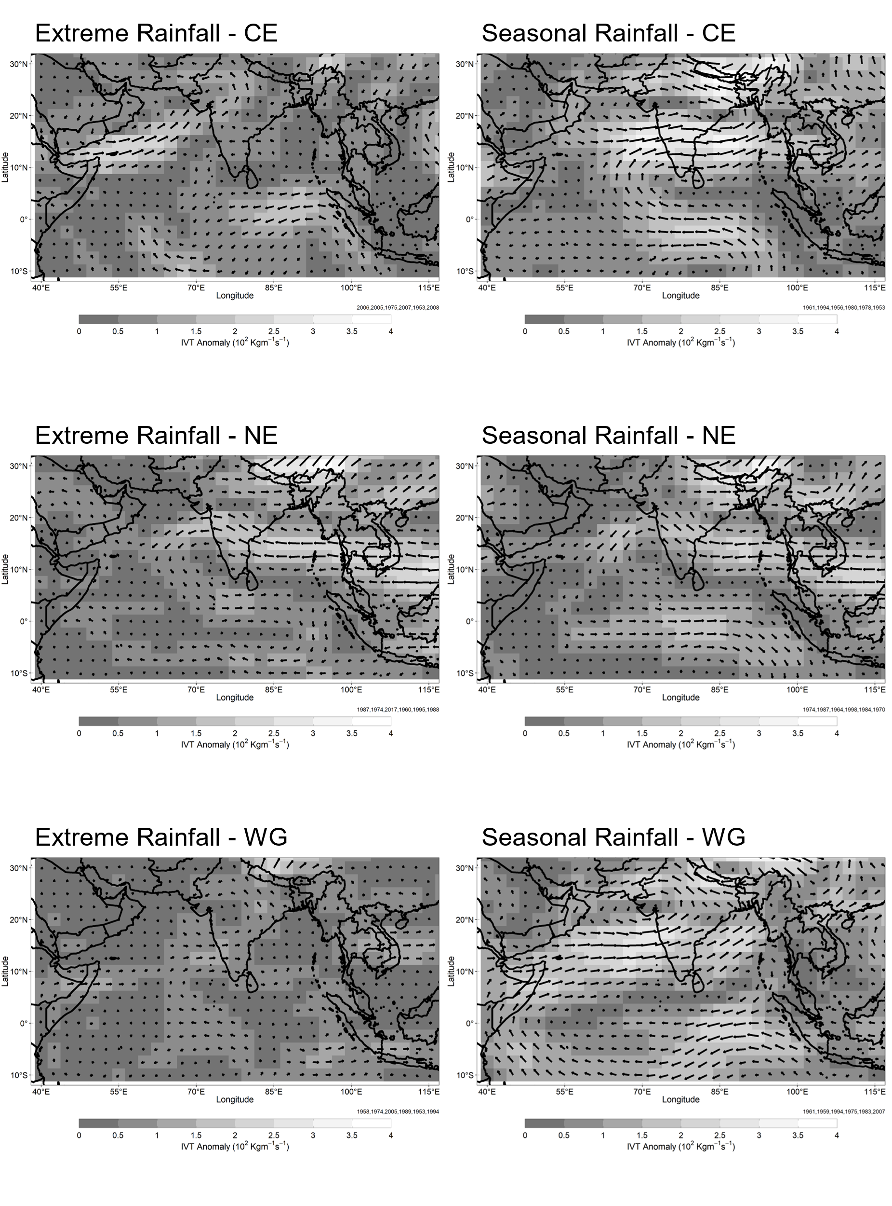
Figure S5. Composite maps of anomalous IVT for wet years of (left column) extreme rainfall, (right column) seasonal rainfall for clusters CE (top row), NE (middle row) and WG(bottom row)
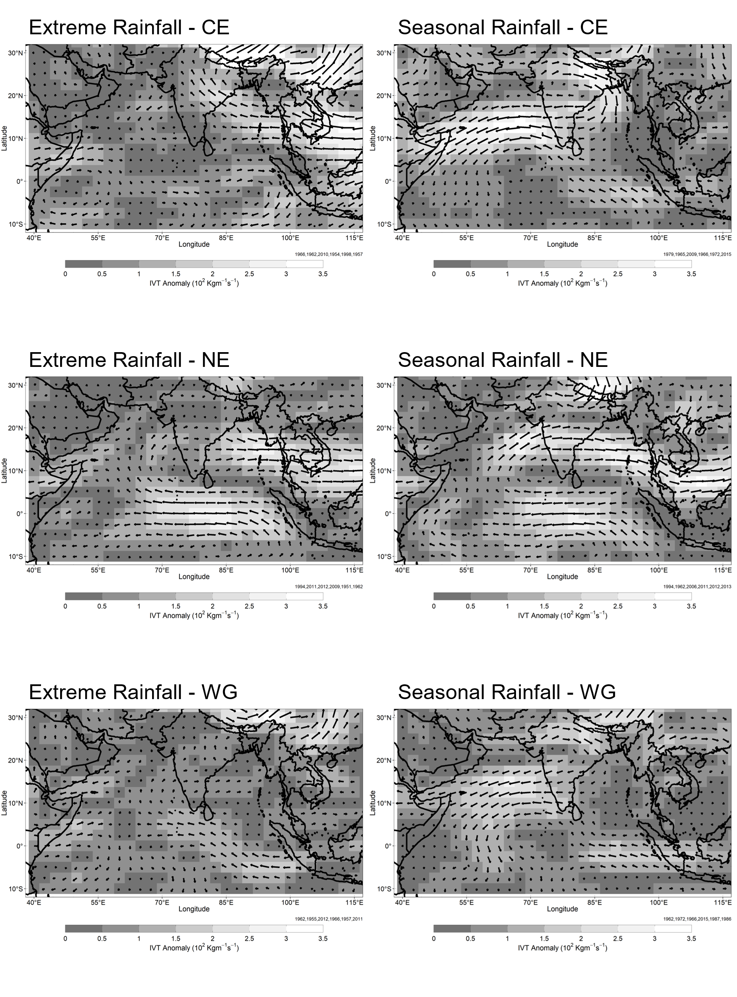
Figure S6. Composite maps of anomalous IVT for dry years of (left column) extreme rainfall, (right column) seasonal rainfall for clusters CE (top row), NE(middle row) and WG (bottom row)
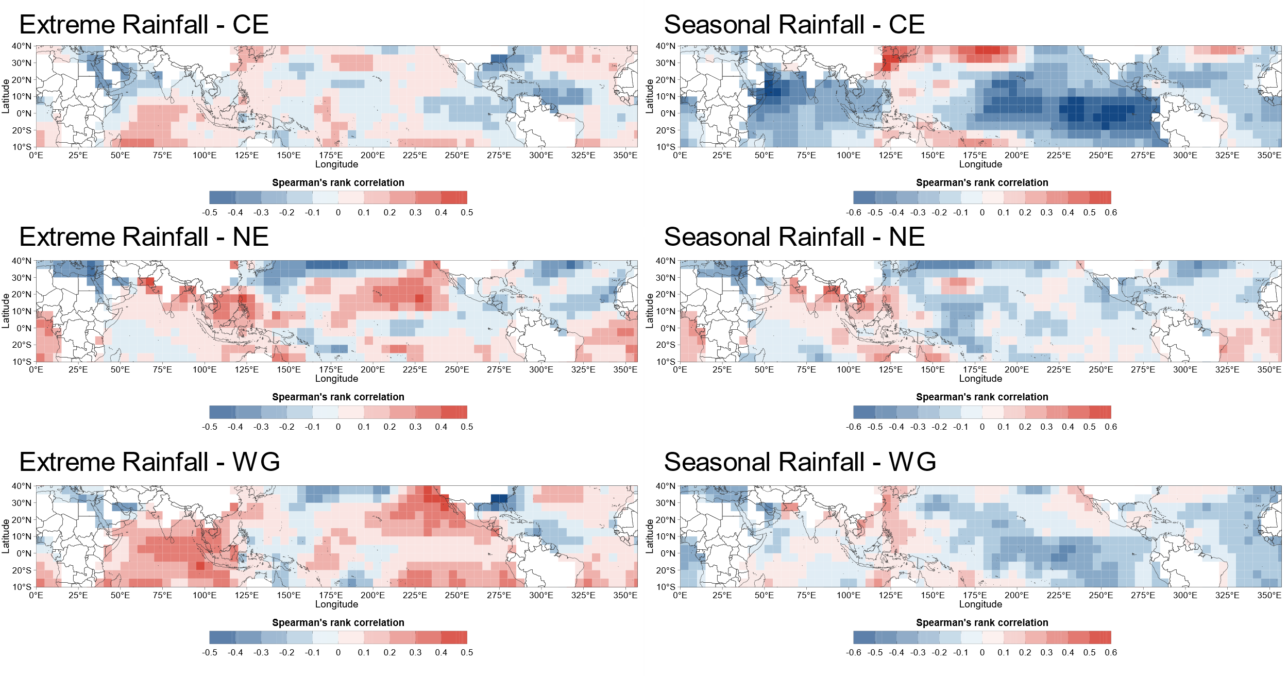
Figure S7. Correlation maps of monsoon season SSTs with (left column) extreme rainfall, (right column) seasonal rainfall for clusters CE (top row), NE (middle row) and WG (bottom row)

