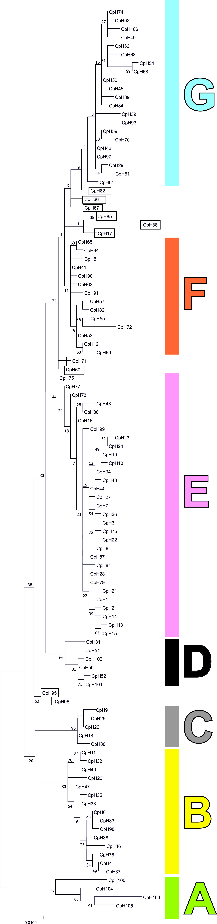

Figure S1: Phylogenetic tree representing the relationships among mtDNA haplogroups of the Siberian roe deer (C. pygargus). Tree constructed in Mega 7.0.14 under Hasegawa, Kishino and Yano (HKY) model. Colours and letters A – G refer to haplogroups shown in Figure 2. Haplotypes not assigned to any haplogroup are marked with boxes. Bootstrap = 10,000.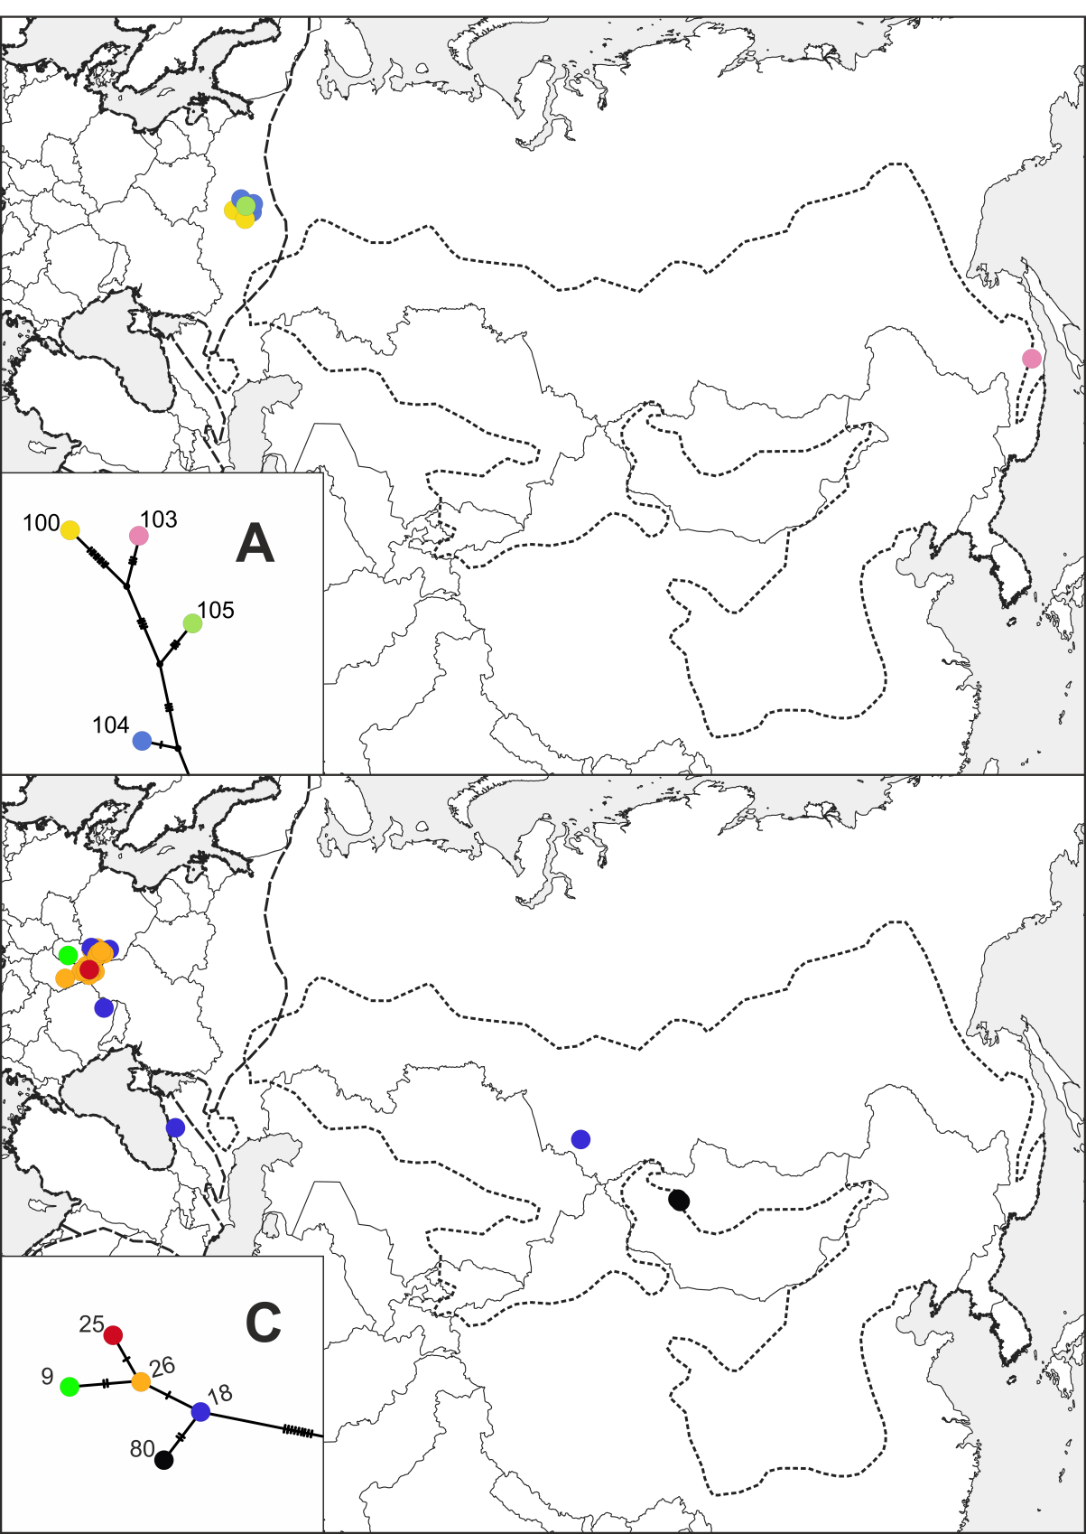

Figure S2. Geographical distribution of the Siberian roe deer haplotypes belonging to haplogroups A (upper panel) and C (lower panel). The small insert panels show fragments of the haplotype network in Figure 2. Colours and numbers denote different haplotypes. Broken lines mark contemporary ranges of the European and Siberian roe deer (see Figure 1).
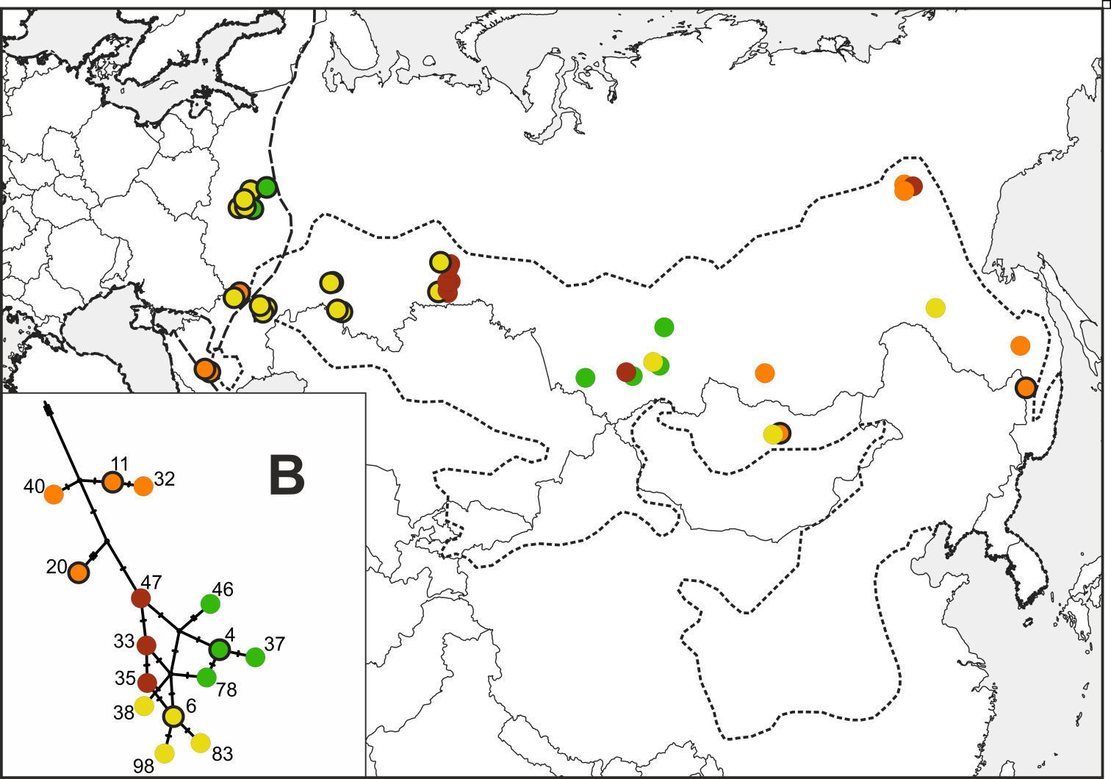

Figure S3. Geographical distribution of the Siberian roe deer haplotypes belonging to haplogroup B. The small insert panel shows a fragment of the haplotype network in Figure 2. Colours denote subgroups of haplotypes. Numbers mark different haplotypes. Haplotypes that were recorded in the range of both the European and Siberian roe deer are encircled in black. Other explanations as in Figure S2.

