Title: Prediction of acute suicidal ideation in young adults using multi-dimensional scales: A graph neural network approach
Kyu Sung Choi, M.D.¹, Byung Hoon Kim, M.D.², Sung Hwan Kim, M.D.¹, Hong Jin Jeon, M.D., Ph.D. ³, Jong-Hoon Kim, M.D., Ph.D. ^{4,5}, *Joon Hwan Jang, M.D., Ph.D ⁶, *Bumseok Jeong, M.D., Ph.D.^{1,7}

- Graduate School of Medical Science and Engineering, Korea Advanced Institute for Science and Technology (KAIST), Daejeon, Republic of Korea
- Bio Imaging and Signal Processing Laboratory, Department of Bio and Brain Engineering, Korea Advanced Institute for Science and Technology (KAIST), Daejeon, Republic of Korea
- Department of Psychiatry, Depression Center, Samsung Medical Center, Sungkyunkwan University School of Medicine, Seoul, Republic of Korea
- Department of Psychiatry, Gachon University College of Medicine, Gil Medical Center, Gachon University, Incheon, Republic of Korea
- Neuroscience Research Institute, Gachon Advanced Institute for Health Science and Technology, Gachon University, Incheon, Republic of Korea
- Department of Human Systems Medicine, Seoul National University College of Medicine, Seoul, Republic of Korea
- KAIST Institute for Health Science and Technology, Korea Advanced Institute for Science and Technology (KAIST), Daejeon, Republic of Korea

Corresponding Author:
*Bumseok Jeong, M.D., Ph.D.
Graduate School of Medical Science and Engineering, Korea Advanced Institute for Science and Technology,
291 Daehak-ro, Yuseong-gu, Daejeon, 34141, Republic of Korea
Tel: 82-42-350-4245
E-mail: bs.jeong@kaist.ac.kr
*Joon Hwan Jang, M.D., Ph.D.
Department of Human Systems Medicine, Seoul National University College of Medicine, 103 Daehak-ro, Jongro-gu, Seoul, 03080, Republic of Korea
Tel: 82-2-880-9022
E-mail: jhjang602@snu.ac.kr
Supplementary Material
Methods and materials
Baseline algorithms for prediction models: logistic regression with LASSO regularization and an SVM
As baseline algorithms for prediction models, logistic regression with least absolute shrinkage and selection operator (LASSO) and a support vector machine (SVM) were selected to be compared with our graph isomorphism network (GIN)-based ensemble model, MindWatchNet, for comparison to the previous study¹.
For classic binary classification, logistic regression is the most widely used, simple linear model. LASSO is also a linear model that estimates sparse coefficients by reducing the size of the coefficients and selecting the remaining non-zero terms after regularization. In other words, LASSO effectively “selects” the important features by minimizing the residual sum of squares subject to the sum of the absolute values of the coefficients being less than a constant². In addition, the SVM maps input vectors into some high-dimensional feature space through a non-linear mapping scheme, such as Gaussian and polynomial mapping³, for binary classification. In the feature space, a linear decision boundary is constructed, which is applicable to both separable and non-separable training data and takes advantage of the property of the decision space to guarantee high generalizability during machine learning³.

Self-report questionnaires on depression, anxiety, and clinical characteristics: the PHQ-9, GAD-7, STAI-S, RAS, RSES, and KSSI
To provide sufficient information about the mental states of the subjects, five scales (i.e., the PHQ-9⁴, GAD-7⁵, STAI-S^{6,7}, RAS⁸, and RSES⁹) and two labels (lifetime SA and the true or pseudo-label for MaDE) were each involved in assessing multi-dimensional aspects of SI, including depression, symptoms associated with GAD, status and trait anxiety, resilience, self-esteem, MaDEs, and suicide risk. More specifically, 23 input features were used to train and test prediction models for acute SI: gender and type of institution comprised 2 input features; each item of the PHQ-9 and GAD-7 comprised 16 input features; the total scores for the STAI-S, RAS, RSES comprised 3 input features (i.e., STAI-S_total, RAS_total, and RSES_total); the MaDE label comprised 1 input feature; and the lifetime SA label comprised 1 input feature. An item of a scale is referred to as (scale name)_(item number), i.e., PHQ_1, PHQ_2 …, PHQ_9 indicate items 1, 2, …, 9 of the PHQ-9, respectively. All the input features were one-hot encoded as a four-dimensional vector because the number of possible answers to each item of the PHQ-9 and GAD-7 was four (i.e., 0-3 points)^{4,5}. Gender was defined as binary: 0 if the subject was male and 1 if the subject was female. The type of institution was defined as binary: 0 if the institution is in a university setting, which has a lower incidence of depression, or 1 if the institution is in a hospital setting, which has a higher incidence of depression. The type of institution was employed as an input feature to provide information on different incidences of depression or the data distribution to the model.

PHQ-9
The Patient Health Questionnaire-9 (PHQ-9)⁴ is a nine-item instrument that screens for the presence and severity of depression. It asks the patient about their experiences over the preceding 2 weeks. The scores range from 0 to 27. In general, a score ≥10 suggests depression. The PHQ-9 is an instrument for making criteria-based diagnoses of depressive and other mental disorders commonly encountered in primary care, based on 9 items upon which the diagnosis of depressive disorders in the Diagnostic and Statistical Manual of Mental Disorders, 4th Edition (DSM-IV), is based⁴. Major depressive disorder (MDD) was diagnosed if 5 or more of the 9 depressive symptom criteria had been present for at least “more than half the days” in the past 2 weeks. As a severity measure, the score can range from 0 to 27 since the scores for each item range from 0 (not at all) to 3 (nearly every day). The higher the total score is, the higher the level of severity of depressive mood. The Korean version of the PHQ-9 could be a reliable and valid tool for the screening and assessment of depressive patients, showing a high test-retest correlation coefficient (r=0.89, p<0.01)¹⁰.

STAI-S
The State-Trait Anxiety Inventory-State Anxiety (STAI-S)^{6,7} is a psychological inventory that measures state anxiety (i.e., anxiety about an event) and consists of 20 questions. The scores range from 20 to 80, and higher scores mean higher levels of anxiety. More specifically, the STAI-S evaluates state anxiety (S-Anxiety), which assesses the transient anxious state of a subject at the time of the experiment and may be influenced by external factors, while trait anxiety (T-Anxiety) reflects generally experienced anxiety and shows an individual’s characteristic response to anxiety. Responses to each item were measured on a 4-point Likert scale from 1 (not at all) to 4 (very much so), with the total score ranging from 20 to 80. The higher the total score was, the higher the level of state and trait anxiety. The Korean version of the STAI has been validated with appropriate psychometric properties and good internal consistency, showing Cronbach’s α = 0.92 for the SAI and 0.90 for the TAI⁶.

GAD-7
The Generalized Anxiety Disorder-7 (GAD-7)¹¹ is a self-report instrument used to assess the severity of anxiety in general. The GAD-7 has seven items, and the scores range from 0 to 21. Higher scores indicate higher anxiety over the preceding 2 weeks. As a 7-item anxiety scale for generalized anxiety disorder (GAD), the GAD-7 is not only a strong validator for identifying cases of GAD but also an excellent severity measure showing that higher scores on the GAD-7 are strongly associated with multiple domains of functional impairment and disability days (Cronbach’s α for internal consistency = 0.92)⁵. Although GAD and depressive symptoms commonly co-occurred, a factor analysis revealed them as distinct dimensions, which ensures that the GAD-7 has independent input features different from PHQ-9 to provide the MindWatchNet model more information about a subject’s mental state. Each item is scored from 0 (not at all) to 3 (nearly every day), with a total score ranging from 0 to 21. The Korean version of the GAD-7 also showed acceptable diagnostic accuracy in detecting GAD with similar recommended thresholds (Cronbach’s α for internal consistency = 0.93)¹¹.

RAS
The Resilience Appraisal Scale (RAS)⁸ is used to assess an individual's ability to cope with his or her emotions, solve problems, and acquire social support. It consists of 12 items, and the scores range from 12 to 60. Higher scores indicate more positive self-appraisals. An individual’s ability to cope with emotions, solve problems, and gain social support are known as 3 types of positive self-appraisals that are particularly important in buffering individuals from suicidal ideation (SI) when facing stressful events. The RAS was developed to measure these appraisals quatitatively⁸. Reflecting the three areas, 12 items were developed and are scored from 1 (strongly disagree) to 5 (strongly agree). The alpha value of reliability was 0.88 for the scale. The Korean version of the RAS has been validated, showing that the mean score of the general population was signiﬁcantly higher than that of psychiatric outpatients and that the RAS has high internal consistency (Cronbach’s α = 0.92)¹².

RSES
The Rosenberg Self-Esteem Scale (RSES)⁹ consists of 10 items answered using a four-point scale to measure feelings of worthiness. The scores range from 10 to 40, and higher scores indicate higher self-esteem. Self-esteem represents a positive or negative attitude towards oneself. Rosenberg et al.⁹ revealed that people who have high self-esteem feel more happiness, are more stable and have goal-driven tendencies, whereas those who have low self-esteem become angry more frequently, feel unhappiness and are annoyed more frequently. The RSES⁹ evaluates self-esteem on 10 items (i.e., 5 items expressed are positive statements, and 5 items expressed as negative statements), scored from 0 (strongly disagree) to 4 (strongly agree). The Korean version of the RSES was validated and has a reported high internal consistency (Cronbach’s α = 0.90)¹³.

MINI
The Mini International Neuropsychiatric Interview (MINI) is a widely used brief structured diagnostic interview for major psychiatric disorders in the Diagnostic and Statistical Manual of Mental Disorders (DSM), which is validated for reliability comparing the MINI to the Structured Clinical Interview for DSM-III-R-Patient Version, showing similar performance in a shorter period of time¹⁴.

KSSI
The KAIST Scale for Suicidal Ideation (KSSI) was developed and validated on college students via mental health screening questionnaires¹⁵. Shim et al. reported that several factors, including low self-esteem, may enhance the prediction of future SI¹⁵. The KSSI comprises 28 items: 14 items on the past 2 weeks and another 14 items on the past 1 year. In the current study, the KSSI total score was defined as the sum of the scores on the first 14 items, rated from 0 to 4 to assess various levels of SI over the past 2 weeks on a scale ranging from mild (“I would rather fall asleep and not wake up”) to severe (“I will carry out my thoughts of wanting to take my own life”).

Graph construction
A graph s defined as $G=\left(V,E\right)$, where $V=\left\{v_{1},v_{2}, …, v_{N}\right\}$ is a set of vertices, or nodes, and $E=[e_{ij}]$ is a set of edge weights, where edge $e_{ij}$ connects vertices $v_{i}$ and $v_{j}$, if they are adjacent ($i, j=1,2, ⋯, N)$. $X=\{x_{1},x_{2}, …, x_{N}\}∈R^{N×D}$ is a set of node feature vectors $x_{i}$ for $v_{i}∈V$, where D is the dimension of the node feature vector. A = ${[e}_{ij}]∈R^{N×N}$is an adjacent matrix with edge weights as components. More specifically, $e_{ij}=\frac{COV(r_{x_{i}},r_{x_{j}})}{{r_{σ_{x_{i}}}}_{ }{r_{σ_{x_{j}}}}_{ }}$ is the covariance of rank variables when the node feature vectors are $r_{x_{i}} and r_{x_{j}}$, and the standard deviations of the rank variables of the node feature vectors are ${r_{σ_{x_{i}}}}_{ } and {r_{σ_{x_{j}}}}_{ }$, or Spearman’s rank correlation coefficient when the node feature vectors are ordinal variables (i.e., gender, type of institution, lifetime SA, PHQ_1, PHQ_2 …, PHQ_9, GAD_1, GAD_2 …, GAD_7). Similarly, Pearson’s correlation coefficient, or $e_{ij}=\frac{COV(x_{i}, x_{j})}{{σ_{x_{i}}}_{ }{σ_{x_{j}}}_{ }}$, was used for edge weights when the node feature vectors were continuous variables, i.e., for the STAI-S_total, RAS_total, and RSES_total scores. For the prediction of MaDEs and acute SI, seven questionnaires obtained from each subject were used to construct a graph, $G$. Because each item was an ordinal variable ranging from 0-3 for two questionnaires, the PHQ-9 and GAD-7, the node feature vectors of the graph, $x_{i}$, is a one-hot encoded vector of the point of each item (i.e., 0-3 points). The item values of the STAI-S, RAS, and RSES questionnaires were summed and discretized into values from 0-3 using quantiles to make the total scores ordinal variables.
For the RAS and RSES, the ordinality was flipped (i.e., higher total scores were discretized to 1, and lower total scores were discretized to 4) to make all the correlation coefficients or edge weights non-negative, considering that the RAS and RSES were negatively correlated with acute SI, which was investigated via exploratory data analysis (Supplementary Fig. 1).
The edge weights between the nodes, $a_{ij}$, were calculated from Spearman’s rank correlation coefficients between the node features before one-hot encoding. More specifically, the edge was calculated from the pairwise correlation coefficients between each item value (i.e., 0-3 points) of the questionnaire using the qgraph R package for the training and validation set. To prevent edges in the graph from being non-negative, the absolute values of the edge weights were used. The sparsity of the graph edges was controlled by setting the threshold to 0.6; i.e., edges with correlation coefficients < 0.6 were removed.
Finally, a questionnaire obtained from each subject was used to construct a graph, where the number of nodes was 23, and the number of edges was 127 with non-zero, positive edge weights for each graph. For validation and testing, the same edge matrix obtained from the training set was used for graph construction in the validation and test sets.

Mathematical process of the GNN
More specifically, a GNN aggregates neighbouring node features and combines the aggregation with the previous node feature, namely, aggregate and combine functions. The GIN specifies the function for aggregation and combination as an addition operation, and multi-layer perceptron (MLP) layers are added for high-dimensional transformation¹⁶. More specifically, K hidden graph convolutional layers were used (Eq. 2): the aggregate and combine functions from Eq. 1 were replaced by the addition operation and combined with an MLP.
$a_{v}^{\left(k\right)}=AGGREGATE^{\left(k\right)}\left(\left\{h_{u}^{\left(k-1\right)}:u∈N\left(v\right)\right\}\right), h_{v}^{\left(k\right)}={COMBINE}^{\left(k\right)}\left(h_{v}^{\left(k-1\right)}, a_{v}^{\left(k\right)}\right)$ (Eq. 1)
$h_{v}^{(k)}=MLP^{\left(k\right)}(\left(1+ϵ^{\left(k\right)}\right)∙h_{v}^{\left(k\right)}+\sum_{u∈N\left(v\right)}{h_{u}^{\left(k-1\right)}})$ for $k=0,1, ⋯, K$(Eq. 2)
where $h_{v}^{\left(k\right)}$ is the feature vector of node $v∈V$ in graph $G=\left(V,E\right)$ at the kth hidden layer; $N(v)$ indicates neighbouring nodes of node $v$, which decided by the edge features, $E$; and $ϵ^{\left(k\right)}$ is a learnable parameter at the kth hidden layer. For graph classification, the READOUT function aggregates node features from the final layer to obtain the representation of the entire graph, $h_{G}$:
$h_{G}=CONCAT\left(READOUT\left(\left\{h_{v}^{\left(k\right)} | v∈G\right\}\right) | k=0,1,⋯,K\right)$ (Eq. 3)
In the GIN, READOUT is replaced by sum-pooling of all the node features from the same layers and concatenating the sum-pooled features across all the layers to obtain $h_{G}$. Finally, $h_{G}$ is fed to the final classifier to obtain the sigmoid prediction score for acute SI.

pseudo-labels for MaDE
For the GIN-MaDE networks, each item of the PHQ-9 (9 items), GAD-7 (7 items), and STAI-S (20 items) were one-hot encoded as 4-dimensional vectors (0-3 points) to create 36 input node features in total, the 36 nodes were constructed into a graph; and the correlation coefficients between the ordinal variables of nodes (i.e., PHQ_1 and GAD_1 given as 0-3 points) were calculated in the same way described in the Graph construction section to construct the edge features. The labels were binary (0 or 1) according to whether the MaDE negative or positive, respectively: there were 79 positive cases out of a total of n=294. The data from centre 4, which were used for the external validation of the GIN SI model, were used as the test set: there were 23 positive cases out of n=64. The data from the remaining three centres (1-3) were used as the training and validation set; the positive cases in the training set were augmented approximately 3 times using the synthetic minority over-sampling technique (SMOTE)¹⁷ (detailed in the following section), and randomly divided at an 8:2 ratio. After training, MaDE pseudo-labels were generated for all the subjects without true MaDE labels by forward-passing their PHQ-9, GAD-7, and STAI-S items as input node features into the trained GIN-MaDE network.

Detailed subsampling strategy
For under-sampling, random subsampling of the majority class was used. For over-sampling, we augmented the training data with positive labels (i.e., subjects with SI) using a strategy called SMOTE¹⁷ and to address class imbalance in the dataset – a ratio of nearly 1:100 – because of the low incidence of acute SI. In the binary classification task, the larger the difference between the number of samples of the majority and minority classes is, the worse the model performs. Additionally, the more data we have, the better the model performs. Specifically, SMOTE introduces synthetic examples by taking the k nearest neighbour minority samples and selecting a random point along the line segment between them or taking a linear combination of neighbours in the “feature space” rather than the “data space”¹⁷. Because our dataset contains both ordinal and continuous variables, we used SMOTE for nominal and continuous features (SMOTE-NC). In SMOTE-NC, the categories of a new synthetic sample are selected as the most frequent category of the nearest neighbours present during generation¹⁸. In this way, we can augment the training data and balance the number in each class.

Implementation details
For the GIN models, 5 graph convolutional layers, combined with the MLP of two 128-dimensional hidden linear layers, were used; i.e., K=5 in Eq. 2. A one-dimensional batch normalization layer and rectified linear units (ReLU) function were applied as the activation function at the end of each hidden layer. Dropout was applied to the final hidden layer to prevent overfitting (rate = 0.5)¹⁹. A sigmoid function was applied to the final prediction score to achieve binary classification. The binary cross-entropy function was used as an objective function. The adaptive moment estimation (Adam)²⁰ optimizer was used with an initial learning rate of 0.01 and decayed by gamma = 0.2 every 10 epochs. The minibatch size was 64, and the models were trained for 50 epochs; the best model was saved using early stopping. The model was implemented using Python 3.6.0, PyTorch 1.4.0, and Deep Graph Library (DGL) 0.4.0²¹ and trained on a workstation equipped with a Tesla P-100 GPU (NVIDIA, Champaign, IL).

T-SNE
To visualize the high-dimensional latent feature space in the two-dimensional plane, t-distributed stochastic neighbour embedding (t-SNE) was used²². T-SNE maps the pairwise similarity between data points in high-dimensional space and is capable of capturing the local structure as well as revealing the global structure such as the presence of clusters²². Because the last layer of a GIN model contains the most encoded latent features, a t-SNE plot was obtained using the high-dimensional features in the last layer just before the last fully connected layer to output the sigmoid prediction score. For each of the three GIN models and the ensemble GIN model, t-SNE plots were obtained for both the validation and test sets.

Results
Attention plots in the training/validation set
A two-dimensional matrix of attention values, or an attention plot, was obtained for each subject and averaged across all the subjects in specific datasets (i.e., the training/validation set or test set). The averaged attention plot was converted using different normalization method for a better visualization of the results. The following set of attention plots was constructed: 1) the raw averaged attention plot without normalization (Fig. 2a); 2) an attention plot comparing questionnaire items by using row-wise normalization or dividing the raw averaged attention plot by the largest absolute values of each row (only for 19 questionnaire items, Fig. 2b); 3) an attention plot comparing binary items by using column-wise normalization or dividing the raw averaged attention plot by the smallest absolute values of each column for only 4 binary categorical clinico-demographic variables (i.e., gender, type of institution, MaDE, and lifetime SA; Fig. 2c); and 4) a bar plot by using the L1-norm of the attention vector, which is obtained for each column of the 19 questionnaire items and 4 clinico-demographic variables (Fig. 2d).
The overall findings in the training/validation set were similar to those in the test set. The raw averaged attention plots without normalization are given in Supplementary Fig. 3a for the training/validation set. In the attention plot comparing questionnaire items by using row-wise normalization (Supplementary Fig. 3b), a high score (i.e., 4 points) for PHQ_2 was the most salient positive feature, and a high total score in the STAI-S (i.e., the 4th quartile group) was the 2nd most salient positive feature among 19 items of the questionnaires. In the attention plot comparing binary items by using column-wise normalization, the attention values were highest for lifetime SA (OR, 5.79), presence of an MaDE (OR, 3.67) and type of institution (OR, 2.37), and the OR for female sex was 1.00 (Supplementary Fig. 3c). The L1-norm of the attention vector was obtained for each column of the 19 questionnaire items (Supplementary Fig. 2d).

T-SNE
In the validation and test sets, subjects with acute SI (i.e., positive cases) were well classified by all the GIN models (Supplementary Fig. 4). In the validation set, positive cases were well clustered in the lower half, right lower half, and left lower space (Supplementary Figs. 4b-d), and the numbers of positive and negative cases in the training/validation set were 129 and 1290, 129 and 645, and 17,353 and 17,353, respectively, which were controlled by the balance ratio (Supplementary Table 1) for the GIN-synthetic minority over-sampling technique (SMOTE), GIN-u1, and GIN-u2 models, respectively. In the test set using the ensemble GIN model, positive cases were well clustered to the right of centre (Supplementary Fig. 4a), although the number of positive cases was too small to recognize compared to the validation set. In the test set, there were 177 positive and 14,061 negative cases (positive ratio, 1.24%) (Supplementary Table 1).

Supplementary Table 1. Demographics of subjects
Dataset | Train/valid |  |  |  | Test | Total | p-value
Center/  item | Center 1 (n=17,322) | Center 2 (n=69) | Center 3 (n=91) | Centers 1+2+3  (n=17,482) | Center 4  (n=14,238) | Centers 1+2+3+4  (n=31,720) | Train/valid vs  Test
Age (years)* | 23.15$±$4.17  (16-51) | 24.65$±$3.81  (19-37) | 25.96$±$3.89  (19-35) | 23.17$±$4.17  (16-51) | 24.23$±$3.59  (18-35) | 23.64$±$3.96  (16-51) | <0.0001
Gender  (Male)** | 13,888  (80.18%) | 31  (44.93%) | 57  (62.64%) | 13,976  (79.95%) | 7663 (53.82%) | 21,639 (68.22%) | <0.0001
Suicidal ideation (lifetime)** | 1029  (5.94%) | 30  (43.48%) | 25  (27.47%) | 1,084  (6.20%) | 1,557  (10.94%) | 2,641 (8.33%) | <0.0001
Acute suicidal ideation** | 107  (0.62%) | 11  (15.94%) | 11  (12.09%) | 129  (0.74%) | 177  (1.24%) | 306  (0.97%) | <0.0001
Suicidal attempt  (lifetime)** | 127  (0.73%) | 14  (20.29%) | 9  (9.89%) | 150  (0.86%) | 287  (2.02%) | 437  (1.38%) | <0.0001
MaDE | 8  (0.046%) | 29  (42.03%) | 42  (46.15%) | 79  (0.45%) | 23  (0.16%) | 102  (0.32%) | <0.0001
PHQ-9* | 1.65$±$2.89  (0-27) | 8.42$±$8.20  (0-22) | 7.09$±$6.99  (0-25) | 1.71$±$3.02  (0-27) | 2.90$±$3.77  (0-27) | 2.23$±$3.42  (0-27) | <0.0001
GAD-7* | 1.04$±$2.33  (0-21) | 5.00$±$6.21  (0-21) | 4.81$±$5.55  (0-21) | 1.08$±$2.41  (0-21) | 1.96$±$3.12  (0-21) | 1.46$±$2.77  (0-21) | <0.0001
STAI-S* | 38.16$±$10.03  (20-80) | 38.12$±$7.14  (23-53) | 49.21$±$9.65  (20-76) | 38.22$±$10.06  (20-80) | 38.46$±6$.50  (20-80) | 38.23$±$8.69  (20-80) | 0.01
RAS* | 48.29$±$8.46  (0-60) | 40.41$±$10.87  (18-60) | 41.03$±$11.02  (12-60) | 48.22$±$8.52  (0-60) | 46.01$±$7.98  (0-60) | 47.26$±$8.36  (0-60) | <0.0001
RSES* | 31.95$±$5.24  (0-40) | 24.45$±$2.79  (17-29) | 27.53$±$7.35  (12-40) | 31.90$±$5.28  (0-40) | 25.04$±$2.47  (0-40) | 28.91$±$5.47  (0-40) | <0.0001
* indicates mean $±$ standard deviation (range)
** indicates positive (or male)/total subjects of the group, and numbers in parenthesis indicates percentage (%).
Abbreviations: MaDE, Major depressive episode

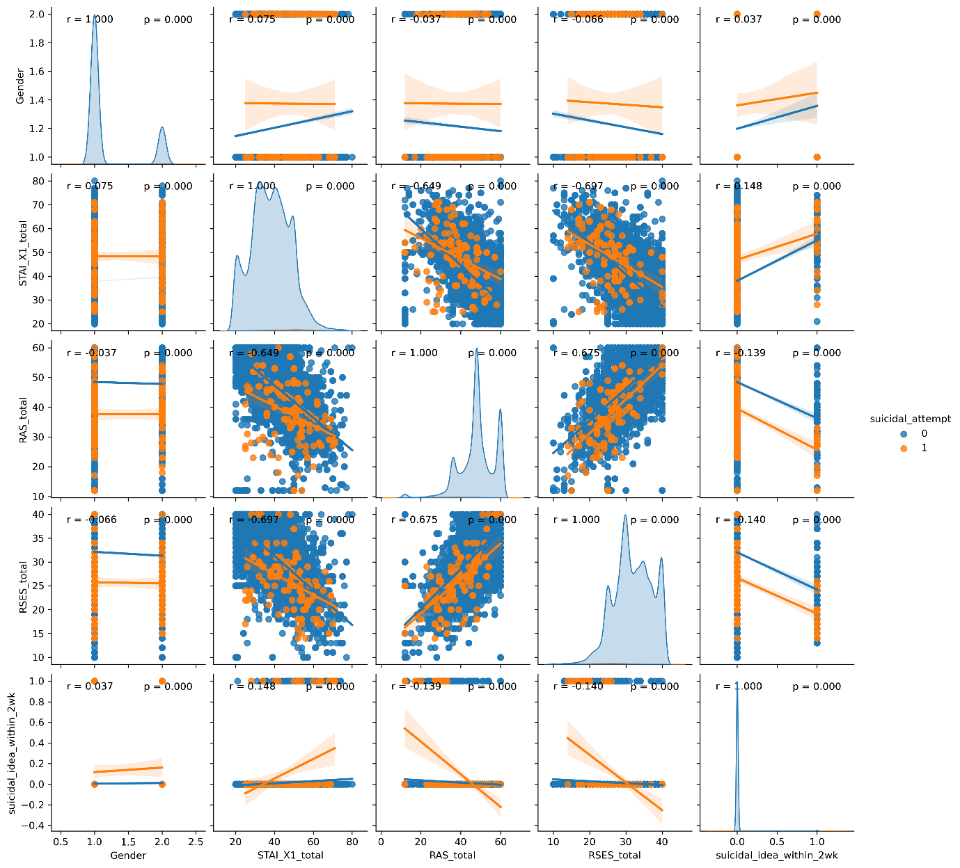
Supplementary Figure 1. Exploratory data analysis

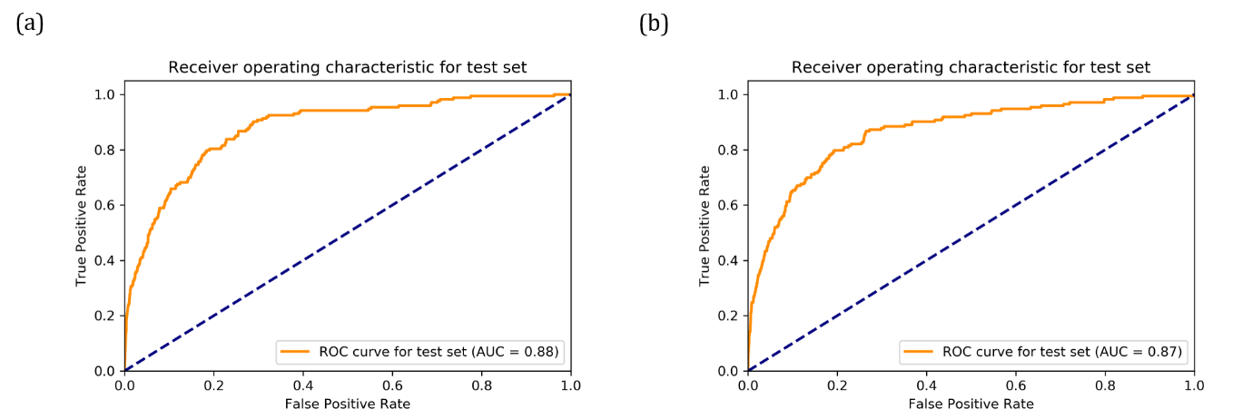
Supplementary Figure 2. Receiver operating characteristic (ROC) curves of MindWatchNet (a) with and (b) without item 9 of the PHQ-9: the areas under the curves (AUCs) were 0.877 and 0.869, respectively, and there was no significant difference between the diagnostic performances of the two models (p=0.150; DeLong’s method).

Supplementary Figure 3. Attention plots. (a) The raw averaged attention plots, (b) the attention plot comparing the questionnaire items, (c) the attention plot comparing the binary items, (d) the attention plot for the mixed Gaussian model-based graphical network (generated with the “mgm” R package for visualization) for the questionnaire items on the training/validation set (n=17,482).

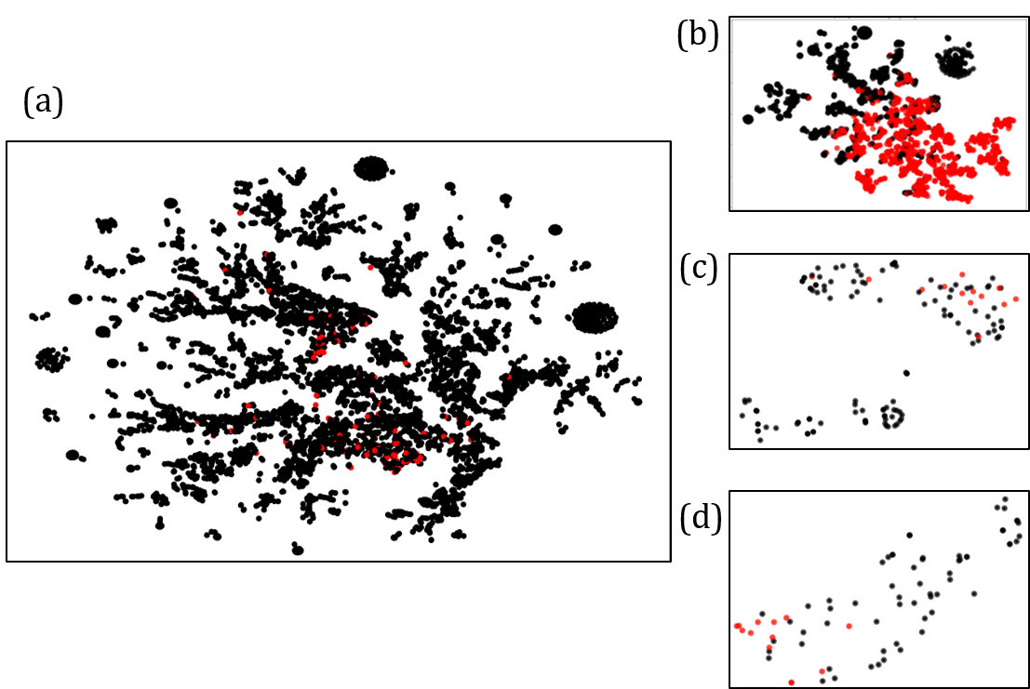
Supplementary Figure 4. t-distributed stochastic neighbour embedding (t-SNE) plots of (a) the ensemble GIN model, or MindWatchNet, for the test set (177 positive cases out of 14,238), (b-d) GIN-synthetic minority over-sampling technique (SMOTE) (1,734 positive cases out of 3,468), GIN-u1 (13 positive cases out of 142), GIN-u2 (13 positive cases out of 78) for the validation set, respectively.

Supplementary References
1. Simon, G.E., et al. Predicting suicide attempts and suicide deaths following outpatient visits using electronic health records. American Journal of Psychiatry 175, 951-960 (2018).
2. Tibshirani, R. Regression shrinkage and selection via the lasso. Journal of the Royal Statistical Society: Series B (Methodological) 58, 267-288 (1996).
3. Cortes, C. & Vapnik, V. Support-vector networks. Machine learning 20, 273-297 (1995).
4. Kroenke, K., Spitzer, R.L. & Williams, J.B. The PHQ-9: validity of a brief depression severity measure. J Gen Intern Med 16, 606-613 (2001).
5. Spitzer, R.L., Kroenke, K., Williams, J.B. & Lowe, B. A brief measure for assessing generalized anxiety disorder: the GAD-7. Arch Intern Med 166, 1092-1097 (2006).
6. Hahn, D.-W. Korean adaptation of Spielberger's STAI (K-STAI). Kor J Health Psychol 1, 1-14 (1996).
7. Spielberger, C. State-trait anxiety inventory. The Corsini encyclopedia of psychology. Hoboken: Wiley 1(2010).
8. Johnson, J., Gooding, P.A., Wood, A.M. & Tarrier, N. Resilience as positive coping appraisals: Testing the schematic appraisals model of suicide (SAMS). Behaviour Research and Therapy 48, 179-186 (2010).
9. Rosenberg, M. Rosenberg self-esteem scale (RSE). Acceptance and commitment therapy. Measures package 61, 18 (1965).
10. Park, S.-J., Choi, H.-R., Choi, J.-H., Kim, K.-W. & Hong, J.-P. Reliability and validity of the Korean version of the Patient Health Questionnaire-9 (PHQ-9). Anxiety and mood 6, 119-124 (2010).
11. Ahn, J.-K., Kim, Y. & Choi, K.-H. The psychometric properties and clinical utility of the Korean version of GAD-7 and GAD-2. Frontiers in psychiatry 10, 127 (2019).
12. Jung, Y.E., et al. The Korean version of the Connor–Davidson Resilience Scale: an extended validation. Stress and Health 28, 319-326 (2012).
13. Bae, H.-N., Choi, S.-W., Yu, J.-C. & Lee, J.-S. Reliability and validity of the Korean version of the Rosenberg Self-Esteem Scale (K-RSES) in adult. Mood Emot 12, 43-49 (2014).
14. Sheehan, D.V., et al. The Mini-International Neuropsychiatric Interview (M.I.N.I.): the development and validation of a structured diagnostic psychiatric interview for DSM-IV and ICD-10. J Clin Psychiatry 59 Suppl 20, 22-33;quiz 34-57 (1998).
15. Shim, G. & Jeong, B. Predicting Suicidal Ideation in College Students with Mental Health Screening Questionnaires. Psychiatry Investig 15, 1037-1045 (2018).
16. Xu, K., Hu, W., Leskovec, J. & Jegelka, S. How powerful are graph neural networks? arXiv preprint arXiv:1810.00826 (2018).
17. Chawla, N.V., Bowyer, K.W., Hall, L.O. & Kegelmeyer, W.P. SMOTE: Synthetic minority over-sampling technique. Journal of Artificial Intelligence Research 16, 321-357 (2002).
18. Lemaître, G., Nogueira, F. & Aridas, C.K. Imbalanced-learn: A python toolbox to tackle the curse of imbalanced datasets in machine learning. The Journal of Machine Learning Research 18, 559-563 (2017).
19. Srivastava, N., Hinton, G., Krizhevsky, A., Sutskever, I. & Salakhutdinov, R. Dropout: A Simple Way to Prevent Neural Networks from Overfitting. Journal of Machine Learning Research 15, 1929-1958 (2014).
20. Kingma, D.P. & Ba, J. Adam: A method for stochastic optimization. arXiv preprint arXiv:1412.6980 (2014).
21. Wang, M., et al. Deep graph library: Towards efficient and scalable deep learning on graphs. arXiv 2019. arXiv preprint cs.LG/1909.01315.
22. Van der Maaten, L. & Hinton, G. Visualizing data using t-SNE. Journal of machine learning research 9(2008).

