Supplementary Materials

Table S1 Aboveground and belowground plant attributes and soil properties in 87 subplots. [This file is a large table (Excel file) and submitted separately]

Table S2 Means of the first three root orders of fine root functional traits in 20 common woody plants.
Species (Mycorrhizal type) | C | N | C:N | SRL | Diam
Pinus massoniana (ECM) | 447  (16.1) | 14.9  (0.67) | 30.7  (2.47) | 42.5  (7.07) | 0.34  (0.03)
Lithocarpus glaber (ECM) | 512  (12.7) | 23.6  (1.01) | 22.0  (1.36) | 53.7  (4.22) | 0.27  (0.01)
Loropetalumchinense (R. Br.) Oliver (ECM) | 458  (10.5) | 22.7  (1.20) | 20.5  (1.22) | 26.0  (4.90) | 0.34  (0.02)
Quercus glauca (ECM) | 524  (16.2) | 17.5  (0.64) | 30.3  (1.97) | 54.5  (10.1) | 0.24  (0.01)
Quercus fabri Hance (ECM) | 417  (8.96) | 26.6  (1.50) | 15.9  (0.86) | 54.8  (10.9) | 0.28  (0.02)
Sassafras tzumu (AM) | 501  (17.0) | 19.7  (0.39) | 25.5  (1.13) | 38.3  (3.23) | 0.33  (0.02)
Choerospondias axillaris (AM) | 469  (13.3) | 17.6  (0.87) | 27.2  (2.16) | 90.5  (23.3) | 0.27  (0.03)
Liquidambar formosana (AM) | 518  (18.2) | 17.3  (0.78) | 30.4  (2.20) | 45.4  (8.57) | 0.34  (0.03)
Cunninghamia lanceolata (AM) | 489  (12.5) | 17.6  (1.16) | 28.4  (1.89) | 13.7  (2.69) | 0.63  (0.06)
Cinnamomum camphora (AM) | 438  (14.1) | 17.7  (0.42) | 24.9  (1.29) | 18.1  (2.70) | 0.51  (0.04)
Schima superb (AM) | 557  (9.00) | 20.3  (1.03) | 27.9  (1.72) | 87.9  (7.31) | 0.26  (0.02)
Ilex formosana (AM) | 534  (14.2) | 10.3  (0.70) | 54.4  (4.92) | 52.4  (11.8) | 0.38  (0.05)
Vernicia fordii (Hemsl.) (AM) | 547  (7.52) | 22.0  (0.41) | 25.0  (0.67) | 22.3  (5.56) | 0.70  (0.07)
Rhododendron (AM) | 520  (6.34) | 11.1 (0.44) | 47.3  (2.20) | 18.5  (6.67) | 0.19  (0.01)
Diospyros kaki Thunb. var. silvestris Makino (AM) | 487  (11.8) | 24.6  (0.96) | 20.0  (1.17) | 1.29  (0.17) | 0.54  (0.03)
Camellia oleiferaAbel (AM) | 577  (17.4) | 17.8  (1.23) | 34.3  (3.23) | 129  (40.4) | 0.29  (0.05)
Litsea cubeba (AM) | 500  (18.0) | 24.1  (1.25) | 21.6  (1.98) | 35.1  (9.01) | 0.62  (0.04)
Symplocos caudata (NM) | 538  (8.41) | 13.7  (1.43) | 44.0  (5.81) | 76.1  (19.5) | 0.47  (0.10)
Symplocos stellaris (NM) | 542  (11.7) | 9.97  (1.67) | 69.0  (11.5) | 66.0  (21.2) | 0.44  (0.08)
Eurya muricata Dunn (NM) | 532  (27.6) | 10.6  (0.21) | 50.7  (3.67) | 34.0  (13.0) | 0.45  (0.08)
Inside the brackets represent standard error (SE). ECM, ectomycorrhizal; AM, arbuscular mycorrhizal; NM, nonmycorrhizal; C, root carbon content (g kg⁻¹); N, root nitrogen content (g kg⁻¹); C:N, root carbon:nitrogen ratio; SRL, specific root length (m g⁻¹); Diam, root diameter (mm).

Table S3 Results of multiple regression models of bacterial richness in the organic horizon. We present the AICc for all selected models with a ∆AICc ≤2. The selected variables are shaded (blue).
Model parameters |  |  |  |  |  | CWM |  |  | FDis
df | AICc | ∆AICc | Weight | Root com.2 | FRB | C:N | SRL | Diam | C:N | SRL
7 | 7 | 179.5 | 0
7 | 8 | 180.2 | 0.66
6 | 8 | 181.3 | 1.81
Relative contribution (%) |  |  |  | 15 | 1.6 | 12 | 15 | 28 | 0.7 | 27
p value |  |  |  | <0.001 | 0.61 | 0.006 | 0.04 | <0.001 | 0.79 | <0.001
CWM, community weighted mean; FDis, functional dispersion; Root com.2, fine root composition based on the axis 2 of a principal component analysis; FRB, fine root biomass; C:N, root carbon:nitrogen ratio; SRL, specific root length (m g⁻¹); Diam, fine root diameter (mm).

Table S4 Results of multiple regression models of fungal richness in the organic horizon. We present the AICc for all selected models with a ∆AICc ≤2. The selected variables are shaded (blue).
Model parameters |  |  |  |  |  |  | CWM |  |  | FDis
df | AICc | ∆AICc | Weight | FRSR | Root com.2 | FRB | C:N | SRL | Diam | SRL
7 | 211.47 | 0 | 0.13
8 | 211.81 | 0.34 | 0.11
7 | 211.92 | 0.45 | 0.10
6 | 211.05 | 0.58 | 0.09
6 | 212.21 | 0.74 | 0.09
6 | 212.53 | 1.06 | 0.07
5 | 212.60 | 1.13 | 0.07
7 | 212.93 | 1.46 | 0.06
5 | 213.02 | 1.55 | 0.06
7 | 213.05 | 1.57 | 0.06
7 | 213.10 | 1.62 | 0.06
6 | 213.27 | 1.80 | 0.05
8 | 213.35 | 1.88 | 0.05
Relative contribution (%) |  |  |  | 0.7 | 6 | 5 | 10 | 28 | 38 | 13
p value |  |  |  | 0.82 | 0.40 | 0.44 | 0.20 | 0.06 | 0.007 | 0.30
CWM, community weighted mean; FDis, functional dispersion; FRSR, fine root species richness; Root com.2, fine root composition based on the axis 2 of a principal component analysis; FRB, fine root biomass; C:N, root carbon:nitrogen ratio; SRL, specific root length (m g⁻¹); Diam, fine root diameter (mm).

Table S5 Results of multiple regression models of bacterial richness in the mineral horizon. We present the AICc for all selected models with a ∆AICc ≤2. The selected variables are shaded (blue).
Model parameters |  |  |  |  |  |  | CWM | FDis
df | AICc | ∆AICc | Weight | FRSR | Root com.2 | FRB | C:N | SRL
4 | 232.27 | 0 | 0.25
5 | 233.24 | 0.96 | 0.15
4 | 233.39 | 1.11 | 0.14
5 | 233.60 | 1.33 | 0.13
5 | 233.65 | 1.38 | 0.12
3 | 233.84 | 1.56 | 0.11
5 | 234.09 | 1.81 | 0.10
Relative contribution (%) |  |  |  | 18 | 3 | 1.4 | 7 | 70
p value |  |  |  | 0.08 | 0.30 | 0.37 | 0.17 | <0.001
CWM, community weighted mean; FDis, functional dispersion; FRSR, fine root species richness; Root com.2, fine root composition based on the axis 2 of a principal component analysis; FRB, fine root biomass; C:N, root carbon:nitrogen ratio; SRL, specific root length (m g⁻¹).

Table S6 Results of multiple regression models of bacterial richness in the mineral horizon. We present the AICc for all selected models with a ∆AICc ≤2. The selected variables are shaded (blue).
Model parameters |  |  |  |  |  | CWM |  |  | FDis
df | AICc | ∆AICc | Weight | Root com.2 | FRB | C: N | SRL | Diam | C:N | SRL
6 | 237.72 | 0 | 0.18
5 | 237.92 | 0.20 | 0.16
7 | 238.01 | 0.29 | 0.16
6 | 238.19 | 0.47 | 0.14
5 | 238.87 | 1.16 | 0.10
6 | 238.92 | 1.20 | 0.10
6 | 239.04 | 1.32 | 0.09
5 | 239.62 | 1.91 | 0.07
Relative contribution (%) |  |  |  | 10 | 27 | 1.5 | 10 | 15 | 25 | 12
p value |  |  |  | 0.48 | 0.03 | 0.81 | 0.54 | 0.36 | 0.08 | 0.49
CWM, community weighted mean; FDis, functional dispersion; Root com.2, fine root composition based on the axis 2 of a principal component analysis; FRB, fine root biomass; C:N, root carbon:nitrogen ratio; SRL, specific root length (m g⁻¹); Diam, fine root diameter (mm).

Table S7 ANOVA-like results based on redundancy analysis (RDA) testing the effect of the forward-selected biotic and abiotic factors on the bacterial (phylum level) and fungal (fungal functional guild) composition in organic and mineral horizons.
 | Variables | Variance | F | P | Model R²_{adj} | Model P
Bacterial community composition in organic horizon | FDis_SRL | 788798 | 41.2 | 0.001 | 0.41 | 0.001
Bacterial community composition in organic horizon | CWM_SRL | 100289 | 5.23 | 0.01
Bacterial community composition in organic horizon | CWM_diam | 95957 | 5.01 | 0.01
Bacterial community composition in organic horizon | CWM_CN | 108171 | 5.65 | 0.006
Bacterial community composition in organic horizon | FRB | 82726 | 4.32 | 0.03
Bacterial community composition in organic horizon | Residual | 1552138
Fungal functional guild in organic horizon | FDis_SRL | 14223707 | 32.7 | 0.001 | 0.32 | 0.001
Fungal functional guild in organic horizon | Root com.2 | 4703686 | 10.8 | 0.002
Fungal functional guild in organic horizon | Residual | 36543762
Bacterial community composition in mineral horizon | FDis_CN | 172048 | 6.09 | 0.007 | 0.12 | 0.001
Bacterial community composition in mineral horizon | FRSR | 219003 | 7.75 | 0.004
Bacterial community composition in mineral horizon | Residual | 2375020
Fungal functional guild in mineral horizon | FDis_SRL | 38128989 | 55.8 | 0.001 | 0.40 | 0.001
Fungal functional guild in mineral horizon | CWM_diam | 2432085 | 3.56 | 0.04
Fungal functional guild in mineral horizon | Residual | 57417111
The F statistics was tested using the Monte Carlo test based on 999 permutations. FDis_SRL, functional dispersion (FDis) of specific root length; FRB, fine root biomass; CWM_SRL, community weighted means (CWM) of specific root length; CWM_diam, CWM of fine root diameter; CWM_CN, CWM of root carbon:nitrogen ratio; Root com.2, fine root composition based on the axis 2 of a principal component analysis; FRSR, fine root species richness.

Table S8 Relativeeffects of plant and soil properties on bacterial and fungal richness in organic and mineral horizons.
Variables | Organic horizon |  |  |  | Mineral horizon
Variables | Bacterial richness Adj. R² = 0.73 |  | Fungal richness Adj. R² = 0.52 |  | Bacterial richness Adj. R² = 0.38 |  | Fungal richness Adj. R² = 0.27
Variables | Estimate | Relative contribution (%) | Estimate | Relative contribution (%) | Estimate | Relative contribution (%) | Estimate | Relative contribution (%)
CWM_diam | 0.18** | 9 | 0.29*** | 14 |  |  | 0.18 | 11
CWM_CN |  |  |  |  | -0.02 | 0.8
FDis_SRL | 0.24* | 12 | 0.08 | 4 | 0.53*** | 26 | 0.01 | 0.8
FDis_CN | -0.01 | 0.5 | -0.01 | 0.7 |  |  | 0.01 | 0.5
Root com.2 | -0.01 | 0.5 |  |  | -0.25* | 13 | 0.09 | 5
Fine root richness | -0.02 | 1 | 0.05 | 2 | -0.07 | 4
FRB |  |  |  |  | -0.13 | 7 | -0.24* | 14
Soil C:N | -0.30*** | 15 | -0.27** | 13 | -0.19 | 9 | 0.01 | 0.6
Soil TP | 0.27*** | 14 | 0.43*** | 20 |  |  | 0.50*** | 30
Soil TN | -0.17* | 9 | -0.26* | 12 |  |  | 0.04 | 3
Soil AP | 0.01 | 0.3 | -0.003 | 0.1 | 0.02 | 0.8 | -0.49*** | 30
Soil pH | 0.36*** | 19 | 0.11 | 5 | 0.08 | 4 | -0.06
Soil moisture |  |  | 0.04 | 2 | -0.24* | 12 |  | 4
Aboveground com.1 | 0.21* | 11 | 0.38** | 17 | 0.14 | 7 | 0.02 | 1.4
Aboveground com.2 |  |  | -0.01 | 0.3 | -0.32*** | 16 | -0.004 | 0.2
Aboveground richness | -0.17 | 9 | -0.22 | 10 | -0.01 | 0.4 | -0.01 | 0.9
Litter biomass | -0.01 | 0.3
LAI |  |  |  |  |  |  | 0.005 | 0.3
C:N, carbon:nitrogen ratio; TN, total nitrogen; TP, total phosphorus; AP, available phosphorus; CWM_diam, community weighted means (CWM) of root diameter; CWM_CN, CWM of root carbon:nitrogen ratio; FDis_SRL, functional dispersion (FDis) of specific root length; FDis_CN, FDis of root carbon:nitrogen ratio; Root com.2, fine root composition based on the axis 2 of a principal component analysis; FRB, fine root biomass; Aboveground com.1 and Aboveground com.1, Aboveground plant composition based on the axis 1 and 2 of a principal component analysis; LAI, the leaf area index. Bold indicated p value < 0.05. *p < 0.05; **p < 0.01; ***p < 0.001.
Table S9 The contribution of plant and soil factors to soil microbial composition based on hierarchical partitioning analysis.
Variables | Organic horizon |  |  |  | Mineral horizon
Variables | Bacterial composition Adj. R² = 0.41 |  | Fungal composition Adj. R² = 0.33 |  | Bacterial composition Adj. R² = 0.12 |  | Fungal composition Adj. R² = 0.47
Variables | Individual contribution (%) | p | Individual contribution (%) | p | Individual contribution (%) | p | Individual contribution (%) | p
FDis_SRL | 19 | 0.001 | 8 | 0.02 |  |  | 14 | 0.001
FDis_CN |  |  |  |  | 4 | 0.02
CWM_diam |  |  |  |  |  |  | 2 | 0.08
Root com.2 |  |  | 6 | 0.01 |  |  | 3 | 0.06
FRB | 1 | 0.13
Soil C:N | 15 | 0.001 | 9 | 0.001
Soil TN |  |  |  |  |  |  | 11 | 0.001
Soil AP | 5 | 0.02
Soil pH |  |  | 10 | 0.001 |  |  | 3 | 0.06
Above richness |  |  |  |  | 6 | 0.003
Above com.1 |  |  |  |  |  |  | 14 | 0.001
Above com.2 |  |  |  |  | 3 | 0.08
Litter biomass | 1 | 0.20
FDis_SRL, functional dispersion (FDis) of specific root length; FDis_CN, FDis of root carbon:nitrogen ratio; FRB, fine root biomass; Root com.2, fine root composition based on the axis 2 of a principal component analysis; Aboveground com.1 and Aboveground com.1, Aboveground plant composition based on the axis 1 and 2 of a principal component analysis; CWM_diam, community weighted means (CWM) of root diameter; C:N, carbon:nitrogen ratio; TN, total nitrogen; AP, available phosphorus. Bold indicated p value < 0.05.

Table S10 Statistical results of univariate models testing the impact of soil properties on microbial richness in organic and mineral horizons.
Microbial richness | Soil horizon | Variables | Estimate | R² | F value | p value
Bacterial richness | Organic horizon | pH | 876 | 0.52 | 91.7 | <0.001
Bacterial richness | Organic horizon | SOC | -1.34 | 0.25 | 28.8 | <0.001
Bacterial richness | Organic horizon | TN | 60.8 | 0.11 | 10.1 | 0.002
Bacterial richness | Organic horizon | C:N ratio | -11.6 | 0.41 | 59.7 | <0.001
Bacterial richness | Organic horizon | TP | 35.8 | 0.10 | 9.68 | 0.002
Bacterial richness | Organic horizon | AP | 3.03 | <0.001 | 0.05 | 0.83
Bacterial richness | Mineral horizon | pH | 78.56 | 0.01 | 0.88 | 0.35
Bacterial richness | Mineral horizon | SOC | 1.32 | 0.01 | 0.93 | 0.34
Bacterial richness | Mineral horizon | TN | 141 | 0.11 | 10.0 | 0.002
Bacterial richness | Mineral horizon | C:N ratio | -3.50 | 0.01 | 1.08 | 0.30
Bacterial richness | Mineral horizon | TP | 63.1 | 0.05 | 4.75 | 0.03
Bacterial richness | Mineral horizon | AP | 70.6 | 0.06 | 5.86 | 0.02
Fungal richness | Organic horizon | pH | 0.99 | 0.24 | 26.9 | <0.001
Fungal richness | Organic horizon | SOC | -0.002 | 0.12 | 11.4 | 0.001
Fungal richness | Organic horizon | TN | 0.07 | 0.05 | 4.94 | 0.03
Fungal richness | Organic horizon | C:N ratio | -0.01 | 0.20 | 20.7 | <0.001
Fungal richness | Organic horizon | TP | 0.07 | 0.13 | 12.8 | <0.001
Fungal richness | Organic horizon | AP | 0.001 | <0.001 | 0.001 | 0.97
Fungal richness | Mineral horizon | pH | -0.36 | 0.03 | 2.80 | 0.1
Fungal richness | Mineral horizon | SOC | 0.005 | 0.02 | 1.66 | 0.2
Fungal richness | Mineral horizon | TN | 0.11 | 0.01 | 0.84 | 0.36
Fungal richness | Mineral horizon | C:N ratio | 0.005 | 0.004 | 0.36 | 0.55
Fungal richness | Mineral horizon | TP | 0.14 | 0.04 | 3.31 | 0.07
Fungal richness | Mineral horizon | AP | -0.16 | 0.05 | 4.45 | 0.04
pH, soil pH value; SOC, soil organic carbon (g kg⁻¹); TN, soil total nitrogen content (g kg⁻¹); TP soil total phosphorus content (g kg⁻¹); C:N ratio, soil carbon: nitrogen ratio; AP, soil available phosphorus content (mg kg⁻¹). Bold indicated p values < 0.05

Table S11 Spearman correlations between bacterial phylum, fungal functional guild and soil properties.
Variables |  | Coefficients |  |  | Coefficients
Variables | Bacterial composition | Organic horizon | Mineral horizon | Fungal functional guild | Organic horizon | Mineral horizon
Moisture | Proteobacteria | 0.07 | 0.05 | Saprotrophs | -0.11 | -0.01
pH | Proteobacteria | 0.40** | -0.08 | Saprotrophs | 0.41** | 0.11
SOC | Proteobacteria | -0.26* | 0.17 | Saprotrophs | -0.29** | 0.21
TN | Proteobacteria | 0.35** | -0.02 | Saprotrophs | 0.38** | 0.33**
C:N | Proteobacteria | -0.44** | 0.29** | Saprotrophs | -0.49** | 0.07
TP | Proteobacteria | 0.33** | -0.01 | Saprotrophs | 0.07 | 0.24*
AP | Proteobacteria | 0.11 | -0.07 | Saprotrophs | 0.10 | 0.22*
Moisture | Acidobacteria | 0.06 | 0.13 | Pathogens | -0.09 | -0.01
pH | Acidobacteria | -0.51** | -0.05 | Pathogens | 0.44** | 0.22*
SOC | Acidobacteria | 0.29** | -0.20 | Pathogens | -0.34** | 0.13
TN | Acidobacteria | -0.58** | -0.17 | Pathogens | 0.51** | 0.22*
C:N | Acidobacteria | 0.56** | -0.15 | Pathogens | -0.58** | 0.03
TP | Acidobacteria | -0.29** | -0.17 | Pathogens | 0.10 | 0.21
AP | Acidobacteria | -0.20 | -0.18 | Pathogens | 0.10 | 0.17
Moisture | Actinobacteria | -0.15 | -0.20 | Ectomycorrhizal | 0.03 | -0.14
pH | Actinobacteria | 0.25* | -0.19 | Ectomycorrhizal | -0.63** | -0.11
SOC | Actinobacteria | 0.20 | 0.13 | Ectomycorrhizal | 0.19 | -0.36**
TN | Actinobacteria | 0.30** | -0.09 | Ectomycorrhizal | -0.46** | -0.56**
C:N | Actinobacteria | 0.05 | 0.34** | Ectomycorrhizal | 0.41** | -0.09
TP | Actinobacteria | 0.03 | 0.14 | Ectomycorrhizal | -0.21 | -0.37**
AP | Actinobacteria | 0.22* | 0.08 | Ectomycorrhizal | -0.11 | -0.22*
Moisture | Chloroflexi | -0.05 | -0.06 | Arbuscular | -0.02 | 0.07
pH | Chloroflexi | 0.62** | 0.24* | Arbuscular | 0.12 | -0.07
SOC | Chloroflexi | -0.60** | -0.01 | Arbuscular | -0.05 | 0.19
TN | Chloroflexi | 0.37** | 0.25* | Arbuscular | 0.21* | 0.36**
C:N | Chloroflexi | -0.79** | -0.28** | Arbuscular | -0.15 | 0.01
TP | Chloroflexi | 0.09 | 0.14 | Arbuscular | 0.16 | 0.20
AP | Chloroflexi | -0.01 | 0.21 | Arbuscular | 0.16 | 0.21
Moisture | Planctomycetes | -0.17 | -0.30** | Other_mycorrhizal | 0.03 | -0.13
pH | Planctomycetes | 0.04 | 0.34** | Other_mycorrhizal | -0.46** | 0.13
SOC | Planctomycetes | 0.01 | -0.31** | Other_mycorrhizal | 0.37** | -0.33**
TN | Planctomycetes | -0.13 | -0.40** | Other_mycorrhizal | -0.49** | -0.49**
C:N | Planctomycetes | 0.05 | -0.16 | Other_mycorrhizal | 0.58** | -0.13
TP | Planctomycetes | -0.08 | -0.19 | Other_mycorrhizal | -0.36** | -0.25*
AP | Planctomycetes | 0.04 | -0.20 | Other_mycorrhizal | -0.26* | -0.35**
Moisture | Other | -0.09 | -0.16 | Endophyte | -0.26* | -0.16
pH | Other | 0.06 | -0.10 | Endophyte | 0.32** | 0.04
SOC | Other | -0.36** | 0.31** | Endophyte | -0.24* | 0.08
TN | Other | 0.34** | 0.34** | Endophyte | 0.36** | 0.13
C:N | Other | -0.49** | 0.16 | Endophyte | -0.38** | 0.05
TP | Other | -0.01 | 0.37** | Endophyte | -0.05 | 0.12
AP | Other | 0.01 | 0.48** | Endophyte | -0.04 | 0.03
SOC, soil organic carbon content (g kg⁻¹); TN, soil total nitrogen content (g kg⁻¹); C:N, soil carbon:nitrogen ratio; TP, soil total phosphorus content (g kg⁻¹); AP, soil available phosphorus content (mg kg⁻¹).
Table S12 Spearman correlations between bacterial phylum, fungal functional guild and explanatory variables.
 |  | Coefficients |  |  |  | Coefficients
Bacterial composition | Variables | Organic horizon | Mineral horizon | Fungal functional guild | Variables | Organic horizon | Mineral horizon
Proteobacteria | CWM_CN | 0.07 | -0.11 | Saprotrophic | CWM_CN | 0.03 | -0.08
Proteobacteria | CWM_SRL | 0.38** | -0.04 | Saprotrophic | CWM_SRL | 0.41** | 0.14
Proteobacteria | CWM_diam | 0.18 | 0.09 | Saprotrophic | CWM_diam | 0.06 | 0.16
Proteobacteria | FDis_CN | -0.09 | 0.45** | Saprotrophic | FDis_CN | -0.18 | -0.02
Proteobacteria | FDis_SRL | 0.51** | 0.07 | Saprotrophic | FDis_SRL | 0.51** | 0.40**
Proteobacteria | FDis_diam | 0.32** | 0.08 | Saprotrophic | FDis_diam | 0.17 | 0.19
Proteobacteria | Richness | -0.14 | 0.16 | Saprotrophic | Richness | 0.27* | 0.34**
Proteobacteria | FRB | 0.32** | 0.12 | Saprotrophic | FRB | 0.20 | 0.17
Proteobacteria | Root com.1 | 0.52** | -0.16 | Saprotrophic | Root com.1 | 0.47** | 0.25*
Proteobacteria | Root com.2 | -0.07 | 0.43** | Saprotrophic | Root com.2 | -0.07 | 0.18
Acidobacteria | CWM_CN | -0.05 | 0.05 | Pathogenic | CWM_CN | 0.05 | -0.04
Acidobacteria | CWM_SRL | -0.54** | -0.03 | Pathogenic | CWM_SRL | 0.41** | 0.10
Acidobacteria | CWM_diam | -0.07 | -0.08 | Pathogenic | CWM_diam | 0.15 | 0.14
Acidobacteria | FDis_CN | 0.28** | -0.05 | Pathogenic | FDis_CN | -0.30** | 0.05
Acidobacteria | FDis_SRL | -0.636** | -0.229* | Pathogenic | FDis_SRL | 0.560** | 0.325**
Acidobacteria | FDis_diam | -0.19 | -0.13 | Pathogenic | FDis_diam | 0.24* | 0.17
Acidobacteria | Richness | -0.05 | -0.32** | Pathogenic | Richness | 0.32** | 0.20
Acidobacteria | FRB | -0.42** | -0.21 | Pathogenic | FRB | 0.12 | 0.14
Acidobacteria | Root com.1 | -0.73** | -0.05 | Pathogenic | Root com.1 | 0.60** | 0.16
Acidobacteria | Root com.2 | 0.10 | -0.21 | Pathogenic | Root com.2 | -0.12 | 0.15
Actinobacteria | CWM_CN | -0.21 | -0.08 | Ectomycorrhizal | CWM_CN | 0.14 | 0.09
Actinobacteria | CWM_SRL | 0.22* | -0.08 | Ectomycorrhizal | CWM_SRL | -0.25* | -0.33**
Actinobacteria | CWM_diam | -0.02 | 0.05 | Ectomycorrhizal | CWM_diam | -0.39** | -0.35**
Actinobacteria | FDis_CN | -0.18 | 0.05 | Ectomycorrhizal | FDis_CN | 0.07 | 0.05
Actinobacteria | FDis_SRL | 0.23* | -0.06 | Ectomycorrhizal | FDis_SRL | -0.64** | -0.67**
Actinobacteria | FDis_diam | -0.08 | -0.04 | Ectomycorrhizal | FDis_diam | -0.38** | -0.42**
Actinobacteria | Richness | 0.38** | 0.16 | Ectomycorrhizal | Richness | -0.52** | -0.47**
Actinobacteria | FRB | 0.271* | 0.230* | Ectomycorrhizal | FRB | -0.060 | -0.013
Actinobacteria | Root com.1 | 0.25* | -0.13 | Ectomycorrhizal | Root com.1 | -0.58** | -0.61**
Actinobacteria | Root com.2 | 0.19 | 0.13 | Ectomycorrhizal | Root com.2 | -0.25* | -0.09
Chloroflexi | CWM_CN | 0.09 | 0.02 | Arbuscular | CWM_CN | 0.13 | 0.11
Chloroflexi | CWM_SRL | 0.46** | 0.21* | Arbuscular | CWM_SRL | 0.02 | 0.18
Chloroflexi | CWM_diam | 0.11 | -0.06 | Arbuscular | CWM_diam | 0.02 | -0.05
Chloroflexi | FDis_CN | -0.24* | -0.42** | Arbuscular | FDis_CN | 0.06 | -0.04
Chloroflexi | FDis_SRL | 0.65** | 0.22* | Arbuscular | FDis_SRL | 0.12 | 0.31**
Chloroflexi | FDis_diam | 0.26* | 0.04 | Arbuscular | FDis_diam | -0.03 | -0.01
Chloroflexi | Richness | 0.006 | 0.20 | Arbuscular | Richness | -0.10 | 0.11
Chloroflexi | FRB | 0.35** | 0.04 | Arbuscular | FRB | 0.16 | -0.08
Chloroflexi | Root com.1 | 0.71** | 0.33** | Arbuscular | Root com.1 | 0.17 | 0.33**
Chloroflexi | Root com.2 | -0.17 | -0.25* | Arbuscular | Root com.2 | -0.02 | -0.05
Planctomycetes | CWM_CN | -0.15 | -0.01 | Other_mycorrhizal | CWM_CN | -0.01 | 0.007
Planctomycetes | CWM_SRL | -0.14 | -0.32** | Other_mycorrhizal | CWM_SRL | -0.39** | -0.50**
Planctomycetes | CWM_diam | -0.01 | -0.10 | Other_mycorrhizal | CWM_diam | -0.12 | 0.11
Planctomycetes | FDis_CN | -0.11 | 0.09 | Other_mycorrhizal | FDis_CN | 0.34** | 0.28**
Planctomycetes | FDis_SRL | -0.11 | -0.39** | Other_mycorrhizal | FDis_SRL | -0.55** | -0.41**
Planctomycetes | FDis_diam | -0.13 | -0.19 | Other_mycorrhizal | FDis_diam | -0.20 | 0.02
Planctomycetes | Richness | 0.12 | -0.19 | Other_mycorrhizal | Richness | -0.18 | -0.11
Planctomycetes | FRB | -0.04 | 0.29** | Other_mycorrhizal | FRB | 0.13 | 0.11
Planctomycetes | Root com.1 | -0.12 | -0.50** | Other_mycorrhizal | Root com.1 | -0.69** | -0.61**
Planctomycetes | Root com.2 | 0.08 | 0.12 | Other_mycorrhizal | Root com.2 | 0.12 | 0.20
Other | CWM_CN | 0.33** | 0.13 | Endophyte and Lichenized | CWM_CN | 0.06 | 0.17
Other | CWM_SRL | 0.25* | 0.27* | Endophyte and Lichenized | CWM_SRL | 0.18 | 0.02
Other | CWM_diam | -0.12 | 0.05 | Endophyte and Lichenized | CWM_diam | 0.24* | 0.08
Other | FDis_CN | -0.29** | -0.22* | Endophyte and Lichenized | FDis_CN | -0.09 | 0.18
Other | FDis_SRL | 0.21* | 0.32** | Endophyte and Lichenized | FDis_SRL | 0.43** | 0.18
Other | FDis_diam | -0.01 | 0.17 | Endophyte and Lichenized | FDis_diam | 0.30** | 0.06
Other | Richness | -0.16 | 0.13 | Endophyte and Lichenized | Richness | 0.29** | 0.22*
Other | FRB | 0.08 | 0.06 | Endophyte and Lichenized | FRB | 0.12 | -0.10
Other | Root com.1 | 0.38** | 0.40** | Endophyte and Lichenized | Root com.1 | 0.34** | 0.003
Other | Root com.2 | -0.40** | -0.20 | Endophyte and Lichenized | Root com.2 | 0.05 | 0.19
CWM_CN, community weighted means (CWM) of root carbon: nitrogen ratio; CWM_SRL, CWMof specific root length; CWM_diam, CWM of fine root diameter; FDis_CN, functional dispersion (FDis) of root carbon:nitrogen ratio; FDis_SRL, FDis of specific root length; FDis_SRL, FDis of root diameter; FRB, fine root biomass. Root com.1 and 2, fine root composition based on the axis 1 and 2 of a principal component analysis, respectively. *p< 0.05, **p< 0 01.

Table S13 Correlation matrix (Spearman´s) among the plant fine root attributes and soil properties.
Soil horizon | Variables | Richness | Biomass | Root com.1 | Root com.2 | CWM_CN | CWM_SRL | CWM_diam | FDis_CN | FDis_SRL | FDis_diam
Organic  horizon | Moisture | -0.01 | -0.13 | 0.11 | -0.05 | 0.20 | 0.12 | -0.10 | 0.09 | -0.03 | -0.06
Organic  horizon | pH | 0.38** | 0.05 | 0.59** | 0.01 | -0.07 | 0.18 | 0.32** | 0.15 | 0.63** | 0.49**
Organic  horizon | SOC | -0.05 | 0.19 | -0.32** | 0.27* | 0.14 | -0.09 | -0.10 | 0.06 | -0.27* | -0.18
Organic  horizon | TN | 0.28** | 0.11 | 0.60** | -0.02 | 0.08 | 0.41** | 0.12 | 0.26* | 0.50** | 0.21
Organic  horizon | C:N | -0.21 | 0.15 | -0.60** | 0.27* | 0.08 | -0.30** | -0.16 | -0.10 | -0.51** | -0.29**
Organic  horizon | TP | 0.35** | -0.09 | 0.31** | -0.005 | -0.07 | 0.20 | 0.08 | 0.29** | 0.32** | 0.17
Organic  horizon | AP | 0.17 | 0.08 | 0.19 | -0.08 | -0.05 | 0.14 | -0.12 | -0.02 | 0.05 | -0.04
Mineral  horizon | Moisture | 0.30** | -0.12 | 0.21 | 0.01 | 0.12 | -0.01 | 0.07 | 0.10 | 0.11 | 0.12
Mineral  horizon | pH | 0.04 | 0.12 | -0.04 | -0.02 | -0.01 | -0.07 | -0.009 | -0.25* | 0.03 | 0.08
Mineral  horizon | SOC | 0.25* | 0.001 | 0.57** | -0.08 | 0.007 | 0.33** | 0.06 | 0.25* | 0.46** | 0.18
Mineral  horizon | TN | 0.37** | -0.09 | 0.70** | -0.13 | -0.01 | 0.29** | 0.19 | 0.16 | 0.61** | 0.30**
Mineral  horizon | C:N | 0.09 | 0.08 | 0.30** | -0.05 | 0.05 | 0.30** | -0.07 | 0.29** | 0.20 | 0.02
Mineral  horizon | TP | 0.43** | 0.12 | 0.45** | -0.11 | 0.05 | 0.25* | 0.19 | 0.12 | 0.51** | 0.34**
Mineral  horizon | AP | 0.19 | 0.003 | 0.44** | -0.21 | -0.02 | 0.22* | 0.003 | -0.07 | 0.32** | 0.11
SOC, soil organic carbon content (g kg⁻¹); TN, soil total nitrogen content (g kg⁻¹); C:N, soil carbon:nitrogen ratio; TP, soil total phosphorus content (g kg⁻¹); AP, soil available phosphorus content (mg kg⁻¹); Root com.1 and 2, fine root composition based on the axis 1 and 2 of a principal component analysis; CWM_CN,community weighted means (CWM) of root carbon:nitrogen ratio; CWM_SRL, CWM of specific root length; CWM_diam, CWM of root diameter; FDis_CN, FDis of root carbon:nitrogen ratio; FDis_SRL, FDis of specific root length; FDis_diam, FDis of root diameter. *, p< 0.05; **, p< 0.01
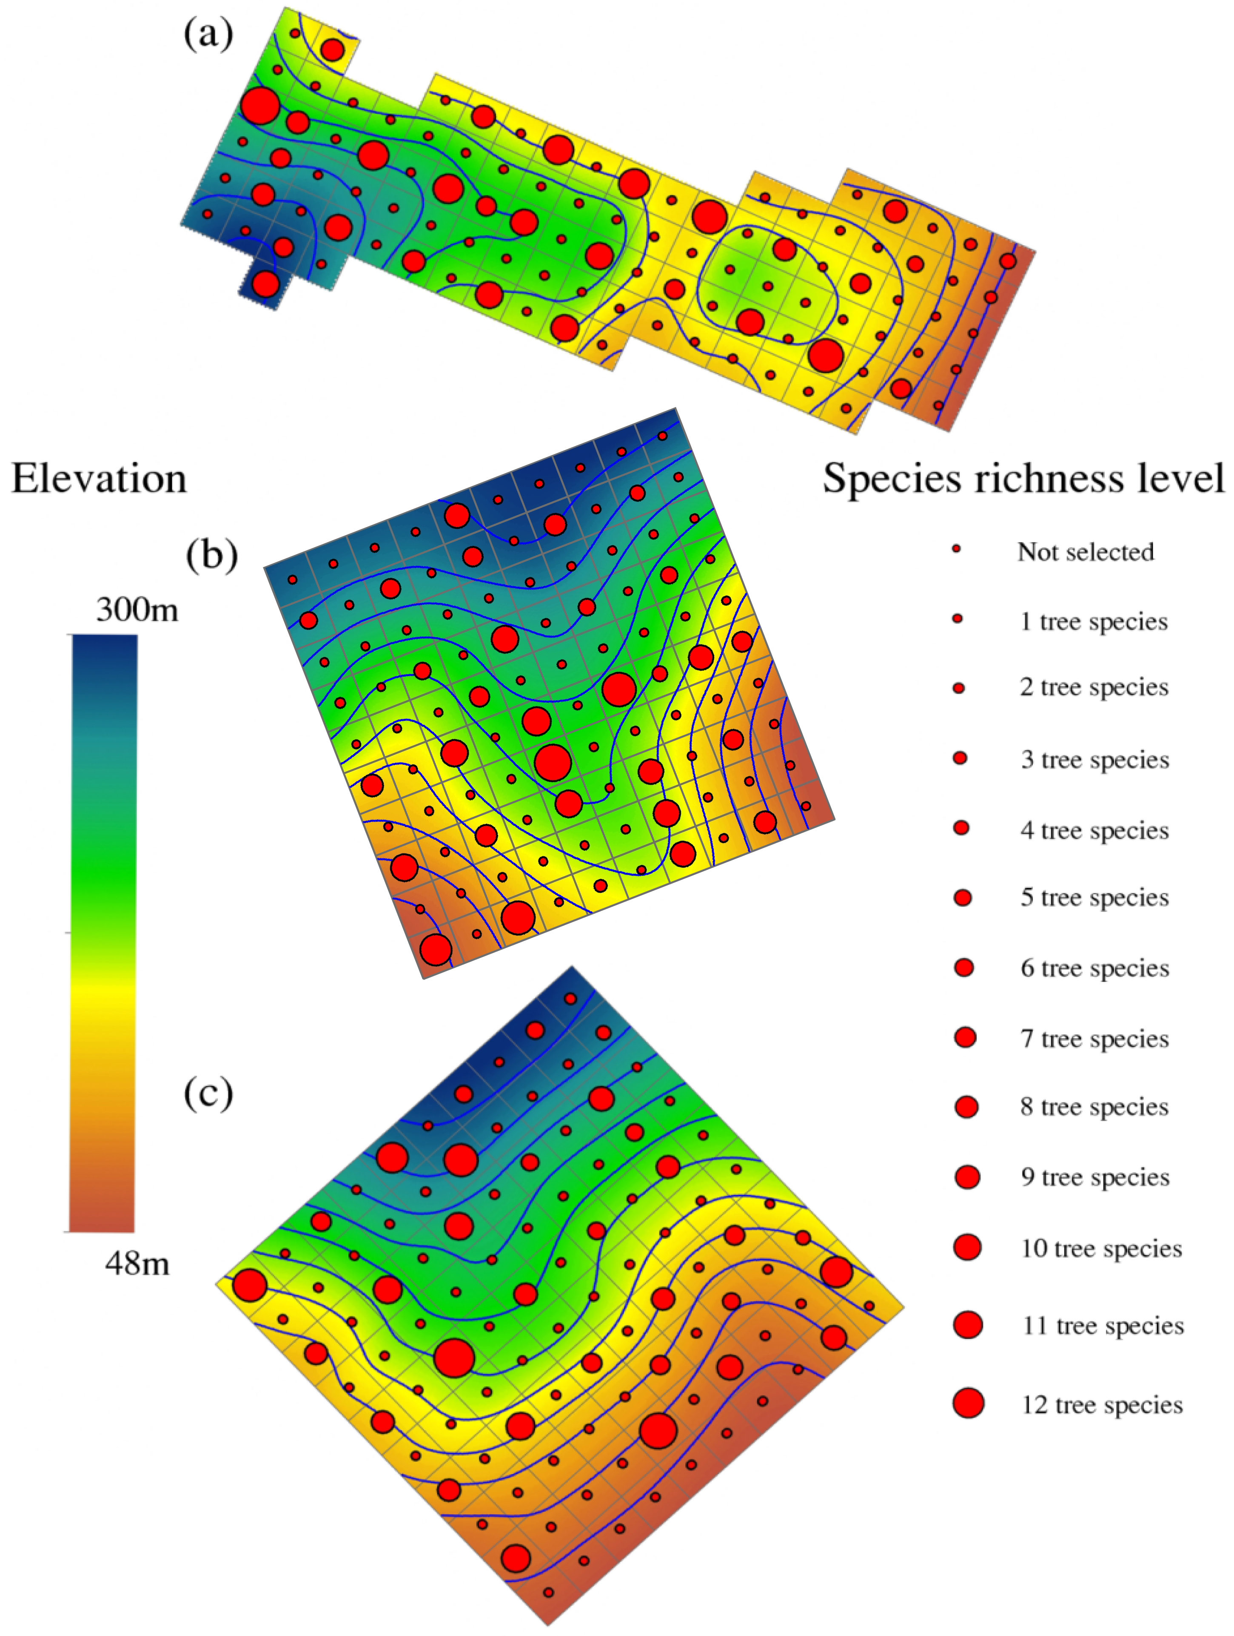
Fig. S1. Maps of the experimental plots. Figure (a) is coniferous and evergreen broad-leaved mixed forest dominated by Pinus massoniana and Lithocarpus glaber; figure (b) is deciduous broad-leaved forest dominated by Choerospondias axillaris; and figure (c) is broad-leaved evergreen forest dominated by L. glaber and Cyclobalanopsis glauca.

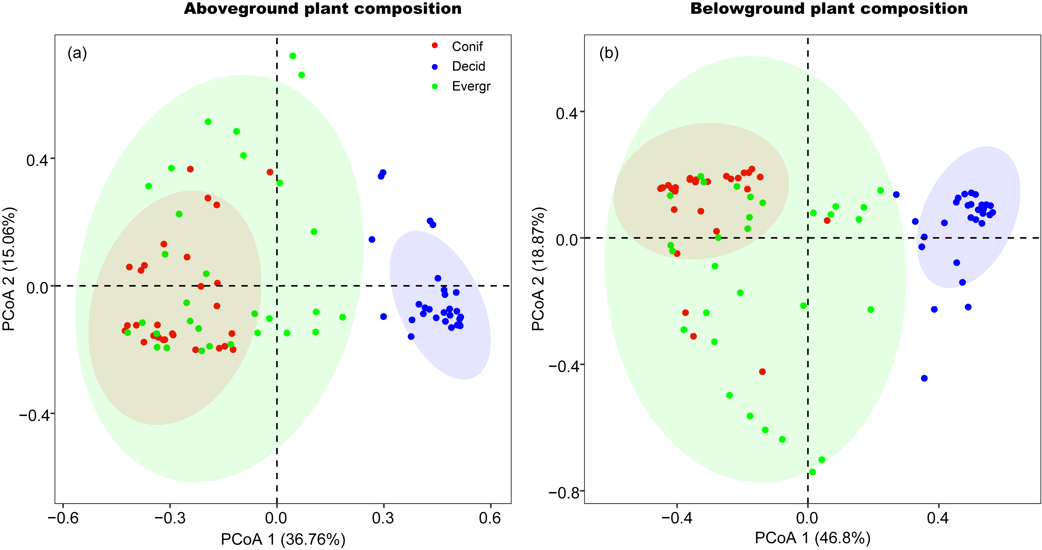
Fig. S2. Principal coordinate analysis (PCoA) of the composition of plant aboveground (a) and belowground (i.e. root composition, b) collected from the three secondary forest stands. Conif, a coniferous and evergreen broad-leaved mixed forest dominated by Pinus massoniana and Lithocarpus glaber at the early succession stage; Decid, a deciduous broad-leaved forests dominated by Choerospondias axillaris at the intermediate successional stage; Evergr, a broad-leaved evergreen forest dominated by L. glaber and Cyclobalanopsis glauca at the late successional stage.

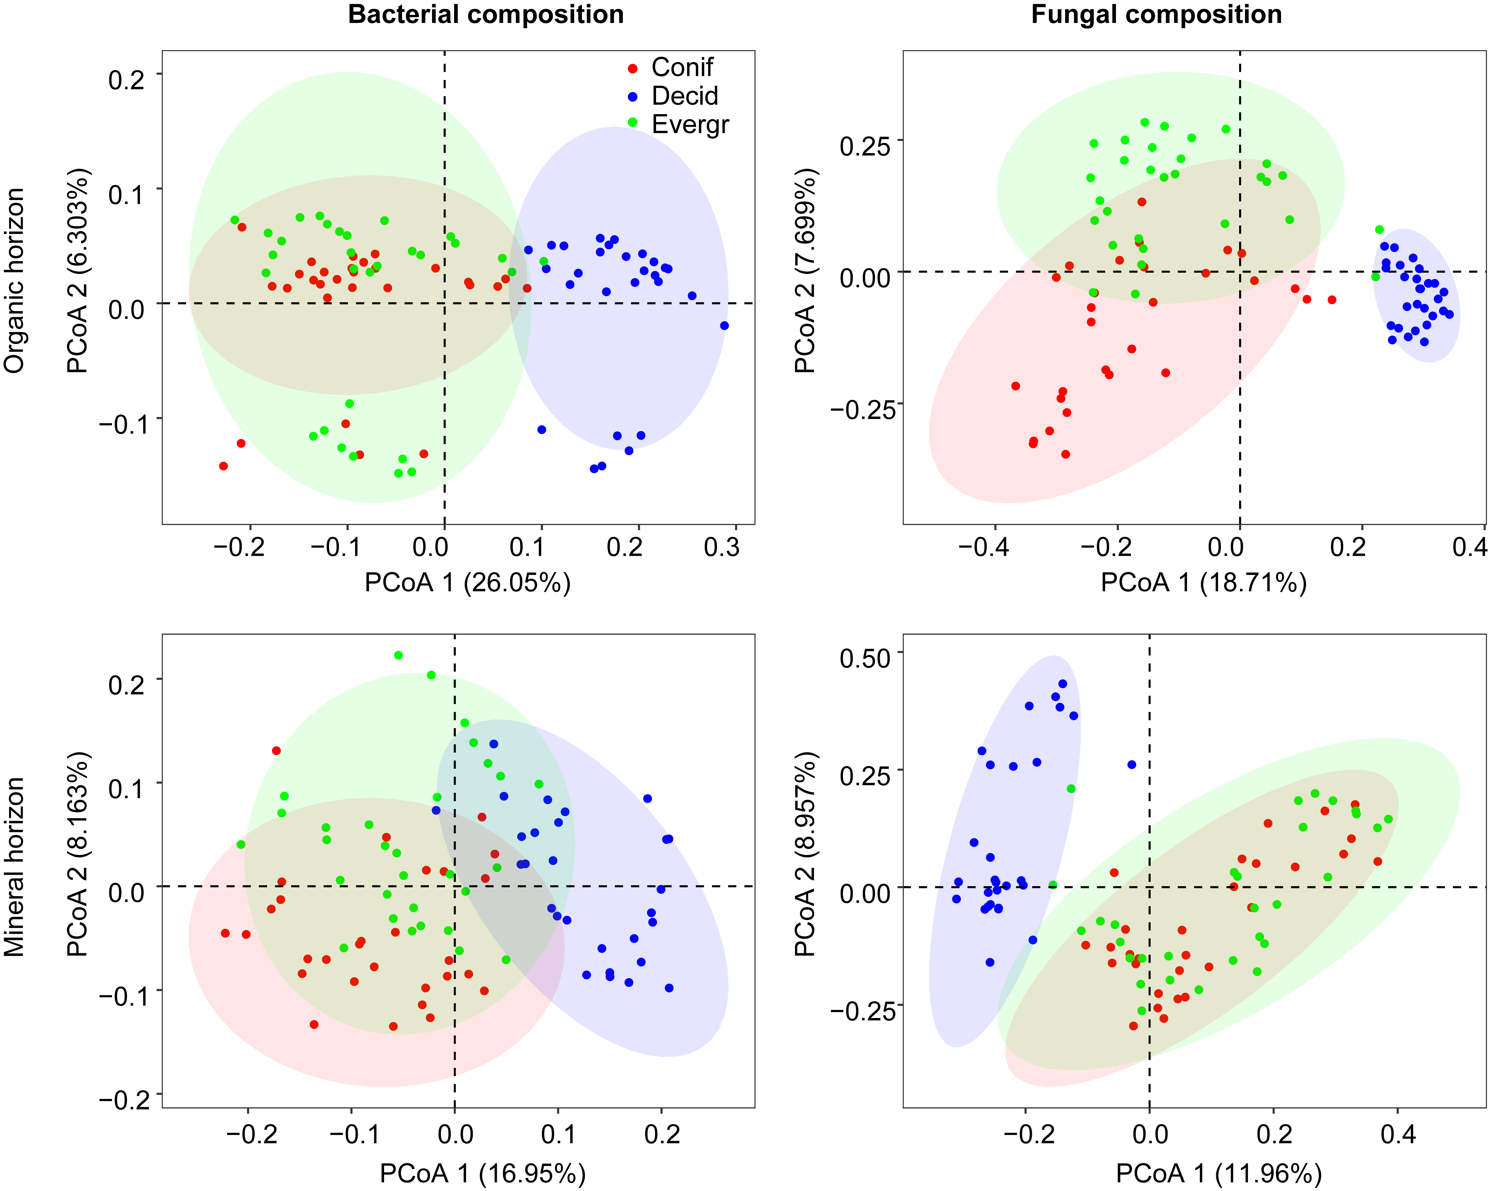
Fig. S3 Principal coordinate analysis (PCoA) of the composition of bacterial (a, c) and fungal communities (b, d) in the organic and mineral horizons soil samples collected from the three secondary forest stands. Conif, a coniferous and evergreen broad-leaved mixed forest dominated by Pinus massoniana and Lithocarpus glaber at the early succession stage; Decid, a deciduous broad-leaved forests dominated by Choerospondias axillaris at the intermediate successional stage; Evergr, a broad-leaved evergreen forest dominated by L. glaber and Cyclobalanopsis glauca at the late successional stage.

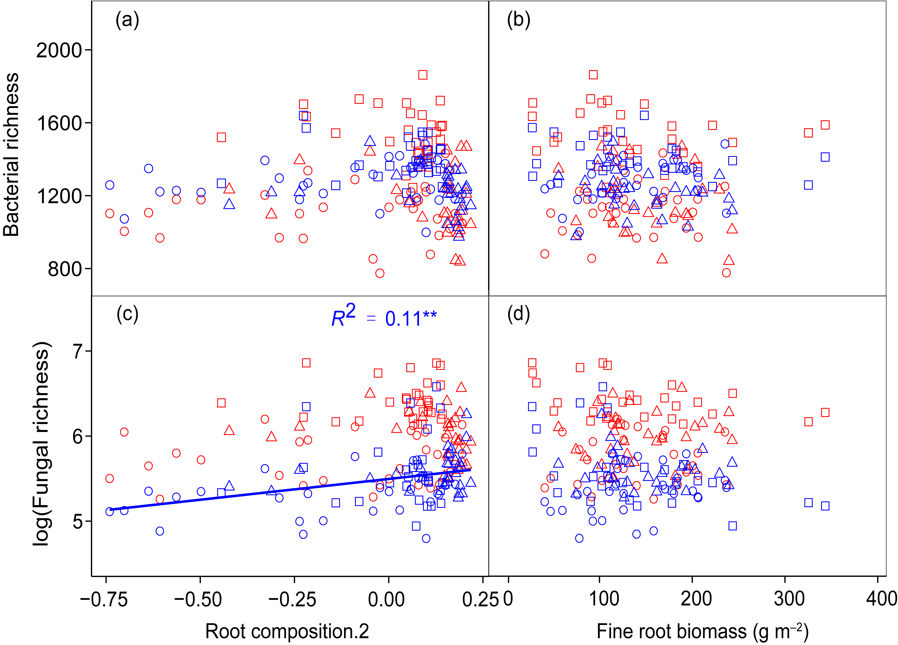
Fig. S4 Linear regressions between fine root composition, biomass and bacterial and fungal richness. Root compostion.2: fine root composition based on axis 2 of a principal component analysis. The fitted lines were presented for the significant (p < 0.05) relationships. **p < 0.01.

