Supplementary table 1. AUC values calculated by time-dependent ROC analysis
Variable | Measured time | AUC at D300 | AUC at D500
JAK2-MRD VAF | D30 | 0.404 | 0.309
JAK2-MRD VAF | D100 | 0.918 | 0.787
JAK2-MRD VAF | D180 | 0.955 | 0.750
JAK2-MRD VAF | D360 | - | 0.753
JAK2-MRD ratio | D100 | 1.000 | 0.986
JAK2-MRD ratio | D180 | 0.743 | 0.565
JAK2-MRD ratio | D360 | - | 0.680
NGS chimerism | D30 | 0.447 | 0.442
NGS chimerism | D100 | 0.692 | 0.583
NGS chimerism | D180 | 0.932 | 0.834
NGS chimerism | D360 | - | 0.655
STR chimerism | D30 | 0.301 | 0.429
STR chimerism | D100 | 0.508 | 0.439
STR chimerism | D180 | 0.926 | 0.728
STR chimerism | D360 | - | 0.691
Abbreviations: AUC, Area Under the ROC Curve; ROC, Receiver Operating Characteristic; MRD, measurable residual disease; VAF, Variant allele frequency; NGS, Next-generation sequencing; STR, Short Tandem Repeat; D, day.

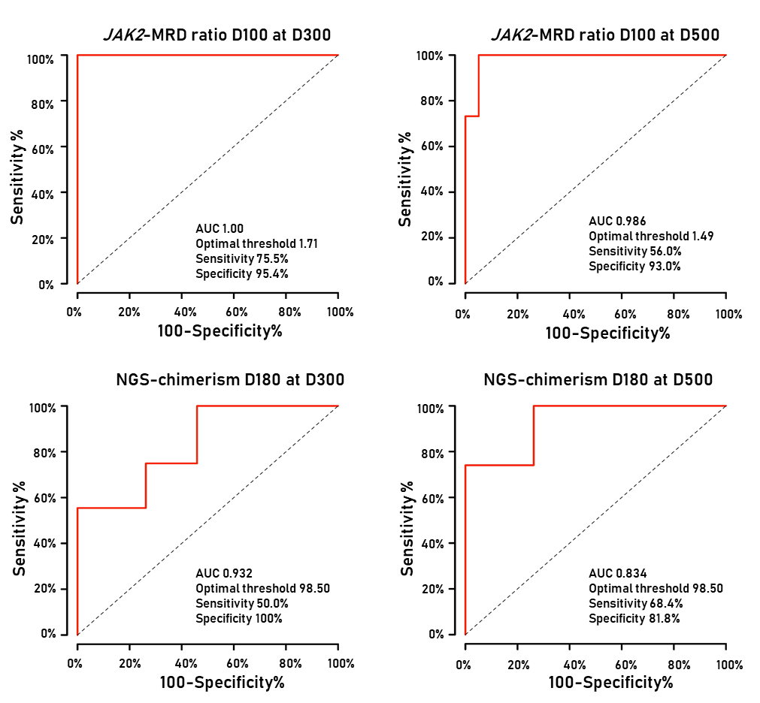

Supplementary Figure 1. Time-dependent ROC curves of the overt relapse prediction markers. (A) JAK2-MRD ratio at D100 for overt relpase prediction at D300 and (B) D500. (C) NGS chimerism at D180 for overt relapse prediction at D300 and (D) D500.
Abbreviations: AUC, Area Under the ROC Curve; ROC, Receiver Operating Characteristic; MRD, measurable residual disease; D, day; NGS, Next-generation sequencing.

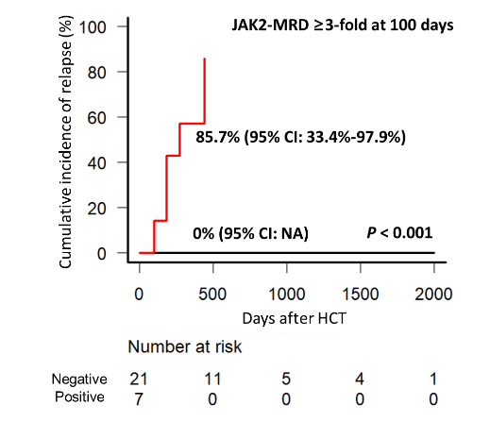  A | 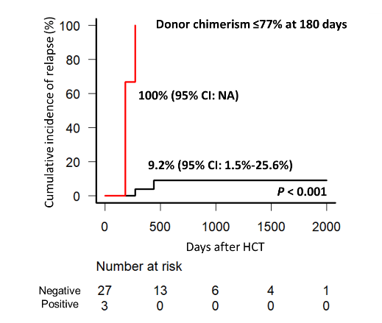  B | 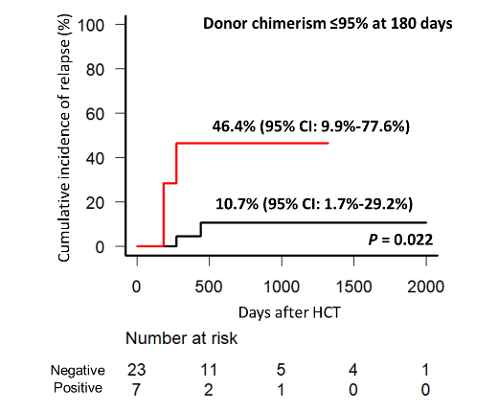  C
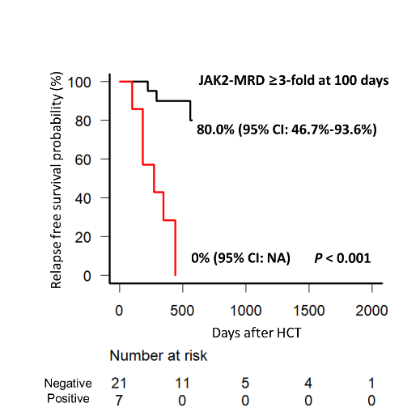  D | 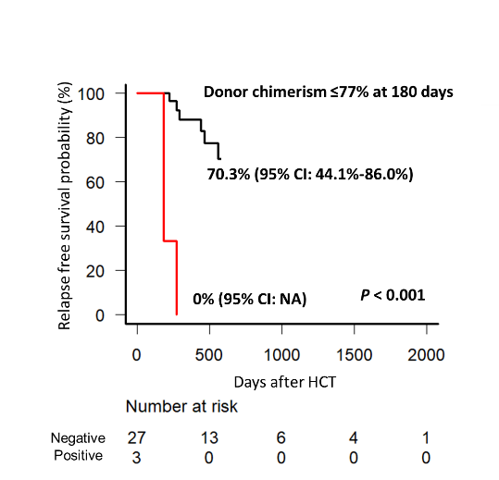  E | 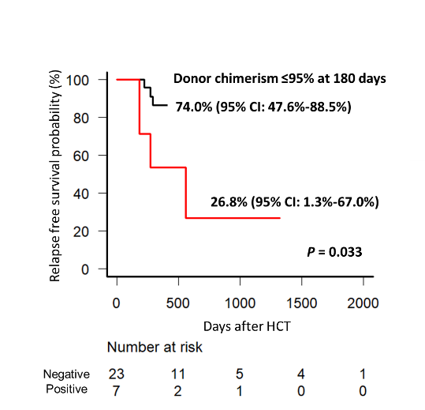  F
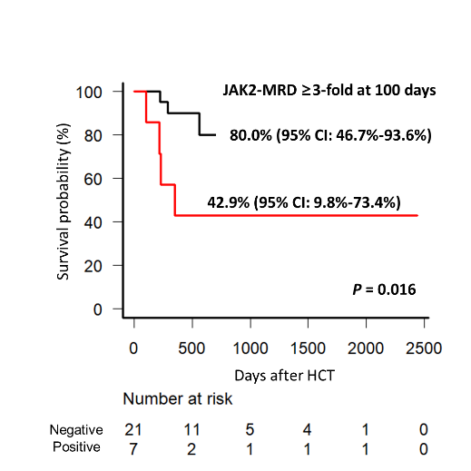  G | 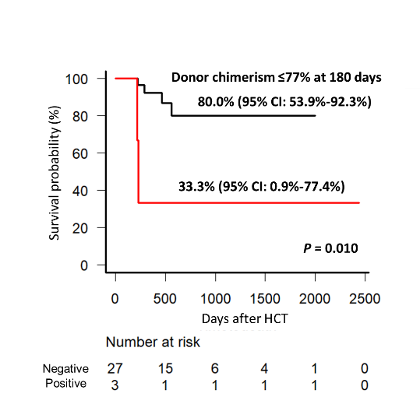  H | 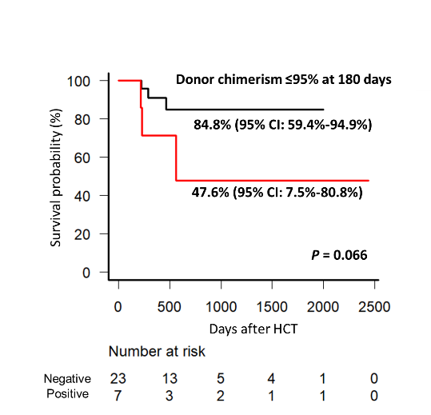  I

Supplementary Figure 2. Relapse and probability by JAK2-MRD ratio and chimerism. (A) Cumulative relapse incidence for patients with JAK2-MRD ratio ≥3-fold at 100 days. (B) Donor chimerism ≤77% at 180 days. (C) Donor chimerism ≤95% at 180 days. (D) Relapse-free survival probability for patients with JAK2-MRD ratio ≥3-fold at 100 days. (E) Donor chimerism ≤77% at 180 days. (F) Donor chimerism ≤95% at 180 days. (G) Survival probability for patients with JAK2-MRD ratio ≥3-fold at 100 days. (H) Donor chimerism ≤77% at 180 days. (I) Donor chimerism ≤95% at 180 days. Red, positive; black, negative.
Abbreviations: HCT, hematopoietic stem cell transplantation; CI, confidential interval; NA, not available; MRD, measurable residual disease

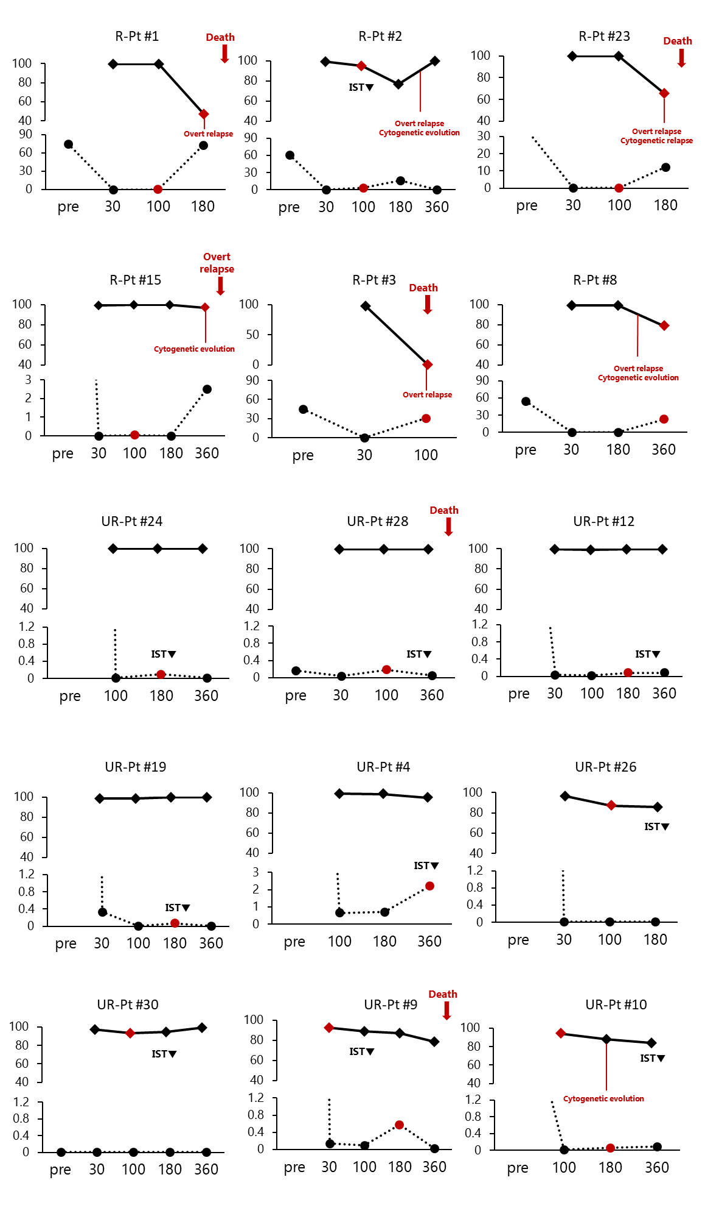
Supplementary Figure 3. Dynamics of JAK2-MRD and chimerism. The graphs show the molecular follow-up of 15 patients with emerging relapse evidences; increased JAK2-MRD ratio (≥ 3-fold) and/or mixed chimerism (≤95%) marked by red dots. Solid lines and dotted lines display the quantification of donor chimerism (%) and JAK2-MRD VAF (%), respectively.
Abbreviations: R-Pt, relapsed patient; UR-Pt, unrelapsed patient; ITS▼, early tapering of immunosuppresive therapy; MRD, measurable residual disease; VAF, variant allele frequency.

