Supplementary table, figures and legends

TableS1. Longitudinal biochemical and cytological results of cerebrospinal fluid in the case 3.
 | June 7 | June 10 | June 15 | June 22
ICP (mmH2O) (80-180) | >500 | 190 | 240 | 260
The total number of cells (× 10⁶/L) | 1110 | 1600 | 1500 | 1000
WBC (× 10⁶/L) | 880 | 1290 | 880 | 840
Polynuclear cells ratio (%) | 30 | 70 | 60 | 40
Monocyte ratio (%) | 70 | 30 | 40 | 60
Mpro (g/L) (0.15-0.45) | 2.69 | 3.02 | 2.72 | 3.23
ADA(U/L) (0-8) | 11.4 | 24 | 20.2 | 21
GLU (mmol/L) (2.5-4.4) | 0.89 | 1.86 | 5.36 | 4.06
LDH(U/L) (<40) | 408 | 301 | 136 | 111
Cl⁺(mmol/L) (120-130) | 104.8 | 104.9 | 106.9 | 112.8
Acid-fast stain | + | + | – | –
X-pert | + | + | – | –
+= positive. –= negative. ICP= intracranial pressure. WBC=white blood cell. Mpro= Microprotein. ADA= adenosine deaminase. GLU= glucose. LDH= lactate dehydrogenase. Cl⁺= chloride ions.

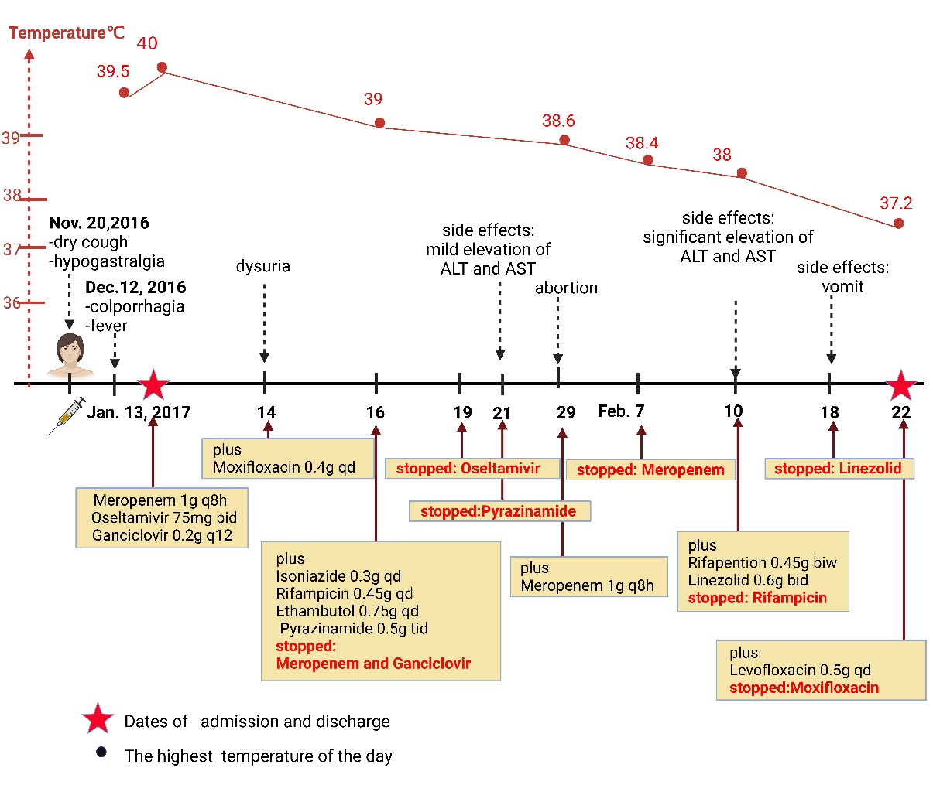
Fig. S1. Time line of the clinical course of the patient 1 from onset to hospitalization.
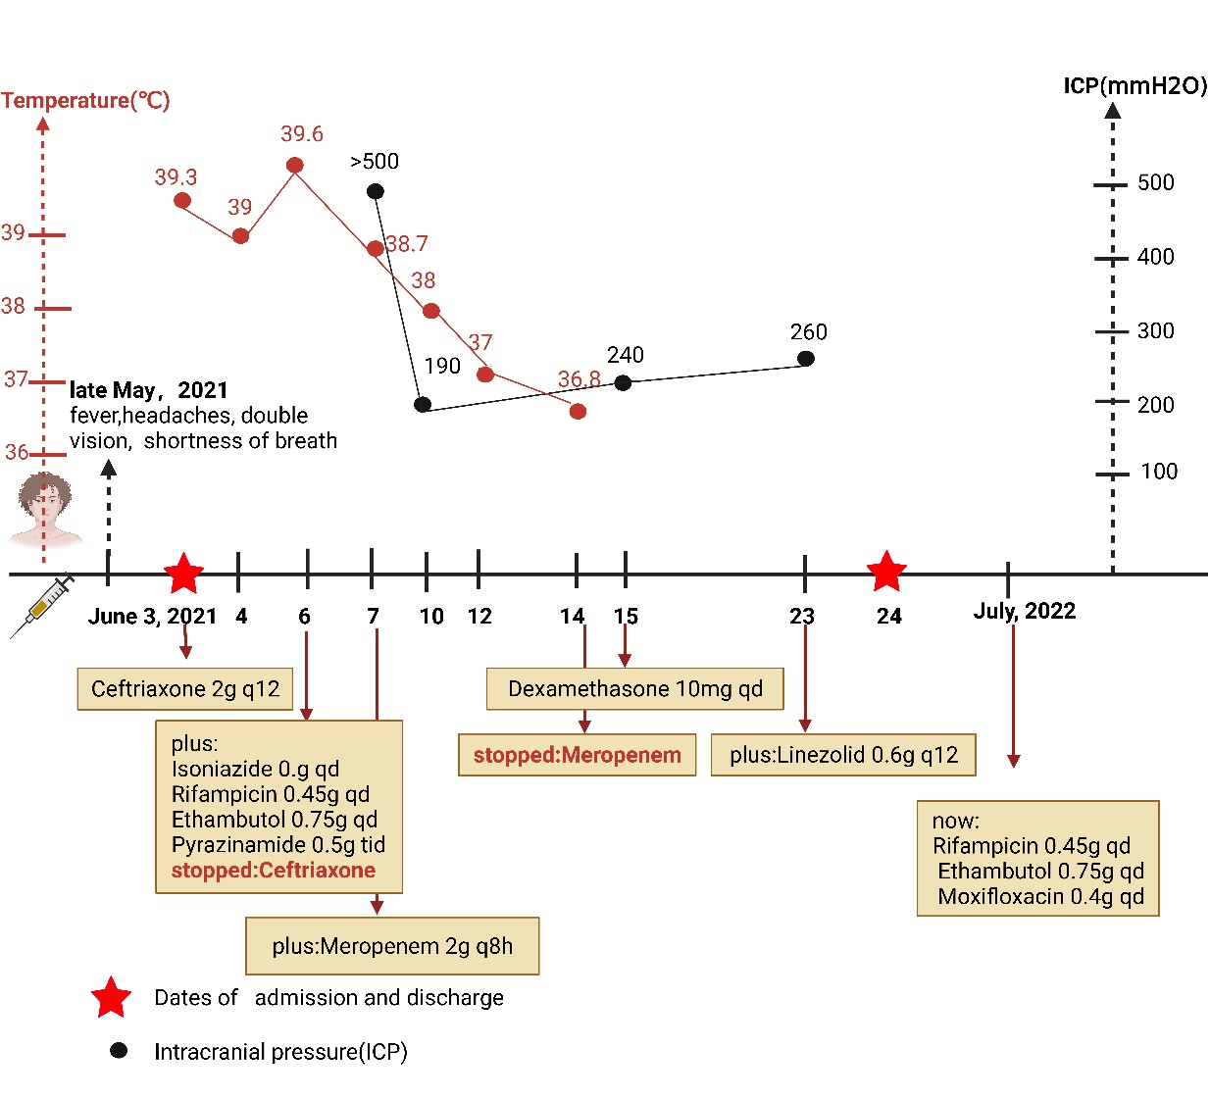
Fig. S2. Time line of the clinical course of the patient 3 from onset to July, 2022.

