Unveiling the anti-glioma potential of a marine derivative, Fucoidan: its synergistic cytotoxicity with Temozolomide-an in vitro and in silico experimental study

Indrani Biswas¹, Daisy S Precilla^{1#}, Shreyas S Kuduvalli¹, Muralidharan Arumugam Ramachandran² Akshaya S³, Venkat Raman⁴, Dhamodharan Prabhu⁵, Anitha T. S^{1*}
¹Mahatma Gandhi Medical Advanced Research Institute, Sri Balaji Vidyapeeth (Deemed to-be University), Puducherry – 607402, India.
²Department of Visual Neurosciences, Singapore Eye Research Institute, Singapore-169856, Singapore.
³ Jeppiaar College of Engineering, Chennai-600119, Tamil Nadu, India.
⁴ Thiruvalluvar University, Vellore-632115, Tamil Nadu, India.
⁵Research and Development Wing, Sree Balaji Medical College and Hospital, Chennai-600044, Tamil Nadu, India.
#Equal Contribution with the first author
(✉) Corresponding author:
Dr. Anitha T. S^{1*}
¹Previous affiliation: Mahatma Gandhi Medical Advanced Research Institute (MGMARI), Sri Balaji Vidyapeeth (Deemed to-be University) Puducherry- 607 403, India, tsanitha6@gmail.com

*Current affiliation: Assistant Professor, Department of Biochemistry and Molecular Biology, Pondicherry University, Puducherry- 605 014, India, tsanitha6@pondiuni.ac.in, Ph. +91 9843576675

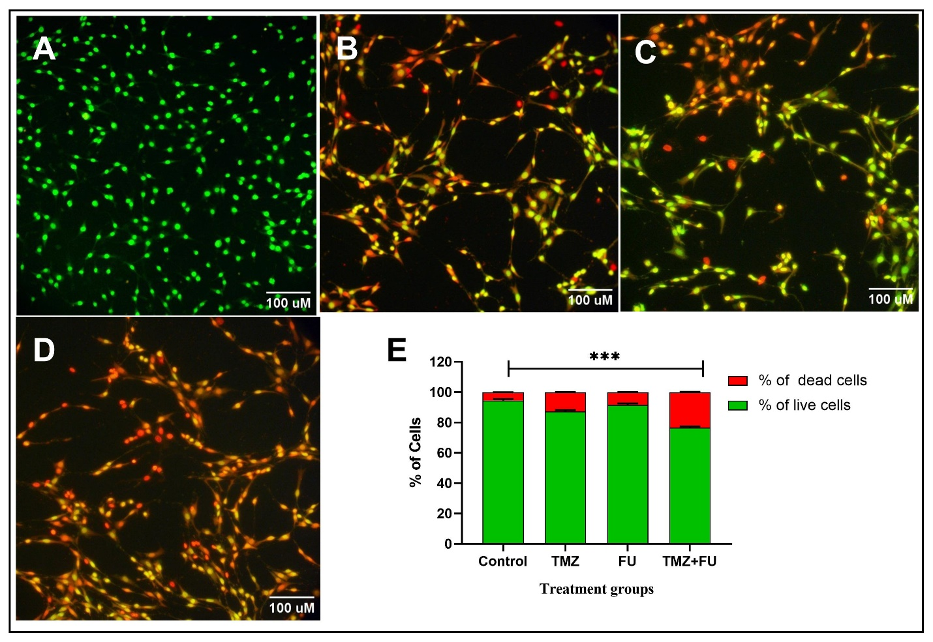
Supplementary Fig 1 Apoptotic cell death was observed by AO/EtBr staining under different experimental treatment groups on C6 glioma cells (A) Control, (B) TMZ (C) FU (D) TMZ+ FU, (E) Percentage of apoptotic cells were measured by scoring viable and dead cells. *** indicates p<0.001 in comparison to untreated control
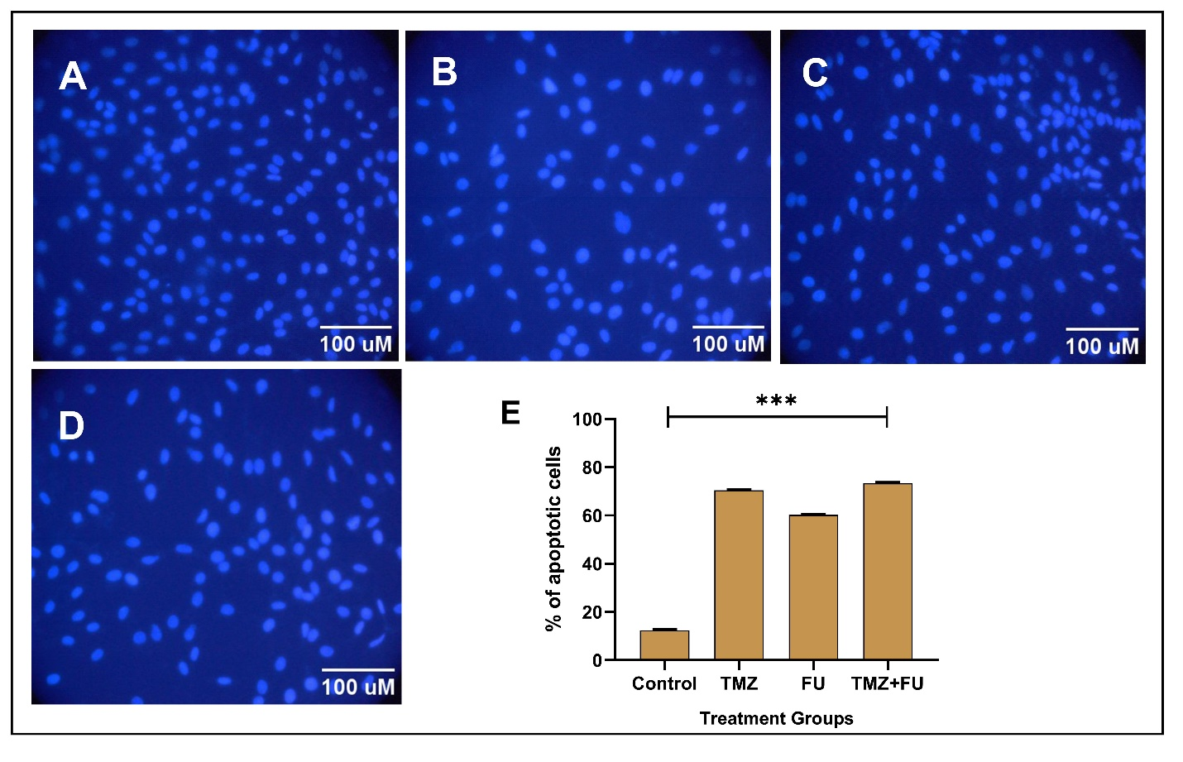
Supplementary Fig 2 DAPI staining under different experimental treatment groups on C6 glioma cells- (A) Control, (B) TMZ (C) FU (D) TMZ+ FU, *** indicates p<0.001 in comparison to untreated control
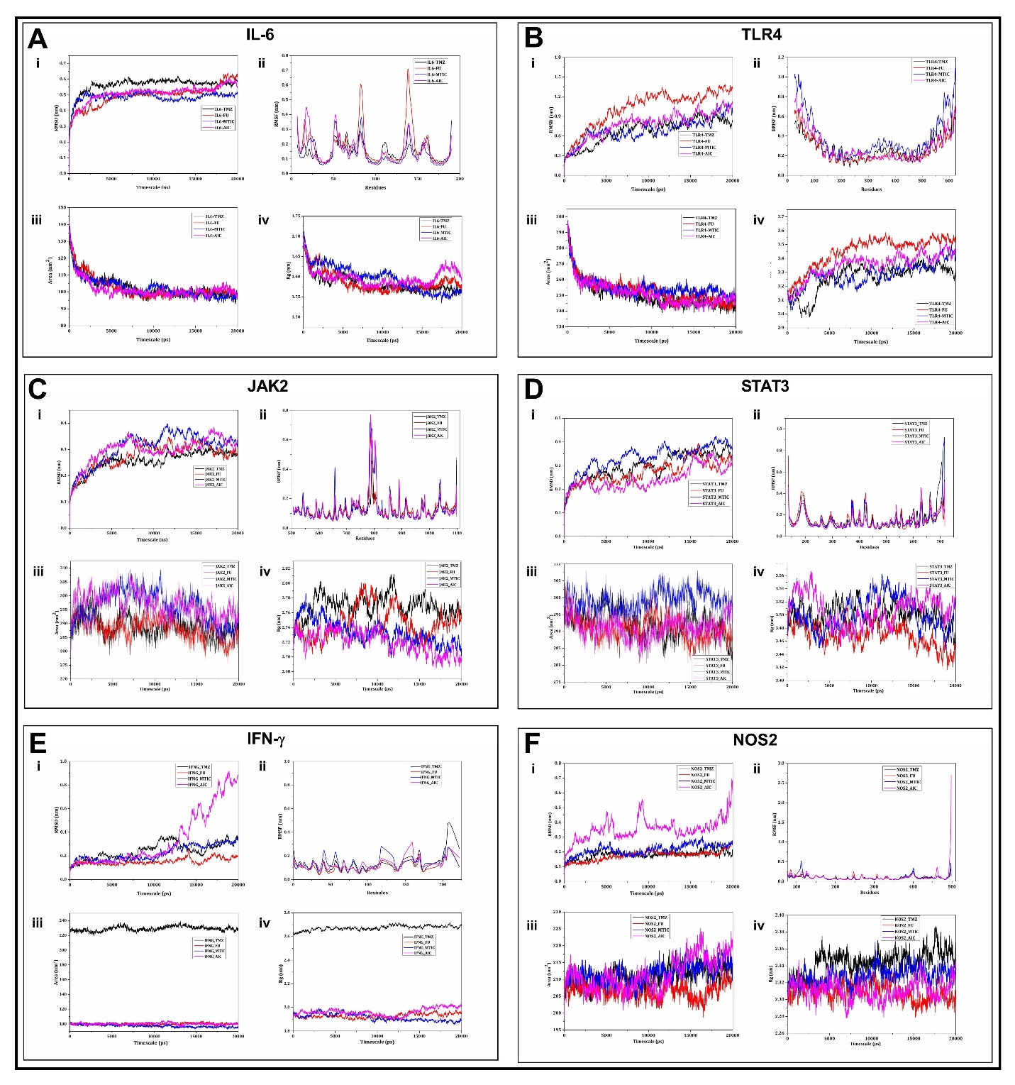
Supplementary Fig 3 RMSD, RMSF, SASA and Rg plots for (A) IL-6, (B) TLR4, (C) JAK2, (D) STAT3, (E) IFN-γ and (F) NOS2.

Supplementary Table 1 List of active site residues for each of the inflammatory targets
Sl. No. | Protein Targets | Residues involved in active site
1. | IL-6 | Ile72, Arg74, Leu89, Leu90,Lys91,Ile92,Phe179,Thr183,Ser 186
2. | TLR4 | Arg233, Phe262, Lys263, Asp264, Tyr291, Ala314, Gly315, Arg337
3. | JAK2 | Leu824, Val832, Ala849, Val880, Met898, Glu899, Tyr900, Leu901, Pro902, Glu904, Leu952
4. | STAT3 | Trp243, Lys244, Gln247, Val322, Val323, Glu324, Gln326, Thr456, His457, Pro487
5. | IFN-γ | Gln1, Met45, Gln46, Ser47, Phe60, Thr96, Asn97, Tyr98, Ser99, Val100
6. | NOS2 | Thr184, Trp188, Ala191, Cys194, Leu203, Ala237, Ile238, Phe363, Asn364, Tyr483.

