Supplementary data:
Table S1
Factors and levels of response surface methodology.
Levels | X1 | X2 | X3 | X4
Levels | Inclusion Temperature  (℃) | Inclusion Time  (h) | Core-Wall Molar Ratio  — | Inclusion Rate  (r/min)
-1 | 55 | 2 | 2:1 | 600
0 | 60 | 3 | 1:1 | 700
1 | 65 | 4 | 1:2 | 800

Table S2
Multi-index detection results and appearance of ASG
Indicators | Measurements (%) | Appearances
Granularity | 13.5±1.46
Moisture | 5.43±1.51
Dry weight loss | 1.28±2.39
Solubility

Table S3
Sensory assessment criteria of ASGs.
Indicators | Contents | Scores
Color and Luster | Uniform color, bright, the whole is off-white | 15-20
Color and Luster | Uniform color, slightly dark | 7-14
Color and Luster | Uneven color, dark heavy | 1-6
Granularity | Uniform and full particles, no caking, moderate hardness, can be crushed | 15-20
Granularity | More uniform particles, slightly agglomerate, harder hardness, can be crushed | 7-14
Granularity | Uneven particles, caking, hard hardness, not easy to crush | 1-6
Flavor | Cool, sweet, basically no bitterness | 15-20
Flavor | Cool, slightly sweet, bitter aftertaste | 7-14
Flavor | Bitter taste | 1-6
Solubility | Instant solution, no mushy taste | 15-20
Solubility | Slower dissolution, a little mushy taste | 7-14
Solubility | Sparingly soluble, mushy taste heavy | 1-6
Acceptability | Easy to accept | 15-20
Acceptability | Be able to accept | 7-14
Acceptability | Hard to accept | 1-6

Table S4
The Box–Behnken design factors and response values.
Run | X₁ | X₂ | X₃ | X₄ | Response
Run | Inclusion Temperature  (℃) | Inclusion Time  (h) | Core-Wall Molar Ratio  — | Inclusion Rate  (r/min) | Encapsulation Efficiency  (%)
1 | 60 | 3 | 2:1 | 600 | 72.75
2 | 65 | 4 | 1:1 | 700 | 75.28
3 | 55 | 2 | 1:1 | 700 | 70.74
4 | 55 | 3 | 1:1 | 600 | 76.56
5 | 55 | 3 | 1:1 | 800 | 75.75
6 | 60 | 4 | 1:2 | 700 | 75.27
7 | 60 | 2 | 2:1 | 700 | 69.52
8 | 65 | 2 | 1:1 | 700 | 73.61
9 | 60 | 3 | 1:1 | 700 | 81.25
10 | 55 | 3 | 1:2 | 700 | 73.73
11 | 60 | 3 | 1:2 | 600 | 76.77
12 | 60 | 3 | 1:2 | 800 | 78.52
13 | 65 | 3 | 1:1 | 800 | 78.33
14 | 60 | 3 | 1:1 | 700 | 79.35
15 | 65 | 3 | 2:1 | 700 | 72.49
16 | 60 | 4 | 2:1 | 700 | 71.25
17 | 60 | 4 | 1:1 | 600 | 75.58
18 | 60 | 2 | 1:1 | 600 | 73.75
19 | 60 | 2 | 1:1 | 800 | 75.52
20 | 60 | 3 | 1:1 | 700 | 80.77
21 | 55 | 4 | 1:1 | 700 | 72.58
22 | 60 | 2 | 1:2 | 700 | 73.59
23 | 55 | 3 | 2:1 | 700 | 69.75
24 | 60 | 3 | 2:1 | 800 | 74.58
25 | 60 | 4 | 1:1 | 800 | 77.25
26 | 65 | 3 | 1:2 | 700 | 76.78
27 | 65 | 3 | 1:1 | 600 | 76.25
28 | 60 | 3 | 1:1 | 700 | 81.52
29 | 60 | 3 | 1:1 | 700 | 80.68

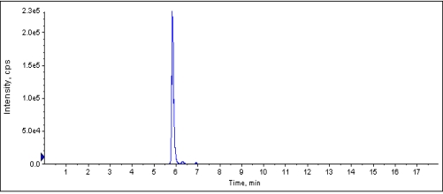
Fig. S1. HPLC chromatogram of extracted and purified AsIV.
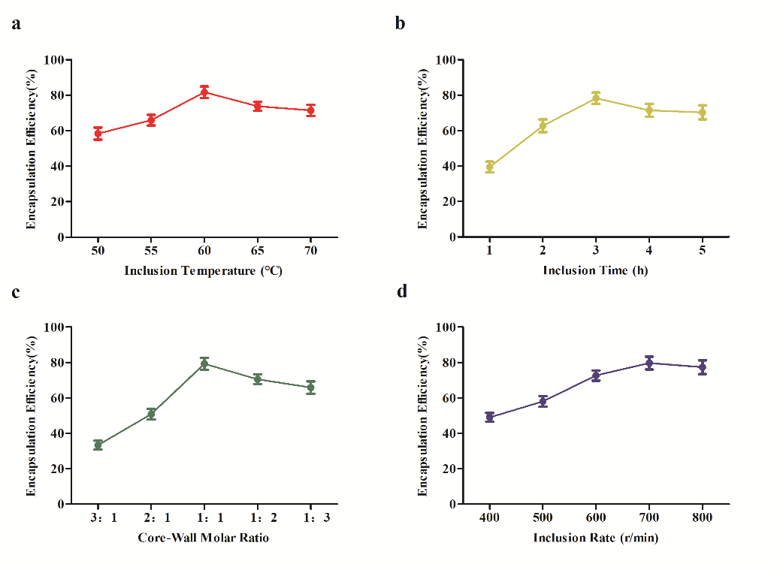
Fig. S2. Single factor optimization results of the AsⅣ/β-CD formation.

Fig. S3. Sensory assessment criteria of ASGs.

Fig. S4. Schematic diagrams of the K-B antibacterial activity of ASG against six strains. (a) E. coli; (b) S. aureus; (c) C. albicans; (d) P. aeruginosa; (e) B. subtilis; (f) P. acnes.

