Supplement-2: Effectiveness and Safety of Vitrectomy Combined with Cataract Surgery Concurrently Versus Vitrectomy with Subsequent Cataract Surgery for Proliferative Diabetes Retinopathy Patients with Mild-moderate Cataract: A Multicenter Randomized Controlled Study
1. Details of participant recruitment
The individual recruitment and follow-up were performed in 3 different hospitals in China (Zhongshan Ophthalmic Center, Sun Yat-sen University; Shenzhen Eye Hospital Affiliated to Jinan University and The Affiliated Hospital of Guizhou Medical University), and strictly conformed to the inclusion and exclusion criteria. From February 2021 to October 2021, a total of 129 patients were recruited. The details of individuals recruitment in each hospital are shown in Tab.S1.
Tab.S1 The details of recruitment in each hospital.
 | ZOC | SEH | GMU | P-value*
Numbers of recruitment | 66 | 41 | 22 | /
Individuals in the combined group (%) | 35 (53%) | 19 (46.3%) | 12 (54.5%) | 0.750
Age (years), mean (SD) | 57.2 (7.5) | 59.4 (8.4) | 56 (7.9) | 0.216
Male sex (%) | 40 (60.6%) | 25 (60.9%) | 12 (54.5%) | 0.864
Indication of PPV, n (%) |  |  |  | 0.094
Vitreous hemorrhage | 23 (34.8%) | 24 (58.5%) | 8 (36.3%)
Epiretinal membrane | 32 (48.4%) | 10 (24.3%) | 11 (50%)
Retinal detachment | 11 (16.6%) | 7 (17%) | 3 (13.6%)
Cataract type, n (%) |  |  |  | 0.956
Cortical | 11 (16.6%) | 6 (14.6%) | 3 (13.6%)
Nuclear | 19 (28.7%) | 15 (36.5%) | 7 (31.8%)
Posterior subcapsular | 30 (45.4%) | 16 (39%) | 11 (50%)
Crystal | 6 (9%) | 4 (9.7%) | 1 (4.5%)
Abbreviations: ZOC is for Zhongshan Ophthalmic Center, Sun Yat-sen University; SHE is for Shenzhen Eye Hospital; GMU is for The Affiliated Hospital of Guizhou Medical University; PPV is for pars plana vitrectomy; SD is for standard deviation. *Chi-squared test for group and sex, ANOVA for age, and Fisher’s exact test for Indication of PPV and Cataract type.

2. Details of best correct vision acuity (BCVA) and visual function questionnaire (VFQ-25) scores during the entire follow-up on pre-protocol analysis.
On pre-protocol analysis, the mean and standard deviation (SD) of BCVA and VFQ-25 scores at each visit are shown in Tab.S2 and changes from the baseline are exhibited in Fig.S1. As we can see, in the first 3 months after PPV, there was no significant difference in the changes of BCVA between the two group. However, at month 6, the BCVA improvement in the subsequent group (mean 22.98 letters; 95%CI, 15.76-30.20 letters) was significantly (P=0.003) lower than that in the combined group (mean 38.07 letters; 95%CI, 31.83-44.7 letters). As shown in Fig.S1-A, the BCVA in the subsequent group was greatly improved after the cataract surgery and no significant difference was found at month 12 between the two groups. As for the vision related life quality, participants in the combined group gained significantly better (P<0.05) VFQ-25 composite scores than the subsequent group during month 3-6 (Fig.S1-B). On pre-protocol analysis, the maximum of improvement of vision quality after PPV alone was mean 10.22 (95%CI, 7.03-13.42) at month 1 in the subsequent group, while the betterment attenuated to mean 5.66 (95%CI, 1.83-9.50) in the following months. An augmentation of VFQ-25 composite score was detected after the subsequent cataract surgery and no significant difference was found between the two groups at month 12.
Tab.S2 The mean and SD of BCVA and VFQ-25 composite score during the 12-month follow-up on Pre-protocol analysis.
 |  | 1W | 1M | 3M | 6M | 6M1W | 7M | 9M | 1Y
BCVA | Combined group, mean (SD) | 31.92 (24.05) | 50.42 (19.98) | 58.93 (17.55) | 59.26 (19.19) | / | / | / | 58.57 (17.08)
BCVA | Subsequent group, mean (SD) | 34.84 (23.97) | 47.48 (22.67) | 46.71 (23.12) | 41.75 (22.00) | 53.75 (22.63) | 58.41 (21.41) | 58.33 (23.96) | 56.98 (22.78)
BCVA | P value | 0.492 | 0.451 | 0.002 | <0.001 | / | / | / | 0.694
VFQ-25 | Combined group, mean (SD) | 59.61 (19.88) | 67.04 (17.32) | 71.50 (16.98) | 71.93 (16.57) | / | / | / | 72.11 (16.97)
VFQ-25 | Subsequent group, mean (SD) | 57.79 (18.77) | 63.21 (18.40) | 63.02 (18.13) | 59.70 (17.37) | 68.48 (16.74) | 71.02 (16.72) | 68.66 (18.58) | 68.65 (17.39)
VFQ-25 | P value | 0.594 | 0.241 | 0.013 | <0.001 | / | / | / | 0.319
Abbreviations: SD is for standard deviation; BCVA is for best correct vision acuity; VFQ-25 is for visual function questionnaire; W is for week; M is for month; Y is for year.
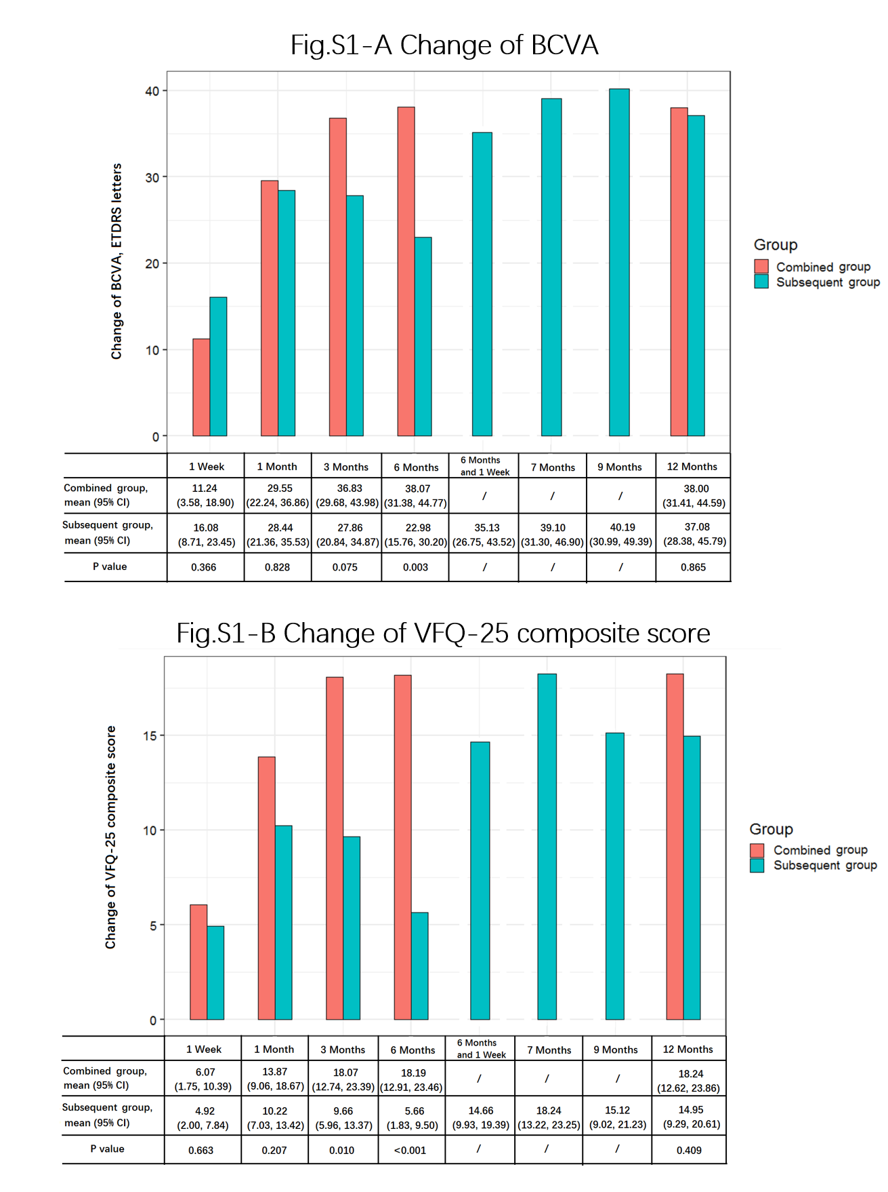 Fig.S1. Change of BCVA and VFQ-25 composite from baseline on Pre-protocol analysis at each visit during the 12-month follow-up. Abbreviations: BCVA is for best correct visual acuity. VFQ is for Visual Function Questionnaire. CI is for confidence interval. ETDRS is for Early Treatment of Diabetic Retinopathy Study.

3. Center effects between the three hospitals
The center effect was checked in use of likelihood ratio test (LRT) by comparing the likelihood scores of the nested mixed-effects models with and without considering center effect (Tab.S3). LRT statistic approximately follows a chi-square distribution. P>0.05, indicated that the null hypothesis that the intervention effect was homogeneous among all centers in this trial, was accepted. The intra-class correlation (ICC) within center was 5.60e-21 which means that an extremely small proportion of the total variance in outcome that is accounted for by the clustering.
Tab.S3 The center effect in likelihood ratio test
Mixed-effects model | -lnL | LR | df | Critical value (X²)  (P = 0.05) | P-value
Group | 507.34 | /
Group+center | 507.33 | 2(507.34-507.33)=0.02 | 1 | 3.84 | 0.888
Group+center+group*center | 506.71 | 2(507.33-506.71)=1.24 | 1 | 3.84 | 0.265
Abbreviations: LR is for likelihood ratio.
As we can see from the Fig.S2, no statistical differences on the mean changes of BCVA in the combined group (P=0.585, by ANOVA) and the subsequent group (P=0.985, by ANOVA) were found among the centers.
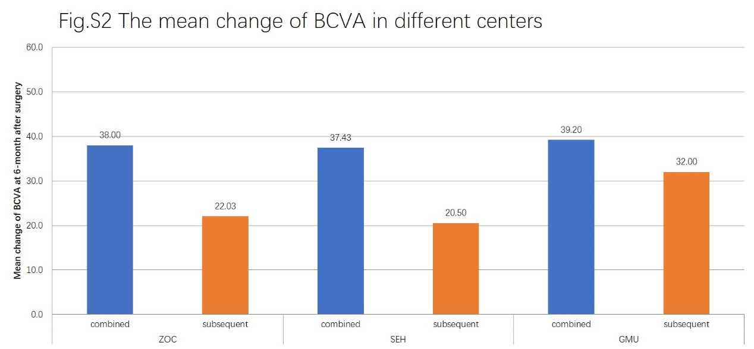
Abbreviations: ZOC is for Zhongshan Ophthalmic Center, Sun Yat-sen University; SHE is for Shenzhen Eye Hospital; GMU is for The Affiliated Hospital of Guizhou Medical University. BCVA is for best correct visual acuity.

4. Postoperative complications and modified allocated intervention
Macular edema (ME) was the most commonly found complications and a total of 22 ME cases were observed. Most of them were transient and recovered spontaneously in one month. To those with refractory ME or exacerbated ME, 1 patient in the subsequent group and 2 patients in the combined group received additional anti-VEGF intravitreal injection, and 1 patient in the subsequent group received panretinal photocoagulation as modified allocated interventions. Refractory ME was defined as OCT central retinal subfield thickness (CST) >250 µm for more than 3 months. Exacerbation of ME was defined as an increasing CST by more than 50 µm compared with baseline.
Recurrent vitreous hemorrhage (VH) and retinal detachment (RD) were observed occasionally. Oral medicine and/or panretinal photocoagulation were allocated first in patients with VH. 6 cases of hemorrhage absorbed in 4-21 days. To those with persistent VH for more than 1 month or no response to oral medicine, 2 patients in the combined group received additional PPV surgery. 4 patients with recurrent RD received additional PPV.
Neovascular glaucoma (NVG) was the severest complication in this study. Unlike transient intraocular hypertension which was observed with occasional relief, NVG usually presented persistent hyper intraocular pressure (IOP), drastic fall in visual acuity, iris neovascularization, and severe headache. In the subsequent group, a total of 9 patients were diagnosed NVG during the follow-up period, and 7 of them emerged after the subsequent cataract surgery. All the NVG patients received fundus fluorescence angiography (FFA), IOP-lowering eye drops, and retinal photocoagulation. If the IOP demonstrated no reduction, anti-VEGF intravitreal injection and/or anti-glaucoma surgery would be allocated. In Fig.S3, we provide a typical example of NVG case in the subsequent group after the cataract surgery. In spite of careful surgical procedures and sufficient panretinal photocoagulations, retinal non-perfusion zone was still detected on FFA images. A total of 10 NVG patients received anti-VEGF intravitreal injection. Six and two patients received trabeculectomy and aqueous humor drainage device implantation respectively.
In Tab.S4, we exhibited the time period when these four complications were first diagnosed. In the combined group, most of the complications were first diagnosed within 6 months after the combined surgery, while only one participant with new-emerging ME was diagnosed during 7-12 months. In the subsequent group, the conditions were approximately similar to the combined group in the first 6 months. However, compared with the relatively stabilized condition in the combined group, we found high occurrences of ME and NVG during 7-12 months. The majority of NVG cases (77.7%) and nearly half of ME cases (46.1%) in the subsequent group were first diagnosed after the cataract surgery. To be noticed, the rate of NVG was relatively lower in both groups during 1-6 months, the high occurrence of NVG was only observed in the subsequent group during 7-12 months.
Tab.S4 The time period when complications were first diagnosed
complications | 1-6 months |  |  | 7-12 months
complications | Combined group | Subsequent group |  |  | Combined group | Subsequent group
VH, 人（%） | 5 | 3 |  |  | 0 | 0
NVG, 人（%） | 2 | 2 |  |  | 0 | 7
RD, 人（%） | 2 | 2 |  |  | 0 | 0
ME, 人（%）* | 8 | 7 |  |  | 1 | 6
Abbreviations: ME is for macular edema; VH is for vitreous hemorrhage; RD is for retinal detachment; NVG is for neovascular glaucoma. *Participants in the subsequent group received cataract surgery at month six.
The summarization of the four major complications and corresponding modified allocated interventions are provided in Tab.S5. Other mild postoperative complications, like cornea edema, corneal epithelium defect, transient intraocular hypertension, etc., were observed occasionally. Most of them recovered spontaneously or experienced symptom alleviation in a few days. Certain supportive treatment, including NaCl eye drops, epidermal growth factor eye gel, and brinzolamide eye drops, etc., were given according to the actual conditions.
Tab.S5 The summarization of the four major complications and corresponding modified allocated interventions in both groups.
Complications | Modified interventions | Combined group, n | Subsequent group, n
ME | Anti-VEGF intravitreal injection | 2 | 1
ME | PRP | 0 | 1
VH | Oral medicine | 5 | 3
VH | PRP | 3 | 3
VH | Additional PPV | 2 | 0
RD | Additional PPV | 2 | 2
NVG | PRP | 2 | 9
NVG | Anti-VEGF intravitreal injection | 2 | 8
NVG | Trabeculectomy | 2 | 4
NVG | Aqueous humor drainage device implantation | 0 | 2
Abbreviations: ME is for macular edema; VH is for vitreous hemorrhage; RD is for retinal detachment; NVG is for neovascular glaucoma; PRP is for panretinal photocoagulation; Anti-VEGF is for anti-vascular endothelial growth factor; PPV is for pars plana vitrectomy.
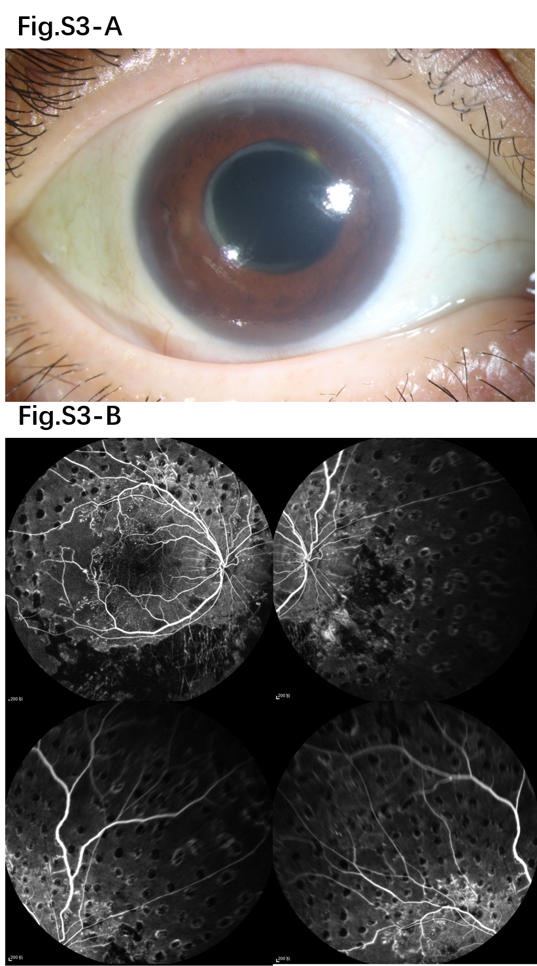
Fig.S3 These images were from a typical example of NVG patients in the subsequent group 2 months after the cataract surgery. From the cornea photograph (A), an obvious cornea edema was found. From the FFA images (B), in spite of sufficient panretinal photocoagulations, non-perfusion zone was still detected. This patient was then diagnosed with NVG and received photocoagulation, anti-VEGF intravitreal injection and trabeculectomy.

5. Operation details and intraoperative complications.
As we can see in Tab.S6, most of the surgical details were balanced in the both groups, except for the duration of work incapacity. The majority of the participants strictly adhered to our study protocol and received corresponding allocated therapy. All the participants in our study received pars plana vitrectomy (PPV) surgery. In the subsequent group, a total of 11 patients discontinued the subsequent cataract surgery, 8 due to lack of adherence, 3 due to failure to meet the criteria. Surgical expenses, including economical expense, time of operation and duration of work incapacity were analyzed only in participants who finished PPV and cataract surgery according our protocol in both groups.
The safety of the participants was always our priority in this study. If any unexpected accidents happened during the surgeries, surgeons were allowed to make any necessary modification on surgical plan to ensure the health of participants. The most common intraoperative complication was iatrogenic retinal breaks/detachment. In this study, severe retinal detachment cases with silicon oil tamponade were excluded preoperatively. However, as an inevitable intraoperative complication, the iatrogenic retinal breaks/detachment still caused 14 cases with unplanned silicon oil tamponade (5 in the combined group and 9 in the subsequent group).
Tab.S6 Medical expenses and operation details in both groups.
 | Combined group | Subsequent group | P
Surgical expenses, n | 66 | 52
Total economical expense, USD, Median (IQR) | 3114 (2885-3314) | 3228 (3042-3428) | 0.090†
Total operation time (min), Median (IQR) | 74.5 (60-96) | 70 (52-96) | 0.209†
Total duration of work incapacity (day), Mean (SD) | 12.44 (6.48) | 22.54 (9.11) | <0.001‡
Pars plana vitrectomy, n (%) | 66 (100) | 63 (100) | /
Retinal endophotocoagulation spots, Median (IQR) | 890 (600-1207) | 786 (642-991) | 0.332†
Intraocular tamponade |  |  | 0.571⁋
BSS, n (%) | 49 (74.24) | 45 (71.43)
filtered air, n (%) | 5 (7.58) | 5 (7.94)
C₃F₈, n (%) | 7 (10.61) | 4 (6.35)
silicon oil, n (%) | 5 (7.58) | 9 (14.29)
Phacoemulsification, n (%) | 66 (100.0) | 52 (100.0) | /
IOL type, n (%) |  |  | 0.808§
SN60WF | 52 (78.79) | 40 (76.92)
Other | 14 (21.21) | 12 (23.08)
Abbreviations: IQR is for Inter quartile range; SD is for Standard deviation; PPV is for pars plana vitrectomy; BSS is for balanced salt solution; USD is for United States dollar.
* In subsequent-surgery group, 11 persons did not receive cataract surgery.
† Wilcoxon rank sum test; ‡ Two-sample t test; ⁋ Fisher’s exact test; § Chi-square test

6. Cataract aggravation in the subsequent group
In the subsequent group, lens opacity was evaluated based on LOCSⅢ during 1-6 months. Any exacerbation in cortex, nuclear or posterior subcapsular opacities more than one degree would be defined as cataract aggravation. A total of 8 participants lost to our follow-up with unknown cataract condition in the first six months. In the rest 55 participants adhered in study, 54 were diagnosed with complicated cataract and only 1 did not appear obvious cataract aggravation six months after the PPV. The most common type of complicated cataract after PPV was posterior subcapsular cataract (PSC, 42.8%), followed by nuclear sclerosing cataract (NSC, 41.3%). In Tab.S7, we elaborated the number and percentage of cataract aggravation situation in the subsequent group during the follow-up and a typical example of lens photographs is provided in Fig.S4.
Tab.S7 The details of cataract degrees and aggravation situation during the follow-up time in the subsequent group.
Cataract type | 1 month* | 3 months* | 6 months*
Cortical | 8 (12.6%) | 3 (4.7%) | 1 (1.5%)
Nuclear | 19 (30.1%) | 21 (33.3%) | 26 (41.3%)
Posterior subcapsular | 30 (47.6%) | 29 (46%) | 27 (42.8%)
Crystal | 4 (6.3%) | 3 (4.7%) | 1 (1.5%)
Cataract aggravation | 5 (7.9%) | 18 (28.5%) | 54 (85.7%)
Lost follow-up | 2 (3.17%) | 7 (11.1%) | 8 (12.6)
* After the PPV surgery, 2 persons at 1months, 7 persons at 3 months, and 8 persons at 6 months were lost to follow up with unknown conditions of lens opacity.
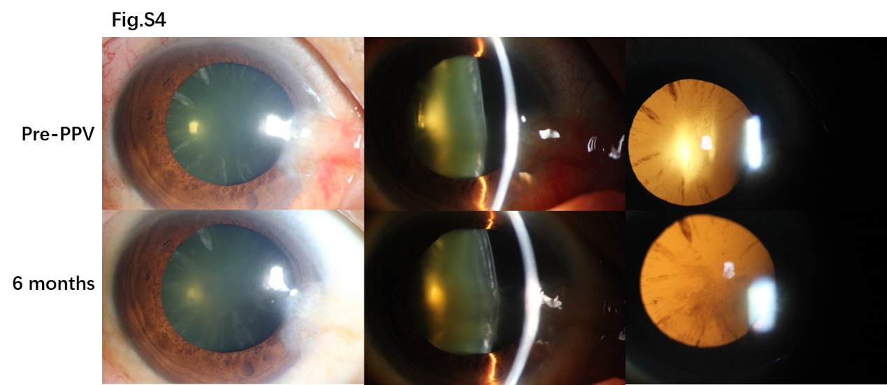Fig.S4 A typical example of participants in the subsequent group. Compared to the pre-PPV condition, nuclear and post subcapsular opacities were clearly found six months later.

7.Surgical procedure and devices
All participants were allocated anti-vascular endothelial growth factor (anti-VEGF, KANGHONG, China) intravitreal injection 1 week before an extensive 3-port PPV using 25-gauge instrument. All PPV surgeries were performed by three experienced surgeons in each hospital respectively under retrobulbar local anesthesia. Using non-contact lenses, posterior hyaloid separation, removal of the posterior vitreous membrane and peripheral vitrectomy were performed, and then manual delamination, dissection, and segment were used to remove proliferative tissues. Membrane dissection and segmentation were performed when necessary to eliminate all tangential tractions. Panretinal endophotocoagulation were routinely performed under air or fluid condition. A total of 600–1200 burns with a spot size of approximately 500 µm were applied on the retina over 50–200 ms. The laser power was modified according to the retinal conditions until an effective retinal laser spot is obtained. Air-fluid exchange and C3F8 tamponade were performed when an iatrogenic retinal tear/rhegmatogenous retinal detachment were identified intraoperatively. Triamcinolone acetonide was injected intraocularly at the end of PPV if conditions allowed.
As for the cataract surgery, lens extraction was routinely performed by phacoemulsification under surface anesthesia through a 3.2-mm clear corneal incision, followed by implantation of aspherical monofocal foldable IOL. In the combined surgery, lens extraction would be the first step before vitrectomy to assure a clear surgical field and IOL implantation would be left to the last step until all PPV procedures were successfully accomplished.
In Tab.S8, we exhibit the details of surgical devices used in each hospital. Retinal endophotocoagulation was performed using Constellation Vision System (Alcon laboratories, USA) during PPV. The keratometric values, axial length, anterior chamber depth and other biometers were measured before cataract surgery using IOL Master 700/500 (Carl Zeiss Meditec AG, Germany). Barret U Ⅱ was used as the IOL power calculation in three hospitals.
Tab.S8 The details of surgical devices in each hospital.
 | ZOC | SEH | GMU
PPV device | Constellation Vision System (Alcon laboratories, USA) | Constellation Vision System (Alcon laboratories, USA) | Constellation Vision System (Alcon laboratories, USA)
Phacoemulsification device | Centurion (Alcon laboratories, USA) | Centurion (Alcon laboratories, USA) | Constellation (Alcon laboratories, USA)
Optical Biometry device | IOL Master 700 (Carl Zeiss Meditec AG, Germany) | IOL Master 700 (Carl Zeiss Meditec AG, Germany) | IOL Master 500 (Carl Zeiss Meditec AG, Germany)
ZOC is for Zhongshan Ophthalmic Center, Sun Yat-sen University; SHE is for Shenzhen Eye Hospital; GMU is for The Affiliated Hospital of Guizhou Medical University; PPV is for pars plana vitrectomy.

