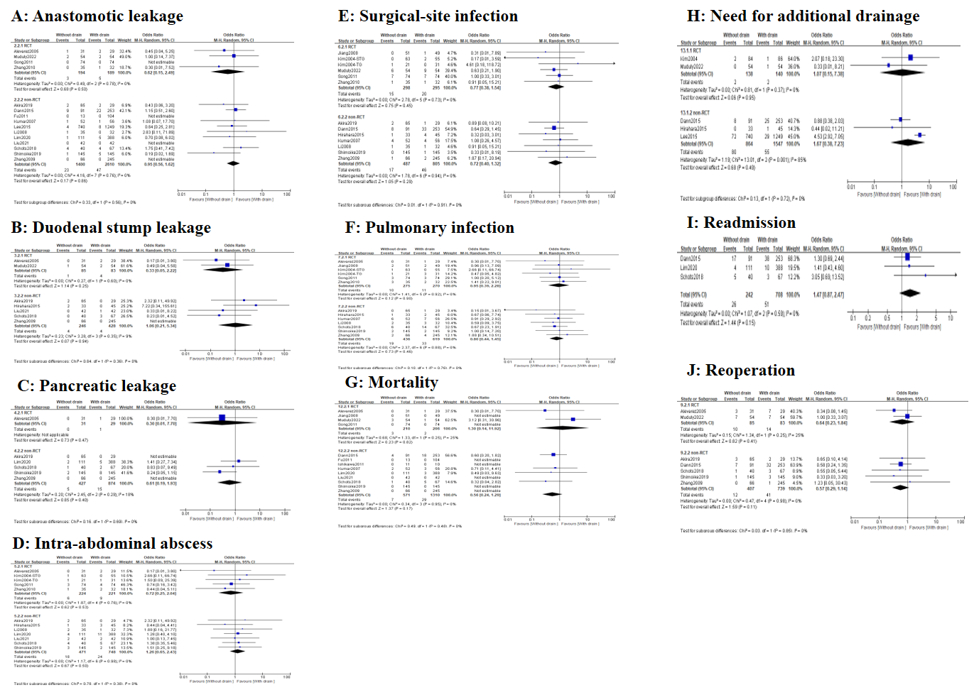
Figure S1. Forest plots of perioperative outcomes including: A. anastomotic leakage; B. Duodenal stump leakage; C. Pancreatic leakage; D. Intra-abdominal abscess; E. Surgical-site infection; F. Pulmonary infection; G. Mortality; H. Need for additional drainage; I. Readmission; J. Reoperation.

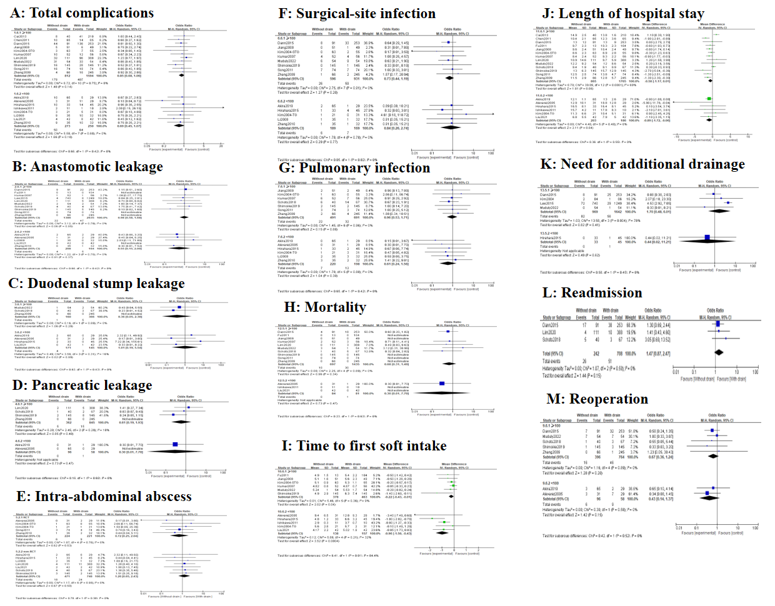
Figure S2. Subgroup analyses of perioperative outcomes based on sample size (≥100 vs. <100). A. total complications; B. anastomotic leakage; C. Duodenal stump leakage; D. Pancreatic leakage; E. Intra-abdominal abscess; F. Surgical-site infection; G. Pulmonary infection; H. Mortality; I. Time to first soft diet; J. Length of hospital stay; K. Need for additional drainage; L. Readmission; M. Reoperation.
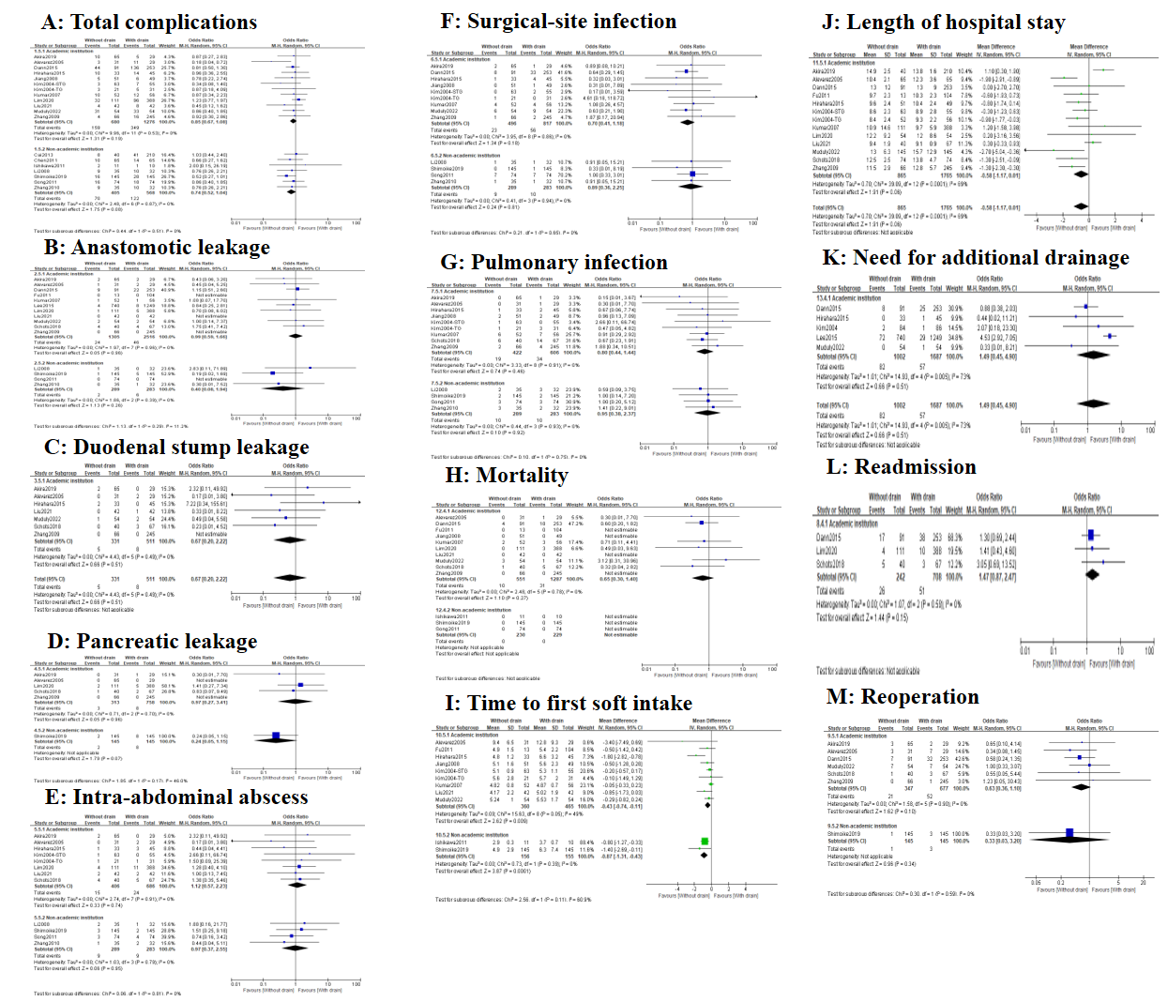
Figure S3. Subgroup analyses of perioperative outcomes based on academic institution (Yes vs. No). A. total complications; B. anastomotic leakage; C. Duodenal stump leakage; D. Pancreatic leakage; E. Intra-abdominal abscess; F. Surgical-site infection; G. Pulmonary infection; H. Mortality; I. Time to first soft diet; J. Length of hospital stay; K. Need for additional drainage; L. Readmission; M. Reoperation.
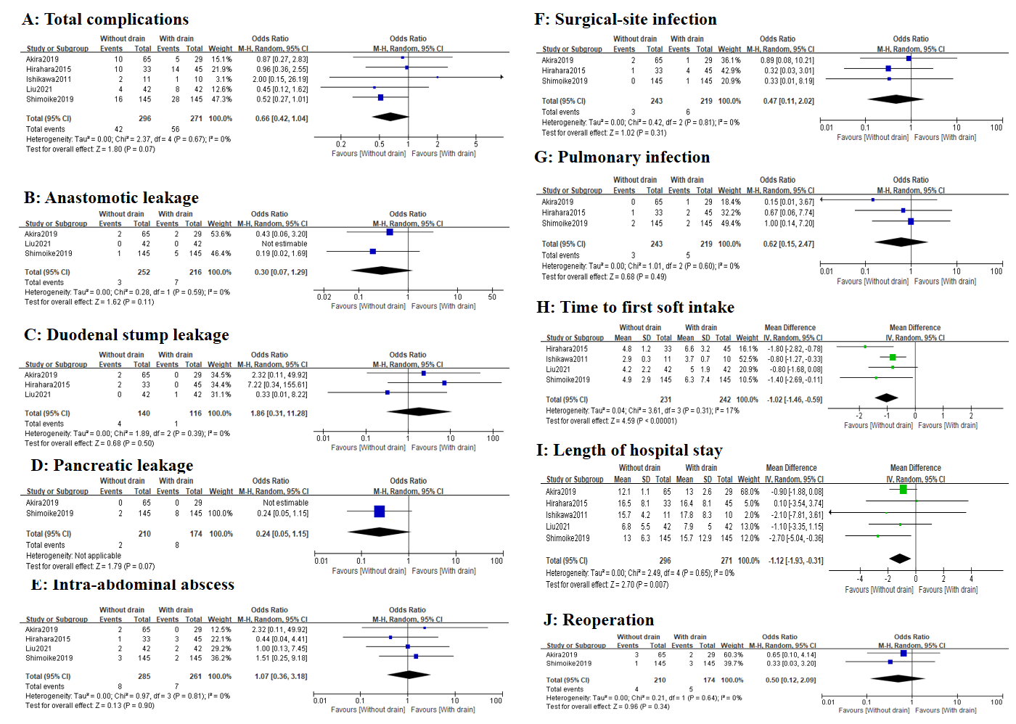
Figure S4. Subgroup analyses of perioperative outcomes in GC patients who underwent laparoscopic surgery. A. total complications; B. anastomotic leakage; C. Duodenal stump leakage; D. Pancreatic leakage; E. Intra-abdominal abscess; F. Surgical-site infection; G. Pulmonary infection; H. Time to first soft diet; I. Length of hospital stay; J. Reoperation.
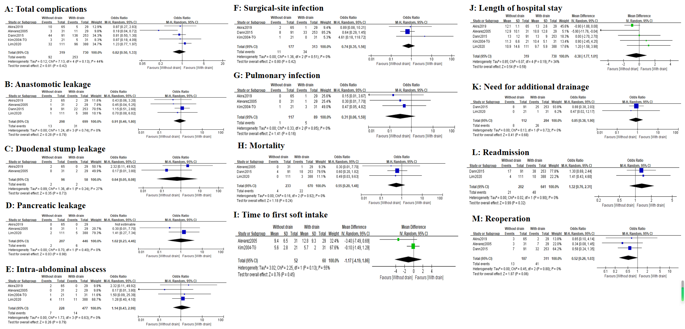
Figure S5. Subgroup analyses of perioperative outcomes in GC patients who underwent total gastrectomy. A. total complications; B. anastomotic leakage; C. Duodenal stump leakage; D. Pancreatic leakage; E. Intra-abdominal abscess; F. Surgical-site infection; G. Pulmonary infection; H. Mortality; I. Time to first soft diet; J. Length of hospital stay; K. Need for additional drainage; L. Readmission; M. Reoperation.
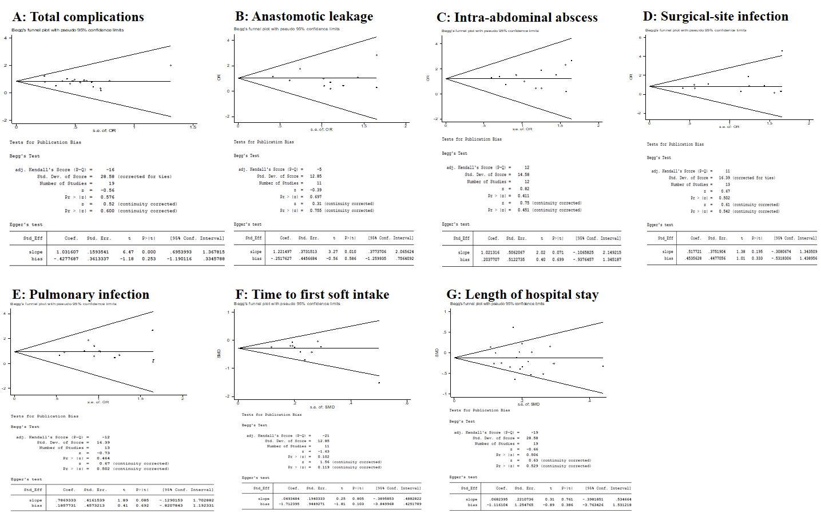
Figure S6. Begg’s funnel plot of perioperative outcomes including: A. total complications; B. anastomotic leakage; C. Intra-abdominal abscess; D. Surgical-site infection; E. Pulmonary infection; F. Time to first soft diet; G. Length of hospital stay. All P values >0.05.

