Viviana K. Rivera Flores¹, Timothy A. DeMarsh¹, Xingrui Fan¹, and Samuel D. Alcaine¹*

¹Department of Food Science, Cornell University, Ithaca, NY, USA 14853
*Corresponding author: Dr. Samuel D. Alcaine. 362 Stocking Hall, Cornell University, Ithaca NY, 14853. Phone: 607-255-9183. alcaine@cornell.edu

Table S1. Experimental runs to develop response surface models that maximize the obtainment of galactose and ethanol from the fermentation of whey permeate by B. claussenii OYL-201. E/S = Enzyme/Substrate
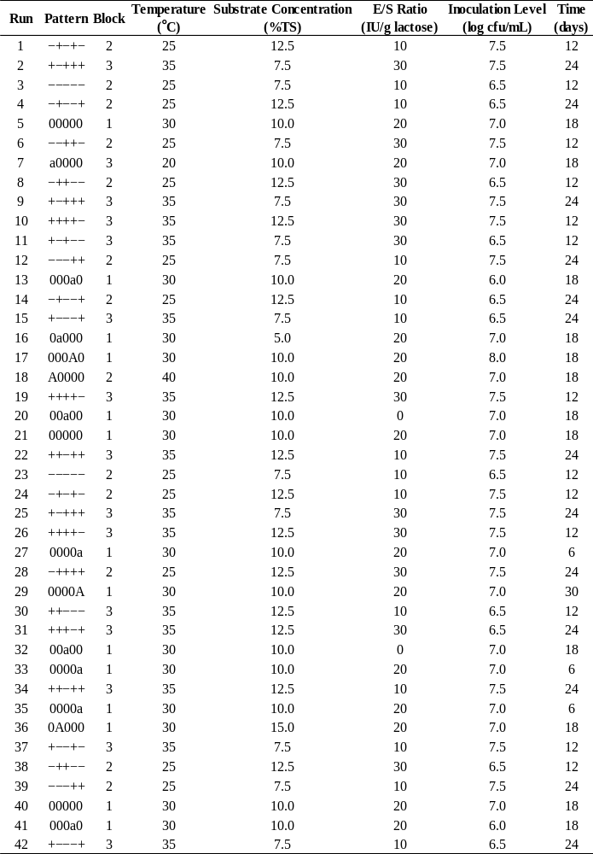

Table S1 (continuation). Experimental runs to develop response surface models that maximize the obtainment of galactose and ethanol from the fermentation of whey permeate by B. claussenii OYL-201. E/S = Enzyme/Substrate
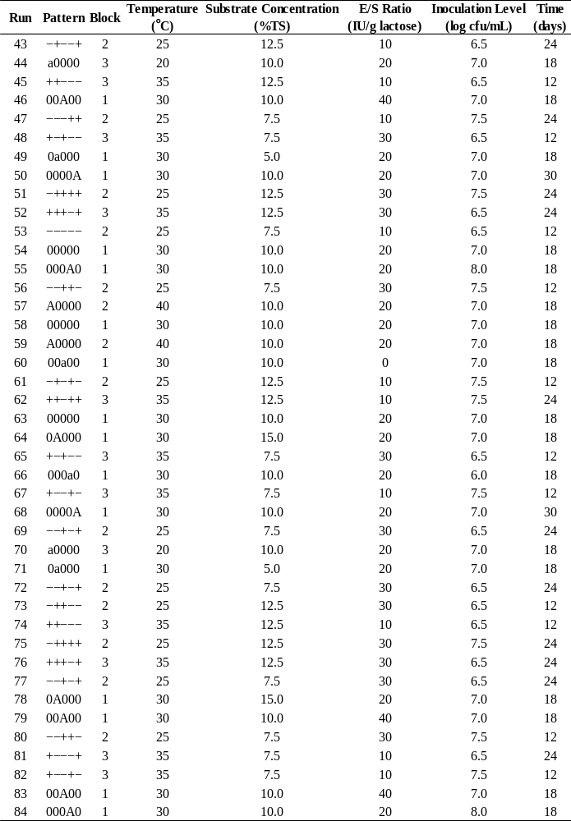
F
Figure S1. Effects of different fermentation factors on obtainment of ethanol (a) and galactose (b) from the fermentation of whey permeate by B. claussenii OYL-201. Triangles indicate respective sensitivities. Due to the significance of certain interactions between factors, these effects are subject to variation along the tested range. An interactive profiler can be found at: [link]

a. 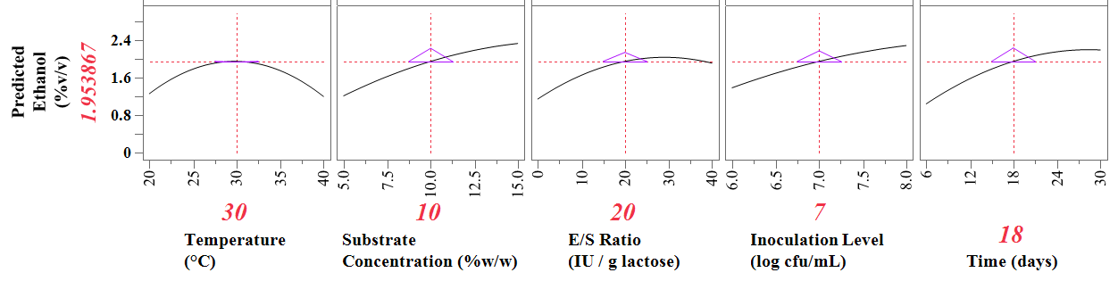
b. 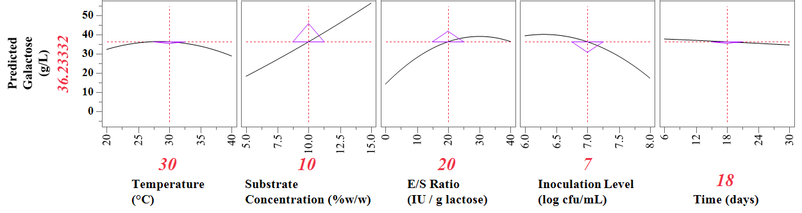

Figure S2. Interaction plot generated using response surface methodology, showing the relationships between the factors studied, as well as their effects on ethanol obtainment during the fermentation of whey permeate by B.
claussenii OYL-201. The random variables considered in the study-- block and incubator-- have also been included.

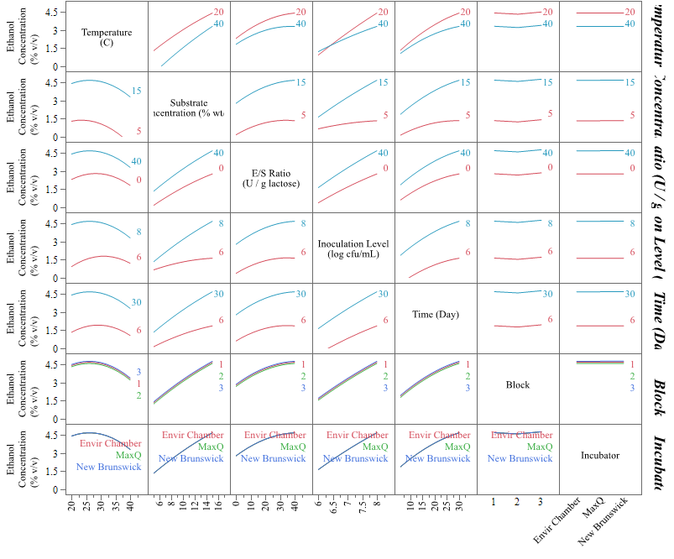
Temperature
(°C)
Substrate
Concentration
(%w/w)
E/S Ratio
(IU/g lactose)
Inoculation
Level
(log cfu/mL)
Time
(days)
Block
Incubator

Figure S3. Interaction plot generated using response surface methodology, showing the relationships between the factors studied, as well as their effects on final galactose during the fermentation of whey permeate by B.
claussenii OYL-201. The random variables considered in the study-- block and incubator-- have also been included.

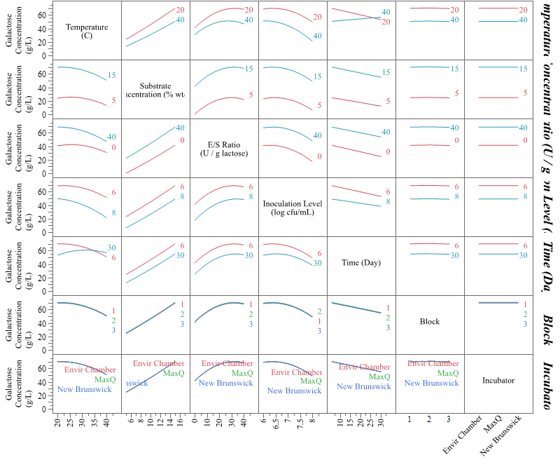
Temperature
(°C)
Substrate
Concentration
(%w/w)
E/S Ratio
(IU/g lactose)
Inoculation
Level
(log cfu/mL)
Time
(days)
Block
Incubator

Table S2. Estimated coefficients and standard errors (in g/L) of the linear, quadratic, and interaction terms of an additional model generated to assess the effects of the investigated fermentation factors on the final concentration of lactose in whey permeate fermented by B. claussenii. The interaction effect between E/S Ratio and Inoculation Level was deemed significant (p <0.0001).
Term |  | Estimate | Standard Error | p-value | Significance
Intercept |  | -0.641 | 2.797 | 0.8332
Linear
 | Temperature | 0.576 | 0.121 | <.0001 | ***
 | E/S Ratio | -9.186 | 0.513 | <.0001 | ***
 | Inoculation Level | 6.812 | 0.513 | <.0001 | ***
 | Substrate Concentration | 0.122 | 0.513 | 0.8136
 | Time | -0.045 | 0.513 | 0.9300
Interactions
 | E/S Ratio x Inoculation Level | -7.076 | 0.628 | <.0001 | ***
 | Temperature x E/S Ratio | -0.444 | 0.628 | 0.4823
 | Temperature x Inoculation Level | 0.444 | 0.628 | 0.4823
 | Substrate Concentration x Time | 0.444 | 0.628 | 0.4823
 | Substrate Concentration x E/S Ratio | -0.182 | 0.628 | 0.7728
 | Substrate Concentration x Inoculation Level | 0.182 | 0.628 | 0.7728
 | Temperature x Time | 0.182 | 0.628 | 0.7728
 | Temperature x Substrate Concentration | -0.068 | 0.628 | 0.9143
 | E/S Ratio x Time | 0.068 | 0.628 | 0.9143
 | Inoculation Level x Time | -0.068 | 0.628 | 0.9143
Quadratic
 | E/S Ratio x E/S Ratio | 6.561 | 0.676 | <.0001 | ***
 | Inoculation Level x Inoculation Level | 3.000 | 0.676 | <.0001 | ***
 | Substrate Concentration x Substrate Concentration | -0.143 | 0.676 | 0.8338
 | Time x Time | -0.143 | 0.676 | 0.8338
 | Temperature x Temperature | -0.027 | 1.038 | 0.9816
E/S = enzyme/substrate
***Statistically significant at 99.9% probability level (p<0.001)

Table S3. Estimated coefficients and standard errors (in %v/v) of the linear, quadratic, and interaction terms of the reduced optimization model to maximize ethanol production from whey permeate by B. claussenii, using response surface methodology.
Term |  | Coefficient | Standard Error | p-value | Significance
Intercept |  | 1.811 | 0.062 | 0.0024 | **
Linear
 | Substrate Concentration | 0.280 | 0.021 | <.0001 | ***
 | E/S Ratio | 0.191 | 0.021 | <.0001 | ***
 | Inoculation Level | 0.226 | 0.021 | <.0001 | ***
 | Time | 0.288 | 0.021 | <.0001 | ***
 | Temperature | -0.015 | 0.026 | 0.5634
Interactions
 | Substrate Concentration x Inoculation Level | 0.149 | 0.026 | <.0001 | ***
 | Substrate Concentration x Time | 0.102 | 0.026 | 0.0002 | ***
 | Temperature x Inoculation Level | -0.087 | 0.026 | 0.0012 | **
 | Temperature x Time | -0.053 | 0.026 | 0.0442 | *
Quadratic
 | Temperature x Temperature | -0.139 | 0.017 | <.0001 | ***
 | E/S Ratio x E/S Ratio | -0.082 | 0.021 | 0.0003 | ***
 | Time x Time | -0.060 | 0.021 | 0.0067 | **
E/S = enzyme/substrate
***Statistically significant at 99.9% probability level (p<0.001)
**Statistically significant at 99% probability level (p<0.01)
*Statistically significant at 95% probability level (p<0.05)

Table S4. Estimated coefficients and standard errors (in g/L) of the linear, quadratic, and interaction terms of the reduced optimization model to maximize galactose retention from whey permeate fermented by B. claussenii, using response surface methodology.
Term |  | Coefficient | Standard Error | p-value | Significance
Intercept |  | 34.251 | 1.650 | 0.0030 | **
Linear
 | Substrate Concentration | 9.494 | 0.385 | <.0001 | ***
 | E/S Ratio | 5.528 | 0.385 | <.0001 | ***
 | Inoculation Level | -5.499 | 0.385 | <.0001 | ***
 | Time | -0.779 | 0.385 | 0.0464 | *
 | Temperature | -0.740 | 0.999 | --
Interactions
 | Temperature x Time | 1.428 | 0.471 | 0.0034 | **
Quadratic
 | E/S Ratio x E/S Ratio | -2.735 | 0.387 | <.0001 | ***
 | Inoculation Level x Inoculation Level | -1.976 | 0.387 | <.0001 | ***
E/S = enzyme/substrate
***Statistically significant at 99.9% probability level (p<0.001)
**Statistically significant at 99% probability level (p<0.01)
*Statistically significant at 95% probability level (p<0.05)

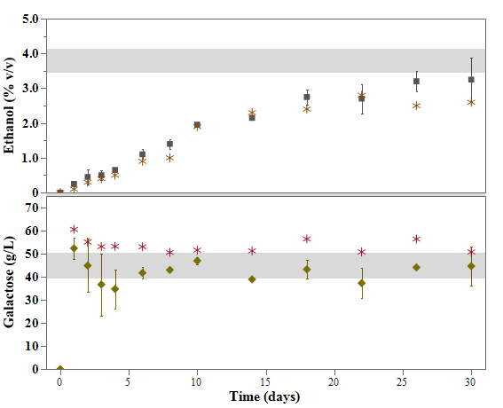
Figure S4. Predictions for ethanol and galactose, generated using the parameters for the combined optimization (as presented in Table 5), inputted into the respective reduced models. Fermentations were performed by B. claussenii OYL-201 in whey permeate with 15 %TS. Each result is presented in the form of a mean and standard deviation for 2 biological replicates; data for the third replicate of this experiment are included in the form of asterisks, due to the different method used for the analyses of these samples. Each shaded area corresponds to the respective 95% confidence interval of the predicted results for day 30.

Table S5. Fermentation parameters predicted by the reduced optimization models for the maximum obtainment of ethanol and galactose from whey permeate fermented by Brettanomyces claussenii. Each response range (in brackets) was determined according to the 95% confidence interval of the predicted value.

Factor | Ethanol  [4.01 - 4.84]  (% v/v) | Galactose  [61.06 - 76.15]  (g/L) | Combined
Factor | Ethanol  [4.01 - 4.84]  (% v/v) | Galactose  [61.06 - 76.15]  (g/L) | Ethanol  [2.91 - 3.51]  (% v/v) | Galactose  [49.10 - 60.22]  (g/L)
Temperature (°C) | 24.7 | 20.0 | 31.2
Substrate Concentration (% TS) | 15.0 | 15.0 | 15.0
E/S Ratio (IU/g lactose) | 31.6 | 30.1 | 30.0
Inoculation Level (log cfu/mL) | 8.0 | 6.3 | 7.0
Time (days) | 30.0 | 6.0 | 30.0
E/S=Enzyme/Substrate

Table S6. P-values resulting from the paired t-tests executed for all possible pairs of quality attributes for the products obtained through the fermentation and distillation of whey permeate (WP) using B. claussenii OYL-201. Comparisons were made for n = 3, with a significance level of 0.05.
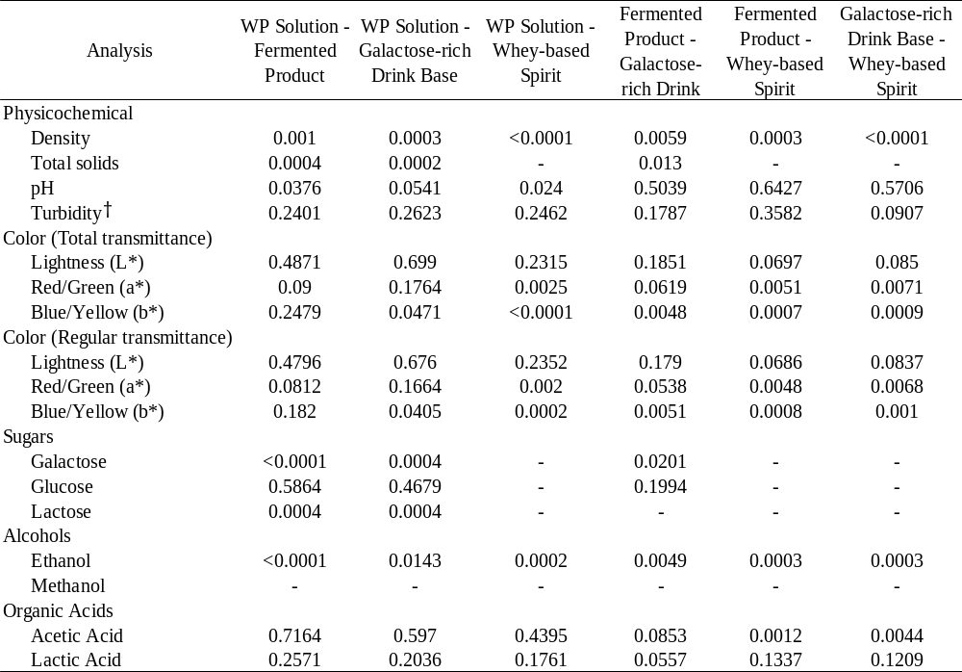
† n =2; given the matched-pairs nature of the analysis, all timepoints of replicate 1 were excluded due to the outlier measurement of turbidity in the WP solution.

