Whole genome and RNA sequencing analyses for 254 Taiwanese hepatocellular carcinomas
Ya-Sian Chang^{1,2,3,4}, Siang-Jyun Tu^{1,2,3}, Hong-Da Chen^{1,2,3}, Chin-Chun Chung^{1,2}, Ming-Hon Hsu^{1,2,3}, Yu-Pao Chou^{1,2,3}, Ya-Ting Lee^{1,2}, Ju-Chen Yen^{1,2}, Long-Bin Jeng⁵, Jan-Gowth Chang^{1,2,3,4}

Contents
Supplementary methods 3
Liver samples and clinical data 3
DNA extraction and whole genome sequencing (WGS) 3
Somatic variant calling 4
Copy number variation 5
Structure variant (SV) calling 5
Mutational signature analysis 6
RNA extraction and RNA sequencing (RNA-seq) 6
RNA differential expression (DE) analysis 7
Gene fusion analysis 8
Metatranscriptomic analysis 8
RNA alternative splicing (AS) analysis 8
Cell score 9
Statistical analyses 9
Supplementary figures 10
Fig. S1. 10
Fig. S2. 11
Fig. S3. 13
Fig. S4. 15
Fig. S5. 19
Fig. S6. 22
Fig. S7. 23
Fig. S8. 24
Fig. S9. 25
Fig. S10. 26
Fig. S11. 27
Fig. S12. 28
Fig. S13. 29
Fig. S14. 30
Fig. S15. 31
Fig. S16. 32
Fig. S17. 33
Fig. S18. 34
Fig. S19. 35
Fig. S20. 36
Fig. S21. 38
Fig. S22. 39
Supplementary tables 40
Table S1 40
Table S2 43
Table S3 45
Table S4 47
Table S5 50
Table S6 59
Table S7 67
Table S8 72
Supplementary results 76
Clinical data 76
References 77

Supplementary methods

Liver samples and clinical data
Hepatocellular carcinoma (HCC) was identified by pathological diagnosis. Tumor and adjacent non-tumor liver tissue samples were collected after surgical resection, then frozen at −80 °C and stored at the Tissue Bank of China Medical University Hospital (CMUH). The Tissue Bank was established in 2005; has been accredited by the Taiwanese government since October 25, 2012; and contains > 20,000 cancer tissues of more than 20 types of cancers. We performed the Cancer Genome Sequencing project of CMUH [The Cancer Genome Atlas (TCGA) of CMUH], which was approved by the Ethics Committee of CMUH (CMUH110-REC3-221); this project sequenced > 1000 cases of different types of cancers from the Tissue Bank of CMUH. This HCC study was also approved by the Ethics Committee of CMUH (CMUH 109-REC3-055), and informed consent was obtained from all participants in accordance with the standard procedure of the CMUH Tissue Bank. Additionally, both the Declaration of Helsinki and the Good Clinical Practice Guidelines were followed.

DNA extraction and whole genome sequencing (WGS)
Frozen tissue DNA was extracted using a QIAamp® DNA mini kit (Qiagen, Heidelberg, Germany), in accordance with the manufacturer’s instructions. Barcoded DNA libraries were generated using a DNA PCR-Free Prep kit (Illumina, San Diego, CA, USA). Genomic DNA was diluted to 40 ng/μl using Resuspension Buffer (Illumina). Then, 25 μl of Bead-Linked Transposomes were used to fragment DNA; this was followed by the ligation of DNA fragments to barcoded adapters without polymerase chain reaction amplification. WGS libraries were sequenced on the NovaSeq 6000 instrument (Illumina) using 2x151-bp paired-end sequencing flow cells, in accordance with the manufacturer’s instructions.

Somatic variant calling
On average, > 400 Gb and 40–60× depth of mappable sequence data were obtained. After using Illumina Dragen Bio-IT Platform (v3.7) analysis of WGS data, we selected the variants of PASS on the FILTER column of VCF file, and data were analyzed in our bioinformatics pipeline. Variant frequencies were evaluated using the gnomAD (https://gnomad.broadinstitute.org/) and Taiwan biobank (TWB) (https://www.twbiobank.org.tw/new_web/) databases, as well as our database. Variant characteristics were analyzed using the ClinVar database (https://ftp.ncbi.nlm.nih.gov/pub/clinvar/vcf_GRCh38/) and combined annotation dependent depletion (CADD; https://cadd.gs.washington.edu/download). We collected pathogenic or likely pathogenic (P or LP) variants from the ClinVar database, as well as variants without annotations (after filtering out variants with a CADD score < 30, variants classified as benign or likely benign in ClinVar, and variants with allele frequency > 0.01 in the gnomAD and TWB databases, as well as our database) as previous described [1]. Variants were annotated using VEP (v104.3); the data for 1,171 cancer-related genes [2] were converted into an MAF file using vcf2maf (v1.6.21). The MAF file was loaded into R software for analysis and visualized using maftools (v2.6.05).
Mutations of histone-related genes, HCC-related long non-coding RNAs (lncRNAs), and non-coding driver genes were analyzed. We collected 114 histone-related genes from HistoneDB 2.0 [3] and selected the important variants using criteria similar to the constraints selected for cancer-related genes. We collected 74 HCC-related lncRNAs [4] and 36 non-coding driver genes, as described by Rheinbay et al. [5], then analyzed their alterations to explore their roles in the onset and progression of HCC [1].

Copy number variation
For copy number alteration (CNA) analysis, we used the Illumina Dragen CNV pipeline (v3.7), annotation by BEDTools and GENCODE gene data (GRCh38, V37), analysis in R, and visualization with the circlize package (v0.4.13).

Structure variant (SV) calling
SV merge by SURVIVOR (v1.0.7) (max distance, 1000; minimum size of SVs, 30; and minimum number of supporting callers, 1), annotate and query of SVs vcf file by BCFtools, and final annotated by AnnotSV (v3.0) were performed. For analysis of somatic SVs, we used gnomAD and WGS of 1491 samples from TWB and our database to generate a reference set. Then, we compared these SVs with non-cancerous and benign liver tissues to identify HCC-related somatic SVs. We used probability of being loss-of-function intolerant (pLI) ≥ 0.9 to select important SVs [6, 7]. The SV included cancer driver gene(s) was selected as HCC-related driver SV.

Mutational signature analysis
Mutational signature analysis was performed using the non-negative matrix factorization method in the R package NMF [8], along with BCFtools (v1.9) to filter variants (FILTER=PASS, ALT frequency > 0.1, DP > 20, QUAL > 30) [9]. Reference mutational signatures were obtained from the Catalogue of Somatic Mutations in Cancer (COSMIC) v3 (May 2019) [10]

RNA extraction and RNA sequencing (RNA-seq)
Total RNA was extracted from tissue samples using a NucleoSpin® RNA Kit (Macherey-Nagel, Duren, Germany), in accordance with the manufacturer’s instructions and our existing method [11]. The quality, quantity, and integrity of total RNA were evaluated using a NanoDrop1000 spectrophotometer and a Bioanalyzer 2100 (Agilent Technologies, Santa Clara, CA, USA). Samples with an RNA integrity number > 6.0 were used for RNA-seq. A ribosomal RNA (rRNA)-depleted, barcoded total RNA library was generated using a Total RNA Library Preparation Kit (Illumina). Brief, 100 ng of total RNA were treated with a Ribo-Zero Gold rRNA Removal Kit (Illumina) to deplete rRNA. The resulting RNA was fragmented, reverse transcribed, and synthesized to generate double-stranded complementary DNA (cDNA), which was subsequently ligated to barcoded adapters and polymerase chain reaction-amplified to construct a cDNA library. The libraries were sequenced on the NovaSeq 6000 instrument (Illumina), using 2×76-bp paired-end sequencing flow cells in accordance with the manufacturer’s instructions. Approximately 100 million pairs of reads were generated from each library.

RNA differential expression (DE) analysis
RNA DE analysis was performed as previously described [11]. Briefly, after RNA-seq, the raw data were processed by the Illumina Dragen RNA Pipeline v3.6 and v3.7, reads were aligned to GRCh38, and bam files were used to quantify gene expression based on GENCODE v35. Transcript per million (TPM) values and read counts were used for differential expression gene (DEG) analysis.
To characterize DE between HCC tumor and non-tumor tissues, the R package Deseq2 (v1.36.0) was used after normalization and the removal of genes for which there were few or no reads. Genes with log₂ fold change ≥ ±1.5 and adjusted p-values < 0.01 were considered DEGs in DEseq2 analysis; these genes were visualized using volcano plots with EnhancedVolcano (v11.6.0). To identify DEGs important for survival, we compared tumor samples with expression levels in the top 25 % and bottom 25%.

Gene fusion analysis
Fusion genes were predicted with Illumina Dragen Bio-IT version 3.7. Locus and transcripts information were obtained from GENCODE version 35; the human genome version is GRCh38. High-confidence fusion genes were selected using the following criteria: (1) number of split read and supported fragment alignment (NumSplitReads and NumPairedReads) > 5, (2) prediction score from Dragen > 0.9, and (3) absence in adjacent normal samples.

Metatranscriptomic analysis
Kraken2 (v2.1.1) was used for analysis of metatranscriptomic data [12]. The July 2020 Kraken2 database was used to annotate human, viral, archaea, bacterial, and fungal genes; National Center for Biotechnology Information (NCBI) RefSeq was used as the reference sequence database [13]. For the standard Kraken output, the lowest common mapping data of each k-mer in the sequence(s) were used to identify reads containing both human and HBV taxon IDs (#9606 and #10407, respectively). RNA-seq reads were then extracted from the fastq file, and Arriba was used to detect gene fusions in RNA-seq data, as previously described [2, 14].

RNA alternative splicing (AS) analysis
Bioinformatics identification of AS events was performed as previous described [15]. Briefly, high-confidence transcripts were identified in conditions where the TPM expression value was > 0.1 in more than 80% of the sample. Proportion spliced-in (PSI) value was calculated with SUPPA2 [16] and used to estimate abundances of AS event. The types of AS event (e.g., skipping exon, retained intron, mutually exclusive exon, alternative 5’ splice site, alternative 3’ splice site, alternative first exon, and alternative last exon) were collected from the GENCODE v35 annotation file. The splicing events, which contained the PSI value for all samples, were used for downstream analysis.

Cell score
For evaluate of tumor microenvironment characteristics, xCell [17] was used to calculate the enrichment scores of 64 immune and stromal cell types from gene expression data, as described previously [14].

Statistical analyses
Survival analysis was performed using survival v. 3.2.3 [18] using the log-rank test for comparisons among groups. Kaplan–Meier survival curves were visualized using ggfortify v. 0.4.10 [19] and surviminer v.0.4.9. Patients who had undergone transplantation were excluded for survival analysis. The wilcoxon rank sum test was performed for comparisons between two groups, using the R package ggpubr (v0.4.0).

Supplementary figures

Fig. S1.
Fig. S1. Mutation frequency comparison and correlation of mutated genes. Comparison of frequencies of 17 common mutated genes between subgroups of Taiwanese HCCs and TCGA-LIHC (full cohort and split by major racial subgroups, namely Asian and White people).
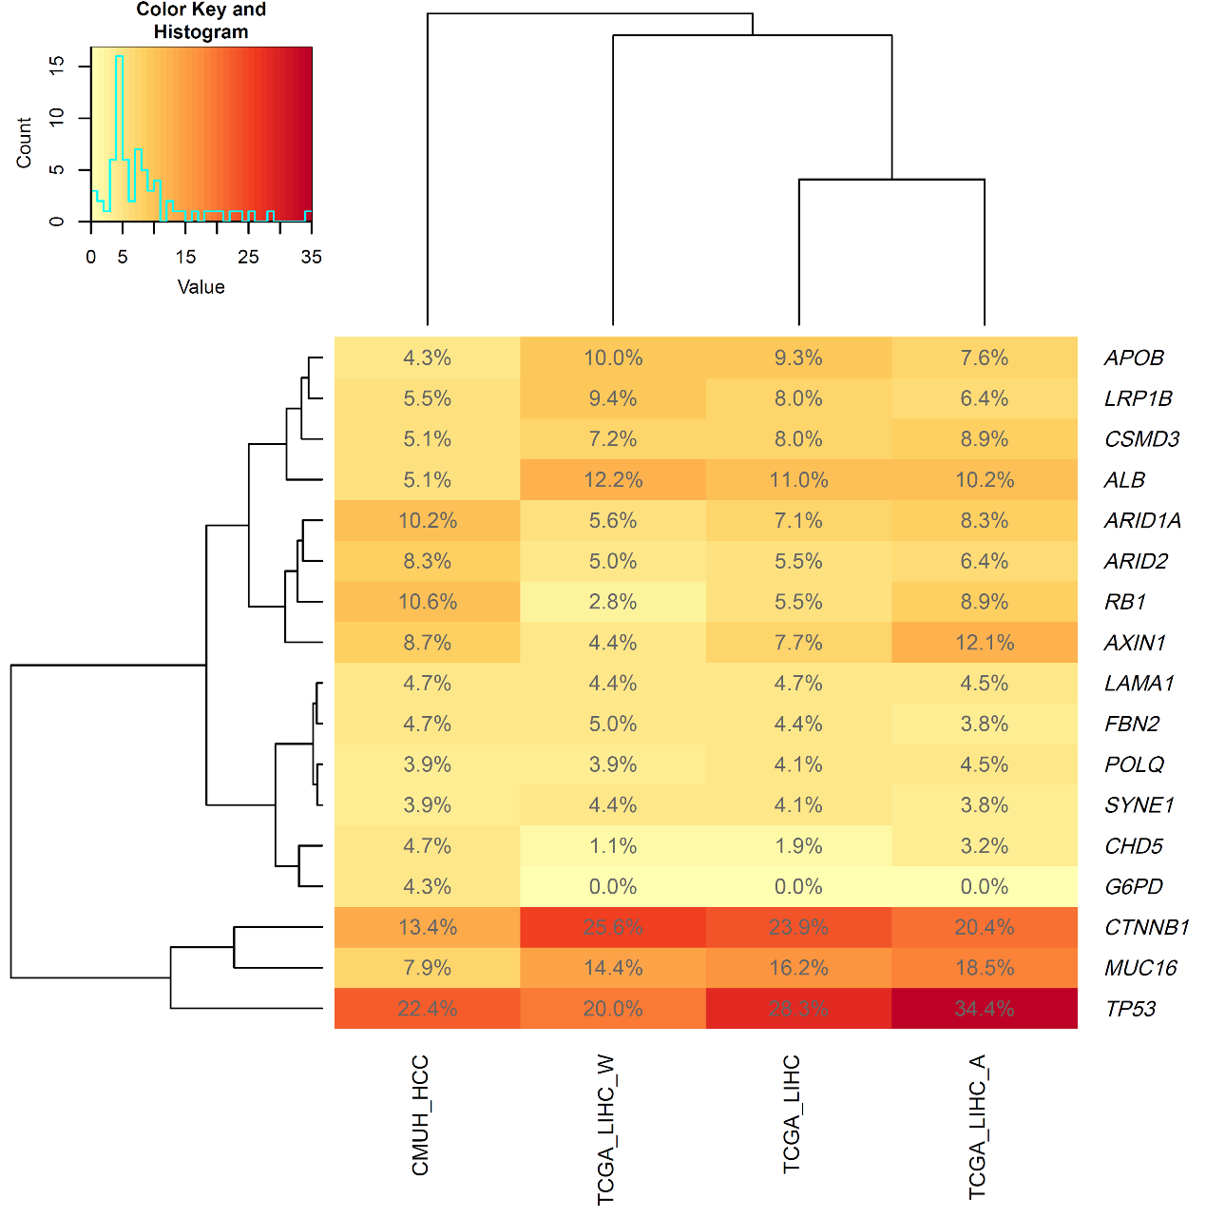

Fig. S2.
Fig. S2. Correlation between clinical data and etiology of HCC. (A) Female has more HCV-related HCC. (B) HCV-related HCC has more cirrhosis. (C) No correlation of survival with etiology of HCC.
(A)
Gender\HCV | No | Yes
Female | 25+2* | 36
Male | 109+8* | 65+9*
p = 0.0127
*Patients with double cancer count
p-value by Chi-square test or Fisher’s exact test when appropriated.
(B)
Cirrhosis\HCV | No | Yes
No | 65+6* | 25+1*
Yes | 69+4* | 76+8*
p = 2.961e-05
*Patients with double cancer count
p-value by Chi-square test or Fisher’s exact test when appropriated.

(C)
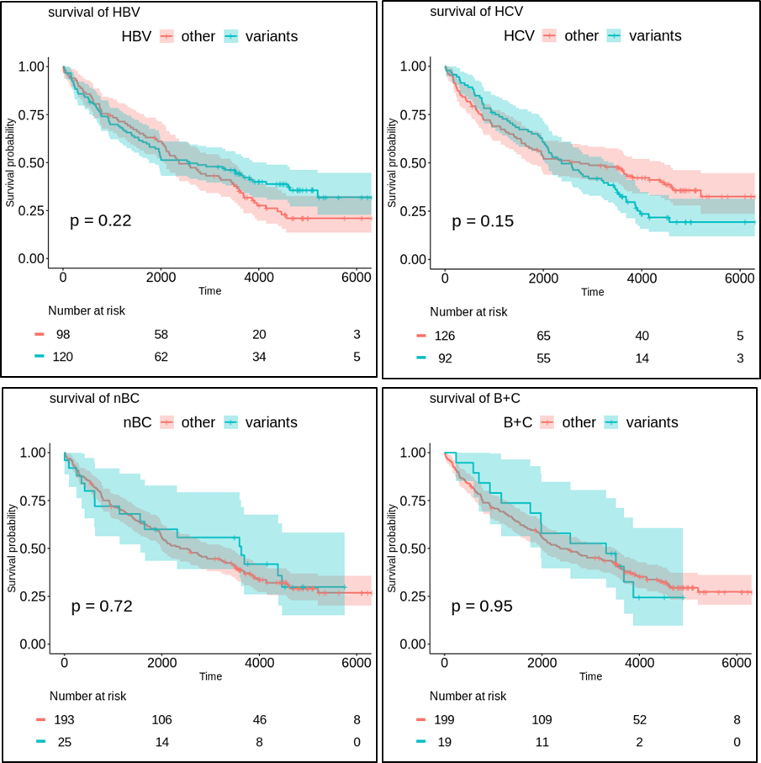
Patients were excluded if transplanted receive (36 cases) in survival analysis.

Fig. S3.
Fig. S3. Correlation between clinical data and TERT mutation. (A) TERT mutation correlation with HCV-related HCC, but not HBV. (B) TERT mutation correlated with poorer survival of HCC.
(A)
TERT\HBV | No | Yes
Mutation | 69+7* | 40+4*
Wild-type | 41+4* | 85+4*
p = 2.812e-06
*Patients with double cancer count
p-value by Chi-square test or Fisher’s exact test when appropriated.
TERT\HCV | No | Yes
Mutation | 45+5* | 64+6*
Wild-type | 89+5* | 37+3*
p = 5.024e-06
*Patients with double cancer count
p-value by Chi-square test or Fisher’s exact test when appropriated.

(B)
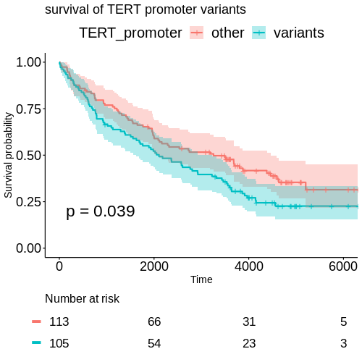
Patients were excluded if transplanted receive (36 cases) in survival analysis.

Fig. S4.
Fig. S4. Chromosome alterations and survival correlation of HCC. (A) The heatmap of chromosomal alterations. Left: Unsupervised hierarchical clustering using chromosomal alterations, and the association with TERT mutations and etiological groups. Upper: chromosome association. Right: the meaning of color markers. (B) The survival correlation between chromosomal changes and patient’s survival. (C) The genes in the chromosomal alteration regions and the correlation between involved genes and survival.

(A)
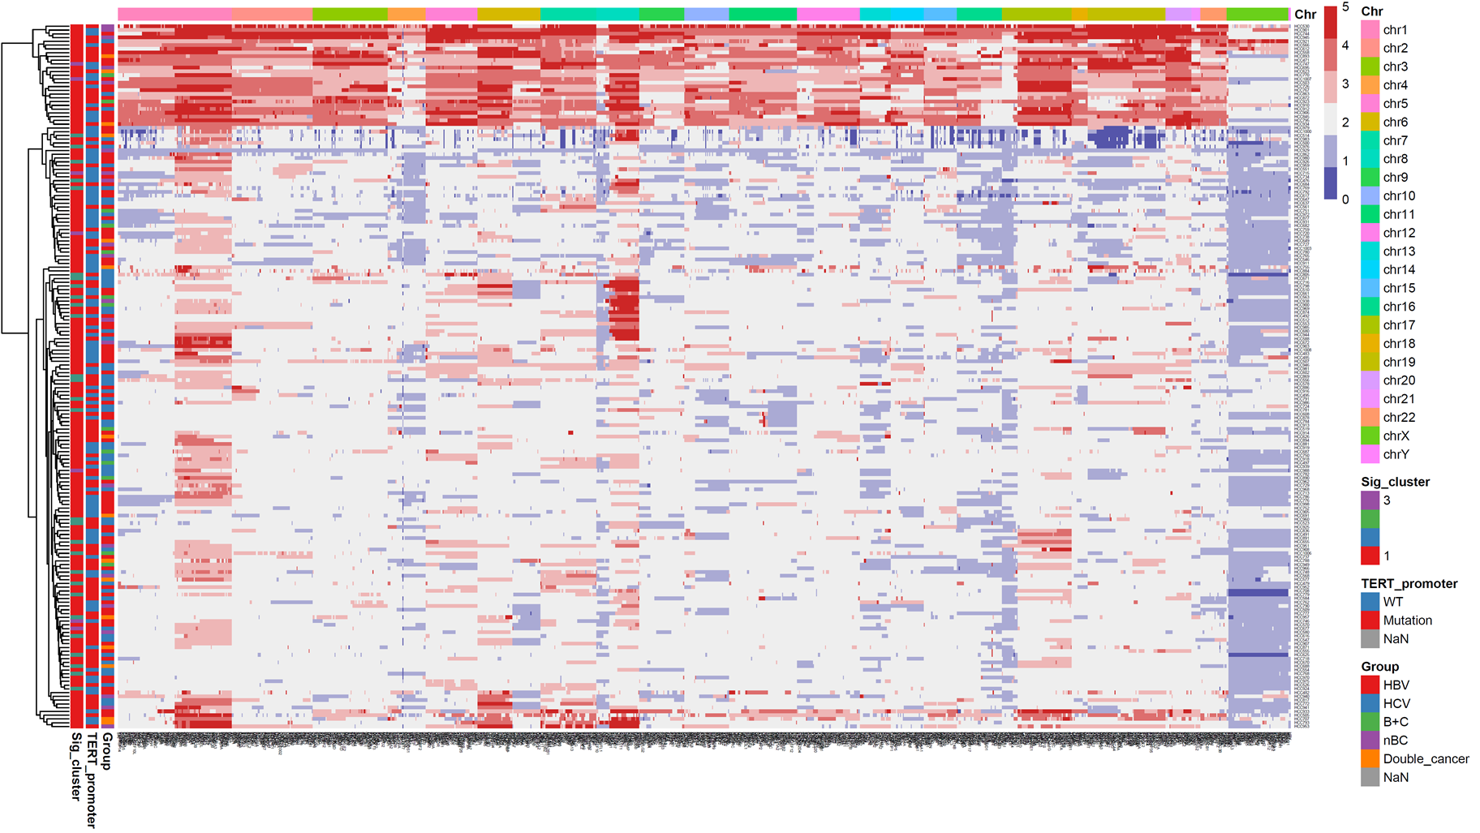

(B)
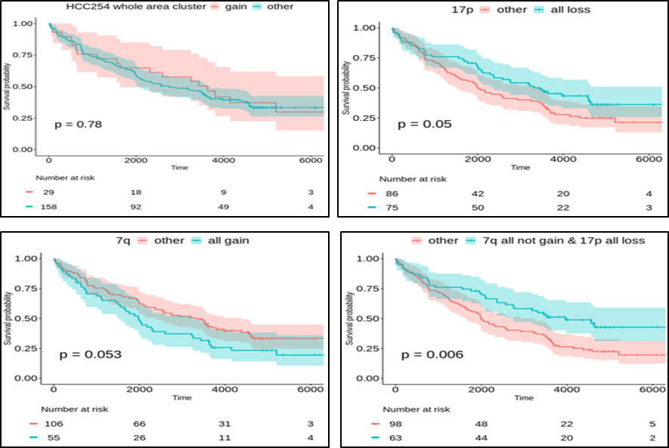

(C)
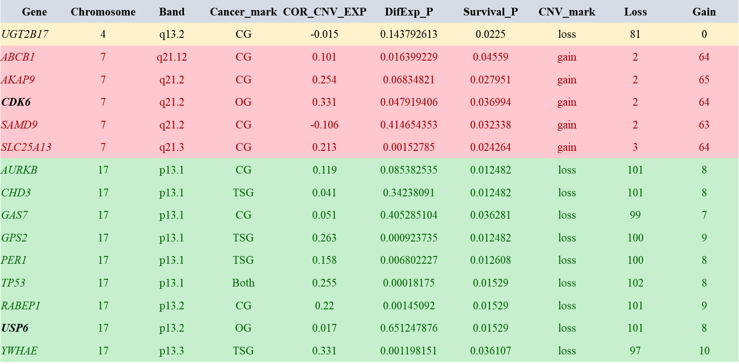

Fig. S5.
Fig. S5. The landscape of copy number alterations (CNAs) in 254 Taiwanese HCCs.
(A) The circos plot of CNAs. Outer: copy alteration and correlation with down expression (green) or over-expression (red) and survival. Middle: chromosome marker. Inner: copy gain (red) and copy loss (green). Oncogene, tumor suppressor gene, and both characters are depicted in bold, italics, and bold italic, respectively. (B) Survival-related copy changes. (C) The correlation between different etiology and copy alterations.
(A)
(B)
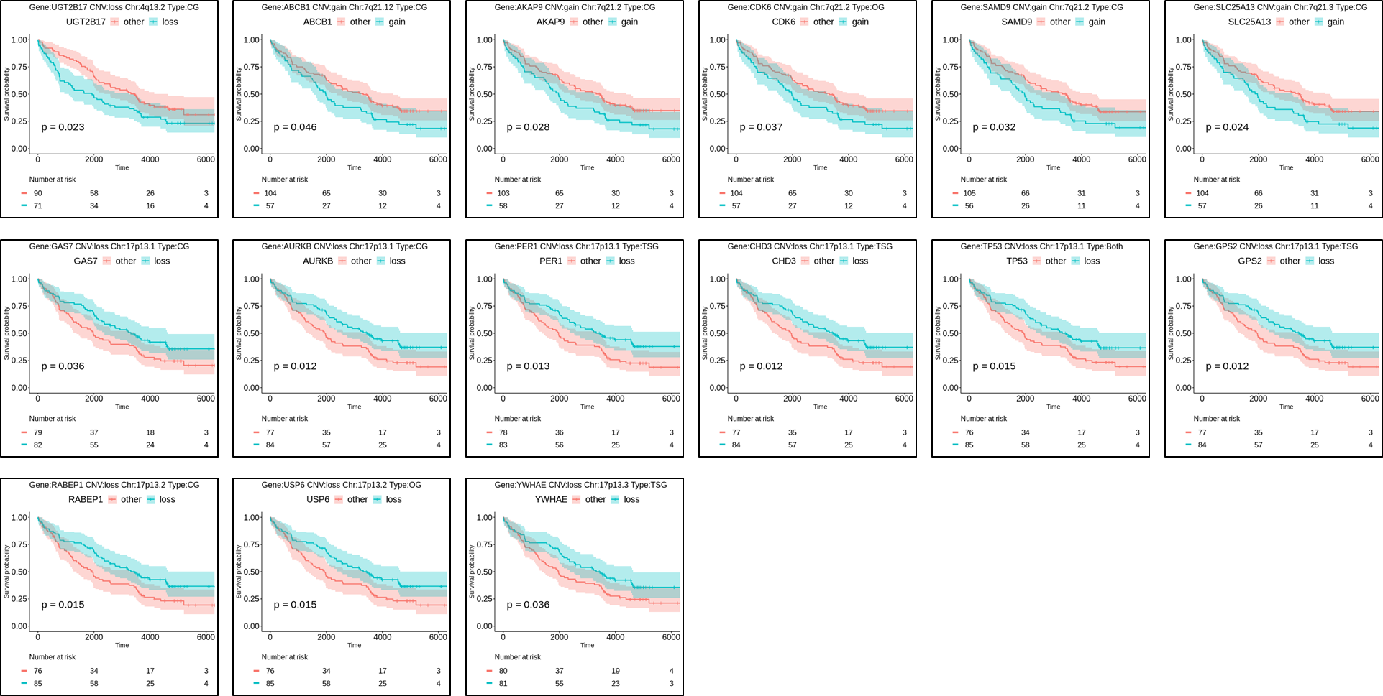

(C)
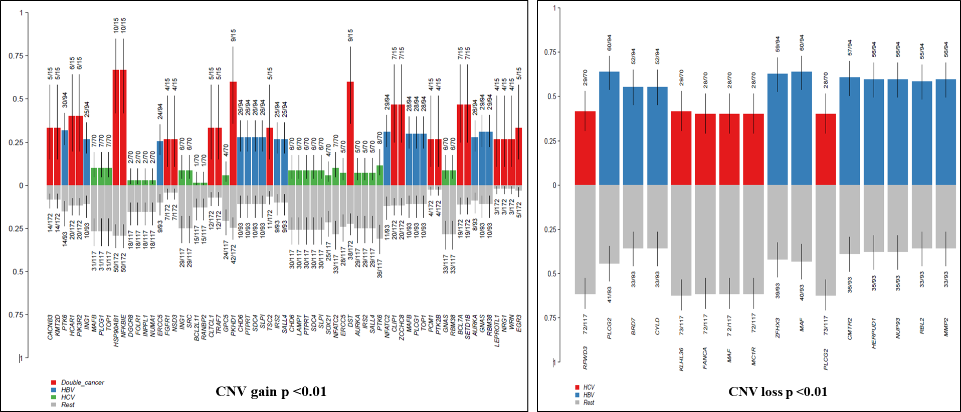

Fig. S6.
Fig. S6. The results of analysis of structural variants (SVs). The Venn plot of SVs among 254 HCCs in our cohort, Taiwan biobank (TWB), normal controls and liver benign lesions.
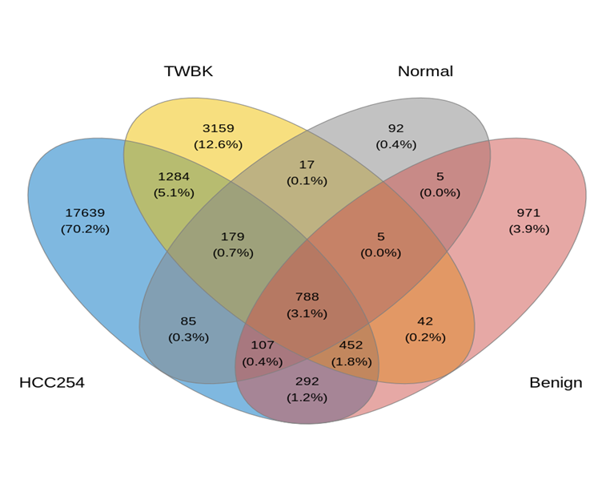

Fig. S7.
Fig. S7. The correlation between probability of being loss-of-function intolerant (pLI) analysis and cancer-related genes. pLI analysis of unique SVs with loss-of-function-intolerance of 254 HCCs in our cohort. p-value by t-test.
(A)
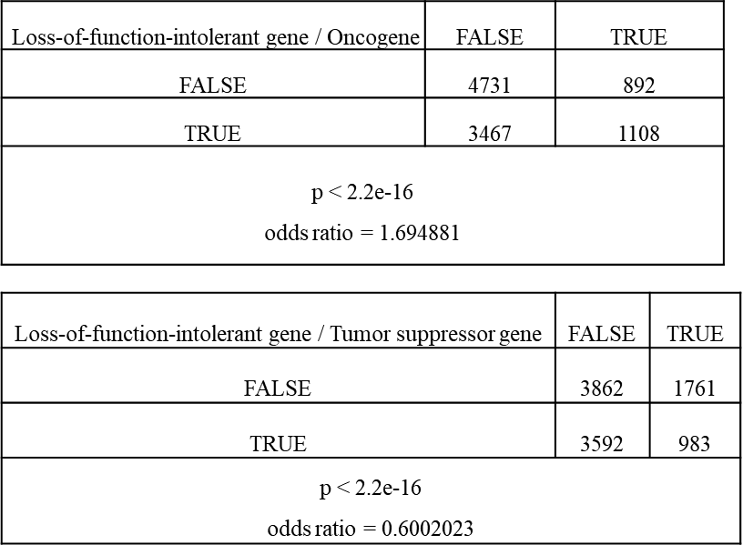

Fig. S8.
Fig. S8. The Kaplan-Meier plot of 13 survival-related somatic SVs for 254 HCCs in our cohort.
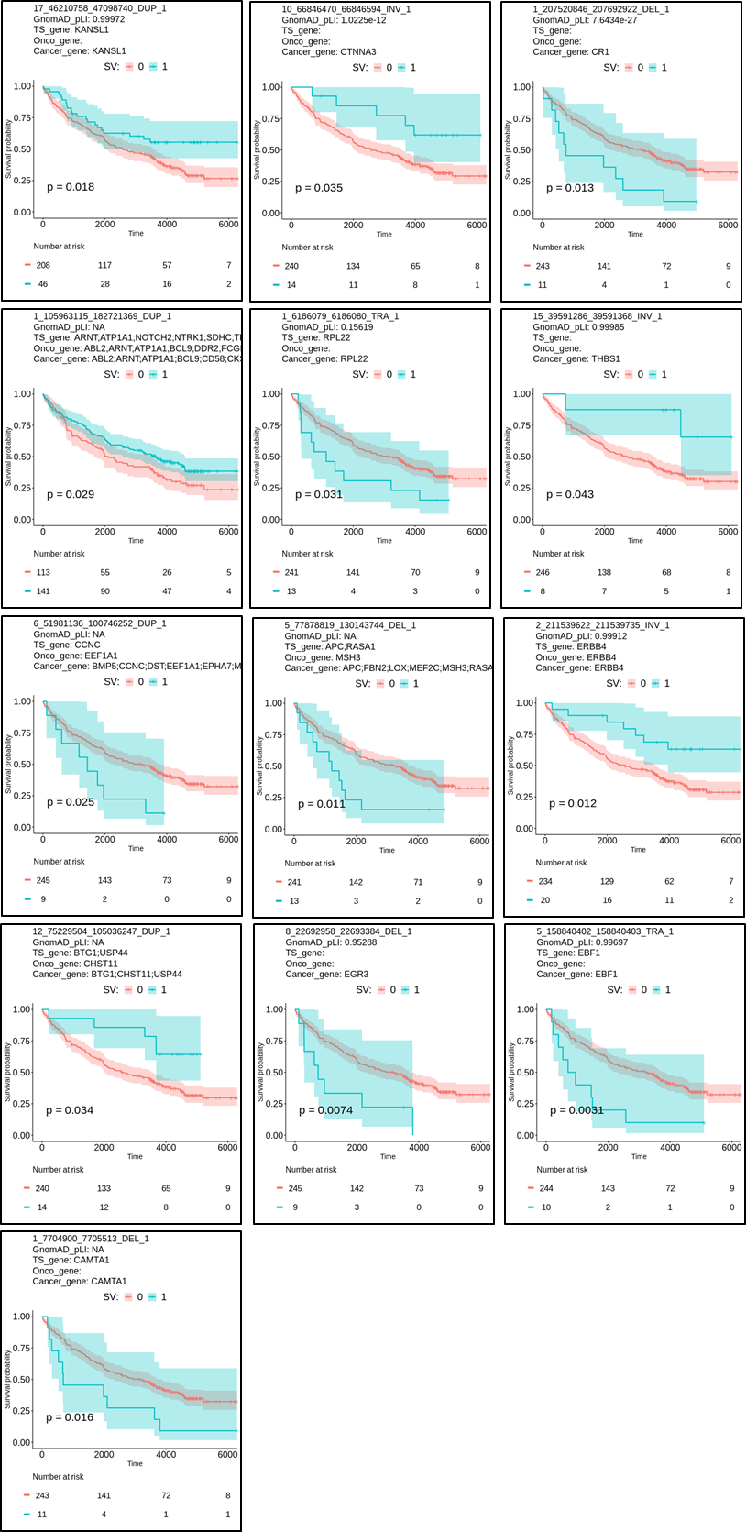

Fig. S9.
Fig. S9. The details of novel survival-related somatic SVs for 254 HCCs in our cohort.
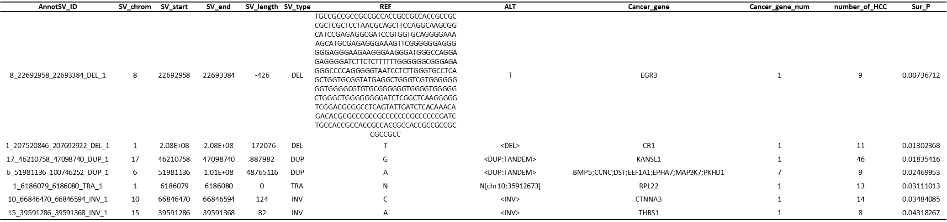
Known SVs means following paper was reported.
Li Y, Roberts ND, Wala JA, Shapira O, Schumacher SE, Kumar K, et al. Patterns of somatic structural variation in human cancer genomes. Nature 2020;578:112-121.

Fig. S10.
Fig. S10. Sanger sequencing validated the HILS1 mutations detected by our WGS data.
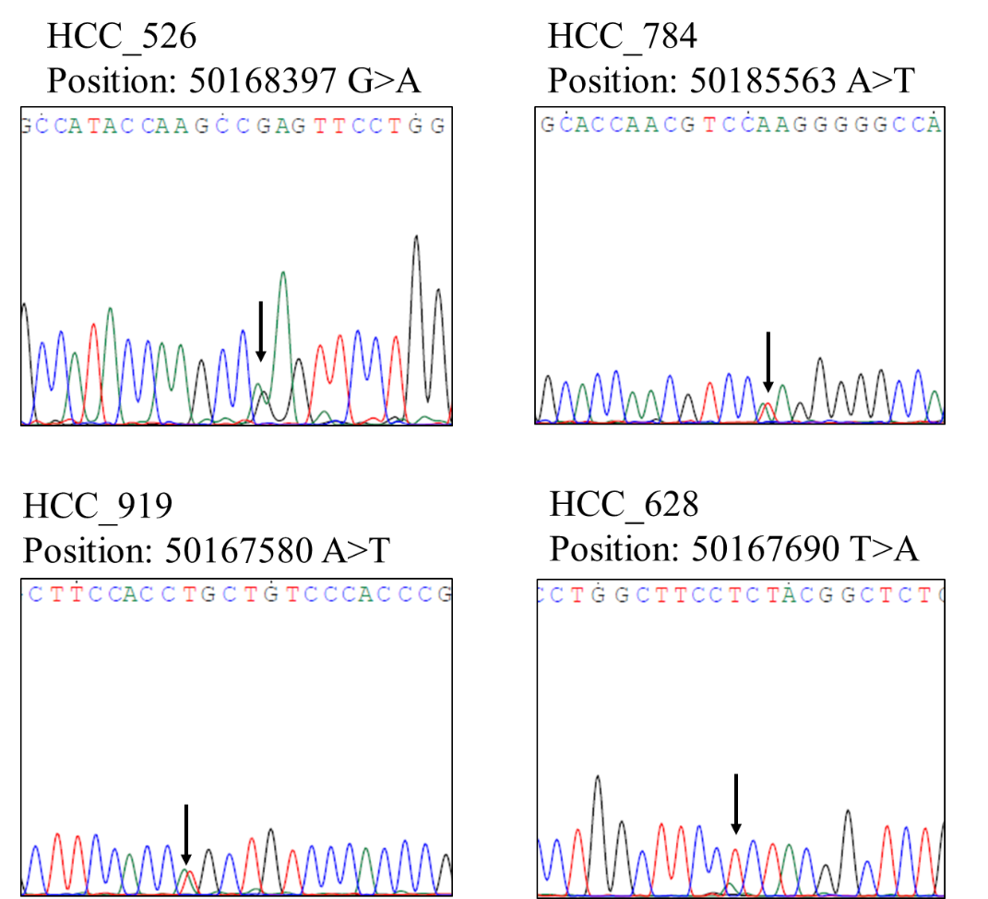

Fig. S11.
Fig. S11. Mutational signature on 254 Taiwanese HCCs. Cosine similarity by validated signatures in each sample and correlated with clinicopathological data and TERT mutation.
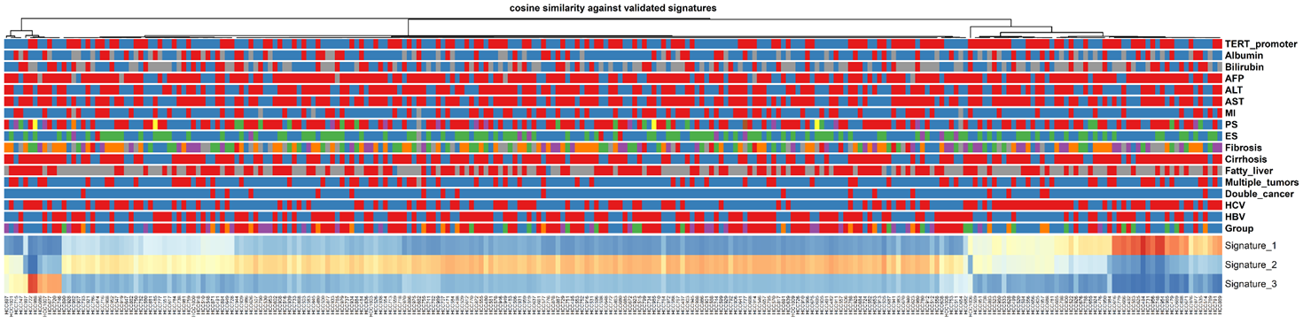
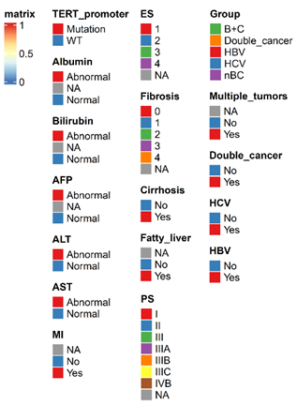

Fig. S12.
Fig. S12. The results of correlation between fusion genes and survival. (A) The results of fusion genes involving more than one case are shown. (B) The results of correlation of fusion genes with patient’s survival.
(A)
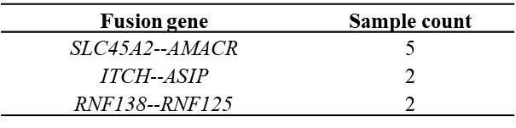
(B)
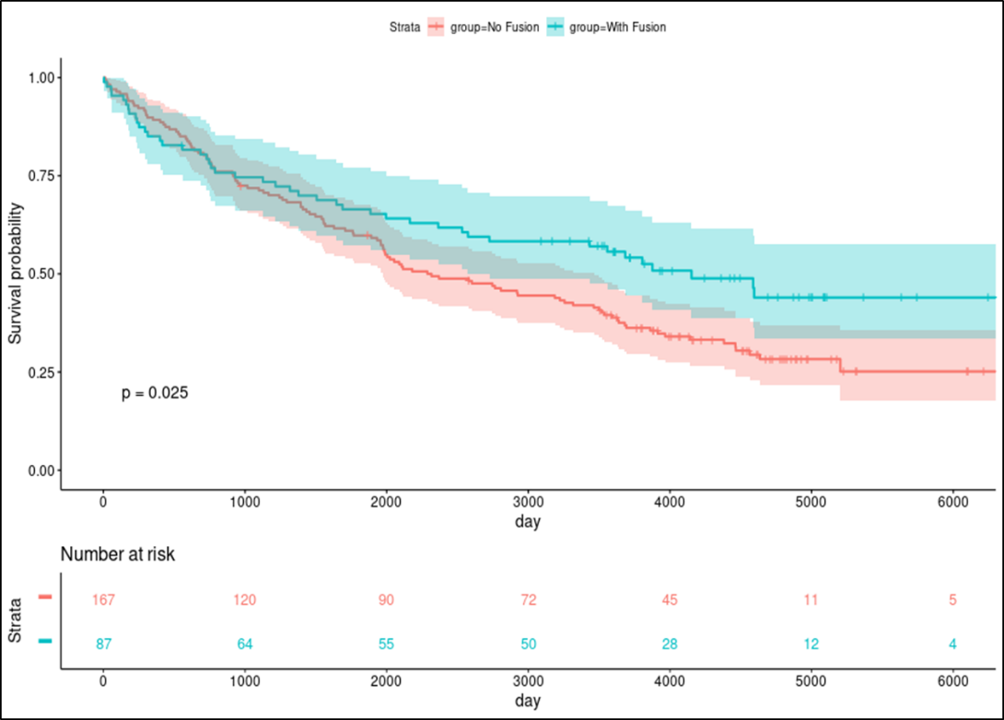

Fig. S13.
Fig. S13. The results of correlation between HBV fusion genes and survival. (A) RNA fusion. (B) DNA fusion.
(A)
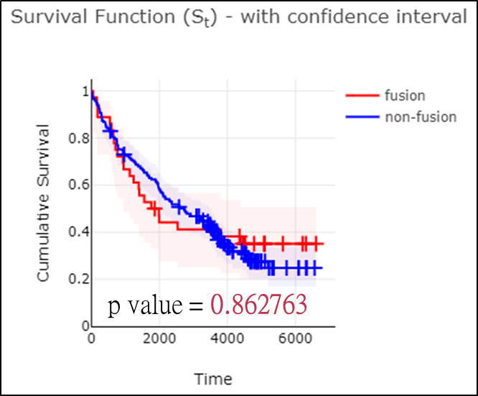
(B)
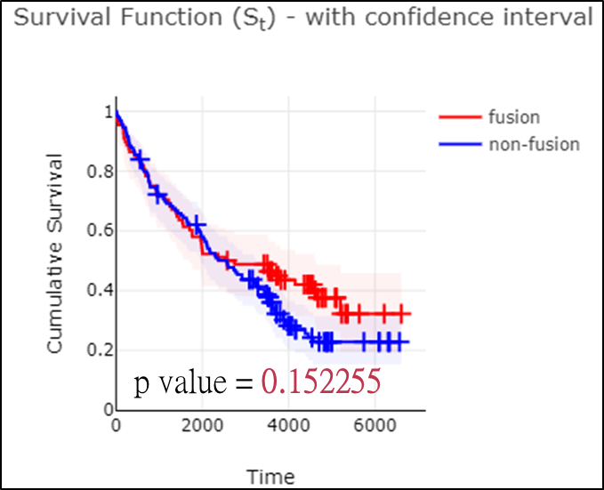

Fig. S14.
Fig. S14. The results of analysis of alternative splicing (AS) events using proportion spliced-in (PSI). Venn plot shows 345 intersection events using both 0.2 and 0.3 PSI.
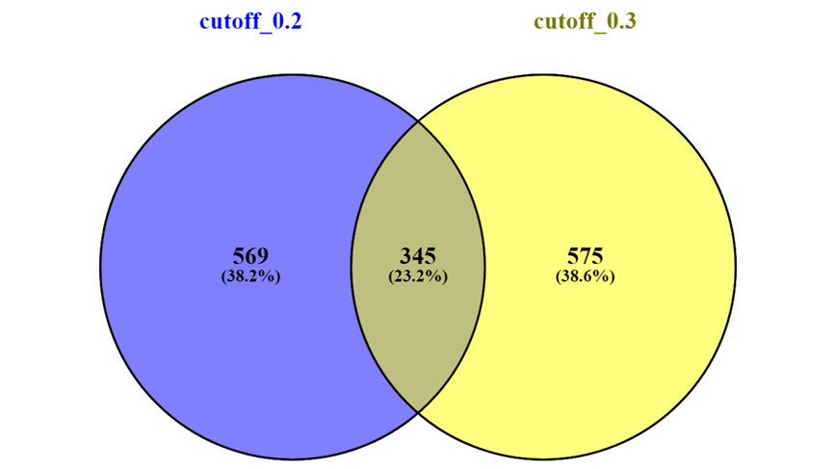

Fig. S15.
Fig. S15. The results of analysis of survival-related AS events. We only select the 98 and 86 AS events with both percentage (pct) 20 and 30 positive for good or bad condition for further study.
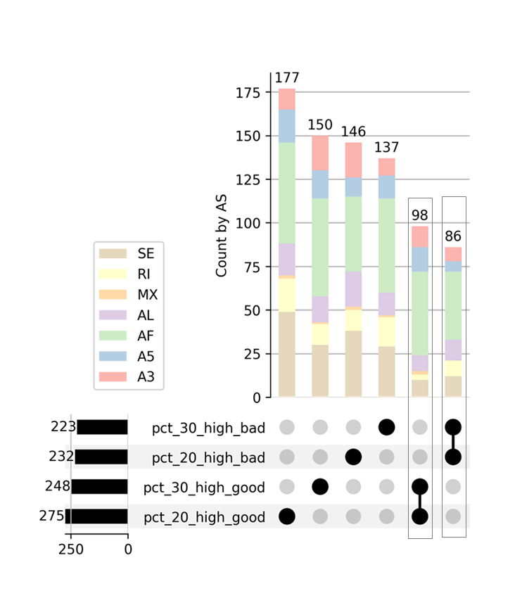

Fig. S16.
Fig. S16. The novel alternative splicing genes correlation between good and poor survival-related genes.
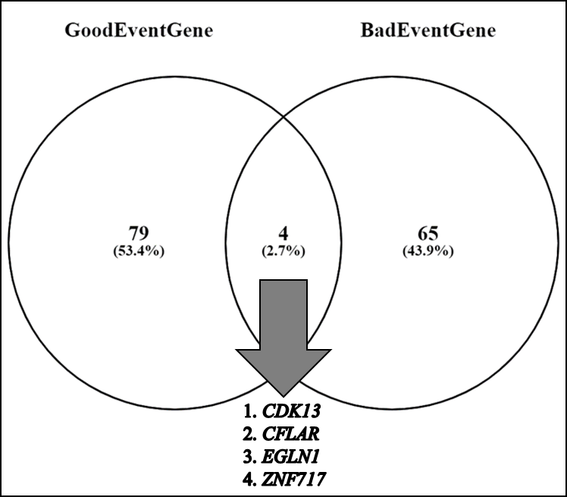
Known AS gene means following papers were reported.

[1] Chen H, Gao F, He M, Ding XF, Wong AM, Sze SC, et al. Long-Read RNA Sequencing Identifies Alternative Splice Variants in Hepatocellular Carcinoma and Tumor-Specific Isoforms. Hepatology 2019;70:1011-1025.
[2] Endo K, Terada T. Protein expression of CD44 (standard and variant isoforms) in hepatocellular carcinoma: relationships with tumor grade, clinicopathologic parameters, p53 expression, and patient survival. J Hepatol 2000;32:78-84.
[3] Wang XQ, Luk JM, Leung PP, Wong BW, Stanbridge EJ, Fan ST. Alternative mRNA splicing of liver intestine-cadherin in hepatocellular carcinoma. Clin Cancer Res 2005;11:483-489.
[4] Liu Z, Ye J, Khan AA, Chen J, Zhou L, Zheng S, et al. Genome-Wide Profiling of Alternative Splicing Signatures Associated with Prognosis and Immune Microenvironment of Hepatocellular Carcinoma. Med Sci Monit 2021;27:e930052.
[5] Li S, Hu Z, Zhao Y, Huang S, He X. Transcriptome-Wide Analysis Reveals the Landscape of Aberrant Alternative Splicing Events in Liver Cancer. Hepatology 2019;69:359-375.

Fig. S17.
Fig. S17. The representative examples of size changes of coding amino acid for the gene with better survival-related alternative splicing (AS) event. (A) to (N) for the amino acid size changes of ALDH5A1, ATAD2B, C1orf109, CLPTM1, DAPK1, FOXK2, HSD3B7, HSPA12B, ING1, MPST, NCKIPSD, RNF40, ZBTB7A, and ZNF428, respectively.
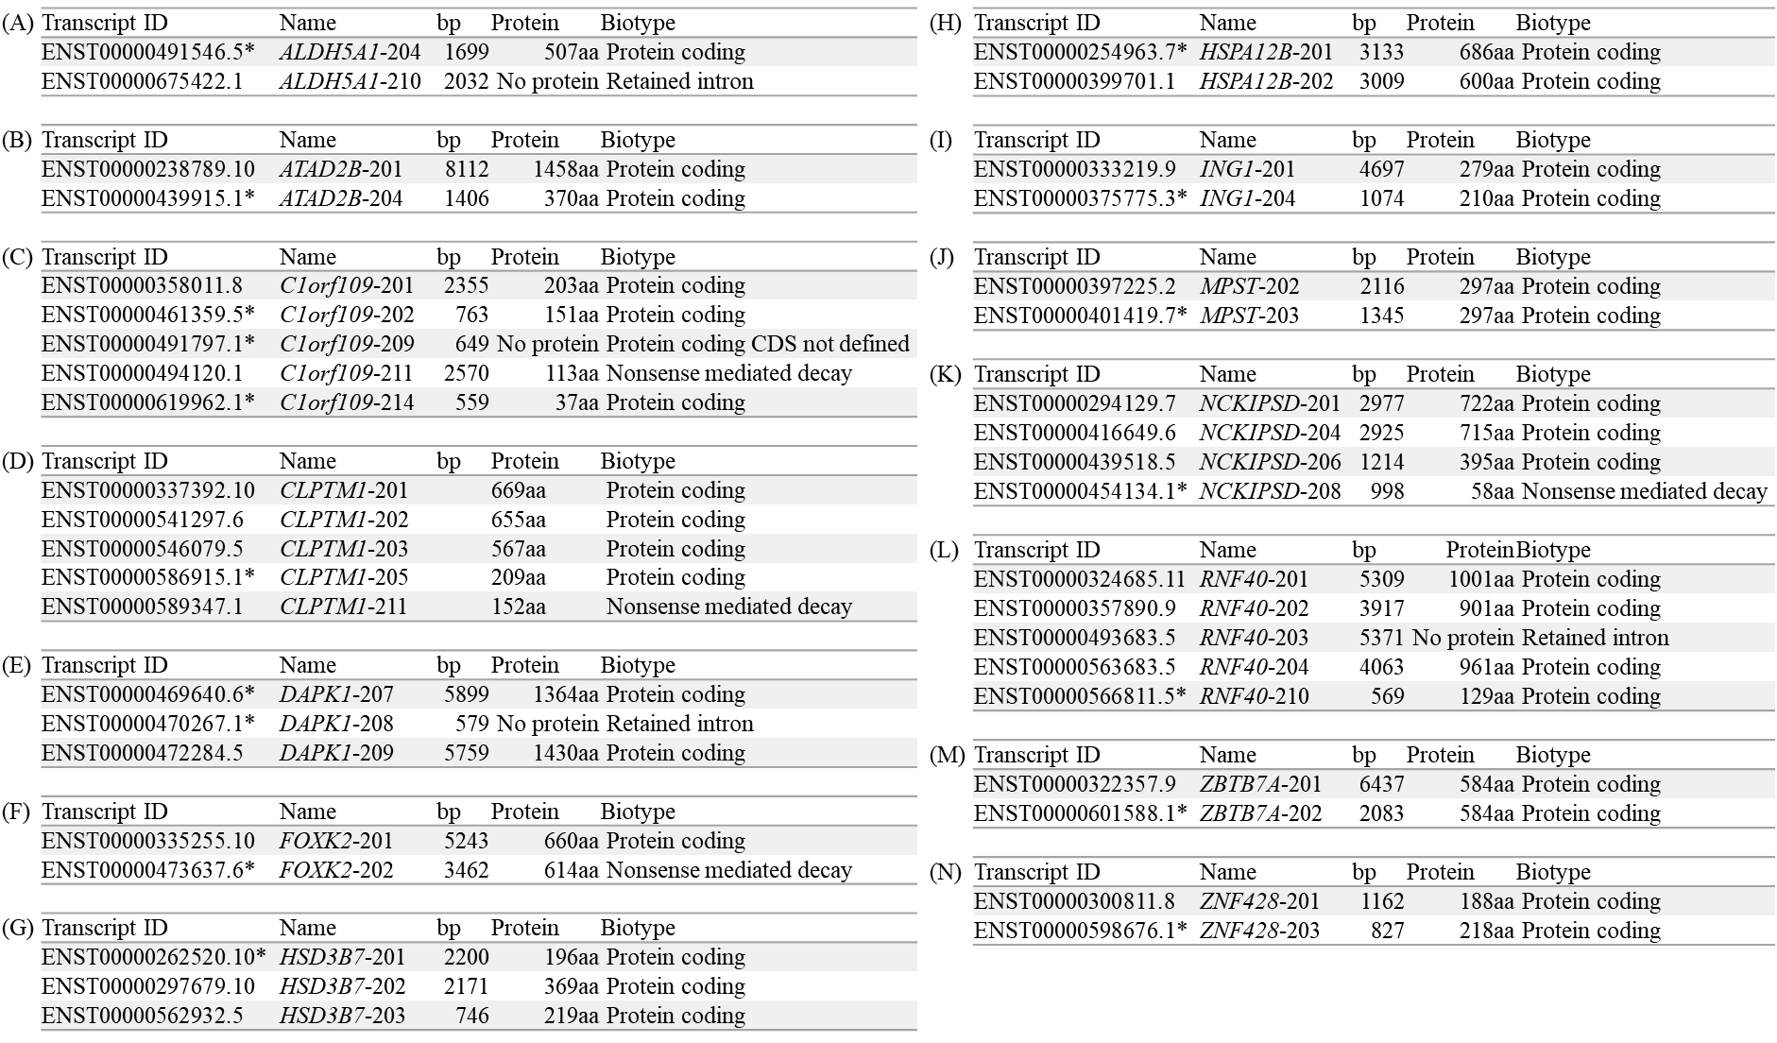
*: survival-related AS event. Oncogenes: ATAD2B, C1orf109, CLPTM1, FOXK2, HSD3B7, HSPA12B, ING1, MPST, RNF40, ZBTB7A

Fig. S18.
Fig. S18. The representative examples of size changes of coding amino acid for the gene with poorer survival-related alternative splicing (AS) event. (A) to (L) for the amino acid size changes of BRD7, CDK13, CTNND1, DNM2, FAM20A, FHIT, NBN, PPP1R13L, RPL22, RSL1D1, and TRIM25, respectively.
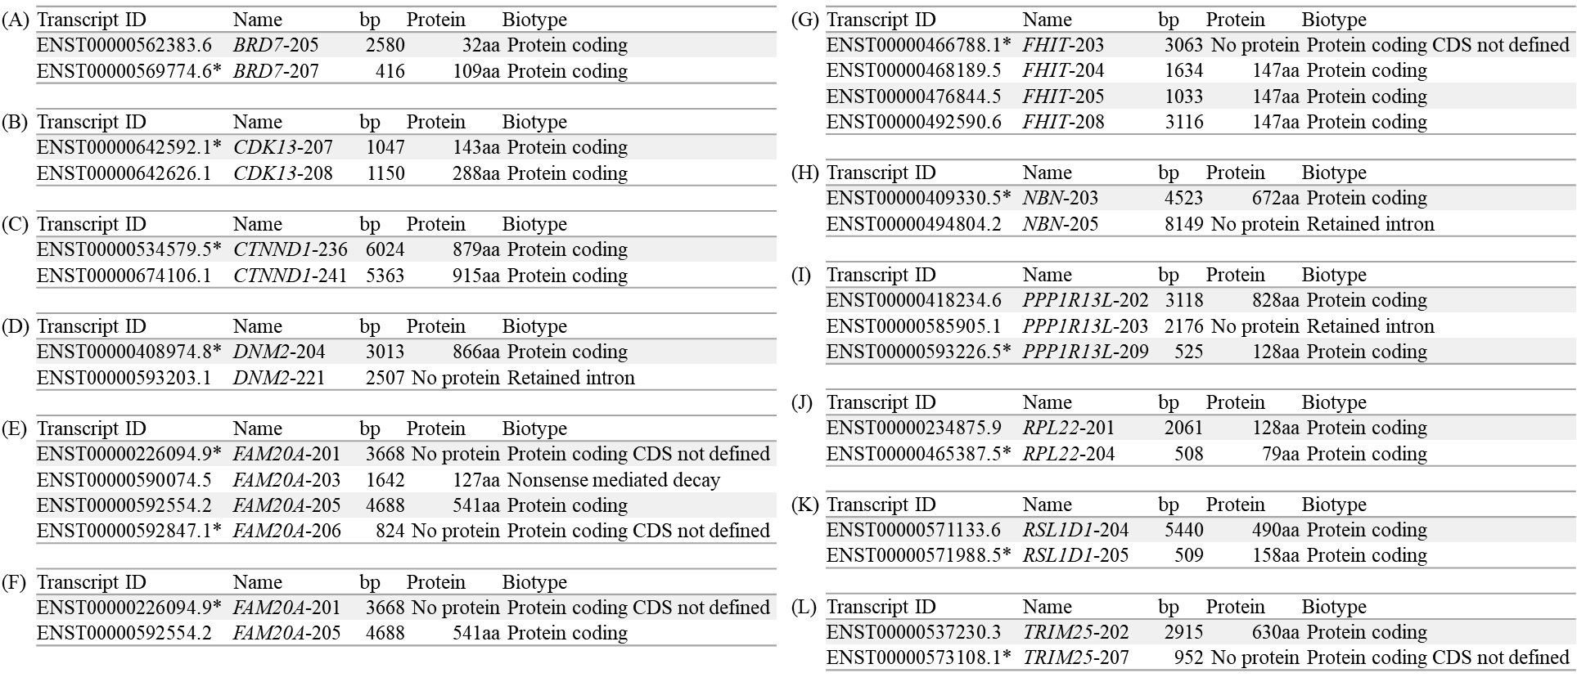
*: survival-related AS event

Fig. S19.
Fig. S19. The results of correlation between the expression of immune checkpoint genes and genomic alterations including somatic mutations and copy alterations. (A) ARID1A mutation with higher CD70 expression. (B)-(V) copy alterations of AKT1, AKT2, ARID1A, ARID1B, AXIN1, GNAS, IDH2, NF1, SMARCA4, STAT3 and TSC2 influencing the expressions of different immune checkpoint genes.
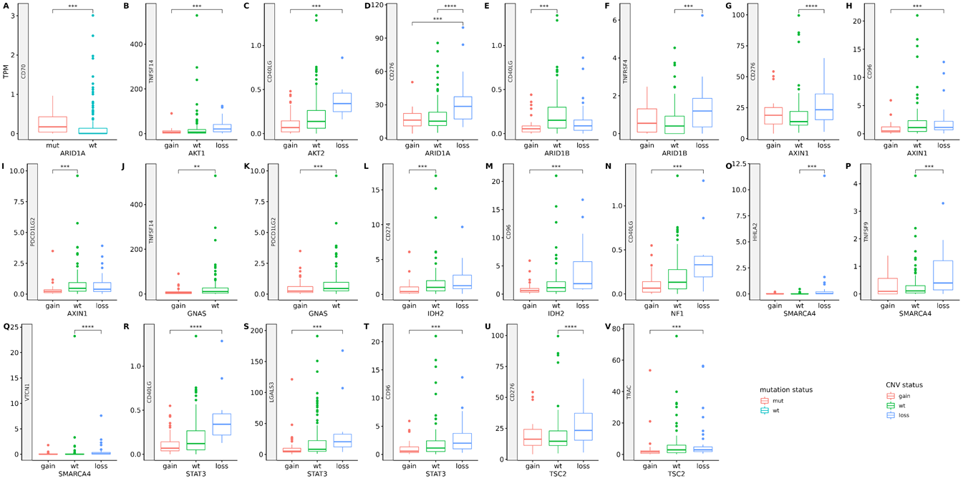

Fig. S20.
Fig. S20. The correlation of point mutations and copy alterations of cancer-related genes and quantity of 64 immune and stroma cells and 3 scores. (A) Point mutations of cancer-related genes and immune, stroma cells and scores. (B) Copy alterations of cancer-related genes and immune, stroma cells and scores.
(A)
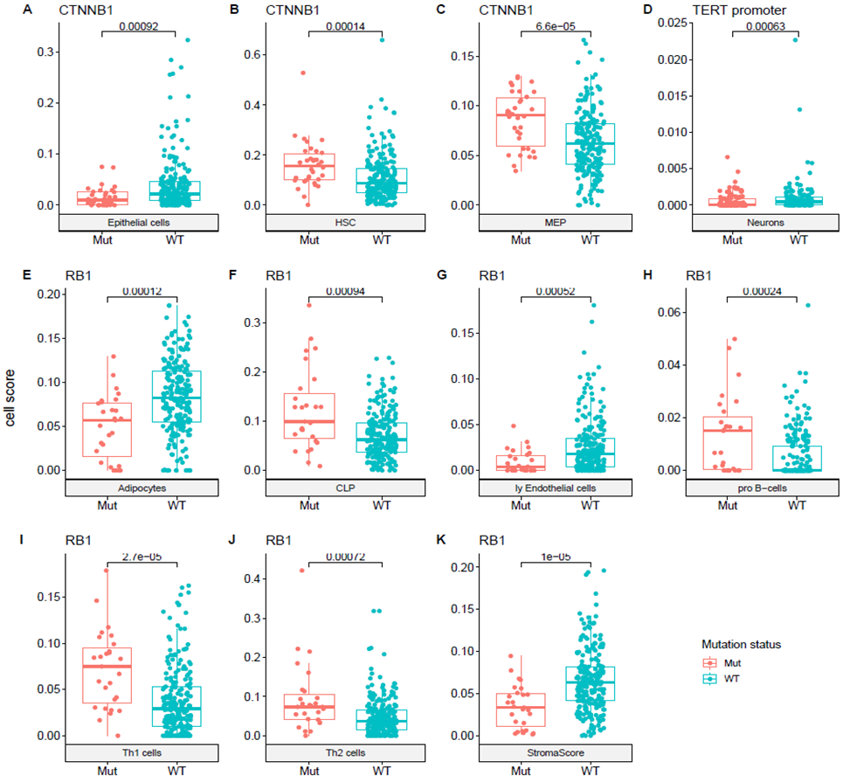

(B)
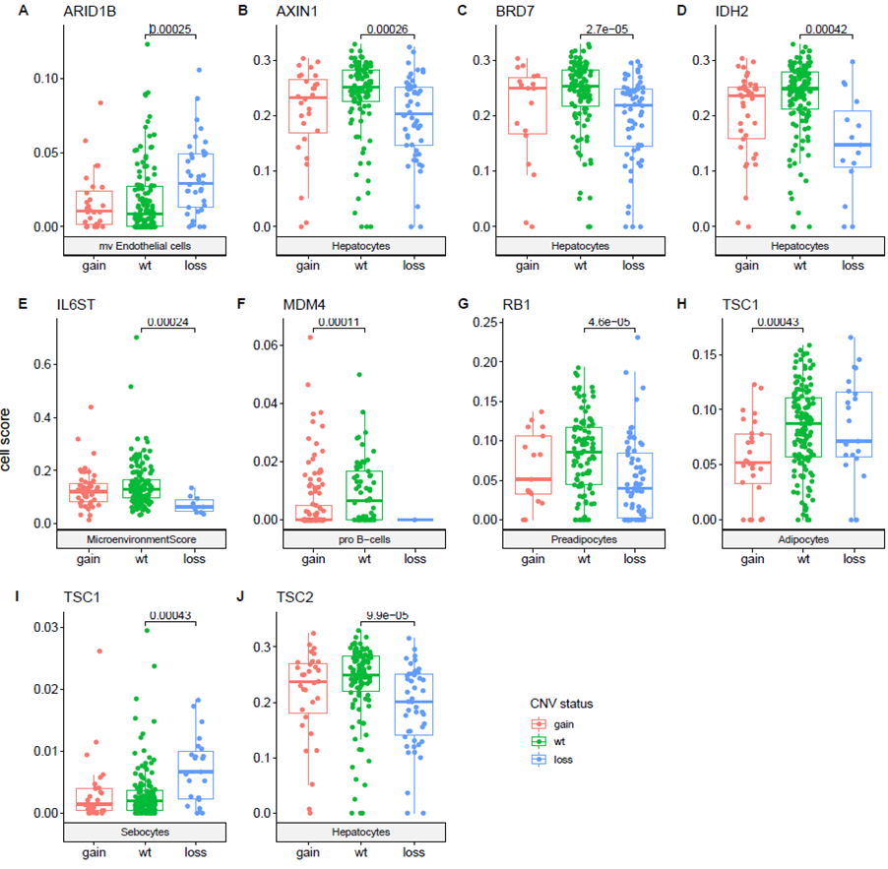

Fig. S21.
Fig. S21. The results of correlation between tumor microenvironment and SVs. The details of the only SV (AnnotSV_ID: 1_105963115_182721369_DUP_1) with significance after further selection using adjusted p-value.
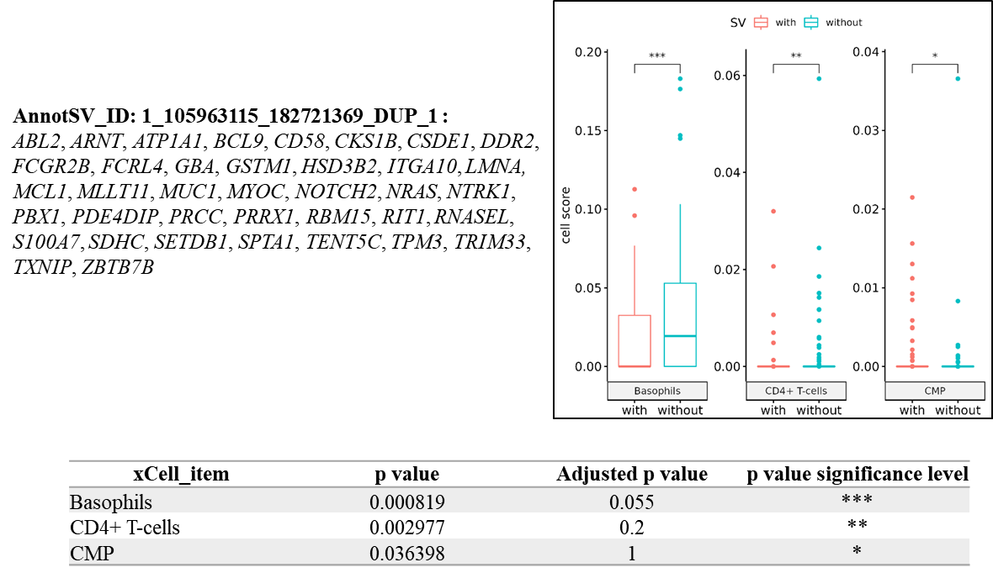

Fig. S22.
Fig. S22. The heatmap for the association between bad survival-related alternative splicing (AS) events and the expression of immune checkpoint genes, as well as the immune and stroma cell types and scores. The heatmap illustrates the significant differences between higher and lower PSI groups of bad survival-related AS events. The red color indicates that the median cell score or gene expression in the higher PSI group is higher than in the lower PSI group, while blue indicates the opposite. The depth of the color indicates the adjusted p-value, with deeper colors representing lower p values.

Supplementary tables

Table S1
Table S1. The demographic data of 254 Taiwanese HCCs.
Clinical Variable |  | All Partients  n (%) | HBV+ HCV-  n (%) | HBV- HCV+  n (%) | HBV+ HCV+  n (%) | HBV- HCV-  n (%) | Double Cancer  n (%)
Cohort size |  | 254 ( 100 ) | 106 ( 42 ) | 82 ( 32 ) | 19 ( 7 ) | 28 ( 11 ) | 19 ( 7 )
Gender | Male | 191 ( 75 ) | 84 ( 79 ) | 51 ( 62 ) | 14 ( 74 ) | 25 ( 89 ) | 17 ( 89 )
 | Female | 63 ( 25 ) | 22 ( 21 ) | 31 ( 38 ) | 5 ( 26 ) | 3 ( 11 ) | 2 ( 11 )
Age | Mean | 60 | 55 | 65 | 61 | 58 | 66
ClinicalStage | I | 122 ( 48 ) | 44 ( 42 ) | 41 ( 50 ) | 10 ( 53 ) | 14 ( 50 ) | 13 ( 68 )
 | II | 95 ( 37 ) | 40 ( 38 ) | 31 ( 38 ) | 9 ( 47 ) | 9 ( 32 ) | 6 ( 32 )
 | III | 17 ( 7 ) | 10 ( 9 ) | 6 ( 7 ) | 0 ( 0 ) | 1 ( 4 ) | 0 ( 0 )
 | IIIA | 12 ( 5 ) | 8 ( 8 ) | 2 ( 2 ) | 0 ( 0 ) | 2 ( 7 ) | 0 ( 0 )
 | IIIB | 1 ( 0 ) | 1 ( 1 ) | 0 ( 0 ) | 0 ( 0 ) | 0 ( 0 ) | 0 ( 0 )
 | IIIC | 4 ( 2 ) | 2 ( 2 ) | 1 ( 1 ) | 0 ( 0 ) | 1 ( 4 ) | 0 ( 0 )
 | IVB | 1 ( 0 ) | 0 ( 0 ) | 0 ( 0 ) | 0 ( 0 ) | 1 ( 4 ) | 0 ( 0 )
 | Unknown/Missing | 2 ( 1 ) | 1 ( 1 ) | 1 ( 1 ) | 0 ( 0 ) | 0 ( 0 ) | 0 ( 0 )
Number of tumor | 1 | 185 ( 73 ) | 84 ( 79 ) | 52 ( 63 ) | 15 ( 79 ) | 22 ( 79 ) | 12 ( 63 )
 | 2 | 41 ( 16 ) | 12 ( 11 ) | 19 ( 23 ) | 4 ( 21 ) | 1 ( 4 ) | 5 ( 26 )
 | 3 | 13 ( 5 ) | 5 ( 5 ) | 3 ( 4 ) | 0 ( 0 ) | 3 ( 11 ) | 2 ( 11 )
 | 4 | 4 ( 2 ) | 2 ( 2 ) | 2 ( 2 ) | 0 ( 0 ) | 0 ( 0 ) | 0 ( 0 )
 | 5 | 2 ( 1 ) | 1 ( 1 ) | 1 ( 1 ) | 0 ( 0 ) | 0 ( 0 ) | 0 ( 0 )
 | Multinodular | 9 ( 4 ) | 2 ( 2 ) | 5 ( 6 ) | 0 ( 0 ) | 2 ( 7 ) | 0 ( 0 )
 | Unknown/Missing | 1 ( 0 ) | 0 ( 0 ) | 1 ( 1 ) | 0 ( 0 ) | 0 ( 0 ) | 0 ( 0 )
Tumor size | <3 cm | 79 ( 31 ) | 25 ( 24 ) | 34 ( 41 ) | 7 ( 37 ) | 5 ( 18 ) | 8 ( 42 )
 | >=3 cm | 171 ( 67 ) | 81 ( 76 ) | 46 ( 56 ) | 12 ( 63 ) | 22 ( 79 ) | 10 ( 53 )
 | Unknown/Missing | 4 ( 2 ) | 0 ( 0 ) | 2 ( 2 ) | 0 ( 0 ) | 1 ( 4 ) | 1 ( 5 )
Tumor size | <5 cm | 159 ( 63 ) | 61 ( 58 ) | 63 ( 77 ) | 13 ( 68 ) | 9 ( 32 ) | 13 ( 68 )
 | >=5 cm | 91 ( 36 ) | 45 ( 42 ) | 17 ( 21 ) | 6 ( 32 ) | 18 ( 64 ) | 5 ( 26 )
 | Unknown/Missing | 4 ( 2 ) | 0 ( 0 ) | 2 ( 2 ) | 0 ( 0 ) | 1 ( 4 ) | 1 ( 5 )
Macrovascular invasion | Yes | 76 ( 30 ) | 43 ( 41 ) | 15 ( 18 ) | 8 ( 42 ) | 8 ( 29 ) | 2 ( 11 )
 | No | 173 ( 68 ) | 60 ( 57 ) | 66 ( 80 ) | 11 ( 58 ) | 19 ( 68 ) | 17 ( 89 )
 | Unknown/Missing | 5 ( 2 ) | 3 ( 3 ) | 1 ( 1 ) | 0 ( 0 ) | 1 ( 4 ) | 0 ( 0 )
AST | Normal, 13-39 IU/L | 94 ( 37 ) | 45 ( 42 ) | 16 ( 20 ) | 7 ( 37 ) | 16 ( 57 ) | 10 ( 53 )
 | Abnormal, ≥40 IU/L | 160 ( 63 ) | 61 ( 58 ) | 66 ( 80 ) | 12 ( 63 ) | 12 ( 43 ) | 9 ( 47 )
ALT | Normal, 5-40 IU/L | 105 ( 41 ) | 49 ( 46 ) | 28 ( 34 ) | 6 ( 32 ) | 14 ( 50 ) | 8 ( 42 )
 | Abnormal, ≥41 IU/L | 149 ( 59 ) | 57 ( 54 ) | 54 ( 66 ) | 13 ( 68 ) | 14 ( 50 ) | 11 ( 58 )
AFP | Normal, <9 ng/mL | 59 ( 23 ) | 24 ( 23 ) | 11 ( 13 ) | 5 ( 26 ) | 10 ( 36 ) | 9 ( 47 )
 | Abnormal, ≥9 ng/mL | 195 ( 77 ) | 82 ( 77 ) | 71 ( 87 ) | 14 ( 74 ) | 18 ( 64 ) | 10 ( 53 )
Total bilirubin | Normal, 0.3-1.0 mg/dL | 189 ( 74 ) | 74 ( 70 ) | 65 ( 79 ) | 15 ( 79 ) | 20 ( 71 ) | 15 ( 79 )
 | Abnormal, >1.0 mg/dL | 65 ( 26 ) | 32 ( 30 ) | 17 ( 21 ) | 4 ( 21 ) | 8 ( 29 ) | 4 ( 21 )
Albumin | Normal, 3.5-5.7 g/dL | 103 ( 41 ) | 44 ( 42 ) | 37 ( 45 ) | 6 ( 32 ) | 10 ( 36 ) | 6 ( 32 )
 | Abnormal, <3.5 g/dL | 151 ( 59 ) | 62 ( 58 ) | 45 ( 55 ) | 13 ( 68 ) | 18 ( 64 ) | 13 ( 68 )
Fibrosis score | 0 | 10 ( 4 ) | 6 ( 6 ) | 0 ( 0 ) | 0 ( 0 ) | 4 ( 14 ) | 0 ( 0 )
 | 1 | 41 ( 16 ) | 19 ( 18 ) | 6 ( 7 ) | 2 ( 11 ) | 9 ( 32 ) | 5 ( 26 )
 | 2 | 51 ( 20 ) | 22 ( 21 ) | 18 ( 22 ) | 6 ( 32 ) | 2 ( 7 ) | 3 ( 16 )
 | 3 | 46 ( 18 ) | 20 ( 19 ) | 16 ( 20 ) | 3 ( 16 ) | 1 ( 4 ) | 6 ( 32 )
 | 4 | 69 ( 27 ) | 30 ( 28 ) | 28 ( 34 ) | 5 ( 26 ) | 5 ( 18 ) | 1 ( 5 )
 | Unknown/Missing | 37 ( 15 ) | 9 ( 8 ) | 14 ( 17 ) | 3 ( 16 ) | 7 ( 25 ) | 4 ( 21 )
Cirrhosis | Yes | 157 ( 62 ) | 60 ( 57 ) | 64 ( 78 ) | 12 ( 63 ) | 9 ( 32 ) | 12 ( 63 )
 | No | 97 ( 38 ) | 46 ( 43 ) | 18 ( 22 ) | 7 ( 37 ) | 19 ( 68 ) | 7 ( 37 )
Fatty liver | Yes | 120 ( 47 ) | 47 ( 44 ) | 34 ( 41 ) | 13 ( 68 ) | 13 ( 46 ) | 13 ( 68 )
 | No | 4 ( 2 ) | 3 ( 3 ) | 0 ( 0 ) | 1 ( 5 ) | 0 ( 0 ) | 0 ( 0 )
 | Unknown/Missing | 130 ( 51 ) | 56 ( 53 ) | 48 ( 59 ) | 5 ( 26 ) | 15 ( 54 ) | 6 ( 32 )
Edmondson grade | 1 | 3 ( 1 ) | 1 ( 1 ) | 2 ( 2 ) | 0 ( 0 ) | 0 ( 0 ) | 0 ( 0 )
 | 2 | 135 ( 53 ) | 53 ( 50 ) | 40 ( 49 ) | 12 ( 63 ) | 17 ( 61 ) | 13 ( 68 )
 | 3 | 106 ( 42 ) | 48 ( 45 ) | 38 ( 46 ) | 5 ( 26 ) | 10 ( 36 ) | 5 ( 26 )
 | 4 | 9 ( 4 ) | 4 ( 4 ) | 1 ( 1 ) | 2 ( 11 ) | 1 ( 4 ) | 1 ( 5 )
 | Unknown/Missing | 1 ( 0 ) | 0 ( 0 ) | 1 ( 1 ) | 0 ( 0 ) | 0 ( 0 ) | 0 ( 0 )
BMI | <18.5 | 127 ( 50 ) | 58 ( 55 ) | 42 ( 51 ) | 10 ( 53 ) | 11 ( 39 ) | 6 ( 32 )
 | Normal, 18.5<=BMI<24 | 34 ( 13 ) | 14 ( 13 ) | 10 ( 12 ) | 0 ( 0 ) | 5 ( 18 ) | 5 ( 26 )
 | Abnormal, >=24 | 93 ( 37 ) | 34 ( 32 ) | 30 ( 37 ) | 9 ( 47 ) | 12 ( 43 ) | 8 ( 42 )
Cholesterol Total | Normal, <180 mg/dL | 241 ( 95 ) | 98 ( 92 ) | 82 ( 100 ) | 17 ( 89 ) | 25 ( 89 ) | 19 ( 100 )
 | Abnormal, >=180 mg/dL | 13 ( 5 ) | 8 ( 8 ) | 0 ( 0 ) | 2 ( 11 ) | 3 ( 11 ) | 0 ( 0 )
TERT | Wild-type | 134 (53) | 75 (71) | 27 (33) | 10 (53) | 14 (50) | 8 (42)
 | Mutation | 120 (47) | 31 (29) | 55 (67) | 9 (47) | 14 (50) | 11 (58)

Table S2
Table S2. The details of mutations of 114 histone-related genes of 254 Taiwanese HCCs in our cohort.
CHROM | POS | REF | ALT | case_no | Clinvar | GenomAD | TWB | dbSNP_155 | GeneName | CADD | mRNA | Protein
chr17 | 50168397 | G | A | HCC_526_S | Pathogenic/Likely_pathogenic | 0.000013963 | 6.71E-04 | rs372210292 | HILS1 | 23
chr6 | 26055813 | T | A | HCC_951_S | NULL | NULL | NULL | NULL | HIST1H1C | 53 | c.616T>A | p.K206*
chr17 | 50185563 | A | T | HCC_784_S | NULL | NULL | NULL | NULL | HILS1 | 45
chr7 | 151214167 | C | A | HCC_555_S | NULL | NULL | NULL | NULL | AC021097.2 | 43
chr6 | 26103996 | A | T | HCC_919_S | NULL | NULL | NULL | NULL | HIST1H1T | 42
chr6 | 26033214 | T | A | HCC_919_S | NULL | NULL | NULL | NULL | HIST1H2AB | 42 | c.355T>A | p.K119*
chr6 | 26103996 | A | T | HCC_583_S | NULL | NULL | NULL | NULL | HIST1H4C | 42 | c.121A>T | p.K17*
chr6 | 26020694 | C | T | HCC_933_S | NULL | 0.000160453 | 0.005365526 | rs181930473 | HIST1H1A | 41
chr6 | 26020694 | C | T | HCC_933_S | NULL | 0.000160453 | 0.005365526 | rs181930473 | HIST1H3A | 41 | c.205C>T | p.Q69*
chr6 | 26020694 | C | T | HCC_933_S | NULL | 0.000160453 | 0.005365526 | rs181930473 | HIST1H4A | 41
chr7 | 151210201 | T | A | HCC_921_S | NULL | NULL | NULL | NULL | AC021097.2 | 39 | c.178T>A | p.K40*
chr10 | 70091799 | A | T | HCC_665_S | NULL | NULL | NULL | NULL | H2AFY2 | 38 | c.586A>T | p.R108*
chr6 | 26216610 | T | A | HCC_946_S | NULL | NULL | NULL | NULL | AL031777.2 | 37
chr6 | 26216610 | T | A | HCC_946_S | NULL | NULL | NULL | NULL | HIST1H2AE | 37
chr6 | 26216610 | T | A | HCC_946_S | NULL | NULL | NULL | NULL | HIST1H2BG | 37 | c.83T>A | p.K12*
chr3 | 129547534 | A | T | HCC_944_S | NULL | NULL | NULL | NULL | H1FOO | 36 | c.237A>T | p.K78*
chr5 | 135370110 | T | A | HCC_786_S | NULL | NULL | NULL | NULL | H2AFY | 36 | c.799T>A | p.R69*
chr1 | 149886571 | T | A | HCC_786_S | NULL | NULL | NULL | NULL | HIST2H2AB | 36
chr1 | 149886595 | T | A | HCC_786_S | NULL | NULL | NULL | NULL | HIST2H2AB | 36
chr1 | 149886571 | T | A | HCC_676_S | NULL | NULL | NULL | NULL | HIST2H2AC | 36
chr1 | 149886595 | T | A | HCC_676_S | NULL | NULL | NULL | NULL | HIST2H2AC | 36
chr1 | 149886571 | T | A | HCC_676_S | NULL | NULL | NULL | NULL | HIST2H2BE | 36 | c.82T>A | p.K24*
chr1 | 149886595 | T | A | HCC_522_S | NULL | NULL | NULL | NULL | HIST2H2BE | 36 | c.58T>A | p.K16*
chr5 | 17486671 | A | T | HCC_649_S | NULL | NULL | NULL | NULL | AC106774.4 | 35
chr2 | 26776480 | A | T | HCC_919_S | NULL | NULL | NULL | NULL | CENPA | 33
chr17 | 50167580 | A | T | HCC_919_S | NULL | NULL | NULL | NULL | HILS1 | 33
chr6 | 26156626 | G | C | HCC_655_S | NULL | NULL | NULL | NULL | HIST1H1E | 32 | c.273G>C | p.R79P
chr6 | 26156626 | G | C | HCC_655_S | NULL | NULL | NULL | NULL | HIST1H2BD | 32
chr1 | 149886514 | A | T | HCC_655_S | NULL | NULL | NULL | NULL | HIST2H2AB | 32
chr1 | 149886514 | A | T | HCC_551_S | NULL | NULL | NULL | NULL | HIST2H2AC | 32
chr1 | 149886514 | A | T | HCC_551_S | NULL | NULL | NULL | NULL | HIST2H2BE | 32 | c.139A>T | p.Y43N
chr1 | 143905819 | G | A | HCC_874_S | NULL | 4.99871E-05 | 0.003353454 | rs587605296 | AC239798.4 | 31
chr6 | 26156625 | C | A | HCC_874_S | NULL | 6.97623E-06 | NULL | rs1481520703 | HIST1H1E | 31 | c.272C>A | p.R79S
chr6 | 26156625 | C | A | HCC_751_S | NULL | 6.97623E-06 | NULL | rs1481520703 | HIST1H2BD | 31
chr6 | 26188790 | C | A | HCC_776_S | NULL | NULL | NULL | NULL | HIST1H2BE | 31
chr6 | 26188790 | C | A | HCC_776_S | NULL | NULL | NULL | NULL | HIST1H4D | 31 | c.287C>A | p.R96L
chr17 | 50167690 | T | A | HCC_628_S | NULL | NULL | NULL | NULL | HILS1 | 30
chr6 | 26156719 | A | T | HCC_772_S | NULL | NULL | NULL | NULL | HIST1H1E | 30 | c.366A>T | p.K110M
chr6 | 26156719 | A | T | HCC_772_S | NULL | NULL | NULL | NULL | HIST1H2BD | 30

Table S3
Table S3. The detail of mutations of 74 HCC-related long non-coding RNA genes of 254 Taiwanese HCCs in our cohort.
CHROM | POS | REF | ALT | case_no | Clinvar | GenomAD | TWB | dbSNP_155 | GeneName | CADD
chr11 | 9785177 | G | A | HCC_612_S | NULL | NULL | NULL | rs750756174 | SBF2-AS1 | 42
chr6 | 1.65E+08 | G | C | HCC_925_S | NULL | NULL | NULL | NULL | LINC473 | 40
chr16 | 54933463 | A | T | HCC_531_S | NULL | NULL | NULL | NULL | CRNDE | 39
chr6 | 1.66E+08 | T | A | HCC_869_S | NULL | NULL | NULL | NULL | LINC473 | 38
chr16 | 54932538 | T | A | HCC_1007_S | NULL | NULL | NULL | NULL | CRNDE | 37
chr8 | 1.27E+08 | G | T | HCC_741_S | NULL | 2.09E-05 | 0.001341 | rs536151237 | PCAT1 | 36
chr14 | 20699756 | A | T | HCC_688_S | NULL | NULL | NULL | NULL | Lnc-EGFR | 35
chr5 | 93585484 | A | T | HCC_784_S | NULL | NULL | NULL | NULL | NR2F1-AS1 | 35
chr2 | 1.76E+08 | C | T | HCC_555_S | NULL | NULL | NULL | NULL | HAGLR | 34
chr1 | 32280077 | A | T | HCC_503_S | NULL | NULL | NULL | NULL | Lnc-Tim3 | 34
chr16 | 67621440 | A | T | HCC_669_S | NULL | NULL | NULL | NULL | ICR | 33
chr6 | 1.65E+08 | T | C | HCC_770_S | NULL | NULL | NULL | NULL | LINC473 | 33
chr1 | 3732796 | G | A | HCC_509_S | NULL | 3.49E-05 | NULL | rs779902863 | TP73-AS1 | 33
chr5 | 93585360 | A | T | HCC_938_S | NULL | NULL | NULL | NULL | NR2F1-AS1 | 33
chr2 | 1.76E+08 | C | A | HCC_1009_S, HCC_561_S, HCC_960_S | NULL | 4.19E-05 | 0.005366 | rs764238870 | HAGLR | 33
chr7 | 97007830 | A | T | HCC_656_S | NULL | NULL | NULL | NULL | DLX6-AS1 | 33
chr6 | 1.65E+08 | T | C | HCC_872_S | NULL | NULL | NULL | NULL | LINC473 | 32
chr1 | 1.51E+08 | A | T | HCC_877_S | NULL | NULL | NULL | NULL | FALEC | 32
chr6 | 1.65E+08 | T | C | HCC_924_S | NULL | NULL | NULL | NULL | LINC473 | 32
chr2 | 1.77E+08 | T | C | HCC_713_S | Uncertain_significance | NULL | NULL | NULL | NRAL | 32
chr16 | 54931340 | T | C | HCC_596_S | NULL | NULL | NULL | NULL | CRNDE | 32
chr11 | 9780500 | C | T | HCC_552_S | Uncertain_significance | 2.09E-05 | NULL | rs369992460 | SBF2-AS1 | 32
chr8 | 1.27E+08 | G | T | HCC_626_S | NULL | 6.98E-06 | 0.000671 | rs1410347595 | PCAT1 | 31
chr2 | 1.76E+08 | A | T | HCC_584_S | NULL | NULL | NULL | NULL | HAGLR | 31

Table S4
Table S4. The details of mutations of 36 non-coding driver genes of 254 Taiwanese HCCs in our cohort.
CHR | POS | REF | ALT | case_no | Clinvar | GenomAD | TWB | dbSNP_155 | GeneName | CADD
chr19 | 55358317 | T | A | HCC_1008_S | NULL | 3.49E-05 | 0.004024 | rs188366684 | COX6B2 | 33
chr9 | 35658019 | A | ACGTCCTCAGCTT | HCC_924_S | Likely_pathogenic | 6.98E-06 | NULL | rs1554651400 | RMRP | 0.486
chr9 | 35658020 | C | CGTCCTCAGCTTCACAGAGTA | HCC_675_S | Pathogenic/Likely_pathogenic | 7.68E-05 | NULL | rs1554651411 | RMRP | 0.409
chr19 | 55352661 | AG | A | HCC_940_S | NULL | NULL | NULL | NULL | COX6B2 | -
chr11 | 65418792 | AG | A | HCC_691_S | NULL | NULL | NULL | NULL | NEAT1 | -
chr11 | 65419609 | G | GA | HCC_767_S | NULL | NULL | NULL | NULL | NEAT1 | -
chr11 | 65422673 | GTC | G | HCC_516_S | NULL | NULL | NULL | NULL | NEAT1 | -
chr11 | 65425449 | TG | T | HCC_894_S | NULL | NULL | NULL | NULL | NEAT1 | -
chr11 | 65426675 | AGATAGAACTG | A | HCC_891_S | NULL | NULL | NULL | NULL | NEAT1 | -
chr11 | 65427756 | CTCT | C | HCC_623_S | NULL | NULL | NULL | NULL | NEAT1 | -
chr11 | 65428267 | A | AG | HCC_880_S | NULL | NULL | NULL | NULL | NEAT1 | -
chr11 | 65428613 | G | GAAATGGC | HCC_896_S | NULL | NULL | NULL | NULL | NEAT1 | -
chr11 | 65429005 | ATT | A | HCC_523_S | NULL | NULL | NULL | NULL | NEAT1 | -
chr11 | 65429041 | AATG | A | HCC_588_S | NULL | NULL | NULL | NULL | NEAT1 | -
chr11 | 65429481 | GGTGTGTGTGTGTGTGCGTGT | G | HCC_970_S | NULL | NULL | NULL | NULL | NEAT1 | -
chr11 | 65430642 | T | TA | HCC_913_S | NULL | NULL | NULL | NULL | NEAT1 | -
chr11 | 65430902 | CATAT | C | HCC_881_S | NULL | NULL | NULL | NULL | NEAT1 | -
chr11 | 65431089 | TGTGA | T | HCC_762_S | NULL | NULL | NULL | NULL | NEAT1 | -
chr11 | 65431251 | ATT | A | HCC_878_S | NULL | NULL | NULL | NULL | NEAT1 | -
chr11 | 65431278 | TC | T | HCC_921_S | NULL | NULL | NULL | NULL | NEAT1 | -
chr11 | 65431458 | T | TG | HCC_997_S | NULL | NULL | NULL | NULL | NEAT1 | -
chr11 | 65431928 | CT | C | HCC_577_S | NULL | NULL | NULL | NULL | NEAT1 | -
chr11 | 65431930 | AATTT | A | HCC_577_S | NULL | NULL | NULL | NULL | NEAT1 | -
chr11 | 65432337 | GCCACTTATGATTGTAAACCT | G | HCC_653_S | NULL | NULL | NULL | NULL | NEAT1 | -
chr11 | 65432646 | TATA | T | HCC_649_S | NULL | NULL | NULL | NULL | NEAT1 | -
chr11 | 65432684 | GT | G | HCC_976_S | NULL | NULL | NULL | NULL | NEAT1 | -
chr11 | 65432771 | AT | A | HCC_923_S | NULL | NULL | NULL | NULL | NEAT1 | -
chr11 | 65432904 | CATAAGTTAGCTCTCACTT | C | HCC_559_S | NULL | NULL | NULL | NULL | NEAT1 | -
chr11 | 65433297 | TAAAATG | T | HCC_934_S | NULL | NULL | NULL | NULL | NEAT1 | -
chr11 | 65433307 | TGG | T | HCC_934_S | NULL | NULL | NULL | NULL | NEAT1 | -
chr11 | 65433310 | AAT | A | HCC_934_S | NULL | NULL | NULL | NULL | NEAT1 | -
chr11 | 65433375 | TAAGGCAAGAATATTCTCTCTGTTGGAACTCA | T | HCC_710_S | NULL | NULL | NULL | NULL | NEAT1 | -
chr11 | 65433687 | ACTT | A | HCC_623_S | NULL | NULL | NULL | NULL | NEAT1 | -
chr11 | 65433809 | GTGAAGTCTGAGATTTTACTACACCT | G | HCC_755_S | NULL | NULL | NULL | NULL | NEAT1 | -
chr11 | 65434104 | T | TC | HCC_926_S | NULL | NULL | NULL | NULL | NEAT1 | -
chr11 | 65434155 | AGTTT | A | HCC_981_S | NULL | NULL | NULL | NULL | NEAT1 | -
chr11 | 65434447 | TACATTATTGATTACTTTTTTTCATTTA | T | HCC_894_S | NULL | NULL | NULL | NULL | NEAT1 | -
chr11 | 65434620 | A | ATG | HCC_951_S | NULL | NULL | NULL | NULL | NEAT1 | -
chr11 | 65434928 | AGCATTCATGGGCTTAAT | A | HCC_782_S | NULL | NULL | NULL | NULL | NEAT1 | -
chr11 | 65435210 | G | GAAT | HCC_599_S | NULL | NULL | NULL | NULL | NEAT1 | -
chr11 | 65436547 | TCA | T | HCC_884_S | NULL | NULL | NULL | NULL | NEAT1 | -
chr11 | 65436762 | ATTAAGTTGTTTCAGC | A | HCC_939_S | NULL | NULL | NULL | NULL | NEAT1 | -
chr11 | 65436852 | TGA | T | HCC_713_S | NULL | NULL | NULL | NULL | NEAT1 | -
chr11 | 65437077 | GATTA | G | HCC_872_S | NULL | NULL | NULL | NULL | NEAT1 | -
chr11 | 65437079 | TTAA | T | HCC_786_S, HCC_777_S | NULL | NULL | NULL | NULL | NEAT1 | -
chr11 | 65437180 | AGTTTATATATATATG | A | HCC_569_S | NULL | NULL | NULL | NULL | NEAT1 | -
chr11 | 65437250 | T | TAC | HCC_985_S | NULL | NULL | NULL | NULL | NEAT1 | -
chr11 | 65438026 | TC | T | HCC_869_S | NULL | NULL | NULL | NULL | NEAT1 | -
chr11 | 65440118 | AAAT | A | HCC_727_S | NULL | NULL | NULL | NULL | NEAT1 | -
chr11 | 65440195 | TTTTATCATCTGATGATGAACTTAATGTTTCCATTTG | T | HCC_938_S | NULL | NULL | NULL | NULL | NEAT1 | -
chr11 | 65440490 | CA | C | HCC_984_S | NULL | NULL | NULL | NULL | NEAT1 | -
chr11 | 65441060 | TAA | T | HCC_569_S | NULL | NULL | NULL | NULL | NEAT1 | -
chr11 | 65441100 | T | TAA | HCC_507_S | NULL | NULL | NULL | NULL | NEAT1 | -
chr11 | 65443951 | G | GT | HCC_972_S | NULL | NULL | NULL | NULL | NEAT1 | -
chr11 | 65445536 | C | CA | HCC_471_S | NULL | NULL | NULL | NULL | NEAT1 | -
chr11 | 65445770 | T | TG | HCC_872_S | NULL | NULL | NULL | NULL | NEAT1 | -
chr11 | 65446796 | GTC | G | HCC_505_S | NULL | NULL | NULL | NULL | NEAT1 | -
chr11 | 65447822 | T | TCTCA | HCC_969_S | NULL | NULL | NULL | NULL | NEAT1 | -
chr11 | 65449233 | G | GT | HCC_555_S | NULL | NULL | NULL | NULL | NEAT1 | -
chr11 | 65498221 | T | TG | HCC_686_S | NULL | NULL | NULL | rs749464304 | MALAT1 | -
chr11 | 65501744 | TATTC | T | HCC_675_S | NULL | NULL | NULL | NULL | MALAT1 | -
chr11 | 65504921 | TGTGGGGATTGGGAACCACTA | T | HCC_726_S | NULL | NULL | NULL | NULL | MALAT1 | -
chr11 | 65505063 | TATGGGACA | T | HCC_556_S | NULL | NULL | NULL | NULL | MALAT1 | -
chr11 | 65506510 | G | GA | HCC_878_S | NULL | NULL | 0.000671 | rs1355113792 | MALAT1 | -
chr11 | 65506660 | T | TA | HCC_599_S | NULL | NULL | NULL | NULL | MALAT1 | -

Table S5
Table S5. The details of genes with differential expression and survival of 254 Taiwanese HCCs. (A) protein-coding genes. (B) non-coding genes.
(A)
ensembl_gene_id | Gene_name | chr. | band | baseMean | log2FoldChange | lfcSE | padj | TPM_mean | sur_pvalue | High | Low | good_sur
ENSG00000100101 | Z83844.1 | 22 | q13.1 | 1.507746473 | -2.606250067 | 1.512674 | 0.002503 | 0.006070866 | 0.015899777 | 16 | 238 | High
ENSG00000103056 | SMPD3 | 16 | q22.1 | 106.2407722 | -3.37346077 | 0.320067 | 2.47E-25 | 0.383275591 | 0.019339631 | 68 | 186 | High
ENSG00000103710 | RASL12 | 15 | q22.31 | 62.01948181 | 1.51462524 | 0.207641 | 2.58E-13 | 0.867822835 | 0.03138274 | 83 | 171 | High
ENSG00000105173 | CCNE1 | 19 | q12 | 104.4919934 | 2.428897525 | 0.263795 | 6.54E-20 | 3.953291339 | 0.01728307 | 42 | 212 | High
ENSG00000105963 | ADAP1 | 7 | p22.3 | 112.3428 | -1.523039194 | 0.351167 | 3.88E-06 | 1.897102362 | 0.008392013 | 51 | 203 | High
ENSG00000107281 | NPDC1 | 9 | q34.3 | 269.5051385 | -1.697409636 | 0.380773 | 1.59E-06 | 4.228429134 | 0.042585571 | 85 | 169 | High
ENSG00000118137 | APOA1 | 11 | q23.3 | 84349.83241 | -1.999358086 | 0.32651 | 2.51E-10 | 2015.380638 | 0.014196567 | 104 | 150 | High
ENSG00000126705 | AHDC1 | 1 | p35.3 | 1220.228653 | -1.52906906 | 0.282811 | 2.40E-08 | 6.086370079 | 0.047575176 | 99 | 155 | High
ENSG00000130943 | PKDREJ | 22 | q13.31 | 13.5040136 | 1.949769585 | 0.366797 | 2.08E-08 | 0.05142126 | 0.047541572 | 66 | 188 | High
ENSG00000141449 | GREB1L | 18 | q11.1 | 1421.823975 | 1.519365132 | 0.204386 | 9.49E-14 | 9.770279528 | 0.006617562 | 99 | 155 | High
ENSG00000146192 | FGD2 | 6 | p21.2 | 576.5033433 | -1.609635008 | 0.221393 | 2.38E-13 | 6.152677165 | 0.038182893 | 88 | 166 | High
ENSG00000146809 | ASB15 | 7 | q31.32 | 3.20503635 | 2.637833487 | 0.776704 | 4.70E-05 | 0.058035433 | 0.042163382 | 39 | 215 | High
ENSG00000148671 | ADIRF | 10 | q23.2 | 279.3005236 | -1.793110158 | 0.405835 | 1.65E-06 | 11.03909843 | 0.023858048 | 56 | 198 | High
ENSG00000148795 | CYP17A1 | 10 | q24.32 | 1129.054568 | 4.401650178 | 0.46287 | 9.33E-22 | 24.97533071 | 0.008488754 | 44 | 210 | High
ENSG00000149926 | TLCD3B | 16 | p11.2 | 13.49393826 | 1.692354976 | 0.409123 | 6.26E-06 | 0.310098425 | 0.020489794 | 62 | 192 | High
ENSG00000161243 | FBXO27 | 19 | q13.2 | 455.9862922 | 1.507030067 | 0.262299 | 4.12E-09 | 10.95554724 | 0.006343572 | 66 | 188 | High
ENSG00000163792 | TCF23 | 2 | p23.3 | 4.630360346 | 1.641645469 | 0.463172 | 6.61E-05 | 0.027586614 | 0.00441028 | 74 | 180 | High
ENSG00000179772 | FOXS1 | 20 | q11.21 | 11.33192469 | 1.552904734 | 0.460464 | 0.000144 | 0.243212598 | 0.036966195 | 97 | 157 | High
ENSG00000183186 | C2CD4C | 19 | p13.3 | 15.20393715 | -1.926927555 | 0.468495 | 5.15E-06 | 0.094114173 | 0.01197674 | 80 | 174 | High
ENSG00000186766 | FOXI2 | 10 | q26.2 | 1.872327298 | 1.52233721 | 0.673153 | 0.003938 | 0.017814961 | 0.015939978 | 74 | 180 | High
ENSG00000196787 | H2AC11 | 6 | p22.1 | 677.4785904 | 1.815826643 | 0.295888 | 2.49E-10 | 7.76011811 | 0.047739948 | 87 | 167 | High
ENSG00000197408 | CYP2B6 | 19 | q13.2 | 14030.80091 | -2.452277069 | 0.350894 | 1.55E-12 | 84.26816142 | 0.021932619 | 82 | 172 | High
ENSG00000204653 | ASPDH | 19 | q13.33 | 731.4559946 | -1.865663746 | 0.42334 | 1.60E-06 | 15.89166142 | 0.019223485 | 92 | 162 | High
ENSG00000205116 | TMEM88B | 1 | p36.33 | 6.369562512 | 2.060715861 | 1.142354 | 0.004476 | 0.395251969 | 0.000590043 | 44 | 210 | High
ENSG00000221818 | EBF2 | 8 | p21.2 | 66.09701178 | 3.146202197 | 0.272154 | 6.41E-30 | 0.40092126 | 0.022268852 | 89 | 165 | High
ENSG00000244234 | GMCL2 | 5 | q35.3 | 10.05666262 | 3.623266715 | 0.628012 | 1.54E-09 | 0.302464567 | 0.03396424 | 21 | 233 | High
ENSG00000244242 | IFITM10 | 11 | p15.5 | 223.0901005 | -2.163719708 | 0.377629 | 2.35E-09 | 2.013547244 | 0.011860101 | 55 | 199 | High
ENSG00000274286 | ADRA2B | 2 | q11.2 | 87.95984754 | -2.444475752 | 0.271292 | 3.63E-19 | 0.423700787 | 0.019206114 | 93 | 161 | High
ENSG00000005073 | HOXA11 | 7 | p15.2 | 13.29814817 | 5.34937529 | 0.820507 | 6.32E-12 | 0.210622047 | 3.70E-05 | 38 | 216 | Low
ENSG00000007350 | TKTL1 | X | q28 | 26.53005576 | 2.834515009 | 0.781419 | 2.04E-05 | 2.863515748 | 0.012506346 | 11 | 243 | Low
ENSG00000007372 | PAX6 | 11 | p13 | 32.15359233 | 5.143558988 | 0.763212 | 1.51E-12 | 0.45992126 | 0.026774369 | 36 | 218 | Low
ENSG00000043355 | ZIC2 | 13 | q32.3 | 223.2373191 | 5.06973402 | 0.421482 | 3.15E-33 | 3.692377953 | 0.027700827 | 78 | 176 | Low
ENSG00000051341 | POLQ | 3 | q13.33 | 496.3520577 | 2.875671138 | 0.24281 | 2.89E-31 | 1.876094488 | 0.019371894 | 86 | 168 | Low
ENSG00000066405 | CLDN18 | 3 | q22.3 | 9.952591991 | 4.102977575 | 1.055983 | 3.61E-06 | 0.795858268 | 0.003191612 | 8 | 246 | Low
ENSG00000073756 | PTGS2 | 1 | q31.1 | 130.1070657 | -2.004117882 | 0.348755 | 2.10E-09 | 0.723338583 | 0.011449574 | 53 | 201 | Low
ENSG00000074410 | CA12 | 15 | q22.2 | 491.1663169 | 2.566152981 | 0.44611 | 2.51E-09 | 4.922716535 | 0.046636274 | 47 | 207 | Low
ENSG00000079112 | CDH17 | 8 | q22.1 | 31.62469517 | 2.590872645 | 0.79065 | 6.92E-05 | 1.291720472 | 2.21E-05 | 15 | 239 | Low
ENSG00000090382 | LYZ | 12 | q15 | 10614.06098 | 2.930777262 | 0.385054 | 2.75E-14 | 220.3297913 | 0.044803189 | 52 | 202 | Low
ENSG00000090402 | SI | 3 | q26.1 | 4.553531748 | 3.158891477 | 1.284652 | 0.000355 | 0.252866142 | 0.024987451 | 10 | 244 | Low
ENSG00000091651 | ORC6 | 16 | q11.2 | 173.887856 | 1.757344995 | 0.232162 | 2.22E-14 | 3.636224409 | 0.014237692 | 80 | 174 | Low
ENSG00000100362 | PVALB | 22 | q12.3 | 1.409622476 | -3.013398824 | 0.608191 | 1.27E-07 | 0.052377953 | 0.029946443 | 47 | 207 | Low
ENSG00000100604 | CHGA | 14 | q32.12 | 3.091395783 | 1.992652104 | 0.888301 | 0.001956 | 0.219720472 | 0.029259558 | 22 | 232 | Low
ENSG00000103313 | MEFV | 16 | p13.3 | 71.08435325 | -1.6047396 | 0.209556 | 1.51E-14 | 0.51984252 | 0.03918162 | 74 | 180 | Low
ENSG00000105509 | HAS1 | 19 | q13.41 | 5.015168554 | -2.410855117 | 0.750719 | 9.40E-05 | 0.061358268 | 0.020883582 | 42 | 212 | Low
ENSG00000105523 | FAM83E | 19 | q13.33 | 4.200212672 | -3.305328897 | 0.529155 | 1.52E-10 | 0.057015748 | 0.047176893 | 56 | 198 | Low
ENSG00000105825 | TFPI2 | 7 | q21.3 | 88.33070676 | -1.614545848 | 0.36661 | 2.35E-06 | 1.226232283 | 0.021773723 | 35 | 219 | Low
ENSG00000106366 | SERPINE1 | 7 | q22.1 | 8518.367766 | -2.121605029 | 0.294341 | 2.79E-13 | 47.16865748 | 0.049081611 | 85 | 169 | Low
ENSG00000110881 | ASIC1 | 12 | q13.12 | 84.72415482 | 2.594642648 | 0.376859 | 3.36E-12 | 0.913472441 | 0.026256563 | 68 | 186 | Low
ENSG00000112852 | PCDHB2 | 5 | q31.3 | 73.54496553 | 2.035111247 | 0.442979 | 6.33E-07 | 0.609169291 | 0.000715949 | 51 | 203 | Low
ENSG00000113205 | PCDHB3 | 5 | q31.3 | 80.35535176 | 1.661921692 | 0.408144 | 8.61E-06 | 0.834846457 | 0.02074369 | 42 | 212 | Low
ENSG00000113327 | GABRG2 | 5 | q34 | 11.00487878 | 4.385463638 | 0.9108 | 7.76E-08 | 0.219712598 | 0.044613179 | 31 | 223 | Low
ENSG00000115507 | OTX1 | 2 | p15 | 45.8803584 | 2.669604033 | 0.40207 | 1.63E-11 | 0.659476378 | 0.011957084 | 64 | 190 | Low
ENSG00000118785 | SPP1 | 4 | q22.1 | 8102.712078 | 3.001107442 | 0.439739 | 5.36E-12 | 195.0535118 | 0.049704685 | 63 | 191 | Low
ENSG00000119535 | CSF3R | 1 | p34.3 | 360.8830104 | -1.530194818 | 0.276964 | 1.28E-08 | 3.563417323 | 0.002388749 | 66 | 188 | Low
ENSG00000120322 | PCDHB8 | 5 | q31.3 | 40.70060432 | 1.63943785 | 0.467835 | 7.65E-05 | 0.498685039 | 0.000708615 | 42 | 212 | Low
ENSG00000123485 | HJURP | 2 | q37.1 | 323.5309734 | 3.376167111 | 0.239865 | 1.75E-43 | 4.408728346 | 0.028247316 | 85 | 169 | Low
ENSG00000125820 | NKX2-2 | 20 | p11.22 | 5.233367909 | 2.514705895 | 1.446511 | 0.002738 | 0.234240157 | 0.000762709 | 17 | 237 | Low
ENSG00000126778 | SIX1 | 14 | q23.1 | 46.46071472 | 2.945218107 | 0.476843 | 2.65E-10 | 0.493141732 | 0.015593673 | 62 | 192 | Low
ENSG00000126787 | DLGAP5 | 14 | q22.3 | 290.8892967 | 3.285787975 | 0.260673 | 2.97E-35 | 3.929728346 | 0.038114213 | 78 | 176 | Low
ENSG00000126838 | PZP | 12 | p13.31 | 546.8401164 | -1.876527357 | 0.549867 | 7.39E-05 | 2.495783465 | 0.006405158 | 26 | 228 | Low
ENSG00000128683 | GAD1 | 2 | q31.1 | 40.81307852 | 2.108224429 | 0.497241 | 2.77E-06 | 0.644787402 | 0.016177854 | 48 | 206 | Low
ENSG00000133710 | SPINK5 | 5 | q32 | 59.82317872 | 3.630579349 | 0.459877 | 1.98E-15 | 0.622114173 | 0.038714761 | 64 | 190 | Low
ENSG00000135144 | DTX1 | 12 | q24.13 | 1170.427387 | -2.673271426 | 0.376449 | 8.57E-13 | 7.395086614 | 0.027471841 | 68 | 186 | Low
ENSG00000136231 | IGF2BP3 | 7 | p15.3 | 836.6433424 | 4.90429912 | 0.389193 | 3.37E-36 | 8.655799213 | 0.004541269 | 78 | 176 | Low
ENSG00000139800 | ZIC5 | 13 | q32.3 | 132.2744494 | 5.680379096 | 0.502492 | 1.86E-29 | 1.223448819 | 0.020259764 | 63 | 191 | Low
ENSG00000142405 | NLRP12 | 19 | q13.42 | 12.23397852 | -2.012996328 | 0.304466 | 1.30E-11 | 0.065318898 | 0.005288387 | 83 | 171 | Low
ENSG00000145386 | CCNA2 | 4 | q27 | 551.1013194 | 2.926787455 | 0.28072 | 1.03E-24 | 6.284 | 0.047790293 | 66 | 188 | Low
ENSG00000147206 | NXF3 | X | q22.1 | 26.88057995 | -2.930677647 | 0.457686 | 7.21E-11 | 0.462251969 | 0.024794799 | 33 | 221 | Low
ENSG00000147509 | RGS20 | 8 | q11.23 | 2.626039571 | 2.316566462 | 0.829658 | 0.000337 | 0.115224409 | 7.63E-06 | 47 | 207 | Low
ENSG00000149948 | HMGA2 | 12 | q14.3 | 78.0560869 | 4.239574374 | 0.714637 | 3.09E-10 | 2.29234252 | 0.003552479 | 24 | 230 | Low
ENSG00000154025 | SLC5A10 | 17 | p11.2 | 14.03207265 | 1.524902057 | 0.471487 | 0.000243 | 0.383751969 | 0.039047141 | 33 | 221 | Low
ENSG00000159184 | HOXB13 | 17 | q21.32 | 7.413585171 | 3.290851675 | 1.186972 | 0.000156 | 0.370366142 | 0.001494618 | 18 | 236 | Low
ENSG00000160932 | LY6E | 8 | q24.3 | 2925.799924 | -2.549914271 | 0.361069 | 1.03E-12 | 52.64826772 | 0.029532497 | 78 | 176 | Low
ENSG00000162415 | ZSWIM5 | 1 | p34.1 | 504.7192346 | 2.378923151 | 0.276688 | 1.05E-17 | 2.685110236 | 0.011426248 | 99 | 155 | Low
ENSG00000163092 | XIRP2 | 2 | q24.3 | 3.683917201 | 1.760160663 | 0.925611 | 0.005808 | 0.032291339 | 0.00684016 | 24 | 230 | Low
ENSG00000163464 | CXCR1 | 2 | q35 | 17.59795704 | -1.615869424 | 0.34351 | 6.18E-07 | 0.133661417 | 0.000180146 | 71 | 183 | Low
ENSG00000163577 | EIF5A2 | 3 | q26.2 | 493.905445 | 1.802620545 | 0.309103 | 1.45E-09 | 2.983141732 | 0.039160958 | 82 | 172 | Low
ENSG00000163736 | PPBP | 4 | q13.3 | 17.98493728 | -2.366137815 | 0.43153 | 9.33E-09 | 0.233700787 | 0.020948946 | 51 | 203 | Low
ENSG00000164841 | TMEM74 | 8 | q23.1 | 176.1711883 | 3.03007649 | 0.313395 | 1.40E-21 | 0.803448819 | 0.044263531 | 74 | 180 | Low
ENSG00000165449 | SLC16A9 | 10 | q21.2 | 319.9048355 | 2.250711184 | 0.515052 | 1.58E-06 | 2.957401575 | 0.033601675 | 50 | 204 | Low
ENSG00000166845 | C18orf54 | 18 | q21.2 | 155.023222 | 1.513508684 | 0.218185 | 2.91E-12 | 1.018244094 | 0.014431173 | 77 | 177 | Low
ENSG00000167757 | KLK11 | 19 | q13.41 | 2.814546358 | -3.257769504 | 1.059968 | 7.56E-05 | 0.035141732 | 0.023843612 | 23 | 231 | Low
ENSG00000168995 | SIGLEC7 | 19 | q13.41 | 64.8530715 | -1.531457269 | 0.205987 | 9.11E-14 | 1.016834646 | 0.033923316 | 84 | 170 | Low
ENSG00000170417 | TMEM182 | 2 | q12.1 | 210.728198 | 1.58160012 | 0.279812 | 5.64E-09 | 2.805929134 | 0.021895069 | 61 | 193 | Low
ENSG00000170703 | TTLL6 | 17 | q21.32 | 31.84138536 | 2.001179573 | 0.433532 | 5.83E-07 | 0.418976378 | 0.038687409 | 37 | 217 | Low
ENSG00000170956 | CEACAM3 | 19 | q13.2 | 4.584687984 | -1.635002198 | 0.387432 | 4.93E-06 | 0.106192913 | 0.001615715 | 74 | 180 | Low
ENSG00000171033 | PKIA | 8 | q21.13 | 57.73019375 | 1.961485661 | 0.484224 | 6.42E-06 | 0.725216535 | 0.001011193 | 40 | 214 | Low
ENSG00000171049 | FPR2 | 19 | q13.41 | 26.10694268 | -1.608267243 | 0.323276 | 1.76E-07 | 0.299740157 | 0.048689012 | 70 | 184 | Low
ENSG00000171431 | KRT20 | 17 | q21.2 | 22.64320223 | 5.303271258 | 0.96497 | 2.12E-09 | 1.80696063 | 0.030083694 | 17 | 237 | Low
ENSG00000172350 | ABCG4 | 11 | q23.3 | 5.436714826 | -1.766471878 | 0.304848 | 1.85E-09 | 0.041590551 | 0.036051131 | 77 | 177 | Low
ENSG00000172986 | GXYLT2 | 3 | p13 | 135.6836483 | 1.935996662 | 0.419064 | 5.94E-07 | 1.402531496 | 0.047675001 | 60 | 194 | Low
ENSG00000173391 | OLR1 | 12 | p13.2 | 91.5345435 | 1.757189357 | 0.484311 | 4.03E-05 | 1.444732283 | 0.011264149 | 50 | 204 | Low
ENSG00000178460 | MCMDC2 | 8 | q13.1 | 136.4295649 | 2.197876903 | 0.212037 | 1.06E-24 | 1.477354331 | 0.003752706 | 89 | 165 | Low
ENSG00000180318 | ALX1 | 12 | q21.31 | 4.593943272 | 2.393196667 | 1.488729 | 0.00387 | 0.287291339 | 5.37E-06 | 25 | 229 | Low
ENSG00000181085 | MAPK15 | 8 | q24.3 | 8.20013436 | -1.876178535 | 0.571462 | 0.000115 | 0.478913386 | 0.010273225 | 33 | 221 | Low
ENSG00000181617 | FDCSP | 4 | q13.3 | 29.57812302 | 1.698636054 | 0.818836 | 0.004435 | 17.43990945 | 0.000615891 | 12 | 242 | Low
ENSG00000181690 | PLAG1 | 8 | q12.1 | 375.2180021 | 2.091682137 | 0.302972 | 2.07E-12 | 2.13130315 | 0.024023174 | 79 | 175 | Low
ENSG00000181751 | MACIR | 5 | q21.1 | 150.0615026 | 1.769475218 | 0.297592 | 7.85E-10 | 1.690940945 | 0.018860974 | 74 | 180 | Low
ENSG00000184363 | PKP3 | 11 | p15.5 | 34.05834938 | -1.665052222 | 0.727384 | 0.002829 | 0.497177165 | 0.004015198 | 25 | 229 | Low
ENSG00000184956 | MUC6 | 11 | p15.5 | 532.8301678 | -3.119315864 | 0.799483 | 7.13E-06 | 2.465629921 | 0.019984373 | 14 | 240 | Low
ENSG00000185002 | RFX6 | 6 | q22.1 | 6.958780306 | 3.568002034 | 0.8561 | 2.05E-06 | 0.19323622 | 0.04829418 | 19 | 235 | Low
ENSG00000185046 | ANKS1B | 12 | q23.1 | 504.9232251 | 1.537868411 | 0.405295 | 3.29E-05 | 8.406374016 | 0.019525465 | 62 | 192 | Low
ENSG00000187537 | POTEG | 14 | q11.2 | 12.00220732 | 4.997766574 | 1.158711 | 4.89E-07 | 0.445330709 | 0.045848031 | 26 | 228 | Low
ENSG00000187908 | DMBT1 | 10 | q26.13 | 30.39484685 | 1.515772877 | 0.599545 | 0.002028 | 0.907724409 | 0.005534753 | 18 | 236 | Low
ENSG00000189108 | IL1RAPL2 | X | q22.3 | 46.5425118 | -2.090433286 | 0.446185 | 4.17E-07 | 0.319625984 | 0.026981863 | 66 | 188 | Low
ENSG00000196091 | MYBPC1 | 12 | q23.2 | 11.51562336 | 2.247431782 | 0.637641 | 3.77E-05 | 3.086677165 | 5.36E-07 | 7 | 247 | Low
ENSG00000197123 | ZNF679 | 7 | q11.21 | 5.229479686 | 3.413975233 | 1.330387 | 0.000225 | 0.200700787 | 0.024611842 | 31 | 223 | Low
ENSG00000198062 | POTEH | 22 | q11.1 | 9.593192616 | 2.996875675 | 1.040773 | 0.000153 | 0.370751969 | 0.009266821 | 25 | 229 | Low
ENSG00000198648 | STK39 | 2 | q24.3 | 426.6781117 | 1.573813342 | 0.250139 | 1.48E-10 | 4.264440945 | 0.034909895 | 84 | 170 | Low
ENSG00000198758 | EPS8L3 | 1 | p13.3 | 271.4129557 | 3.00642211 | 0.434503 | 2.94E-12 | 7.939964567 | 0.008714072 | 68 | 186 | Low
ENSG00000203877 | RIPPLY2 | 6 | q14.2 | 3.625867419 | 2.965329115 | 1.187727 | 0.000391 | 0.170141732 | 0.022504802 | 28 | 226 | Low
ENSG00000204614 | TRIM40 | 6 | p22.1 | 61.62231847 | -1.528005579 | 0.553379 | 0.001038 | 0.884811024 | 0.003345882 | 38 | 216 | Low
ENSG00000206047 | DEFA1 | 8 | p23.1 | 5.707446564 | -2.75095322 | 0.721099 | 1.15E-05 | 0.219165354 | 0.000549624 | 46 | 208 | Low
ENSG00000206262 | FOXL2NB | 3 | q22.3 | 1.89157305 | 1.691320956 | 0.858309 | 0.005635 | 0.020755906 | 0.008648037 | 46 | 208 | Low
ENSG00000206557 | TRIM71 | 3 | p22.3 | 1032.312012 | 5.445452748 | 0.564239 | 2.33E-22 | 4.051007874 | 0.017648295 | 58 | 196 | Low
ENSG00000221986 | MYBPHL | 1 | p13.3 | 2.440212363 | 1.743187834 | 0.892973 | 0.005389 | 0.123574803 | 0.015566349 | 41 | 213 | Low
ENSG00000235162 | C12orf75 | 12 | q23.3 | 275.9318846 | 2.239183472 | 0.319387 | 1.13E-12 | 11.59794094 | 0.023127001 | 61 | 193 | Low
ENSG00000253293 | HOXA10 | 7 | p15.2 | 123.8477472 | 4.569631428 | 0.562573 | 9.53E-17 | 2.269543307 | 0.023156775 | 64 | 190 | Low
ENSG00000257008 | GPR142 | 17 | q25.1 | 1.19771666 | -2.069204955 | 0.644974 | 0.000121 | 0.024377953 | 0.017982439 | 46 | 208 | Low
ENSG00000257743 | MGAM2 | 7 | q34 | 399.1492159 | 3.229068481 | 0.529431 | 3.67E-10 | 1.63234252 | 0.023180951 | 38 | 216 | Low
ENSG00000263513 | FAM72C | 1 | q21.1 | 66.5528482 | 3.767251403 | 0.352448 | 3.04E-26 | 1.044759843 | 0.034554319 | 62 | 192 | Low
ENSG00000285566 | AL445238.1 | 13 | q21.31 | 3.888879855 | 3.693660276 | 0.825579 | 5.83E-07 | 0.118984252 | 0.00153035 | 48 | 206 | Low
ENSG00000287856 | AL445524.2 | 1 | q42.2 | 26.33697715 | 23.72406476 | 1.927498 | 1.47E-32 | 0.459988189 | 0.017027538 | 29 | 225 | Low

(B) *: novel transcripts
ensembl_gene_id | Gene_name | chr. | band | baseMean | log2FoldChange | lfcSE | padj | TPM_mean | sur_pvalue | High | Low | good_sur
ENSG00000189366 | ALG1L | 3 | q21.2 | 61.68134355 | 3.330603161 | 0.337122 | 1.61E-22 | 2.648547244 | 0.033119072 | 84 | 170 | High
ENSG00000205890 | *AC108134.1 | 16 | p13.3 | 1.385201781 | -3.593164527 | 0.82434 | 9.91E-07 | 0.004267717 | 0.031936477 | 36 | 218 | High
ENSG00000224004 | ATP5F1CP1 | 14 | q22.2 | 1.980980017 | 2.363611016 | 0.967547 | 0.000794 | 0.10257874 | 0.046831499 | 34 | 220 | High
ENSG00000225522 | *AL592114.2 | 1 | q32.1 | 5.093624472 | 1.900951578 | 0.702634 | 0.000658 | 0.46792126 | 0.002405435 | 43 | 211 | High
ENSG00000226580 | RPL39P40 | 21 | q21.1 | 2.768806604 | 1.659260513 | 0.573377 | 0.000544 | 2.801216535 | 0.015227941 | 72 | 182 | High
ENSG00000226622 | *AC092155.1 | 2 | p15 | 7.551861071 | -1.929616002 | 0.432739 | 1.21E-06 | 0.102968504 | 0.042162377 | 56 | 198 | High
ENSG00000228314 | CYP4F29P | 21 | q11.2 | 9.120525983 | -1.550773309 | 0.489832 | 0.000287 | 0.224992126 | 0.008485841 | 54 | 200 | High
ENSG00000230918 | DPP4-DT | 2 | q24.2 | 9.752923435 | 1.607078395 | 0.382524 | 5.64E-06 | 0.424559055 | 0.045441141 | 65 | 189 | High
ENSG00000233485 | FHAD1-AS1 | 1 | p36.21 | 4.377462952 | 1.616776586 | 0.649049 | 0.001837 | 0.098145669 | 0.030092709 | 27 | 227 | High
ENSG00000235774 | *AC023347.1 | 2 | q14.3 | 2.808063102 | 2.857565732 | 1.029062 | 0.000223 | 0.143192913 | 0.044230354 | 57 | 197 | High
ENSG00000241158 | ADAMTS9-AS1 | 3 | p14.1 | 7.849807694 | -1.846574555 | 0.375828 | 1.65E-07 | 0.154822835 | 0.042418127 | 56 | 198 | High
ENSG00000247735 | AC120114.1 | 16 | p11.2 | 34.86906901 | 1.545282171 | 0.197558 | 5.19E-15 | 0.565192913 | 0.005797991 | 86 | 168 | High
ENSG00000248431 | *AC021134.1 | 4 | q32.2 | 19.15867855 | 23.21792242 | 1.041044 | 9.95E-107 | 1.215913386 | 0.019502858 | 31 | 223 | High
ENSG00000248774 | *AC097534.1 | 4 | q34.1 | 2.95508576 | 1.829583662 | 0.53353 | 7.39E-05 | 0.239200787 | 0.021880891 | 79 | 175 | High
ENSG00000248886 | UGT2A3P7 | 4 | q13.3 | 12.85487697 | 1.954612822 | 0.400499 | 1.78E-07 | 0.623708661 | 0.004161897 | 79 | 175 | High
ENSG00000250358 | LINC02200 | 5 | q22.2 | 12.80378035 | 4.207757651 | 0.928519 | 2.98E-07 | 0.45361811 | 0.009210374 | 38 | 216 | High
ENSG00000253931 | AC105118.1 | 8 | q24.3 | 5.120400001 | 3.868679015 | 0.941719 | 1.98E-06 | 2.464933071 | 0.03244947 | 15 | 239 | High
ENSG00000254739 | *AC137894.1 | 11 | p15.5 | 6.733287943 | -2.236299928 | 0.401285 | 5.57E-09 | 0.294110236 | 0.008507505 | 75 | 179 | High
ENSG00000255121 | CCDC84-DT | 11 | q23.3 | 59.03422731 | 1.666600927 | 0.191733 | 4.01E-18 | 1.707799213 | 0.022853261 | 76 | 178 | High
ENSG00000259416 | LINC02883 | 15 | q25.3 | 28.7293589 | -1.706023146 | 0.287841 | 9.53E-10 | 0.839503937 | 0.028965031 | 80 | 174 | High
ENSG00000260874 | *AC106820.5 | 16 | p13.3 | 7.555099361 | 2.655980259 | 0.375227 | 9.91E-13 | 0.413704724 | 0.002988339 | 92 | 162 | High
ENSG00000260992 | DOCK9-DT | 13 | q32.3 | 6.060216317 | 2.294967036 | 0.366501 | 1.27E-10 | 0.270633858 | 0.04251149 | 90 | 164 | High
ENSG00000261172 | *AC133919.2 | 16 | q24.3 | 23.04304827 | 4.237012449 | 0.65079 | 1.03E-11 | 1.634043307 | 0.014098365 | 69 | 185 | High
ENSG00000261481 | AC022167.4 | 16 | p13.2 | 2.306112337 | -2.558411922 | 0.663492 | 1.07E-05 | 0.074925197 | 0.018006881 | 54 | 200 | High
ENSG00000273828 | *AL133227.1 | 20 | q13.12 | 7.60648637 | 1.539168677 | 0.359194 | 4.65E-06 | 0.057614173 | 0.049236975 | 74 | 180 | High
ENSG00000280187 | AC022107.1 | 5 | q13.2 | 61.05439533 | 1.820556235 | 0.178534 | 4.37E-24 | 0.543283465 | 0.03081382 | 106 | 148 | High
ENSG00000280767 | *AL732314.4 | X | p22.33 | 1.376110753 | -1.515231856 | 0.471796 | 0.000268 | 0.078555118 | 0.037891626 | 66 | 188 | High
ENSG00000281189 | GHET1 | 7 | q36.1 | 14.80125605 | 2.391680255 | 0.283988 | 4.48E-17 | 0.23134252 | 0.042782101 | 95 | 159 | High
ENSG00000286271 | *AC008945.2 | 5 | p12 | 23.17177036 | 3.011974261 | 0.438832 | 4.20E-12 | 0.490496063 | 0.04681313 | 75 | 179 | High
ENSG00000287024 | *AL022162.1 | X | q26.1 | 6.345731178 | 1.565561984 | 0.427929 | 5.13E-05 | 0.913295276 | 0.026999484 | 88 | 166 | High
ENSG00000287712 | *AC005865.2 | 12 | p13.32 | 4.236407148 | -2.523317673 | 0.556704 | 8.01E-07 | 0.07007874 | 0.04685042 | 56 | 198 | High
ENSG00000287729 | *AF241728.2 | X | p11.4 | 5.605540356 | 2.331730832 | 0.42058 | 6.74E-09 | 0.147527559 | 0.015111108 | 79 | 175 | High
ENSG00000288095 | *AC005618.4 | 5 | q31.3 | 9.409460149 | 2.10100477 | 0.356103 | 9.06E-10 | 0.210826772 | 0.029797891 | 93 | 161 | High
ENSG00000250420 | AACSP1 | 5 | q35.3 | 7.595484049 | 4.370286239 | 1.094881 | 2.10E-06 | 0.222259843 | 0.017118248 | 21 | 233 | Low
ENSG00000266261 | *AC005324.5 | 17 | p12 | 1.997500803 | 2.074386304 | 1.110626 | 0.003906 | 0.137653543 | 0.021623376 | 38 | 216 | Low
ENSG00000232006 | *AC005537.1 | 7 | p14.1 | 3.178933178 | 1.544100225 | 0.840045 | 0.009596 | 0.12111811 | 0.006700103 | 43 | 211 | Low
ENSG00000287390 | *AC006525.1 | 5 | q23.3 | 16.36523223 | 5.272728226 | 0.683703 | 1.95E-15 | 0.209472441 | 0.001400534 | 59 | 195 | Low
ENSG00000263680 | *AC007639.1 | 17 | q24.3 | 9.29121946 | 3.288047832 | 0.679285 | 1.80E-07 | 0.384492126 | 0.007404604 | 62 | 192 | Low
ENSG00000233491 | *AC008163.1 | 7 | q21.11 | 17.37186056 | 2.226730925 | 0.668034 | 7.18E-05 | 0.38861811 | 0.003855885 | 29 | 225 | Low
ENSG00000249738 | *AC008691.1 | 5 | q33.3 | 8.465965851 | 1.67084664 | 0.498783 | 0.000123 | 0.179484252 | 0.029095274 | 54 | 200 | Low
ENSG00000272554 | *AC012087.2 | 3 | p24.2 | 4.878606876 | 2.668394437 | 0.60675 | 1.38E-06 | 0.232271654 | 0.020142302 | 76 | 178 | Low
ENSG00000234327 | AC012146.1 | 17 | p13.2 | 39.6396005 | 1.633537035 | 0.208848 | 4.21E-15 | 2.451295276 | 0.012386672 | 75 | 179 | Low
ENSG00000259772 | AC012236.1 | 15 | q13.3 | 33.98982361 | 1.924942474 | 0.450755 | 2.71E-06 | 1.600641732 | 0.048553084 | 63 | 191 | Low
ENSG00000260597 | *AC012531.1 | 12 | q13.13 | 6.875888773 | 2.173293295 | 0.976407 | 0.00163 | 0.095334646 | 0.000868014 | 36 | 218 | Low
ENSG00000226468 | AC018641.1 | 7 | p14.3 | 3.195022131 | 1.708278958 | 0.844026 | 0.00488 | 0.174102362 | 0.037277047 | 45 | 209 | Low
ENSG00000260648 | *AC020658.3 | 15 | q15.1 | 2.725770363 | 2.435474808 | 0.601733 | 5.48E-06 | 0.020594488 | 0.001285753 | 75 | 179 | Low
ENSG00000245482 | *AC046130.1 | 12 | p11.1 | 22.20332971 | 5.475415706 | 0.913469 | 1.50E-10 | 0.547885827 | 0.046880877 | 35 | 219 | Low
ENSG00000287045 | *AC072028.1 | 3 | q23 | 4.942621251 | 2.273388441 | 0.675333 | 6.28E-05 | 0.039948819 | 0.000724293 | 53 | 201 | Low
ENSG00000251550 | AC091133.5 | 17 | q21.32 | 3.381788108 | 3.003326613 | 0.887791 | 3.90E-05 | 0.739232283 | 0.03439718 | 49 | 205 | Low
ENSG00000273679 | AC100757.1 | 15 | q11.2 | 3.672869225 | 1.752754476 | 0.455193 | 1.76E-05 | 0.06292126 | 0.044188452 | 80 | 174 | Low
ENSG00000249803 | *AC112178.1 | 5 | q31.1 | 22.53325462 | 5.131559554 | 0.894529 | 5.84E-10 | 0.726129921 | 0.003675544 | 54 | 200 | Low
ENSG00000250049 | *AC114316.1 | 5 | q14.3 | 45.18664857 | 4.027599913 | 0.45536 | 5.35E-19 | 0.842519685 | 0.039460582 | 76 | 178 | Low
ENSG00000250612 | AC114786.2 | 4 | q13.2 | 28.19627057 | 2.302534253 | 0.562772 | 4.75E-06 | 0.739787402 | 0.048622413 | 43 | 211 | Low
ENSG00000287862 | *AC114971.1 | 5 | q14.3 | 11.48612107 | 1.742650667 | 0.686664 | 0.00131 | 0.100047244 | 0.024510245 | 44 | 210 | Low
ENSG00000288029 | *AC115282.2 | 3 | p21.1 | 3.703837732 | 1.751680702 | 0.965251 | 0.006987 | 0.05376378 | 0.029944522 | 26 | 228 | Low
ENSG00000249413 | *AC116049.1 | 4 | q13.2 | 16.50971133 | 4.73128236 | 0.516183 | 1.49E-20 | 0.757106299 | 0.022071465 | 95 | 159 | Low
ENSG00000261069 | *AC124312.3 | 15 | q11.2 | 553.9042955 | 1.660704609 | 0.545334 | 0.000339 | 15.11248031 | 0.004924315 | 54 | 200 | Low
ENSG00000274840 | AC132807.2 | 3 | p24.3 | 5.352009551 | 1.926642183 | 0.873963 | 0.002336 | 1.013850394 | 0.049868336 | 58 | 196 | Low
ENSG00000261020 | *AC132825.3 | 17 | p11.2 | 2.675100117 | 2.748543295 | 1.040913 | 0.000342 | 0.035129921 | 0.005294603 | 34 | 220 | Low
ENSG00000251468 | AC135352.1 | 8 | p22 | 29.64203985 | -1.735527217 | 0.386954 | 1.33E-06 | 0.444862205 | 0.046829272 | 77 | 177 | Low
ENSG00000272108 | *AC244517.1 | 5 | q31.3 | 20.86602689 | 2.09571149 | 0.490067 | 2.40E-06 | 0.371779528 | 0.004552501 | 40 | 214 | Low
ENSG00000272942 | *AL022324.3 | 22 | q11.23 | 2.124498677 | 2.464225949 | 0.877444 | 0.000286 | 0.113598425 | 0.014177917 | 55 | 199 | Low
ENSG00000285407 | *AL033530.1 | 1 | p31.2 | 12.0934033 | 3.658003336 | 0.81116 | 5.24E-07 | 0.383224409 | 0.007979952 | 50 | 204 | Low
ENSG00000233358 | *AL035401.1 | 6 | p22.3 | 3.123245612 | 3.365448248 | 0.746972 | 6.74E-07 | 0.139370079 | 0.030572823 | 62 | 192 | Low
ENSG00000230973 | AL049734.2 | X | q26.2 | 1.798914815 | 1.989447478 | 0.947029 | 0.002719 | 0.123814961 | 0.010267005 | 48 | 206 | Low
ENSG00000236389 | *AL121970.1 | 6 | q23.3 | 26.59203227 | 4.531311327 | 0.640755 | 2.05E-13 | 1.344885827 | 0.031194493 | 38 | 216 | Low
ENSG00000287923 | *AL138701.2 | 13 | q33.2 | 8.309542886 | 3.147976572 | 1.195492 | 0.000244 | 0.211125984 | 0.009270213 | 25 | 229 | Low
ENSG00000230234 | *AL162582.1 | 6 | q25.3 | 6.146123527 | 2.944805161 | 0.825275 | 2.31E-05 | 0.562228346 | 0.009375454 | 55 | 199 | Low
ENSG00000258793 | *AL355102.4 | 14 | q32.2 | 31.26921884 | 1.753375516 | 0.436168 | 9.13E-06 | 1.514003937 | 0.018490456 | 68 | 186 | Low
ENSG00000230533 | AL356234.2 | 6 | q23.3 | 8.209364515 | 2.356882386 | 0.571608 | 4.16E-06 | 0.358267717 | 0.029834708 | 66 | 188 | Low
ENSG00000286060 | *AL365256.1 | X | q26.2 | 2.889701485 | 2.865090732 | 0.886443 | 6.62E-05 | 0.035779528 | 0.048681932 | 60 | 194 | Low
ENSG00000272954 | *AP000553.2 | 22 | q11.21 | 3.100770408 | 1.562609422 | 0.531241 | 0.000567 | 0.383122047 | 0.042795497 | 73 | 181 | Low
ENSG00000279793 | *AP000676.3 | 11 | q14.2 | 4.229858727 | 1.893646814 | 0.924757 | 0.003489 | 0.350858268 | 0.032987442 | 45 | 209 | Low
ENSG00000230789 | ARHGAP26-IT1 | 5 | q31.3 | 2.756792256 | -1.699556295 | 0.341403 | 1.46E-07 | 0.23115748 | 0.006599674 | 82 | 172 | Low
ENSG00000170629 | DPY19L2P2 | 7 | q22.1 | 68.67200209 | 1.898213849 | 0.339403 | 5.00E-09 | 0.731720472 | 0.048916749 | 50 | 204 | Low
ENSG00000183929 | DUSP5P1 | 1 | q42.13 | 15.91539967 | 4.830746286 | 0.612654 | 5.11E-16 | 0.629625984 | 0.04017267 | 50 | 204 | Low
ENSG00000236081 | ELFN1-AS1 | 7 | p22.3 | 4.580877113 | 1.964544171 | 0.886959 | 0.002169 | 0.333720472 | 0.019816311 | 43 | 211 | Low
ENSG00000180178 | FAR2P1 | 2 | q21.1 | 64.21767021 | 6.841496454 | 0.93439 | 7.90E-14 | 2.235216535 | 0.049310212 | 37 | 217 | Low
ENSG00000123201 | GUCY1B2 | 13 | q14.3 | 40.76386904 | 2.847429229 | 0.516597 | 9.24E-09 | 0.699444882 | 0.019537768 | 56 | 198 | Low
ENSG00000281344 | HELLPAR | 12 | q23.2 | 3621.294746 | 1.849646334 | 0.28429 | 2.60E-11 | 0.511255906 | 0.031211249 | 60 | 194 | Low
ENSG00000240990 | HOXA11-AS | 7 | p15.2 | 5.781497371 | 3.5516445 | 0.968356 | 1.11E-05 | 0.240944882 | 0.018497598 | 41 | 213 | Low
ENSG00000224853 | LINC00393 | 13 | q22.1 | 1.662745538 | 1.804031615 | 0.951816 | 0.005495 | 0.588385827 | 0.006269375 | 7 | 247 | Low
ENSG00000250682 | LINC00491 | 5 | q21.1 | 33.87952408 | 3.939446785 | 0.642241 | 1.42E-10 | 0.672712598 | 0.013558568 | 55 | 199 | Low
ENSG00000231532 | LINC01249 | 2 | p25.2 | 2.295189244 | 2.043705628 | 0.974963 | 0.002555 | 0.068452756 | 0.006193358 | 46 | 208 | Low
ENSG00000225328 | LINC01594 | 2 | q12.3 | 2.58282734 | 2.148480241 | 0.742165 | 0.000293 | 0.147625984 | 0.006503673 | 36 | 218 | Low
ENSG00000229243 | LINC01981 | 3 | p24.1 | 2.821495416 | 1.973860046 | 1.00915 | 0.003778 | 0.039535433 | 0.012031446 | 45 | 209 | Low
ENSG00000229155 | LINC02038 | 3 | q29 | 13.21957816 | 1.83684065 | 0.472434 | 1.37E-05 | 0.681692913 | 0.024112522 | 57 | 197 | Low
ENSG00000259485 | LINC02253 | 15 | q26.2 | 5.184939084 | 3.66019058 | 1.20104 | 5.90E-05 | 0.216952756 | 0.006671765 | 27 | 227 | Low
ENSG00000203688 | LINC02487 | 6 | q27 | 27.20853968 | 1.787136993 | 0.3856 | 6.38E-07 | 0.356708661 | 0.002192989 | 64 | 190 | Low
ENSG00000260265 | LINC02562 | 4 | q13.3 | 8.049305571 | 2.421251264 | 0.922436 | 0.00048 | 0.411015748 | 0.003615403 | 59 | 195 | Low
ENSG00000254480 | LINC02749 | 11 | p15.4 | 12.92832522 | 2.109178767 | 0.659894 | 0.000121 | 1.092972441 | 0.001358612 | 41 | 213 | Low
ENSG00000215424 | MCM3AP-AS1 | 21 | q22.3 | 212.126593 | 2.707278605 | 0.238476 | 6.23E-29 | 2.736314961 | 0.047336661 | 87 | 167 | Low
ENSG00000251230 | MIR3945HG | 4 | q35.1 | 2.206149722 | -1.594140736 | 0.420996 | 2.99E-05 | 0.096610236 | 0.036649371 | 58 | 196 | Low
ENSG00000279864 | NCOR1P4 | 21 | p11.2 | 3.195213839 | 2.274295587 | 1.344317 | 0.004019 | 0.327003937 | 0.043361417 | 20 | 234 | Low
ENSG00000181355 | OFCC1 | 6 | p24.3 | 10.61780715 | 3.170195222 | 1.393006 | 0.000515 | 0.53980315 | 0.014513578 | 28 | 226 | Low
ENSG00000219926 | OR7E104P | 13 | q21.31 | 15.84125203 | 5.400037958 | 0.683691 | 5.22E-16 | 0.594314961 | 0.015435239 | 66 | 188 | Low
ENSG00000215418 | PEX12P1 | 13 | q31.3 | 8.169170691 | 2.685056038 | 0.884196 | 0.00013 | 0.411338583 | 0.016380937 | 41 | 213 | Low
ENSG00000199197 | RN7SKP72 | 18 | p11.32 | 2.995801625 | 1.748469259 | 0.900143 | 0.005453 | 0.661377953 | 0.037337226 | 43 | 211 | Low
ENSG00000240964 | RN7SL751P | 3 | p12.3 | 11.37436502 | 2.333085139 | 0.458994 | 6.73E-08 | 2.762114173 | 0.025712618 | 69 | 185 | Low
ENSG00000199347 | RNU5E-1 | 1 | p36.22 | 4.560972489 | 2.897928196 | 0.711012 | 4.38E-06 | 7.898917323 | 0.001611243 | 66 | 188 | Low
ENSG00000199377 | RNU5F-1 | 1 | p34.1 | 3.087900452 | 2.877498905 | 0.887375 | 6.37E-05 | 10.84712205 | 0.00113652 | 41 | 213 | Low
ENSG00000270722 | RNVU1-31 | 1 | q21.1 | 127.5002018 | 2.251564757 | 0.351244 | 5.04E-11 | 98.18461024 | 0.015324055 | 64 | 190 | Low
ENSG00000243742 | RPLP0P2 | 11 | q12.2 | 7.615509265 | 2.566890098 | 0.593561 | 1.86E-06 | 0.204531496 | 0.017632255 | 34 | 220 | Low
ENSG00000237506 | RPSAP15 | X | q21.31 | 38.41287273 | 1.753788569 | 0.231526 | 2.14E-14 | 1.553224409 | 0.0077271 | 91 | 163 | Low
ENSG00000214244 | SETP21 | 5 | q12.1 | 6.036118098 | 1.999486276 | 0.773278 | 0.000813 | 0.245913386 | 0.033280225 | 43 | 211 | Low
ENSG00000232727 | YWHAEP1 | 7 | q11.21 | 5.806391201 | 3.391290974 | 0.711806 | 2.32E-07 | 0.287913386 | 0.04020207 | 47 | 207 | Low

Table S6
Table S6. The details of fusion genes of 254 Taiwanese HCCs in our cohort.
sampleID | #FusionGene | LeftBreakpoint | RightBreakpoint | Gene1_CGT | Gene2_CGT
C1000_RNA_HCC_933_T | A2M--PZP | chr12:9093465:- | chr12:9182117:-
C1000_RNA_HCC_908_T | ABCC3--TMEM100 | chr17:50679899:+ | chr17:55721135:-
C1000_RNA_HCC_957_T | ABLIM1--ATRNL1 | chr10:114487958:- | chr10:115394659:+
C1000_RNA_HCC_940_T | ABLIM1--GFRA1 | chr10:114631902:- | chr10:116125557:-
C1000_RNA_HCC_940_T | ABLIM1--NRAP | chr10:114631902:- | chr10:113640331:-
C1000_RNA_HCC_498_T | ACADS--SPPL3 | chr12:120727189:+ | chr12:120791557:-
C1000_RNA_HCC_913_T | ACER3--TSKU | chr11:76861079:+ | chr11:76795609:+
C1000_RNA_HCC_669_T | ACSM2A--ACSM2B | chr16:20486676:+ | chr16:20555476:-
C1000_RNA_HCC_558_T | ACVR1B--ACVRL1 | chr12:51960187:+ | chr12:51918985:+ | TSG
C1000_RNA_HCC_893_T | AFMID--SYNGR2 | chr17:78191060:+ | chr17:78170817:+
C1000_RNA_HCC_946_T | AGMO--DGKB | chr7:15431005:- | chr7:14841450:-
C1000_RNA_HCC_969_T | AKR1C3--AKR1C1 | chr10:5102357:+ | chr10:4982365:+
C1000_RNA_HCC_623_T | AKR1C4--AKR1C8P | chr10:5200348:+ | chr10:5163020:-
C1000_RNA_HCC_648_T | AL355315.1;HOGA1--UBTD1 | chr10:97584914:+ | chr10:97567914:+
C1000_RNA_HCC_906_T | AL358113.1;TJP2--PIP5K1B | chr9:69240147:+ | chr9:68991140:+
C1000_RNA_HCC_479_T | ALDH2;AC002996.1--ACAD10 | chr12:111785346:+ | chr12:111733923:+ | CG
C1000_RNA_HCC_986_T | AP000781.2;SLC43A3--SLC43A1 | chr11:57414615:- | chr11:57501329:-
C1000_RNA_HCC_906_T | APOH--NKTR | chr17:66223698:- | chr3:42642501:+ |  | CG
C1000_RNA_HCC_898_T | ARF3--PRKAG1 | chr12:48956098:- | chr12:49005852:-
C1000_RNA_HCC_516_T | ARHGEF10L--HEG1 | chr1:17621941:+ | chr3:125029488:- | TSG
C1000_RNA_HCC_672_T | ATP5F1A--DYM | chr18:46095053:- | chr18:49044204:-
C1000_RNA_HCC_482_T | B4GALT1--RYR1 | chr9:33166758:- | chr19:38577918:+
C1000_RNA_HCC_482_T | B4GALT1--RYR1 | chr9:33166758:- | chr19:38578144:+
C1000_RNA_HCC_691_T | BAZ1B--MLXIPL | chr7:73447264:- | chr7:73599695:-
C1000_RNA_HCC_506_T | BIRC6--SPAST | chr2:32465164:+ | chr2:32087492:+ | OG
C1000_RNA_HCC_750_T | BIRC6--TTC27 | chr2:32473239:+ | chr2:32811024:+ | OG
C1000_RNA_HCC_726_T | BRPF3--KHDRBS2 | chr6:36225364:+ | chr6:61732764:-
C1000_RNA_HCC_782_T | C19orf12--ZNF875 | chr19:29715125:- | chr19:37322185:+
C1000_RNA_HCC_672_T | C1S--GNAI2 | chr12:7060877:+ | chr3:50252100:+ |  | CG
C1000_RNA_HCC_975_T | CALU--FAM71F1 | chr7:128748804:+ | chr7:128726834:+
C1000_RNA_HCC_728_T | CARD10--RBPMS | chr22:37496449:- | chr8:30570637:+
C1000_RNA_HCC_913_T | CCND1--FGF19 | chr11:69643991:+ | chr11:69703961:- | OG
C1000_RNA_HCC_913_T | CCND1--FGF19 | chr11:69643991:+ | chr11:69703364:- | OG
C1000_RNA_HCC_916_T | CDK13--SUGCT | chr7:40063100:+ | chr7:40274513:+
C1000_RNA_HCC_959_T | CECR2--BCL2L13 | chr22:17477682:+ | chr22:17726677:+
C1000_RNA_HCC_986_T | CFHR5--CFHR2 | chr1:196996201:+ | chr1:196957891:+
C1000_RNA_HCC_988_T | CFLAR--NBEAL1 | chr2:201130146:+ | chr2:203144600:+
C1000_RNA_HCC_722_T | CGNL1--TCF12 | chr15:57407102:+ | chr15:57197773:+ |  | TSG
C1000_RNA_HCC_479_T | CHCHD3--IMMP2L | chr7:133070142:- | chr7:110663721:-
C1000_RNA_HCC_682_T | CHP1--INO80 | chr15:41243739:+ | chr15:41096353:- |  | CG
C1000_RNA_HCC_929_T | CLNS1A--RSF1 | chr11:77611315:- | chr11:77693611:-
C1000_RNA_HCC_1009_T | CNST--FMO4 | chr1:246642037:+ | chr1:171331640:+
C1000_RNA_HCC_906_T | COBLL1--SLC38A11 | chr2:164841156:- | chr2:164939556:-
C1000_RNA_HCC_906_T | COBLL1--SLC38A11 | chr2:164841156:- | chr2:164945727:-
C1000_RNA_HCC_741_T | COPB2--MRPS22 | chr3:139366568:- | chr3:139350179:+
C1000_RNA_HCC_908_T | COX11--VMP1 | chr17:54963306:- | chr17:59764971:+
C1000_RNA_HCC_983_T | CPB2--LCP1 | chr13:46064648:- | chr13:46144520:- |  | CG
C1000_RNA_HCC_906_T | CPEB3--IDE | chr10:92290926:- | chr10:92487318:- | TSG
C1000_RNA_HCC_986_T | CPT1A--AHNAK | chr11:68794804:- | chr11:62491831:-
C1000_RNA_HCC_986_T | CREBRF--ERGIC1 | chr5:173056479:+ | chr5:172888699:+
C1000_RNA_HCC_682_T | CTNNA1--KDM3B | chr5:138827718:+ | chr5:138435620:+ | CG | CG
C1000_RNA_HCC_648_T | CYB561A3--CPSF7 | chr11:61350991:- | chr11:61404704:-
C1000_RNA_HCC_675_T | CYP2C19--CYP2C18;AL583836.1 | chr10:94775961:+ | chr10:94733297:+ | CG
C1000_RNA_HCC_891_T | CYP3A5--CYP3A4 | chr7:99660499:- | chr7:99770235:-
C1000_RNA_HCC_891_T | CYP3A5--TRIM4 | chr7:99660499:- | chr7:99903598:-
C1000_RNA_HCC_986_T | DCHS2--FGA | chr4:154489304:- | chr4:154589562:-
C1000_RNA_HCC_871_T | DDX46--SEC24A | chr5:134796150:+ | chr5:134674615:+
C1000_RNA_HCC_883_T | DNAJB1--PRKACA | chr19:14518139:- | chr19:14107409:- | CG | OG
C1000_RNA_HCC_722_T | ECE1--HP1BP3 | chr1:21272699:- | chr1:20776750:-
C1000_RNA_HCC_734_T | EDC3--CHRNA3 | chr15:74640466:- | chr15:78602264:-
C1000_RNA_HCC_891_T | EDC3--DUOXA1 | chr15:74655733:- | chr15:45123043:-
C1000_RNA_HCC_672_T | EIF3L--JUND | chr22:37851490:+ | chr19:18281105:-
C1000_RNA_HCC_482_T | ELOVL5--GCLC | chr6:53348817:- | chr6:53516222:-
C1000_RNA_HCC_894_T | FBXW11--STK10 | chr5:171996890:- | chr5:172093960:-
C1000_RNA_HCC_941_T | FDXR--ALDH1A2 | chr17:74872036:- | chr15:58420105:-
C1000_RNA_HCC_569_T | FGA--FGG | chr4:154590634:- | chr4:154605066:-
C1000_RNA_HCC_682_T | FMC1-LUC7L2;FMC1--TMEM209 | chr7:139341522:+ | chr7:130206978:-
C1000_RNA_HCC_668_T | FUT10--MTMR7 | chr8:33453216:- | chr8:17349081:-
C1000_RNA_HCC_799_T | G3BP1--SAR1B | chr5:151800346:+ | chr5:134612756:-
C1000_RNA_HCC_886_T | GBF1--ELOVL3 | chr10:102245781:+ | chr10:102226432:+
C1000_RNA_HCC_672_T | GIGYF2--EFHD1 | chr2:232703489:+ | chr2:232681585:+
C1000_RNA_HCC_1009_T | GOLT1A--RXRG | chr1:204213882:- | chr1:165428966:-
C1000_RNA_HCC_764_T | GRAMD4--CERK | chr22:46668908:+ | chr22:46701710:-
C1000_RNA_HCC_977_T | IL1R1--IL1R2 | chr2:102154017:+ | chr2:102008515:+
C1000_RNA_HCC_905_T | IL6R--UBAP2L | chr1:154454581:+ | chr1:154253900:+
C1000_RNA_HCC_905_T | IL6R--UBAP2L | chr1:154454581:+ | chr1:154254836:+
C1000_RNA_HCC_905_T | IL6R--UBAP2L | chr1:154454581:+ | chr1:154246204:+
C1000_RNA_HCC_905_T | IL6R--UBAP2L | chr1:154449980:+ | chr1:154254836:+
C1000_RNA_HCC_914_T | INTS4--PRUNE2 | chr11:77955942:- | chr9:76854208:-
C1000_RNA_HCC_886_T | IP6K1--UBA7 | chr3:49786354:- | chr3:49813953:-
C1000_RNA_HCC_672_T | IRAK2--BRK1 | chr3:10178020:+ | chr3:10125626:+
C1000_RNA_HCC_672_T | ITCH--ASIP | chr20:34369470:+ | chr20:34260365:+
C1000_RNA_HCC_672_T | ITCH--ASIP | chr20:34369470:+ | chr20:34238860:+
C1000_RNA_HCC_975_T | ITCH--ASIP | chr20:34408792:+ | chr20:34260365:+
C1000_RNA_HCC_986_T | ITPK1--MIPOL1 | chr14:92946331:- | chr14:37422855:+
C1000_RNA_HCC_905_T | JUP--ACLY | chr17:41786588:- | chr17:41912542:-
C1000_RNA_HCC_908_T | KANSL1--AC005324.3;CDRT1 | chr17:46082441:- | chr17:15615809:- | TSG
C1000_RNA_HCC_957_T | KDM4B--ZFYVE9 | chr19:5138070:+ | chr1:52263773:+
C1000_RNA_HCC_594_T | KIAA1958--PLPP7 | chr9:112487118:+ | chr9:131307923:+
C1000_RNA_HCC_594_T | KIAA1958--SNX30 | chr9:112487118:+ | chr9:112864247:+
C1000_RNA_HCC_648_T | LARP1B--MFSD8 | chr4:128082305:+ | chr4:127949847:-
C1000_RNA_HCC_666_T | LASP1--NCOR1 | chr17:38870258:+ | chr17:16158873:- | CG | TSG
C1000_RNA_HCC_986_T | LIMD1--AC006059.2;HIGD1A | chr3:45596287:+ | chr3:42786162:-
C1000_RNA_HCC_893_T | LINC02203--AC134980.3 | chr15:21617244:+ | chr15:22030926:+
C1000_RNA_HCC_986_T | LPIN2--MYOM1 | chr18:2960649:- | chr18:3119995:-
C1000_RNA_HCC_570_T | LPP--RNF139 | chr3:188225527:+ | chr8:124485831:+ | OG
C1000_RNA_HCC_954_T | LRP5--CHKA | chr11:68416527:+ | chr11:68097130:- | CG
C1000_RNA_HCC_929_T | MALRD1--PLXDC2 | chr10:19790186:+ | chr10:20001775:+
C1000_RNA_HCC_482_T | MARS1--SPRYD4 | chr12:57490644:+ | chr12:56475168:+
C1000_RNA_HCC_907_T | MAST2--TMEM69 | chr1:45829581:+ | chr1:45693204:+
C1000_RNA_HCC_506_T | MAST3--GID4 | chr19:18151308:+ | chr17:18047366:+
C1000_RNA_HCC_747_T | MBNL2--TNFSF13B | chr13:97276409:+ | chr13:108303253:+
C1000_RNA_HCC_747_T | MBNL2--TNFSF13B | chr13:97276409:+ | chr13:108302776:+
C1000_RNA_HCC_905_T | MED15--COMT | chr22:20507746:+ | chr22:19961199:+
C1000_RNA_HCC_744_T | MED1--NLRP13 | chr17:39424627:- | chr19:55892121:-
C1000_RNA_HCC_779_T | MPHOSPH9--PITPNM2 | chr12:123214744:- | chr12:123010077:-
C1000_RNA_HCC_655_T | MYH14--LRRC4B | chr19:50252753:+ | chr19:50548873:-
C1000_RNA_HCC_648_T | NDST1--CYTH4 | chr5:150535885:+ | chr22:37294660:+
C1000_RNA_HCC_551_T | NFIC--CELF5 | chr19:3435207:+ | chr19:3250985:+
C1000_RNA_HCC_682_T | NPLOC4--CCDC57 | chr17:81596116:- | chr17:82201952:-
C1000_RNA_HCC_682_T | NPLOC4--CCDC57 | chr17:81596116:- | chr17:82208048:-
C1000_RNA_HCC_1009_T | NR5A2--NFASC | chr1:200120955:+ | chr1:204920632:+
C1000_RNA_HCC_906_T | NUCKS1--RAB29 | chr1:205719527:- | chr1:205772567:-
C1000_RNA_HCC_568_T | PADI1--CROCC | chr1:17232970:+ | chr1:16965723:+
C1000_RNA_HCC_884_T | PAH--C12orf42 | chr12:102894735:- | chr12:103263371:-
C1000_RNA_HCC_884_T | PAH--C12orf42 | chr12:102894735:- | chr12:103237902:-
C1000_RNA_HCC_666_T | PARD3B--DNER | chr2:204686282:+ | chr2:229591888:-
C1000_RNA_HCC_799_T | PARG--BMS1 | chr10:49885203:- | chr10:42791627:+
C1000_RNA_HCC_498_T | PDXDC1--AC138969.1 | chr16:15008847:+ | chr16:16344045:+
C1000_RNA_HCC_691_T | PEX5--EMG1 | chr12:7201841:+ | chr12:6975229:+
C1000_RNA_HCC_648_T | PI4KB--SELENBP1 | chr1:151326172:- | chr1:151372705:-
C1000_RNA_HCC_648_T | PI4KB--SELENBP1 | chr1:151326172:- | chr1:151369769:-
C1000_RNA_HCC_672_T | PIK3R1--NKD2 | chr5:68227009:+ | chr5:1032152:+ | TSG
C1000_RNA_HCC_779_T | PLEKHA5--ATP5IF1 | chr12:19132450:+ | chr1:28246589:+
C1000_RNA_HCC_906_T | PLPP1--SLC38A9 | chr5:55534572:- | chr5:55649314:-
C1000_RNA_HCC_906_T | PLPP1--SLC38A9 | chr5:55534572:- | chr5:55645895:-
C1000_RNA_HCC_708_T | PPFIA1--RBM4;RBM14-RBM4 | chr11:70272436:+ | chr11:66639700:+
C1000_RNA_HCC_691_T | PPFIBP1--STK38L | chr12:27524365:+ | chr12:27297710:+ | CG
C1000_RNA_HCC_862_T | PPP3CC--COP1 | chr8:22533018:+ | chr1:175989479:-
C1000_RNA_HCC_928_T | PTPRF--AL451062.3;ST3GAL3 | chr1:43569778:+ | chr1:43792102:+
C1000_RNA_HCC_672_T | QKI--CDC45 | chr6:163455421:+ | chr22:19499101:+ | Both
C1000_RNA_HCC_672_T | QKI--CDC45 | chr6:163455421:+ | chr22:19505362:+ | Both
C1000_RNA_HCC_891_T | RABEP2--ATP2A1 | chr16:28924403:- | chr16:28888787:+
C1000_RNA_HCC_793_T | RAPGEF6;AC008695.1--DACH2 | chr5:131592383:- | chrX:86651036:+
C1000_RNA_HCC_682_T | RAPH1--CYP20A1 | chr2:203489584:- | chr2:203266514:+
C1000_RNA_HCC_682_T | RAPH1--CYP20A1 | chr2:203470239:- | chr2:203266514:+
C1000_RNA_HCC_891_T | RFC1--UGDH | chr4:39320383:- | chr4:39514184:- | CG
C1000_RNA_HCC_891_T | RFC1--UGDH | chr4:39320383:- | chr4:39514180:- | CG
C1000_RNA_HCC_647_T | RHOA--IP6K1 | chr3:49411820:- | chr3:49738422:- | Both
C1000_RNA_HCC_954_T | RHOA--MST1 | chr3:49375434:- | chr3:49687897:- | Both
C1000_RNA_HCC_954_T | RHOA--MST1 | chr3:49373220:- | chr3:49687897:- | Both
C1000_RNA_HCC_583_T | RND1--ARF3;AC073610.2 | chr12:48860997:- | chr12:48939108:-
C1000_RNA_HCC_676_T | RNF138--RNF125 | chr18:32092886:+ | chr18:32068298:+
C1000_RNA_HCC_746_T | RNF138--RNF125 | chr18:32092886:+ | chr18:32068298:+
C1000_RNA_HCC_570_T | RNF139--LPP | chr8:124475290:+ | chr3:188406112:+ |  | OG
C1000_RNA_HCC_891_T | RNF213--SLC26A11 | chr17:80263778:+ | chr17:80236928:+ | CG
C1000_RNA_HCC_779_T | RNGTT--PKNOX2 | chr6:88801564:- | chr11:125331819:+
C1000_RNA_HCC_722_T | RPL12--NIBAN2 | chr9:127451281:- | chr9:127531778:-
C1000_RNA_HCC_912_T | RPS6KB1;AC005702.1--NSF | chr17:59945518:+ | chr17:46704759:+
C1000_RNA_HCC_906_T | RXRA--RAPGEF1 | chr9:134434207:+ | chr9:131650949:- | CG
C1000_RNA_HCC_986_T | RXRA--WDR5 | chr9:134326659:+ | chr9:134155693:+ | CG
C1000_RNA_HCC_986_T | RXRA--WDR5 | chr9:134326659:+ | chr9:134157893:+ | CG
C1000_RNA_HCC_594_T | SEC16A--NOTCH1 | chr9:136462887:- | chr9:136544102:- |  | Both
C1000_RNA_HCC_612_T | SETD5--ITPR1 | chr3:9453868:+ | chr3:4699813:+
C1000_RNA_HCC_616_T | SHC1--ENAH | chr1:154969378:- | chr1:225508017:-
C1000_RNA_HCC_986_T | SHMT1--SHROOM3 | chr17:18347496:- | chr4:76770626:+
C1000_RNA_HCC_906_T | SLC25A25--ASH1L | chr9:128068580:+ | chr1:155439068:-
C1000_RNA_HCC_482_T | SLC25A27--UBR2 | chr6:46671228:+ | chr6:42573734:+
C1000_RNA_HCC_1008_T | SLC30A7--DPYD | chr1:100921841:+ | chr1:97883374:- |  | CG
C1000_RNA_HCC_906_T | SLC35D1--C1orf141 | chr1:67042236:- | chr1:67096321:-
C1000_RNA_HCC_682_T | SLC38A10--CCDC57 | chr17:81289691:- | chr17:82163357:-
C1000_RNA_HCC_531_T | SLC45A2--AMACR;C1QTNF3-AMACR | chr5:33982236:- | chr5:34005899:-
C1000_RNA_HCC_551_T | SLC45A2--AMACR;C1QTNF3-AMACR | chr5:33982236:- | chr5:34005899:-
C1000_RNA_HCC_559_T | SLC45A2--AMACR;C1QTNF3-AMACR | chr5:33982236:- | chr5:34005899:-
C1000_RNA_HCC_599_T | SLC45A2--AMACR;C1QTNF3-AMACR | chr5:33982236:- | chr5:34005899:-
C1000_RNA_HCC_755_T | SLC45A2--AMACR;C1QTNF3-AMACR | chr5:33982236:- | chr5:34005899:-
C1000_RNA_HCC_479_T | SPATA6L--INSL6 | chr9:4600653:- | chr9:5164265:-
C1000_RNA_HCC_482_T | SREBF2--TEF | chr22:41833358:+ | chr22:41387351:+
C1000_RNA_HCC_770_T | SRSF3--PNPLA1 | chr6:36594481:+ | chr6:36291320:+ | OG
C1000_RNA_HCC_588_T | ST7--CAPZA2 | chr7:116953691:+ | chr7:116916060:+
C1000_RNA_HCC_747_T | STAMBPL1--LIPM | chr10:88916817:+ | chr10:88802939:+
C1000_RNA_HCC_568_T | STX12--FAM76A | chr1:27789631:+ | chr1:27755195:+
C1000_RNA_HCC_583_T | TBC1D14--KIAA0232 | chr4:6967424:+ | chr4:6880787:+
C1000_RNA_HCC_672_T | TBCD--CCN4 | chr17:82884202:+ | chr8:133212864:+
C1000_RNA_HCC_672_T | TCF12--TMOD3 | chr15:56921098:+ | chr15:51916015:+ | TSG
C1000_RNA_HCC_672_T | TCF12--TMOD3 | chr15:56921098:+ | chr15:51934250:+ | TSG
C1000_RNA_HCC_962_T | TIAM2--SCAF8 | chr6:154860998:+ | chr6:154773989:+
C1000_RNA_HCC_583_T | TJP2--UQCR10 | chr9:69174432:+ | chr22:29769678:+
C1000_RNA_HCC_516_T | TLK1--SCTR | chr2:171160290:- | chr2:119441599:-
C1000_RNA_HCC_516_T | TLK1--SCTR | chr2:171160290:- | chr2:119446885:-
C1000_RNA_HCC_682_T | TMEM63A--LIN9 | chr1:225877395:- | chr1:226266332:-
C1000_RNA_HCC_684_T | TSTD3--MAP7 | chr6:99531790:+ | chr6:136411697:-
C1000_RNA_HCC_653_T | TTPAL--HNF4A | chr20:44486706:+ | chr20:44431175:+
C1000_RNA_HCC_891_T | UBE2H--PDK4 | chr7:129951278:- | chr7:95595164:-
C1000_RNA_HCC_891_T | UBE2H--PDK4 | chr7:129952881:- | chr7:95595164:-
C1000_RNA_HCC_734_T | UBE2Q1--TDRD10 | chr1:154551397:- | chr1:154544860:+
C1000_RNA_HCC_558_T | UBL3--SYNE1 | chr13:29849512:- | chr6:152381362:- |  | CG
C1000_RNA_HCC_682_T | UBXN6--MPND | chr19:4452364:- | chr19:4352897:+
C1000_RNA_HCC_916_T | UHRF1BP1L--ANKS1B | chr12:100142592:- | chr12:99825389:-
C1000_RNA_HCC_588_T | USP14--THOC1 | chr18:180339:+ | chr18:226901:-
C1000_RNA_HCC_912_T | USP22--GRAP | chr17:21015752:- | chr17:19024383:-
C1000_RNA_HCC_786_T | UVSSA--ESRRG | chr4:1366431:+ | chr1:216677491:-
C1000_RNA_HCC_988_T | VAV2--AP003419.1;POLD4 | chr9:133939103:- | chr11:67352019:-
C1000_RNA_HCC_583_T | WAC--KIAA1217 | chr10:28589851:+ | chr10:23877406:+
C1000_RNA_HCC_906_T | WDFY2--SERPINE3 | chr13:51584824:+ | chr13:51355043:+
C1000_RNA_HCC_908_T | WDR45B--ANKFN1 | chr17:82643949:- | chr17:56440327:+
C1000_RNA_HCC_779_T | WNK1--ERC1 | chr12:894635:+ | chr12:1141620:+ |  | CG
C1000_RNA_HCC_988_T | XPR1--RASAL2 | chr1:180682411:+ | chr1:178473075:+
C1000_RNA_HCC_972_T | XRRA1--NXPE2 | chr11:74921214:- | chr11:114679657:+
C1000_RNA_HCC_495_T | ZBTB1--SYNE2 | chr14:64516751:+ | chr14:64174944:+
C1000_RNA_HCC_506_T | ZBTB25--PPP4R4 | chr14:64487114:- | chr14:94227275:+
C1000_RNA_HCC_482_T | ZC3H7B--EP300 | chr22:41351646:+ | chr22:41176247:+ |  | TSG
C1000_RNA_HCC_906_T | ZCCHC14--TANGO6 | chr16:87460008:- | chr16:68974028:+
C1000_RNA_HCC_910_T | ZNF490--TECR | chr19:12597149:- | chr19:14562525:+
C1000_RNA_HCC_551_T | ZNF512B--SYCP2 | chr20:63959918:- | chr20:59882165:-
C1000_RNA_HCC_672_T | ZNF592--GPR37L1 | chr15:84778312:+ | chr1:202127741:+

Table S7
Table S7. The details of novel fusion genes of 254 Taiwanese HCCs in our cohort.
Group | #FusionGene | head group | tail group | sample count
Novel-111 | ABCC3--TMEM100 |  |  | 1
Novel-111 | ABLIM1--ATRNL1 |  |  | 1
Novel-111 | ABLIM1--GFRA1 |  |  | 1
Novel-111 | ABLIM1--NRAP |  |  | 1
Novel-111 | AGMO--DGKB |  |  | 1
Novel-111 | AKR1C4--AKR1C8P |  |  | 1
Novel-111 | APOH--NKTR |  | CG | 1
Novel-111 | ARF3--PRKAG1 |  |  | 1
Novel-111 | ARHGEF10L--HEG1 | TSG |  | 1
Novel-111 | ATP5F1A--DYM |  |  | 1
Novel-111 | B4GALT1--RYR1 |  |  | 1
Novel-111 | BRPF3--KHDRBS2 |  |  | 1
Novel-111 | C19orf12--ZNF875 |  |  | 1
Novel-111 | C1S--GNAI2 |  | CG | 1
Novel-111 | CALU--FAM71F1 |  |  | 1
Novel-111 | CARD10--RBPMS |  |  | 1
Novel-111 | CCND1--FGF19 | OG |  | 1
Novel-111 | CFLAR--NBEAL1 |  |  | 1
Novel-111 | CHCHD3--IMMP2L |  |  | 1
Novel-111 | CHP1--INO80 |  | CG | 1
Novel-111 | CNST--FMO4 |  |  | 1
Novel-111 | COX11--VMP1 |  |  | 1
Novel-111 | CPB2--LCP1 |  | CG | 1
Novel-111 | CPT1A--AHNAK |  |  | 1
Novel-111 | CREBRF--ERGIC1 |  |  | 1
Novel-111 | CYB561A3--CPSF7 |  |  | 1
Novel-111 | CYP3A5--TRIM4 |  |  | 1
Novel-111 | DCHS2--FGA |  |  | 1
Novel-111 | EDC3--CHRNA3 |  |  | 1
Novel-111 | EDC3--DUOXA1 |  |  | 1
Novel-111 | EIF3L--JUND |  |  | 1
Novel-111 | ELOVL5--GCLC |  |  | 1
Novel-111 | FDXR--ALDH1A2 |  |  | 1
Novel-111 | FMC1-LUC7L2;FMC1--TMEM209 |  |  | 1
Novel-111 | FUT10--MTMR7 |  |  | 1
Novel-111 | G3BP1--SAR1B |  |  | 1
Novel-111 | GBF1--ELOVL3 |  |  | 1
Novel-111 | GOLT1A--RXRG |  |  | 1
Novel-111 | GRAMD4--CERK |  |  | 1
Novel-111 | IL6R--UBAP2L |  |  | 1
Novel-111 | INTS4--PRUNE2 |  |  | 1
Novel-111 | KANSL1--AC005324.3;CDRT1 | TSG |  | 1
Novel-111 | KDM4B--ZFYVE9 |  |  | 1
Novel-111 | KIAA1958--PLPP7 |  |  | 1
Novel-111 | LARP1B--MFSD8 |  |  | 1
Novel-111 | LASP1--NCOR1 | CG | TSG | 1
Novel-111 | LIMD1--AC006059.2;HIGD1A |  |  | 1
Novel-111 | LINC02203--AC134980.3 |  |  | 1
Novel-111 | LPP--RNF139 | OG |  | 1
Novel-111 | MARS1--SPRYD4 |  |  | 1
Novel-111 | MAST3--GID4 |  |  | 1
Novel-111 | MBNL2--TNFSF13B |  |  | 1
Novel-111 | MED1--NLRP13 |  |  | 1
Novel-111 | MYH14--LRRC4B |  |  | 1
Novel-111 | NDST1--CYTH4 |  |  | 1
Novel-111 | NR5A2--NFASC |  |  | 1
Novel-111 | NUCKS1--RAB29 |  |  | 1
Novel-111 | PADI1--CROCC |  |  | 1
Novel-111 | PAH--C12orf42 |  |  | 1
Novel-111 | PARD3B--DNER |  |  | 1
Novel-111 | PDXDC1--AC138969.1 |  |  | 1
Novel-111 | PEX5--EMG1 |  |  | 1
Novel-111 | PIK3R1--NKD2 | TSG |  | 1
Novel-111 | PLEKHA5--ATP5IF1 |  |  | 1
Novel-111 | PPP3CC--COP1 |  |  | 1
Novel-111 | QKI--CDC45 | Both |  | 1
Novel-111 | RABEP2--ATP2A1 |  |  | 1
Novel-111 | RAPGEF6;AC008695.1--DACH2 |  |  | 1
Novel-111 | RAPH1--CYP20A1 |  |  | 1
Novel-111 | RHOA--MST1 | Both |  | 1
Novel-111 | RND1--ARF3;AC073610.2 |  |  | 1
Novel-111 | RNF139--LPP |  | OG | 1
Novel-111 | RNGTT--PKNOX2 |  |  | 1
Novel-111 | RPL12--NIBAN2 |  |  | 1
Novel-111 | RPS6KB1;AC005702.1--NSF |  |  | 1
Novel-111 | RXRA--RAPGEF1 | CG |  | 1
Novel-111 | SETD5--ITPR1 |  |  | 1
Novel-111 | SHC1--ENAH |  |  | 1
Novel-111 | SHMT1--SHROOM3 |  |  | 1
Novel-111 | SLC25A25--ASH1L |  |  | 1
Novel-111 | SLC25A27--UBR2 |  |  | 1
Novel-111 | SLC30A7--DPYD |  | CG | 1
Novel-111 | SLC35D1--C1orf141 |  |  | 1
Novel-111 | SPATA6L--INSL6 |  |  | 1
Novel-111 | SREBF2--TEF |  |  | 1
Novel-111 | SRSF3--PNPLA1 | OG |  | 1
Novel-111 | STAMBPL1--LIPM |  |  | 1
Novel-111 | STX12--FAM76A |  |  | 1
Novel-111 | TBCD--CCN4 |  |  | 1
Novel-111 | TCF12--TMOD3 | TSG |  | 1
Novel-111 | TJP2--UQCR10 |  |  | 1
Novel-111 | TLK1--SCTR |  |  | 1
Novel-111 | TMEM63A--LIN9 |  |  | 1
Novel-111 | TSTD3--MAP7 |  |  | 1
Novel-111 | UBE2H--PDK4 |  |  | 1
Novel-111 | UBE2Q1--TDRD10 |  |  | 1
Novel-111 | UBL3--SYNE1 |  | CG | 1
Novel-111 | UBXN6--MPND |  |  | 1
Novel-111 | USP22--GRAP |  |  | 1
Novel-111 | UVSSA--ESRRG |  |  | 1
Novel-111 | VAV2--AP003419.1;POLD4 |  |  | 1
Novel-111 | WAC--KIAA1217 |  |  | 1
Novel-111 | WDR45B--ANKFN1 |  |  | 1
Novel-111 | XPR1--RASAL2 |  |  | 1
Novel-111 | XRRA1--NXPE2 |  |  | 1
Novel-111 | ZBTB1--SYNE2 |  |  | 1
Novel-111 | ZBTB25--PPP4R4 |  |  | 1
Novel-111 | ZCCHC14--TANGO6 |  |  | 1
Novel-111 | ZNF490--TECR |  |  | 1
Novel-111 | ZNF512B--SYCP2 |  |  | 1
Novel-111 | ZNF592--GPR37L1 |  |  | 1
Novel-actifact-7 | ACSM2A--ACSM2B |  |  | 1
Novel-actifact-7 | AKR1C3--AKR1C1 |  |  | 1
Novel-actifact-7 | AP000781.2;SLC43A3--SLC43A1 |  |  | 1
Novel-actifact-7 | CFHR5--CFHR2 |  |  | 1
Novel-actifact-7 | CYP2C19--CYP2C18;AL583836.1 | CG |  | 1
Novel-actifact-7 | CYP3A5--CYP3A4 |  |  | 1
Novel-actifact-7 | FGA--FGG |  |  | 1
Novel-reverse-HEAD-TAIL-12 | ACADS--SPPL3 |  |  | 1
Novel-reverse-HEAD-TAIL-12 | ACER3--TSKU |  |  | 1
Novel-reverse-HEAD-TAIL-12 | CECR2--BCL2L13 |  |  | 1
Novel-reverse-HEAD-TAIL-12 | CLNS1A--RSF1 |  |  | 1
Novel-reverse-HEAD-TAIL-12 | MAST2--TMEM69 |  |  | 1
Novel-reverse-HEAD-TAIL-12 | MPHOSPH9--PITPNM2 |  |  | 1
Novel-reverse-HEAD-TAIL-12 | NPLOC4--CCDC57 |  |  | 1
Novel-reverse-HEAD-TAIL-12 | RFC1--UGDH | CG |  | 1
Novel-reverse-HEAD-TAIL-12 | RHOA--IP6K1 | Both |  | 1
Novel-reverse-HEAD-TAIL-12 | SLC38A10--CCDC57 |  |  | 1
Novel-reverse-HEAD-TAIL-12 | TTPAL--HNF4A |  |  | 1
Novel-reverse-HEAD-TAIL-12 | ZC3H7B--EP300 |  | TSG | 1
Reported-43 | AFMID--SYNGR2 |  |  | 1
Reported-43 | AL355315.1;HOGA1--UBTD1 |  |  | 1
Reported-43 | ALDH2;AC002996.1--ACAD10 | CG |  | 1
Reported-43 | BAZ1B--MLXIPL |  |  | 1
Reported-43 | BIRC6--SPAST | OG |  | 1
Reported-43 | BIRC6--TTC27 | OG |  | 1
Reported-43 | CDK13--SUGCT |  |  | 1
Reported-43 | CGNL1--TCF12 |  | TSG | 1
Reported-43 | COBLL1--SLC38A11 |  |  | 1
Reported-43 | COPB2--MRPS22 |  |  | 1
Reported-43 | CPEB3--IDE | TSG |  | 1
Reported-43 | CTNNA1--KDM3B | CG | CG | 1
Reported-43 | DDX46--SEC24A |  |  | 1
Reported-43 | DNAJB1--PRKACA | CG | OG | 1
Reported-43 | ECE1--HP1BP3 |  |  | 1
Reported-43 | FBXW11--STK10 |  |  | 1
Reported-43 | GIGYF2--EFHD1 |  |  | 1
Reported-43 | IP6K1--UBA7 |  |  | 1
Reported-43 | IRAK2--BRK1 |  |  | 1
Reported-43 | ITCH--ASIP |  |  | 2
Reported-43 | ITPK1--MIPOL1 |  |  | 1
Reported-43 | JUP--ACLY |  |  | 1
Reported-43 | KIAA1958--SNX30 |  |  | 1
Reported-43 | LPIN2--MYOM1 |  |  | 1
Reported-43 | LRP5--CHKA | CG |  | 1
Reported-43 | MED15--COMT |  |  | 1
Reported-43 | NFIC--CELF5 |  |  | 1
Reported-43 | PI4KB--SELENBP1 |  |  | 1
Reported-43 | PLPP1--SLC38A9 |  |  | 1
Reported-43 | PPFIA1--RBM4;RBM14-RBM4 |  |  | 1
Reported-43 | PPFIBP1--STK38L | CG |  | 1
Reported-43 | PTPRF--AL451062.3;ST3GAL3 |  |  | 1
Reported-43 | RNF213--SLC26A11 | CG |  | 1
Reported-43 | RXRA--WDR5 | CG |  | 1
Reported-43 | SEC16A--NOTCH1 |  | Both | 1
Reported-43 | SLC45A2--AMACR;C1QTNF3-AMACR |  |  | 5
Reported-43 | ST7--CAPZA2 |  |  | 1
Reported-43 | TBC1D14--KIAA0232 |  |  | 1
Reported-43 | TIAM2--SCAF8 |  |  | 1
Reported-43 | UHRF1BP1L--ANKS1B |  |  | 1
Reported-43 | USP14--THOC1 |  |  | 1
Reported-43 | WDFY2--SERPINE3 |  |  | 1
Reported-43 | WNK1--ERC1 |  | CG | 1
Reported-actifact-7 | A2M--PZP |  |  | 1
Reported-actifact-7 | ACVR1B--ACVRL1 | TSG |  | 1
Reported-actifact-7 | AL358113.1;TJP2--PIP5K1B |  |  | 1
Reported-actifact-7 | IL1R1--IL1R2 |  |  | 1
Reported-actifact-7 | MALRD1--PLXDC2 |  |  | 1
Reported-actifact-7 | PARG--BMS1 |  |  | 1
Reported-actifact-7 | RNF138--RNF125 |  |  | 2

Table S8
Table S8. The details of 148 genes with novel alternative splicing of 254 Taiwanese HCCs in our cohort.
Group | Gene name | Gene ID | Gene type
both_high_bad | ABCC5 | ENSG00000114770 | protein_coding
both_high_bad | AHCYL2 | ENSG00000158467 | protein_coding
both_high_bad | ANXA6 | ENSG00000197043 | protein_coding
both_high_bad | BRD7 | ENSG00000166164 | protein_coding
both_high_bad | C17orf75 | ENSG00000108666 | protein_coding
both_high_bad | CCDC121 | ENSG00000176714 | protein_coding
both_high_bad | CCDC88A | ENSG00000115355 | protein_coding
both_high_bad | CCNL2 | ENSG00000221978 | protein_coding
both_high_bad | CYB5R1 | ENSG00000159348 | protein_coding
both_high_bad | DLEU2 | ENSG00000231607 | lncRNA
both_high_bad | DLG1 | ENSG00000075711 | protein_coding
both_high_bad | DNAJB12 | ENSG00000148719 | protein_coding
both_high_bad | DNM2 | ENSG00000079805 | protein_coding
both_high_bad | EFCAB12 | ENSG00000172771 | protein_coding
both_high_bad | EFCAB13 | ENSG00000178852 | protein_coding
both_high_bad | EIF1 | ENSG00000173812 | protein_coding
both_high_bad | EIF2AK3 | ENSG00000172071 | protein_coding
both_high_bad | EIF5A | ENSG00000132507 | protein_coding
both_high_bad | FAM20A | ENSG00000108950 | protein_coding
both_high_bad | FGG | ENSG00000171557 | protein_coding
both_high_bad | FHIT | ENSG00000189283 | protein_coding
both_high_bad | FXR2 | ENSG00000129245 | protein_coding
both_high_bad | GNS | ENSG00000135677 | protein_coding
both_high_bad | HNRNPL | ENSG00000104824 | protein_coding
both_high_bad | IDI1 | ENSG00000067064 | protein_coding
both_high_bad | INTS8 | ENSG00000164941 | protein_coding
both_high_bad | MAP3K12 | ENSG00000139625 | protein_coding
both_high_bad | MAP4K3 | ENSG00000011566 | protein_coding
both_high_bad | MCM8 | ENSG00000125885 | protein_coding
both_high_bad | MXRA7 | ENSG00000182534 | protein_coding
both_high_bad | N4BP2L1 | ENSG00000139597 | protein_coding
both_high_bad | NABP1 | ENSG00000173559 | protein_coding
both_high_bad | NBN | ENSG00000104320 | protein_coding
both_high_bad | NDUFA9 | ENSG00000139180 | protein_coding
both_high_bad | NUP50-DT | ENSG00000226328 | lncRNA
both_high_bad | PIGH | ENSG00000100564 | protein_coding
both_high_bad | PITPNM1 | ENSG00000110697 | protein_coding
both_high_bad | PPP1R13L | ENSG00000104881 | protein_coding
both_high_bad | PWWP3A | ENSG00000160953 | protein_coding
both_high_bad | RND1 | ENSG00000172602 | protein_coding
both_high_bad | RPL22 | ENSG00000116251 | protein_coding
both_high_bad | RRP7A | ENSG00000189306 | protein_coding
both_high_bad | RSL1D1 | ENSG00000171490 | protein_coding
both_high_bad | SCYL2 | ENSG00000136021 | protein_coding
both_high_bad | SENP8 | ENSG00000166192 | protein_coding
both_high_bad | SLC25A1 | ENSG00000100075 | protein_coding
both_high_bad | SLC39A3 | ENSG00000141873 | protein_coding
both_high_bad | SREBF1 | ENSG00000072310 | protein_coding
both_high_bad | SRP9 | ENSG00000143742 | protein_coding
both_high_bad | SRSF5 | ENSG00000100650 | protein_coding
both_high_bad | STRIP1 | ENSG00000143093 | protein_coding
both_high_bad | SVIP | ENSG00000198168 | protein_coding
both_high_bad | TC2N | ENSG00000165929 | protein_coding
both_high_bad | TMEM250 | ENSG00000238227 | protein_coding
both_high_bad | TNFSF4 | ENSG00000117586 | protein_coding
both_high_bad | TP53TG1 | ENSG00000182165 | lncRNA
both_high_bad | TPGS2 | ENSG00000134779 | protein_coding
both_high_bad | TRIM25 | ENSG00000121060 | protein_coding
both_high_bad | UBAC2 | ENSG00000134882 | protein_coding
both_high_bad | UBC | ENSG00000150991 | protein_coding
both_high_bad | UBE2V1 | ENSG00000244687 | protein_coding
both_high_bad | VPS13A | ENSG00000197969 | protein_coding
both_high_bad | VPS29 | ENSG00000111237 | protein_coding
both_high_bad | WDR12 | ENSG00000138442 | protein_coding
both_high_bad | ZBED8 | ENSG00000221886 | protein_coding
both_high_good | AFF4 | ENSG00000072364 | protein_coding
both_high_good | AGAP4 | ENSG00000188234 | protein_coding
both_high_good | AHCYL1 | ENSG00000168710 | protein_coding
both_high_good | ALDH5A1 | ENSG00000112294 | protein_coding
both_high_good | ARMC10 | ENSG00000170632 | protein_coding
both_high_good | ARPC5 | ENSG00000162704 | protein_coding
both_high_good | ASMTL | ENSG00000169093 | protein_coding
both_high_good | ATAD2B | ENSG00000119778 | protein_coding
both_high_good | ATR | ENSG00000175054 | protein_coding
both_high_good | BRPF1 | ENSG00000156983 | protein_coding
both_high_good | C1orf109 | ENSG00000116922 | protein_coding
both_high_good | CALCOCO2 | ENSG00000136436 | protein_coding
both_high_good | CCNI | ENSG00000118816 | protein_coding
both_high_good | CD59 | ENSG00000085063 | protein_coding
both_high_good | CERS2 | ENSG00000143418 | protein_coding
both_high_good | CES1 | ENSG00000198848 | protein_coding
both_high_good | CHERP | ENSG00000085872 | protein_coding
both_high_good | CLPTM1 | ENSG00000104853 | protein_coding
both_high_good | COA4 | ENSG00000181924 | protein_coding
both_high_good | COL4A2 | ENSG00000134871 | protein_coding
both_high_good | CROCCP2 | ENSG00000215908 | transcribed_unprocessed_pseudogene
both_high_good | CUL4A | ENSG00000139842 | protein_coding
both_high_good | DAPK1 | ENSG00000196730 | protein_coding
both_high_good | DHRSX | ENSG00000169084 | protein_coding
both_high_good | DIPK2A | ENSG00000181744 | protein_coding
both_high_good | DNHD1 | ENSG00000179532 | protein_coding
both_high_good | DSTN | ENSG00000125868 | protein_coding
both_high_good | DYM | ENSG00000141627 | protein_coding
both_high_good | EEF2K | ENSG00000103319 | protein_coding
both_high_good | EPB41L5 | ENSG00000115109 | protein_coding
both_high_good | ETFRF1 | ENSG00000205707 | protein_coding
both_high_good | FOXN3 | ENSG00000053254 | protein_coding
both_high_good | FRMD4B | ENSG00000114541 | protein_coding
both_high_good | FSTL1 | ENSG00000163430 | protein_coding
both_high_good | GGA1 | ENSG00000100083 | protein_coding
both_high_good | GRINA | ENSG00000178719 | protein_coding
both_high_good | H3-3A | ENSG00000163041 | protein_coding
both_high_good | HMGCR | ENSG00000113161 | protein_coding
both_high_good | HSD3B7 | ENSG00000099377 | protein_coding
both_high_good | HSPA12B | ENSG00000132622 | protein_coding
both_high_good | ING1 | ENSG00000153487 | protein_coding
both_high_good | IRF3 | ENSG00000126456 | protein_coding
both_high_good | KCMF1 | ENSG00000176407 | protein_coding
both_high_good | L3MBTL1 | ENSG00000185513 | protein_coding
both_high_good | LDHA | ENSG00000134333 | protein_coding
both_high_good | LETMD1 | ENSG00000050426 | protein_coding
both_high_good | LINC00884 | ENSG00000233058 | lncRNA
both_high_good | LRPAP1 | ENSG00000163956 | protein_coding
both_high_good | MAF | ENSG00000178573 | protein_coding
both_high_good | MIOS | ENSG00000164654 | protein_coding
both_high_good | MPST | ENSG00000128309 | protein_coding
both_high_good | NARF | ENSG00000141562 | protein_coding
both_high_good | NFIB | ENSG00000147862 | protein_coding
both_high_good | NOLC1 | ENSG00000166197 | protein_coding
both_high_good | NPIPB14P | ENSG00000226232 | transcribed_unprocessed_pseudogene
both_high_good | NR2C2 | ENSG00000177463 | protein_coding
both_high_good | OSER1-DT | ENSG00000223891 | lncRNA
both_high_good | PARK7 | ENSG00000116288 | protein_coding
both_high_good | PDLIM3 | ENSG00000154553 | protein_coding
both_high_good | PHF3 | ENSG00000118482 | protein_coding
both_high_good | PTDSS2 | ENSG00000174915 | protein_coding
both_high_good | RAB7A | ENSG00000075785 | protein_coding
both_high_good | REPIN1 | ENSG00000214022 | protein_coding
both_high_good | RSRP1 | ENSG00000117616 | protein_coding
both_high_good | SIN3A | ENSG00000169375 | protein_coding
both_high_good | SMAD1 | ENSG00000170365 | protein_coding
both_high_good | SNX17 | ENSG00000115234 | protein_coding
both_high_good | SPPL2B | ENSG00000005206 | protein_coding
both_high_good | SSBP1 | ENSG00000106028 | protein_coding
both_high_good | TCP11L2 | ENSG00000166046 | protein_coding
both_high_good | TEF | ENSG00000167074 | protein_coding
both_high_good | TRAPPC12 | ENSG00000171853 | protein_coding
both_high_good | TTC6 | ENSG00000139865 | protein_coding
both_high_good | UBA1 | ENSG00000130985 | protein_coding
both_high_good | VEZF1 | ENSG00000136451 | protein_coding
both_high_good | ZBTB7A | ENSG00000178951 | protein_coding
both_high_good | ZMAT1 | ENSG00000166432 | protein_coding
both_high_good | ZMYM2 | ENSG00000121741 | protein_coding
both_high_good | ZNF428 | ENSG00000131116 | protein_coding
both_high_good & both_high_bad | CDK13 | ENSG00000065883 | protein_coding
both_high_good & both_high_bad | CFLAR | ENSG00000003402 | protein_coding
both_high_good & both_high_bad | EGLN1 | ENSG00000135766 | protein_coding
both_high_good & both_high_bad | ZNF717 | ENSG00000227124 | protein_coding

Supplementary results

Clinical data
The demographic data of 254 HCC patients are shown in Table S1. There were 42% HBV infection-related HCC patients, 32% HCV infection-related HCC patients, 11% patients with HCC unrelated to HBV or HCV, 7% with HCC related to both HBV and HCV infection, and 7% with double cancers including HCC and another cancer. The male-to-female ratio was 75:25, and the mean age was 60. The mean ages were 55, 65, 61, 58, and 66 years for the HBV, HCV, HBV+HCV, no-B-nor-C, and double cancer groups, respectively. For Edmondson-Steiner grade, 3 cases (1%), 135 cases (53%), 106 cases (42%), 9 cases (4%), and 1 case were grade I, II, III, IV, and unknown, respectively. Macrovascular invasion was present in 76 (30%) cases. For fibrosis score (METAVIR system), 10 cases (4%), 41 cases (16%), 51 cases (20%), 46 cases (18%), 69 cases (27%), and 37 cases (15%) for score 0, 1, 2, 3, 4, and unknown, respectively. The cirrhosis was present in 157 (62%) cases. For clinical stage, 122 cases (48%), 95 cases (37%), 17 cases (7%), 12 cases (5%), 1 case, 4 cases (2%), 1 case, and 2 cases (1%) were stage I, II, III, IIIA, IIIB, IIIC, IVB and unknown, respectively.

References
1. Chang, Y.S., et al., Cancer carrier screening in the general population using whole-genome sequencing. Cancer Med, 2022.
2. Chang, Y.S., et al., Integrated genomic analyses of hepatocellular carcinoma. Hepatol Int, 2022.
3. Draizen, E.J., et al., HistoneDB 2.0: a histone database with variants--an integrated resource to explore histones and their variants. Database (Oxford), 2016. 2016.
4. Lim, L.J., et al., Roles and Regulation of Long Noncoding RNAs in Hepatocellular Carcinoma. Cancer Res, 2019. 79(20): p. 5131-5139.
5. Rheinbay, E., et al., Analyses of non-coding somatic drivers in 2,658 cancer whole genomes. Nature, 2020. 578(7793): p. 102-111.
6. Karczewski, K.J., et al., The mutational constraint spectrum quantified from variation in 141,456 humans. Nature, 2020. 581(7809): p. 434-443.
7. Gudmundsson, S., et al., Variant interpretation using population databases: Lessons from gnomAD. Hum Mutat, 2022. 43(8): p. 1012-1030.
8. Gaujoux, R. and C. Seoighe, A flexible R package for nonnegative matrix factorization. BMC Bioinformatics, 2010. 11: p. 367.
9. Danecek, P., et al., Twelve years of SAMtools and BCFtools. Gigascience, 2021. 10(2).
10. Tate, J.G., et al., COSMIC: the Catalogue Of Somatic Mutations In Cancer. Nucleic Acids Res, 2019. 47(D1): p. D941-D947.
11. Chang, Y.S., et al., Molecular Classification of Hepatocellular Carcinoma Using Wnt-Hippo Signaling Pathway-Related Genes. Cancers (Basel), 2022. 14(19).
12. Wood, D.E., J. Lu, and B. Langmead, Improved metagenomic analysis with Kraken 2. Genome Biol, 2019. 20(1): p. 257.
13. O'Leary, N.A., et al., Reference sequence (RefSeq) database at NCBI: current status, taxonomic expansion, and functional annotation. Nucleic Acids Res, 2016. 44(D1): p. D733-45.
14. Chang, Y.S., et al., Metatranscriptomic Analysis of Human Lung Metagenomes from Patients with Lung Cancer. Genes (Basel), 2021. 12(9).
15. Chang, Y.S., et al., Genome-Wide Analysis of Prognostic Alternative Splicing Signature and Splicing Factors in Lung Adenocarcinoma. Genes (Basel), 2020. 11(11).
16. Yu, C.H., et al., ARID1A loss derepresses a group of human endogenous retrovirus-H loci to modulate BRD4-dependent transcription. Nature Communications, 2022. 13(1): p. 3501.
17. Aran, D., Z. Hu, and A.J. Butte, xCell: digitally portraying the tissue cellular heterogeneity landscape. Genome Biol, 2017. 18(1): p. 220.
18. Therneau, T.M.E., A. ;Cynthia, C, survival: Survival Analysis. 2021.
19. Kassambara, A.K., M. ; Biecek, P.; Fabian, S., survminer: Drawing Survival Curves using ‘ggplot2’. (2021). 2021.

