Supplementary Materials
Education parents
The highest level of completed education of the first parent out of the 161 adolescents at T2 was for 6.8% pre-vocational secondary education (VMBO), 5.6% senior general secondary education (HAVO), 6.2% pre-university education (VWO), 22.3% secondary vocational education (MBO), 38.5% high professional education (HBO), and 19.9% university education (WO). The highest level of completed education of the second parent out of the 161 adolescents at T2 was for 0.6% primary education, 13.7% VMBO, 5.6% HAVO, 3.1% VWO, 39.1% MBO, 27.3% HBO, and 6.8% WO.

Outliers
We detected two significant outliers (z-values > |3.29|) in mean positive friendship quality (FQ), and one significant outlier in mean negative FQ. All significant outliers (z-values > |3.29|) were winsorized.

Sensitivity Analyses on Missing Data
Of all 250 participants at T1, 81 adolescents only completed the online questionnaires at T1, and 169 adolescents participated in at least one additional data collection point at T2, T3 and/or T4. We performed five separate Welch two sample t-tests to examine whether age, positive friendship quality (FQ), negative FQ, academic achievement and internalizing problems at T1 differed between adolescents who only participated in T1 and adolescents who participated in at least one additional data collection point besides T1. The results showed that adolescents who only participated in T1 and adolescents who participant in at least one additional data collection point did not differ in age, positive FQ, negative FQ, and academic achievement at T1 (all ts < 0.83; all ps > .41). Internalizing problems at T1 were lower in adolescents who only participated in T1 (M = 1.41) compared to adolescents who participated in at least one additional data collection point (M = 1.55), t(144.73) = 2.11, p = .04, but this difference did not survive a Bonferroni correction to control for multiple comparisons (α = 0.01, number of tests = 5).
Additionally, we performed three separate chi-square tests to examine whether the demographic characteristics gender identity, educational level, and country of birth at T1 differed between adolescents who only participated in T1 and adolescents who participated in at least one additional data collection point besides T1. We included two categories of education level in the analysis: classes of pre-university education (VWO) and classes of senior general secondary education (HAVO, for the first-grade classes mixed with VWO). For the participants’ country of birth, we included two categories: the Netherlands and another country than the Netherlands. The results showed that adolescents who only participated in T1 and adolescents who participated in at least one additional data collection point did not differ in gender identity, educational level, and country of birth (all χ²s < 1.91; all ps > .16).

Analyses Friendship Quality over Time
To test our hypotheses on friendship quality, we conducted linear mixed models (LMMs) using a step-by-step model-building procedure (see Table S1 for an overview of the models). Specifically, we first fitted a “null model” with friendship quality as dependent variable, including a fixed intercept and a random intercept per participant only. Next, we added gender, timepoint (linear), and a gender × timepoint (linear) interaction effect. Finally, we added timepoint (quadratic, cubic) and gender × timepoint (quadratic, cubic) interaction effects. After selecting the best-fitting gender/time model (based on AIC, BIC values), we added time spent with peers as additional covariate and tested whether this improved model fit. These analyses were conducted separately for positive and negative friendship quality as dependent variables. For these two friendship quality models we indicate which results survive a Bonferroni correction to control for multiple comparisons (α = 0.05/2 = 0.025).
Table S1
Overview of linear mixed effects model-building procedure for friendship quality.
Friendship Quality (FQ)
FQ ~ 1 + 1 | Subject
FQ ~ Gender + 1 | Subject
FQ ~ Gender + Timepoint(linear) + 1 | Subject
FQ ~ Gender × Timepoint(linear) + 1 | Subject
FQ ~ Gender × Timepoint(quadratic) + 1 | Subject
FQ ~ Gender × Timepoint(cubic) + 1 | Subject
FQ ~ [best gender/time model] + Time spent with peers + 1 | Subject

Note. Models were run separately for positive and negative FQ. Polynomials include all lower-order terms as well (e.g., Timepoint(cubic) = Timepoint(linear) + Timepoint(quadratic) + Timepoint(cubic)). Interaction effects presented include main effects as well.

Friendship Quality over Time
The parameter estimates for the best fitting mixed models of friendship quality are shown in Table S2. The best-fitting gender/time model that described negative friendship quality was a model including a main effect of gender and a main effect of timepoint (linear). We next tested whether adding time spent with peers as a covariate improved model fit above this best gender/time model, and this was the case. Time spent with peers was positively associated with negative friendship quality (b = 0.04, SE = 0.02, p = .04), but this relation was not significant after a Bonferroni correction to control for multiple comparisons (α = 0.025). Across timepoints, there was a linear decrease in negative friendship quality (b = -1.98, SE = 0.41, p < .001; see Figure S1A). To further examine between which timepoints negative friendship quality changed, we included timepoint as factor (instead of timepoint linear) in the previous model and performed a post-hoc test to examine which timepoints differed significantly from each other. Our results showed that negative friendship quality was higher at T1 (EMM = 1.72, SE = 0.03) compared to T2 (EMM = 1.58, SE = 0.04, p = .003), T3 (EMM = 1.57, SE = 0.04, p = .007) and compared to T4 (EMM = 1.49, SE = 0.04, p < .001), and negative friendship quality did not differ between the other timepoints (all ps > .19).
The best-fitting gender/time model that described positive friendship quality was a model including only a main effect of gender. Girls (EMM = 3.90, SE = 0.05) reported a higher positive friendship quality than boys (EMM = 3.72, SE = 0.05, b = -0.09, SE = 0.04, p = .02; see Figure S1B).

Table S2
Statistical parameters for the best fitting mixed models of friendship quality.
Dependent variable | Fixed effects | b | SE | p
Negative FQ | Intercept  Gender  Timepoint (linear)  Time spent with peers | 1.61  0.03  -1.98  0.04 | 0.03  0.03  0.41  0.02 | < .001*  .21  < .001*  .04
Positive FQ | Intercept  Gender | 3.81  -0.09 | 0.04  0.04 | < .001*  .02*

Note. *Significant after Bonferroni correction for multiple comparisons (α = 0.05/2 = 0.025).

Figure S1
Results of the best fitting mixed models, showing the effects of (a) Timepoint (linear) on Negative Friendship Quality (FQ), (b) Gender Identity on Positive FQ.
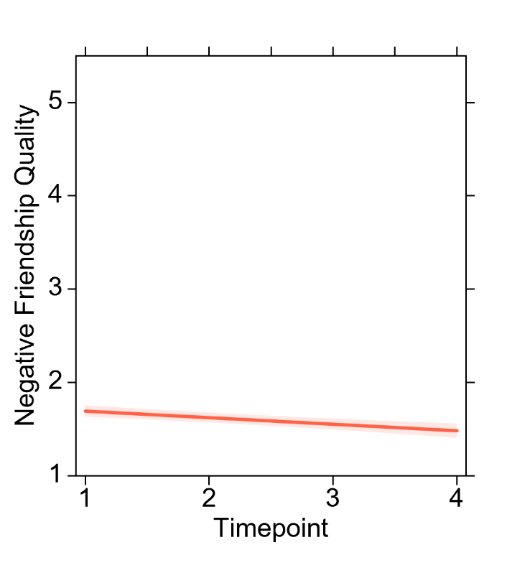
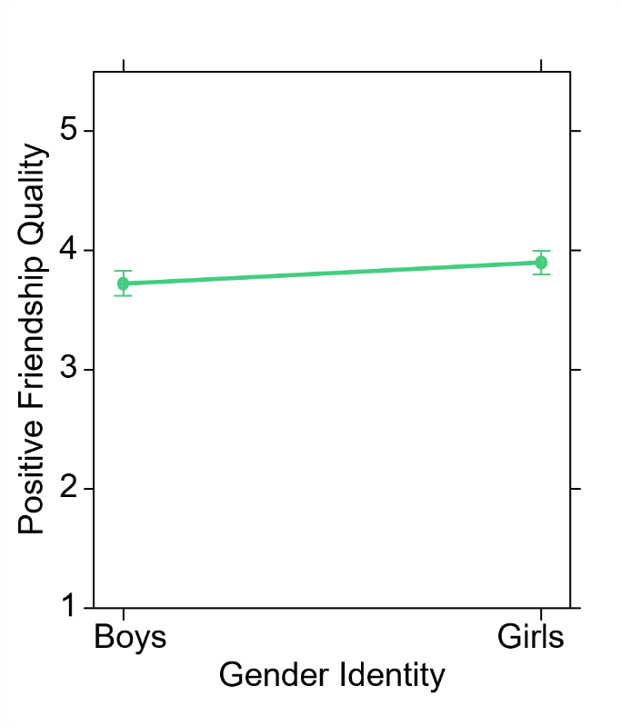
A)
B)

