Preclinical evaluation and pilot clinical study of ¹⁸F-AlF-labeled FAPI-tracers for PET imaging of cancer associated fibroblasts
Kongzhen Hu ¹ · Junqi Li ² · Lijuan Wang ¹ · Yong Huang ^{1,3} · Li Li ¹, Shimin Ye ¹ · Yanjiang Han ¹ · Shun Huang ¹ · Hubing Wu ¹ · Jin Su ^{2,4,*} · Ganghua Tang ^{1,*}
¹ Department of Nuclear Medicine, Nanfang Hospital, Southern Medical University, 1838 Guangzhou North Road, Guangzhou, Guangdong Province, 510515, China.
² Shenzhen International Institute for Biomedical Research, Shenzhen, Guangdong Province, 518116, China.
³ National Cancer Center/National Clinical Research Center for Cancer/Cancer Hospital & Shenzhen Hospital, Chinese Academy of Medical Sciences and Peking Union Medical College, Shenzhen, 518116, China
⁴ State Key Laboratory of Respiratory Disease, National Clinical Research Center for Respiratory Disease, Guangzhou Institute of Respiratory Health, the First Affiliated Hospital of Guangzhou Medical University, Guangzhou, Guangdong Province, 510182, China.

* Corresponding authors: Ganghua Tang, Phone: +86 020 62786625; E-mail addresses: gtang0224@smu.edu.cn. Jin Su, E-mail addresses: sujin@gird.cn

Table of Contents
Materials and Methods 4
Chemistry 4
Scheme 1. Synthetic Route Used to Generate Precursor NOTA-FAPI-42 and Reference Compound ¹⁹F-FAPI-42. 4
Scheme 2. Synthetic Route Used to Generate Precursor P-FAPI and Reference Compound ¹⁹F-P-FAPI. 5
6-(3-chloropropoxy)quinoline-4-carboxylic acid (3) 5
(S)-6-(3-chloropropoxy)-N-(2-(2-cyano-4,4-difluoropyrrolidin-1-yl)-2-oxoethyl)quinoline-4-carboxamide (4) 6
tert-butyl (S)-4-(3-((4-((2-(2-cyano-4,4-difluoropyrrolidin-1-yl)-2-oxoethyl)carbamoyl)quinolin-6-yl)oxy)propyl)piperazine-1-carboxylate (5) 6
(S)-N-(2-(2-cyano-4,4-difluoropyrrolidin-1-yl)-2-oxoethyl)-6-(3-(piperazin-1-yl)propoxy)quinoline-4-carboxamide hydrochloride (6) 7
Precursor NOTA-FAPI-42 8
Reference Compound ¹⁹F-FAPI-42 8
6-(2-(2-((tert-butoxycarbonyl)amino)ethoxy)ethoxy)quinoline-4-carboxylic acid (8)
tert-butyl (S)-(2-(2-((4-((2-(2-cyano-4,4-difluoropyrrolidin-1-yl)-2-oxoethyl)carbamoyl)quinolin-6-yl)oxy)ethoxy)ethyl)carbamate (9) 9
(S)-6-(2-(2-aminoethoxy)ethoxy)-N-(2-(2-cyano-4,4-difluoropyrrolidin-1-yl)-2-oxoethyl)quinoline-4-carboxamide (10) 9
P-FAPI 10
¹⁹F-P-FAPI 10
Quality Control 10
pH 11
Determination of residual solvents by gas chromatography (GC) 11
Integrity of the sterile filter membrane 12
Sterility 12
Bacterial endotoxins. 12
In Vitro Serum Stability and in Vivo Stability 12
Cell lines 13
mRNA isolation and qRT-PCR 13
Western blot 13
Immunofluorescence 14
Cell uptake, efflux, internalization, and tumor transplantation 15
References 16
Spectroscopic Data 17

Materials and Methods

Chemistry

Scheme 1. Synthetic Route Used to Generate Precursor NOTA-FAPI-42 and Reference Compound ¹⁹F-FAPI-42.
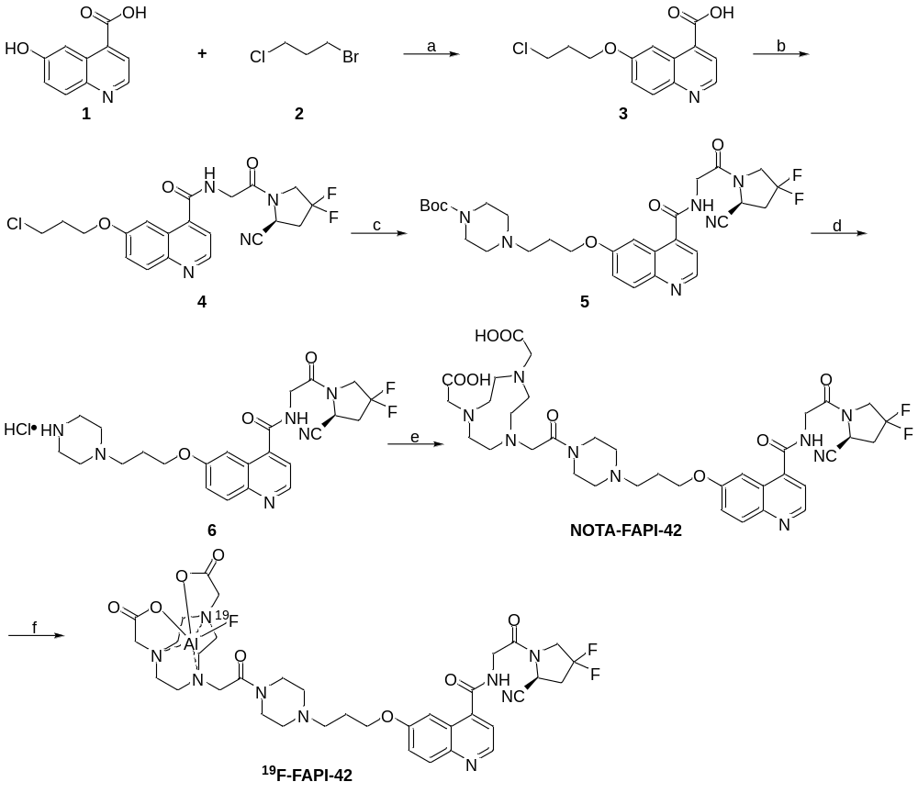
Reagents and conditions. (a) Cs₂CO₃, DMF, 65 °C, 6 h; yield, 81%. (b) (S)-4,4-difluoro-1-glycylpyrrolidine-2-carbonitrile, HATU, DIPEA, DMF, rt., 20 h; yield, 63%. (c) tert-butyl piperazine-1-carboxylate, KI, DMF, 65 °C, 18 h; yield, 52%. (d) HCl in dioxane, CH₂Cl₂, rt., 1 h. (e) (i) 2-(4,7-bis(2-(tert-butoxy)-2-oxoethyl)-1,4,7-triazonan-1-yl)acetic acid, HATU, DIPEA, DMF, rt., 20 h; (ii) TFA, rt., 3 h; yield, 30%. (f) AlCl₃, KF, DMSO, NaOAc, 105 °C, 1 h; yield, 41%.

Scheme 2. Synthetic Route Used to Generate Precursor P-FAPI and Reference Compound ¹⁹F-P-FAPI.
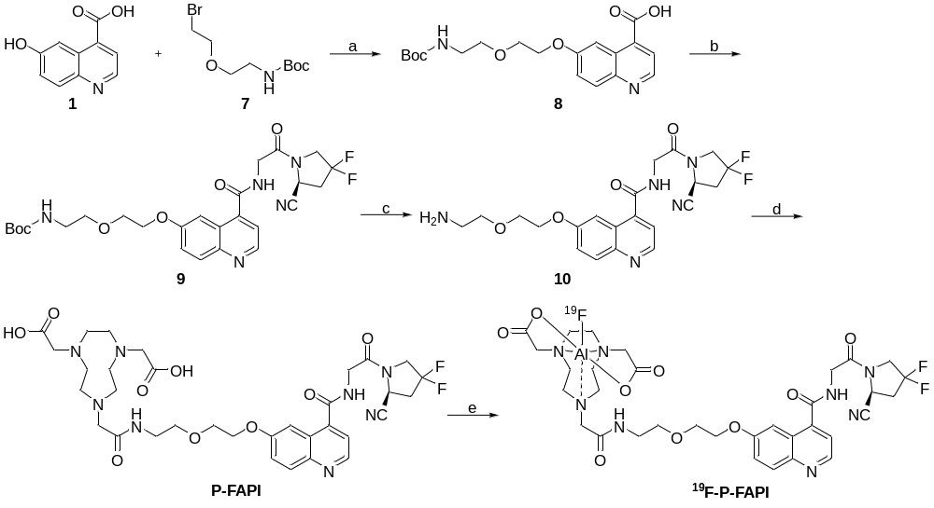
Reagents and conditions. (a) Cs₂CO₃, DMF, 65 °C, 3 h; yield, 32%. (b) (S)-4,4-difluoro-1-glycylpyrrolidine-2-carbonitrile, HATU, DIPEA, DMF, rt, 16 h; yield, 57%. (c) TFA, rt. 1 h; yield, 89%. (d) 2-(4,7-bis(2-(tert-butoxy)-2-oxoethyl)-1,4,7-triazonan-1-yl)acetic acid, HATU, DIPEA, DMF, rt., 16 h; (ii) TFA, rt., 3 h; yield, 48%. (e) AlCl₃, KF, DMSO, NaOAc, 105 °C, 1 h; yield, 45%.

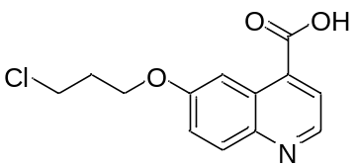

6-(3-chloropropoxy)quinoline-4-carboxylic acid (3)
To a solution of 6-hydroxyquinoline-4-carboxylic acid 1 (0.49 g, 2.59 mmol, 1.00 equiv) in DMF (10.00 mL) was added Cs₂CO₃ (2.95 g, 9.07 mmol, 3.00 equiv) and 1-bromo-3-chloropropane (2) (1.43 g, 9.07 mmol, 3.50 equiv) under nitrogen atmosphere at room temperature. The reaction mixture was heated to 65 °C and stirred for 6 h. The reaction was cooled to 0 °C and quenched with water (50.0 mL) and the aqueous layer was extracted with EtOAc (6 × 10.0 mL). The organic extracts were combined, washed with 5% lithium chloride aqueous (5.00 mL), and then dried over Na₂SO₄. After being concentrated in vacuo, the residue was purified by flash chromatography on silica gel to afford the desired compound as a white solid (0.56 g, 2.17 mmol, 81% yield). NMR Spectroscopy: ¹H NMR (400 MHz, (CD₃)₂SO, 25 °C, δ): 8.85 (d, J = 4.5, 1H), 8.16 (d, J = 2.8, 1H), 8.02 (d, J = 9.2, 1H), 7.90 (d, J = 4.4, 1H), 7.50 (dd, J = 9.2, 2.8, 1H), 4.22 (t, J = 6.0, 2H), 3.84 (t, J = 6.4, 2H), 2.35–2.18 (m, 2H).

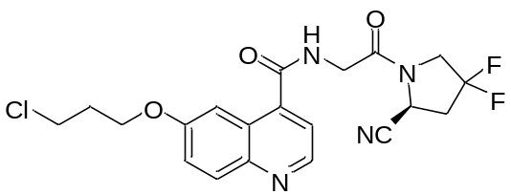

(S)-6-(3-chloropropoxy)-N-(2-(2-cyano-4,4-difluoropyrrolidin-1-yl)-2-oxoethyl)quinoline-4-carboxamide (4)
To a solution of 6-(3-chloropropoxy)quinoline-4-carboxylic acid (3) (0.50 g, 1.88 mmol, 1.00 equiv) in DMF (11.0 mL) was added HATU (0.79 g, 2.07 mmol, 1.10 equiv), DIPEA (0.73 g, 5.64 mmol, 3.00 equiv), and (S)-4,4-difluoro-1-glycylpyrrolidine-2-carbonitrile hydrochloride (0.42 g, 1.88 mmol, 1.00 equiv) at room temperature. The reaction mixture was stirred overnight at room temperature. The reaction was added 5% lithium chloride aqueous (30.0 mL) and extracted with dichloromethane (CH₂Cl₂, 5 × 15.0 mL). Combined the organic layers and dried over magnesium sulfate. The solvent was removed in vacuum, and the residue was purified by flash chromatography on silica gel to afford the title compound as white solid (0.52 g, 1.18 mmol, 63% yield). NMR Spectroscopy: ¹H NMR (400 MHz, (CD₃)₂SO, 25 °C, δ): 9.08 (t, J = 6.1, 1H), 8.81 (d, J = 4.4, 1H), 7.99 (d, J = 9.2, 1H), 7.84-7.93 (m, 1H), 7.51 (d, J = 4.4, 1H), 7.47 (dt, J = 9.2, 3.1, 1H), 5.15 (dd, J = 9.3, 3.2, 1H), 4.39–4.09 (m, 6H), 3.84 (t, J = 6.5, 2H), 2.95–2.81 (m, 2H), 2.35–2.19 (m, 2H).

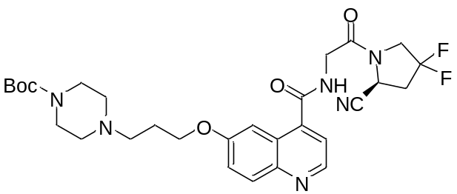

tert-butyl (S)-4-(3-((4-((2-(2-cyano-4,4-difluoropyrrolidin-1-yl)-2-oxoethyl)carbamoyl)quinolin-6-yl)oxy)propyl)piperazine-1-carboxylate (5)
To a solution of (S)-6-(3-chloropropoxy)-N-(2-(2-cyano-4,4-difluoropyrrolidin-1-yl)-2-oxoethyl)quinoline-4-carboxamide (4) (0.40 g, 0.92 mmol, 1.00 equiv) in DMF (10.0 mL) was added tert-butyl piperazine-1-carboxylate (0.69 g, 3.68 mmol, 4.00 equiv), and KI (0.31 g, 1.84 mmol, 2.00 equiv) at room temperature. The reaction mixture was heated to 65 °C and stirred for 18 h. The solvent of the reaction mixture was removed in vacuum, and the residue was purified by flash chromatography on silica gel to afford the title compound as white solid (0.28 g, 0.48 mmol, 52% yield). NMR Spectroscopy: ¹H NMR (400 MHz, (CD₃)₂SO, 25 °C, δ): 9.10 (t, J = 6.0, 1H), 8.81 (d, J = 4.3, 1H), 8.06 – 7.93 (m, 2H), 7.46 (dd, J = 9.2, 2.7, 1H), 5.14 (dd, J = 9.2, 2.7, 1H), 4.42 – 4.07 (m, 6H), 3.31 (s, 3H), 2.90 (s, 2H), 2.74 (s, 2H), 2.70 (s, 1H), 2.39–2.30 (m, 4H), 2.05–1.92 (m, 2H), 1.40 (s, 9H).
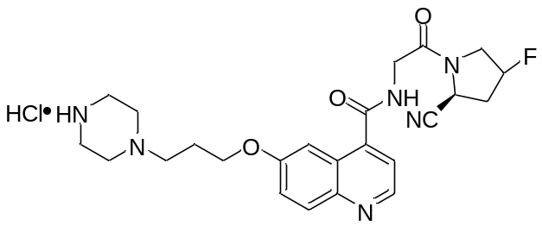

(S)-N-(2-(2-cyano-4,4-difluoropyrrolidin-1-yl)-2-oxoethyl)-6-(3-(piperazin-1-yl)propoxy)quinoline-4-carboxamide hydrochloride (6)
To a solution of tert-butyl (S)-4-(3-((4-((2-(2-cyano-4,4-difluoropyrrolidin-1-yl)-2-oxoethyl)carbamoyl)quinolin-6-yl)oxy)propyl)piperazine-1-carboxylate (5) (0.20 g, 0.34 mmol, 1.00 equiv) in CH₂Cl₂ (2.0 mL) was HCl mixture (1 mL, 4 M in dioxane) at room temperature. The reaction mixture was stirred at room temperature for 1 h. The solvent of the reaction mixture was removed in vacuum, and the crude product was directly used in next step. NMR Spectroscopy: ¹H NMR (400 MHz, D₂O, 25 °C, δ): ¹H NMR (400 MHz, D₂O) δ 9.00 (dd, J = 5.4, 2.0 Hz, 1H), 8.20 (dd, J = 9.3, 2.7 Hz, 1H), 8.05 (dd, J = 5.5, 1.7 Hz, 1H), 7.89 – 7.72 (m, 2H), 5.17 (dd, J = 8.6, 4.4 Hz, 1H), 4.49 – 4.08 (m, 6H), 3.78–3.69 (d, J = 2.0 Hz, 2H), 3.57 (s, 8H), 3.06 – 2.85 (m, 2H), 2.39 (dq, J = 10.3, 5.8 Hz, 2H).

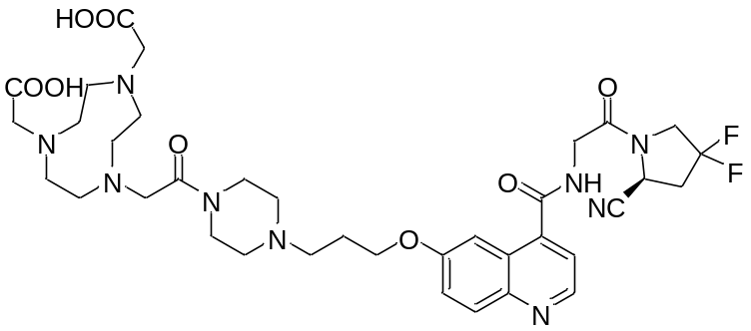

Precursor NOTA-FAPI-42
The crude compound (S)-N-(2-(2-cyano-4,4-difluoropyrrolidin-1-yl)-2-oxoethyl)-6-(3-(piperazin-1-yl)propoxy)quinoline-4-carboxamide hydrochloride (6) (0.34 mmol, 1.00 equiv) was dissolved in DMF (2.0 mL) and was added HATU (0.14 g, 0.37 mmol, 1.10 equiv), DIPEA (0.13 g, 1.02 mmol, 3.00 equiv), and 2-(4,7-bis(2-(tert-butoxy)-2-oxoethyl)-1,4,7-triazonan-1-yl)acetic acid (0.14 g, 0.34 mmol, 1.00 equiv) at room temperature. After the reaction mixture was stirring for 20 h, the solvent was concentrated in vacuo. To the residue was added TFA (5 mL) and stirred for 3 h. The reaction mixture was poured into cool ether, large amount of solid was formed, sent to centrifuge, the solid was dissolved in acetonitrile and water in a ratio of 1:1 (v/v) and purified via reverse-phase C18 column (Sepax GP-C18 5 μm 120A 4.6 × 250 mm) to afford the title compound as yellow oil (77.0 mg, 0.10 mmol, 30% yield). MS (ESI-TOF) (m/z): calcd for C₃₆H₄₈F₂N₉O₈ ([M + H]⁺), 772.4, found, 772.5.
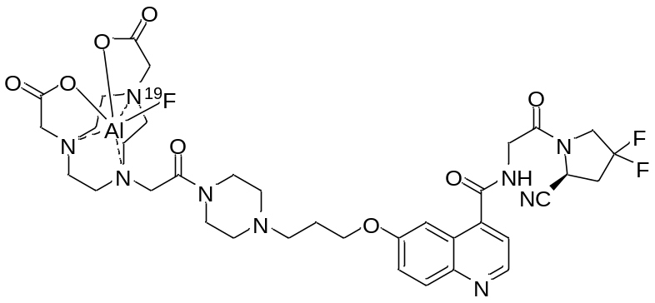

Reference Compound ¹⁹F-FAPI-42
To a solution of NOTA-FAPI-42 (500 μg, 0.68 μmol) in 300 μL of 0.5 M sodium acetate buffer (pH 4.0) was added AlCl₃ [34 μL, 0.68 μmol, 20.0 mM, in sodium acetate buffer (0.2 M, pH 4.0)], dimethyl sulfoxide (300 μL), and potassium fluoride aqueous (34 μL, 0.68 μmol, 20.0 mM). The reaction mixture was heated at 100 °C for 60 min. After cooling to room temperature, the reaction mixture was purified using reverse-phase C18 column (Sepax GP-C18 5 μm 120A 4.6 × 250 mm) to afford the title compound as yellow oil. HRMS (ESI-TOF) (m/z): calcd for C₃₆H₄₆AlF₃N₉O₈ ([M + H]⁺), 816.3232, found, 816.3224.
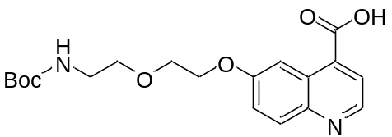

6-(2-(2-((tert-butoxycarbonyl)amino)ethoxy)ethoxy)quinoline-4-carboxylic acid (8)
120 mg (0.32 mmol, 32% yield) were obtained following the previous method. MS (ESI-TOF) (m/z): calcd for C₁₉H₂₅N₂O₆ ([M + H]⁺), 377.2, found, 377.3.
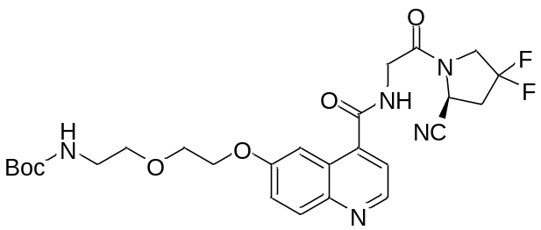

tert-butyl (S)-(2-(2-((4-((2-(2-cyano-4,4-difluoropyrrolidin-1-yl)-2-oxoethyl)carbamoyl)quinolin-6-yl)oxy)ethoxy)ethyl)carbamate (9)
100 mg (0.18 mmol, 57% yield) were obtained following the previous method. MS (ESI-TOF) (m/z): calcd for C₂₆H₃₂F₂N₅O₆ ([M + H]⁺), 548.2, found, 548.2.
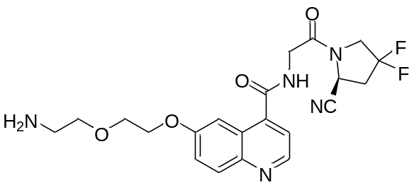

(S)-6-(2-(2-aminoethoxy)ethoxy)-N-(2-(2-cyano-4,4-difluoropyrrolidin-1-yl)-2-oxoethyl)quinoline-4-carboxamide (10)
tert-butyl (S)-(2-(2-((4-((2-(2-cyano-4,4-difluoropyrrolidin-1-yl)-2-oxoethyl)carbamoyl)quinolin-6-yl)oxy)ethoxy)ethyl)carbamate (9) (0.15 g, 0.27 mmol, 1.00 equiv) was added into TFA (5.0 mL) and stirred at room temperature for 18 h. The solvent of the reaction mixture was removed in vacuum, and the residue was purified by flash chromatography on silica gel to afford the title compound as white solid (109 mg, 0.24 mmol, 89% yield). MS (ESI-TOF) (m/z): calcd for C₂₁H₂₄F₂N₅O₄ ([M + H]⁺), 447.2, found, 448.2.

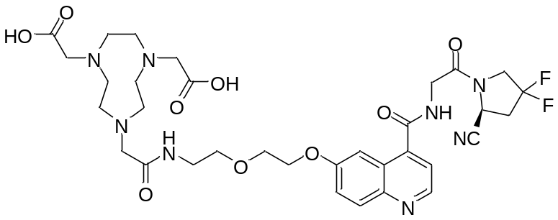

P-FAPI
To a solution of (S)-6-(2-(2-aminoethoxy)ethoxy)-N-(2-(2-cyano-4,4-difluoropyrrolidin-1-yl)-2-oxoethyl)quinoline-4-carboxamide (10) (100.00 mg, 0.18 mmol, 1.00 equiv) was dissolved in DMF (2.0 mL) and was added HATU (68.00 mg, 0.18 mmol, 1.00 equiv), DIPEA (46.50 mg, 0.36 mmol, 2.00 equiv), and 2-(4,7-bis(2-(tert-butoxy)-2-oxoethyl)-1,4,7-triazonan-1-yl)acetic acid (75.00 mg, 0.18 mmol, 1.00 equiv) at room temperature. After the reaction mixture was stirring for 20 h, the solvent was concentrated in vacuo. To the residue was added TFA (5 mL) and stirred for 3 h. The reaction mixture was poured into cool ether, large amount of solid was formed, sent to centrifuge, the solid was dissolved in acetonitrile and water in a ratio of 1:1 (v/v) and purified via reverse-phase C18 column (Sepax GP-C18 5 μm 120A 4.6 × 250 mm) to afford the title compound as yellow oil (63.0 mg, 86.1 μmol, 48% yield). MS (ESI-TOF) (m/z): calcd for C₃₃H₄₃F₂N₈O₉ ([M + H]⁺), 733.3, found, 733.4.
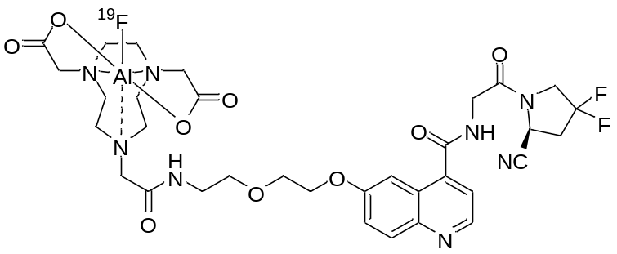

¹⁹F-P-FAPI were obtained following the previous method. HRMS (ESI-TOF) (m/z): calcd for C₃₃H₄₁AlF₃N₈O₉ ([M + H]⁺), 777.2759, found, 777.2746.

Quality Control
High pressure liquid chromatography (HPLC) method used for the identification, radiochemical purity and chemicals in the drug product
Analytical HPLC was performed using a LC-20AD HPLC system (Shimadzu, Japan) coupled in series to a DAD-UV detector (254 nm) (Shimadzu, Japan) and a B-FC-3200 high energy PMT detector (Bioscan. Inc, Washington DC, USA) was used. The system was equipped with a ZORBAX Eclipse XDB-C18 analytic column (4.6 × 150 mm, 5 μm; Agilent Technologies, USA) using the flow rate of 1 mL/min. The gradient program started from 90% solvent A (0.1% TFA in water): 10% solvent B (0.1% TFA in MeCN) ramped to 20% solvent A: 80% solvent B at 10 min, and ramped to 20% solvent A: 80% solvent B at 15 min.

pH
pH values were measured with a pH strip (Q/GHSC pH 0–14, SSS Reagent Co., LTD, China).

Determination of residual solvents by gas chromatography (GC)
Residual solvents were determined by gas chromatography analyses on an Agilent 8890 (Agilent Technologies, USA) gas chromatograph. The procedures of GC were according to Chinses Pharmacopoeia.

Integrity of the sterile filter membrane
The integrity of the sterile filter membrane was determined using the bubble point test.

Sterility
The drug product was tested for microbiological contamination by direct inoculation in fluid thioglycolate medium and soya-casein digest medium incubation according to Chinses Pharmacopoeia.

Bacterial endotoxins
Endotoxins were quantified in the drug product solution using a portable LAL test system according to Chinses Pharmacopoeia.

In Vitro Serum Stability and in Vivo Stability
The in vitro and in vivo stability were performed according to previously reported procedures (1). In brief, an aliquot of ¹⁸F-labeled FAP tracer (3.7 MBq, 10 μL) was added to PBS (200 μL) or the mouse serum (200 μL) and incubated at 37 °C for 2 h. For the PBS study, an aliquot of the solution was directly injected into a radio-HPLC for analysis. Plasma proteins were precipitated using 0.2 mL of acetonitrile and centrifuged (10000 rpm, 5 min). The supernatant was injected into a radio-HPLC column for analysis. Kunming mice were injected intravenously with ¹⁸F-labeled FAP tracer (11.1–18.5 MBq/per mouse, n = 3). The mice were sacrificed 60 min after injection and blood samples (0.4 mL) were collected. An equal volume of acetonitrile was added to the blood samples, which were then centrifuged at 10000 rpm for 5 min. The supernatant was filtered through a 0.45-mm syringe filter and 100 μL of the sample was used for HPLC analysis. The eluted sample was manually collected as 0.5-min fractions over a span of 15 min. The samples were counted using a γ-counter for 20 s; the counts of the sample were plotted as intensity (cpm) versus fractions.
Cell Studies

mRNA isolation and qRT-PCR
Total RNA of A549 and A549-FAP was isolated by using a RNeasy mini kit (Magen, China) and cDNA was transcribed using a HiScript 1st Strand cDNA Synthesis Kit (Vazyme, China) according to the user’s manual. The relative Real-time quantitative polymerase chain reaction (qRT-PCR) analysis was performed using 1 μl of cDNA diluent template, 10 nM of left and right primers (FAP left primer:5’- CAAAGGCTGGAGCTAAGAATCC-3’, and right primer: 5’-ACTGCAAACATACTCGTTCATCA-3’, GAPDH left primer:5’- GGAGCGAGATCCCTCCAAAAT-3’, and right primer:5’- GGCTGTTGTCATACTTCTCATGG-3’), and AceQ Universal SYBR qPCR Master Mix (Vazyme, China) on LC96 system (Roche, Switzerland). The expression of GAPDH was used to normalize the quantification for the relative expression of FAP. The relative expression was calculated by the 2^{-ΔΔC} formula.

Western blot
The cells were collected and lysed in lysis buffer (Boster, China) with 1% PMSF on ice for 0.5 h (shaking the tube every 5 min). After centrifuged for 30 minutes at 4 ℃, 12000 rpm, supernatants were collected to a new tube. The protein concentration was measured by BCA protein assay kit (YEASEN, China). Proteins were separated in Bio-Rad SDS-PAGE system (Bio-Rad, USA), and transferred to PVDF membrane. After blocking with 5% BSA for 1h, the membranes were incubated with primary antibodies (anti-FAP:66562, CST, anti-β-actin:30101ES10, YEASEN) over night at 4 ℃. Corresponding horseradish peroxidase (HRP)-conjugated second antibodies were used against the primary antibody, and proteins were detected using the chemiluminescent detection reagents and films.

Immunofluorescence
The cells cultured in 24 wells culture dish (NEST, USA) were fixed in 4% ice-cold paraformaldehyde for 15 min and permeabilized for 15 min with 0.1% TritonX-100 at room temperature. After blocking the nonspecific proteins for 1h at 37 ℃ with 5% BSA (Sigma, USA), the cells were incubated with primary antibody at 4 ℃ overnight. The Goat anti-Rabbit IgG H&L (FITC, 1:400) was added to cover the cells for 0.5h at room temperature, and then the cells were counterstained with DAPI (YEASEN, China) for 15 min at room temperature. The stained cells were imaged using laser scanning confocal microscope for further study.
Supplemental FIGURE 1. The relative expression of FAP in A549 and A549-FAP cell lines according to qRT-PCR (A), WB (B) and Immunofluorescence (C). * P < 0.05; ** P < 0.01; *** P < 0.001.

Cell uptake, efflux, internalization, and tumor transplantation
The method of cell studies was similar to a method reported previously (2,3). For radioligand uptake studies, A549, A549-FAP, 293T, and 293T-FAP cells were seeded in 12-well plates and cultivated for 48 h to a final confluence of approximately 80–90% (3–8 ×10⁵ cells/well). The medium was replaced using 1 mL of fresh medium without fetal bovine serum. The radiolabeled compound was added to the cell culture and incubated at time intervals ranging from 5–120 min at 37 °C. Subsequently, blocking studies were conducted in A549-FAP cells. The cells were incubated for 1 h at 37 °C with tracer (1.85 kBq), with or without pretreatment with DOTA-FAPI-04 as competitor (2.3 μM/mL). For internalization experiments, A549-FAP cells were incubated with the radiolabeled compound for 60 min at 37 °C. Cellular uptake was terminated by removing the medium from the cells and washing twice with 1 mL of PBS. Subsequently, cells were incubated with 1 mL of glycine HCl (1 M, pH 2.2) for 10 min at 37 °C to remove the surface-bound activity. Next, the cells were washed with 2 mL of ice‐cold PBS and lysed with 1.4 mL of lysis buffer to determine the internalized fraction. For efflux experiments, the radioactive medium was removed after incubation for 60 min and replaced with non-radioactive medium over time intervals ranging from 0–120 min. In all experiments, the cells were washed twice with 1 mL of PBS (pH 7.4) and subsequently lysed with 1.4 mL of lysis buffer (1 M NaOH, 0.2% SDS). Radioactivity was determined using a γ-counter and the results are expressed as %ID/1 mio cells. Each experiment was performed three times with three replicates for each independent experiment.
All animal studies were approved by the Nanfang Hospital Animal Ethics Committee at the Southern Medical University. Male BALB/c nude mice were implanted subcutaneously with A549-FAP cells (2−5 × 10⁶) behind right shoulder and allowed to grow for 2 to 4 weeks. At the time of the experiments, the tumor reached 4−8 mm (diameter), the mice were 6–8 weeks old, and weighed 16 – 24 g.

References
1. Huang S, Wu H, Li B, Fu L, Sun P, Wang M, et al. Automated radiosynthesis and preclinical evaluation of Al[¹⁸F]F-NOTA-P-GnRH for PET imaging of GnRH receptor-positive tumors. Nucl Med Biol [Internet]. Elsevier Inc.; 2020;82–83:64–71. Available from: https://doi.org/10.1016/j.nucmedbio.2020.02.004
2. Loktev A, Lindner T, Mier W, Debus J, Altmann A, Jäger D, et al. A tumor-imaging method targeting cancer-associated fibroblasts. J Nucl Med. 2018;59:1423–9.
3. Toms J, Kogler J, Maschauer S, Daniel C, Schmidkonz C, Kuwert T, et al. Targeting Fibroblast Activation Protein: Radiosynthesis and Preclinical Evaluation of an ¹⁸F-Labeled FAP Inhibitor. J Nucl Med. 2020;61:1806–13.

Spectroscopic Data
The High-resolution mass spectrometry for the reference compound ¹⁹F-P-FAPI.
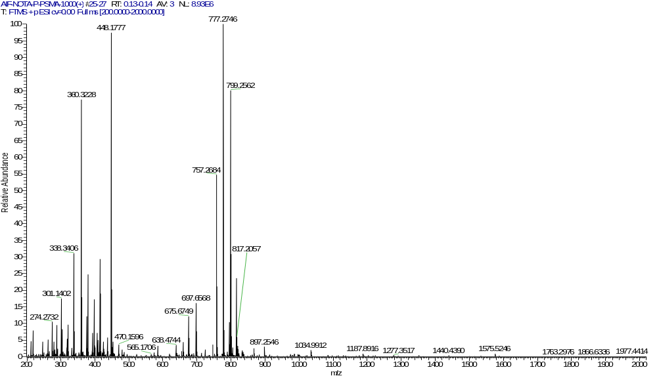
¹⁹F-P-FAPI

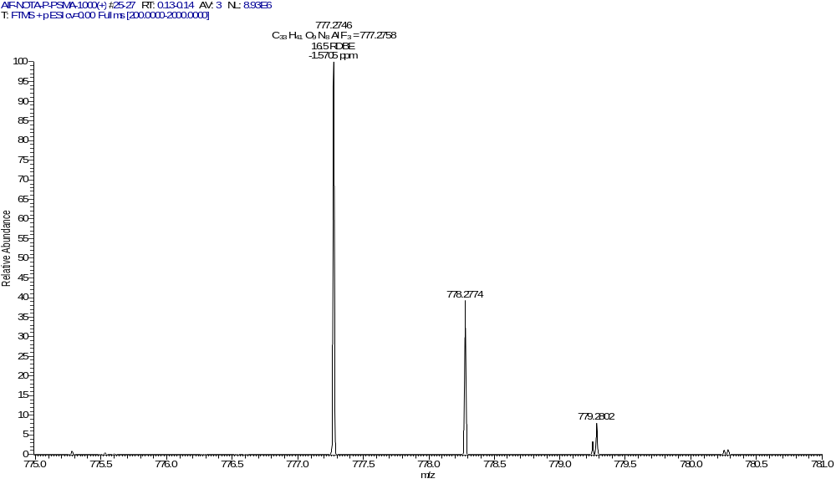
¹⁹F-P-FAPI

The High-resolution mass spectrometry for the reference compound ¹⁹F-FAPI-42.
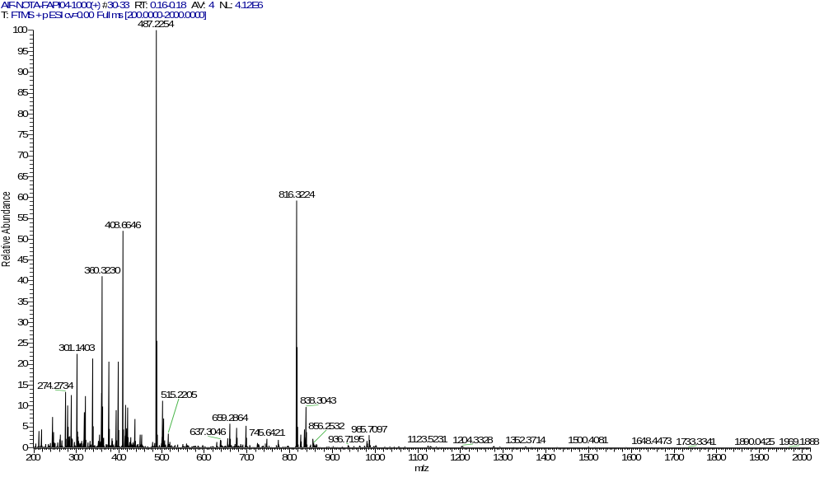

¹⁹F-FAPI-42

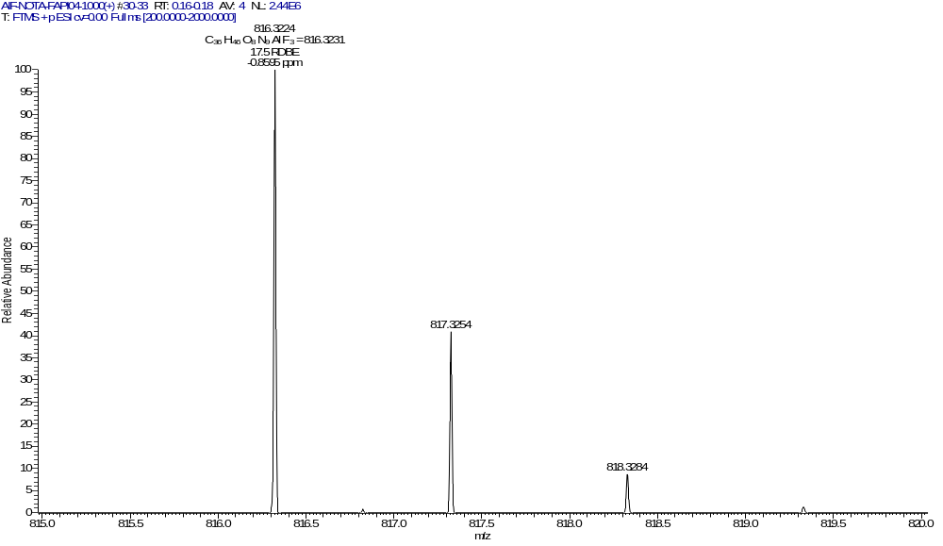

¹⁹F-FAPI-42

The mass spectrometry for the intermediate compounds 8, 9, 10, and P-FAPI.
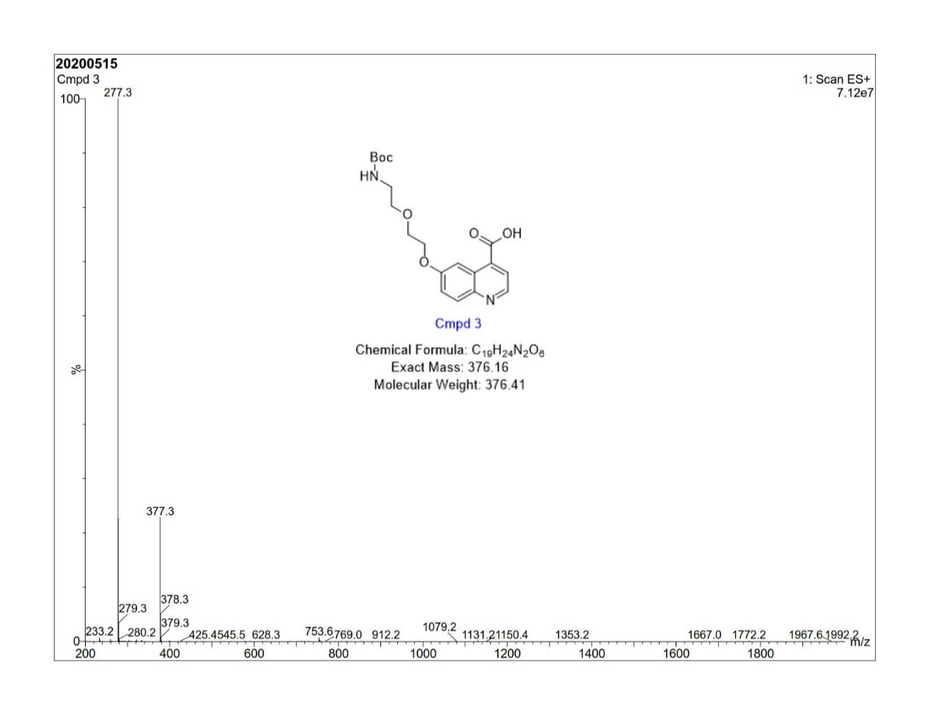

Compound 8

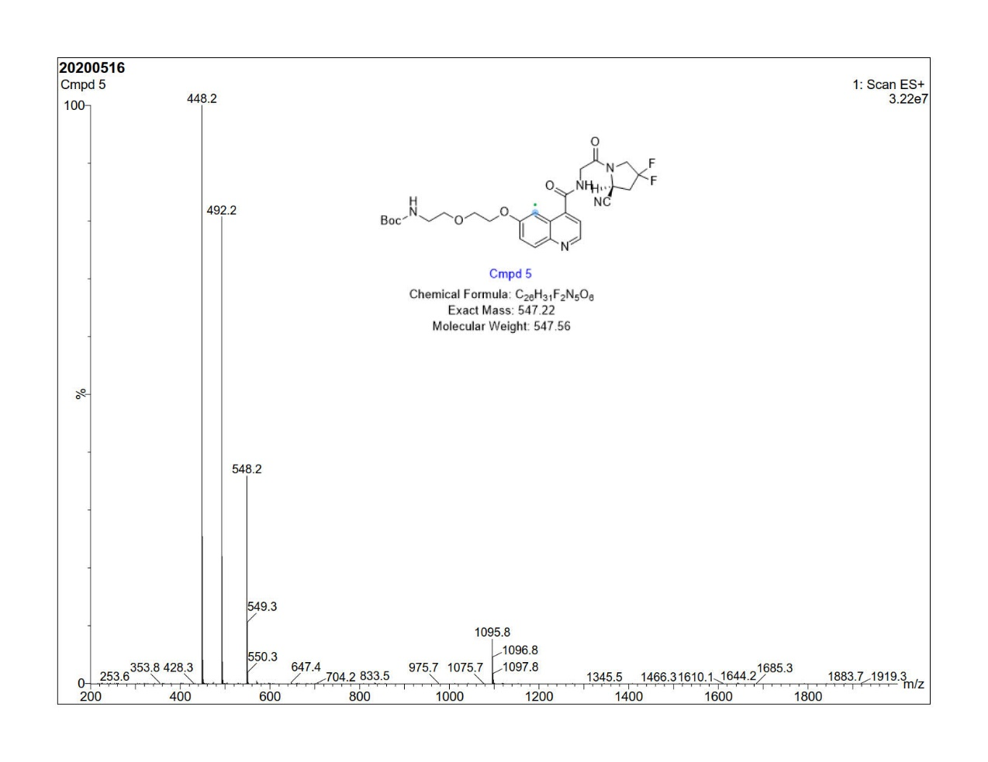

Compound 9

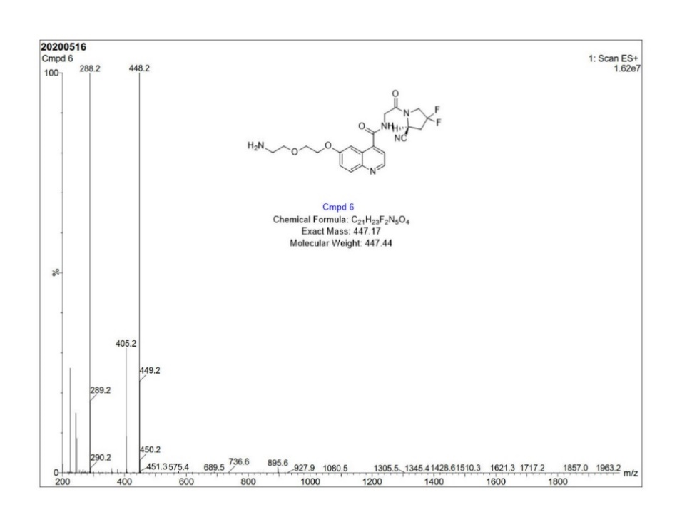
Compound 10

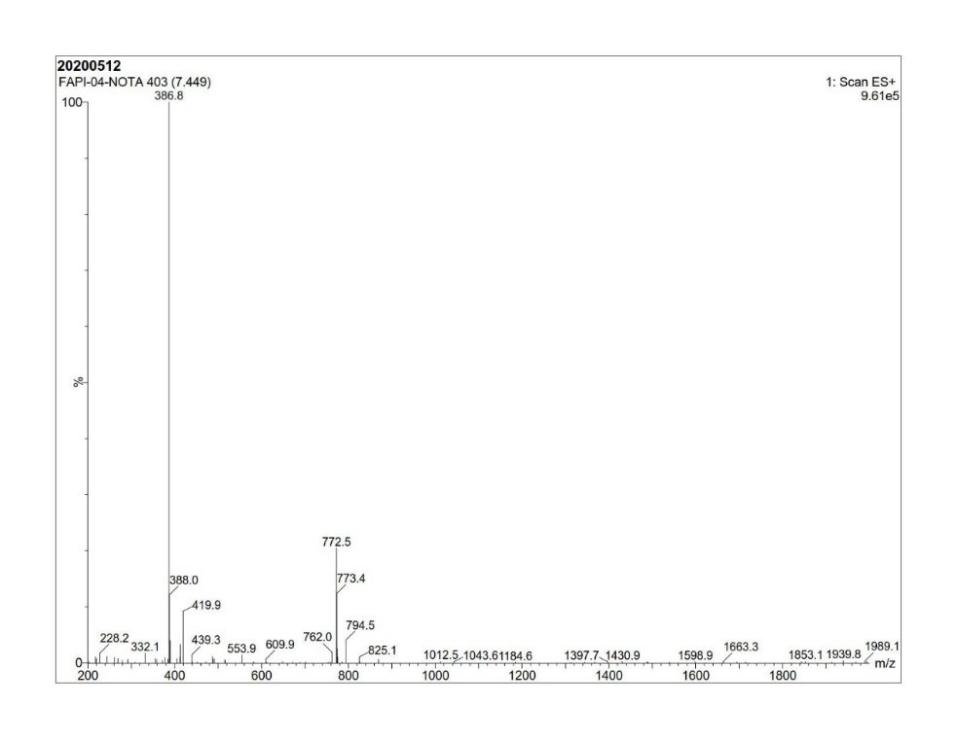

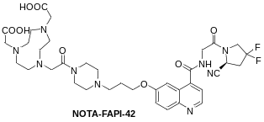

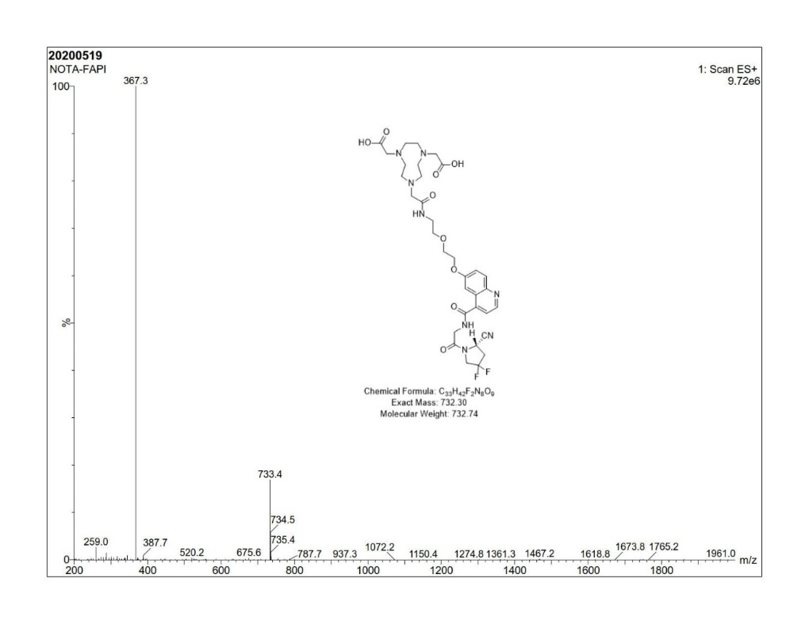

P-FAPI

¹H NMR ((CD₃)₂SO, 25 °C) of 3

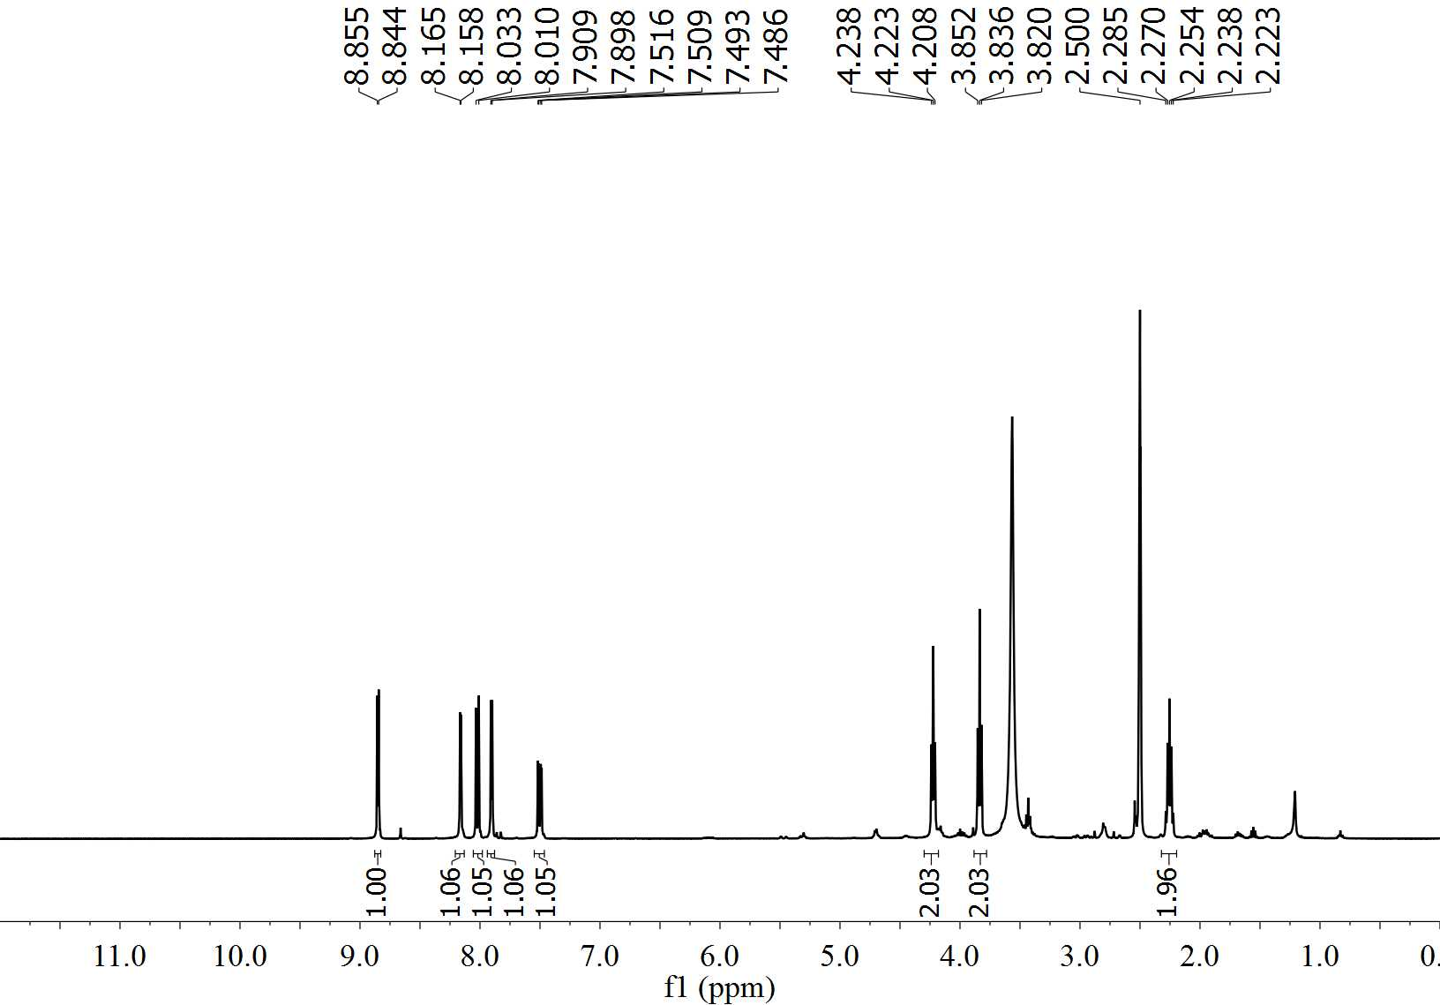

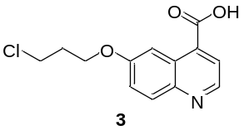

¹H NMR ((CD₃)₂SO, 25 °C) of 4
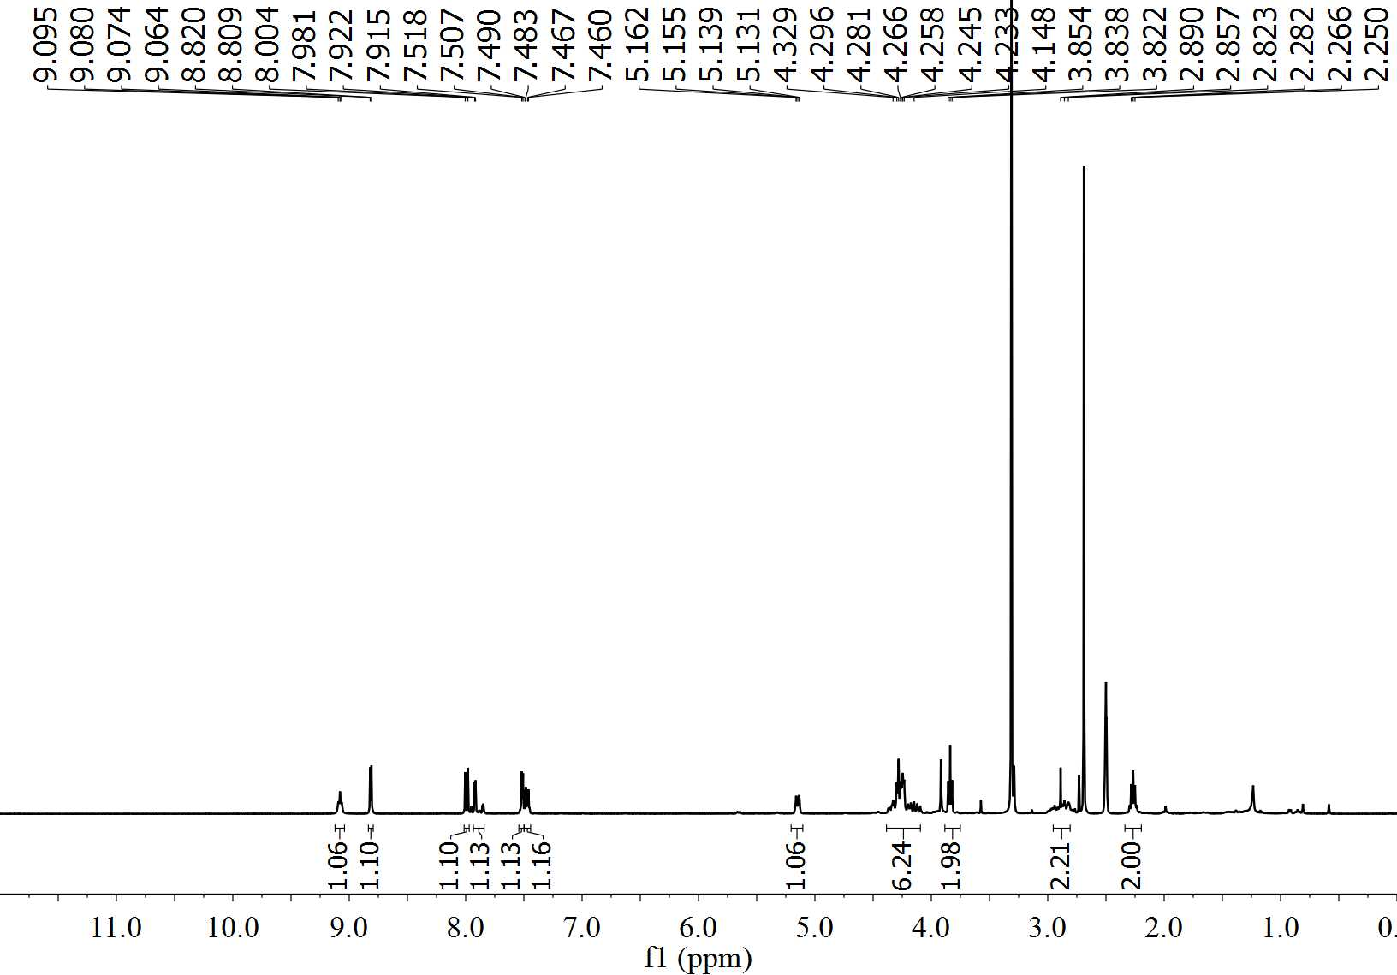

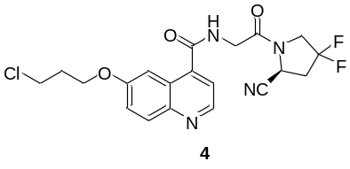

¹H NMR ((CD₃)₂SO, 25 °C) of 5
