Graphs

All together now: disentangling Beatles’ song titles in medical research articles

Stefania M. Maci¹, Cherubino Di Lorenzo², Catello Vollono³

¹ Department of Foreign Languages, Literatures and Cultures, University of Bergamo, Italy stefania.maci@unibg.it
² Department of Medico-Surgical Sciences and Biotechnologies, “Sapienza” University of Rome, Polo Pontino Latina, Italy cherub@inwind.it
³ Università Cattolica del Sacro Cuore, Rome, Italy catello.vollono@policlinicogemelli.it

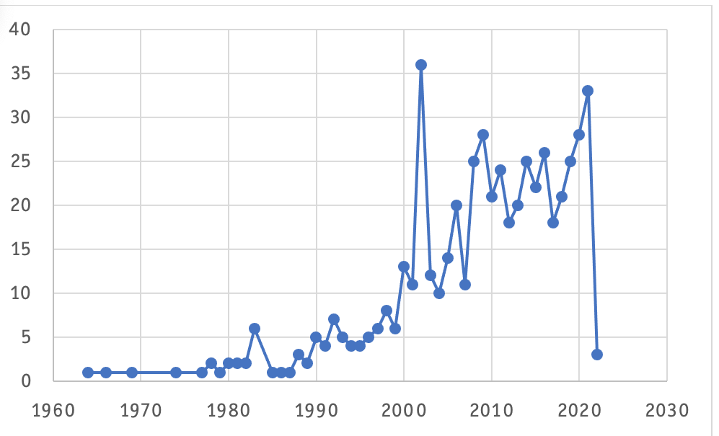

Figure 1. Breakdown of Beatles quotations in publications over time.

