Supplementary Information for
E2E-BPF microscope: Extended depth-of-field microscopy using learning-based implementation of binary phase filter and image deconvolution
Baekcheon Seong¹, Woovin Kim¹, Younghun Kim¹, Jong-Seok Lee², Jeonghoon Yoo¹, and Chulmin Joo^{1,}*

¹ Department of Mechanical Engineering, Yonsei University, Seoul, 03722, Republic of Korea
² School of Integrated Technology, Yonsei University, Incheon 21983, Republic of Korea
* Corresponding author: cjoo@yonsei.ac.kr

Table-of-contents
Section 1 | Evaluated imaging performance of various E2E-BPF structures designed with different initial conditions
Section 2 | Numerical evaluations on the imaging performance of E2E-BPF against reference pupil designs
Section 3 | Improved image contrast over extended depth ranges via E2E-BPF microscope
Section 4 | E2E-BPF design and optical microscope setup
Section 5 | Learning-based implementation of E2E-BPF filter and reconstruction U-Net

Section 1 | Evaluated imaging performance of various E2E-BPF structures designed with different initial conditions
Numerical simulations were performed to investigate DoF-extension performance of the E2E-BPF structures designed under various initial conditions. We considered three axi-symmetric phase functions, i.e., phase axicon, random phases with a normal distribution of zero mean and a standard deviation of 0.8, and spherical aberration, as the initial conditions, and jointly optimized E2E-BPF structures and reconstruction networks. We then used 800 images in the dataset¹ to evaluate the imaging performance of each design based on the RMSE and SSIM scores as a function of defocus distances. The results are summarized in Supplementary Table 1 and Supplementary Figure 1. We determined the DoF enhancement factor by dividing the DoF for pupil A (${DoF}_{A}$) by the DoF of the clear aperture (${DoF}_{Clear}$). It can be observed that the E2E-BPF designed with phase axicon offers superior imaging performance to other BPF designs.

Supplementary Table 1 | Compared imaging performances of the E2E-BPFs designed with various initial conditions.
Index | Initial condition |  |  | RMSE | SSIM |  | ${DoF}_{A}$/${DoF}_{Clear}$
Simulation A | Phase axicon  ($exp(i10ρ)$) |  |  | 0.015±0.006 |  | 0.946±0.020 |  | 16.74
Simulation B | Random noise  ($mean=0$,$s.d.=0.8$) |  |  | 0.028±0.018 |  | 0.906±0.078 |  | 4.47
Simulation C | Spherical aberration ($exp(i10ρ^{3})$) |  |  | 0.030±0.014 |  | 0.901±0.071 |  | 10.21
Clear aperture (without U-Net) |  |  |  | 0.056±0.034 |  | 0.766±0.127 |  | 1.00

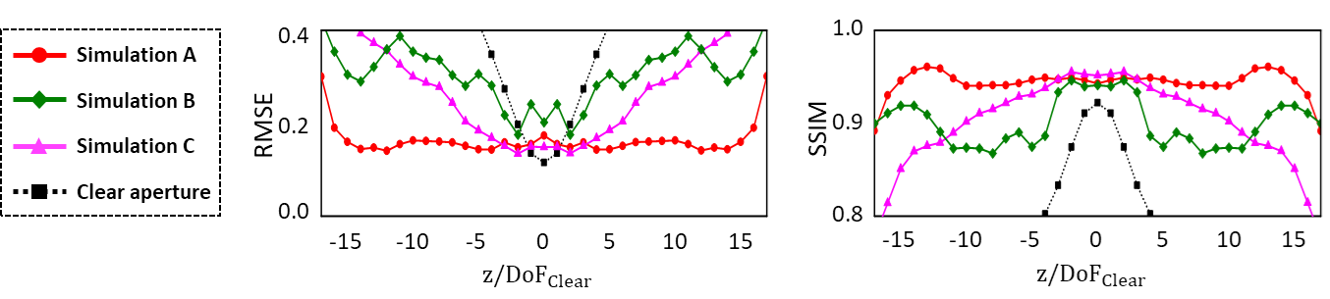
Supplementary Figure 1. Compared imaging performances (i.e., RMSE and SSIM scores) of the E2E-BPF filters designed with phase axicon, random phases in the range of -π to π, and spherical aberration as the initial conditions. For reference, the responses from the standard microscope (clear aperture) were also presented. The RMSE and SSIM values were evaluated over randomly permuted 800 images from the dataset¹.

Section 2 | Numerical evaluations on the imaging performance of E2E-BPF against reference pupil designs
We examined the imaging performance of our E2E-BPF microscope against other phase filters, which included a conventional microscope (with clear aperture) and other prior pupil filters designed for DoF-extension (Table 2 and Supplementary Figure 2). For evaluation, we used the image dataset¹ shown in Figure 3 of the main text to train the reconstruction U-Nets for each configuration and computed the RMSE and SSIM values at various defocus positions. The results are summarized in Table 1.
Supplementary Figure 2 presents representative images obtained with various phase filters. The values below the images denote the corresponding RMSE/SSIM scores. It can be noted that the E2E-BPF microscope produced high-contrast, high-resolution images at up to 16 normalized defocus distances ($z/DoF_{Clear}$), while other pupil designs exhibited a marked decrease in terms of image quality as the defocus distance increased.
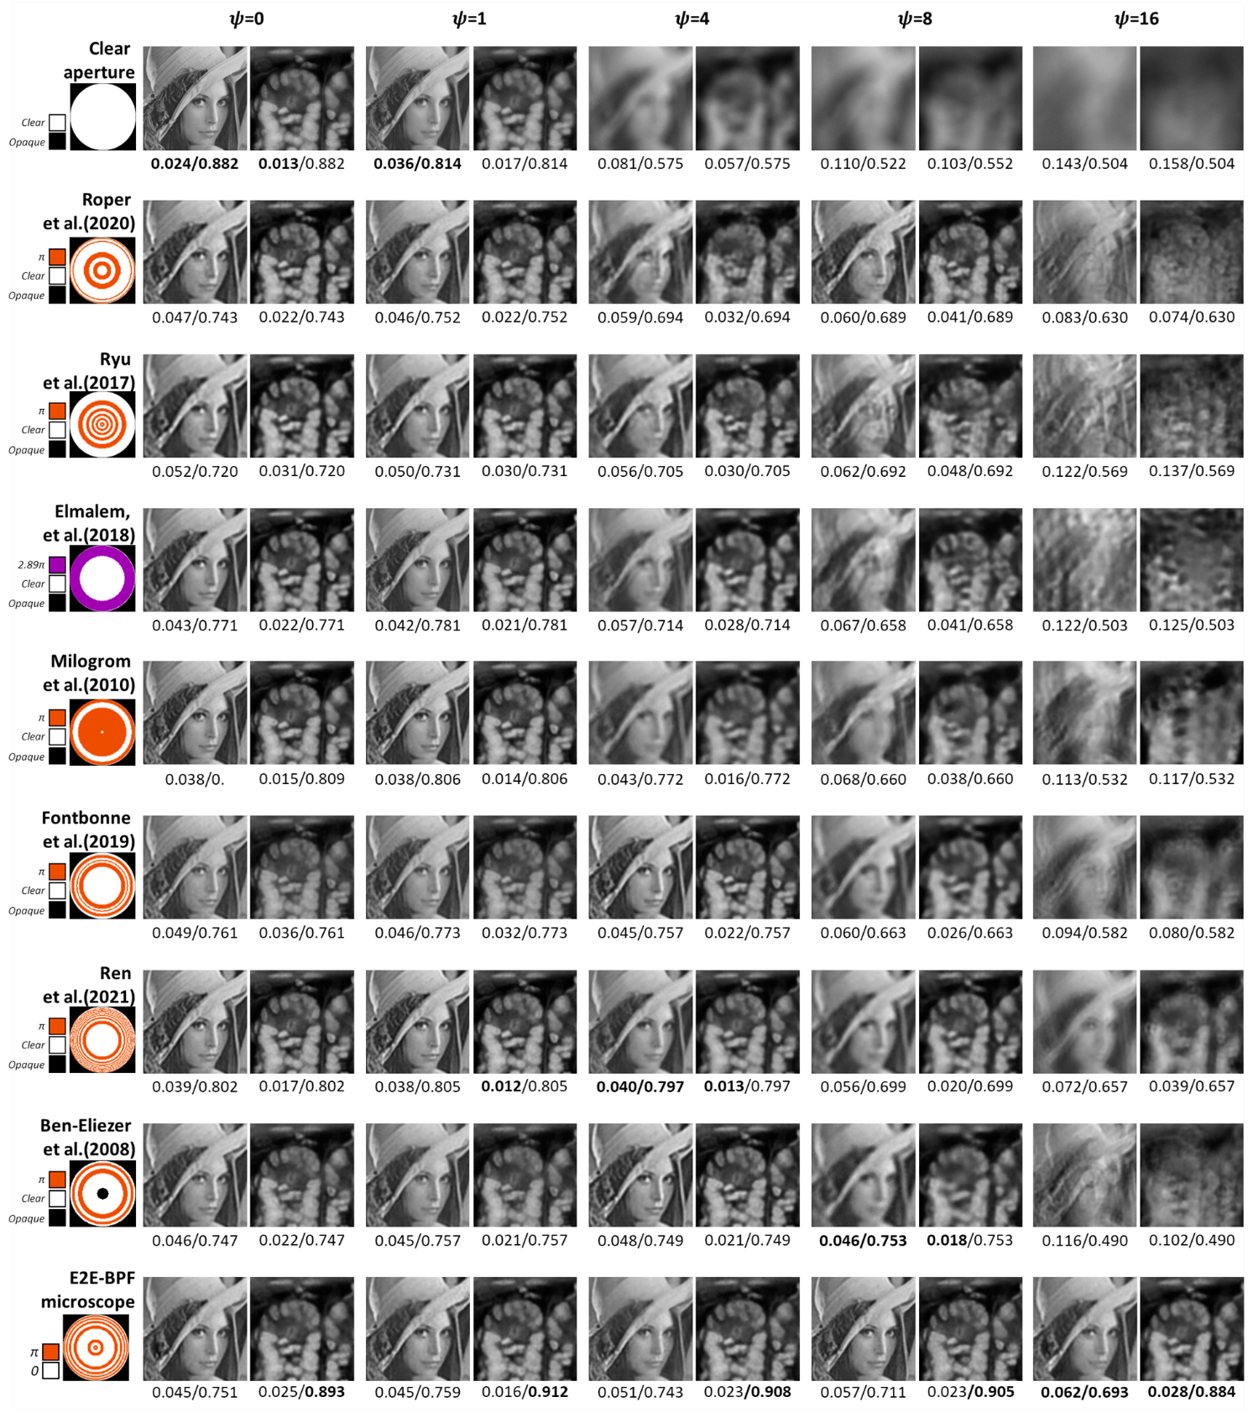
Supplementary Figure 2. Imaging performance comparisons of E2E-BPF against reference pupil designs. The images of Lenna and mouse intestine tissue section were used as the reference, and numerically imaged by a microscope equipped with various pupil filters. Note that the images were post-processed via the corresponding U-Nets optimized for each pupil design. We evaluated RMSE and SSIM values at the representative normalized axial defocus distance. The numerical values below each image denote RMSE/SSIM values.

Section 3 | Improved image contrast over extended depth ranges via E2E-BPF microscope
We further examined the contrasts of mouse kidney tissue section images as a function of the defocus distances (Figure 6). A series of grayscale images in Supplementary Figure 3 (a-d) are the images of each fluorescence channel at various depth positions obtained from the standard (clear aperture) and E2E-BPF microscopes, respectively. The numerical values below the images denote the local image contrast, evaluated as $(I_{max}-I_{min})/(I_{max}+I_{min})$, where $I_{max}$ and $I_{min}$ represent the maximum and minimum pixel values, respectively. It is clearly seen that the images from the E2E-BPF microscope featured contrast values larger than 0.89 in the depth range from 0 μm to 3 μm, and the mean contrast value was measured to be 0.94. In E2E-BPF microscope images, the structures of the glomeruli and nuclei were clearly visualized (Supplementary Figure 3 (a)), and the tubules, ducts, and nuclei were resolved in various regions (Supplementary Figure 3 (b-d)). In contrast, the standard microscope provided relatively low-contrast images, even though the object was placed at the focal plane of the microscope. The mean contrast was measured to be 0.82 over the range of 0 μm to 3 μm, and the contrast estimated from the focal plane images of the standard microscope was 0.88, which is smaller than the minimum contrast obtained in the E2E-BPF microscope images.
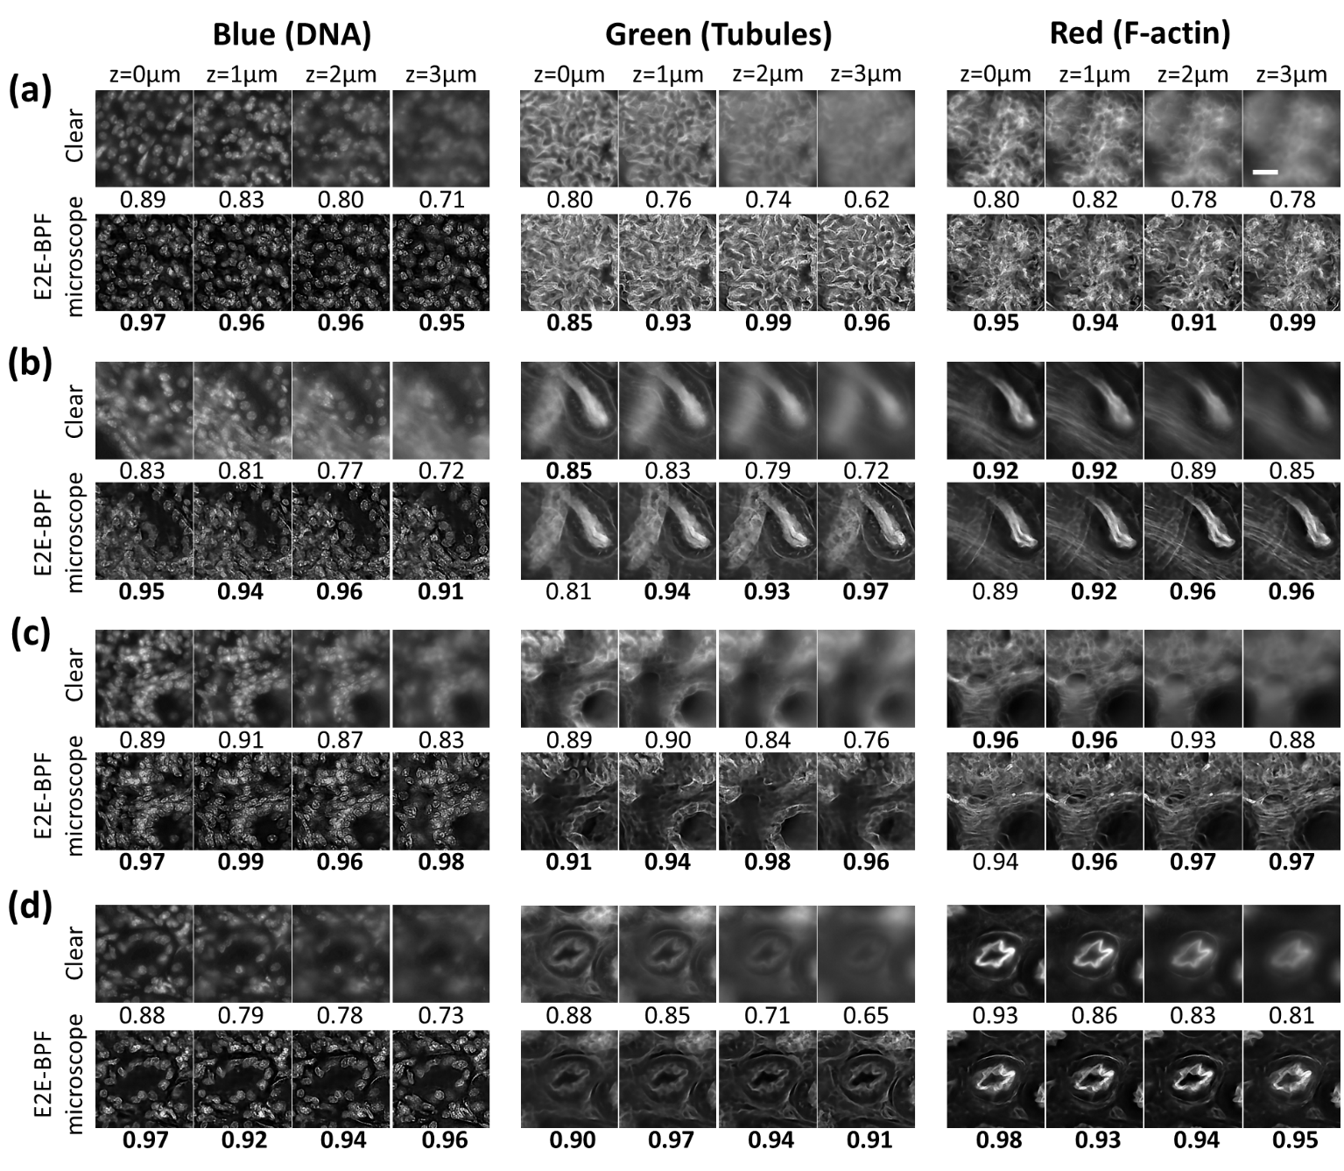
Supplementary Figure 3. Evaluated image contrasts at each fluorescence channel as a function of defocus distances. The images of Figure 6 in the main text were magnified and their contrast values were computed at various depth positions. Scalebar denotes 20 μm. The numeric values below the images represent the local image contrast. (a,c) Glomerular region, same as Figure 6 (c1) and (e1), respectively. (b,d) Tubule and duct region, same as Figure 6 (c2) and (e2), respectively.

Section 4 | E2E-BPF design and optical microscope setup
The E2E-BPF design and optical setup are provided in Supplementary Figure 4. The E2E-BPF consisted of 13 rings with alternating 0 and π phases in the aperture. In our prototype, the pupil diameter was 9 mm, and the phase transition radial coordinates are provided in Supplementary Figure 4. The E2E-BPF was fabricated through a photolithography and placed in the pupil plane of the optical system.

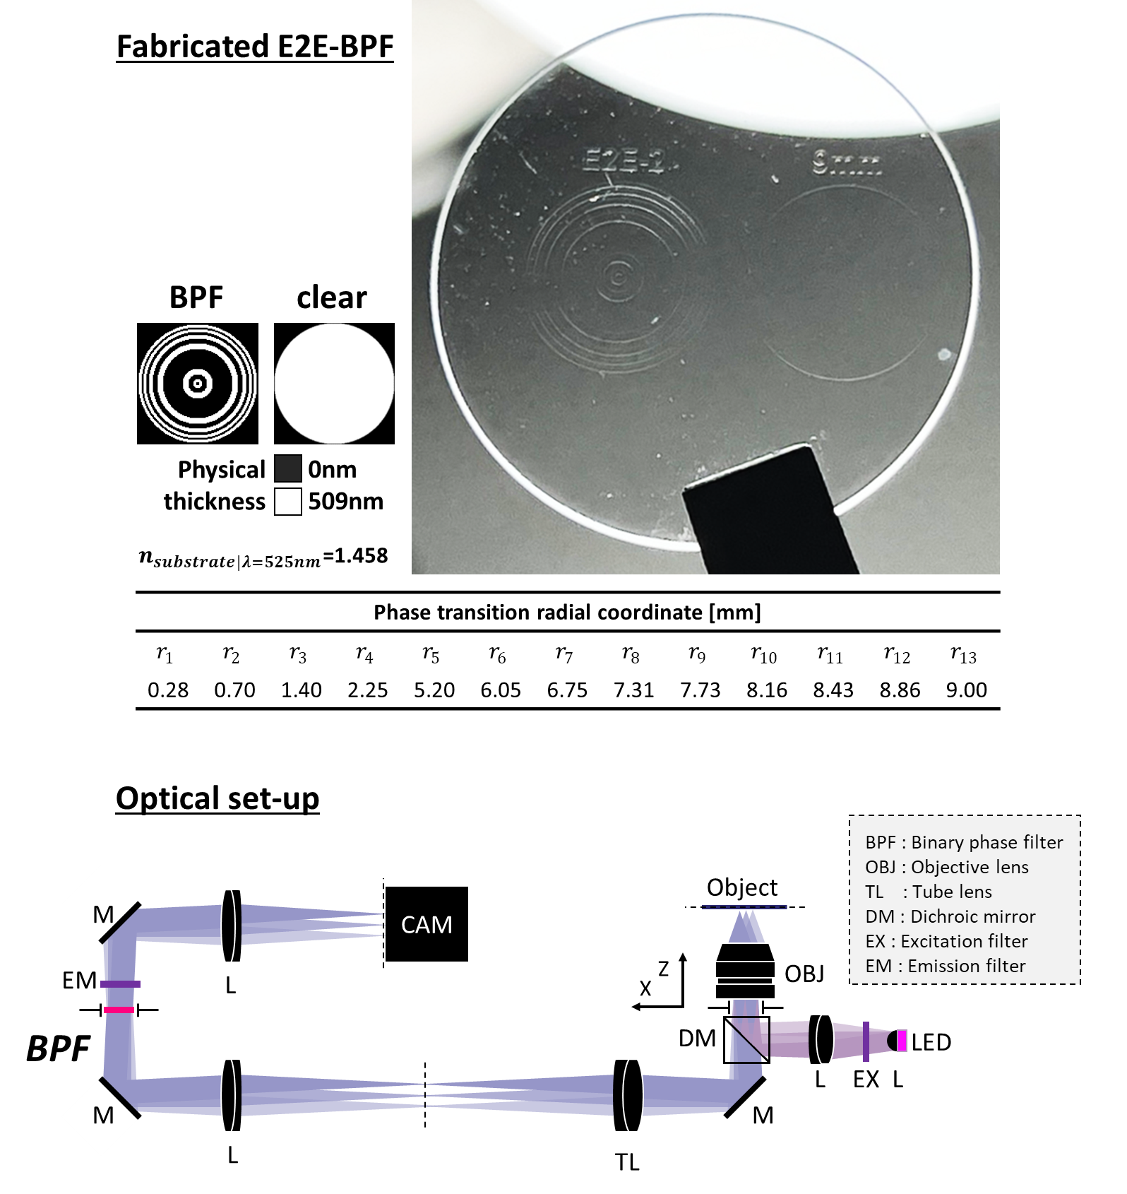
Supplementary Figure 4. Fabricated E2E-BPF filter and optical microscope set-up.

Section 5 | Learning-based implementation of E2E-BPF filter and reconstruction U-Net

Learning-based design of E2E-BPF microscope
The E2E-BPF design and reconstruction algorithms were implemented in Python using TensorFlow library. The first step in the algorithm is to discretize the pupil domain and set a desired DoF ( $ψ_{max}$), followed by the initialization of the penalty parameter $α$and the phase filter parameter $\overline{ϕ}$. For our prototype, the DoF of the conventional microscope was calculated as ~1.19 μm. We nominally set our desired DoF to be ~20 μm and divided the depth range into 41 segments. Within each depth segment, we assumed that PSF is identical over the 3D space. An axi-symmetric function, such as a phase axicon, was used to initialize the phase filter, which was then interpolated using the penalization function and applied to the forward imaging model to generate PSF and intermediate images. Then, the loss function was computed, and the values $\overline{ϕ}$and $W_{net}$ were then updated using the built-in optimizer (Adam optimizer²). This is followed by an update of the penalty parameter $α$. The algorithm was set to terminate if the phase values converge to the binary values (i.e., 0 or π) or maximum number of epochs was reached (100). Details of the optimization procedures are summarized in Supplementary Table 2.

Image reconstruction U-Nets
We employed the U-Net architecture for image deconvolution for its end-to-end property, which allows for efficient reconstruction with no additional calculations and no need of certain forward model. The network architecture and channel information are summarized and illustrated in Supplementary Table 3 and Figure 2.
To begin, the input image is padded (44, 44, 0) by the reflection method. In the encoder, batch-normalization and the ReLU function follow each of the two 2D convolution layers after max-pooling. In the decoder, a similar architecture of batch normalization and the ReLU function were performed in each convolutional layer. The skip connection was concatenated to each convolutional layer after every up-sampling step. The batch normalization and dropout with 30% rate were also deployed during U-net training. With five max-pooling steps, the convolutional layers of the encoder start from (3×3, 1) to (3×3, 32), at last to (3×3, 512). The decoder steps are similar to those of the encoder, except that the layers are reversed and concatenated to each layer. In the last stage, applying a 1×1 convolution with the tanh activation function yields an output by adding the input image. The padding operation in the input stage is removed at the end of the network.

Supplementary Table 2 | Joint optimization of E2E-BPF and image reconstruction U-Nets.
Algorithm $E2E-BPF$
1: | $$Procedure E2E-BPF(Unet,K,ψ_{max} )$$ | Reconstruction network, number of rings, desired DoF
2: | $epoch=0;α=0$; ${\overline{ϕ}}_{0}=AXICON(ψ)$ | Initialize BPF with a phase axicon
3: | $$repeat$$
4: | $I=Optics(P\left({\overline{ϕ}}_{0}\right),ψ, I_{True})$ | Obtain intermediate image via forward imaging model
5: | $\hat{I}=N(I)$ | Input the intermediate to the reconstruction U-Nets to obtain output image
6: | $L=RMSE\left(I_{True},\hat{I}\right)+α(∇P)$ | Evaluate loss function
7: | $Compute ∇L$ | Backward propagation
8: | $W_{net}= W_{net}+ΔW_{net}(∂L/∂W_{net})$ | Adam optimizer step
 | $\overline{ϕ}= \overline{ϕ}+Δ\overline{ϕ}(∂L/∂\overline{ϕ})$
9: | $α ←min⁡(α_{max},α+Δα)$ | Increment $α$
10: | $epoch←epoch+1$ | Continuation
11: | $until ∇P<ϵ_{g}^{*}$ | Check for convergence
12: | $$end procedure$$

- We set E2E-BPF optical parameters to be $NA$ = 0.75, pixel size = 6.5μm, $M$ = 33.3, $λ$ = 525nm, $n_{medium}$ = 1, and desired DoF as $ψ_{max}$ = 20μm.
- The number of rings $K$ was set to 64.
- The Adam optimizer was trained with a batch size of 41, learning rate of 0.001, and default exponential decay rate for both moment estimates (0.9 and 0.999, respectively)
- The $α$ parameter was updated as follows: $α_{0}$ = 0, $α_{max}$= 100 and $Δα$ = 0.05.
- The termination criteria were set as: $ϵ_{g}^{*}$ = 0.001; a maximum of 100 epochs was also imposed.

Supplementary Table 3 |Details of image reconstruction U-Nets
Name | Type | Output size [(batch), x, y, channel]
Input |  | 576 x 576 x 1
2x stack encoder | Conv 3x3  Batch Normalization  ReLU | 576 x 576 x 32
Maxpooling | Maxpool 2x2 | 288 x 288 x 32
2x stack encoder | Conv 3x3  Batch Normalization  ReLU | 288 x 288 x 64
Maxpooling | Maxpool 2x2 | 144 x 144 x 64
2x stack encoder | Conv 3x3  Batch Normalization  ReLU | 144 x 144 x 128
Maxpooling | Maxpool 2x2 | 72 x 72 x 128
2x stack encoder | Conv 3x3  Batch Normalization  ReLU | 72 x 72 x 256
Maxpooling | Maxpool 2x2 | 36 x 36 x 256
2x stack encoder | Conv 3x3  Batch Normalization  ReLU | 36 x 36 x 512
Dropout | Dropout | 36 x 36 x 512
Upsampling | Upconvolution 2x2  Concatenate | 72 x 72 x 768
2x stack decoder | Conv 3x3  Batch Normalization  ReLU | 72 x 72 x 256
Upsampling | Upconvolution 2x2  Concatenate | 144 x 144 x 384
2x stack decoder | Conv 3x3  Batch Normalization  ReLU | 144 x 144 x 128
Upsampling | Upconvolution 2x2  Concatenate | 288 x 288 x 192
2x stack decoder | Conv 3x3  Batch Normalization  ReLU | 288 x 288 x 64
Upsampling | Upconvolution 2x2  Concatenate | 576 x 576 x 96
2x stack decoder | Conv 3x3  Batch Normalization  ReLU | 576 x 576 x 32
Output | Conv 1x1  tanh | 576 x 576 x 1

Reference
1. Borkowski, A. A. et al. Lung and colon cancer histopathological image dataset (lc25000). arXiv preprint arXiv:1912.12142 (2019).
2. Kingma, D. P. & Ba, J. Adam: A method for stochastic optimization. arXiv preprint arXiv:1412.6980 (2014).

