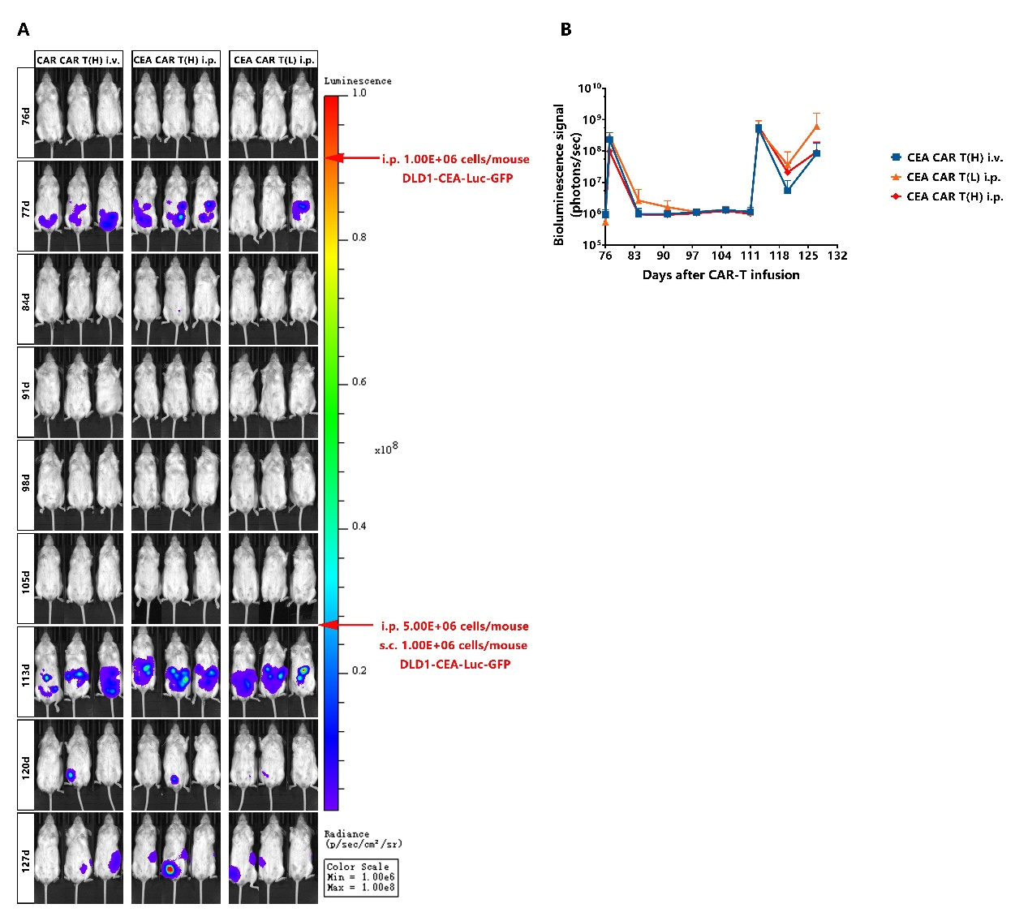Figure S1. CEA CAR-T cells show a durable anti-tumor effect after two tumor rechallenge experiments. (A-B)
Related to Figure 2, bioluminescent flux imaging (A) and quantification of flux (B) of mice with complete tumor regression rechallenged with additional tumor cells. Red arrows on the right indicate the time points and number of tumor cells used for rechallenge. In the first rechallenge experiment, 1 × 10⁶ DLD-1-CEA-Luc-GFP tumor cells were injected intraperitoneally, and imaging studies evidenced complete tumor regression one week later. Subsequently, a high number of tumor cells (5 × 10⁶ for i.p. and 1 × 10⁶ for s.c.) were infused either intraperitoneally or intravenously for higher challenge pressure.

Figure S2. PSCA CAR-T cells show antigen-dependent cytokine production and tumor killing in vitro.
(A) Diagram of the lentiviral expression cassette of PSCA CAR-T cells containing the anti-PSCA single-chain variable fragment (ScFv), the CD8 alpha hinge region, 4-1BB co-stimulatory domain, and the CD3zeta T cell activation domain. (B) GFP and PSCA expression of HPAC-Luc-GFP cells was detected by FACS. (C) PSCA CAR-T cells or activated untransduced T cells (Control T) were co-cultured with HPAC-Luc-GFP cells (PSCA-positive cells) or BxPC3- Luc-GFP cells (PSCA-negative cells) for 24h at effector:target (E:T) ratios of 1:2. (E) IFN-γ and IL-2 in supernatant quantified by ELISA from 24h co-culture of PSCA CAR-T cells or activated untransduced T cells (Control T) with HPAC-Luc-GFP cells or BxPC-3-Luc-GFP cells at an E:T ratio of 1:2.

