Appendix 1. Sensitivity Analyses: Comparison of different trajectory solutions

Table S1. Statistics of the different group-based trajectory models
Nº of trajectories | BIC | Trajectory # | n | A.P.P¹ | O.C.C.² | P.P.³
2-group | -616 803.70 | 1 | 15 122 | 0.93 | 36.06 | 27.32
2-group |  | 2 | 49 508 | 0.92 | 4.80 | 70.64
3-group | -517 051.08 | 1 | 7 803 | 0.94 | 106.86 | 13.66
3-group |  | 2 | 47 574 | 0.92 | 5.70 | 68.11
3-group |  | 3 | 9 253 | 0.94 | 81.11 | 16.19
4-group | -478 649.97 | 1 | 3 828 | 0.93 | 203.96 | 6.33
4-group |  | 2 | 13 269 | 0.90 | 26.94 | 24.95
4-group |  | 3 | 40 370 | 0.85 | 4.81 | 54.51
4-group |  | 4 | 7 163 | 0.94 | 112.96 | 12.18
5 group | -452 215.31 | 1 | 2 956 | 0.93 | 268.04 | 4.77
5 group |  | 2 | 8 463 | 0.91 | 50.92 | 16.01
5 group |  | 3 | 38 189 | 0.82 | 4.49 | 50.04
5 group |  | 4 | 11 220 | 0.89 | 29.23 | 21.08
5 group |  | 5 | 3 802 | 0.93 | 204.78 | 6.07
6 group | -433 309.22 | 1 | 2 245 | 0.93 | 385.73 | 3.55
6 group |  | 2 | 2 704 | 0.91 | 166.17 | 5.51
6 group |  | 3 | 9 419 | 0.88 | 34.85 | 16.89
6 group |  | 4 | 37 347 | 0.81 | 4.57 | 48.59
6 group |  | 5 | 9 498 | 0.89 | 37.57 | 18.01
6 group |  | 6 | 3 417 | 0.93 | 236.85 | 5.40
7-group | -418 983.91 | 1 | 2 145 | 0.93 | 373.91 | 3.36
7-group |  | 2 | 2 699 | 0.9 | 154.86 | 5.40
7-group |  | 3 | 6 995 | 0.88 | 52.41 | 12.53
7-group |  | 4 | 34 461 | 0.77 | 4.49 | 43.24
7-group |  | 5 | 12 192 | 0.84 | 18.59 | 22.50
7-group |  | 6 | 4 306 | 0.90 | 97.94 | 8.13
7-group |  | 7 | 1 832 | 0.93 | 495.35 | 2.80
¹Average Posterior Probabilities; ²Odds of Correct Classification; ³Posterior Probabilities

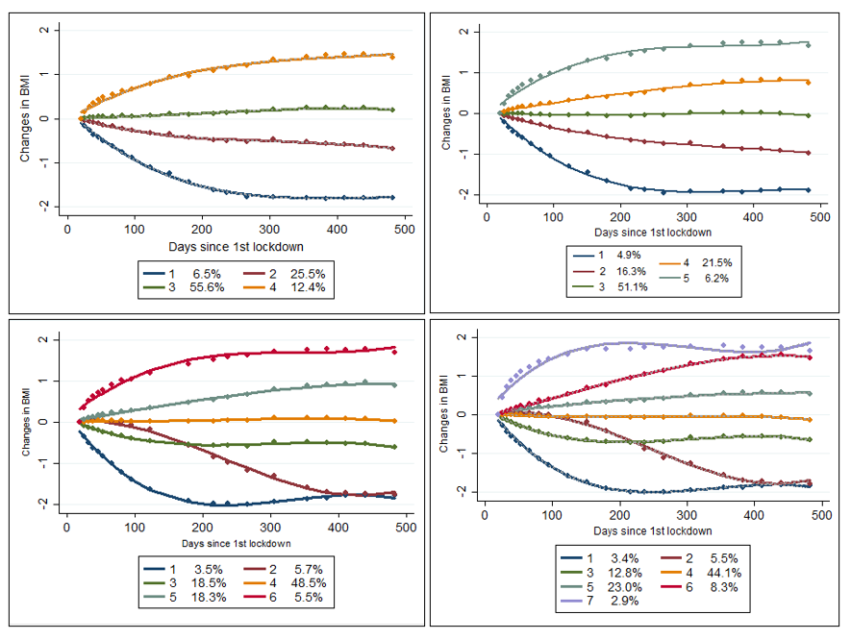Figure S1. Group-based trajectory Analyses. Comparison of 4- to 7-group solutions

Appendix 2. Sensitivity Analyses: Determinants of changes in BMI (margins based on multinomial regression models)

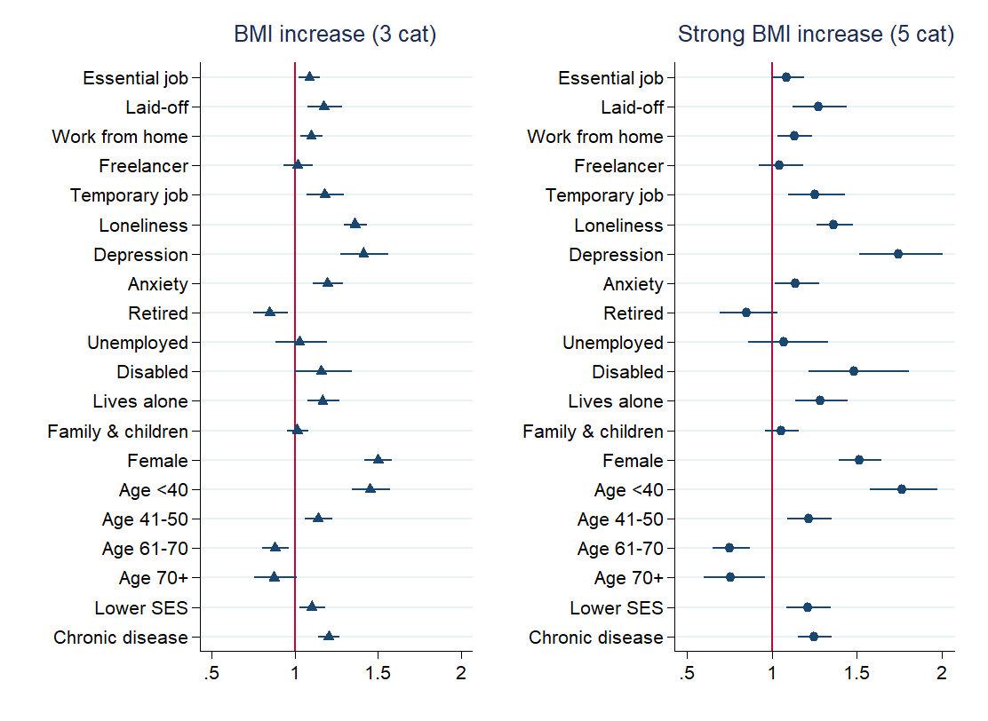
Figure S2. Determinants of (strong) BMI increase: comparison between the 3-group and 5-group solution (Odds Ratios)
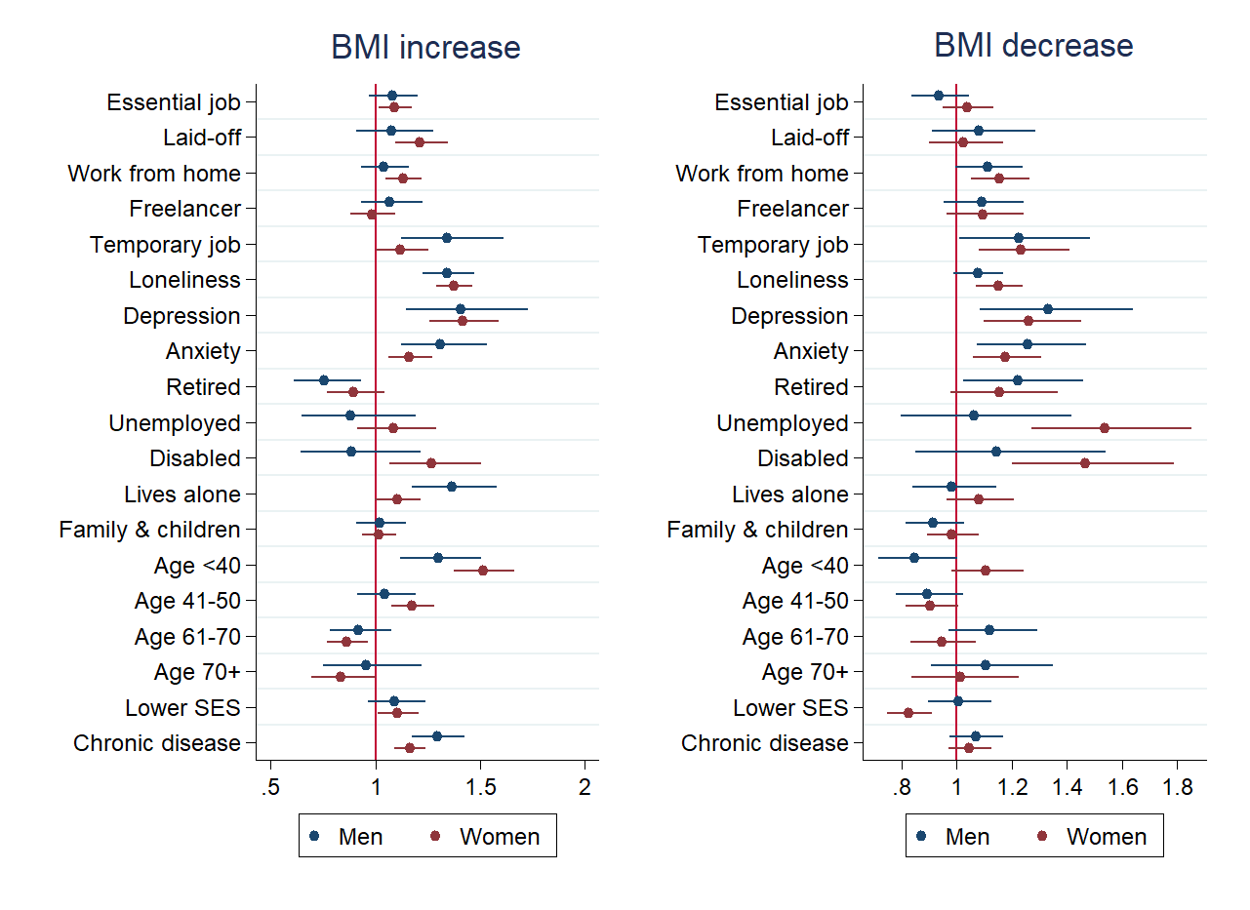
Figure S3. Determinants of experiencing BMI increase and decrease, stratified by Gender. Marginal effects based on multinomial regression models (Odds Ratios).

Table S2. Cumulative effects of work- and health-related eventsª
Ref. Group #2. Stable BMI | Group #1 BMI Increase |  |  | Group #3 BMI Decrease
 | OR | CI 95% |  | OR | CI 95%
Work-related events (0 events) | 1 |  |  | 1
1 event | 1.19** | 1.10 - 1.30 |  | 1.17** | 1.07 - 1.28
2 events | 1.26** | 1.15 - 1.38 |  | 1.24** | 1.13 - 1.37
3 events | 1.37** | 1.21 - 1.57 |  | 1.33** | 1.15 - 1.54
Health-related events (0 events) | 1 |  |  | 1
1 event | 1.39** | 1.32 - 1.47 |  | 1.17** | 1.10 - 1.24
2 events | 1.74** | 1.59 - 1.90 |  | 1.44** | 1.30 - 1.59
3 events | 2.19** | 1.96 - 2.46 |  | 1.60** | 1.41 - 1.83
ªModel accounts for the rest of covariates

Table S3. Cumulative effects all combined eventsª
Ref. Group #2. Stable BMI | Group #1 BMI Increase |  |  | Group #3 BMI Decrease
 | OR | CI 95% |  | OR | CI 95%
Combined events (0 events) | 1 |  |  | 1
1 event | 1.26** | 1.16 - 1.37 |  | 1.10* | 1.01 - 1.19
2 events | 1.61** | 1.46 - 1.76 |  | 1.30** | 1.18 - 1.42
3 events | 1.87** | 1.69 - 2.06 |  | 1.44** | 1.30 - 1.60
4 events | 2.22** | 1.96 - 2.52 |  | 1.74** | 1.52 - 1.99
5 events | 2.74** | 2.31 - 3.26 |  | 1.84** | 1.50 - 2.25
ªModel accounts for the rest of covariates

