Supporting Information

A graphitic nano-onion/molybdenum disulfide nanosheet composite as a platform for HPV-associated cancer-detecting DNA biosensors

Youngjun Kim, Eunah Kang
Department of Chemical Engineering and Materials Science
Chung-Ang University

Figure S1. X-ray diffraction (XRD) spectra of molybdenum disulfide (MoS₂) nanosheets and bulk MoS₂ powder.

Graphic abstract
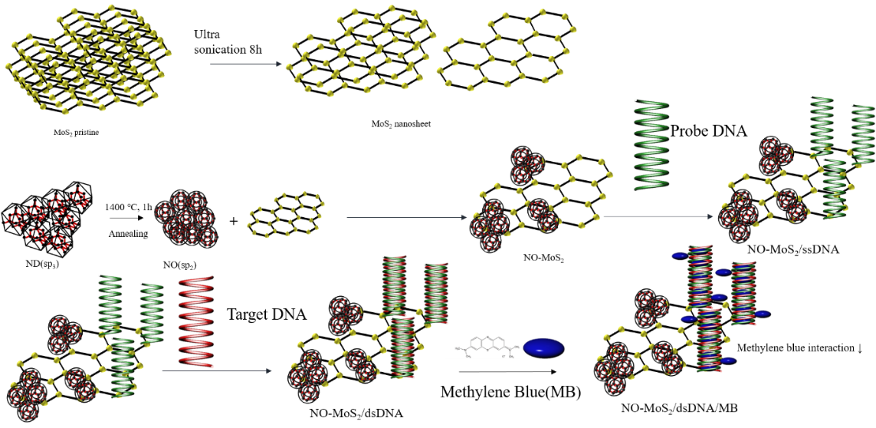
DNA-based electrochemical detection of HPV using the nano-onion/MoS₂ nanosheet composite platform. ND, nanodiamond; NO, nano-onion; ss, single-strand.

