Supplementary Table 1 - Number of participants and person days in each step and each cluster, per time window
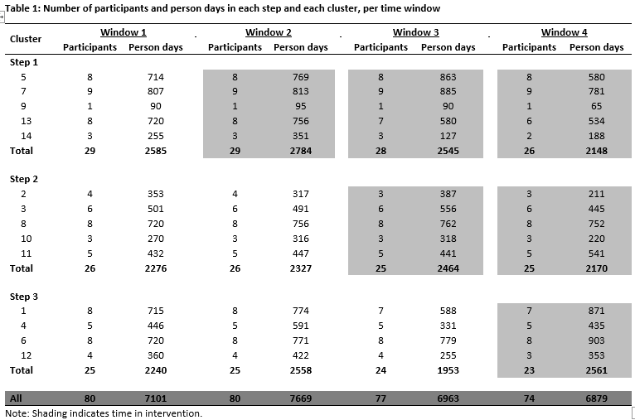
Supplementary Table 2 - Number of ED presentations and rate by step and cluster, per time window
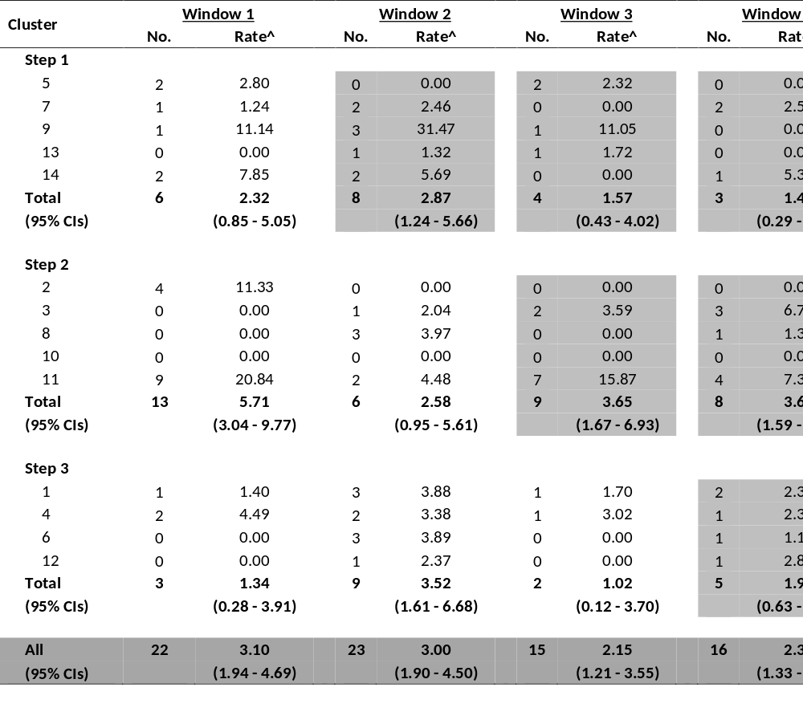
Supplementary Table 3 - Number of Hospital separations and rate by step and cluster, per time window
