Supporting Information:

Wolfgang et al., 2023: “Reciprocal influence of soil, phyllosphere and aphid microbiomes”

Authors: Adrian Wolfgang, Ayco J. M. Tack, Gabriele Berg, Ahmed Abdelfattah

The following document includes the following supporting information:
- Supplementary Figures
  - Fig. S1: Soil microbiome response upon aphid infestation
  - Fig. S2: Differences in microbial soil alpha diversity and abundance arising in corresponding inocula and soils (all soil treatments merged).
  - Fig. S3: Overview of microbial alpha diversity and abundance in inoculum and soil treatments
  - Fig. S4: Microbial community composition development in soils depending on aphid herbivory
- Supplementary Tables
  - Table S1: Source and proportion of soil mixes
  - Table S2: Pairwise PERMANOVA results for soil microbiome dependency of microbial phyllosphere community composition
  - Table S3: Pairwise PERMANOVA results for soil microbiome dependency of aphid microbiome community composition
  - Table S4: Differential abundance analysis results of soil-dependent biomarkers in aphid bacteria
  - Table S5: Differential abundance analysis results of soil-dependent biomarkers in aphid fungi
  - Table S6: Differential abundance analysis results of aphid herbivory-dependent fungal biomarkers in phyllosphere microbiome.
  - Table S7: Differential abundance analysis results for aphid herbivory-dependent bacterial biomarkers in sandy soil microbiome
- Supplementary Methods:
  - Methods S1: Modified protocol of the Standard DNeasy® Blood&Tissue procedure for insects
  - Methods S2: PCR mixes and PCR conditions for amplicon and RT-qPCR
- Supplementary Notes:
  - Notes S1: Detailed description of dominant and biomarker taxa in soil microbial communities
  - Notes S2: Detailed description of dominant and biomarker taxa in aphid microbial communities

Supplementary Figures:

Fig. S1: Soil microbiome response upon aphid infestation in bacterial (a-d) and fungal (e-h) species richness (a,e), Shannon diversity (b,f), abundance (c,g) and community composition (d,h), faceted according to soil type; orange: control group; brown: aphid-infested

Fig. S2: Differences in microbial soil alpha diversity and abundance arising in corresponding inocula and soils (all soil treatments merged). Effect of aphid herbivory on bacterial (a-d) and fungal (e-h) species richness (a,e), Shannon diversity (b,f), evenness (c,g), and abundance (d,h); darkgrey: control; lightgrey: soil from aphid-infested plants

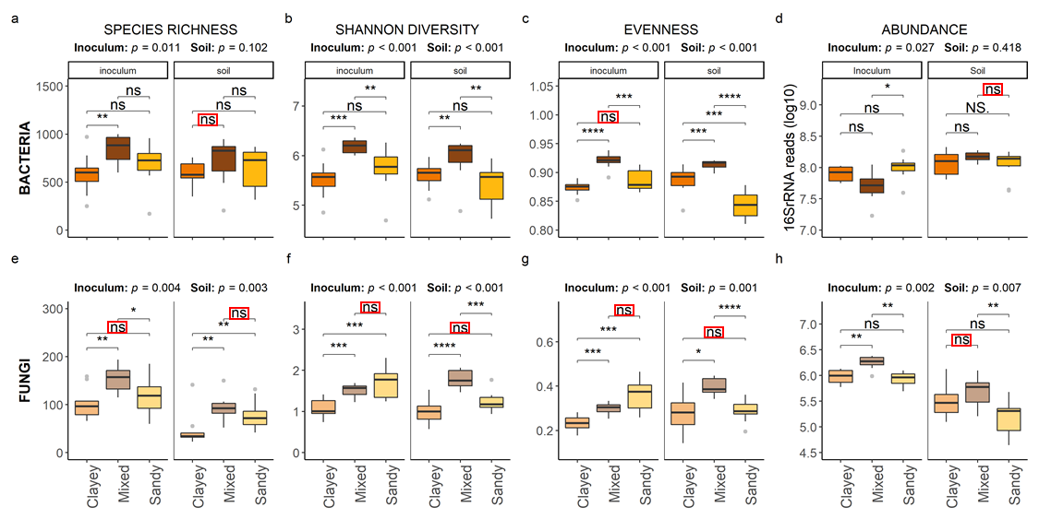
Fig. S3: Overview of microbial alpha diversity and abundance in inoculum and soil treatments. Bacterial (a-d) and fungal (e-h) species richness (a,e), Shannon diversity (b,f), evenness (c,g), and abundance (d,h) in inoculum and soil after the experiment for all soil types separately. Differences between corresponding inocula and soils arising in the course of the experiment highlighted with red rectangles. Orange: clayey soil inoculum; dark brown: mixed soil inoculum; yellow: sandy soil inoculum.

Fig. S4: Microbial community composition development in soils depending on aphid herbivory. PCoA ordination plots based on Bray-Curtis dissimilarity (BCD) index. Communities in soils with clayey (a), mixed (b) and sandy (c) soil inoculum displayed separately. PERMANOVA analyses for the factor ‘aphid infestation’ performed separately for inoculum (circles) and soil communities (triangles), results are displayed on top of the graph. Inoculum and soil cluster separately in all soils alongside axis 1. Coincidental initial differences in clayey inoculum community composition (a) are not observable in soil communities at the end of the experiment. Only sandy soil communities (c) significantly differ between infested (brown) and control plants (ochre) alongside axis 2; coincidental initial differences in sandy inoculum were not observed.

Supplementary Tables:

Table S1: Source and proportion of soil mixes
Soil type | Coordinates | Source | Treatment "Clayey" | Treatment "Mixed" | Treatment "Sandy"
Clayey Soil | 58°56'45.1"N, 17°09'03.3"E | Tovetorp | 1.25 l, inoculum | 1.25 l, sterilized | 1.25 l, sterilized
Mixed Soil | 59°21'54.0"N, 18°03'37.2"E | SU Campus | 1.25 l, sterilized | 1.25 l, inoculum | 1.25 l, sterilized
Sandy Soil | 58°56'51.4"N, 17°08'48.4"E | Tovetorp | 1.25 l, sterilized | 1.25 l, sterilized | 1.25 l, inoculum
Potting Soil | Commercial | Commercial | 7.5 l, sterilized | 7.5 l, sterilized | 7.5 l, sterilized
 |  |  | 11.25 l final soil mix | 11.25 l final soil mix | 11.25 l final soil mix

Table S2: Pairwise PERMANOVA results for soil microbiome dependency of microbial phyllosphere community composition based on Bray Curtis distances. All phyllosphere communities differ significantly according to soil microbiome.
 | pairs |  |  | Df | SumsOfSqs | R2 | F | Pr(>F) | sig
BACTERIA | Mixed | vs | Clayey | 1 | 1.1819 | 0.25158 | 9.4122 | 0.001 | ***
BACTERIA | Mixed | vs | Sandy | 1 | 0.5795 | 0.1188 | 4.5837 | 0.001 | ***
BACTERIA | Clayey | vs | Sandy | 1 | 2.5665 | 0.30324 | 20.891 | 0.001 | ***
FUNGI | Mixed | vs | Clayey | 1 | 1.1853 | 0.06715 | 5.8304 | 0.001 | ***
FUNGI | Mixed | vs | Sandy | 1 | 1.355 | 0.08243 | 7.0973 | 0.001 | ***
FUNGI | Clayey | vs | Sandy | 1 | 0.5135 | 0.04237 | 3.5393 | 0.002 | **

Table S3: Pairwise adonis results for soil community-dependent aphid microbial community composition based on Bray Curtis distances. All aphid microbiomes differ significantly according to soil microbiome, except for Bacteria in aphids reared on clayey or sandy soil microbiome.
 | pairs |  |  | Df | SumsOfSqs | R2 | F | Pr(>F) | sig
BACTERIA | Mixed | vs | Clayey | 1 | 0.6002 | 0.02355 | 1.5439 | 0.001 | ***
BACTERIA | Mixed | vs | Sandy | 1 | 0.6447 | 0.0256 | 1.6551 | 0.001 | ***
BACTERIA | Clayey | vs | Sandy | 1 | 0.4332 | 0.01775 | 1.1022 | 0.178
FUNGI | Mixed | vs | Clayey | 1 | 0.5913 | 0.04201 | 2.4555 | 0.001 | ***
FUNGI | Mixed | vs | Sandy | 1 | 1.2264 | 0.07953 | 5.3566 | 0.001 | ***
FUNGI | Clayey | vs | Sandy | 1 | 0.9592 | 0.06805 | 3.9433 | 0.001 | ***

Table S4: Differential abundance analysis results of biomarker taxa for soil microbiome in aphid bacteria. Top five taxa with the highest LDA score in the corresponding taxonomic rank. Total: Total numbers of taxa with positive abundance response in respective soil group. P-values uncorrected, except for Micromonosporaceae (highlighted in bold).
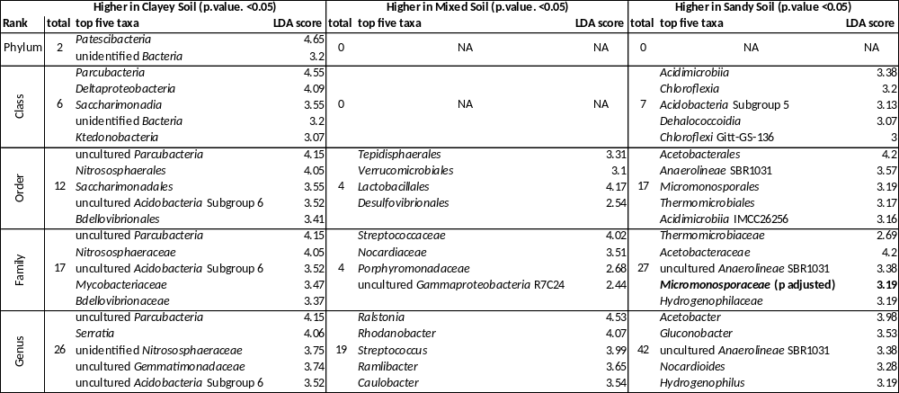

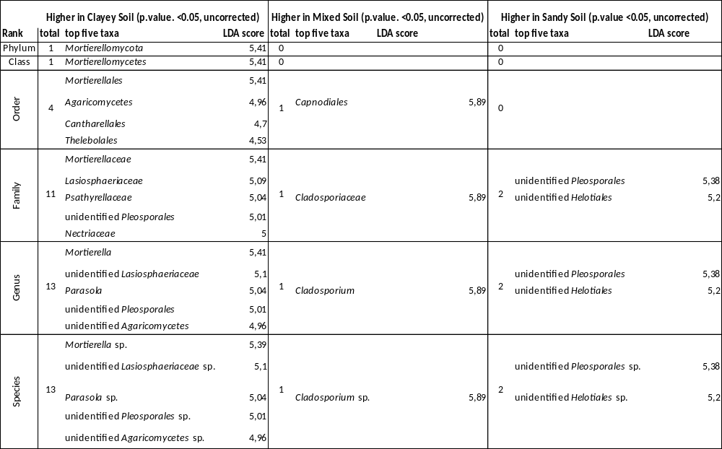
Table S5: Differential abundance analysis results of biomarker taxa for soil microbiome in aphid fungi. Top five taxa with the highest LDA score in the corresponding taxonomic rank. Total: Total numbers of taxa with positive abundance response in respective soil group). P-values uncorrected
Table S6: Differential abundance analysis results of fungal biomarker taxa for aphid infestation in phyllosphere. Top five taxa with the highest LDA score in the corresponding taxonomic rank. Total: Total numbers of taxa with positive abundance response in respective group). P-values corrected, taxa with uncorrected p-value removed.
 | Higher in uninfested Leaves (p.adj. <0.05) |  |  | Higher in infested Leaves (p.adj. <0.05)
Rank | total | top five taxa | LDA score | total | top five taxa | LDA score
Phylum | 3 | Basidiomycota | 5.56 | 1
Phylum | 3 | Chytridiomycota | 3.14 | 1 | Ascomycota | 5.73
Phylum | 3 | unidentified Fungi | 2.51 | 1
Class | 11 | Agaricomycetes | 5.52 | 0
Class | 11 | Leotiomycetes | 5.5 | 0
Class | 11 | Sordariomycetes | 5.5 | 0
Class | 11 | unidentified Ascomycota | 4.96 | 0
Class | 11 | Pezizomycetes | 3.73 | 0
Order | 29 | Helotiales | 5.37 | 0
Order | 29 | Sordariales | 5.36 | 0
Order | 29 | unidentified Ascomycota | 4.96 | 0
Order | 29 | Pleosporales | 4.94 | 0
Order | 29 | Russulales | 4.68 | 0
Family | 51 | unidentified Helotiales | 5.33 | 0
Family | 51 | Lasiosphaeriaceae | 5.21 | 0
Family | 51 | unidentified Ascomycota | 4.96 | 0
Family | 51 | Russulaceae | 4.68 | 0
Family | 51 | Sporormiaceae | 4.62 | 0
Genus | 72 | unidentified Helotiales | 5.33 | 0
Genus | 72 | unidentified Lasiosphaeriaceae | 5.19 | 0
Genus | 72 | unidentified Ascomycota | 4.96 | 0
Genus | 72 | Russula | 4.68 | 0
Genus | 72 | Preussia | 4.56 | 0
Species | 76 | unidentified Helotiales sp. | 5.33 | 0
Species | 76 | unidentified Lasiosphaeriaceae sp. | 5.19 | 0
Species | 76 | unidentified Ascomycota | 4.96 | 0
Species | 76 | Russula sp. | 4.68 | 0
Species | 76 | Preussia sp. | 4.56 | 0

Table S7: Differential abundance analysis results of bacterial biomarker taxa for aphid infestation in sandy soil microbiome. Top five taxa with the highest LDA score in the corresponding taxonomic rank. Total: Total numbers of taxa with positive abundance response in respective group). P-values uncorrected
 | Higher in Sandy control Soil (p.value. <0.05, uncorrected) |  |  | Higher in sandy infested Soil (p.value. <0.05, uncorrected)
Rank | total | top five taxa | LDA score | total | top five taxa | LDA score
Phylum | 0 |  |  | 2 | BRC1 | 2.9
Phylum | 0 |  |  | 2 | WPS-2 | 2.18
Class | 0 |  |  | 6 | uncultured FBP | 3.18
Class | 0 |  |  | 6 | Chloroflexi JG30-KF-CM66 | 2.97
Class | 0 |  |  | 6 | Methanomicrobia | 2.83
Class | 0 |  |  | 6 | Acidobacteria Subgroup 17 | 2.74
Class | 0 |  |  | 6 | Negativicutes | 2.55
Order | 3 |  |  | 12 | Reyranellales | 4.09
Order | 3 | Xanthomonadales | 5.51 | 12 | Isosphaerales | 3.45
Order | 3 | Opitutales | 4.14 | 12 | uncultured FBP | 3.18
Order | 3 | Propionibacteriales | 3.59 | 12 | Azospirillales | 3.02
Order | 3 |  |  | 12 | Methanosarcinales | 2.83
Family | 7 | Rhodanobacteraceae | 5.43 | 29 | Xanthobacteraceae | 4.76
Family | 7 | Opitutaceae | 4.14 | 29 | Rhizobiaceae | 4.69
Family | 7 | Bacillaceae | 3.86 | 29 | Beijerinckiaceae | 4.29
Family | 7 | Sandaracinaceae | 3.66 | 29 | Reyranellaceae | 4.09
Family | 7 | Nocardioidaceae | 3.59 | 29 | Solirubrobacterales 67-14 | 3.58
Genus | 13 | Rhodanobacter | 5.44 | 52 | Allorhizobium-Neorhizobium-Pararhizobium-Rhizobium | 4.52
Genus | 13 | uncultured Sphingomonadaceae | 4.24 | 52 | unidentified Xanthobacteraceae | 4.31
Genus | 13 | Ramlibacter | 4.24 | 52 | Duganella | 4.21
Genus | 13 | Lacunisphaera | 4 | 52 | uncultured Xanthobacteraceae | 4.15
Genus | 13 | Luteimonas | 3.95 | 52 | Mesorhizobium | 4.12

Supplementary Methods:

Methods S1: Modified protocol of the Standard DNeasy® Blood&Tissue procedure for insects. Original protocol available at: https://www.qiagen.com/us/resources/resourcedetail?id=cabd47a4-cb5a-4327-b10d-d90b8542421e&lang=en

- Cell disruption: 180µl of buffer ATL were added in a sterile ribolyzer tube with 2 big (2-3mm) and 1 small (1mm) glass beads. Aphid(s) were added to the tube and ribolyzed two times with 5.5m/s for 30 seconds using Ribolyser FastPrep-24 (MP Biomedicals, Santa Ana, California, USA). The tubes were then centrifuged at 17,250 x g (full speed) for five minute and 6°C to concentrate the foam back to a liquid state.
- Protein lysis: The 180µl of liquid was vortexed, transferred to a new tube and 20 µl of proteinase K was added. Tubes were vortexed and incubated for 1h at 56 °C and 300 rpm.
- Denaturing enzymes: Tubes were vortexed for 15s, 200 µl of buffer AL and 200µl pure ethanol (97-100%) was added until no white flakes were visible.
- Washing DNA: Liquid was transfered to a QIAamp Mini Spin Column and centrifuged at 10,250 x g for 1 min. Flow-through was discarded.
- Column was placed in a new 2 ml collection tube, 500 µl Buffer AW1 was added and centrifuged at 10,250 x g for 1 min. Flow-through was discarded.
- Column was placed in a new 2 ml collection tube, 500 µl Buffer AW2 was added and centrifuged at 17,250 x g (full speed) for 5 min. Flow-through was discarded.
- Elution: Column was placed in a new 1.5 ml Eppendorf tube, membrane was incubated with 40µl buffer AE for 1 min at room temperature. Tube was centrifuged at 10,250 x g and stored at -20°C until further processing.

Methods S2: PCR mixes and PCR conditions for amplicon and RT-qPCR
Bacteria in soils and leaves

Amplicon PCR mix bacteria in soil and leaves
30µl reaction, per sample:
- 19.15 µl PCR-grade water
- 6 µl 5 x Taq&Go Mastermix (MP Biomedicals, Illkirch, France)
- 1.2 µl of each primer [5µM]
- 0.45 µl PNA mix [1:1 pPNA and mPNA, 50µM], preheated (5min at 55°C)
- 2 µl template

Amplicon PCR thermal cycling conditions
- 96°C for 5 min
- 30 cycles of
  - 96°C for 1 min
  - 78°C fo 5s
  - 54°C for 1 min
  - 74°C for 1 min
- 74°C for 10 min

RT-qPCR mix for bacteria in soil and leaf samples
10µl reaction, per sample:
- 2.7 µl PCR grade water
- 5 µl KAPA SYBR Green 2X MM (KAPA Biosystems, Cape Town, South Africa)
- 0.3 µl PNA mix [1:1 pPNA and mPNA, 50µM], preheated (5min at 55°C)
- 0.5µl of each primer 515f/806r [10µM]
- 1µl template, diluted 1:10

RT-qPCR thermal cycling conditions
- 95 °C for 5 min
- 40 cycles of
o 95 °C for 20 s
o 78 °C for 5s
o 54 °C for 15 s
o 72 °C for 30 s
- Final melt curve: 72°C-95°C

Bacteria in aphids
Amplicon PCR Mix for bacteria in aphid samples
30µl reaction, per sample:
- 16µl PCR-grade water
- 6µl 5x Phusion HF buffer (New England Biolabs, Frankfurt, Germany)
- 0.3 µl dNTPs [10mM]
- 1.2µl of each primer [5µM]
- 0.3µl Phusion polymerase (New England Biolabs, Frankfurt, Germany; 2 U/µL)
- 5µl template

Amplicon PCR thermal cycling conditions
- 98°C for 3 min
- 35 cycles of
o 98°C for 10s
o 54°C for 20s
o 72°C for 10s
- 72°C for 10 min

RT-qPCR mix for bacteria in aphid samples
10µl reaction, per sample:
- 3 µl PCR grade water
- 5 µl KAPA SYBR Green 2X MM (KAPA Biosystems, Cape Town, South Africa)
- 0.5µl of each primer 515f/806r [10µM]
- 1µl template

RT-qPCR thermal cycling conditions
- 95 °C for 5 min
- 40 cycles of
o 95 °C for 20 s
o 54 °C for 15 s
o 72 °C for 30 s
- Final melt curve: 72°C-95°C

Fungi in soils and leaves
Amplicon PCR Mix for fungi in soil and leaf samples
30µl reaction, per sample:
- 19.6 µl PCR-grade water
- 6 µl 5 x Taq&Go Mastermix (MP Biomedicals, Illkirch, France)
- 1.8µl MgCl2 [50mM]
- 1.2µl of each primer [5µM]
- 2µl template

Amplicon PCR thermal cycling conditions
- 96°C for 5 min
- 30 cycles of
o 96°C for 1 min
o 58°C for 1 min
o 74°C for 1 min
- 74°C for 10 min

RT-qPCR mix for fungi in soil and leaf samples
10µl reaction, per sample:
- 3 µl PCR grade water
- 5 µl KAPA SYBR Green 2X MM (KAPA Biosystems, Cape Town, South Africa)
- 0.5µl of each primer ITS1f/ITS2r [10µM]
- 1µl template

RT-qPCR thermal cycling conditions
- 95 °C for 3 min
- 40 cycles of
o 95 °C for 5 s
o 58 °C for 35 s
o 72 °C for 5 s
- 72°C for 10 min
- Final melt curve: 72°C-96°C

Fungi in aphids
Amplicon PCR Mix
30µl reaction, per sample:
- 14.2µl PCR-grade water
- 6µl 5x Phusion HF buffer (New England Biolabs, Frankfurt, Germany)
- 0.3µl dNTPs [10mM]
- 1.2µl of each primer [5µM]
- 1.8µl MgCl2 [50mM]
- 0.3µl Phusion polymerase (New England Biolabs, Frankfurt, Germany; 2 U/µL)
- 5µl template

Amplicon PCR thermal cycling conditions
- 98°C for 3 min
- 35 cycles of
o 98°C for 10s
o 58°C for 20s
o 72°C for 10s
- 72°C for 10 min

RT-qPCR mix for aphid samples
- 10µl reaction, per sample:
- 3 µl PCR grade water
- 5 µl KAPA SYBR Green 2X MM (KAPA Biosystems, Cape Town, South Africa)
- 0.5µl of each primer ITS1f/ITS2r [10µM]
- 1µl template

RT-qPCR thermal cycling conditions
- 95°C for 3 min
o 40 cycles of
o 98°C for 5s
o 58°C for 35s
o 72°C for 5s
- 72°C for 10 min
- Final melt curve: 72°C-96°C

Supplementar Notes:

Notes S1: Detailed description of soil community composition
Archaeal reads in inoculum soil before the experiment ranged from 0.15 – 1.6% rˤ (relative abundance). Bacterial community was dominated by Proteobacteria (32-46 % rˤ, Phenylobacterium, Sphingomonas and Ramlibacter highly abundant), Firmicutes (9-31% rˤ, Brevibacillus, Tumebacillus and Paenibacillus highly abundant), Actinobacteria (6-14% rˤ, Conexibacter highly abundant), Bacteroidetes (4-11% rˤ, Pedobacter abundant), and Verrucomicrobia (3-10% rˤ, Chthoniobacter high abundant). Fungal primers did also amplify reads of Rhizaria (unidentified Cercozoa, 0-6.6%, rˤ) which were kept in the dataset. Fungal community in both soil groups was dominated by the ectomycorrhizal genus Lyophyllum (ad Basidiomycota, 43-96% rˤ) and Mortierella (ad Mortierellamycota, 0-19 % rˤ).
Mixed soil displayed the highest richness, Shannon diversity and evenness in both bacterial and fungal communities across the three soil types. Abundance (log10-transformed qPCR reads) did not differ significantly between soils in bacteria, but in fungi abundance was higher in mixed soil. Differential abundance analyses identified 207, 333, and 198 bacterial biomarkers of all taxonomic ranks and 46, 227, and 93 fungal biomarkers for clayey, mixed and sandy soil (without inoculum), respectively. Clayey soil showed significantly higher relative abundance of Gemmatimonadetes; mixed soil had significantly higher relative abundance in Archaea, Acidobacteria and Actinobacteria; sandy soil had significantly higher relative abundance in Alpha- and Gammaproteobacteria. In general, we observe a treatment-dependent community in the three soil types.
Relative abundance of Proteobacteria (32-46 vs. 45-76% rˤ) and Bacteroidetes (4-11 vs. 9-21% rˤ) generally increased in soil, while Firmicutes (9-31 vs. 1-14% rˤ), Actinobacteria (6-14 vs. 1-10% rˤ), and Verrucomicrobia (3-10 vs. 2-8% rˤ) decreased in the course of the experiment. In fungi, especially the genus Rasamsonia (R. aegroticola and R. pulvericola, ad Ascomycota) was only highly (>4% rˤ) abundant in inoculum soil. Differential abundance analysis identified 434 bacterial (176 higher in soil, 258 higher in inoculum) and 131 (123 higher in inoculum, 8 higher in soil) fungal biomarkers significantly differing between the two time points. When comparing tested alpha diversity metrics across all soils, bacterial abundance significantly increases, while fungal community display a significant decrease in richness and abundance, and evenness increases. All soil types at both time points (before/after the experiment) differed significantly according to pairwise PERMANOVA results. Both soil type and time point significantly explain about 55-60% of the variation within both bacterial and fungal Bray Curtis soil dissimilarity matrices. In general, we observed a soil type-dependent community development in the course of the experiment, with mainly an increase in bacterial abundance and fungal evenness, and a decrease in fungal abundance being consistent across all soil types.

Notes S2: Description of aphid community composition
Bacterial aphid-associated communities were dominated by Buchnera (1.5- 99% rˤ). Apart from the primary endosymbiont Buchnera, Burkholderia s. lat. (0-74% rˤ; nine samples > 10%), and Pseudomonas (<0.1-98% rˤ, three samples > 10%) accounted partially for very high abundances. Interestingly, archaeal reads assigned to the family Halomicrobiaceae were found in all except five aphid samples. Fungal aphid-associated communities were dominated mainly by opportunistic air-borne taxa, that were partially high abundant in few samples and as well found in control samples (Penicillium (<0.1-100% rˤ), Cladosporium (1-96%), Talaromyces (0-63% rˤ), Mortierella (0-23% rˤ), and Alternaria (0-12% rˤ). Interestingly, animal- (e.g., Simplicilium (0-80% rˤ)) and plant-pathogenic fungi (e.g., Erysiphe (0-69% rˤ)) were also frequently found in relatively high abundances.

