Yasser Mahrous graduated from the Department of Electronics and Electrical Communications Engineering, Faculty of Electronic Engineering (FEE), Menoufia University, Menouf, Egypt in 2012. He had his M.Sc. degree from the same department in 2022. His research interests include medical image processing, and watermarking.

Waleed Al‑Hanafy received the B.Sc. (Honors) and M.Sc. degrees from the Faculty of Electronic Engineering, Menoufia University, Menouf, Egypt, in 1996 and 2002, respectively, and the Ph.D. from Strathclyde University, Glasgow, UK, in 2010. He joined the teaching staff of the Department of Electronics and Electrical Communications, Faculty of Electronic Engineering, Menoufia University, Menouf, Egypt, in 2010. His research areas of interest include the signal processing for communications in particular precoding and equalization methods of MIMO systems, adaptive power/bit loading approaches, Multi-User MIMO, OFDM systems, and resource allocation of wireless communication systems.

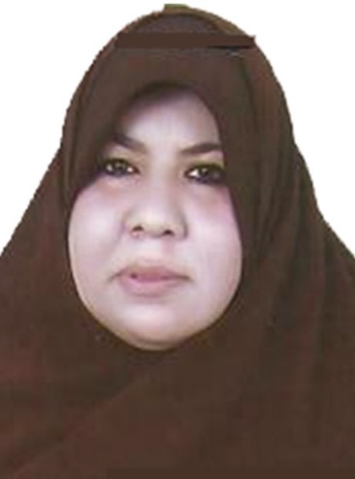

Huda I. Ashiba received the B.Sc., M.Sc., from the Faculty of Electronic Engineering, Menoufia University,
Menouf, Egypt. She receives the Ph.D. from the Faculty of Engineering in Shoubra, Benha University, 2017. She joined the teaching staff of the Department of Electronics and Electrical Communications Engineering, Bilbis Higher Institute of Engineering Bilbis, Sharqia, Egypt. Her current research area of interest include infrared images processing, image processing, image interpolation, super-resolution reconstruction of images, multimedia communications, digital wireless communications, big data and cancelable biometrics.

Adel A. Saleeb received the B.Sc. degree in Electrical Engineering from the Communications Department, Faculty of Engineering, Assiut University, Egypt, in 1971, the M.Sc. degree from Helwan University , Egypt, in 1977, and the Ph.D. degree from Queen Mary
College , University of London, in 1982 . He works as a Professor Emeritus, Faculty of Electronic Engineering, Menoufia University, Egypt. From 1997 to 2003, he worked as the Head of Electrical and Electronic Engineering Department, Altahady University, Sirte, Libya. He is a member of Egyptian Engineering Syndicate since Oct 1971, and a member of the IET (UK) since 1983. He is a chartered Engineer,
registered with the Engineering Council (UK) since 28 Jul 1993 with Registration No.450950. He worked as a visiting professor for three months (Aug – Nov 2007) with Nottingham University, Britain in the application of transmission line modelling method to antenna problems. His current research interests include electromagnetic band gap structures and their applications, reflectarrays, and signal processing for communications.

Ghada M. El‑Banby received the M.Sc. and Ph.D. degrees in Automatic Control Engineering from Menoufia University, Egypt in 2006, and 2012, respectively. She works as an Associate Professor at the Department of Industrial Electronics and Control Engineering, Faculty of Electronic Engineering, Menoufia University. Her current research interests include computer vision, data fusion, systems, image processing,
signal processing, medical imaging, modeling, and control.

Eman A. Sultan received the B.Sc., M.Sc. and Ph.D. degrees from Menoufia University, Menouf, Egypt, in 1999, 2007, and 2014, respectively. She is Teaching Staff Member with the Department of Electronics and Electrical Communications Engineering, Faculty of Electrical Engineering, Menoufia University. Her current research interests include image enhancement, medical image interpolation, super-resolution
reconstruction of images, and image dehazing using deep
learning.

Adel S. El‑Fishawy received the B.Sc. in electronics and communications engineering, Menoufia University, in 1974 and the M.Sc degree from Cairo University, Egypt, in 1982. He received the Ph.D degree in signals and systems from Drexel University, ECE Dept., Phila., PA, USA, 1990. He is working as a Professor Emeritus with the Department of Electronics and Electrical Communications Engineering, Faculty of Electronic Engineering, Menoufia University, Egypt. His areas of interest are electronics, modeling and simulations, digital communications, signal, speech, biomedical image processing, and digital communications.



Fathi E. Abd El-Samie received the B.Sc. (Honors), M.Sc., and Ph.D. degrees from Menouﬁa University, Menouf, Egypt, in 1998, 2001, and 2005, respectively. Since 2005, he has been a Teaching Staff Member with the Department of Electronics and Electrical Communications, Faculty of Electronic Engineering, Menouﬁa University. He worked as a researcher at KACST-TIC in Radio Frequency and Photonics for the e-Society (RFTONICs) from 2013 to 2015. He is a coauthor of several papers in international conference proceedings and journals, and several textbooks. His current research interests include image enhancement, image restoration, image interpolation, super-resolution reconstruction of images, data hiding, multimedia communications, medical image processing, optical signal processing, and digital communications. Dr. Abd El-Samie was a recipient of the Most Cited Paper Award from the Digital Signal Processing journal in 2008.

