The semisynthetic cannabinoid Hexahydrocannabinol (HHC)
Fabiana Russo^{a,b}, Maria Angela Vandelli^{c}, Giuseppe Biagini^{b}, Martin Schmid^{d}, Livio Luongo^{e}, Michela Perrone^{e}, Federica Ricciardi^{e}, Sabatino Maione^{e}, Aldo Laganà^{f,g}, Anna Laura Capriotti^{f}, Alfonso Gallo^{g}, Luigi Carbone^{h}, Elisabetta Perrone^{h}, Giuseppe Gigli^{h}, Giuseppe Cannazza^{c,h,*}, Cinzia Citti^{h,c,*}
ª Clinical and Experimental Medicine PhD Program, University of Modena and Reggio Emilia, 41125 – Modena, Italy
^{b} Department of Biomedical, Metabolic and Neural Sciences, University of Modena and Reggio Emilia, 41125 – Modena, Italy
^{c} Department of Life Sciences, University of Modena and Reggio Emilia, Via Campi 103, 41125 – Modena, Italy
^{d} Institute of Pharmaceutical Sciences, Department of Pharmaceutical Chemistry, University of Graz, Schubertstraße 1, Graz, A-8010, Austria
^{e} Department of Experimental Medicine, Division of Pharmacology, Università della Campania “L. Vanvitelli”, Via Santa Maria di Costantinopoli 16, 80138, Naples, Italy.
^{f} Department of Chemistry, Sapienza University of Rome, Piazzale Aldo Moro 5, 00185 – Rome, Italy
^{g} Department of Chemistry, Istituto Zooprofilattico Sperimentale del Mezzogiorno, Via Salute 2, 80055 Portici, Italy
^{h} Institute of Nanotechnology – CNR NANOTEC, Campus Ecotekne, Via Monteroni, 73100 – Lecce, Italy

Table of Content
Table S1. ¹H NMR assignments (δ) of (9S)-HHC and (9R)-HHC | … SI-2
Figure S1. ¹H NMR spectroscopic characterization of (9S)-HHC | … SI-3
Figure S2. ¹³C NMR spectroscopic characterization of (9S)-HHC | … SI-3
Figure S3. ¹H NMR spectroscopic characterization of (9R)-HHC | … SI-4
Figure S4. ¹³C NMR spectroscopic characterization of (9R)-HHC | … SI-4
Figure S5. HPLC-UV chromatograms of the analysed samples | … SI-5
Figure S6. MS data of the unknown impurity in sample HHC-4 | … SI-6
Table S2. Calibration parameters of the analytes | … SI-7

Table S1. ¹H NMR assignments for (9S)-HHC and (9R)-HHC. In bold the discriminant signals.
 | ¹H chemical shifts (ppm)
Atom number | (9S)-HHC | (9R)-HHC
2 | 6.07 | 6.07
4 | 6.25 | 6.25
6a | 1.46-1.44 | 1.46-1.44
7 | 1.68-1.61 | 1.87-1.80  1.16-1.07
8 | 1.68-1.61 | 1.87-1.80  1.16-1.07
9 | 2.11 | 1.67-1.60
10a | 2.67 | 2.49-2.37
10α | 2.92-2.79 | 3.03
10β | 1.33-1.28 | 0.78
11 | 1.13 | 0.94
12 | 1.36 | 1.36
13 | 1.09 | 1.06
-OH | 4.61 | 4.64
1’ | 2.46-2.38 | 2.49-2.37
2’ | 1.58-1.52 | 1.59-1.52
3’ | 1.33-1.28 | 1.34-1.24
4’ | 1.33-1.28 | 1.34-1.24
5’ | 0.88 | 0.88

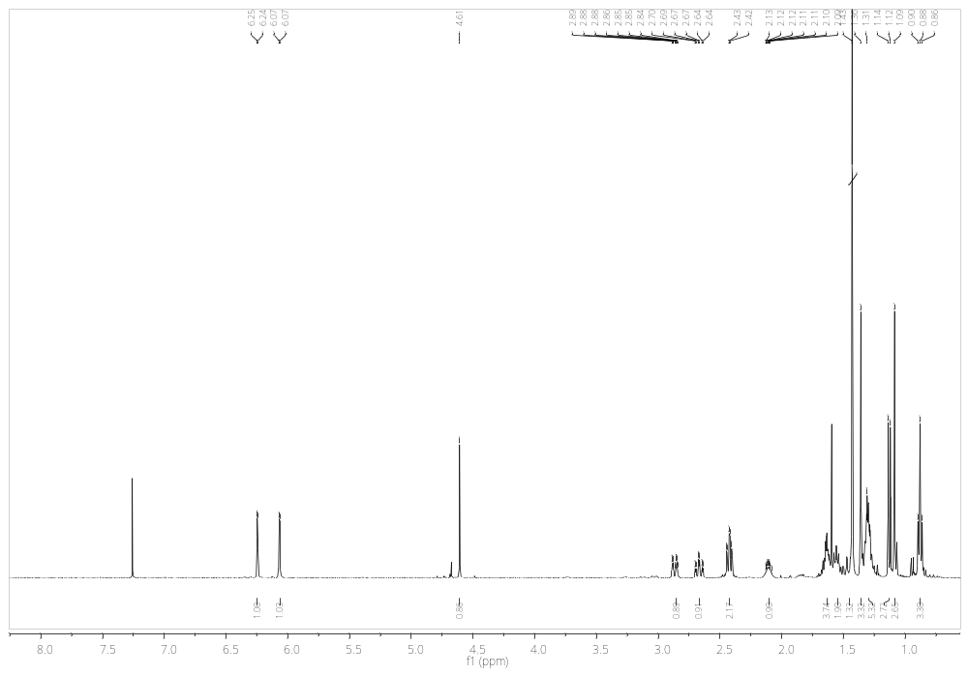
Figure S1. ¹H NMR of (9S)-HHC
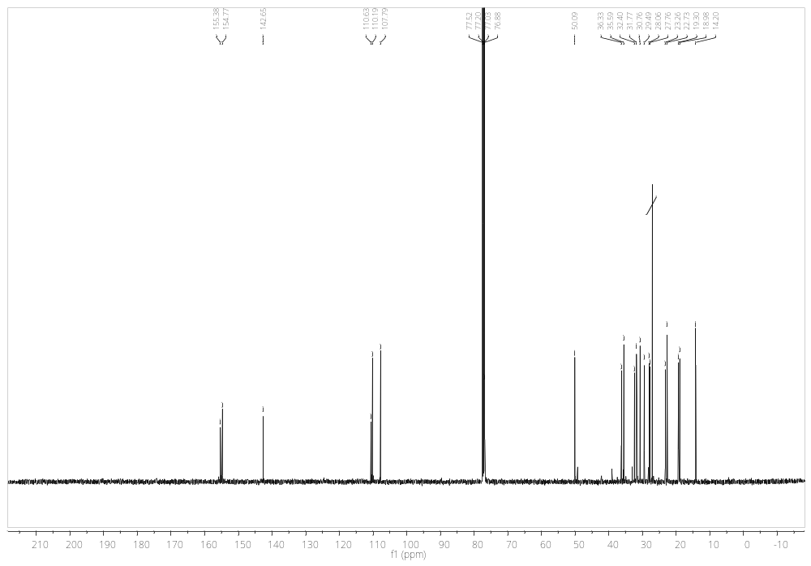
Figure S2. ¹³C NMR of (9S)-HHC
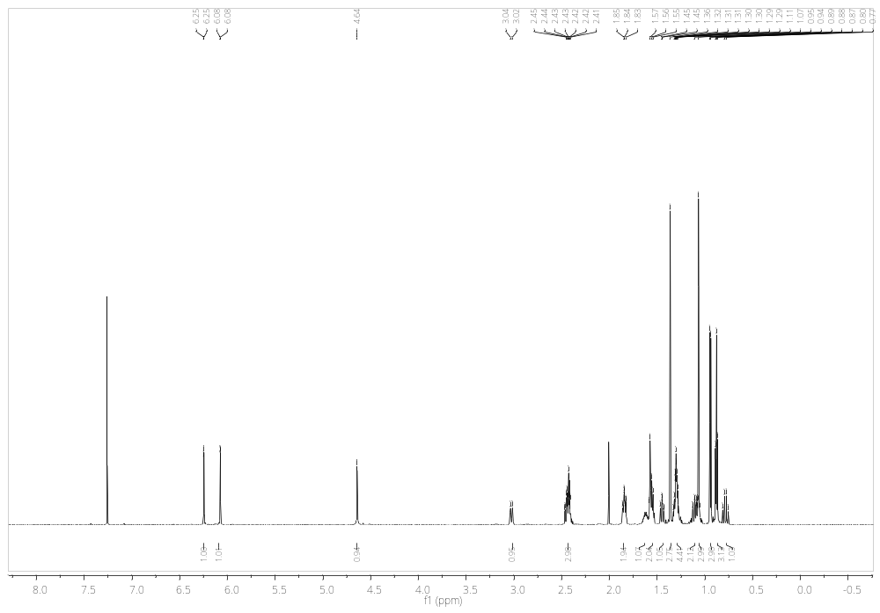
Figure S3. ¹H NMR of (9R)-HHC
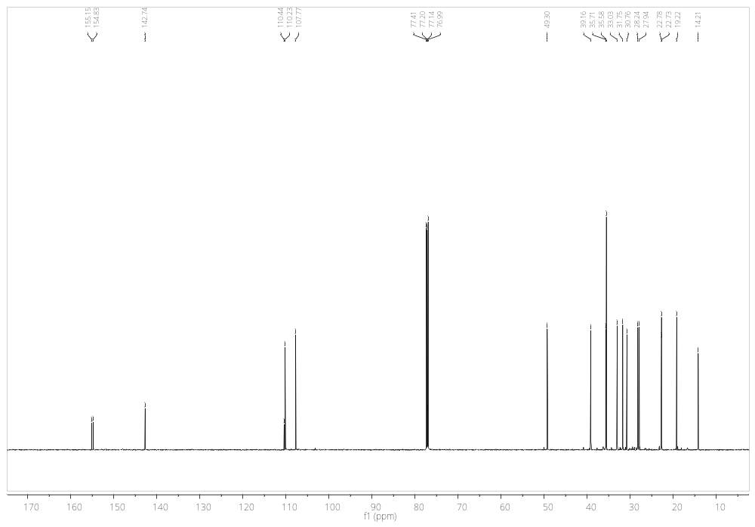
Figure S4. ¹³C NMR of (9S)-HHC
Figure S5. HPLC-UV chromatograms of the four samples: industrial hemp inflorescences (HHC-1 (a) and HHC-2 (b)), HHC hashish (HHC-3) (c) and pure HHC (HHC-4) (d). Picture of each sample is attached to the corresponding chromatogram.
Figure S6. MS data of unknown impurity in sample HHC-4. Total ion current in HESI+ (a) and HESI- mode (b); extracted exact mass in HESI + (c) and HESI- mode (d); MS² spectrum in HESI+ and HESI- mode (f).
Table S2. UV Calibration parameters (linearity range and coefficient of determination R²), retention time (R_{T}) and MS precursor ions in HESI+ and HESI- mode of the analytes.
Compound | R_{T} (min) | [M+H]⁺ | [M-H]⁻ | Linearity range (µg/mL) | R²
CBDA | 11.60 | 359.2217 | 357.2071 | 0.1-10.0 | 0.99791
CBGA | 12.10 | 361.2373 | 359.2228 | 0.1-10.0 | 0.99833
CBG | 12.30 | 317.2475 | 315.2330 | 0.1-10.0 | 0.99939
CBD | 12.42 | 315.2319 | 313.2173 | 0.1-10.0 | 0.99813
CBN | 14.60 | 311.2006 | 309.1864 | 0.1-10.0 | 0.99951
Δ⁹-THC | 15.73 | 315.2319 | 313.2173 | 0.1-10.0 | 0.99938
Δ⁸-THC | 15.95 | 315.2319 | 313.2173 | 0.1-10.0 | 0.99917
CBC | 16.55 | 315.2319 | 313.2173 | 0.1-10.0 | 0.99810
(9S)-HHC | 16.59 | 317.2475 | 315.2330 | 1.0-20.0 | 0.99959
(9R)-HHC | 16.88 | 317.2475 | 315.2330 | 1.0-20.0 | 0.99959
Δ⁹-THCA | 17.20 | 359.2217 | 357.2071 | 0.1-10.0 | 0.99874
CBCA | 17.90 | 359.2217 | 357.2071 | 0.1-10.0 | 0.99746

* Corresponding authors: Giuseppe Cannazza, Ph.D., Email: giuseppe.cannazza@unimore.it; Tel.: +39 059 2055013.; Fax: +39 059 2055750. Cinzia Citti, Ph.D., Email: cinzia.citti@unimore.it; Tel.: +39 0832 319206.

