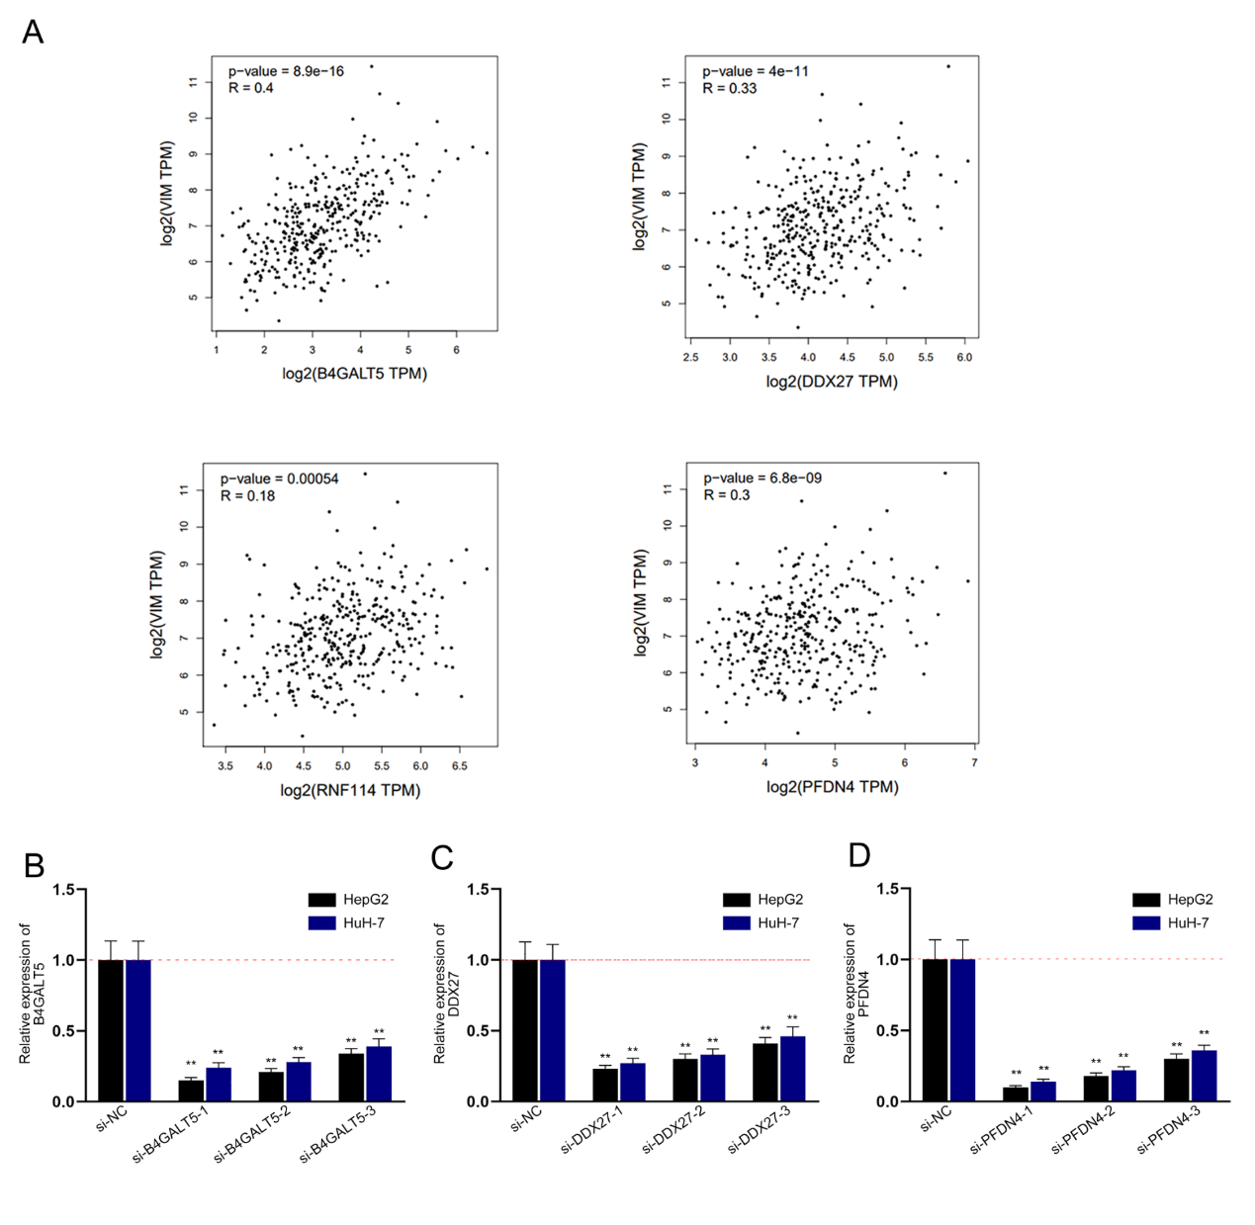
Figure S1

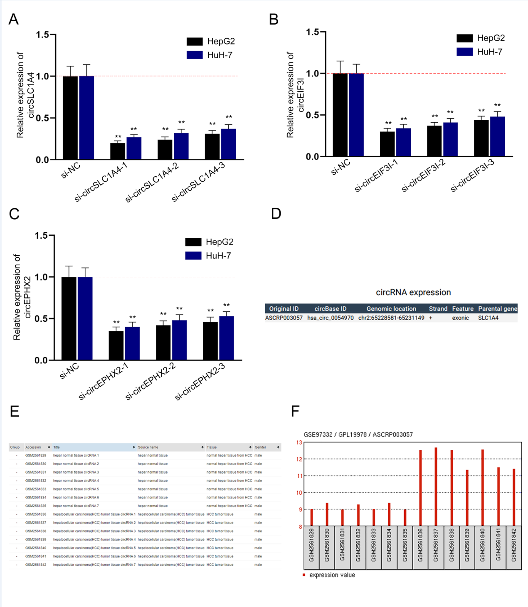
Figure S2
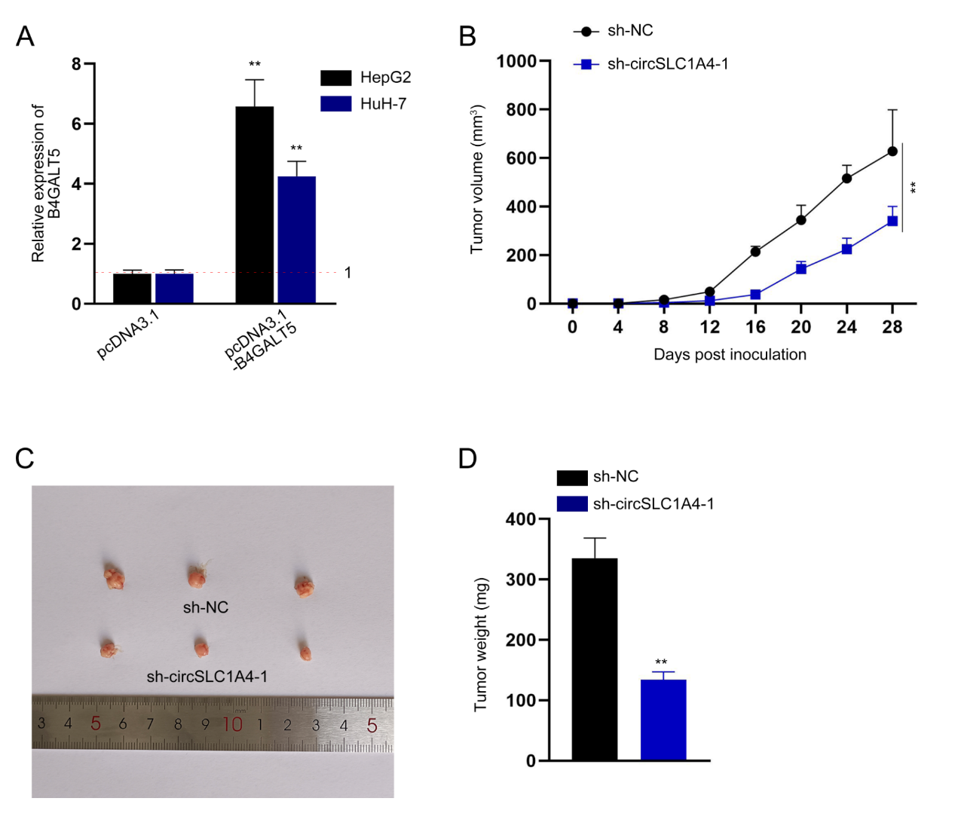
Figure S3
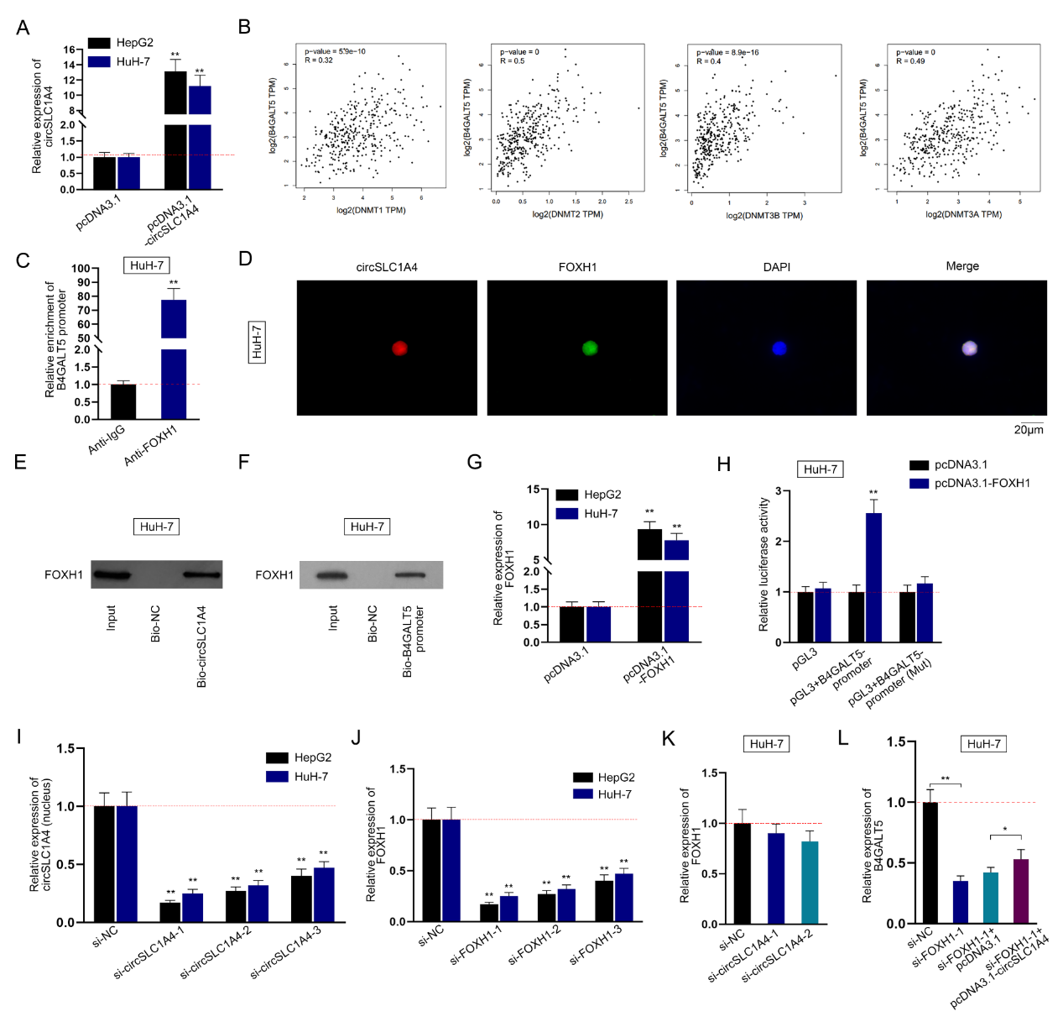
Figure S4
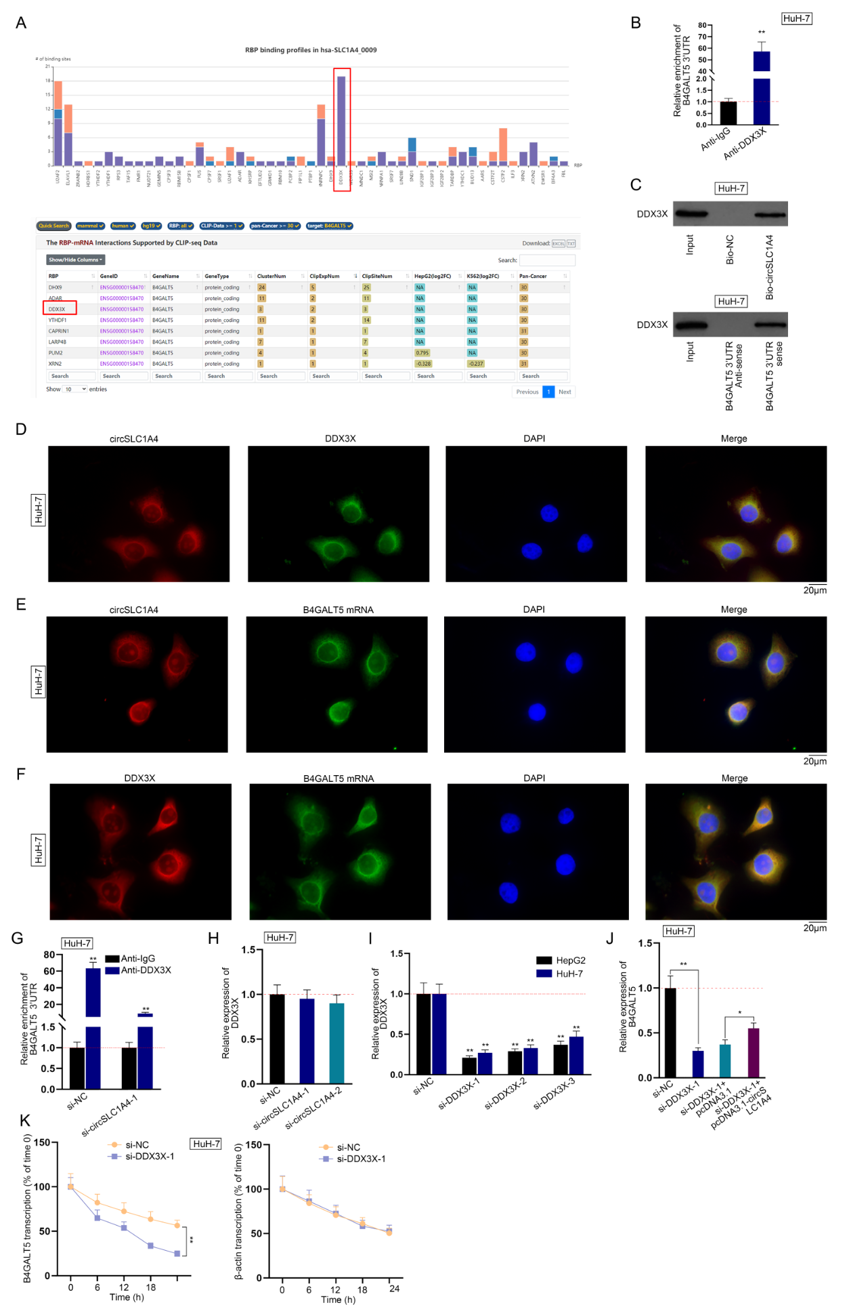
Figure S5
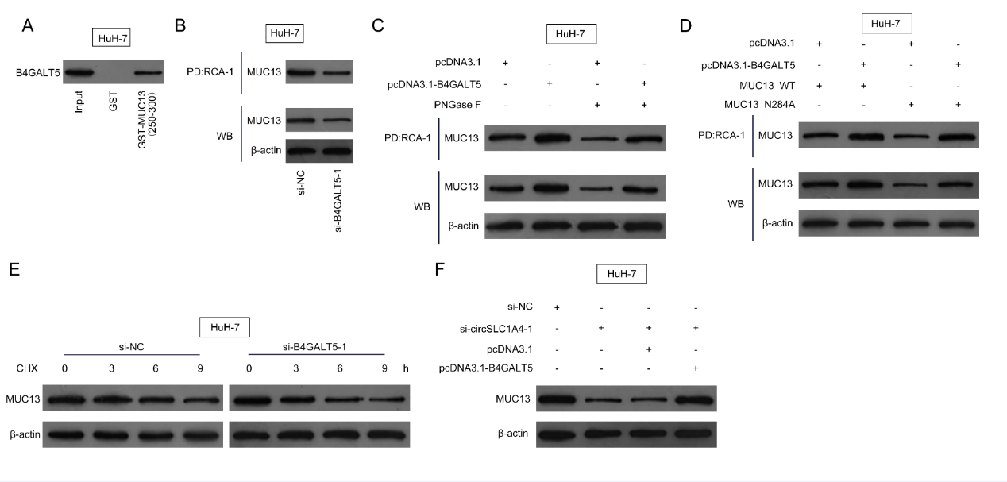
Figure S6

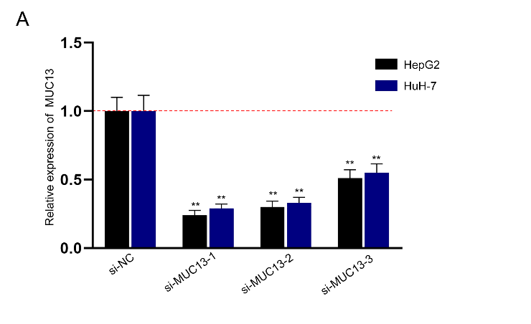
Figure S7

Figure S1
A. GEPIA correlation analysis of Vimentin (VIM) and B4GALT5/DDX27/RNF114/PFDN4 in HCC. B-D. The knockdown efficiency of si-B4GALT5-1/2/3, si-DDX27-1/2/3 or si-PFDN4-1/2/3 in HepG2 and HuH-7 cells was verified via qRT-PCR. **P < 0.01.
Figure S2
A-C. The interference efficiency of si-circSLC1A4-1/2/3, si-circEIF3I-1/2/3 or si-circEPHX2-1/2/3 in HCC cells was validated via qRT-PCR. D. ID of circSLC1A4 in the GSE97332 datasets was acquired from the circExp database. E-F. The analysis of circSLC1A4 expression in HCC tumor tissues and normal tissues was obtained from the GSE97332 datasets. **P < 0.01.
Figure S3
A. QRT-PCR was applied to examine the overexpression efficiency of pcDNA3.1-B4GALT5 in HepG2 and HuH-7 cells. B-D. Tumor volume, representative images and tumor weight of xenografts from mice injected with circEPHX2-silenced cells or control sh-NC cells were shown. **P < 0.01.
Figure S4
A. QRT-PCR was used to analyze the overexpression efficiency of pcDNA3.1-circSLC1A4 in HepG2 and HuH-7 cells. B. GEPIA correlation analysis of B4GALT5 and DNMT1/DNMT2/DNMT3B/DNMT3A. C. ChIP assay was performed to detect the association between B4GALT5 promoter and FOXH1 in HuH-7 cells. D. FISH-IF was conducted to determine the co-localization of circSLC1A4 and FOXH1 protein in HuH-7 cells. E. RNA pulldown was performed to evaluate the binding between circSLC1A4 and FOXH1 in HuH-7 cells. F. DNA pulldown was performed to assess the binding between FOXH1 and B4GALT5 promoter in HuH-7 cells. G. QRT-PCR was used to assess the overexpression efficiency of pcDNA3.1-FOXH1 in HepG2 and HuH-7 cells. H. Luciferase activity of pGL3+B4GALT5-promoter and pGL3+B4GALT5-promoter (Mut) was detected. pGL3+B4GALT5-promoter (Mut) was formed via mutation from TCGAATCCACA into TCGCCTAAACA. I. The expression of circSLC1A4 in the nucleus of HCC cells after the transfection of si-circSLC1A4-1/2/3 was detected via qRT-PCR. U6 was used as internal control. J. QRT-PCR was applied to evaluate the knockdown efficiency of si-FOXH1-1/2/3 in HepG2 and HuH-7 cells. K. QRT-PCR was used to analyze the effect of circSLC1A4 knockdown on FOXH1 expression. L. QRT-PCR was used to detect B4GALT5 levels in HuH-7 cells after different transfections. *P < 0.05, **P < 0.01.
Figure S5
A. RBPs of circSLC1A4 were predicted by circAltas database analysis. The B4GALT5-binding RBPs were predicted by starBase (Pan-cancer ≥ 30). B. RIP assay was performed to analyze the binding between B4GALT5 3’UTR and DDX3X in HuH-7 cells. C. RNA pulldown assay was conducted to verify the binding between DDX3X and circSLC1A4/B4GALT5 3’UTR in HuH-7 cells. D. FISH-IF was conducted to determine the co-localization of circSLC1A4 and DDX3X protein in HuH-7 cells. E. FISH was performed to detect the co-localization of circSLC1A4 and B4GALT5 mRNA in HuH-7 cells. F. FISH-IF was performed to measure the co-localization of B4GALT5 mRNA and DDX3X protein in HuH-7 cells. G. The binding between DDX3X and B4GALT5 3’UTR after si-circSLC1A4-1 treatment was assessed by RIP assay. H. The effect of circSLC1A4 on DDX3X expression was analyzed via qRT-PCR. I. QRT-PCR was applied to examine the downregulation efficiency of si-DDX3X-1/2/3 in HepG2 and HuH-7 cells. J. Rescue experiment was applied to assess the regulatory relationship on of circSLC1A4/DDX3X/B4GALT5. K. The stability of B4GALT5 mRNA after si-DDX3X-1 treatment was analyzed via mRNA stability assay using 50mM α-amanitin. *P < 0.05, **P < 0.01.
Figure S6
A. GST-pulldown was performed to evaluate the interaction of B4GALT5 and MUC13 protein. B. Lectin (LCA) pulldown assay was performed to evaluate the effect of B4GALT5 knockdown on glycosylation of MUC13. C. Lectin (RCA-1) pulldown assay was performed to evaluate the effect of B4GALT5 overexpression on N-glycosylation of MUC13 using PNGase F (N-glycosylation inhibitor). D. Lectin (LCA) pulldown assay was performed to determine B4GALT5-mediated N-glycosylation site of MUC13. E. Western blot was applied to analyze the effect of B4GALT5 knockdown on MUC13 expression in HuH-7 cells treated with CHX (25 μg/mL). F. Western blot was applied to evaluate the effect of circSLC1A4/B4GALT5 on the expression of MUC13 protein.
Figure S7
A. QRT-PCR was applied to analyze the knockdown efficiency of si-MUC13-1/2/3 in HepG2 and HuH-7 cells. **P < 0.01.

