Supplementary file
File name: Supplementary file_DAS-EP
File format: Word document (.docx)
Title of data: Appendix of Urban Environment and Health: a cross-sectional multiregional project based on Population Health Surveys in Spain (DAS-EP project), study protocol.
Description of data: Additional information for the main text, including four main sections: Section 1. GENERAL CHARACTERISTICS OF THE STUDY AREAS; Section 2. GENERAL CHARACTERISTICS OF THE POPULATION HEALTH SURVEYS; Section 3. OVERVIEW OF THE VARIABLES UNDER STUDY PER STUDY AREA; and Section 4. DATA MANAGEMENT PLAN
Table of contents
Section 1. GENERAL CHARACTERISTICS OF THE STUDY AREAS
Figure S1. Study areas of the project
Figure S2. Population density of Spanish provinces in 2022
Section 2. GENERAL CHARACTERISTICS OF THE POPULATION HEALTH SURVEYS
Table S1. Characteristics of the Population Health Surveys
Section 3. OVERVIEW OF THE VARIABLES UNDER STUDY PER STUDY AREA
Table S2. Objective urban environmental exposures obtained through GIS estimations
Table S3. Variables from the Population Health Surveys
Section 4. DATA MANAGEMENT PLAN
- Research activities
- Data storage and processing
- Ethical considerations and accountability

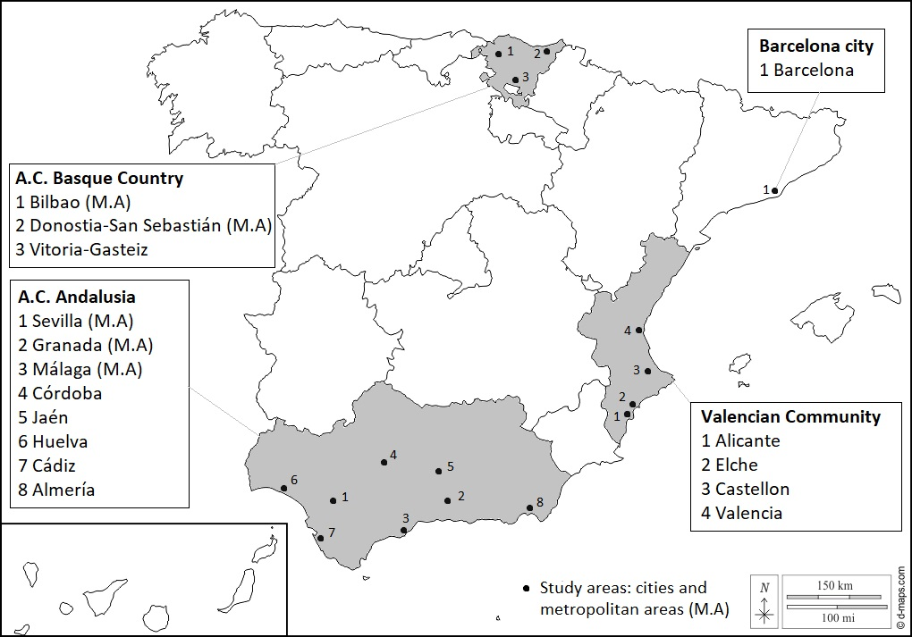
Section 1. GENERAL CHARACTERISTICS OF THE STUDY AREAS
Figure S1. Study areas of the project, being the cities and metropolitan areas (M.A) with more than 100,000 inhabitants from the autonomous communities of the Basque Country and Andalusia, Valencian Community, and the city of Barcelona. Figure edited from Daniel Dalet / d-maps.com.

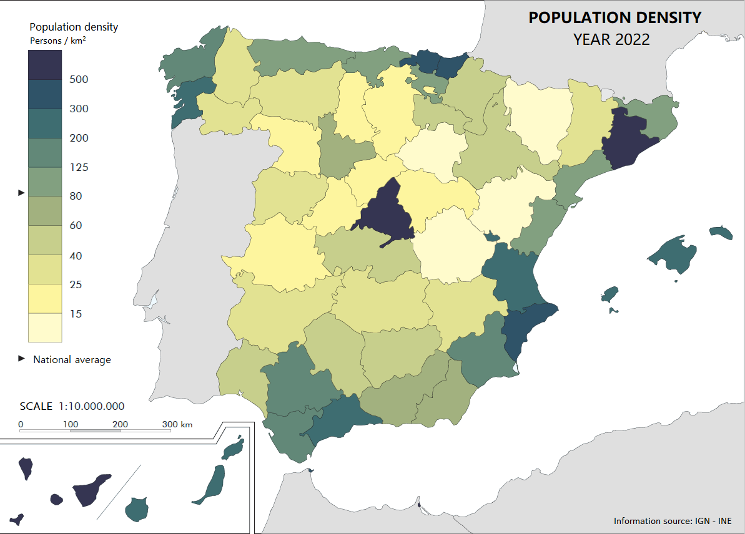
Figure S2. Population density of Spanish provinces in 2022. Figure edited from Instituto Geográfico Nacional, La población en España 2022. Accessed through: https://www.ign.es/pobesp/pe1.htm

Study area | Cities and areas of influence | Population health survey | Responsible body | Sample size | Data collection period
A.C. Basque Country | Vitoria-Gasteiz  Donostia-San Sebastián (M.A)  Bilbao (M.A) | Encuesta de Salud de la Comunidad Autónoma País Vasco (ESCAV) | - Basque Department of Health | 7,846 | 2022 October –  2023 June
A.C. Andalusia | Almería  Cádiz  Córdoba  Huelva  Jaén  Granada (M.A)  Malaga (M.A)  Sevilla (M.A) | Encuesta Andaluza de Salud (EAS) | - Andalusian School of Public Health (EASP) | 3,085 | 2022 April –  2023 April
Barcelona city | Barcelona | Encuesta de Salud de Barcelona (ESB) | - Barcelona Public Health Agency (ASPB) | 4,000 | 2021 February –  2022 March
Valencian Community | Castellon  Valencia  Elche  Alicante | Encuesta Salud Comunidad Valenciana (ESCV) | - Foundation for the Promotion of Health and Biomedical Research in the Valencian Region (DGSP) | 3,134 | 2022 April –  2022 December
Abbreviations: A.C., Autonomous community; M.A, Metropolitan Area.
Section 2. GENERAL CHARACTERISTICS OF THE POPULATION HEALTH SURVEYS

Table S1. Characteristics of the study areas and the population health surveys comprised in the project.

Section 3. OVERVIEW OF THE VARIABLES OF THE STUDY PER STUDY AREA
Table S2. Objective urban environmental exposures obtained through GIS estimations.
GIS Variables | Study areas: A.C. s of the Basque Country and Andalusia, Valencian Community & the city of Barcelona
OBJECTIVE URBAN ENVIRONMENTAL EXPOSURES | Scale | Variable
- Surrounding natural spaces
Green Spaces
Green space percentage | 100, 300, 500m buffers | Percentage of green space.
NDVI | 100, 300, 500m buffers | Annual mean Normalised Difference Vegetation Index (NDVI) of the year when the surveys were conducted and the mean NDVI of the last 5 years previous to the surveys.
Tree percentage | 100, 300, 500m buffers | Percentage of tree cover based on Growing stock volume (GSV) data.
Distance to green space |  | Euclidean distance to the nearest major green space (green surface over 5,000m²).
Green spaces Yes (vs. No) | 100, 300, 500m buffers | Dichotomous variable of presence of major green spaces (green surface over 5,000m²) from local topographical or Europe-wide maps (Urban atlas).
Blue spaces
Blue spaces Yes (vs. No) | 100, 300, 500m buffers | Dichotomous variable of presence of water surfaces. Based on Urban Atlas.
Blue space percentage | 100, 300, 500m buffers | Percentage of water surface. Based on Urban Atlas.
Distance to blue space |  | Euclidean distance to the nearest water surface over 5,000m². Based on Urban Atlas.
- Built environment
Building density | 100, 300, 500m buffers | The building density around each household will be calculated accounting for the perimeter and height of the buildings from local cadastre data or Europe-wide maps (Urban Atlas).
Population density | 100, 300, 500m buffers | The number of inhabitants (per km²) surrounding the home addresses.
Street connectivity | 100, 300, 500m buffers | Using data from OpenStreetMap® .
Accessibility (bus lines) | 100, 300, 500m buffers | Access to public transport bus lines from local topographical maps or OpenStreetMap®.
Accessibility (bus stops) | 100, 300, 500m buffers | Access to public transport bus stops from local topographical maps or OpenStreetMap®.
Facility richness | 100, 300, 500m buffers | Using local topographical maps or OpenStreetMap®.
Facility density | 100, 300, 500m buffers | Using local topographical maps or OpenStreetMap®.
Land use | 100, 300, 500m buffers | Mixed land use will be estimated by Shannon's Eveness Index based on Urban Atlas data.
Walkability index | 100, 300, 500m buffers | Index constructed from seven indicators: population density, street connectivity, facility richness, land use, destination density, street density, and average slope.
- Traffic infrastructure
Major road Yes (vs. No) | 100, 300, 500m buffers | Dichotomous variable of presence of a major road (OpenStreetMap®).
Inverse distance |  | Inverse distance to the nearest major road (OpenStreetMap®).
GIS Variables | Study areas: A.C. s of the Basque Country and Andalusia, Valencian Community & the city of Barcelona
OBJECTIVE URBAN ENVIRONMENTAL EXPOSURES | Scale | Variable
- Environmental stressors
Air pollution
PM_{2.5} | Street level (at residential address) | PM_{2.5} exposure indicators include: a) the annual average for the last five years, and b) the five-year average for the last five years based on spatiotemporal land-use random-forest models.
PM₁₀ | Street level (at residential address) | PM₁₀ exposure indicators include: a) the annual average for the last five years, and b) the five-year average for the last five years based on spatiotemporal land-use random-forest models.
NO₂ | Street level (at residential address) | NO₂ exposure indicators include: a) the annual average for the last five years, and b) the five-year average for the last five years based on spatiotemporal land-use random-forest models.
Noise
Day (L_{d}) | Street level (at residential address) | Exposition to environmental noise at street level during the day indicated as: a) the annual average for the last five years, and b) the five-year average for the last five years based on Strategic Noise Maps derived under the EU Directive 2002/49/EC from the Ministry for the Ecological Transition and the Demographic Challenge.
Evening (L_{e}) | Street level (at residential address) | Exposition to environmental noise at street level during the evening indicated as: a) the annual average for the last five years, and b) the five-year average for the last five years based on Strategic Noise Maps derived under the EU Directive 2002/49/EC from the Ministry for the Ecological Transition and the Demographic Challenge.
Night (L_{n}) | Street level (at residential address) | Exposition to environmental noise at street level during the night indicated as: a) the annual average for the last five years, and b) the five-year average for the last five years based on Strategic Noise Maps derived under the EU Directive 2002/49/EC from the Ministry for the Ecological Transition and the Demographic Challenge.
Total (L_{den}) | Street level (at residential address) | Total exposition to environmental noise at street level indicated as: a) the annual average for the last five years, and b) the five-year average for the last five years based on Strategic Noise Maps derived under the EU Directive 2002/49/EC from the Ministry for the Ecological Transition and the Demographic Challenge.
Abbreviations: A.C., Autonomous community; NDVI, Normalised Difference Vegetation Index; GSV, Growing stock volume; PM_{2.5}, Fine particulate matter with a diameter of 2.5μm or less; PM₁₀, Fine particulate matter with a diameter of 10μm or less; NO₂, Nitrogen dioxide

Table S3. Variables collected through Population Health Surveys.
Population Health Survey Variables | Study areas
Population Health Survey Variables | A.C. Basque Country | A.C. Andalusia | Barcelona city | Valencian Community
OUTCOMES
a) Self-perceived health
General Health | Ordinal 1-5 | Ordinal 1-5 | Ordinal 1-5 | Ordinal 1-5
Mental Health | Ordinal 1-5 [Mental Health Inventory /5 items] | Ordinal 1-6 [SF-12 / 3 items] | Ordinal 1-4 [GHQ-12/ 12 items] | Ordinal 1-4 [GHQ-12 / 12 items]
b) Quality of life
Health-related quality of life | Ordinal 1-5 [EuroQoL / 5 items] | Ordinal 1-6/1-5 [SF-12 / 5 items] | Ordinal 1-5 [EuroQoL / 5 items] | Ordinal 1-5 [EuroQoL / 5 items]
c) Sleep
Sleep duration | Continuous - Total hours/day | Continuous - Total hours/day | Continuous - Total hours/day | Continuous - Total hours/day
Quality of sleep | Ordinal 1-5 [SATED / 5 items] | yes/no & Ordinal 1-4 [4 items] | Ordinal 1-10 | Ordinal 1-5 [SATED / 5 items]
d) Consumption of medication for common mental disorders¹
Antidepressants | yes/no – reference 2 days | yes/no – reference 2 weeks | yes/no - reference 2 days | yes/no - reference 2 weeks
Hypnotics | yes/no - reference 2 days | yes/no - reference 2 weeks | yes/no - reference 2 days | yes/no – reference 2 weeks
Anxiolytics | yes/no - reference 2 days | yes/no - reference 2 weeks | yes/no - reference 2 days | yes/no - reference 2 weeks
e) Chronic mental health problems²
Anxiety | yes/no - reference ever | yes/no – reference present | yes/no - reference ever | yes/no – reference ever
Depression | yes/no - reference ever | yes/no - reference present | yes/no - reference ever | yes/no - reference ever
Insomnia | yes/no - reference ever | - | - | yes/no - reference ever
Other | yes/no - reference ever | - | yes/no - reference ever | yes/no - reference ever
COVARIATES
a) Anthropometric variables
Age | Discrete | Discrete | Discrete | Discrete
Weight | Continuous | Continuous | Continuous | Continuous
Height | Continuous | Continuous | Continuous | Continuous
BMI | Continuous | Continuous | Continuous | Continuous
Biologic sex | Categorical - 3 conditions | Categorical - 2 conditions | Categorical - 2 conditions | Categorical - 2 conditions
Gender identity | Categorical - 3 conditions | - | Categorical - 3 conditions | -
b) Socioeconomic variables
Education level | Categorical - 9 conditions | Categorical - 13 conditions | Categorical - 11 conditions | Categorical - 9 conditions
Occupational status | Categorical [CNO11] | Categorical [CNO11] | Categorical [CNO11] | Categorical [CNO11]
Household size | Discrete | Discrete | Discrete | Discrete
Population Health Survey Variables | Study areas
Population Health Survey Variables | A.C. Basque Country | A.C. Andalusia | Barcelona city | Valencian Community
Household income | Categorical - 11 conditions | - | - | Categorical - 8 conditions
Economic difficulty | Categorical - 6 conditions | Categorical - 6 conditions | Categorical - 6 conditions | Categorical - 6 conditions
Employment status | yes/no | yes/no | yes/no | yes/no
Country of birth | Categorical & Open | Categorical & Open | Categorical & Open | Categorical & Open
Marital status | Categorical - 6 conditions | Categorical - 5 conditions | Categorical - 5 conditions | Categorical - 5 conditions
c) Lifestyle factors
Alcohol consumption | Categorical - 8 conditions | Categorical - 10 conditions | Categorical - 4 conditions | Categorical - 8 conditions
Passive smoking at home | Likert 1-5 | yes/no | Discrete (Nº smokers) | yes/no
Daily tobacco consumption | yes/no | Categorical - 4 conditions | Categorical - 3 conditions | Categorical - 4 conditions
e) Physical Health
Non-mental chronic health problems | Categorical - 38 conditions | Categorical - 25 conditions | Categorical - 25 conditions | Categorical - 21 conditions
d ) Mobility
Years at household | Discrete | - | Discrete | Discrete
MEDIATORS
a) Physical activity
Physical activity | Discrete - IPAQ | Discrete - IPAQ | Discrete - IPAQ | Discrete - IPAQ
- Vigorous | MET-min/week | MET-min/week | MET-min/week | MET-min/week
- Moderate | MET-min/week | MET-min/week | MET-min/week | MET-min/week
- Walking | MET-min/week | MET-min/week | MET-min/week | MET-min/week
- Sitting | Time spent (hours + minutes) | Time spent (hours + minutes) | Time spent (hours + minutes) | Time spent (hours + minutes)
b) Social cohesion
Social support | Ordinal 1-5 [Duke / 11 items] | Ordinal 1-5 [Duke / 11 items] | Ordinal 1-5/1-4 [OSLO/ 3 items] | Ordinal 1-5 [Duke / 11 items]
Loneliness | Ordinal 1-4 | Ordinal 1-4 | Ordinal 1-4 | Ordinal 1-4
SUBJECTIVE URBAN ENVIRONMENTAL EXPOSURES
a) Perception of the neighbourhood
Noise outside dwelling | Likert 1-3 | Likert 1-3 | Likert 1-5 | Likert 1-3
Neighbourhood air pollution | Likert 1-3 | Likert 1-3 | - | Likert 1-3
Shortage of green spaces | Likert 1-3 | Likert 1-3 | - | Likert 1-3
Insecurity | Likert 1-3 | Likert 1-3 | Likert 1-5 | Likert 1-3
¹ The subjects are provided with a list of medications and are asked if they have consumed any of them in the last 2 days or 2 weeks depending on the study area.
² The subjects are provided with a list of chronic health problems and are asked if they currently suffer or have ever suffered (depending on the study area) from any of them.

Section 4. DATA MANAGEMENT PLAN
A) RESEARCH ACTIVITIES
Step 1. Population Health Surveys’ (PHS) data curation and calibration
The selected individuals were contacted by a phone call, SMS, or letter to arrange an appointment for a face-to face interview for the purpose of the survey. The database produced with the interviews will be pseudonymised from that with the personal data for the contact by assigning a unique code for each participant and remains under the custody of the responsible body in each study area; the Basque Department of Health in the Basque Country, Escuela Andaluza de Salud Pública (EASP) in Andalusia, Agència de Salud Pública de Barcelona (ASPB) in Barcelona, and Conselleria de Salut Universal i Salut Pública (DGSP) in Valencian Community.
Step 2. Harmonisation
Initially, the databases of each study area will be cleaned, and the variables that require it will be harmonised. The vast majority of the variables to be used in the project have been collected identically in the Population Health Surveys of the study areas included. The variables to be harmonized are listed below and the measures used in each study area can be found in Table S2.
The variables that need harmonisation can be distinguished between simple or complex variables, depending on the level of difficulty and the manipulation of data that require the harmonisation of the respective variable:
- Simple variables: Chronic mental health problems, Educational level, Occupation status, Household income, Loneliness, Noise outside dwelling, and Insecurity.
- Complex variables: mental health, health-related quality of life, sleep quality, consumption of medication for common mental disorders, alcohol consumption, passive smoking at home, tobacco consumption, physical health, and social support.
The Maelstrom Research Guidelines for the rigorous harmonisation of retrospective data (77) will be applied. Among the variables that need harmonisation, the majority can be easily re-categorised (simple variables). For instance, in the case of scales with different score ranges (e.g., Likert scale levels), standardised scores will be calculated, or other procedures will be followed to ensure comparability. The procedure to follow with variables measured with different scales will be more complex (complex variables). For these, the content of each variable will be studied to detect the common content (e.g., items) in each of the study areas. Once detected, aggregate scores will be calculated for the common items, and these scores will be used for statistical analyses. The remaining non-harmonizable variables will be assessed for their potential for performing separate statistical analysis for each study area.
Step 3. Georeferentiation
The responsible bodies, in collaboration with regional Statistical Institutes or Population Registers, will link the health survey data to the geographical coordinates of each respondent’s home address. The geographical coordinates will also be pseudonymised and sent this way to the research group specialised in Geographic Information System (GIS) estimations that will calculate UrbEE. In order to further ensure the protection of the personal data of the survey participants and enhance their anonymity, fictional coordinates will be created in a number five times the number of participants selected for the study in each study area and sent to the research group specialised in GIS estimations together with the real coordinates.
Step 4. GIS estimation of Urban Environmental Exposures (UrbEE)
A company specialised in GIS estimations will calculate the objective urban environmental exposures (UrbEE) of all the geocodes, including the participants’ coordinates and the fictional coordinates by GIS.
Step 5. Selection and linkage of data
After the estimations are finalised, the responsible bodies of the surveys in each study area will re-select the geocodes of the participants and add the new urban environmental variables to the database with the PHS data. The researchers will be provided with the resultant database of each study area composed by the PHS data and the UrbEE (without geocodes and personal data of the participants). This guarantees that the data supplied are protected by statistical secrecy, not misused and treated anonymously and globally at all times.
Step 6. Pooling
Finally, the final databases of all the study areas will be pooled, creating the final pooled database to be used in the planned analyses.
B) DATA STORAGE AND PROCESSING
Data will be kept at all times on servers located in the responsible centre of this project. This way, data will be stored on the University of the Basque Country UPV/EHU's own servers, complying with the greater security and privacy requirements of the LOPD as the data is not sent to external servers. The entire process of recording, dumping and storage of the data will be anonymised, with the data collected being exclusively linked to a sample unit code. Access to the anonymised microdata will be limited to technicians from the responsible centres of each study area through profiles with regulated permissions that allow for supervising and controlling access to the information. Supervision of the data management will be assigned to the principal investigators with expert advice, and to the data protection officer of the centre responsible for the project.
C) ETHICAL CONSIDERATIONS AND ACCOUNTABILY
The study was approved by the regional Research Ethics Committee of the Basque Country, ETHICS COMMITTEE FOR RESEARCH INVOLVING MEDICINAL PRODUCTS IN THE BASQUE COUNTRY (CEIm-E) (protocol code PI2022138, dated 9th November 2022); Andalusia, BIOMEDICAL RESEARCH ETHICS COMMITTEE OF THE PROVINCE OF GRANADA (CEI/CEIM GRANADA) (protocol code 2078-N-22, dated 27th December 2022); Barcelona, PARC DE SALUT MAR CLINICAL RESEARCH ETHICS COMMITTE (CEIm) (protocol code 2022/10667, dated 2nd December 2022); Valencian Community, ETHICS COMMITTEE FOR CLINICAL RESEARCH OF THE DIRECTORATE GENERAL OF PUBLIC HEALTH AND CENTER FOR ADVANCED RESEARCH IN PUBLIC HEALTH (CEIC DGSP / CSISP) (protocol code 20221125/04, dated 25th November 2022).
This study is based on secondary data obtained from four independent Population Health Surveys (PHS) from Spain. Since the present study does not involve the activity of data collection, to obtain the informed consent from the subjects is not applicable for this study. However, the PHS included this project are official statistical operations included in the respective Statistical Plans of each study area. This ensures that the data provided is protected by statistical confidentiality, it is not misused, its treatment is anonymous and global at all times, and that indirect identification is impossible. Data are collected and processed in accordance with the provisions of the General Data Protection Regulation (GDPR) and in accordance with the provisions of Article 5 of the Organic Law 3/2018 of 5 December on the Protection of Personal Data and the guarantee of digital rights (Regulation (EU) 2016/679), they will be treated confidentially, with access to them being granted to personnel who strictly need to process them in the framework of the study.
Furthermore, the transfer of data occurs between organisations within the Public Health System of each region and the regional or local government itself. This is done in the context of a research project conducted exclusively in the public sphere and with the legitimacy of the use of administrative records as research infrastructures in accordance with the General Health Act, the Biomedical Research Act and the General Law on Public Health. The results of the study will provide information at a sufficiently aggregated territorial level to prevent indirect identification. Furthermore, the project’s results will be beneficial to the general population in a holistic way, thanks to its socioeconomic and environmental context, and its evolution over several years from the onset of the COVID-19 pandemic. Therefore, the risk to the privacy of the study population is minimal compared to the potential benefits the results will bring.

