Table 1 Risk of Bias Assessment
(A) Risk of bias assessment with Newcastle-Ottawa scales for NRS
 | Aquino 2015 | Picone 2020
Selection
- Representativeness of the exposed cohort (or Is the case definition adequate?) | ＊ | ＊
- Selection of the non exposed cohort (or Representativeness of the cases) | / | /
- Ascertainment of exposure (or Selection of Controls) | / | ＊
- Demonstration that outcome of interest was not present at start of study (or Definition of Controls) | ＊ | ＊
Comparability
- Comparability of cohorts on the basis of the design or analysis (or Comparability of cases and controls on the basis of the design or analysis) | ＊  ＊ | ＊
Outcome
- Assessment of outcome (or exposure) | ＊ | ＊
- Was follow-up long enough for outcomes to occur ( or same method of ascertainment for cases and controls) | ＊ | ＊
- Adequacy of follow up of cohorts (or Non-Response rate) | ＊ | ＊
Total score | 6 | 7
Quality | fair | good

(B) Risk of bias assessment for RCT
 | Random sequence generation (selection bias) | Allocation concealment (selection bias) | Blinding of participants and personnel (performance bias) | Blinding of outcome assessment (detection bias) | Incomplete outcome data (attrition bias) | Selective reporting (reporting bias) | Other bias
Compbell 2021 | ○ | △ | ⅹ | ○ | ⅹ | ○ | △
Johnson 2001 | △ | ○ | ⅹ | ○ | ⅹ | ○ | △
Martinson 2011 | ○ | ○ | ⅹ | △ | ⅹ | ○ | △
Rivero 2007 | △ | △ | ⅹ | △ | ⅹ | △ | △
Swindells 2019 | ○ | ○ | ⅹ | △ | ○ | ○ | △
Mwinga 1998 | ○ | ○ | △ | △ | ⅹ | ○ | △
Hawken 1997 | ○ | ○ | △ | ○ | ⅹ | ○ | △
○: low risk of bias; ⅹ: high risk of bias; △: unclear risk of bias

Table 2 The efficacy for LTBI therapy
- Isoniazid versus Placebo or non-treatment
- The efficacy for NRSs
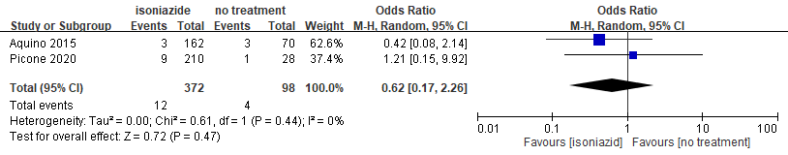
- The efficacy for RCTs
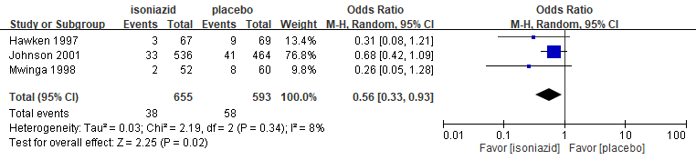
- Rifamycin-base regimens versus placebo or non-treatment
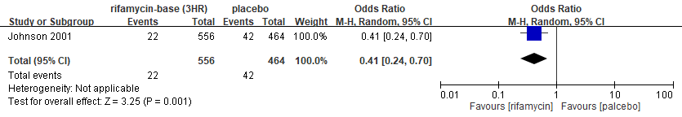
- Rifamycin-base regimens versus isoniazid
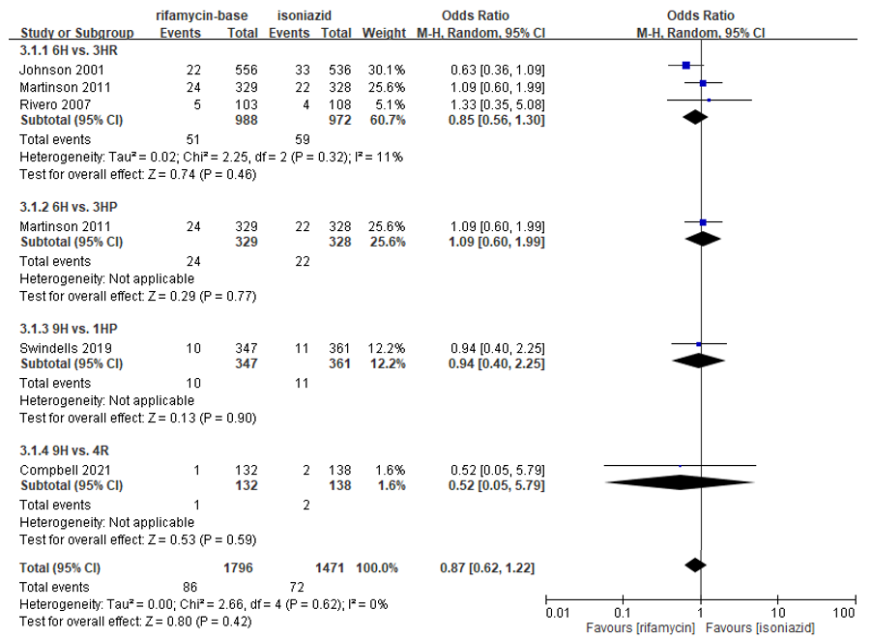
Table 3 The adhesion rate of LTBI therapy
- Isoniazid versus placebo or non-treatment
- The adhesion rate of NRS
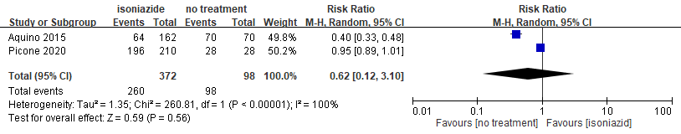
- The adhesion rate of RCT
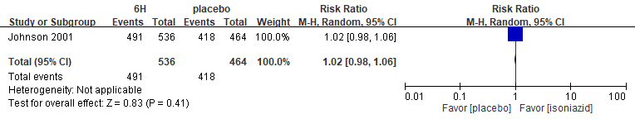
- Rifamycin-base regimens versus isoniazid
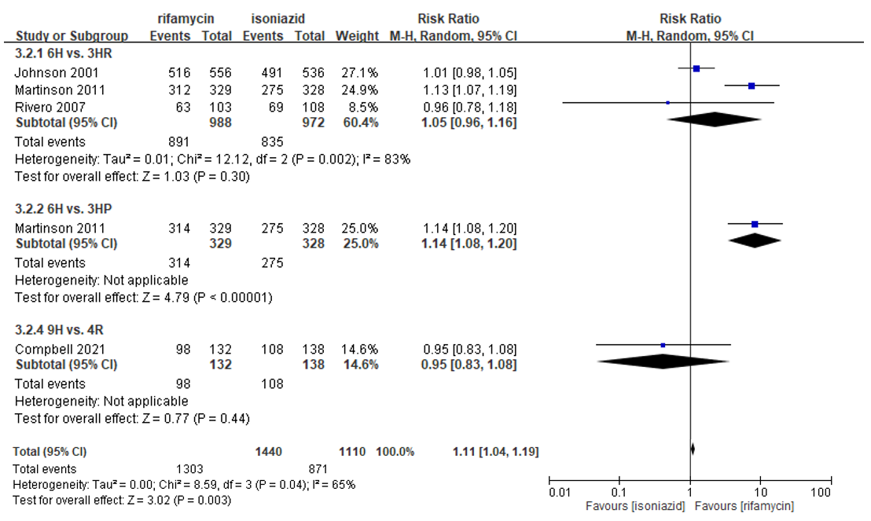

Table 4 The severe adverse events for LTBI therapy
Rifamycin-base regimens versus isoniazid
