Supplement 1: Search Strategy
- Pubmed
("latent TB" or "latent tuberc*" or LTBI or "inactive TB" or "inactive tuberc*") and (isoniazide or rifampicin or rifapentine or "anti-TB" or "anti-tuberc*")

B) Medline ovid
- Latent Tuberculosis/
- (Latent TB or latent tuberc* or LTBI).ti,ab.
- (inactive TB or inactive tuber*).ti,ab.
- (TB prevention or tuberc* prevention or prevent TB or prevent tuberc*).ti,ab.
- (isoniazide or rifampicin or rifapentine).ti,ab.
- (anti-tuberc* or anti-TB).ti,ab.
- Or/1-4
- Or/5-6
- 7 and 8
- randomized controlled trial.pt.
- controlled clinical trial.pt.
- randomized.ab.
- placebo.ab.
- clinical trials as topic.sh.
- randomly.ab.
- trial.ti.
- or/10-16
- exp animals/ not humans.sh.
- 17 not 18
- 9 and 19

C) Cochrane library
#1 MeSH descriptor: [Latent Tuberculosis] explode all trees
#2 (“latent TB” or “latent tuberc*” or LTBI)
#3 (“inactive TB” or “inactive tuber*”)
#4 (tuberc* near prevent*)
#5 (isoniazide or rifampicin or rifapentine)
#6 (anti-tuberc* or anti-TB)
#7 #1 or #2 or #3 or #4
#8 #5 or #6
#9 #7 and #8
D)Embase Elsevier
#9. #8 AND ('case control study'/de OR 'case study'/de OR 'clinical article'/de OR 'clinical trial'/de OR 'clinical trial topic'/de OR 'cohort analysis'/de OR 'comparative study'/de OR 'controlled clinical trial'/de OR 'controlled study'/de OR 'cross sectional study'/de OR 'major clinical study'/de OR 'observational study'/de OR 'phase 3 clinical trial'/de OR 'phase 3 clinical trial topic'/de OR 'pilot study'/de OR 'prospective study'/de OR 'randomized controlled trial'/de OR 'randomized controlled trial topic'/de OR 'retrospective study'/de)
#8. #6 AND #7
#7. #4 OR #5
#6. #1 OR #2 OR #3
#5. 'anti-tuberc*' OR 'anti-tb'
#4. 'isoniazide' OR 'rifampicin' OR 'rifapentine'
#3. 'tuberc*' NEAR/5 'prevent*'
#2. 'inactive tb' OR 'inactive tuber*'
#1. 'latent tuberculosis'/exp OR 'latent tuberculosis' OR 'latent tuberc*' OR ltbi

- ICTRP
latent tuberc*

- clinicaltrials.gov
Latent Tuberculosis

Supplement 2: Summary of findings tables of outcomes
- Isoniazid compared to placebo or non-treatment for LTBI treatment
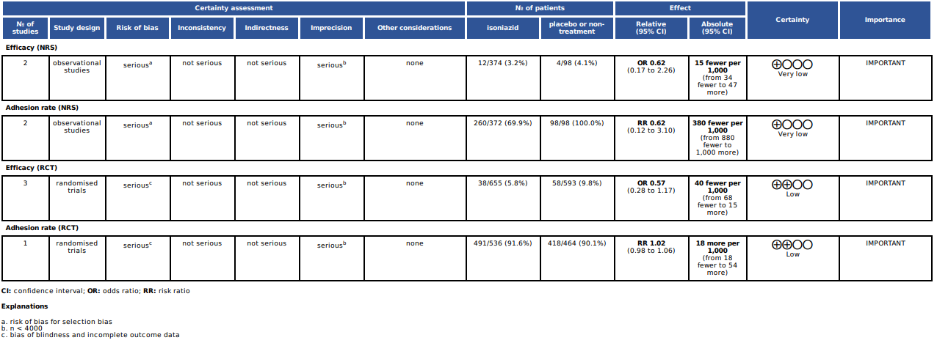

- Rifamycin-base compared to placebo or non-treatment for LTBI treatment
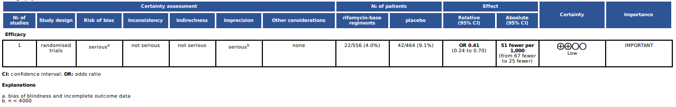

- Rifamycin-base compared isoniazid for LTBI treatment
