Supplementary materials
Identification of novel missense mutations in a large number of recent SARS-CoV-2 genome sequences
Hugh Y. Cai*, Kimberly K. Cai, Julang Li* 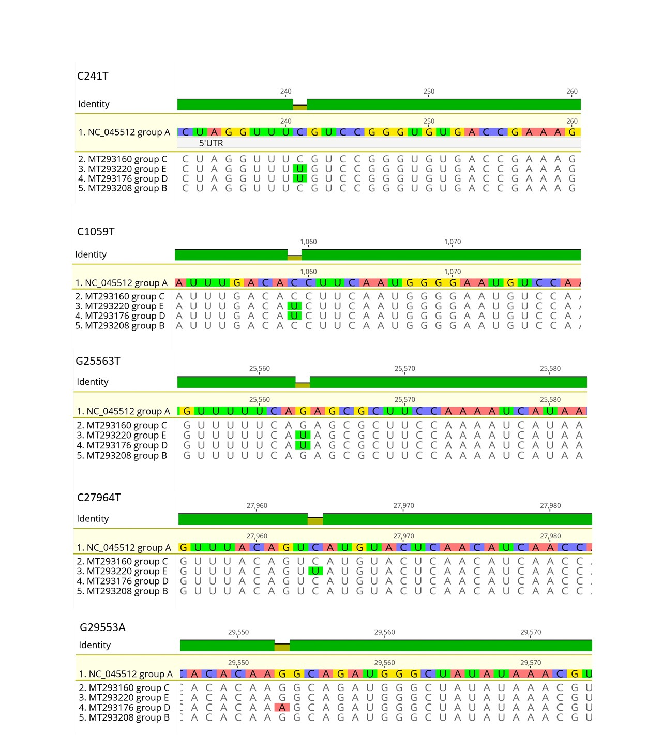
Figure S1. Representative novel mutations in SARS-COV-2 genomes
Table S1. GenBank accession number for the SARS-COV-2 genomes with novel mutations

G25563T(Q-H) orf3a group D (100/474) | C1059T (T to I) orf1ab group D (95/470) | C27964T (S to L) orf8 Group E 16/474 | G29553A (Noncoding) 48/474 | C241T (5'UTR) 112/474
MT293224.1 | MT293224.1 | MT293220.1 | MT293224.1 | MT293224.1
MT293223.1 | MT293223.1 | MT293182.1 | MT293223.1 | MT293222.1
MT293222.1 | MT293222.1 | MT293167.1 | MT293217.1 | MT293220.1
MT293221.1 | MT293221.1 | MT263459.1 | MT293212.1 | MT293219.1
MT293220.1 | MT293220.1 | MT263415.1 | MT293204.1 | MT293215.1
MT293217.1 | MT293217.1 | MT263406.1 | MT293196.1 | MT293213.1
MT293215.1 | MT293215.1 | MT259277.1 | MT293193.1 | MT293212.1
MT293214.1 | MT293214.1 | MT259258.1 | MT293191.1 | MT293209.1
MT293213.1 | MT293213.1 | MT259256.1 | MT293180.1 | MT293207.1
MT293212.1 | MT293212.1 | MT259249.1 | MT293178.1 | MT293205.1
MT293205.1 | MT293205.1 | MT259244.1 | MT293176.1 | MT293204.1
MT293204.1 | MT293204.1 | MT259243.1 | MT293174.1 | MT293201.1
MT293201.1 | MT293201.1 | MT259235.1 | MT293173.1 | MT293197.1
MT293197.1 | MT293196.1 | MT258378.1 | MT293172.1 | MT293196.1
MT293196.1 | MT293195.1 | MT246484.1 | MT293171.1 | MT293195.1
MT293195.1 | MT293193.1 | MT246453.1 | MT293165.1 | MT293191.1
MT293193.1 | MT293191.1 |  | MT293164.1 | MT293189.1
MT293191.1 | MT293189.1 |  | MT293162.1 | MT293184.1
MT293189.1 | MT293182.1 |  | MT263467.1 | MT293182.1
MT293182.1 | MT293180.1 |  | MT263465.1 | MT293178.1
MT293180.1 | MT293178.1 |  | MT263446.1 | MT293176.1
MT293178.1 | MT293176.1 |  | MT263445.1 | MT293175.1
MT293176.1 | MT293175.1 |  | MT263442.1 | MT293174.1
MT293175.1 | MT293174.1 |  | MT263437.1 | MT293173.1
MT293174.1 | MT293173.1 |  | MT263436.1 | MT293172.1
MT293173.1 | MT293172.1 |  | MT263426.1 | MT293171.1
MT293172.1 | MT293171.1 |  | MT263417.1 | MT293165.1
MT293171.1 | MT293167.1 |  | MT263413.1 | MT293164.1
MT293167.1 | MT293165.1 |  | MT263407.1 | MT293162.1
MT293165.1 | MT293164.1 |  | MT263394.1 | MT293161.1
MT293164.1 | MT293162.1 |  | MT263393.1 | MT292580.1
MT293162.1 | MT293161.1 |  | MT263392.1 | MT292575.1
MT293161.1 | MT263468.1 |  | MT263391.1 | MT292570.1
MT263468.1 | MT263467.1 |  | MT263390.1 | MT292569.1
MT263467.1 | MT263465.1 |  | MT259286.1 | MT276598.1
MT263465.1 | MT263459.1 |  | MT259278.1 | MT276330.1
MT263459.1 | MT263446.1 |  | MT259273.1 | MT276329.1
MT263446.1 | MT263445.1 |  | MT259261.1 | MT276327.1
MT263445.1 | MT263442.1 |  | MT259260.1 | MT276323.1
MT263442.1 | MT263439.1 |  | MT259240.1 | MT263468.1
MT263439.1 | MT263437.1 |  | MT259239.1 | MT263467.1
MT263437.1 | MT263436.1 |  | MT251979.1 | MT263465.1
MT263436.1 | MT263432.1 |  | MT251976.1 | MT263459.1
MT263433.1 | MT263431.1 |  | MT251973.1 | MT263446.1
MT263432.1 | MT263428.1 |  | MT246490.1 | MT263445.1
MT263431.1 | MT263426.1 |  | MT246487.1 | MT263442.1
MT263428.1 | MT263417.1 |  | MT246450.1 | MT263439.1
MT263426.1 | MT263415.1 |  | MT246449.1 | MT263438.1
MT263417.1 | MT263413.1 |  |  | MT263437.1
MT263415.1 | MT263408.1 |  |  | MT263436.1
MT263413.1 | MT263407.1 |  |  | MT263433.1
MT263411.1 | MT263406.1 |  |  | MT263432.1
MT263409.1 | MT263394.1 |  |  | MT263431.1
MT263408.1 | MT263393.1 |  |  | MT263428.1
MT263407.1 | MT263392.1 |  |  | MT263426.1
MT263406.1 | MT263391.1 |  |  | MT263417.1
MT263394.1 | MT263390.1 |  |  | MT263415.1
MT263393.1 | MT259286.1 |  |  | MT263413.1
MT263392.1 | MT259283.1 |  |  | MT263411.1
MT263391.1 | MT259281.1 |  |  | MT263408.1
MT263390.1 | MT259278.1 |  |  | MT263406.1
MT259286.1 | MT259277.1 |  |  | MT263402.1
MT259281.1 | MT259273.1 |  |  | MT263394.1
MT259278.1 | MT259265.1 |  |  | MT263392.1
MT259277.1 | MT259264.1 |  |  | MT263391.1
MT259273.1 | MT259261.1 |  |  | MT263390.1
MT259265.1 | MT259260.1 |  |  | MT263388.1
MT259264.1 | MT259258.1 |  |  | MT263074.1
MT259261.1 | MT259256.1 |  |  | MT259286.1
MT259260.1 | MT259251.1 |  |  | MT259281.1
MT259258.1 | MT259249.1 |  |  | MT259278.1
MT259256.1 | MT259248.1 |  |  | MT259277.1
MT259251.1 | MT259246.1 |  |  | MT259273.1
MT259249.1 | MT259244.1 |  |  | MT259264.1
MT259248.1 | MT259243.1 |  |  | MT259263.1
MT259246.1 | MT259240.1 |  |  | MT259261.1
MT259244.1 | MT259239.1 |  |  | MT259260.1
MT259243.1 | MT259235.1 |  |  | MT259256.1
MT259240.1 | MT258383.1 |  |  | MT259251.1
MT259239.1 | MT258382.1 |  |  | MT259250.1
MT259235.1 | MT258381.1 |  |  | MT259249.1
MT258383.1 | MT258380.1 |  |  | MT259248.1
MT258382.1 | MT258378.1 |  |  | MT259246.1
MT258381.1 | MT251979.1 |  |  | MT259244.1
MT258380.1 | MT251976.1 |  |  | MT259243.1
MT258378.1 | MT251973.1 |  |  | MT259235.1
MT251979.1 | MT246490.1 |  |  | MT258383.1
MT251976.1 | MT246487.1 |  |  | MT258382.1
MT251974.1 | MT246484.1 |  |  | MT258381.1
MT251973.1 | MT246481.1 |  |  | MT258380.1
MT246490.1 | MT246467.1 |  |  | MT258379.1
MT246487.1 | MT246460.1 |  |  | MT258378.1
MT246484.1 | MT246453.1 |  |  | MT251979.1
MT246481.1 | MT246450.1 |  |  | MT251976.1
MT246480.1 | MT246449.1 |  |  | MT251974.1
MT246467.1 |  |  |  | MT251973.1
MT246460.1 |  |  |  | MT246490.1
MT246453.1 |  |  |  | MT246487.1
MT246450.1 |  |  |  | MT246484.1
MT246449.1 |  |  |  | MT246481.1
 |  |  |  | MT246480.1
 |  |  |  | MT246470.1
 |  |  |  | MT246467.1
 |  |  |  | MT246460.1
 |  |  |  | MT246453.1
 |  |  |  | MT246451.1
 |  |  |  | MT246450.1
 |  |  |  | MT246449.1
 |  |  |  | MT240479.1
 |  |  |  | MT233522.1
 |  |  |  | MT198653.1
 |  |  |  | MT192765.1

