Decision trees as feature selection methods to characterize the novice panel’s perception of Pinot noir wines

Supplementary Materials
Chemical reagent
Folin-Ciocalteu reagent (Merck), vanillin assay (99%, ECP), gallic acid (98%, ACROS), catechin-hydrate (99.8%, Sigma Aldrich), methyl cellulose (1500cp, Sigma Aldrich), methanol (Merck), ρ-(dimethylamino)cinamaldehyde (ρ-DMACA) (Sigma Aldrich), HCl (37%, Thermo Fisher Scientific), glycerol (99%, Thermo Fisher Scientific), Na₂CO₃ (99.5%, ECP), Ammonium sulfate (100.1%, AnalaR NORMAPUR®).

Chemical measurement procedure
Colour measurement
Shimadzu 2550 with 0.2 cm path length cuvettes were used for colour measurements. The colour of red wine can be determined at absorbance 420nm (A_{420nm}) for yellow colour, absorbance 520nm (A_{520nm}) for red colour and absorbance 620nm (A_{620nm}) for blue colour. (Dobrei, Poiana, Sala, Ghita, & Gergen, 2010).

Total phenolics assay
The total phenolic contents (TP) of wines were determined using the Folin-Ciocalteu method. Briefly, an aliquot (1 mL) of diluted wines was placed in a 10 mL volumetric flask, containing 5 mL of distilled water and 0.5 mL of Folin-Ciocalteu’s reagent. After 3 min, 1.5 mL solution of Na₂CO₃ (20g/L) was added and the total volume was made up to 10 mL with distilled water. Samples were stored for 60 min at room temperature in sealed flasks surrounded by aluminium foil, and the absorbance was measured against the blank (distilled water) at 750nm. Gallic acid was used as a standard for the construction of the calibration curve. The concentration of TP was expressed in mg/L as gallic acid equivalents (Ivanova et al., 2011).

Total flavanol assay
Total flavanol content was evaluated by the vanillin assay, in which one molecule of vanillin reacts with one molecule of flavanol to produce a red chromophore. The conversion was monitored as an increase in absorbance at 500 nm. One volume of sample diluted in methanol was mixed with 2.5 volumes of vanillin (1% in methanol) and 2.5 volumes of HCl (9M in methanol). The mixture was incubated for 20 min at 35 ºC before analysis. For each sample, a blank was used in which the vanillin solution was replaced with methanol alone. A standard curve was constructed with catechin-hydrate (Tabart, Kevers, Pincemail, Defraigne, & Dommes, 2010).

Total flavan-3-ols assay
The concentration of total flavan-3-ols was measured using the ρ-(dimethylamino)cinamaldehyde (ρ-DMACA) method (Ivanova, Stefova, & Chinnici, 2010). The contents of flavan-3-ols in the wines are expressed as catechin-hydrate equivalents. An aliquot (1mL) of an appropriately diluted sample was added to a 10 mL volumetric flask followed by the addition of 3 drops of glycerol and 5 mL ρ-DMACA reagent. The total volume was made up to 10 mL with methanol and after 7 min, the absorbance was read at 640nm against a methanol blank. The DMACA reagent was prepared immediately before use, and contained 1% (w/v) DMACA in a cold mixture of methanol and HCl (4:1).

Total anthocyanins assay
Wine samples were diluted with a solution consisting of 70/30/1(v/v/v) ethanol/water/HCl (concentrated) and the absorbance was measured at 540nm (Ivanova, Stefova, & Chinnici, 2010). Due to the lack of a malvidin-3-glucoside standard, the total anthocyanic content are expressed as malvidin-3-glucoside equivalents and calculated using the following equation
TA_{540nm} (mg/L) =A_{540nm}16.7d (Ivanova, Stefova, & Chinnici, 2010)
Where A_{540nm} is the absorbance at 540nm and d is the dilution.

Total tannins assay
The use of other polymers to precipitate tannins has also been utilized in the methyl cellulose precipitable tannin assay (MCP). Briefly 3 mL MCP solution (0.04% w/v, 1500 cP viscosity) was added into 0.25 ml wine sample. After 1 minute, 2 mL of a saturated solution of (NH₄)₂SO₄ and 4.75 mL distilled water are added. A control sample is also prepared, but with distilled water instead of MCP solution. After 10 minutes, the samples are centrifuged for 5 min, and the tannin content is obtained by comparing the A_{280nm}^{control} and A_{280nm} treatment referenced to catechin-hydrate equivalents (Aleixandre-Tudo, Buica, Nieuwoudt, Aleixandre, & Du Toit, 2017).

Chemical age
To 0.1 mL of wine, 10 mL of 1 N HCl was added and the value of absorbance was measured at 520nm in a 10 mm cuvette after 60 minutes. And then, this sample was measure at 520nm (A_{520nm}^{HCl}) and 280nm (A_{280nm}^{HCl}). Chemical age=A_{520nm}^{HCl}/ A_{280nm}^{HCl} (Dobrei, Poiana, Sala, Ghita, & Gergen, 2010).

pH measurement
Edge pH meter has been applied to measure Pinot noir wines’ pH.

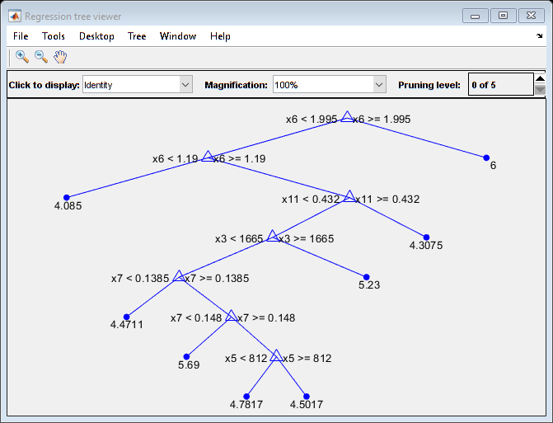
(a) NZ wines’ chemical parameters selected by NCA (b) NZ wines’ chemical parameters selected by decision trees
X1-X13 in Figure S1 (b): X1= Total anthocyanins, X2=total phenolics, X3=total tannins, X4=total flavan-3ols, X5=total flavanols,
X6=A280nmHCl, X7=A520nmHCl, X8=chemical age, X9=A420nm, X10=A520nm, X11=A620nm, X12=pH, X13=alcohol content
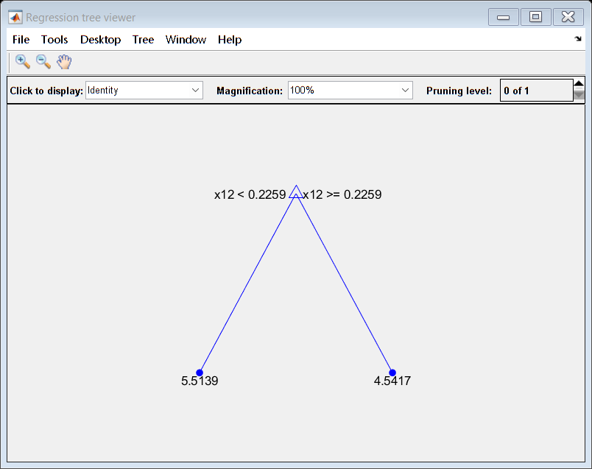
(c) AUS wines’ chemical parameters selected by NCA (d) AUS wines’ chemical parameters selected by decision trees
X1-X13 in Figure S1(d): X1=Total anthocyanins, X2=Total phenolics, X3=total flavan-3ols, X4=total flavanols, X5=pH, X6=A420nm,
X7=A520nm, X8=A620nm, X9=total tannins, X10=A520nmHCl, X11=A280nmHCl, X12=Chemical age, X13=Alcohol content
Figure S1. Selected important chemical parameters for astringency evaluated by novice panels.

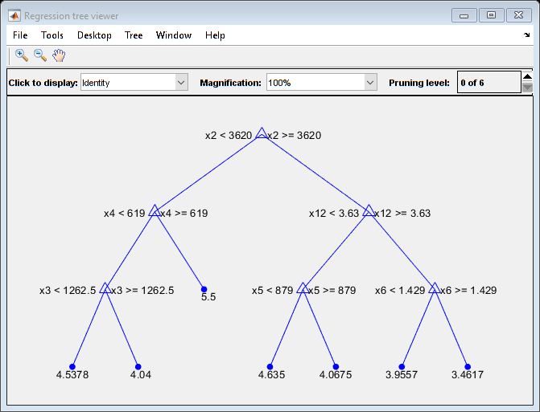
(a) NZ wines’ chemical parameters selected by NCA (b) NZ wines’ chemical parameters selected by decision trees
X1-X13 in Figure S2 (b): X1= Total anthocyanins, X2=total phenolics, X3=total tannins, X4=total flavan-3ols, X5=total flavanols, X6=A280nmHCl, X7=A520nmHCl, X8=chemical age, X9=A420nm, X10=A520nm, X11=A620nm, X12=pH, X13=alcohol content

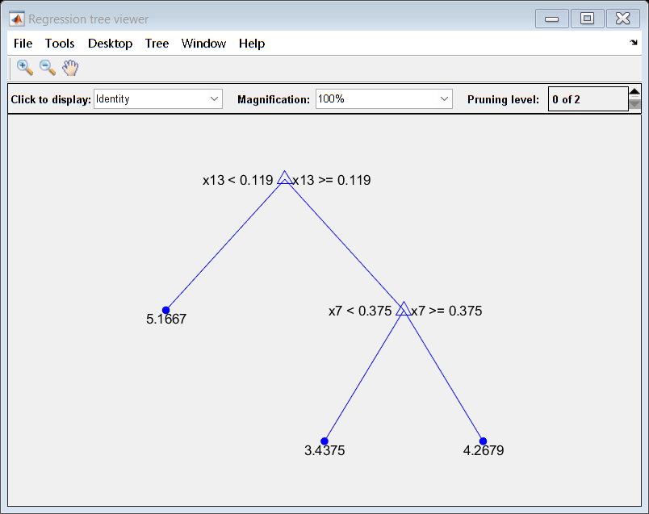
(c) AUS wines’ chemical parameters selected by NCA (d) AUS wines’ chemical parameters selected by decision trees X1-X13 in Figure S2 (d): X1=Total anthocyanins, X2=Total phenolics, X3=total flavan-3ols, X4=total flavanols, X5=pH, X6=A420nm, X7=A520nm, X8=A620nm, X9=total tannins, X10=A520nmHCl, X11=A280nmHCl, X12=Chemical age, X13=Alcohol content
Figure S2. Selected important chemical parameters for sweetness evaluated by novice panels.

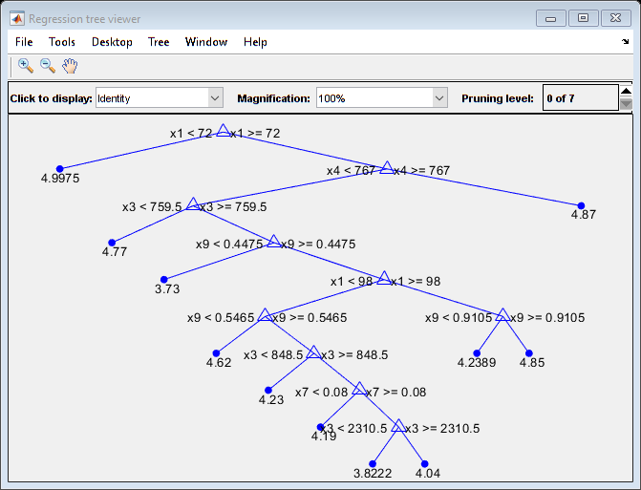
(a) NZ wines’ chemical parameters selected by NCA (b) NZ wines’ chemical parameters selected by decision trees
X1-X13 in Figure S3 (b): X1= Total anthocyanins, X2=total phenolics, X3=total tannins, X4=total flavan-3ols, X5=total flavanols, X6=A280nmHCl, X7=A520nmHCl, X8=chemical age, X9=A420nm, X10=A520nm, X11=A620nm, X12=pH, X13=alcohol content
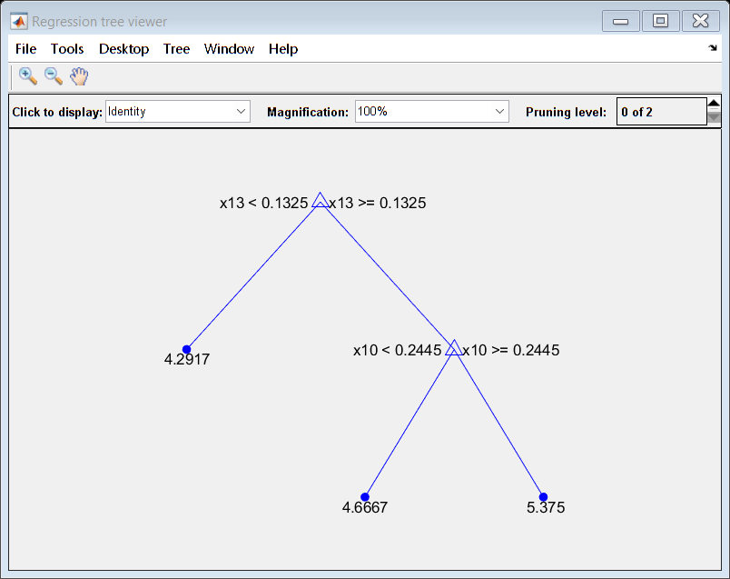
(c) AUS wines’ chemical parameters selected by NCA (d) AUS wines’ chemical parameters selected by decision trees
X1-X13 in Figure S3 (d): X1=Total anthocyanins, X2=Total phenolics, X3=total flavan-3ols, X4=total flavanols, X5=pH, X6=A420nm, X7=A520nm, X8=A620nm, X9=total tannins, X10=A520nmHCl, X11=A280nmHCl, X12=Chemical age, X13=Alcohol content
Figure S3. Selected important chemical parameters for sourness evaluated by novice panels.

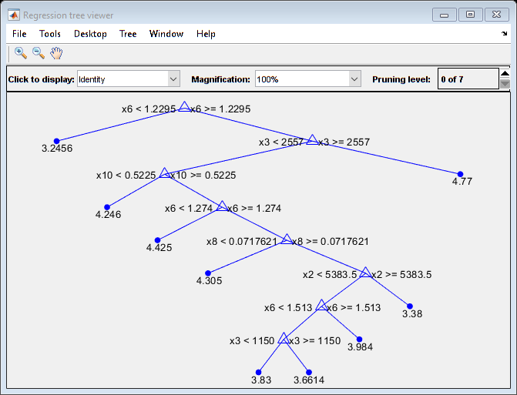
(a) NZ wines’ chemical parameters selected by NCA (b) NZ wines’ chemical parameters selected by decision trees
X1-X13 in Figure S4 (b): X1= Total anthocyanins, X2=total phenolics, X3=total tannins, X4=total flavan-3ols, X5=total flavanols, X6=A280nmHCl, X7=A520nmHCl, X8=chemical age, X9=A420nm, X10=A520nm, X11=A620nm, X12=pH, X13=alcohol content
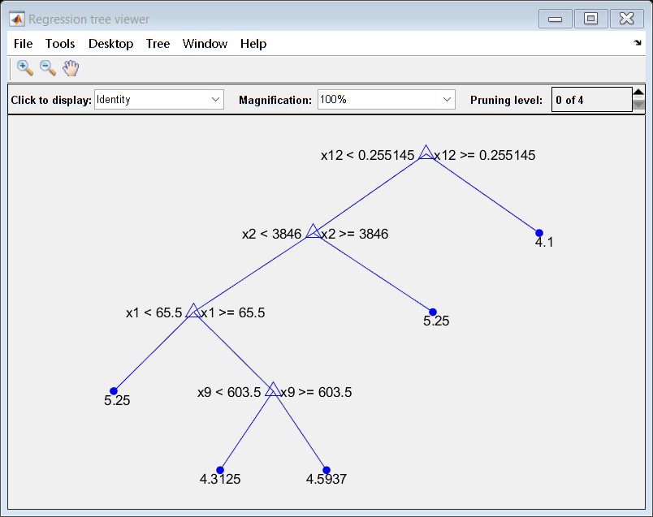
(c) AUS wines’ chemical parameters selected by NCA (d) AUS wines’ chemical parameters selected by decision trees
X1-X13 in Figure S4 (d): X1=Total anthocyanins, X2=Total phenolics, X3=total flavan-3ols, X4=total flavanols, X5=pH, X6=A420nm, X7=A520nm, X8=A620nm, X9=total tannins, X10=A520nmHCl, X11=A280nmHCl, X12=Chemical age, X13=Alcohol content
Figure S4. Selected important chemical parameters for bitterness evaluated by novice panels.

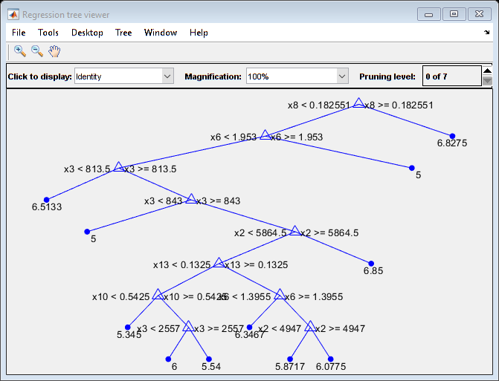
(a) NZ wines’ chemical parameters selected by NCA (b) NZ wines’ chemical parameters selected by decision trees
X1-X13 in Figure S5 (a): X1= Total anthocyanins, X2=total phenolics, X3=total tannins, X4=total flavan-3ols, X5=total flavanols, X6=A280nmHCl, X7=A520nmHCl, X8=chemical age, X9=A420nm, X10=A520nm, X11=A620nm, X12=pH, X13=alcohol content

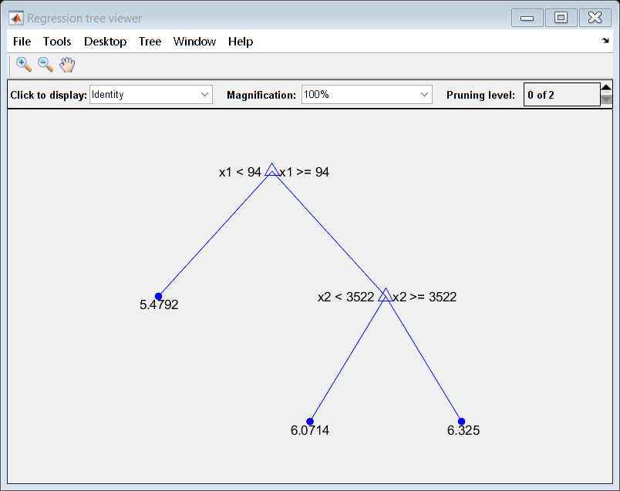
(c) AUS wines’ chemical parameters selected by NCA (d) AUS wines’ chemical parameters selected by decision trees
X1-X13 in Figure S5 (d): X1=Total anthocyanins, X2=Total phenolics, X3=total flavan-3ols, X4=total flavanols, X5=pH, X6=A420nm, X7=A520nm, X8=A620nm, X9=total tannins, X10=A520nmHCl, X11=A280nmHCl, X12=Chemical age, X13=Alcohol content
Figure S5. Selected important chemical parameters for clarity evaluated by novice panels.

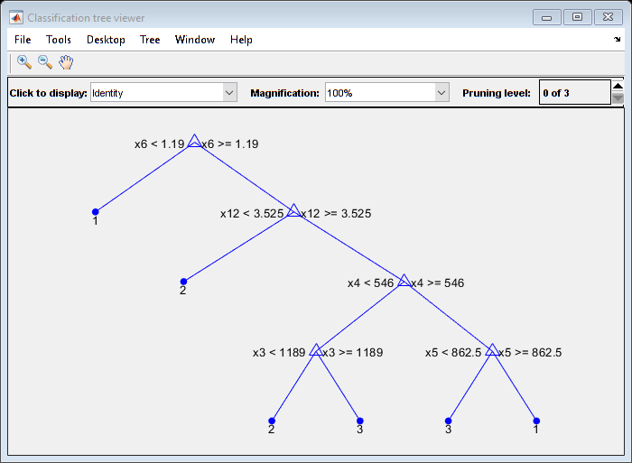
(a) NZ wines’ chemical parameters selected by NCA (b) NZ wines’ chemical parameters selected by decision trees
X1-X13 in Figure S6 (b): X1=Total anthocyanins, X2=Total phenolics, X3=total tannins, X4=total flavan-3ols, X5=total flavanols, X6=A280nmHCl, X7=A520nmHCl, X8=Chemical age, X9=A420nm, X10=A520nm, X11=A620nm, X12=pH, X13=Alcohol content
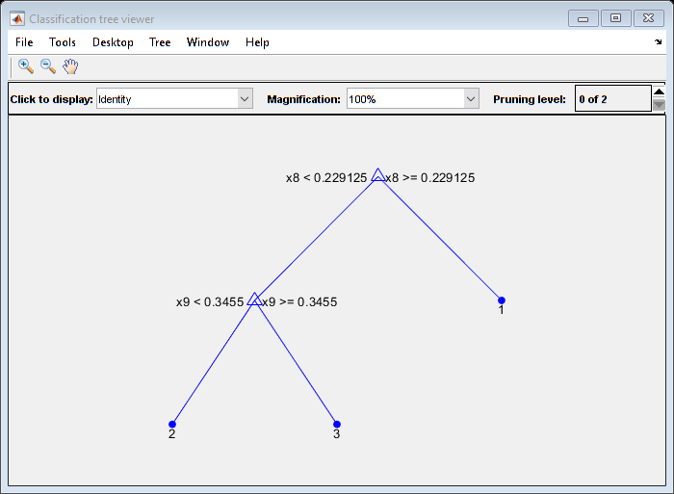
(c) AUS wines’ chemical parameters selected by NCA (d) AUS wines’ chemical parameters selected by decision trees
X1-X13 in Figure S6(d): X1=Total anthocyanins, X2=Total phenolics, X3=total tannins, X4=total flavan-3ols, X5=total flavanols, X6=A280nmHCl, X7=A520nmHCl, X8=Chemical age, X9=A420nm, X10=A520nm, X11=A620nm, X12=pH, X13=Alcohol content
Figure S6. Selected important chemical parameters for astringency evaluated by novice panels.

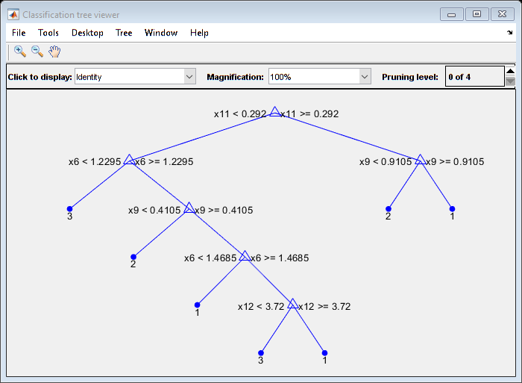
(a) NZ wines’ chemical parameters selected by NCA (b) NZ wines’ chemical parameters selected by decision trees
X1-X13 in Figure S6 (b): X1=Total anthocyanins, X2=Total phenolics, X3=total tannins, X4=total flavan-3ols, X5=total flavanols, X6=A280nmHCl, X7=A520nmHCl, X8=Chemical age, X9=A420nm, X10=A520nm, X11=A620nm, X12=pH, X13=Alcohol content
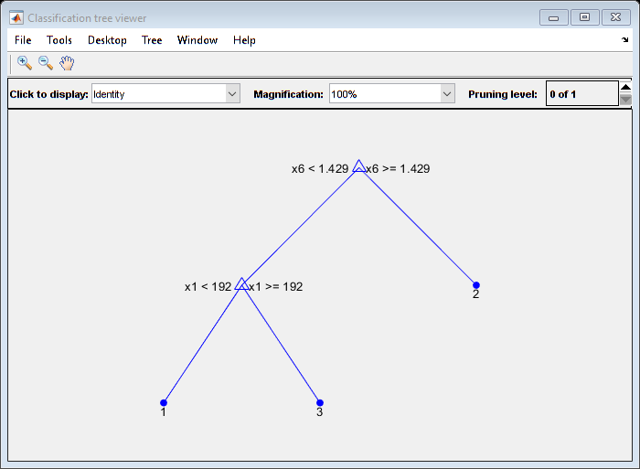
(c) AUS wines’ chemical parameters selected by NCA (d) AUS wines’ chemical parameters selected by decision trees
X1-X13 in Figure S7 (d): X1=Total anthocyanins, X2=Total phenolics, X3=total tannins, X4=total flavan-3ols, X5=total flavanols, X6=A280nmHCl, X7=A520nmHCl, X8=Chemical age, X9=A420nm, X10=A520nm, X11=A620nm, X12=pH, X13=Alcohol content
Figure S7. Selected important chemical parameters for sweetness evaluated by novice panels.

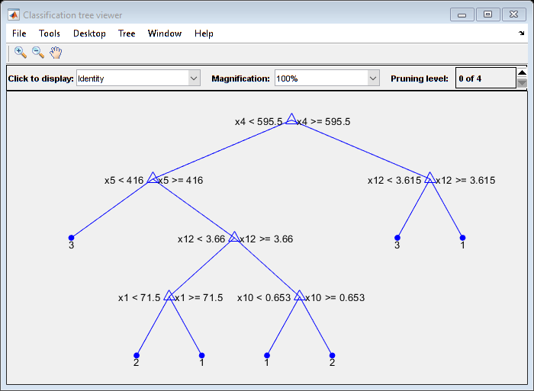
(a) NZ wines’ chemical parameters selected by NCA (b) NZ wines’ chemical parameters selected by decision trees
X1-X13 in Figure S8 (b): X1=Total anthocyanins, X2=Total phenolics, X3=total tannins, X4=total flavan-3ols, X5=total flavanols, X6=A280nmHCl, X7=A520nmHCl, X8=Chemical age, X9=A420nm, X10=A520nm, X11=A620nm, X12=pH, X13=Alcohol content
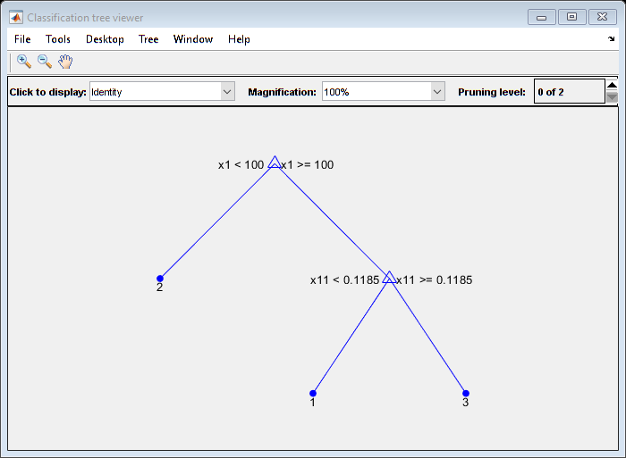
(c) AUS wines’ chemical parameters selected by NCA (d) AUS wines’ chemical parameters selected by decision trees
X1-X13 in Figure S8 (d): X1=Total anthocyanins, X2=Total phenolics, X3=total tannins, X4=total flavan-3ols, X5=total flavanols, X6=A280nmHCl, X7=A520nmHCl, X8=Chemical age, X9=A420nm, X10=A520nm, X11=A620nm, X12=pH, X13=Alcohol content
Figure S8. Selected important chemical parameters for sourness evaluated by novice panels.

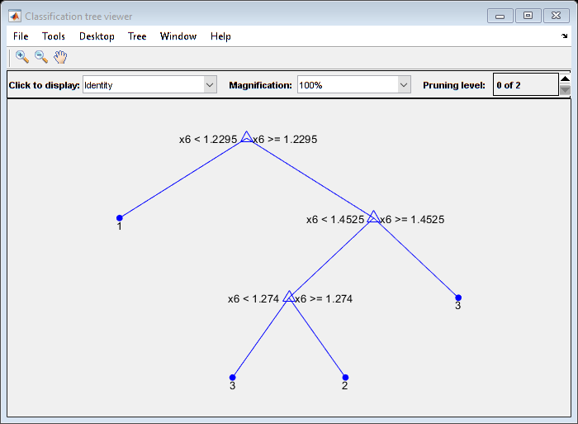
(a) NZ wines’ chemical parameters selected by NCA (b) NZ wines’ chemical parameters selected by decision trees
X1-X13 in Figure S9 (b): X1=Total anthocyanins, X2=Total phenolics, X3=total tannins, X4=total flavan-3ols, X5=total flavanols, X6=A280nmHCl, X7=A520nmHCl, X8=Chemical age, X9=A420nm, X10=A520nm, X11=A620nm, X12=pH, X13=Alcohol content

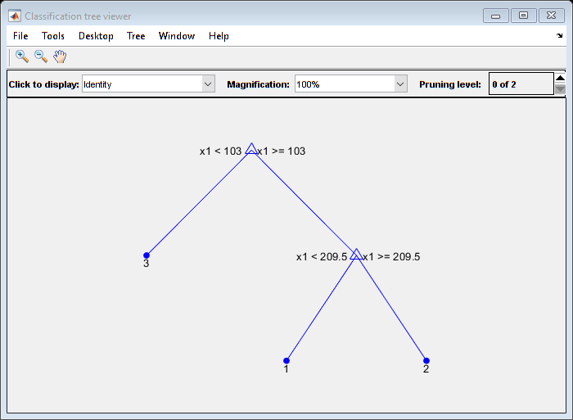
(c) AUS wines’ chemical parameters selected by NCA (d) AUS wines’ chemical parameters selected by decision trees
X1-X13 in Figure S9 (d): X1=Total anthocyanins, X2=Total phenolics, X3=total tannins, X4=total flavan-3ols, X5=total flavanols, X6=A280nmHCl, X7=A520nmHCl, X8=Chemical age, X9=A420nm, X10=A520nm, X11=A620nm, X12=pH, X13=Alcohol content
Figure S9. Selected important chemical parameters for bitterness evaluated by novice panels.

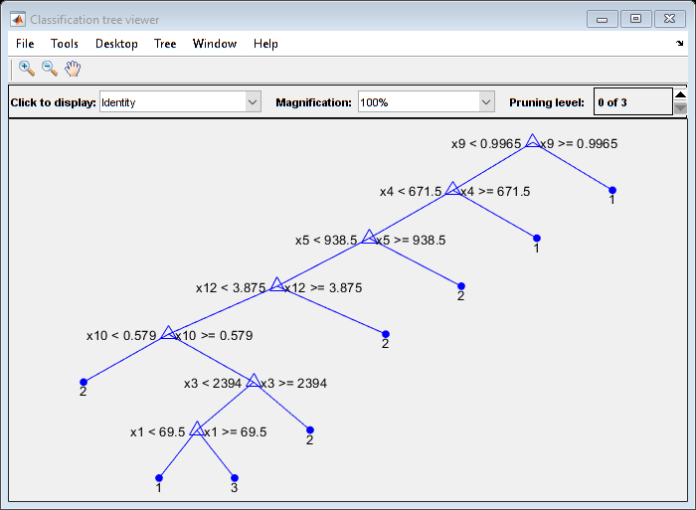
(a) NZ wines’ chemical parameters selected by NCA (b) NZ wines’ chemical parameters selected by decision trees
X1-X13 in Figure S10 (b): X1=Total anthocyanins, X2=Total phenolics, X3=total tannins, X4=total flavan-3ols, X5=total flavanols, X6=A280nmHCl, X7=A520nmHCl, X8=Chemical age, X9=A420nm, X10=A520nm, X11=A620nm, X12=pH, X13=Alcohol content
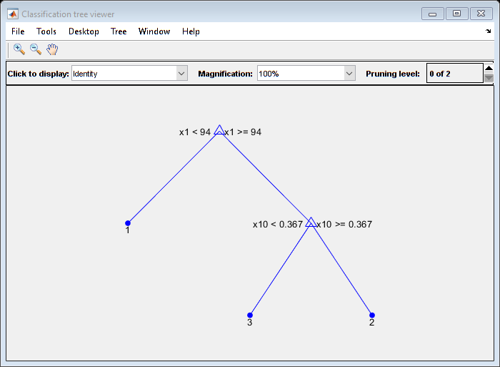
(c) AUS wines’ chemical parameters selected by NCA (d) AUS wines’ chemical parameters selected by decision trees
X1-X13 in Figure S10 (d): X1=Total anthocyanins, X2=Total phenolics, X3=total tannins, X4=total flavan-3ols, X5=total flavanols, X6=A280nmHCl, X7=A520nmHCl, X8=Chemical age, X9=A420nm, X10=A520nm, X11=A620nm, X12=pH, X13=Alcohol content
Figure S10. Selected important chemical parameters for clarity evaluated by novice panels.

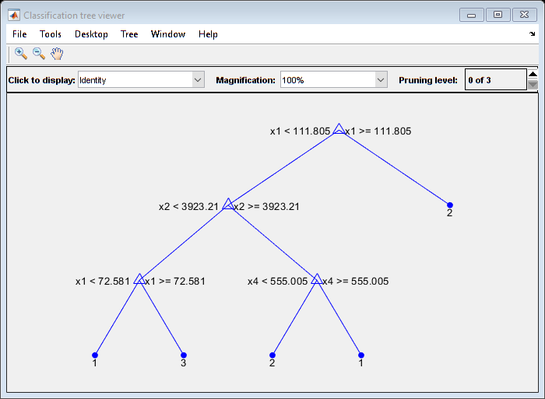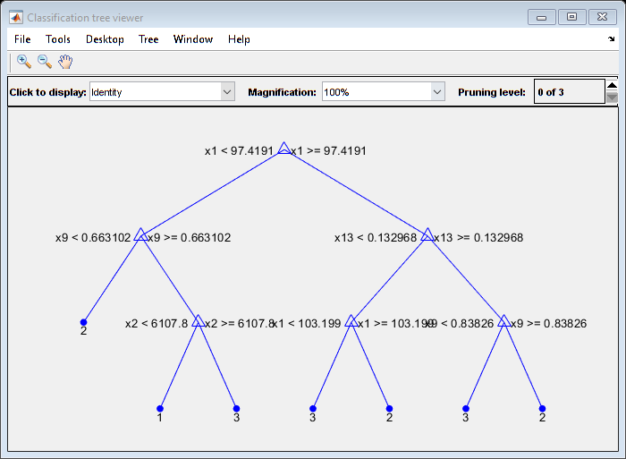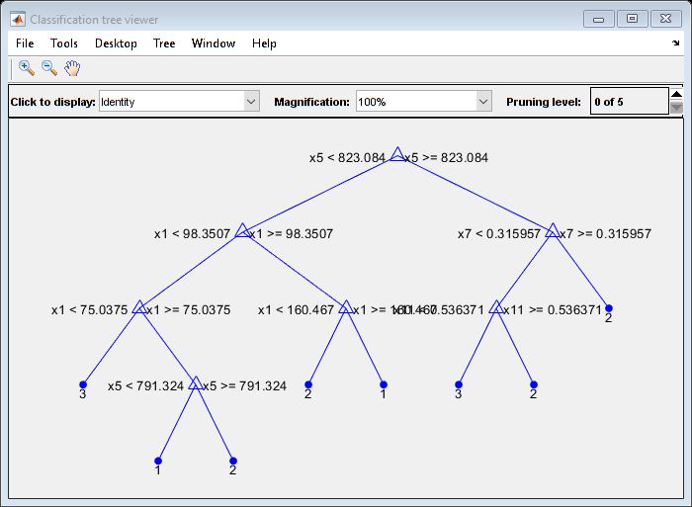
(a) Astringency (b) Sweetness (c) Sourness

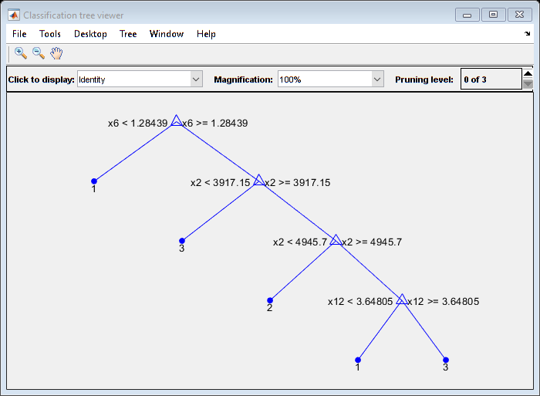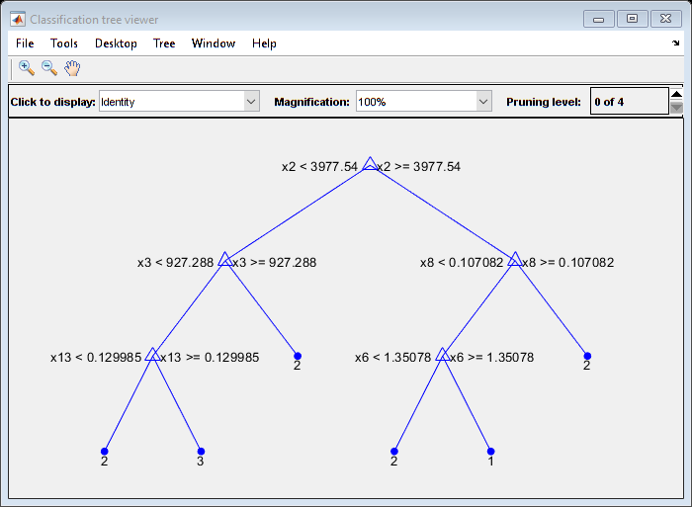
(d) Bitterness (e) Clarity
X1-X13 in decision trees are total anthocyanins, total phenolics, total tannins, total flavan-3ols, total flavanols, A280nm HCl, A520nmHCl, chemical age, A420nm, A520nm, A620nm, pH and alcohol content.
Figure S11. Classification tree viewers in decision trees based on New Zealand Pinot noir wines’ data generated by SMOTE

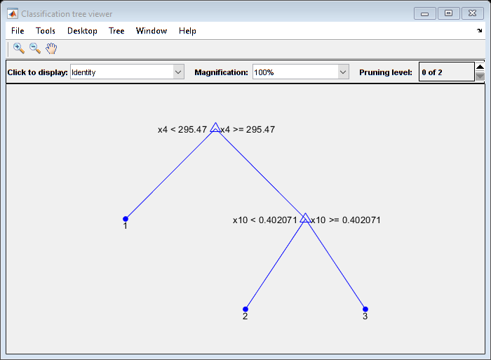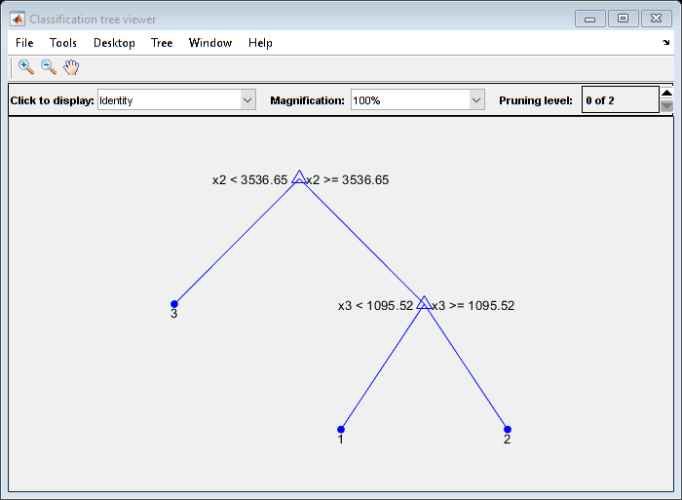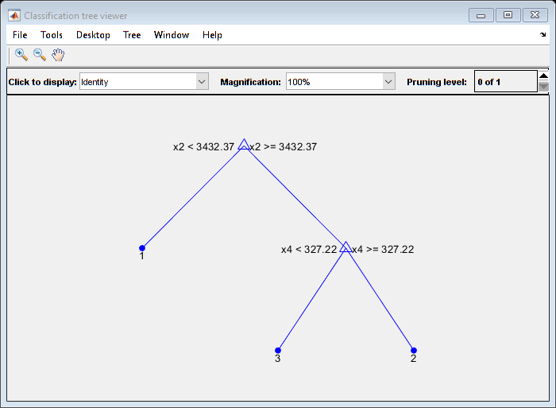
(a) Astringency (b) Sweetness (c) Sourness
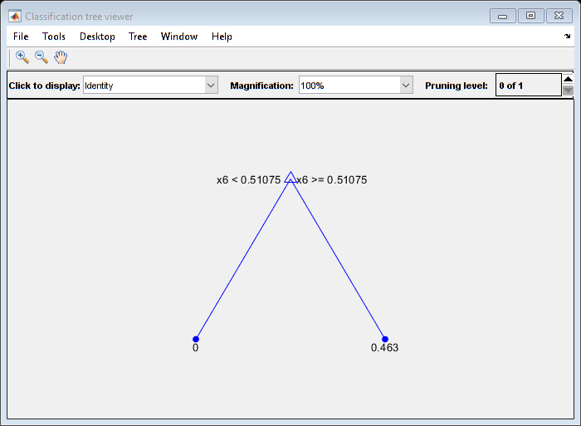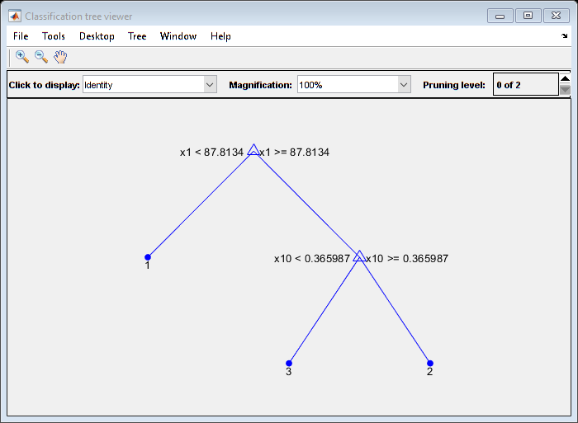
(d) Bitterness (e) Clarity
X1-X13 in decision trees are total anthocyanins, total phenolics, total tannins, total flavan-3ols, total flavanols, A280nm HCl, A520nmHCl, chemical age, A420nm, A520nm, A620nm, pH and alcohol content.
Figure S12. Classification tree viewers in decision trees based on Australian Pinot noir wines’ data generated by SMOTE.

Text S1. Decision tree Code
[num1 text1] =xlsread('AUS wines.xlsx');
X=[num1(:,1:13)]

%Astringency
Y1=num1(:,14);
t1 = fitctree(X,Y1)
Y1_pred=predict(t1,X);
view(t1,'mode','graph')
PredictErr=resubLoss(t1)

Text S2. Neighborhood Component Analysis Code
% NCA
mdl = fscnca(X,Y,'Solver','sgd','Verbose',5);
figure()
plot(mdl.FeatureWeights,'ro')
Str2={'Total anthocyanins','Total phenolics','Total tannins','Total flavan-3-ols','Total flavanols','A280nmHCl','A520nmHCl','Chemical age','A420nm','A520nm','A620nm','pH','Alcohol content'};
for i=1:13
text(i+0.13,mdl.FeatureWeights(i),Str2(i));
end
grid on
xlabel('Feature index')
ylabel('Variable Importance')
Ypred1=predict(mdl,X);
L = loss(mdl,X,Y)
xlim([0 7])

Text S3. PCA codes
%Input
X=xlsread("NZ untrained panellists preference",'A2:E40');
Y=xlsread("NZ untrained panellists preference",'N2:N40');
Z=xlsread("NZ untrained panellists preference",'A2:E40');

%Standby
[N K]=size(Z);
Zmean=mean(Z);
Zstd=std(Z);
%standardized X matrix

X=(Z-repmat(Zmean, [N 1]))./repmat(Zstd, [N 1]); %remove means and normalized the variance
%save data_check x
%format bank
X=[X(:,1:5)];

[U, S, V]=svd(X);

T=U*S;
P=V;

% Eigenvalues of the covariance matrix of X

L=(diag(S).*diag(S))/(N-1);
%score scattered plot for the first two components

%PCA loading
figure(2)
clf

vbls={'Total phenolics' 'Total flavan-3ols' 'Total tannins' 'Total anthocyanins' 'Total flavanols' };

k=5;
plot(V(:,1),V(:,2),'rs','LineWidth',1,...
'MarkerEdgeColor','r',...
'MarkerFaceColor','b',...
'MarkerSize',14)
for i=1:2
text(V(i,1)+0.05,V(i,2),vbls(i),...
'HorizontalAlignment','left',"FontSize",12)
end
for i=3
text(V(i,1),V(i,2)+0.1,vbls(i),...
'HorizontalAlignment','left',"FontSize",12)
end
for i=4:5
text(V(i,1)+0.05,V(i,2),vbls(i),...
'HorizontalAlignment','left',"FontSize",12)
end
xlabel(['PC1',' ','(',num2str(round(L(1)/sum(L)*100)),'%',')'],"FontSize",16)
ylabel(['PC2',' ','(',num2str(round(L(2)/sum(L)*100)),'%',')'],"FontSize",16)
hold on

xlim([-1,1])
ylim([-1.2,0.3])
hold on
plot([-max(V(:,1))*1000 max(V(:,1))*1000],[0,0],'r')
hold on
plot([0,0],[max(V(:,2))*20 -max(V(:,2))*20],'r')
hold on
title('Novice perception: NZ Pinot noir wines',"FontSize",16)

%Score with legend for clustering
figure(4)
clf

x = T(1:39,1);
y = T(1:39,2);
sz = 75;
c = Y;
cmin = 2;
cmax = 7;
scatter(x,y,sz,c,'filled','o')

colorbar;

xlabel(['PC1',' ','(',num2str(round(L(1)/sum(L)*100)),'%',')'],"FontSize",16)
ylabel(['PC2',' ','(',num2str(round(L(2)/sum(L)*100)),'%',')'],"FontSize",16)
hold on

xlim([-max(T(:,1))*2 max(T(:,1))*1.1])
ylim([-max(T(:,2))*2.4 max(T(:,2))*1.1])
hold on
plot([-max(T(:,1))*2 max(T(:,1))*1.1],[0,0],'r')
hold on
plot([0,0],[-max(T(:,2))*2.5 max(T(:,2))*1.1],'r')
hold on

title('Novice perception: NZ Pinot noir wines',"FontSize",16)

Text S4. Scatter plots
% Astringency NCA (NZ)
X=xlsread("NZ untrained panellists preference.xlsx",'C2:C40');
Y=xlsread("NZ untrained panellists preference.xlsx",'E2:E40');
Z=xlsread("NZ untrained panellists preference.xlsx",'V2:V40');
sz = 75
c=Z
cmin = 2;
cmax = 7;
scatter (X,Y,sz,c,'filled','o');
colorbar

Text S5. SMOTE codes
# 使用imlbearn库中上采样方法中的SMOTE接口
from imblearn.over_sampling import SMOTE
import pandas as pd
import numpy as np
from collections import Counter
# 读取xlsx文件
data = pd.read_excel('Food additives.xlsx')
# 读取特征
X = data.iloc[0:31, 0:15]
# 读取标签，标签在第14列
y = data.iloc[0:31,15]
# label转换为numpy数组
y = np.array(y)
print(X)
print(y)
print(Counter(y))
# 定义SMOTE模型，random_state相当于随机数种子的作用 可通过radio参数指定对应类别要生成的数据的数量
smo = SMOTE(sampling_strategy={1:64,2:64},random_state=42)
X = np.array(X, dtype=np.float64)
X_smo, y_smo = smo.fit_resample(X, y)
print(Counter(y_smo))
# 保存数据
data = pd.DataFrame(X_smo)
data['label'] = y_smo
data.to_excel('Food additives_smo.xlsx', index=False)
# Counter({0: 900, 1: 300})

