Supplementary Information for
Weak interaction based interpretation of crystal packing characteristics of aromatic rings accumulating molecules: Hirshfeld surface analyses reinforced X-ray crystal study on
1,8-dibenzoyl-7-ethoxynaphthalen-2-ol and its 2-ethoxylated homologue

K. Iida¹, T. Doi¹, A. Isogai-Koda¹, K. Noguchi², N. Yonezawa¹, A. Okamoto¹*
¹Department of Organic and Polymer Materials Chemistry, Tokyo University of Agriculture and Technology, 2-24-16 Nakamachi, Koganei, Tokyo, 184–8588, Japan.
² Instrumentation Analysis Center, Tokyo University of Agriculture and Technology, 2-24-16, Nakamachi, Koganei, Tokyo 184-8588, Japan

Corresponding author E-mail: aokamoto@cc.tuat.ac.jp

Table of Contents

1. Compound Data S-3
¹H, ¹³C NMR, and IR Spectra
2. X-ray Diffraction Analysis S-15
3. References S-24

- Compound Data
Figure S-1. ¹H NMR spectra of 1-benzoyl-2,7-diethoxynaphthalene:
Chemical shifts -0.5~10.5 ppm (top) and 6.5~8.5 ppm (bottom).
Figure S-2. ¹³C NMR spectra of 1-benzoyl-2,7-diethoxynaphthalene: Chemical shifts -0.5~200.5 ppm.
Intensity

Wavenumber

Affiliation
Organization

(Standard)

(Equal interval)

(Tokyo University of Agriculture and Technology)

Analysis date
Update

Data type
Horizontal axis
Vertical axis
Start
End
Data interval
Number of data

Model name
Serial number

Measurement date

Illuminant
Detector
Scan
Resolution
Zero filling
Apodization
Gain
Aperture
Scan speed
Filter
Intensity

Wavenumber

Figure S-3. IR spectrum of 1-benzoyl-2,7-diethoxynaphthalene
Intensity

Wavenumber

Intensity

Wavenumber

Figure S-3. IR spectrum of 1-benzoyl-2,7-diethoxynaphthalene (continued)
Figure S-4. ¹H NMR spectra of 1-benzoyl-7-ethoxy-2-hydroxynaphthalene:
Chemical shifts -0.5~12.0 ppm (top) and 6.0~8.0 ppm (bottom).

Figure S-5. ¹³C NMR spectrum of 1-benzoyl-7-ethoxy-2-hydroxynaphthalene:
Chemical shifts -0.5~200.5 ppm (top) and 120.0~150 ppm (bottom).

Wavenumber

Intensity

Model name
Serial number

Measurement date

Illuminant
Detector
Scan
Resolution
Zero filling
Apodization
Gain
Aperture
Scan speed
Filter
Analysis date
Update

Data type
Horizontal axis
Vertical axis
Start
End
Data interval
Number of data
Wavenumber

Intensity

Affiliation
Organization

(Tokyo University of Agriculture and Technology)

(Standard)

(Equal interval)

Figure S-6. IR spectrum of 1-benzoyl-7-ethoxy-2-hydroxynaphthalene
Intensity

Wavenumber

Intensity

Wavenumber

Figure S-6. IR spectrum of 1-benzoyl-7-ethoxy-2-hydroxynaphthalene (continued)
Figure S-7. ¹H NMR spectra of 1,8-dibenzoyl-7-ethoxy-2-hydroxynaphthalene: Chemical shifts -0.5~10.5 ppm (top) and 6.5~8.5 ppm (bottom).
Figure S-8. ¹³C NMR spectra of 1,8-dibenzoyl-7-ethoxy-2-hydroxynaphthalene: Chemical shifts -0.5~200.5 ppm (top) and 120.0~145.0 ppm (bottom).

Intensity

Wavenumber

Model name
Serial number

Measurement date

Illuminant
Detector
Scan
Resolution
Zero filling
Apodization
Gain
Aperture
Scan speed
Filter
Analysis date
Update

Data type
Horizontal axis
Vertical axis
Start
End
Data interval
Number of data
(Equal interval)

(Standard)

(Tokyo University of Agriculture and Technology)

Affiliation
Organization

Intensity

Wavenumber

Figure S-9. IR spectra of 1,8-dibenzoyl-7-ethoxy-2-hydroxynaphthalene
Wavenumber

Intensity

Wavenumber

Intensity

Figure S-9. IR spectra of 1,8-dibenzoyl-7-ethoxy-2-hydroxynaphthalene (continued)

- X-ray Diffraction Analysis.
For the crystal structure determination, the single crystal of the title compound was used for data collection on a four circle Rigaku RAXIS RAPID diffractometer (equipped with a two-dimensional area IP detector). The graphite-monochromated CuKα radiation (λ = 1.54187 Å) was used for data collection. The lattice parameters were determined by the least-squares methods on the basis of all reflections with F² > 2σ(F²). Crystal data, data collection, and structure refinement details are summarized in Table S-1. The data collection and cell refinement were performed using RAPID-AUTO software [1]. The data reduction was performed using CrystalStructure [2]. The structures were solved by direct methods using SIR2011[3] and refined by a full-matrix least-squares procedure using the program SHELXL-2014 [4]. All H atoms were found in a difference map and were subsequently refined as riding atoms, with aromatic C–H = 0.95 Å and O–H = 0.84 Å, and with U_{iso}(H) = 1.2U_{eq} (C). Crystallographic data have been deposited at the Cambridge Crystallographic Data Centre, and can be obtained free of charge on application to CCDC, 12 Union Road, Cambridge CB21EZ, UK (fax: (+44) 1223-336-033; email: deposit@ccdc.cam.ac.uk).
Crystal data for title compound: C₂₆H₂₀O₄, colourless block, FW = 396.42, Triclinic, P-1, a = 8.0211(2) Å, b = 11.1964(3) Å, c = 11.6939(4) Å, α =81.2036(14)˚, β= 70.8877(13)°, γ = 86.930(2), V = 980.63(5) Å³, T = 193 K, Z = 2, D_{calcd} = 1.343 g cm⁻³, R₁ = 0.0437, wR₂ = 0.1510, GOF = 1.145. CCDC 2245426.

Table S-1. Crystal data and details of the structure refinement for the title compound and the homologous compound.

Parameters | Title compound | Homologue [5]
Empirical formula | C₂₆H₂₀O₄ | C₂₈H₂₄O₄
Formula weight | 396.42 | 424.47
Temperature (K) | 193 | 193
Crystal system | Triclinic | Monoclinic
Space group | P-1 | P2₁/n
a, (Å) | 8.0211(2) | 7.92185(14)
b, (Å) | 11.1964(3) | 20.6794(4)
c, (Å) | 11.6939(4) | 14.2130(3)
α, (˚) | 81.2036(14) | 90.00
β, (˚) | 70.8877(13) | 106.043(1)
γ, (˚) | 86.930(2) | 90.00
Volume (Å³) | 980.63(5) | 2237.68(7)
Z | 2 | 4
ρ_{calc} (g/cm³) | 1.343 | 1.260
μ (mm¹) | 0.73 | 0.67
F(000) | 416 | 896
Crystal size (mm³) | 0.20 × 0.10 × 0.05 | 0.60× 0.50 × 0.10
Radiation | CuKα (λ = 1.54187) | CuKα (λ = 1.54187)
2Θ range for data collection (°) | 4.0 to 68.2 | 3.2 to 68.3
Index ranges | -9 ≤ h ≤ 9,  -13≤ k ≤13,  -14 ≤ l ≤ 14 | -9 ≤ h ≤ 9,  -24≤ k ≤24,  -17 ≤ l ≤ 17
Reflections collected | 18695 | 39782
Independent reflections | 3541, R_{int} = 0.034 | 4076, R_{int} = 0.041
Data/restraints/parameters | 3541/0/249 | 3736/0/292
Goodness-of-fit on F² | 1.145 | 1.050
Final R indexes [I≥2σ (I)] | R₁ = 0.0437, wR₂ = 0.1510 | R₁ = 0.0348, wR₂ = 0.0905
Final R indexes [all data] | R₁ = 0.1058, wR₂ = 0.0951 | R₁ =0.0374, wR₂ = 0.0886
Largest diff. peak/hole (e Å⁻³) | 0.30/-0.29 | 0.23/-0.16

Table S-2. Geometric parameters for title compound: Bond lengths (Å)

Table S-3. Geometric parameters for title compound: Bond angles (˚).

Table S-4. Geometric parameters for title compound: Torsion angles (˚).

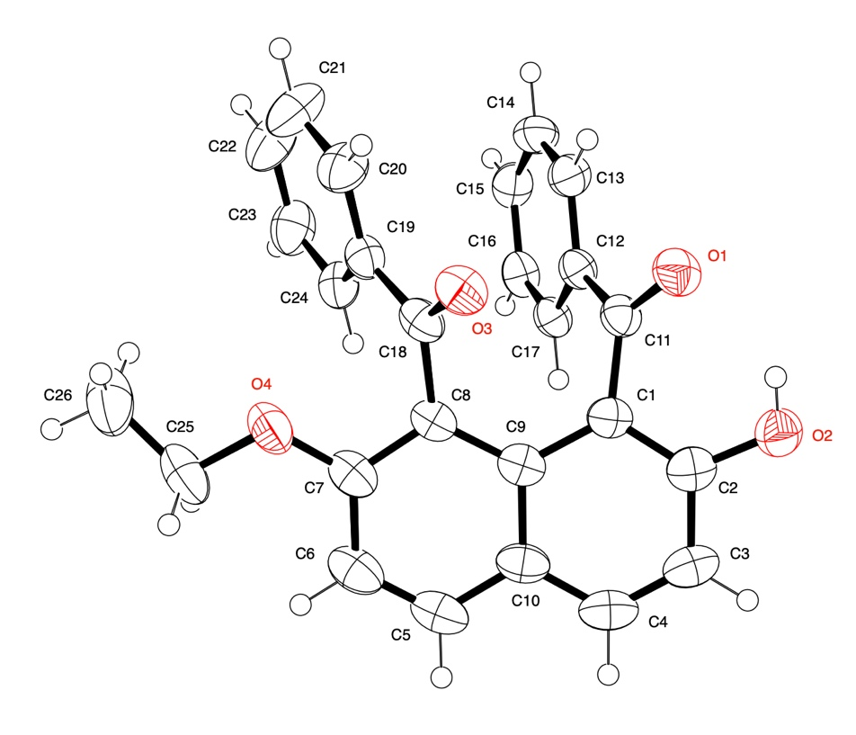
Figure S-10. Molecular structure of title compound in the title compound with the atom-labeling scheme and displacement ellipsoids drawn at the 50% probability level.

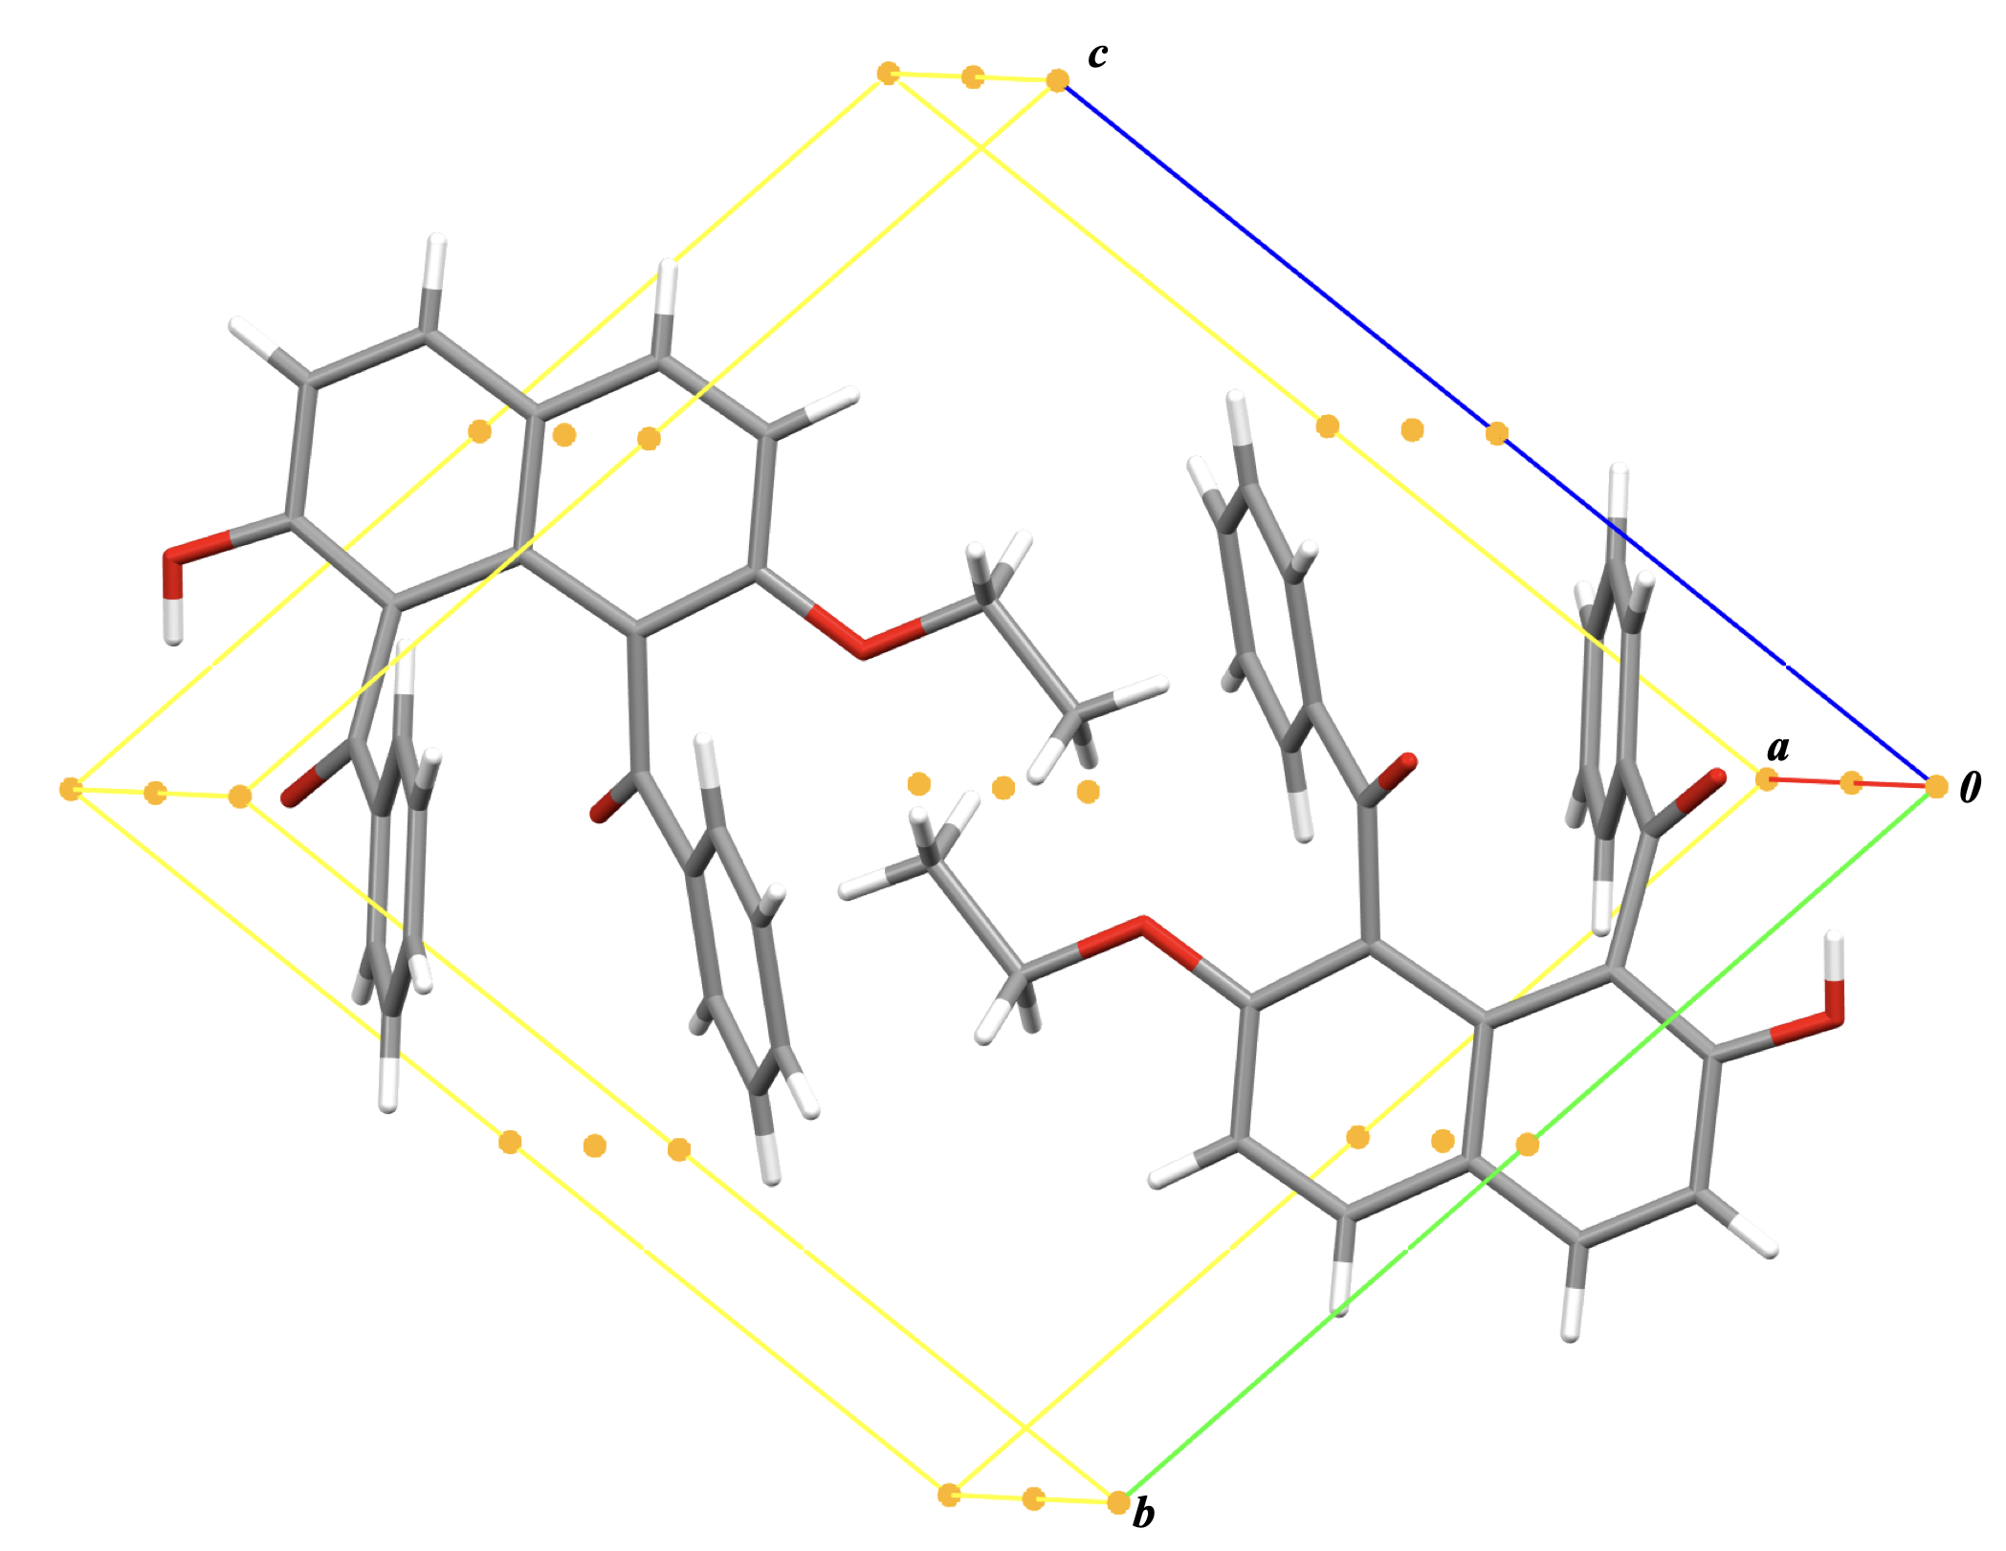

Figure S-11. Molecular unit of title compound with symmetry elements. Centrosymmetric centre is expressed as yellow dot.

Table S-5. Hydrogen bonding interactions for the title compound.
D–H…A | H…A (Å) | D…A (Å) | D–H…A(˚)
IntraO2–H2…O1 | 2.05 | 2.747(3) | 139
O2–H2…O1 ^{i} | 2.20 | 2.830(3) | 132
C15–H15…O2 ^{ii} | 2.58 | 3.387(3) | 143
C16–H16…O1^{iii} | 2.57 | 3.5693(1) | 137
Symmetry code: (i) 1-x, -y, -z; (ii) 2-x, -y, -z; (iii) 1+x, y, z.

Table S-6. π…π Stacking interactions for the title compound.
Ring I…Ring J | Distance (Å) | Slippage (Å) | Interplanar distance (Å) | Dihedral angle (˚) | Slippage angle (˚)
Cg3…Cg3 ^{iv} | 3.7114(10) | 1.536 | 3.3789(7) | 0.00(8) | 24.4
Cg5…Cg5 ^{v} | 3.4961 (15) | 0.860 | 3.3886(10) | 0.02(9) | 14.2
Cg3 centroid of C12–C17 ring; Cg5 centroid of C1/C2/C3/C4/C10/C5/C6/C7/C8/C9 ring
Symmetry code: (iv) 2-x, -y, -z; (v) 1-x, 1-y, -z.
Figure S-12. A part of molecular aggregation of title compound with symmetry elements.
O–H…O classical hydrogen bonds, C–H…O non-classical hydrogen bonds, and π…π stacking interactions are expressed as red dashed lines, black dashed lines, and green dotted lines, respectively.
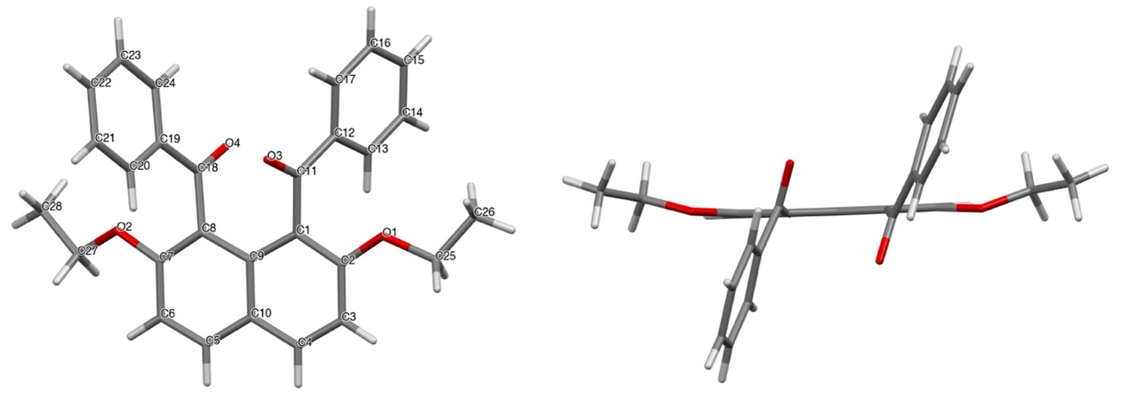
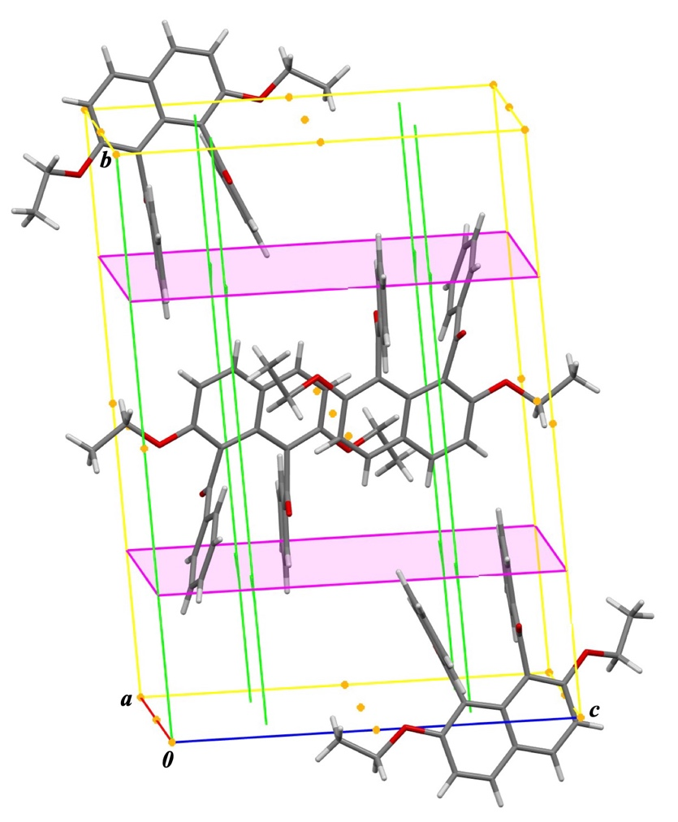
Figure S-13. Molecular structure of the homologous compound with atom-labelling (top) and molecular uni with symmetry elements (bottom). Centrosymmetric centre, two-fold helical axis, glide plane are expressed as yellow dot, green line with flags, and pink sheet, respectively.

Table S-7. Hydrogen bonding interactions for the homologous compound.[5]
D–H…A | H…A (Å) | D…A (Å) | D–H…A(˚)
C14–H14…O3 ^{i} | 2.37 | 3.2404(16) | 153
C21–H21…O4 ^{ii} | 2.39 | 3.3326(16) | 171
Symmetry code: (i) x+1, y, z; (ii) x-1, y, z.

Table S-8. π…π Stacking interactions for the homologous compound.
Ring I…Ring J | Distance (Å) | slippage(Å) | Interplanar distance (Å) | Dihedral angle (˚) | Slippage angle (˚)
Cg1…Cg1^{iii} | 3.6863(7) | 1.573 | 3.3338(5) | 0.00 | 25.26
Cg1 centroid of C1/C2/C3/C4/C10/C9 ring.
Symmetry code: (iii) 1-x,1-y,1-z.
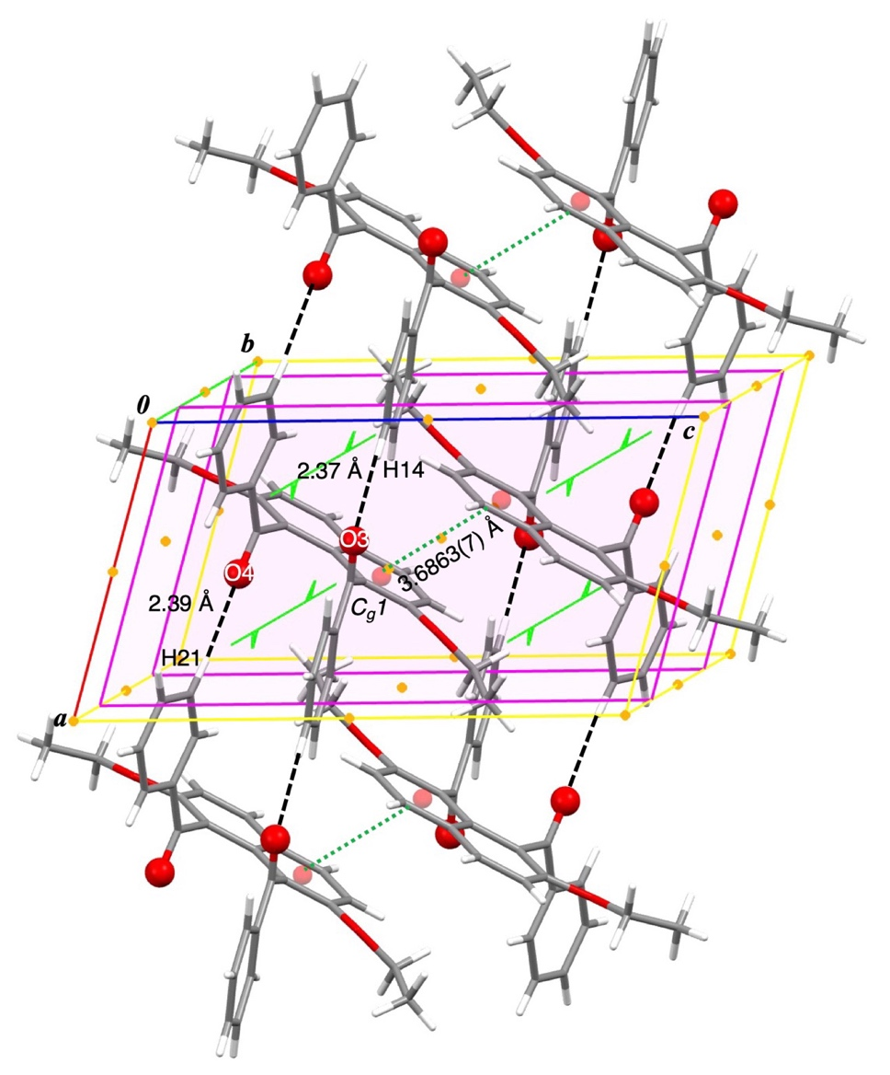
Figure S-14. A part of molecular aggregation of homologous compound with symmetry elements. C–H…O non-classical hydrogen bonds and π…π stacking interactions are expressed as black dashed lines and green dotted lines, respectively.

- References
1. Rigaku (1998). PROCESS‐AUTO. Rigaku Corporation, Tokyo, Japan.
2. Rigaku (2010). CrystalStructure. Rigaku Corporation, Tokyo, Japan.
3. M. C. Burla, R. Caliandro, M. Camalli, B. Carrozzini, G. L. Cascarano, L. De Caro, C. Giacovazzo, G. Polidori, D. Siliqi, and R. Spagna. J. Appl. Cryst. 2007, 40, 609‐613.
4. G. M. Sheldrick, Acta Cryst. A 2008, 64, 112‐122.
5. A. Isogai, T. Tsumuki, S. Murohashi, A. Okamoto, N. Yonezawa, Acta Cryst. 2013, E69, o71.

