Supplementary Figure 1. Monthly average temperature (top) and monthly precipitation totals (bottom) for the 2020-2021 growing season against historical averages from 1990-2021.

Supplemental Table 1. Soil data grouped by replicate blocks (3 sampling points per block) and depth
Replicate Block # | Depth  (cm) | Soil pH  (1:1 H₂O) | SOM  (LOI%) | Nitrate-N conc.  (ppm N) | CEC  (meq/100 g soil)
1 | 0-15.24 | 4.47 (0.06) | 2.17 (0.26) | 41.83 (8.22) | 12.77 (0.49)
1 | 15.24-30.48 | 5.40 (0.26) | 1.57 (0.06) | 11.47 (1.75) | 9.70 (1.01)
2 | 0-15.24 | 4.63 (0.15) | 2.07 (0.15) | 34.00 (11.61) | 12.17 (0.21)
2 | 15.24-30.48 | 5.20 (0.26) | 1.53 (0.06) | 11.03 (3.30) | 9.20 (0.17)
3 | 0-15.24 | 4.80 (0.26) | 2.17 (0.29) | 29.13 (12.70) | 11.57 (0.51)
3 | 15.24-30.48 | 5.37 (0.29) | 1.77 (0.12) | 8.87 (6.05) | 10.23 (0.21)
4 | 0-15.24 | 4.67 (0.12) | 2.10 (0.10) | 36.33 (1.29) | 11.77 (0.06)
4 | 15.24-30.48 | 5.67 (0.32) | 1.70 (0.00) | 8.80 (0.78) | 9.03 (0.15)
5 | 0-15.24 | 5.07 (0.23) | 1.73 (0.06) | 11.83 (3.02) | 10.87 (0.80)
5 | 15.24-30.48 | 5.50 (0.00) | 1.73 (0.06) | 4.73 (0.50) | 8.67 (0.25)

K conc.  (ppm K) | Mg conc.  (ppm Mg) | Ca conc.  (ppm Ca) | Sulfate-S conc.  (ppm S) | Na conc.  (ppm Na) | Fe conc.  (ppm Fe)
112.33 (14.64) | 72.00 (13.75) | 545.33 (83.43) | 9.73 (0.32) | 8.33 (0.58) | 265.47 (11.89)
54.33 (3.51) | 73.67 (4.93) | 1050.67 (47.72) | 5.30 (1.30) | 11.33 (1.15) | 69.20 (12.15)
105.33 (31.50) | 71.00 (6.24) | 611.67 (148.44) | 9.90 (0.61) | 8.33 (0.58) | 229.83 (65.85)
51.33 (10.97) | 68.00 (7.55) | 90.300 (147.42) | 7.43 (2.86) | 11.33 (1.53) | 56.20 (18.11)
86.33 (33.02) | 84.00 (10.82) | 673.33 (154.41) | 10.20 (1.35) | 14.67 (6.43) | 204.50 (58.39)
43.67 (4.04) | 71.00 (2.65) | 1026.33 (208.61) | 9.40 (4.76) | 15.67 (7.23) | 79.50 (41.74)
69.00 (5.57) | 72.67 (13.20) | 647.67 (84.74) | 8.63 (0.42) | 9.00 (1.00) | 230.00 (9.85)
42.33 (3.06) | 60.67 (5.86) | 1101.33 (158.51) | 5.60 (0.95) | 11.33 (0.58) | 63.50 (3.56)
59.00 (5.20) | 70.33 (12.06) | 848.67 (140.57) | 7.27 (0.80) | 10.33 (1.53) | 163.57 (38.38)
43.33 (3.06) | 58.67 (3.21) | 940.00 (24.76) | 7.53 (0.32) | 12.33 (1.15) | 40.10 (9.36)

Soil Horizon Description
Changes in soil color and texture are observed at ~12 cm and ~25 cm depths as shown in Supplemental Figure 1. The first transition at approximately 12 cm soil depth marks a shift from a lighter brown to a darker brown color dotted with whiter specks. The color shift and the crack propagating through the soil core slightly above this transition likely indicate a plow plan and transition from A horizon to E horizon. The second transition occurs at approximately 25 cm and shifts from a dark brown colored soil dotted with light specks to a lighter/whiter colored soil with pronounced iron oxidation indicative of a shift to a clay-rich B horizon.

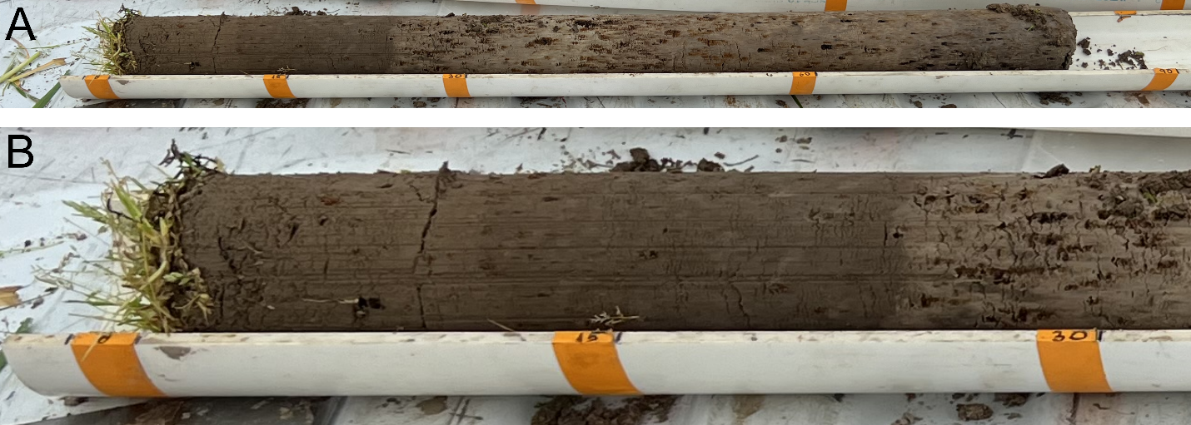
Supplementary Figure 2. Representative image of a 1-meter soil core taken from experimental plots. A) Full-length view of soil core. Orange tape marks 0, 15, 30, 60, and 90 cm soil depths. B) Close-up of the top 30 cm of the soil core.

Supplemental Table 2. Cover crop treatments and their seeding rates for the full field experiment.
Species | Plant Family | Common name | Cultivars | Broadcast Seeding Rate (g/m²)
Crambe abyssinicum | Brassicaceae | African Cabbage | VNS | 9.155
Brassica oleracea | Brassicaceae | Collard | Impact Forage | 9.155
Brassica oleracea | Brassicaceae | Kale | Bayou | 9.155
Brassica napus | Brassicaceae | Siberian Kale | VNS | 9.155
Thlaspi arvense | Brassicaceae | Pennycress | MN106 | 9.155
Raphanus sativus | Brassicaceae | Radish | Nitro, Smart | 9.155
Brassica napus var napus | Brassicaceae | Rapeseed | Trophy | 9.155
Brassica rapa | Brassicaceae | Turnip | Purple Top | 9.155
Pisum sativum | Fabaceae | Austrian Winter Pea | VNS, Wyowinter | 12.206
Trifolium michelianum | Fabaceae | Balansa Clover | FIXatioN | 12.206
Trifolium incarnatum | Fabaceae | Crimson Clover | Dixie, Kentucky Pride | 12.206
Vicia villosa | Fabaceae | Hairy Vetch | AU Merit, MT, TNT | 12.206
Trifolium resupinatum | Fabaceae | Persian Clover | VNS | 12.206
Trifolium pratense | Fabaceae | Red Clover | Medium | 12.206
Lens culinaris | Fabaceae | Winter Lentil | Morton | 12.206
Secale cereale | Poaceae | Cereal Rye | Elbon, Rymin, Yankee | 24.412
Avena strigosa | Poaceae | Black Oat | Cosaque | 24.412
Avena sativa | Poaceae | Spring Oat | Hayden | 24.412
Hordeum vulgare | Poaceae | Winter Barley | P919 | 24.412
X Triticosecale Wittmack | Poaceae | Winter Triticale | Montech Forage FX 1001, SY TF 813 | 24.412
Triticum aestivum | Poaceae | Winter Wheat | Gore Soft Red Beardless | 24.412
 |  | 5 clover Mix# |  | 12.206
 |  | 12 species Mix^ |  | 24.412
# 5-clover mix contains crimson clover cv. Kentucky Pride (27.5%), crimson clover cv. Dixie (27.5%), balansa clover cv. FIXatioN (15%), red clover cv. Medium (15%), and persian clover (15%).
^ 12-species mix contains winter wheat cv. Gore Soft Red Beardless (21.4%), spring oat cv. Hayden (17.1%), cereal rye cv. Elbon (14.3%), black oat cv. Cosaque (14.3%), Austrian winter pea cv. WyoWinter (14.3%), crimson clover cv. Kentucky Pride (4.3%), red clover cv. Medium (4.3%), winter lentils cv. Morton (2.9%), winter barley cv. P919 (2.9%), balansa clover cv. FIXatioN (1.4%), collards cv. Impact Forage (0.7%), and turnip cv. Purple Top (0.7%)

Supplemental Table 3. Cover crop treatments that failed to germinate or winter-killed
Common name | Cultivars | Stand Quality  11/02/22 | Stand Quality  04/19/22
African Cabbage | VNS | Good | Winter-Killed
Collard | Impact Forage | Very Good | Moderate
Kale | Bayou | Very Good | Winter-Killed
Siberian Kale | VNS | Very Good | Very Good
Pennycress | MN106 | Poor | Poor
Radish | Nitro | Moderate | Winter-Killed
Radish | Smart | Moderate | Winter-Killed
Rapeseed | Trophy | Very Good | Good
Turnip | Purple Top | Very Good | Poor
Austrian Winter Pea | VNS | Poor | Poor
Austrian Winter Pea | Wyowinter | Poor | Poor
Balansa Clover | FIXatioN | Moderate | Moderate
Crimson Clover | Dixie | Moderate | Moderate
Crimson Clover | Kentucky Pride | Moderate | Moderate
Hairy Vetch | AU Merit | Moderate | Moderate
Hairy Vetch | MT | Moderate | Moderate
Hairy Vetch | TNT | Poor | Poor
Persian Clover | VNS | Moderate | Winter-Killed
Red Clover | Medium | Good | Moderate
Winter Lentil | Morton | Poor | Poor
Cereal Rye | Elbon | Good | Very Good
Cereal Rye | Rymin | Very Good | Very Good
Cereal Rye | Yankee | Very Good | Very Good
Black Oat | Cosaque | Good | Poor
Spring Oat | Hayden | Good | Winter-Killed
Winter Barley | P919 | Very Good | Very Good
Winter Triticale | Montech Forage FX 1001 | Very Good | Very Good
Winter Triticale | SY TF 813 | Good | Good
Winter Wheat | Gore Soft Red Beardless | Very Good | Very Good
Stand quality may be a result of poor seed-soil contact due to planting method. Soil quality also greatly impacts stand quality and may have resulted in poor establishment of some cover crop species. Low soil pH may have negatively impacted plant growth and winter survival as some plants may not have reached the necessary growth stage to ensure winter survival.

Supplemental Table 4. Soil core sampling scheme
Treatment | Soil Cores per Plot | Replicate Plots | Total Soil Cores per Treatment
Cereal Rye cv. Elbon | 2 | 4 | 8
Cereal Rye cv. Rymin | 2 | 4 | 8
Cereal Rye cv. Yankee | 2 | 4 | 8
Crimson Clover cv. Dixie | 2 | 2 | 4
Crimson Clover cv. Kentucky Pride | 2 | 4 | 8
Hairy Vetch cv. AU Merit | 1 | 3 | 3
Siberian Kale | 1 | 3 | 3
Rapeseed cv. Trophy | 2 | 3 | 6
Red Clover cv. Medium | 2 | 4 | 8
Weeds | 2 | 4 | 8
Winter Barley cv. P919 | 1 | 3 | 3
Winter Triticale cv. Montech Forage FX 1001 | 2 | 5 | 10
Winter Triticale cv. SY TF 813 | 1 | 3 | 3
Winter Wheat cv. Gore Soft Red Beardless | 2 | 5 | 10

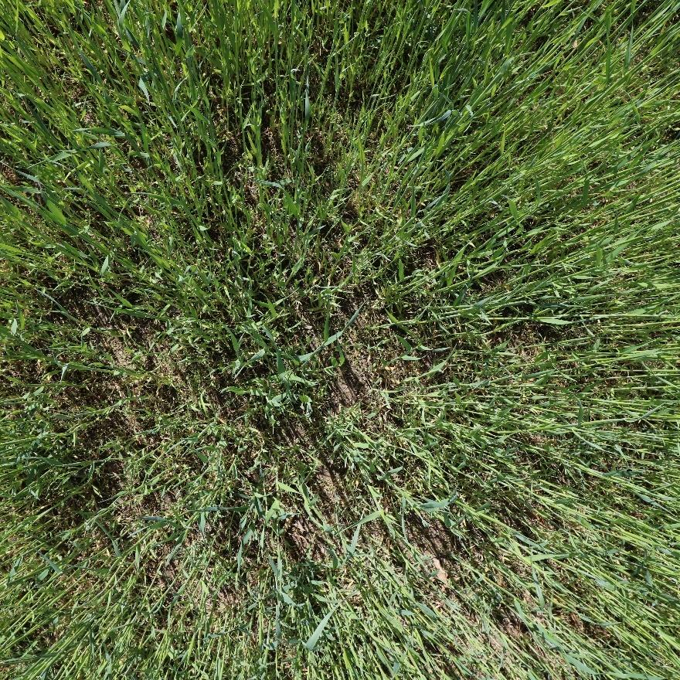

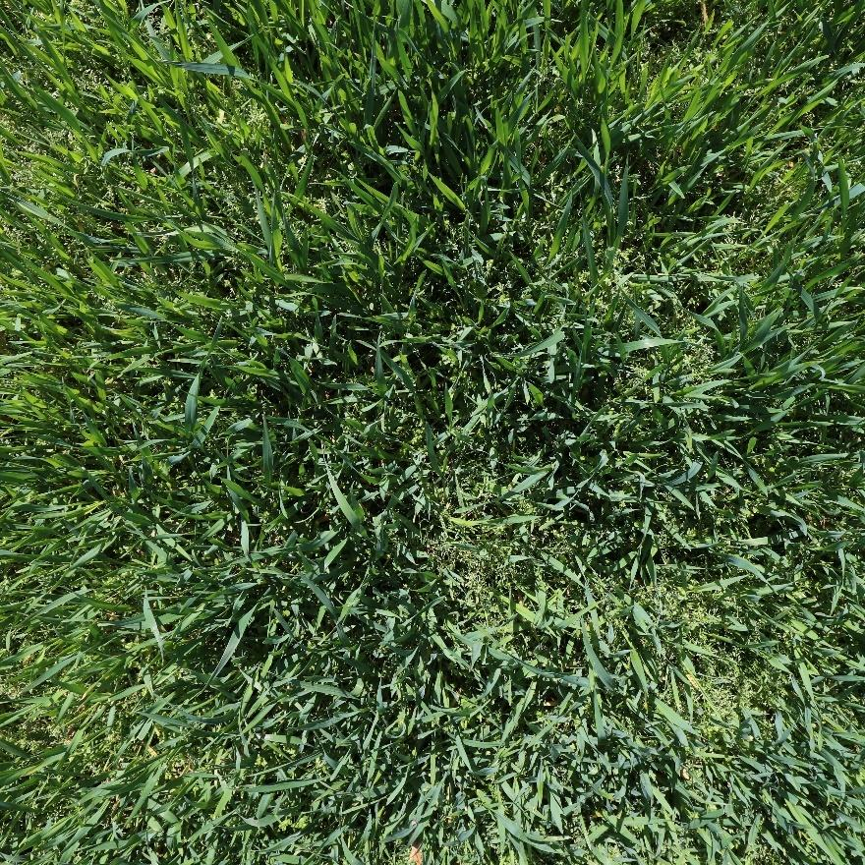
Supplemental Figure 3. Representative canopy image of cereal rye cv. Elbon (top) and winter triticale cv. SY TF 813 (bottom).

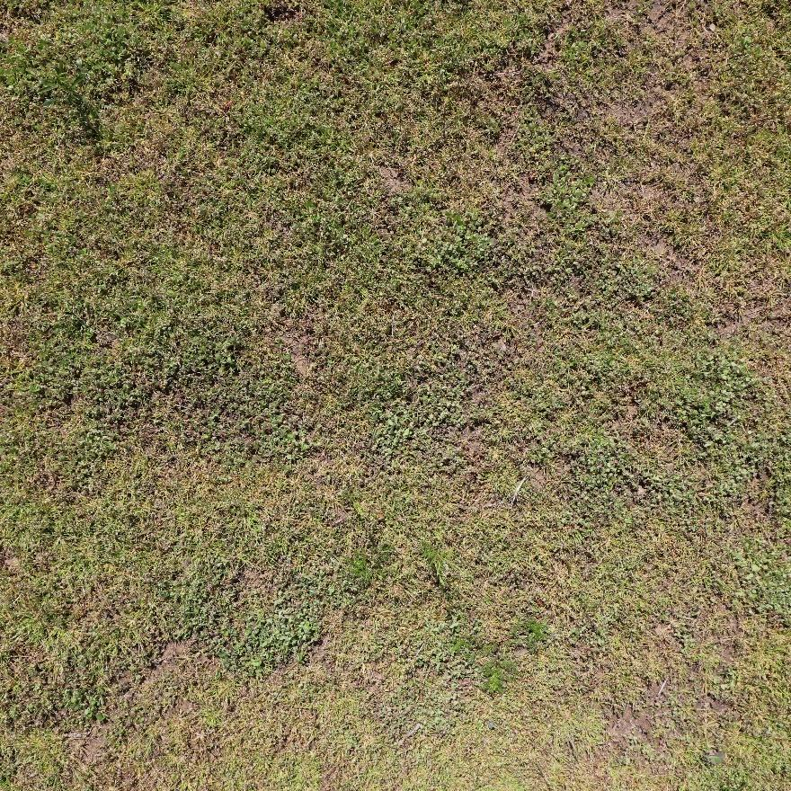

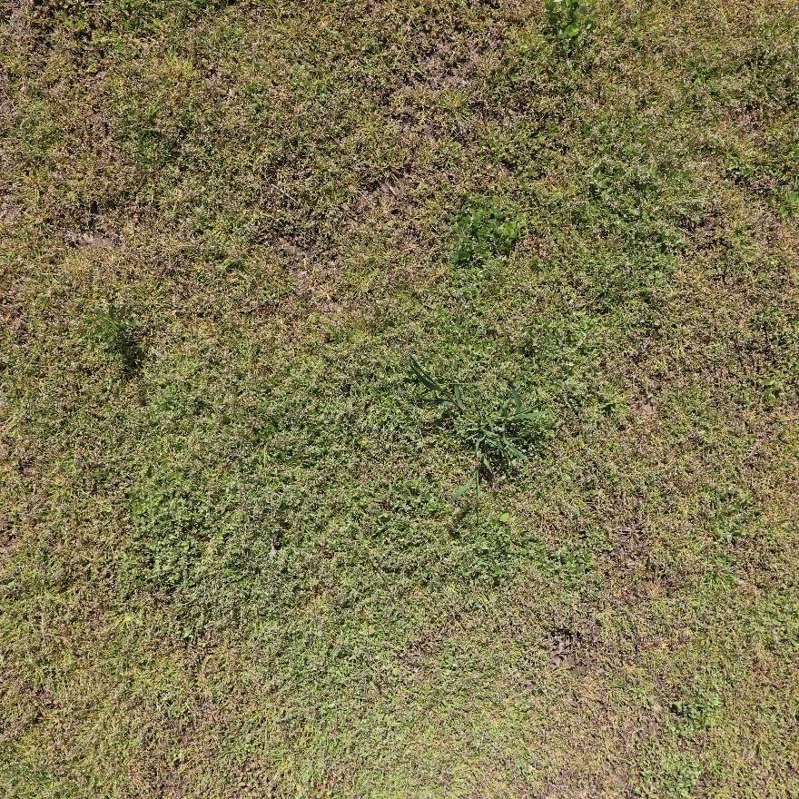
Supplemental Figure 3 (cont.). Representative canopy image of crimson clover cv. Kentucky Pride (top) and red clover cv. Medium (bottom).

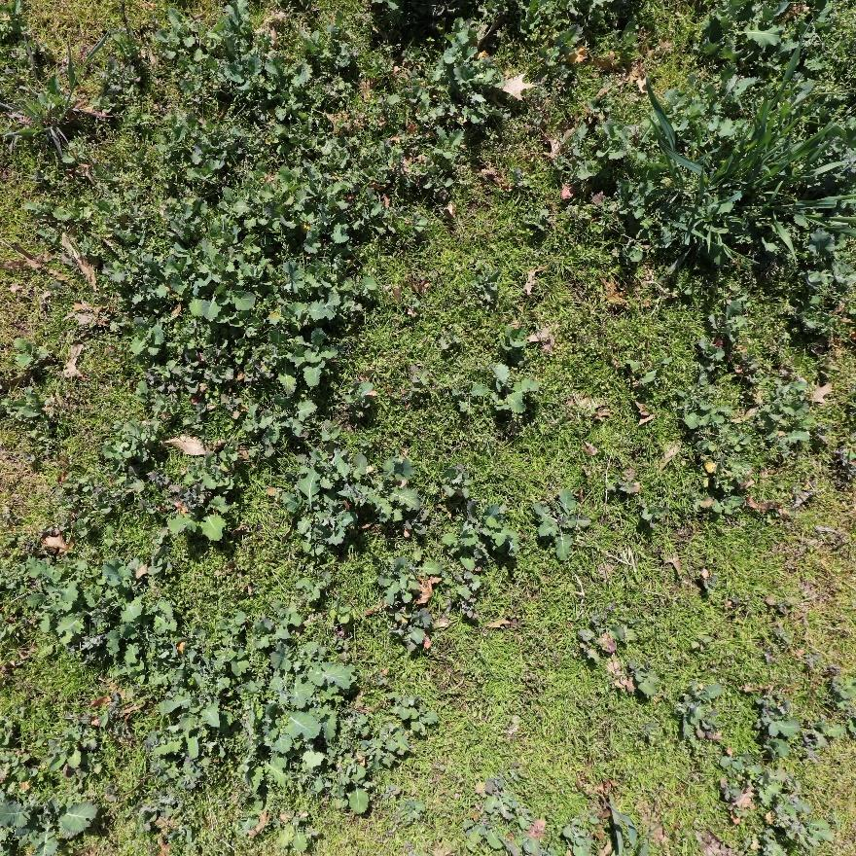

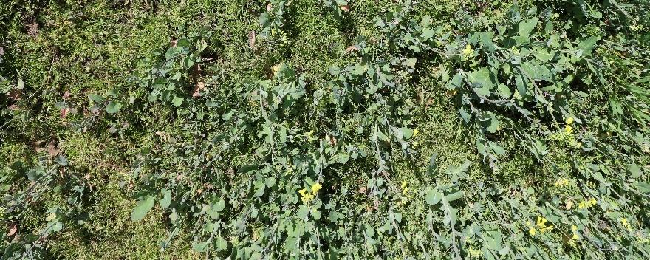
Supplemental Figure 3 (cont.). Representative canopy image of Siberian kale (top) and rapeseed cv. Trophy (bottom). Note: Rapeseed cv. Trophy canopy image is smaller due to cropping to avoid artifacts from sample collections during the growing season.

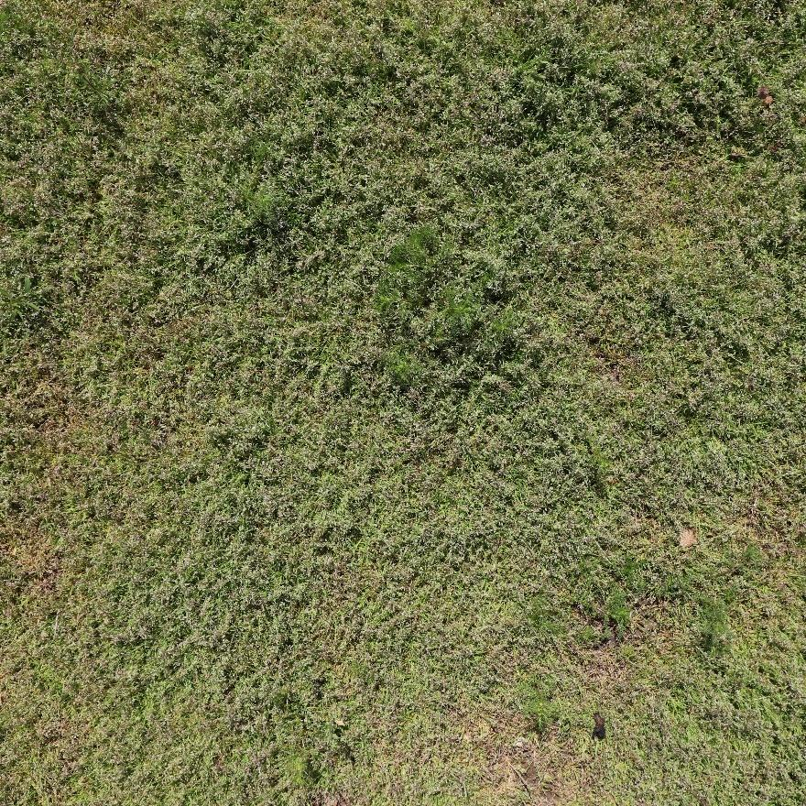
Supplemental Figure 3 (cont.). Representative canopy image of weedy or no cover crop treatment plot.

Supplemental Table 5. Percent canopy cover over the growing season for all treatments with adequate stand establishment. Standard error values are shown in the parenthesis.
Treatment | 10/21/21 | 11/10/21 | 12/23/21 | 2/15/22 | 3/10/22 | 4/19/22
African Cabbage | 43.14  (7.61) | 63.62 (10.44) | 46.13  (5.35) | 3.86  (0.7) | 18.74  (5.05) | 39.65 (13.86)
Balansa Clover cv. FIXatioN | 30.8  (2.45) | 64.18  (7.32) | 52.89 (10.34) | 8.86  (2.36) | 23.88  (6.96) | 55.3  (13.68)
Cereal Rye cv. Elbon | 37.54  (4.75) | 71.47  (7.82) | 61.65  (7.25) | 27.57  (8.43) | 34.44  (8.7) | 74.32  (8.07)
Cereal Rye cv. Rymin | 53.84  (4.72) | 84.22  (6.59) | 72.76  (6.19) | 42.09  (12.16) | 44.14  (11.15) | 70.72  (11.88)
Cereal Rye cv. Yankee | 48.26  (3.13) | 83.3  (4.81) | 75.13  (4.01) | 33.73  (9.68) | 36.11  (8.39) | 67.7  (8.42)
Crimson Clover cv. Dixie | 29.18  (3.62) | 56.32  (10.35) | 51.08  (12.67) | 7.92  (2.65) | 17.87  (5.78) | 37.2  (12.03)
Crimson Clover cv. Kentucky Pride | 29.0  (3.16) | 59.75  (9.81) | 53.92 (11.72) | 9.11  (2.71) | 19.9  (5.98) | 39.93  (11.26)
Collard cv. Impact Forage | 56.23  (2.67) | 71.12 (10.59) | 49.08  (7.89) | 3.18  (0.29) | 16.7  (1.55) | 56.07  (10.4)
Hairy Vetch cv. AU Merit | 19.59  (2.31) | 64.6  (10.07) | 64.08 (10.17) | 9.55  (2.78) | 21.92  (6.39) | 42.75  (15.11)
Hairy Vetch cv. MT | 15.41  (1.27) | 62.1  (8.02) | 58.08  (7.53) | 12.35  (3.62) | 20.86  (5.74) | 39.65  (12.35)
Kale cv. Bayou | 59.86  (4.77) | 66.16  (9.55) | 33.84  (6.95) | 2.19  (0.35) | 13.24  (1.18) | 36.91  (9.07)
Siberian Kale | 61.28  (3.86) | 87.1  (3.93) | 54.53  (8.92) | 2.96  (0.31) | 18.91  (1.68) | 62.49  (10.42)
Black Oat cv. Cosaque | 27.43  (1.33) | 75.78  (4.9) | 69.71  (5.39) | 4.08  (0.55) | 8.45  (1.47) | 52.17  (14.67)
Radish cv. Smart | 44.93  (6.26) | 80.2  (8.85) | 65.49  (7.62) | 2.58  (0.43) | 15.21  (2.06) | 56.21  (12.98)
Radish cv. Nitro | 36.95  (8.81) | 63.03  (12.64) | 54.45  (10.08) | 2.45  (0.49) | 12.67  (1.92) | 44.72  (16.82)
Rapeseed cv. Trophy | 51.75  (5.58) | 65.92  (13.14) | 33.64  (5.99) | 2.35  (0.2) | 15.89  (2.47) | 51.02  (11.52)
Red Clover cv. Medium | 37.18  (4.34) | 72.46  (9.63) | 66.27  (11.78) | 10.53  (3.12) | 30.66  (9.06) | 55.77  (15.73)
Turnip cv. Purple Top | 62.99  (6.75) | 61.5  (13.61) | 35.7  (7.52) | 2.19  (0.23) | 13.15  (2.26) | 53.76  (12.62)
Weeds | 12.41  (1.96) | 66.39  (5.49) | 74.31  (6.67) | 15.99  (4.0) | 26.74  (6.9) | 53.18 (12.64)
Winter Barley cv. P919 | 34.9  (4.25) | 74.35  (8.23) | 62.53  (8.59) | 11.21  (3.98) | 15.91  (3.17) | 54.37  (13.47)
Winter Triticale cv. Montech | 39.68  (2.31) | 78.14  (5.65) | 70.32  (6.55) | 34.15  (8.0) | 50.24  (8.85) | 74.39  (10.04)
Winter Triticale cv. SY TF 813 | 30.85  (3.52) | 73.6  (6.8) | 64.68  (7.1) | 10.09  (3.26) | 29.81  (8.84) | 59.38  (12.0)
Winter Wheat cv. Gore | 32.72  (4.71) | 71.66  (7.89) | 59.07  (8.51) | 13.8  (6.89) | 31.76 (10.07) | 55.87 (11.83)

Supplemental Table 6. Percent canopy cover over the growing season for all treatments with adequate stand establishment. Standard error values are shown in the parenthesis.
Treatment | Shoot Biomass Mean (g) | Root Biomass Mean (g) | Root:Shoot Mean (g/g)
Cereal Rye cv. Elbon | 49.54  (10.53) | 14.31  (3.16) | 0.289  (0.089)
Cereal Rye cv. Rymin | 43.73  (8.30) | 15.88  (4.07) | 0.363  (0.116)
Cereal Rye cv. Yankee | 50.46  (28.91) | 14.37  (1.47) | 0.285  (0.166)
Crimson Clover cv. Dixie | 33.63  (0.88) | 6.36  (1.85) | 0.189  (0.055)
Crimson Clover cv. Kentucky Pride | 20.27  (8.28) | 8.75  (2.15) | 0.432  (0.206)
Hairy Vetch cv. AU Merit | 48.29  (7.13) | 7.18  (1.61) | 0.149  (0.040)
Siberian Kale | 26.15  (7.52) | 7.77  (1.18) | 0.297  (0.097)
Rapeseed cv. Trophy | 21.76  (4.83) | 6.01  (0.19) | 0.276  (0.062)
Red Clover cv. Medium | 26.29  (14.60) | 10.13  (0.76) | 0.385  (0.216)
Weeds | 22.73  (8.22) | 8.45  (2.62) | 0.372  (0.177)
Winter Barley cv. P919 | 50.15  (21.46) | 6.58  (1.82) | 0.131  (0.067)
Winter Triticale cv. Montech | 45.68  (18.05) | 13.83  (1.75) | 0.303  (0.126)
Winter Triticale cv. SY TF 813 | 37.07  (10.26) | 14.68  (1.41) | 0.396  (0.116)
Winter Wheat cv. Gore | 31.75  (12.75) | 11.29  (3.92) | 0.355  (0.189)

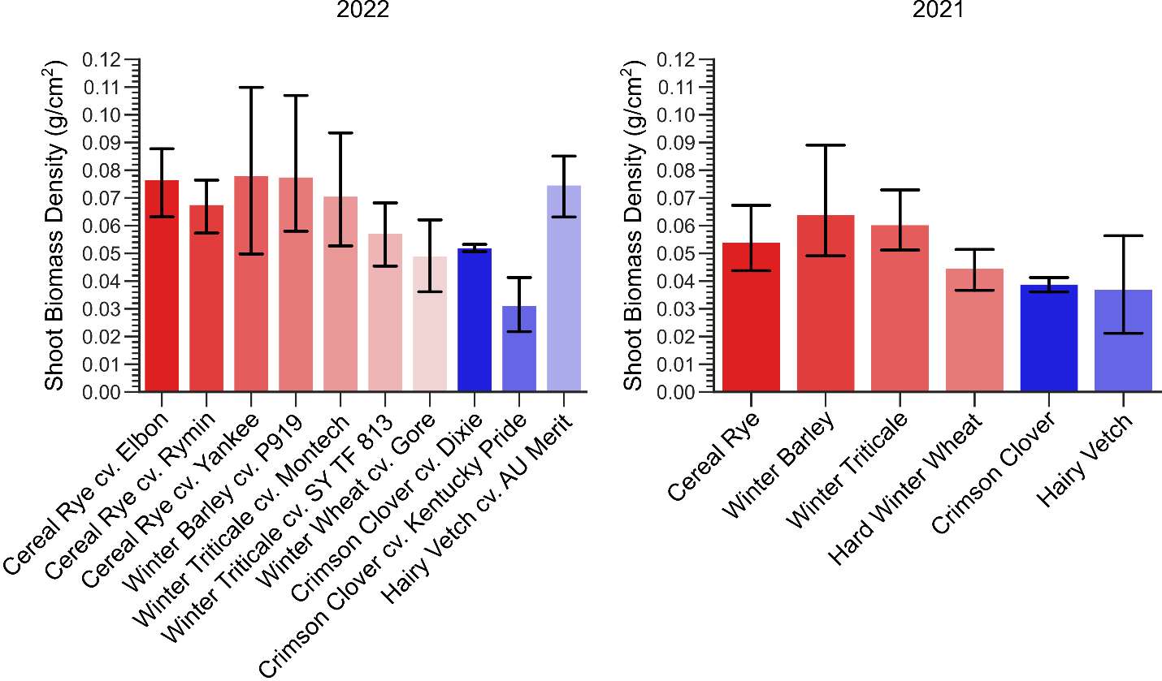

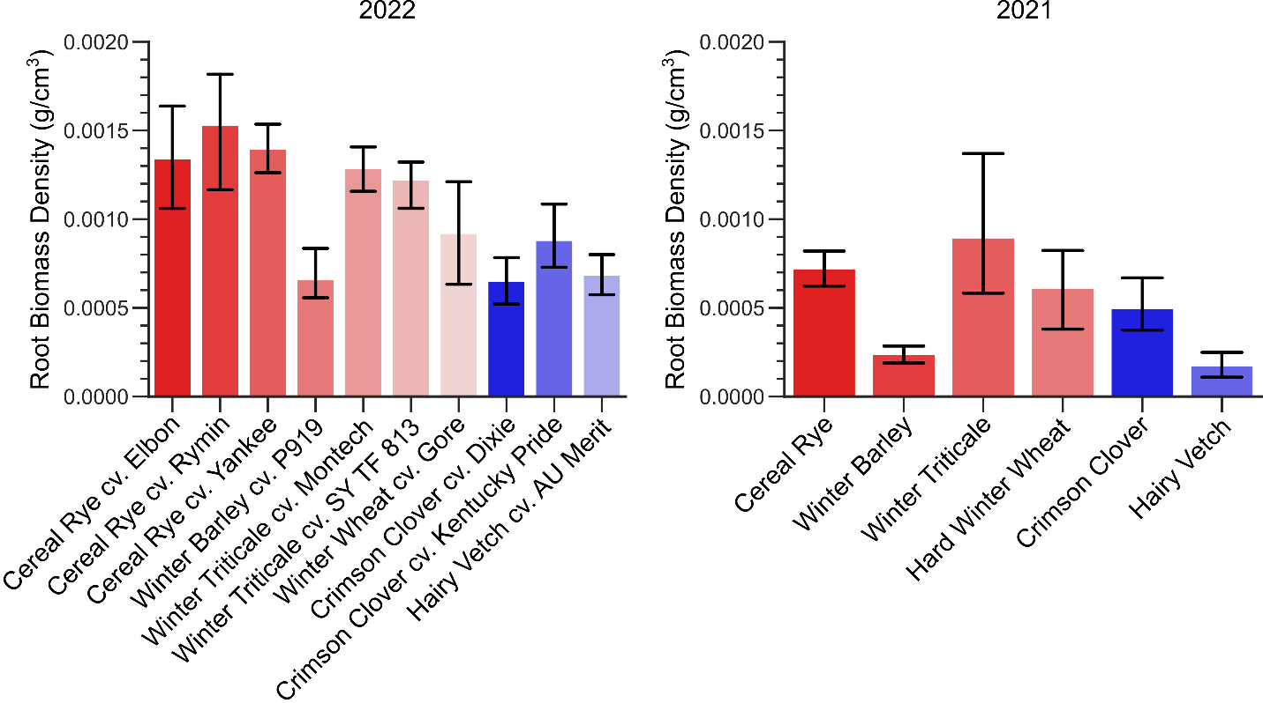
Supplemental Figure 4. Comparison of cover crop shoot and root biomass in separate field experiments sampled at years 2021 and 2022. Similar trends were observed among the cover crop species sampled. 2021 measurements come from previous manuscript by Griffiths, et al., and data accessible at DOI: 10.5281/zenodo.5039308.

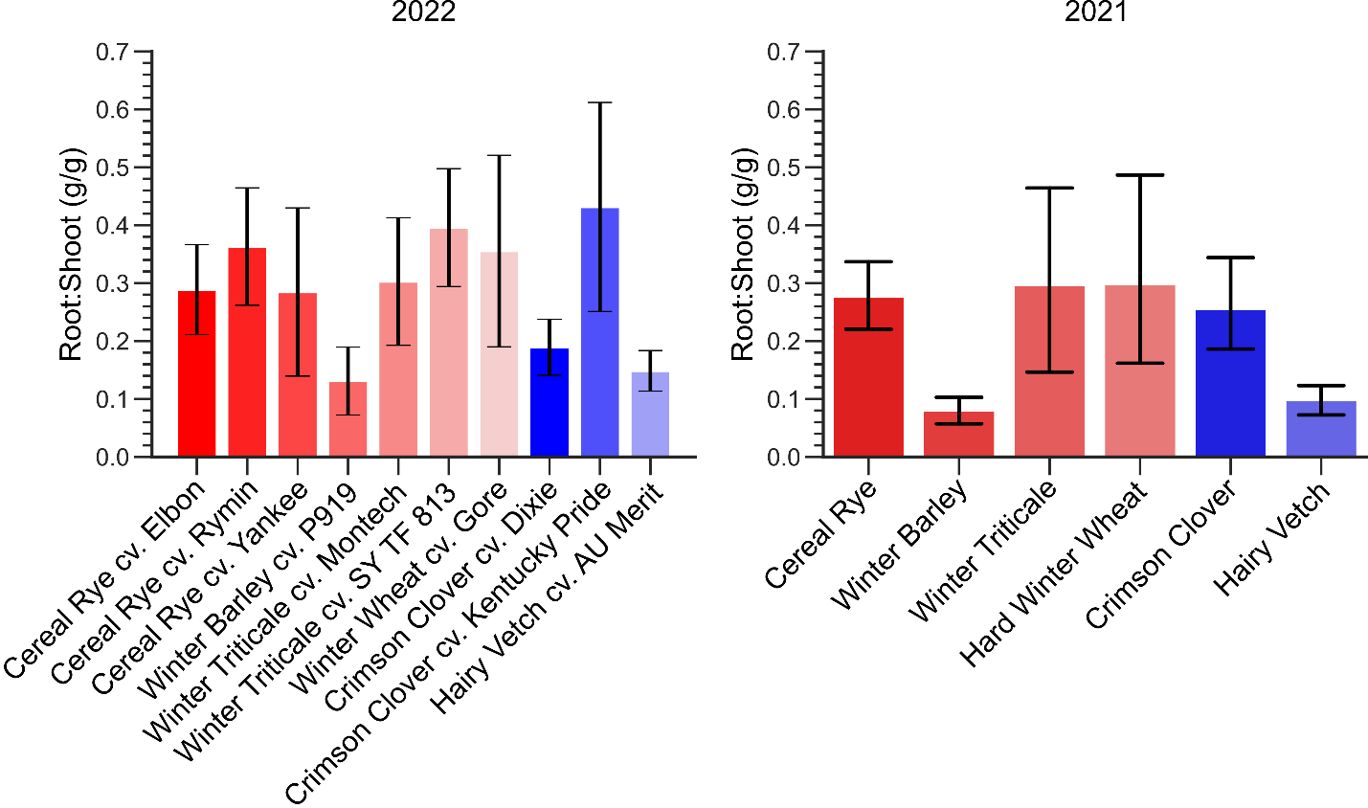
Supplemental Figure 4 (cont.). Comparison of cover crop shoot and root biomass in separate field experiments sampled in the years 2021 and 2022. Similar trends were observed among the cover crop species sampled. 2021 measurements come from previous manuscript by Griffiths, et al., and data accessible at DOI: 10.5281/zenodo.5039308.

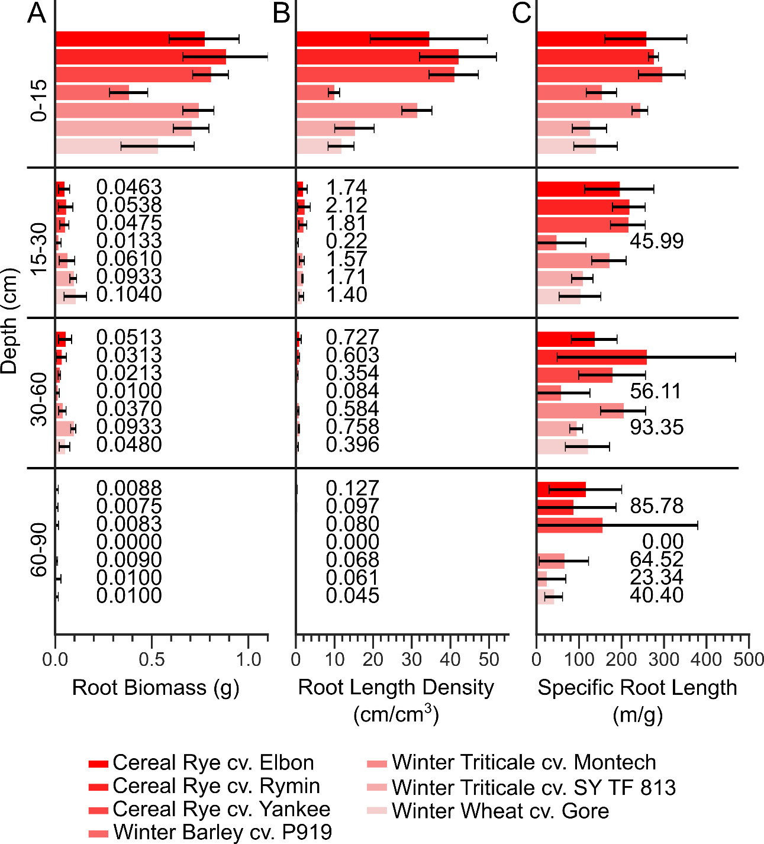

Supplemental Figure 5. Cover crop rooting traits from treatments within the grass family at varying depths. A) Comparison of total root biomass at 4 depths: 0-15, 15-30, 30-60, and 60-90 cm. Error bars indicate 95% confidence intervals. Mean values are shown next to some bars for clarity. B) Comparison of root length density. C) Comparison of specific root length.

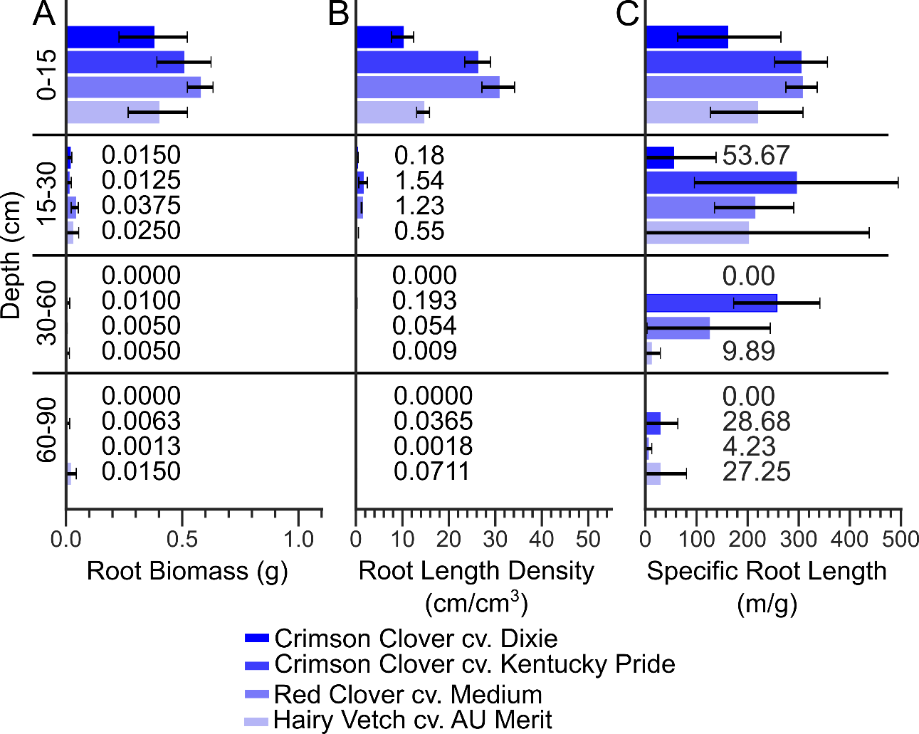

Supplemental Figure 6. Cover crop rooting traits from treatments within the legume family at varying depths. A) Comparison of total root biomass at 4 depths: 0-15, 15-30, 30-60, and 60-90 cm. Error bars indicate 95% confidence intervals. Mean values are shown next to some bars for clarity. B) Comparison of root length density. C) Comparison of specific root length.
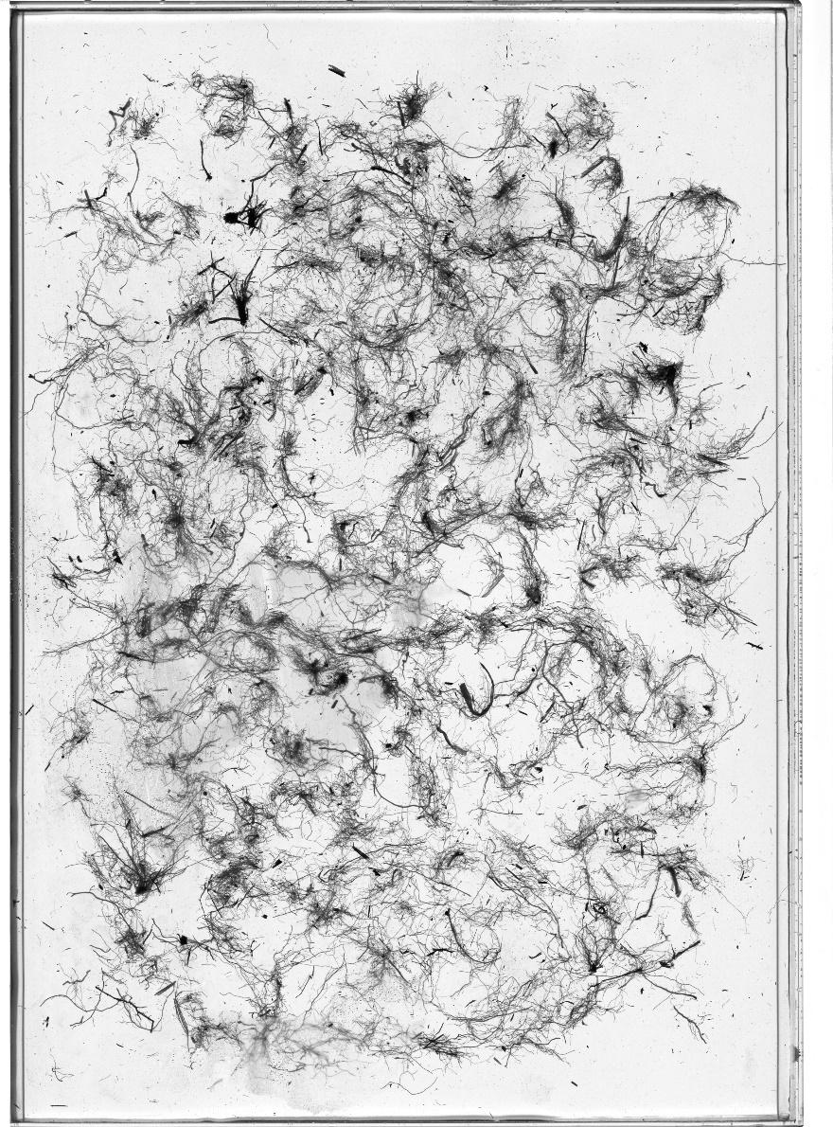
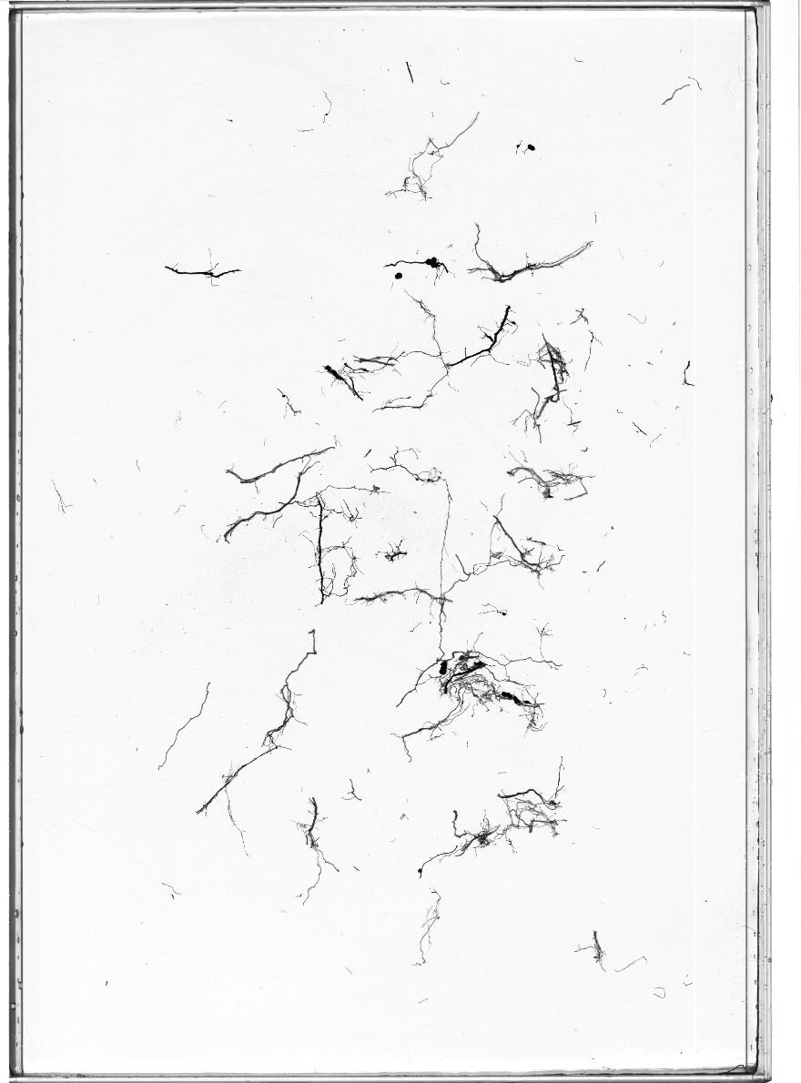
Supplemental Figure 7. Representative flatbed images of washed cereal rye roots from soil cores at different depths (0-15 cm, top; 15-30 cm, bottom).

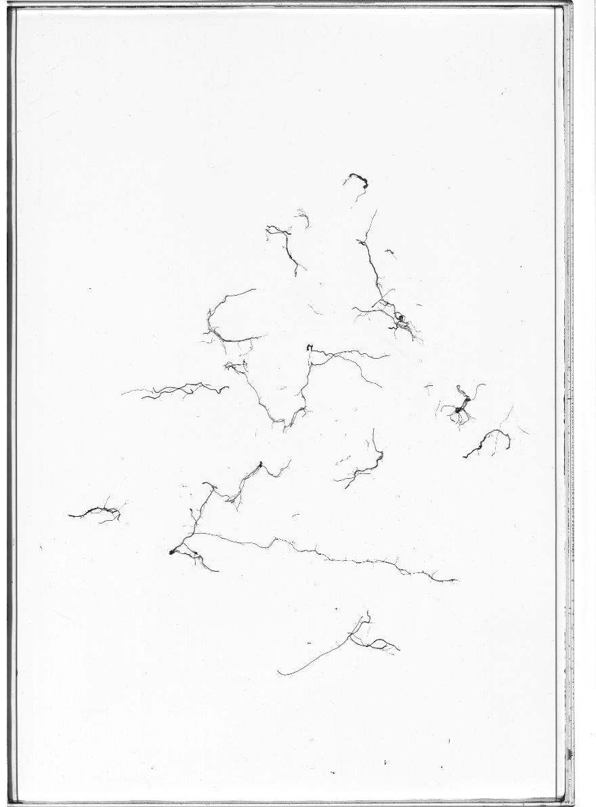
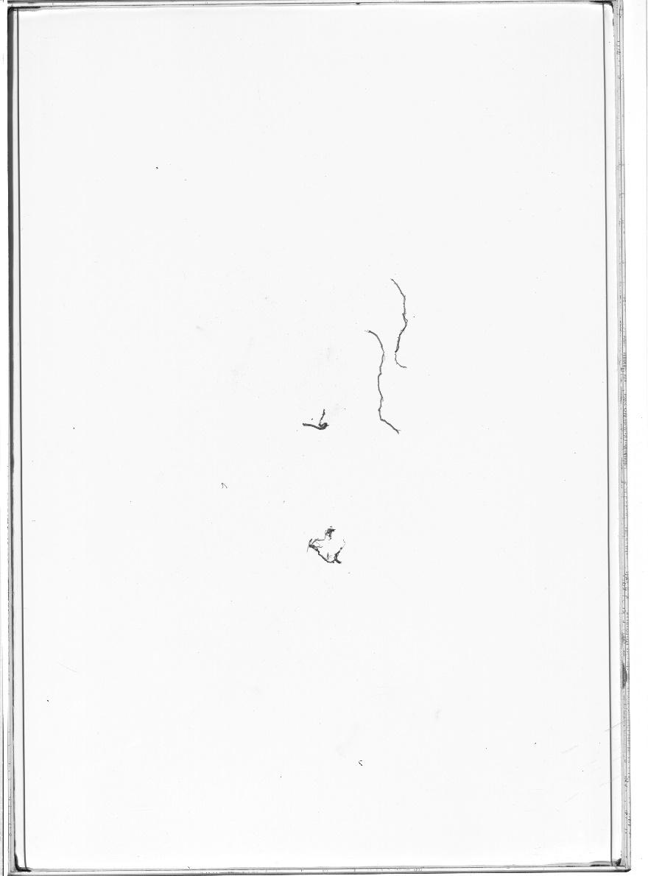
Supplemental Figure 7 (cont.). Representative flatbed images of washed cereal rye roots from soil cores at different depths (30-60 cm, top; 60-90 cm, bottom).

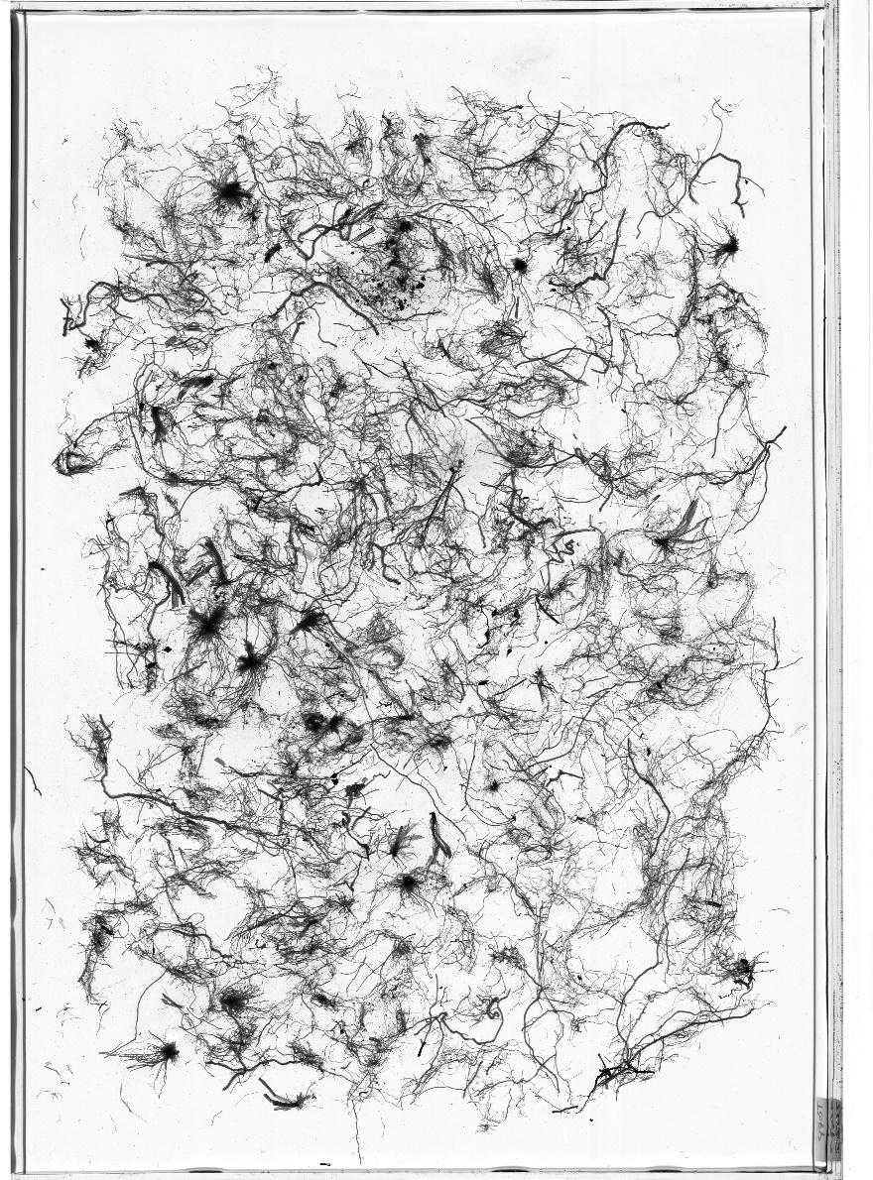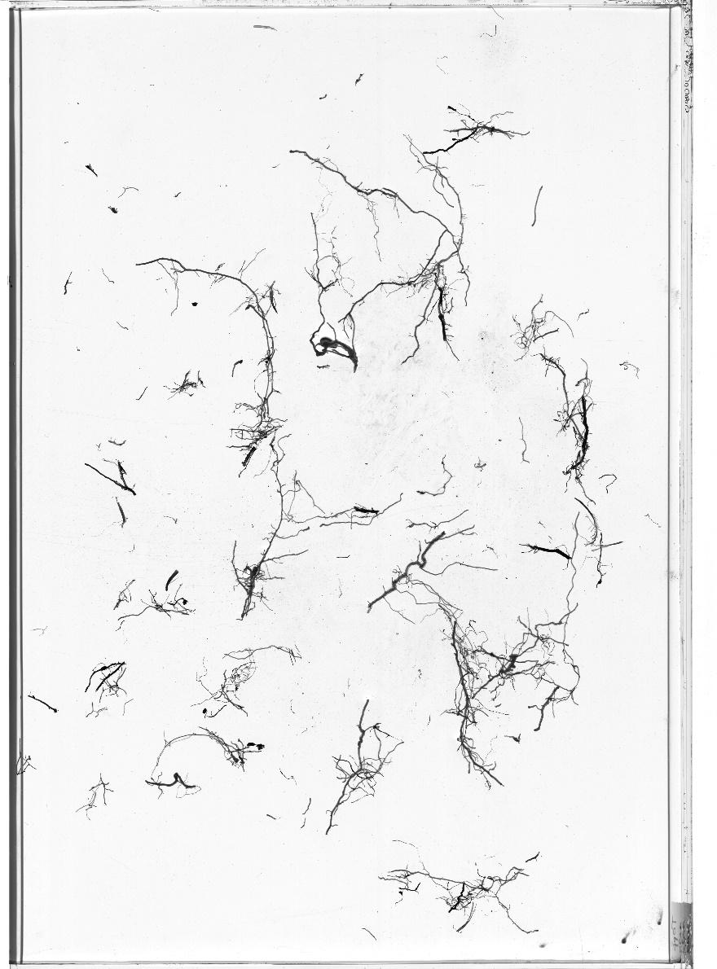
Supplemental Figure 8. Representative flatbed images of washed winter triticale roots from soil cores at different depths (0-15 cm, top; 15-30 cm, bottom).

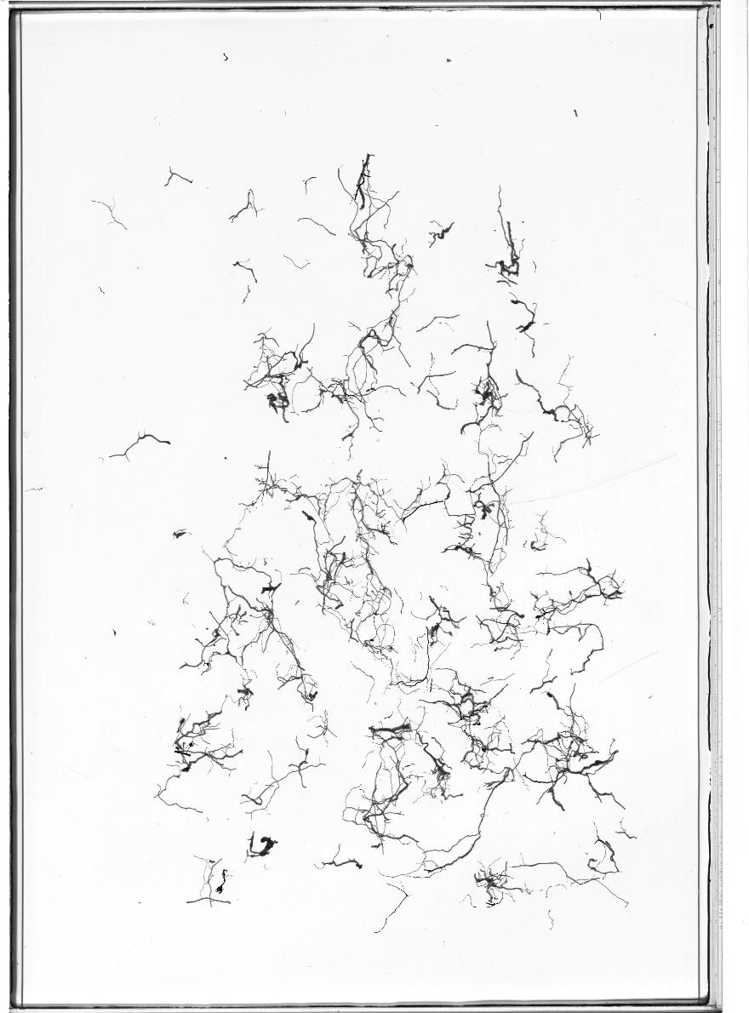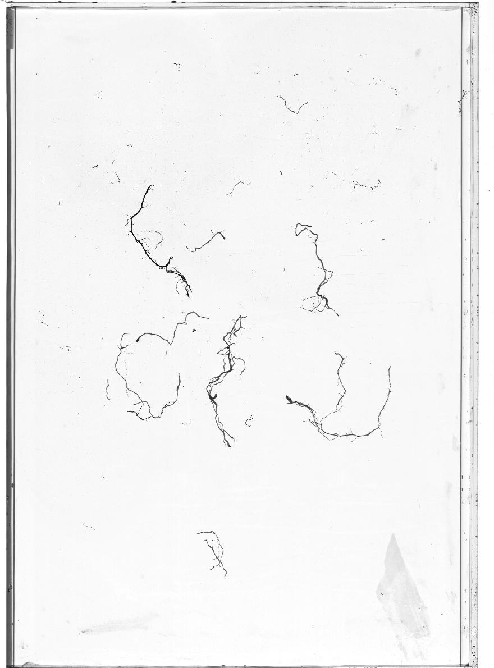
Supplemental Figure 8 (cont.). Representative flatbed images of washed winter triticale roots from soil cores at different depths (30-60 cm, top; 60-90 cm, bottom).

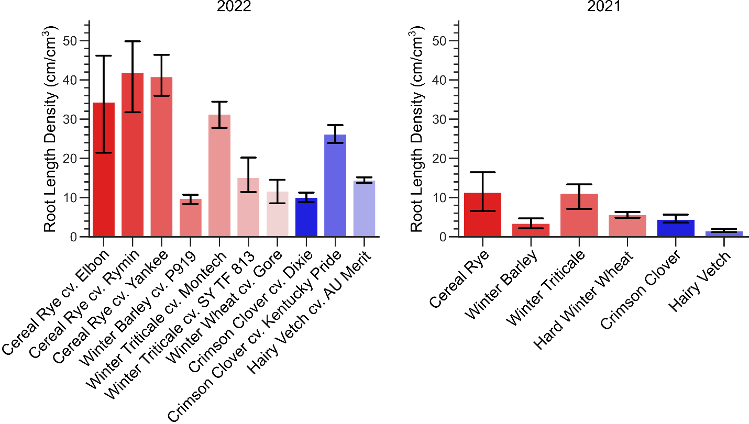
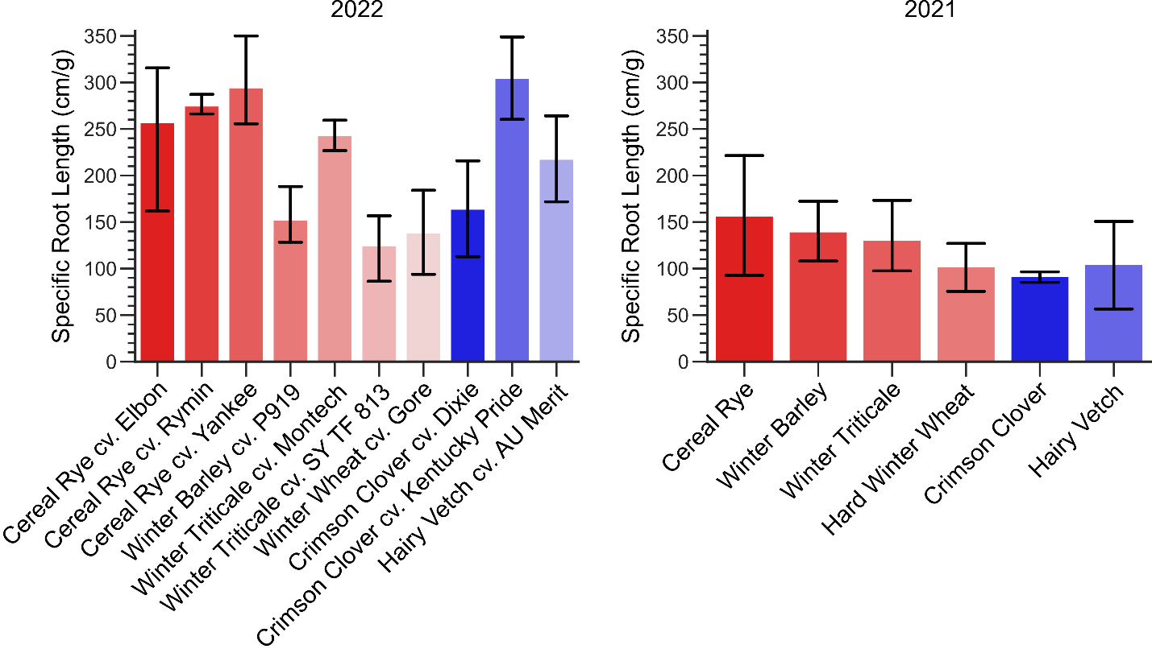

Supplemental Figure 9. Comparison of cover crop root traits, root length density and specific root length, in separate field experiments sampled in the years 2021 and 2022. Similar trends were observed among the cover crop species sampled. 2021 measurements come from previous manuscript by Griffiths, et al., and data accessible at DOI: 10.5281/zenodo.5039308.

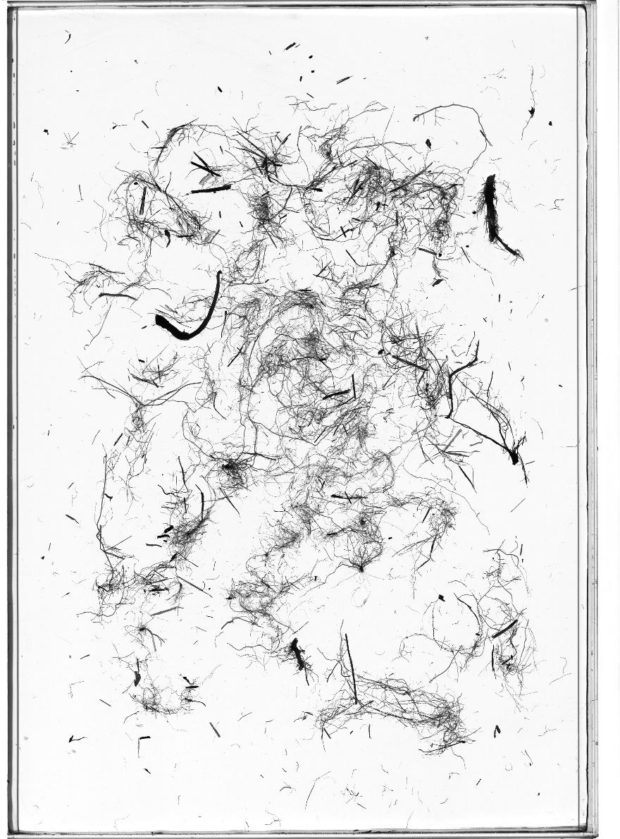
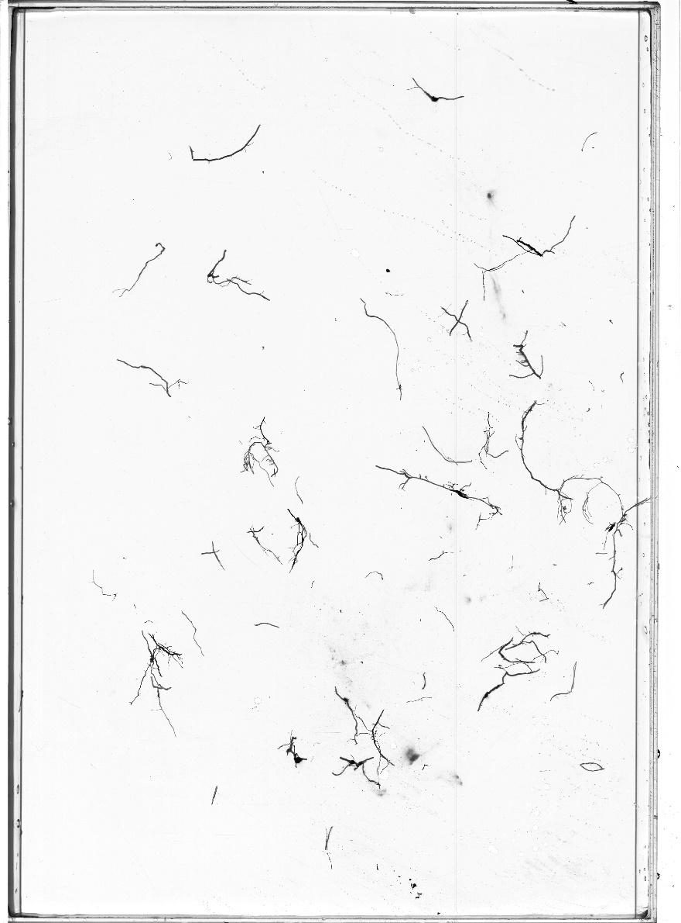
Supplemental Figure 10. Representative flatbed images of washed Siberian kale roots from soil cores at different depths (0-15 cm, top; 15-30 cm, bottom).

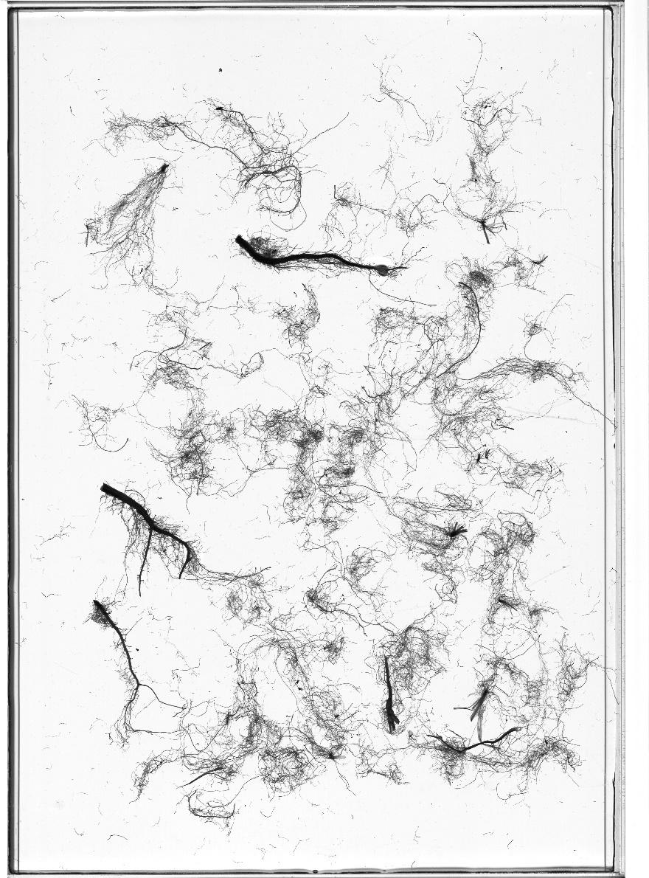
Supplemental Figure 11. Representative flatbed images of washed rapeseed roots from soil cores at depth 0-15 cm.

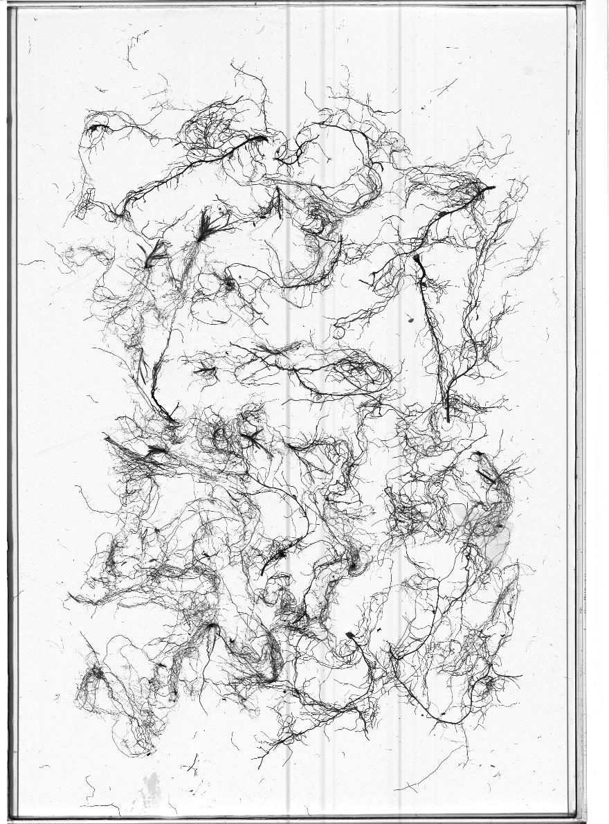
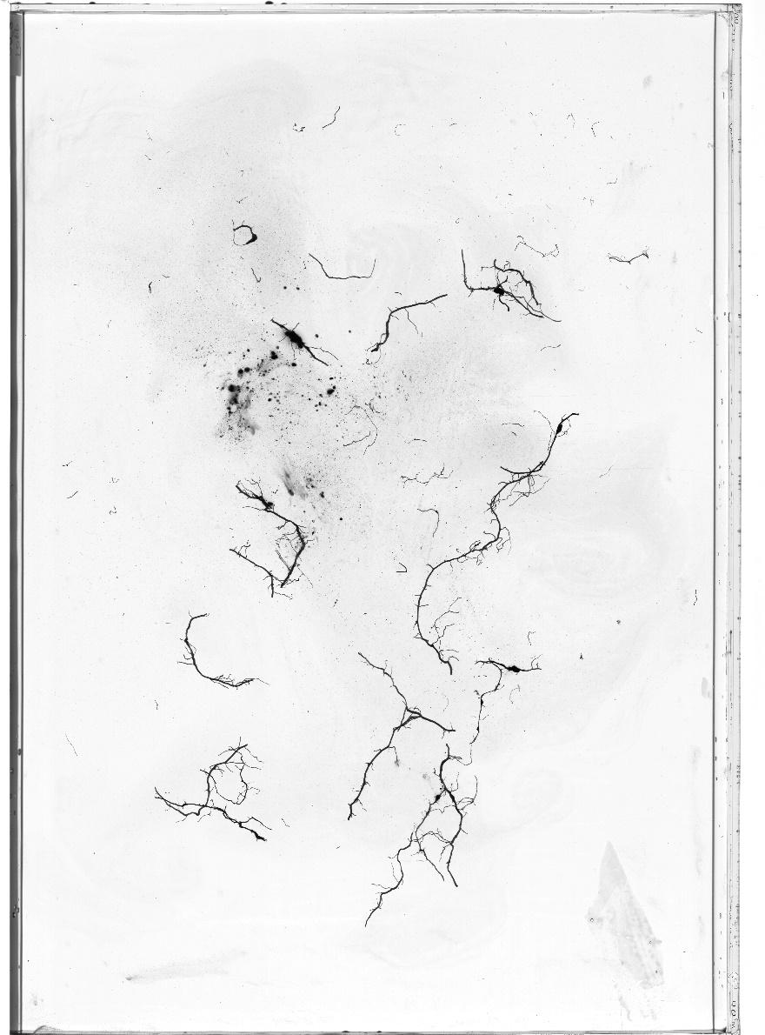
Supplemental Figure 12. Representative flatbed images of washed crimson clover cv. Kentucky Pride roots from soil cores at different depths (0-15 cm, top; 15-30 cm, bottom).

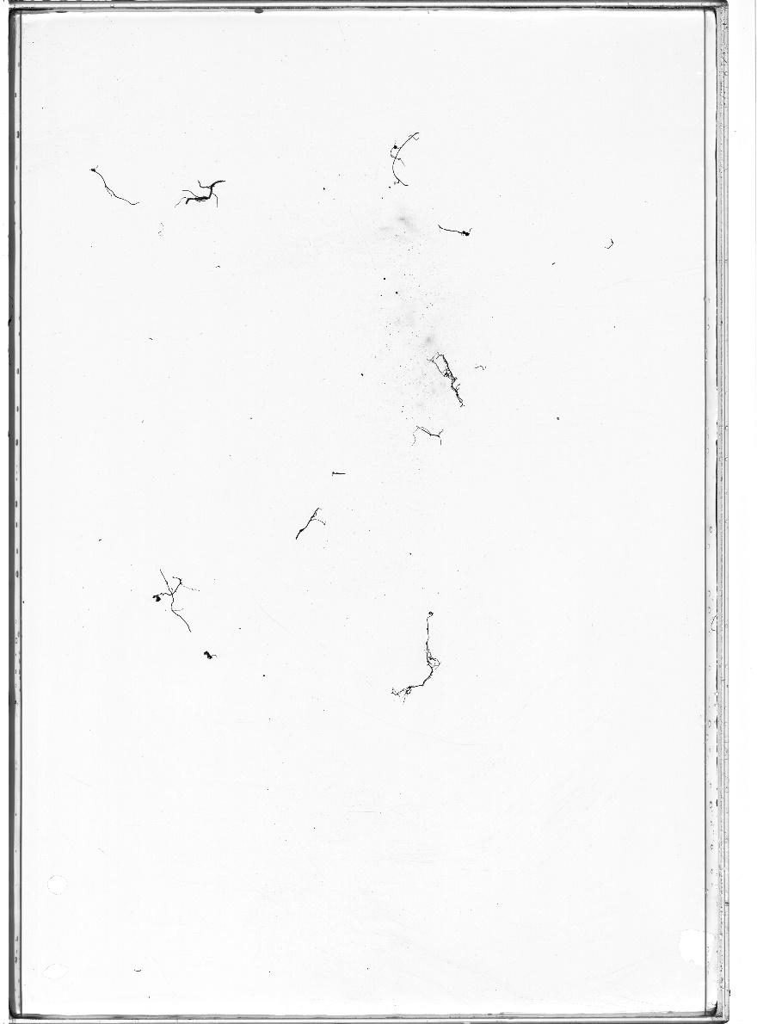

Supplemental Figure 12 (cont.). Representative flatbed images of washed crimson clover cv. Kentucky Pride roots from soil cores at different depths (30-60 cm, top; 60-90 cm, bottom).
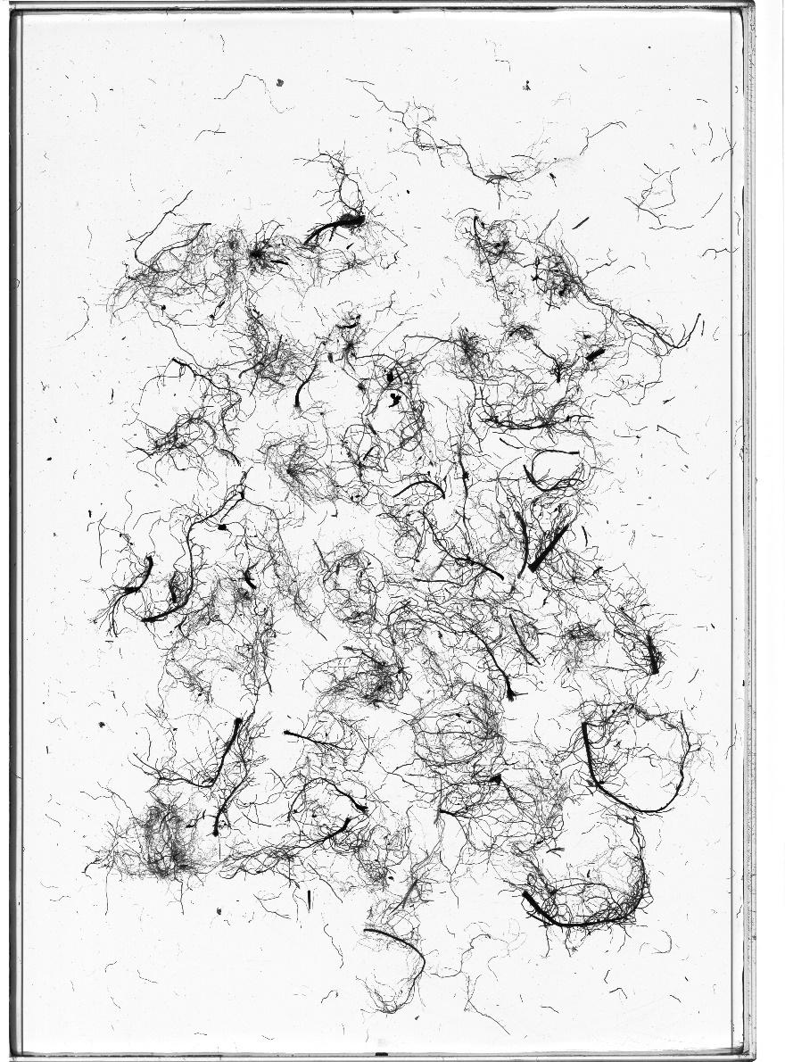
Supplemental Figure 13. Representative flatbed images of washed red clover roots from soil cores at 0-15 cm depth.

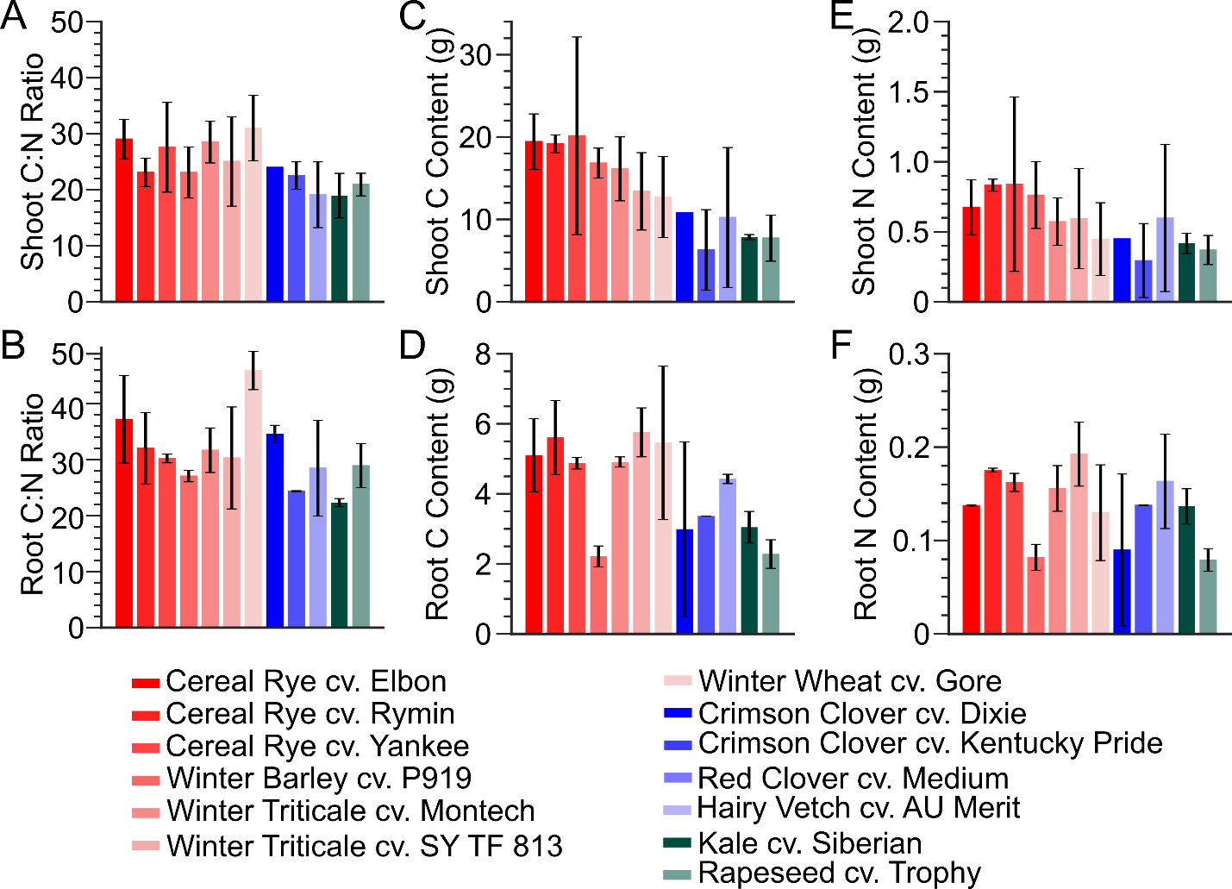

Supplemental Figure 14. Shoot and root C and N concentrations of select cover crop treatments.

Supplemental Table 7. Summary of p-values for pairwise comparisons of shoot biomass
Treatment | Cereal Rye cv. Elbon | Cereal Rye cv. Rymin | Cereal Rye cv. Yankee | Winter Barley cv. P919 | Winter Triticale cv. Montech | Winter Triticale cv. SY TF 813 | Winter Wheat cv. Gore | Crimson Clover cv. Dixie | Crimson Clover cv. Kentucky | Red Clover cv. Medium | Hairy Vetch cv. AU Merit | Siberian Kale | Rapeseed cv. Trophy
Cereal Rye cv. Rymin | 0.332 | - | - | - | - | - | - | - | - | - | - | - | -
Cereal Rye cv. Yankee | 0.948 | 0.596 | - | - | - | - | - | - | - | - | - | - | -
Winter Barley cv. P919 | 0.956 | 0.513 | 0.985 | - | - | - | - | - | - | - | - | - | -
Winter Triticale cv. Montech | 0.685 | 0.815 | 0.738 | 0.716 | - | - | - | - | - | - | - | - | -
Winter Triticale cv. SY TF 813 | 0.079 | 0.245 | 0.310 | 0.216 | 0.334 | - | - | - | - | - | - | - | -
Winter Wheat cv. Gore | 0.029 | 0.075 | 0.149 | 0.091 | 0.132 | 0.430 | - | - | - | - | - | - | -
Crimson Clover cv. Dixie | 0.045 | 0.082 | 0.362 | 0.244 | 0.301 | 0.592 | 0.812 | - | - | - | - | - | -
Crimson Clover cv. Kentucky | 0.001 | 0.001 | 0.052 | 0.020 | 0.018 | 0.016 | 0.110 | 0.036 | - | - | - | - | -
Red Clover cv. Medium | 0.016 | 0.029 | 0.097 | 0.056 | 0.068 | 0.170 | 0.486 | 0.429 | 0.436 | - | - | - | -
Hairy Vetch cv. AU Merit | 0.864 | 0.446 | 0.905 | 0.892 | 0.821 | 0.138 | 0.073 | 0.024 | 0.003 | 0.047 | - | - | -
Siberian Kale | 0.004 | 0.005 | 0.103 | 0.046 | 0.051 | 0.080 | 0.404 | 0.148 | 0.273 | 0.985 | 0.006 | - | -
Rapeseed cv. Trophy | 0.002 | 0.001 | 0.090 | 0.037 | 0.035 | 0.025 | 0.173 | 0.009 | 0.761 | 0.572 | 0.002 | 0.347 | -
Weeds | 0.004 | 0.004 | 0.104 | 0.048 | 0.047 | 0.048 | 0.240 | 0.076 | 0.670 | 0.673 | 0.008 | 0.535 | 0.846

Supplemental Table 8. Summary of p-values for pairwise comparisons of root biomass
Treatment | Cereal Rye cv. Elbon | Cereal Rye cv. Rymin | Cereal Rye cv. Yankee | Winter Barley cv. P919 | Winter Triticale cv. Montech | Winter Triticale cv. SY TF 813 | Winter Wheat cv. Gore | Crimson Clover cv. Dixie | Crimson Clover cv. Kentucky | Red Clover cv. Medium | Hairy Vetch cv. AU Merit | Siberian Kale | Rapeseed cv. Trophy
Cereal Rye cv. Rymin | 0.564 | - | - | - | - | - | - | - | - | - | - | - | -
Cereal Rye cv. Yankee | 0.975 | 0.510 | - | - | - | - | - | - | - | - | - | - | -
Winter Barley cv. P919 | 0.013 | 0.015 | 0.001 | - | - | - | - | - | - | - | - | - | -
Winter Triticale cv. Montech | 0.779 | 0.338 | 0.641 | 0.001 | - | - | - | - | - | - | - | - | -
Winter Triticale cv. SY TF 813 | 0.860 | 0.651 | 0.789 | 0.004 | 0.506 | - | - | - | - | - | - | - | -
Winter Wheat cv. Gore | 0.252 | 0.129 | 0.184 | 0.104 | 0.221 | 0.209 | - | - | - | - | - | - | -
Crimson Clover cv. Dixie | 0.034 | 0.039 | 0.004 | 0.905 | 0.004 | 0.010 | 0.163 | - | - | - | - | - | -
Crimson Clover cv. Kentucky | 0.027 | 0.021 | 0.005 | 0.220 | 0.006 | 0.009 | 0.286 | 0.256 | - | - | - | - | -
Red Clover cv. Medium | 0.042 | 0.032 | 0.002 | 0.016 | 0.006 | 0.003 | 0.585 | 0.019 | 0.270 | - | - | - | -
Hairy Vetch cv. AU Merit | 0.045 | 0.050 | 0.005 | 0.734 | 0.006 | 0.012 | 0.228 | 0.684 | 0.423 | 0.031 | - | - | -
Siberian Kale | 0.020 | 0.022 | 0.001 | 0.393 | 0.002 | 0.003 | 0.192 | 0.360 | 0.517 | 0.023 | 0.659 | - | -
Rapeseed cv. Trophy | 0.007 | 0.009 | 0.000 | 0.617 | 0.000 | 0.000 | 0.065 | 0.743 | 0.085 | 0.000 | 0.268 | 0.063 | -
Weeds | 0.029 | 0.022 | 0.008 | 0.343 | 0.008 | 0.014 | 0.256 | 0.382 | 0.866 | 0.263 | 0.576 | 0.701 | 0.177

Supplemental Table 9. Summary of p-values for pairwise comparisons of root:shoot ratio
Treatment | Cereal Rye cv. Elbon | Cereal Rye cv. Rymin | Cereal Rye cv. Yankee | Winter Barley cv. P919 | Winter Triticale cv. Montech | Winter Triticale cv. SY TF 813 | Winter Wheat cv. Gore | Crimson Clover cv. Dixie | Crimson Clover cv. Kentucky | Red Clover cv. Medium | Hairy Vetch cv. AU Merit | Siberian Kale | Rapeseed cv. Trophy
Cereal Rye cv. Rymin | 0.347 | - | - | - | - | - | - | - | - | - | - | - | -
Cereal Rye cv. Yankee | 0.966 | 0.467 | - | - | - | - | - | - | - | - | - | - | -
Winter Barley cv. P919 | 0.050 | 0.028 | 0.197 | - | - | - | - | - | - | - | - | - | -
Winter Triticale cv. Montech | 0.858 | 0.483 | 0.857 | 0.076 | - | - | - | - | - | - | - | - | -
Winter Triticale cv. SY TF 813 | 0.221 | 0.726 | 0.370 | 0.027 | 0.338 | - | - | - | - | - | - | - | -
Winter Wheat cv. Gore | 0.539 | 0.945 | 0.574 | 0.101 | 0.617 | 0.752 | - | - | - | - | - | - | -
Crimson Clover cv. Dixie | 0.230 | 0.125 | 0.492 | 0.389 | 0.291 | 0.108 | 0.296 | - | - | - | - | - | -
Crimson Clover cv. Kentucky | 0.250 | 0.584 | 0.309 | 0.063 | 0.282 | 0.801 | 0.581 | 0.196 | - | - | - | - | -
Red Clover cv. Medium | 0.440 | 0.862 | 0.487 | 0.112 | 0.493 | 0.943 | 0.831 | 0.297 | 0.768 | - | - | - | -
Hairy Vetch cv. AU Merit | 0.110 | 0.072 | 0.339 | 0.768 | 0.166 | 0.069 | 0.205 | 0.488 | 0.143 | 0.220 | - | - | -
Siberian Kale | 0.909 | 0.462 | 0.912 | 0.071 | 0.951 | 0.321 | 0.644 | 0.258 | 0.350 | 0.546 | 0.142 | - | -
Rapeseed cv. Trophy | 0.841 | 0.296 | 0.936 | 0.051 | 0.748 | 0.190 | 0.518 | 0.209 | 0.270 | 0.443 | 0.087 | 0.766 | -
Weeds | 0.435 | 0.939 | 0.500 | 0.080 | 0.515 | 0.846 | 0.899 | 0.248 | 0.675 | 0.925 | 0.171 | 0.545 | 0.421

Supplemental Table 10. Summary of p-values for pairwise comparisons of root biomass from 0-15 cm soil depth
Treatment | Cereal Rye cv. Elbon | Cereal Rye cv. Rymin | Cereal Rye cv. Yankee | Winter Barley cv. P919 | Winter Triticale cv. Montech | Winter Triticale cv. SY TF 813 | Winter Wheat cv. Gore | Crimson Clover cv. Dixie | Crimson Clover cv. Kentucky | Red Clover cv. Medium | Hairy Vetch cv. AU Merit | Siberian Kale | Rapeseed cv. Trophy
Cereal Rye cv. Rymin | 0.476404 | - | - | - | - | - | - | - | - | - | - | - | -
Cereal Rye cv. Yankee | 0.763216 | 0.54711 | - | - | - | - | - | - | - | - | - | - | -
Winter Barley cv. P919 | 0.0204 | 0.015463 | 0.001757 | - | - | - | - | - | - | - | - | - | -
Winter Triticale cv. Montech | 0.756496 | 0.238625 | 0.347791 | 0.001564 | - | - | - | - | - | - | - | - | -
Winter Triticale cv. SY TF 813 | 0.583993 | 0.254427 | 0.200984 | 0.009349 | 0.581818 | - | - | - | - | - | - | - | -
Winter Wheat cv. Gore | 0.120026 | 0.048504 | 0.052065 | 0.305763 | 0.079432 | 0.241375 | - | - | - | - | - | - | -
Crimson Clover cv. Dixie | 0.052986 | 0.043818 | 0.00704 | 0.957152 | 0.005814 | 0.028403 | 0.394656 | - | - | - | - | - | -
Crimson Clover cv. Kentucky | 0.052996 | 0.025696 | 0.007933 | 0.180665 | 0.01252 | 0.059417 | 0.85821 | 0.257071 | - | - | - | - | -
Red Clover cv. Medium | 0.091194 | 0.03905 | 0.006199 | 0.014334 | 0.01743 | 0.058636 | 0.685117 | 0.031538 | 0.32831 | - | - | - | -
Hairy Vetch cv. AU Merit | 0.059093 | 0.048001 | 0.007278 | 0.864982 | 0.006429 | 0.028568 | 0.45133 | 0.858931 | 0.313539 | 0.034727 | - | - | -
Siberian Kale | 0.026468 | 0.019244 | 0.001703 | 0.548424 | 0.001808 | 0.008332 | 0.434313 | 0.57422 | 0.302172 | 0.01612 | 0.729808 | - | -
Rapeseed cv. Trophy | 0.009849 | 0.008802 | 0.000388 | 0.372557 | 0.000303 | 0.001481 | 0.169306 | 0.477517 | 0.052824 | 0.000801 | 0.278178 | 0.065109 | -
Weeds | 0.062429 | 0.030342 | 0.016661 | 0.376504 | 0.022562 | 0.098582 | 0.745973 | 0.45941 | 0.837677 | 0.341422 | 0.534145 | 0.558025 | 0.17902

Supplemental Table 11. Summary of p-values for pairwise comparisons of root biomass from 15-30 cm soil depth
Treatment | Cereal Rye cv. Elbon | Cereal Rye cv. Rymin | Cereal Rye cv. Yankee | Winter Barley cv. P919 | Winter Triticale cv. Montech | Winter Triticale cv. SY TF 813 | Winter Wheat cv. Gore | Crimson Clover cv. Dixie | Crimson Clover cv. Kentucky | Red Clover cv. Medium | Hairy Vetch cv. AU Merit | Siberian Kale | Rapeseed cv. Trophy
Cereal Rye cv. Rymin | 0.765652 | - | - | - | - | - | - | - | - | - | - | - | -
Cereal Rye cv. Yankee | 0.949163 | 0.791648 | - | - | - | - | - | - | - | - | - | - | -
Winter Barley cv. P919 | 0.138053 | 0.151251 | 0.085675 | - | - | - | - | - | - | - | - | - | -
Winter Triticale cv. Montech | 0.595381 | 0.808013 | 0.613404 | 0.140818 | - | - | - | - | - | - | - | - | -
Winter Triticale cv. SY TF 813 | 0.05299 | 0.158213 | 0.035147 | 0.003036 | 0.293747 | - | - | - | - | - | - | - | -
Winter Wheat cv. Gore | 0.151649 | 0.22271 | 0.152239 | 0.063886 | 0.266684 | 0.798581 | - | - | - | - | - | - | -
Crimson Clover cv. Dixie | 0.22757 | 0.251693 | 0.149424 | 0.898168 | 0.239178 | 0.007271 | 0.132696 | - | - | - | - | - | -
Crimson Clover cv. Kentucky | 0.070841 | 0.083345 | 0.036642 | 0.934267 | 0.080058 | 0.000389 | 0.030572 | 0.78044 | - | - | - | - | -
Red Clover cv. Medium | 0.613709 | 0.462379 | 0.510228 | 0.095693 | 0.364727 | 0.005172 | 0.093295 | 0.135376 | 0.036898 | - | - | - | -
Hairy Vetch cv. AU Merit | 0.418683 | 0.395212 | 0.327635 | 0.517632 | 0.353834 | 0.023395 | 0.176067 | 0.591752 | 0.358328 | 0.44711 | - | - | -
Siberian Kale | 0.170627 | 0.203157 | 0.105408 | 0.78878 | 0.197567 | 0.005268 | 0.116161 | 0.42265 | 0.764806 | 0.077778 | 0.42265 | - | -
Rapeseed cv. Trophy | 0.330789 | 0.301312 | 0.234947 | 0.308065 | 0.264028 | 0.0043 | 0.100141 | 0.33138 | 0.162485 | 0.370881 | 0.916287 | 0.173632 | -
Weeds | 0.122944 | 0.130885 | 0.064449 | 0.429751 | 0.122327 | 0.000225 | 0.041028 | 0.3125 | 0.228258 | 0.0723 | 0.632812 | 0.030906 | 0.354822

Supplemental Table 12. Summary of p-values for pairwise comparisons of root biomass from 30-60 cm soil depth
Treatment | Cereal Rye cv. Elbon | Cereal Rye cv. Rymin | Cereal Rye cv. Yankee | Winter Barley cv. P919 | Winter Triticale cv. Montech | Winter Triticale cv. SY TF 813 | Winter Wheat cv. Gore | Crimson Clover cv. Dixie | Crimson Clover cv. Kentucky | Red Clover cv. Medium | Hairy Vetch cv. AU Merit | Siberian Kale | Rapeseed cv. Trophy
Cereal Rye cv. Rymin | 0.397563 | - | - | - | - | - | - | - | - | - | - | - | -
Cereal Rye cv. Yankee | 0.137857 | 0.500609 | - | - | - | - | - | - | - | - | - | - | -
Winter Barley cv. P919 | 0.106302 | 0.261623 | 0.124374 | - | - | - | - | - | - | - | - | - | -
Winter Triticale cv. Montech | 0.471289 | 0.733597 | 0.207286 | 0.094279 | - | - | - | - | - | - | - | - | -
Winter Triticale cv. SY TF 813 | 0.103324 | 0.014812 | 0.000121 | 0.0007 | 0.006516 | - | - | - | - | - | - | - | -
Winter Wheat cv. Gore | 0.88612 | 0.425558 | 0.139166 | 0.093017 | 0.535025 | 0.056187 | - | - | - | - | - | - | -
Crimson Clover cv. Dixie | 0.118634 | 0.200255 | 0.010794 | 0.272228 | 0.07148 | 0.001678 | 0.094494 | - | - | - | - | - | -
Crimson Clover cv. Kentucky | 0.056349 | 0.177204 | 0.038803 | - | 0.047945 | 5.30E-05 | 0.049195 | 0.082086 | - | - | - | - | -
Red Clover cv. Medium | 0.036443 | 0.101776 | 0.002083 | 0.348066 | 0.022634 | 1.83E-05 | 0.029651 | - | 0.133975 | - | - | - | -
Hairy Vetch cv. AU Merit | 0.150463 | 0.27206 | 0.044613 | 0.590801 | 0.109125 | 0.002536 | 0.126248 | 0.42265 | 0.399162 | - | - | - | -
Siberian Kale | 0.329183 | 0.818704 | 0.634905 | 0.27944 | 0.532963 | 0.008335 | 0.33903 | 0.184167 | 0.177345 | 0.083743 | 0.267628 | - | -
Rapeseed cv. Trophy | 0.110722 | 0.279429 | 0.060785 | 0.795255 | 0.098912 | 0.000287 | 0.098751 | 0.012308 | 0.670368 | 0.004967 | 0.219102 | 0.283998 | -
Weeds | 0.044794 | 0.133085 | 0.007344 | 0.646229 | 0.032198 | 2.62E-05 | 0.037763 | 0.025721 | 0.467994 | 0.133975 | 0.54147 | 0.119 | 0.117387

Supplemental Table 13. Summary of p-values for pairwise comparisons of RLD from 0-15 cm soil depth
Treatment | Cereal Rye cv. Elbon | Cereal Rye cv. Rymin | Cereal Rye cv. Yankee | Winter Barley cv. P919 | Winter Triticale cv. Montech | Winter Triticale cv. SY TF 813 | Winter Wheat cv. Gore | Crimson Clover cv. Dixie | Crimson Clover cv. Kentucky | Red Clover cv. Medium | Hairy Vetch cv. AU Merit | Siberian Kale | Rapeseed cv. Trophy
Cereal Rye cv. Rymin | 0.444383 | - | - | - | - | - | - | - | - | - | - | - | -
Cereal Rye cv. Yankee | 0.470474 | 0.859826 | - | - | - | - | - | - | - | - | - | - | -
Winter Barley cv. P919 | 0.043937 | 0.003132 | 0.000503 | - | - | - | - | - | - | - | - | - | -
Winter Triticale cv. Montech | 0.679253 | 0.070127 | 0.033979 | 0.000208 | - | - | - | - | - | - | - | - | -
Winter Triticale cv. SY TF 813 | 0.096035 | 0.008494 | 0.002118 | 0.121946 | 0.002534 | - | - | - | - | - | - | - | -
Winter Wheat cv. Gore | 0.014778 | 0.000434 | 6.43E-05 | 0.46005 | 6.98E-05 | 0.289815 | - | - | - | - | - | - | -
Crimson Clover cv. Dixie | 0.10409 | 0.013961 | 0.003336 | 0.893805 | 0.001478 | 0.238593 | 0.59625 | - | - | - | - | - | -
Crimson Clover cv. Kentucky | 0.336832 | 0.024198 | 0.006112 | 0.000267 | 0.086496 | 0.010229 | 0.000414 | 0.002028 | - | - | - | - | -
Red Clover cv. Medium | 0.650821 | 0.079486 | 0.032897 | 0.000231 | 0.807326 | 0.003821 | 0.00013 | 0.001804 | 0.101376 | - | - | - | -
Hairy Vetch cv. AU Merit | 0.160709 | 0.022539 | 0.005695 | 0.024659 | 0.003902 | 0.849709 | 0.385409 | 0.088538 | 0.005712 | 0.004041 | - | - | -
Siberian Kale | 0.072447 | 0.00576 | 0.001177 | 0.160339 | 0.000928 | 0.601131 | 0.563442 | 0.293909 | 0.002543 | 0.001248 | 0.683048 | - | -
Rapeseed cv. Trophy | 0.25808 | 0.037444 | 0.018171 | 0.072148 | 0.070022 | 0.300127 | 0.055011 | 0.161038 | 0.344961 | 0.105509 | 0.331015 | 0.182088 | -
Weeds | 0.857448 | 0.215426 | 0.183911 | 0.006749 | 0.756335 | 0.02501 | 0.001689 | 0.025403 | 0.2005 | 0.666773 | 0.048103 | 0.015113 | 0.14906

Supplemental Table 14. Summary of p-values for pairwise comparisons of RLD from 15-30 cm soil depth
Treatment | Cereal Rye cv. Elbon | Cereal Rye cv. Rymin | Cereal Rye cv. Yankee | Winter Barley cv. P919 | Winter Triticale cv. Montech | Winter Triticale cv. SY TF 813 | Winter Wheat cv. Gore | Crimson Clover cv. Dixie | Crimson Clover cv. Kentucky | Red Clover cv. Medium | Hairy Vetch cv. AU Merit | Siberian Kale | Rapeseed cv. Trophy
Cereal Rye cv. Rymin | 0.726506 | - | - | - | - | - | - | - | - | - | - | - | -
Cereal Rye cv. Yankee | 0.942395 | 0.758702 | - | - | - | - | - | - | - | - | - | - | -
Winter Barley cv. P919 | 0.094127 | 0.112785 | 0.057966 | - | - | - | - | - | - | - | - | - | -
Winter Triticale cv. Montech | 0.789249 | 0.513696 | 0.694367 | 0.021526 | - | - | - | - | - | - | - | - | -
Winter Triticale cv. SY TF 813 | 0.966027 | 0.693692 | 0.888127 | 0.002165 | 0.739238 | - | - | - | - | - | - | - | -
Winter Wheat cv. Gore | 0.602184 | 0.396952 | 0.502774 | 0.032202 | 0.706242 | 0.467282 | - | - | - | - | - | - | -
Crimson Clover cv. Dixie | 0.164289 | 0.193256 | 0.11221 | 0.901607 | 0.045927 | 0.002328 | 0.062298 | - | - | - | - | - | -
Crimson Clover cv. Kentucky | 0.80592 | 0.568327 | 0.727998 | 0.072795 | 0.970815 | 0.781125 | 0.791707 | 0.13058 | - | - | - | - | -
Red Clover cv. Medium | 0.433475 | 0.32332 | 0.321767 | 0.002125 | 0.374329 | 0.002865 | 0.641088 | 0.00098 | 0.534332 | - | - | - | -
Hairy Vetch cv. AU Merit | 0.263522 | 0.274847 | 0.19083 | 0.276022 | 0.108482 | 0.001577 | 0.154288 | 0.142479 | 0.237137 | 0.000739 | - | - | -
Siberian Kale | 0.242379 | 0.258264 | 0.173558 | 0.376632 | 0.092925 | 0.002087 | 0.131177 | 0.228108 | 0.213247 | 0.001113 | 0.508857 | - | -
Rapeseed cv. Trophy | 0.320564 | 0.284 | 0.230349 | 0.022272 | 0.185893 | 0.001133 | 0.305219 | 0.009912 | 0.337351 | 0.008625 | 0.005954 | 0.011862 | -
Weeds | 0.481491 | 0.351785 | 0.381521 | 0.035104 | 0.471323 | 0.209859 | 0.721713 | 0.062201 | 0.600884 | 0.962259 | 0.162535 | 0.136362 | 0.396812

Supplemental Table 15. Summary of p-values for pairwise comparisons of RLD from 30-60 cm soil depth
Treatment | Cereal Rye cv. Elbon | Cereal Rye cv. Rymin | Cereal Rye cv. Yankee | Winter Barley cv. P919 | Winter Triticale cv. Montech | Winter Triticale cv. SY TF 813 | Winter Wheat cv. Gore | Crimson Clover cv. Dixie | Crimson Clover cv. Kentucky | Red Clover cv. Medium | Hairy Vetch cv. AU Merit | Siberian Kale | Rapeseed cv. Trophy
Cereal Rye cv. Rymin | 0.765648 | - | - | - | - | - | - | - | - | - | - | - | -
Cereal Rye cv. Yankee | 0.343894 | 0.30857 | - | - | - | - | - | - | - | - | - | - | -
Winter Barley cv. P919 | 0.179564 | 0.079266 | 0.116966 | - | - | - | - | - | - | - | - | - | -
Winter Triticale cv. Montech | 0.674789 | 0.928424 | 0.186272 | 0.016426 | - | - | - | - | - | - | - | - | -
Winter Triticale cv. SY TF 813 | 0.943655 | 0.54947 | 0.043287 | 0.003277 | 0.309628 | - | - | - | - | - | - | - | -
Winter Wheat cv. Gore | 0.345883 | 0.358171 | 0.800689 | 0.089093 | 0.25628 | 0.063022 | - | - | - | - | - | - | -
Crimson Clover cv. Dixie | 0.233087 | 0.107157 | 0.101608 | 0.389562 | 0.023097 | 0.006285 | 0.083604 | - | - | - | - | - | -
Crimson Clover cv. Kentucky | 0.174418 | 0.082221 | 0.213975 | 0.163639 | 0.017008 | 0.000935 | 0.155795 | 0.01676 | - | - | - | - | -
Red Clover cv. Medium | 0.099928 | 0.031073 | 0.03963 | 0.650388 | 0.003771 | 0.00028 | 0.030598 | 0.251042 | 0.016421 | - | - | - | -
Hairy Vetch cv. AU Merit | 0.237733 | 0.110852 | 0.107817 | 0.435274 | 0.024387 | 0.006525 | 0.088792 | 0.42265 | 0.01985 | 0.326587 | - | - | -
Siberian Kale | 0.304171 | 0.224167 | 0.553036 | 0.427997 | 0.108105 | 0.044118 | 0.422837 | 0.334143 | 0.771112 | 0.241306 | 0.349588 | - | -
Rapeseed cv. Trophy | 0.31505 | 0.230576 | 0.588328 | 0.321501 | 0.107401 | 0.034446 | 0.451799 | 0.242108 | 0.631736 | 0.149656 | 0.2552 | 0.93358 | -
Weeds | 0.115199 | 0.041204 | 0.068418 | 0.989386 | 0.006244 | 0.000713 | 0.049919 | 0.299404 | 0.111746 | 0.586901 | 0.345667 | 0.346124 | 0.240181

Supplemental Table 16. Summary of p-values for pairwise comparisons of SRL from 0-15 cm soil depth
Treatment | Cereal Rye cv. Elbon | Cereal Rye cv. Rymin | Cereal Rye cv. Yankee | Winter Barley cv. P919 | Winter Triticale cv. Montech | Winter Triticale cv. SY TF 813 | Winter Wheat cv. Gore | Crimson Clover cv. Dixie | Crimson Clover cv. Kentucky | Red Clover cv. Medium | Hairy Vetch cv. AU Merit | Siberian Kale | Rapeseed cv. Trophy
Cereal Rye cv. Rymin | 0.733329 | - | - | - | - | - | - | - | - | - | - | - | -
Cereal Rye cv. Yankee | 0.534026 | 0.518223 | - | - | - | - | - | - | - | - | - | - | -
Winter Barley cv. P919 | 0.141814 | 0.000751 | 0.01139 | - | - | - | - | - | - | - | - | - | -
Winter Triticale cv. Montech | 0.757505 | 0.031574 | 0.095651 | 0.002584 | - | - | - | - | - | - | - | - | -
Winter Triticale cv. SY TF 813 | 0.080104 | 0.000464 | 0.006044 | 0.364077 | 0.000921 | - | - | - | - | - | - | - | -
Winter Wheat cv. Gore | 0.058238 | 0.002743 | 0.004915 | 0.726369 | 0.005677 | 0.718724 | - | - | - | - | - | - | -
Crimson Clover cv. Dixie | 0.310029 | 0.027802 | 0.067834 | 0.812886 | 0.054313 | 0.457785 | 0.644449 | - | - | - | - | - | -
Crimson Clover cv. Kentucky | 0.429834 | 0.316311 | 0.805349 | 0.007132 | 0.046665 | 0.003904 | 0.003149 | 0.050026 | - | - | - | - | -
Red Clover cv. Medium | 0.388196 | 0.119697 | 0.75041 | 0.00139 | 0.008984 | 0.000821 | 0.001413 | 0.022904 | 0.980713 | - | - | - | -
Hairy Vetch cv. AU Merit | 0.643253 | 0.125977 | 0.203564 | 0.214706 | 0.425746 | 0.120754 | 0.176089 | 0.518961 | 0.148848 | 0.07564 | - | - | -
Siberian Kale | 0.256531 | 0.001481 | 0.024213 | 0.302163 | 0.010795 | 0.094346 | 0.295415 | 0.724789 | 0.014702 | 0.002744 | 0.423837 | - | -
Rapeseed cv. Trophy | 0.240586 | 0.201082 | 0.328299 | 0.057436 | 0.07277 | 0.041884 | 0.014345 | 0.158002 | 0.378901 | 0.358472 | 0.25107 | 0.080862 | -
Weeds | 0.037843 | 0.00084 | 0.022946 | 0.000276 | 0.000107 | 0.000201 | 0.000127 | 0.005357 | 0.028985 | 0.009557 | 0.010998 | 0.000407 | 0.808471

Supplemental Table 17. Summary of p-values for pairwise comparisons of SRL from 15-30 cm soil depth
Treatment | Cereal Rye cv. Elbon | Cereal Rye cv. Rymin | Cereal Rye cv. Yankee | Winter Barley cv. P919 | Winter Triticale cv. Montech | Winter Triticale cv. SY TF 813 | Winter Wheat cv. Gore | Crimson Clover cv. Dixie | Crimson Clover cv. Kentucky | Red Clover cv. Medium | Hairy Vetch cv. AU Merit | Siberian Kale | Rapeseed cv. Trophy
Cereal Rye cv. Rymin | 0.641238 | - | - | - | - | - | - | - | - | - | - | - | -
Cereal Rye cv. Yankee | 0.680237 | 0.935965 | - | - | - | - | - | - | - | - | - | - | -
Winter Barley cv. P919 | 0.048896 | 0.00631 | 0.007392 | - | - | - | - | - | - | - | - | - | -
Winter Triticale cv. Montech | 0.590635 | 0.151843 | 0.179408 | 0.017166 | - | - | - | - | - | - | - | - | -
Winter Triticale cv. SY TF 813 | 0.143462 | 0.007845 | 0.010566 | 0.180128 | 0.075959 | - | - | - | - | - | - | - | -
Winter Wheat cv. Gore | 0.085412 | 0.010619 | 0.012692 | 0.233321 | 0.070126 | 0.880256 | - | - | - | - | - | - | -
Crimson Clover cv. Dixie | 0.104845 | 0.014409 | 0.017039 | 0.900345 | 0.037665 | 0.231686 | 0.35559 | - | - | - | - | - | -
Crimson Clover cv. Kentucky | 0.395315 | 0.479727 | 0.467929 | 0.10051 | 0.218202 | 0.181197 | 0.078467 | 0.193464 | - | - | - | - | -
Red Clover cv. Medium | 0.765538 | 0.920466 | 0.962383 | 0.030207 | 0.347151 | 0.08078 | 0.04371 | 0.070679 | 0.477629 | - | - | - | -
Hairy Vetch cv. AU Merit | 0.959442 | 0.839756 | 0.862926 | 0.226727 | 0.701267 | 0.389591 | 0.258795 | 0.373539 | 0.604447 | 0.900688 | - | - | -
Siberian Kale | 0.284639 | 0.208157 | 0.206103 | 0.028176 | 0.051979 | 0.022384 | 0.015362 | 0.072901 | 0.924859 | 0.369185 | 0.603824 | - | -
Rapeseed cv. Trophy | 0.591394 | 0.76941 | 0.739235 | 0.044733 | 0.241202 | 0.086916 | 0.044844 | 0.10148 | 0.648299 | 0.767466 | 0.79165 | 0.593121 | -
Weeds | 0.037548 | 0.025782 | 0.025262 | 0.002874 | 0.003947 | 0.004102 | 0.000947 | 0.010566 | 0.653232 | 0.053118 | 0.19695 | 0.366629 | 0.139722

Supplemental Table 18. Summary of p-values for pairwise comparisons of SRL from 30-60 cm soil depth
Treatment | Cereal Rye cv. Elbon | Cereal Rye cv. Rymin | Cereal Rye cv. Yankee | Winter Barley cv. P919 | Winter Triticale cv. Montech | Winter Triticale cv. SY TF 813 | Winter Wheat cv. Gore | Crimson Clover cv. Dixie | Crimson Clover cv. Kentucky | Red Clover cv. Medium | Hairy Vetch cv. AU Merit | Siberian Kale | Rapeseed cv. Trophy
Cereal Rye cv. Rymin | 0.309802 | - | - | - | - | - | - | - | - | - | - | - | -
Cereal Rye cv. Yankee | 0.419771 | 0.50767 | - | - | - | - | - | - | - | - | - | - | -
Winter Barley cv. P919 | 0.129699 | 0.18065 | 0.081487 | - | - | - | - | - | - | - | - | - | -
Winter Triticale cv. Montech | 0.125711 | 0.597106 | 0.598529 | 0.015977 | - | - | - | - | - | - | - | - | -
Winter Triticale cv. SY TF 813 | 0.255679 | 0.249825 | 0.13767 | 0.36325 | 0.023398 | - | - | - | - | - | - | - | -
Winter Wheat cv. Gore | 0.69136 | 0.203285 | 0.250435 | 0.195934 | 0.057983 | 0.486594 | - | - | - | - | - | - | -
Crimson Clover cv. Dixie | 0.029917 | 0.182814 | 0.041627 | 0.307953 | 0.006415 | 0.00263 | 0.042678 | - | - | - | - | - | -
Crimson Clover cv. Kentucky | 0.055093 | 0.990991 | 0.22698 | 0.019042 | 0.309006 | 0.02426 | 0.025024 | 0.016352 | - | - | - | - | -
Red Clover cv. Medium | 0.863897 | 0.317404 | 0.488973 | 0.428849 | 0.239622 | 0.694505 | 0.951591 | 0.251042 | 0.126272 | - | - | - | -
Hairy Vetch cv. AU Merit | 0.038874 | 0.196846 | 0.049836 | 0.392554 | 0.008087 | 0.00678 | 0.057089 | 0.42265 | 0.018883 | 0.285741 | - | - | -
Siberian Kale | 0.216264 | 0.215908 | 0.121267 | 0.728722 | 0.025975 | 0.620701 | 0.335337 | 0.191618 | 0.02616 | 0.556586 | 0.246312 | - | -
Rapeseed cv. Trophy | 0.322598 | 0.827764 | 0.617769 | 0.152461 | 0.785753 | 0.214284 | 0.205349 | 0.144645 | 0.734425 | 0.376222 | 0.158059 | 0.18952 | -
Weeds | 0.668054 | 0.255954 | 0.32968 | 0.446973 | 0.123009 | 0.785153 | 0.861476 | 0.21182 | 0.066668 | 0.870263 | 0.249242 | 0.606768 | 0.280489

Supplemental Table 19. Summary of p-values for pairwise comparisons of shoot C:N ratio
Treatment | Cereal Rye cv. Elbon | Cereal Rye cv. Rymin | Cereal Rye cv. Yankee | Winter Barley cv. P919 | Winter Triticale cv. Montech | Winter Triticale cv. SY TF 813 | Winter Wheat cv. Gore | Crimson Clover cv. Dixie | Crimson Clover cv. Kentucky | Red Clover cv. Medium | Hairy Vetch cv. AU Merit | Siberian Kale
Cereal Rye cv. Rymin | 0.113815 | - | - | - | - | - | - | - | - | - | - | -
Cereal Rye cv. Yankee | 0.825108 | 0.509103 | - | - | - | - | - | - | - | - | - | -
Winter Barley cv. P919 | 0.166597 | 0.995318 | 0.427807 | - | - | - | - | - | - | - | - | -
Winter Triticale cv. Montech | 0.858927 | 0.132134 | 0.862264 | 0.144767 | - | - | - | - | - | - | - | -
Winter Triticale cv. SY TF 813 | 0.55608 | 0.765858 | 0.678488 | 0.718352 | 0.52764 | - | - | - | - | - | - | -
Winter Wheat cv. Gore | 0.690071 | 0.156377 | 0.521384 | 0.105927 | 0.544504 | 0.28267 | - | - | - | - | - | -
Crimson Clover cv. Dixie | - | - | - | - | - | - | - | - | - | - | - | -
Crimson Clover cv. Kentucky | 0.052631 | 0.781751 | 0.354787 | 0.845553 | 0.058243 | 0.629553 | 0.069347 | - | - | - | - | -
Red Clover cv. Medium | 0.093223 | 0.390032 | 0.18079 | 0.353839 | 0.056916 | 0.32293 | 0.040251 | - | 0.350884 | - | - | -
Hairy Vetch cv. AU Merit | 0.064866 | 0.22665 | 0.240231 | 0.306963 | 0.045182 | 0.3826 | 0.060252 | - | 0.204224 | 0.972404 | - | -
Siberian Kale | 0.058759 | 0.318149 | 0.341719 | 0.537592 | 0.060009 | 0.537979 | 0.089463 | - | 0.436193 | 0.675183 | 0.476558 | -
Rapeseed cv. Trophy | 0.389549 | 0.284375 | 0.846659 | 0.400036 | 0.485311 | 0.852838 | 0.362792 | - | 0.170312 | 0.177204 | 0.113432 | 0.121746

Supplemental Table 20. Summary of p-values for pairwise comparisons of root C:N ratio
Treatment | Cereal Rye cv. Elbon | Cereal Rye cv. Rymin | Cereal Rye cv. Yankee | Winter Barley cv. P919 | Winter Triticale cv. Montech | Winter Triticale cv. SY TF 813 | Winter Wheat cv. Gore | Crimson Clover cv. Dixie | Crimson Clover cv. Kentucky | Red Clover cv. Medium | Siberian Kale
Cereal Rye cv. Rymin | 0.421752 | - | - | - | - | - | - | - | - | - | -
Cereal Rye cv. Yankee | 0.222837 | 0.632181 | - | - | - | - | - | - | - | - | -
Winter Barley cv. P919 | 0.128035 | 0.271207 | 0.041218 | - | - | - | - | - | - | - | -
Winter Triticale cv. Montech | 0.343592 | 0.936485 | 0.546415 | 0.158613 | - | - | - | - | - | - | -
Winter Triticale cv. SY TF 813 | 0.377353 | 0.789491 | 0.98363 | 0.560004 | 0.810721 | - | - | - | - | - | -
Winter Wheat cv. Gore | 0.101243 | 0.02467 | 0.006106 | 0.003684 | 0.013413 | 0.032405 | - | - | - | - | -
Crimson Clover cv. Dixie | 0.584577 | 0.528472 | 0.038618 | 0.015656 | 0.317451 | 0.461108 | 0.016336 | - | - | - | -
Crimson Clover cv. Kentucky | 0.084632 | 0.143167 | 0.004611 | 0.036177 | 0.069351 | 0.32997 | 0.002391 | 0.006001 | - | - | -
Red Clover cv. Medium | 0.26351 | 0.601298 | 0.778838 | 0.819353 | 0.618807 | 0.798945 | 0.020476 | 0.359415 | 0.519017 | - | -
Siberian Kale | 0.015871 | 0.029385 | 0.000798 | 0.004633 | 0.009732 | 0.106232 | 0.000185 | 0.000524 | 0.023625 | 0.231354 | -
Rapeseed cv. Trophy | 0.127094 | 0.446338 | 0.659754 | 0.529696 | 0.425882 | 0.770789 | 0.003075 | 0.124191 | 0.177883 | 0.928714 | 0.031813

Supplemental Table 21. Summary of p-values for pairwise comparisons of shoot C content.
Treatment | Cereal Rye cv. Elbon | Cereal Rye cv. Rymin | Cereal Rye cv. Yankee | Winter Barley cv. P919 | Winter Triticale cv. Montech | Winter Triticale cv. SY TF 813 | Winter Wheat cv. Gore | Crimson Clover cv. Dixie | Crimson Clover cv. Kentucky | Red Clover cv. Medium | Siberian Kale
Cereal Rye cv. Rymin | 0.897867 | - | - | - | - | - | - | - | - | - | -
Cereal Rye cv. Yankee | 0.942093 | 0.920408 | - | - | - | - | - | - | - | - | -
Winter Barley cv. P919 | 0.234428 | 0.161908 | 0.66729 | - | - | - | - | - | - | - | -
Winter Triticale cv. Montech | 0.332002 | 0.325301 | 0.611823 | 0.766932 | - | - | - | - | - | - | -
Winter Triticale cv. SY TF 813 | 0.182527 | 0.185211 | 0.343812 | 0.296323 | 0.443066 | - | - | - | - | - | -
Winter Wheat cv. Gore | 0.160889 | 0.162905 | 0.30398 | 0.238304 | 0.361279 | 0.851016 | - | - | - | - | -
Crimson Clover cv. Dixie | - | - | - | - | - | - | - | - | - | - | -
Crimson Clover cv. Kentucky | 0.032145 | 0.028564 | 0.125402 | 0.016689 | 0.036586 | 0.099898 | 0.137243 | - | - | - | -
Red Clover cv. Medium | 0.207224 | 0.209301 | 0.275078 | 0.210978 | 0.283224 | 0.522113 | 0.618447 | - | 0.47593 | - | -
Siberian Kale | 0.021558 | 0.002598 | 0.251166 | 0.005017 | 0.047963 | 0.197841 | 0.265699 | - | 0.66365 | 0.699123 | -
Rapeseed cv. Trophy | 0.034661 | 0.017517 | 0.248899 | 0.01087 | 0.056046 | 0.200017 | 0.265903 | - | 0.703228 | 0.689556 | 0.938235

Supplemental Table 22. Summary of p-values for pairwise comparisons of root C content.
Treatment | Cereal Rye cv. Elbon | Cereal Rye cv. Rymin | Cereal Rye cv. Yankee | Winter Barley cv. P919 | Winter Triticale cv. Montech | Winter Triticale cv. SY TF 813 | Winter Wheat cv. Gore | Crimson Clover cv. Dixie | Crimson Clover cv. Kentucky | Red Clover cv. Medium | Siberian Kale
Cereal Rye cv. Rymin | 0.57426 | - | - | - | - | - | - | - | - | - | -
Cereal Rye cv. Yankee | 0.713635 | 0.312232 | - | - | - | - | - | - | - | - | -
Winter Barley cv. P919 | 0.034792 | 0.026248 | 0.004247 | - | - | - | - | - | - | - | -
Winter Triticale cv. Montech | 0.752494 | 0.328465 | 0.79349 | 0.003932 | - | - | - | - | - | - | -
Winter Triticale cv. SY TF 813 | 0.415505 | 0.839912 | 0.138472 | 0.0118 | 0.145981 | - | - | - | - | - | -
Winter Wheat cv. Gore | 0.827891 | 0.926898 | 0.713865 | 0.111005 | 0.729283 | 0.852232 | - | - | - | - | -
Crimson Clover cv. Dixie | 0.265233 | 0.198866 | 0.277437 | 0.607728 | 0.271211 | 0.171554 | 0.248281 | - | - | - | -
Crimson Clover cv. Kentucky | 0.082301 | 0.053351 | 0.003103 | 0.017044 | 0.002326 | 0.021586 | 0.243048 | 0.795248 | - | - | -
Red Clover cv. Medium | 0.193811 | 0.064029 | 0.025078 | 0.000592 | 0.018663 | 0.017726 | 0.40893 | 0.228848 | 0.001215 | - | -
Siberian Kale | 0.025461 | 0.014435 | 0.00917 | 0.078392 | 0.008596 | 0.006524 | 0.10252 | 0.954958 | 0.364974 | 0.004549 | -
Rapeseed cv. Trophy | 0.009764 | 0.006303 | 0.002552 | 0.833978 | 0.002417 | 0.002728 | 0.04918 | 0.525401 | 0.027414 | 0.00061 | 0.068393

Supplemental Table 23. Summary of p-values for pairwise comparisons of shoot N content.
Treatment | Cereal Rye cv. Elbon | Cereal Rye cv. Rymin | Cereal Rye cv. Yankee | Winter Barley cv. P919 | Winter Triticale cv. Montech | Winter Triticale cv. SY TF 813 | Winter Wheat cv. Gore | Crimson Clover cv. Dixie | Crimson Clover cv. Kentucky | Red Clover cv. Medium | Siberian Kale
Cereal Rye cv. Rymin | 0.265089 | - | - | - | - | - | - | - | - | - | -
Cereal Rye cv. Yankee | 0.749777 | 0.988119 | - | - | - | - | - | - | - | - | -
Winter Barley cv. P919 | 0.651732 | 0.688069 | 0.850302 | - | - | - | - | - | - | - | -
Winter Triticale cv. Montech | 0.499488 | 0.105143 | 0.516688 | 0.272847 | - | - | - | - | - | - | -
Winter Triticale cv. SY TF 813 | 0.78674 | 0.433756 | 0.528143 | 0.512723 | 0.927042 | - | - | - | - | - | -
Winter Wheat cv. Gore | 0.335263 | 0.125941 | 0.298603 | 0.153392 | 0.502441 | 0.539057 | - | - | - | - | -
Crimson Clover cv. Dixie | - | - | - | - | - | - | - | - | - | - | -
Crimson Clover cv. Kentucky | 0.137543 | 0.054248 | 0.223676 | 0.061545 | 0.15747 | 0.272099 | 0.463118 | - | - | - | -
Red Clover cv. Medium | 0.84049 | 0.546939 | 0.604496 | 0.606019 | 0.93267 | 0.991639 | 0.606743 | - | 0.368655 | - | -
Siberian Kale | 0.136774 | 0.010652 | 0.426668 | 0.119552 | 0.271187 | 0.554072 | 0.887616 | - | 0.534518 | 0.639237 | -
Rapeseed cv. Trophy | 0.114169 | 0.015127 | 0.381321 | 0.09401 | 0.185919 | 0.460082 | 0.718575 | - | 0.700877 | 0.559061 | 0.537891

Supplemental Table 24. Summary of p-values for pairwise comparisons of root N content.
Treatment | Cereal Rye cv. Elbon | Cereal Rye cv. Rymin | Cereal Rye cv. Yankee | Winter Barley cv. P919 | Winter Triticale cv. Montech | Winter Triticale cv. SY TF 813 | Winter Wheat cv. Gore | Crimson Clover cv. Dixie | Crimson Clover cv. Kentucky | Red Clover cv. Medium | Siberian Kale
Cereal Rye cv. Rymin | 0.000974 | - | - | - | - | - | - | - | - | - | -
Cereal Rye cv. Yankee | 0.03801 | 0.123433 | - | - | - | - | - | - | - | - | -
Winter Barley cv. P919 | 0.016249 | 0.005963 | 0.011545 | - | - | - | - | - | - | - | -
Winter Triticale cv. Montech | 0.279172 | 0.260745 | 0.681409 | 0.035873 | - | - | - | - | - | - | -
Winter Triticale cv. SY TF 813 | 0.088081 | 0.42728 | 0.237025 | 0.028096 | 0.229419 | - | - | - | - | - | -
Winter Wheat cv. Gore | 0.835474 | 0.270956 | 0.410602 | 0.255723 | 0.511556 | 0.181044 | - | - | - | - | -
Crimson Clover cv. Dixie | 0.370019 | 0.175825 | 0.225505 | 0.867886 | 0.267311 | 0.150007 | 0.447065 | - | - | - | -
Crimson Clover cv. Kentucky | 0.475852 | 0.000907 | 0.03898 | 0.015992 | 0.2865 | 0.089144 | 0.827287 | 0.366912 | - | - | -
Red Clover cv. Medium | 0.492453 | 0.745418 | 0.973383 | 0.094453 | 0.840205 | 0.4736 | 0.412027 | 0.203939 | 0.498416 | - | -
Siberian Kale | 0.94628 | 0.053412 | 0.143155 | 0.027554 | 0.303544 | 0.053165 | 0.821147 | 0.256009 | 0.923449 | 0.384458 | -
Rapeseed cv. Trophy | 0.005286 | 0.001246 | 0.002507 | 0.791293 | 0.008231 | 0.005091 | 0.132453 | 0.759455 | 0.005178 | 0.033619 | 0.007468

