[Supplementary information]
Multi-filamentary switching of Cu/SiO_{x} memristive devices with a Ge-implanted a-Si under-layer for analog synaptic devices
Keonhee Kim^{1, 2}, Jae Gwang Lim^{1,2}, Su Man Hu^{1,2}, Yeonjoo Jeong¹, Jaewook Kim¹, Suyoun Lee¹, Joon Young Kwak¹, Jongkil Park¹, Gyu Weon Hwang¹, Kyeong-Seok Lee¹, Seongsik Park¹, Wook-Seong Lee³, Byeong-Kwon Ju², Jong Keuk Park^{1,*}, Inho Kim^{1,⁎}

¹Center for Neuromorphic Engineering, Korea Institute of Science and Technology
²School of Electrical Engineering, Korea University
³Center for Electronic materials, Korea Institute of Science and Technology

*Corresponding author : jokepark@kist.re.kr inhok@kist.re.kr
Ag, Cu, and Ni were used as active metals to manufacture devices with a Metal/SiO_{x}/a-SiGe_{x}/c-Si structure. Current-voltage and retention characteristics of the devices were confirmed through tests. The set and reset processes occurred reliably within 10 cycles in all three cases. In the case of the device with an Ag top electrode, the conductance decreases rapidly after the applied pulse is stopped, while devices with Cu and Ni top electrodes maintain their initial conductance for a longer time.

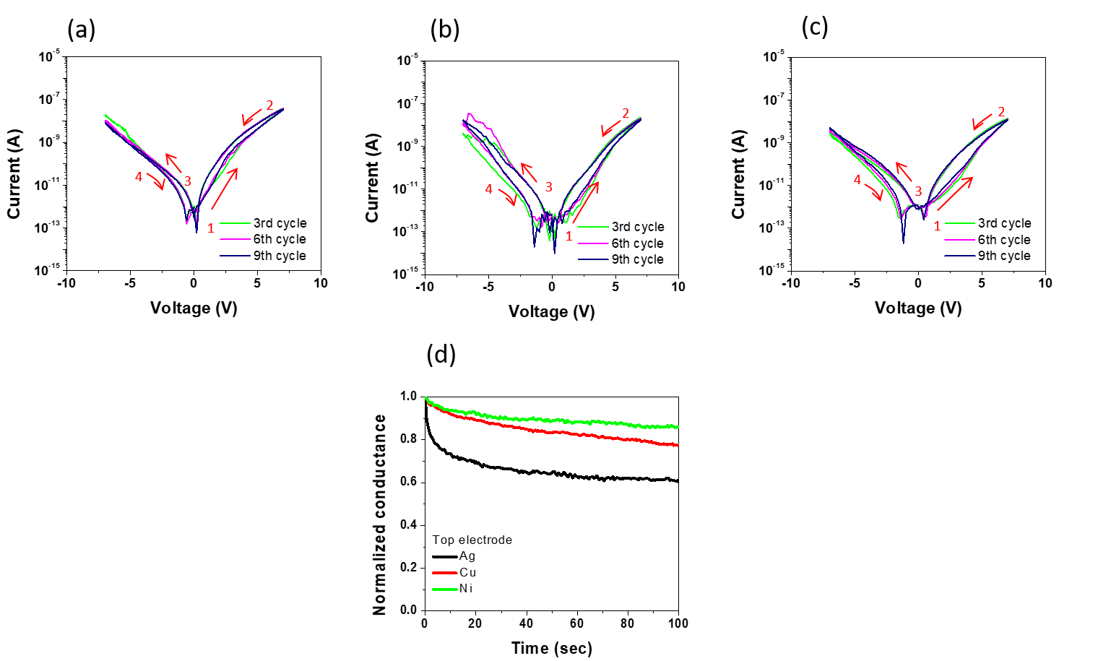
Figure S1 : (a), (b), and (c) show the I-V characteristics of the devices with Ag, Cu, and Ni as the active metals, respectively. I-V test involved sweeping the voltage 10 times in the direction of 0 → +7 V → 0 → -7 V → 0. In Fig. S1(d), the retention time is measured for each metal. The retention test involved applying a pulse with an amplitude of 8 V and a width of 100 ms 500 times and measuring the time for the conductive path to be maintained with a read pulse of 1 ms with an amplitude of 1 V. The data is recorded with an amplitude of 1 V immediately after 500 pulses have been applied.

The Cu/c-Si and Cu/a-Si/c-Si samples were heated at 200 °C for 20 minutes in a furnace. A highly doped p-type wafer was used as the c-Si wafer, and a-Si was deposited to a thickness of 70 nm using LPCVD. The difference in silicide formation at the Cu/c-Si and Cu/a-Si interfaces is clearly visible, with Cu reacting with Si to form a second phase. This second phase can then react with O₂ to form a SiO_{x} layer ¹⁻⁴.
$$Cu_{3}Si+O_{2}→SiO_{2}+3Cu$$
As shown in Figure S2 (a), a 45 nm SiOx layer is formed at the Cu/c-Si interface and Cu_{x}Si_{1-x} is distributed. To confirm this, the distribution of Oxygen and Cu were imaged using the left EDS mapping data. Figure S2(c) shows that there is a thin 5 nm silicide layer at the interface and Cu silicide inside the SiOx. In contrast, Figure S2 (b) shows the Cu/a-Si/c-Si sample that was annealed under the same conditions. In the right EDS mapping data, it can be seen that the oxide is distributed narrowly at the Cu/a-Si interface and that Cu does not penetrate a-Si.

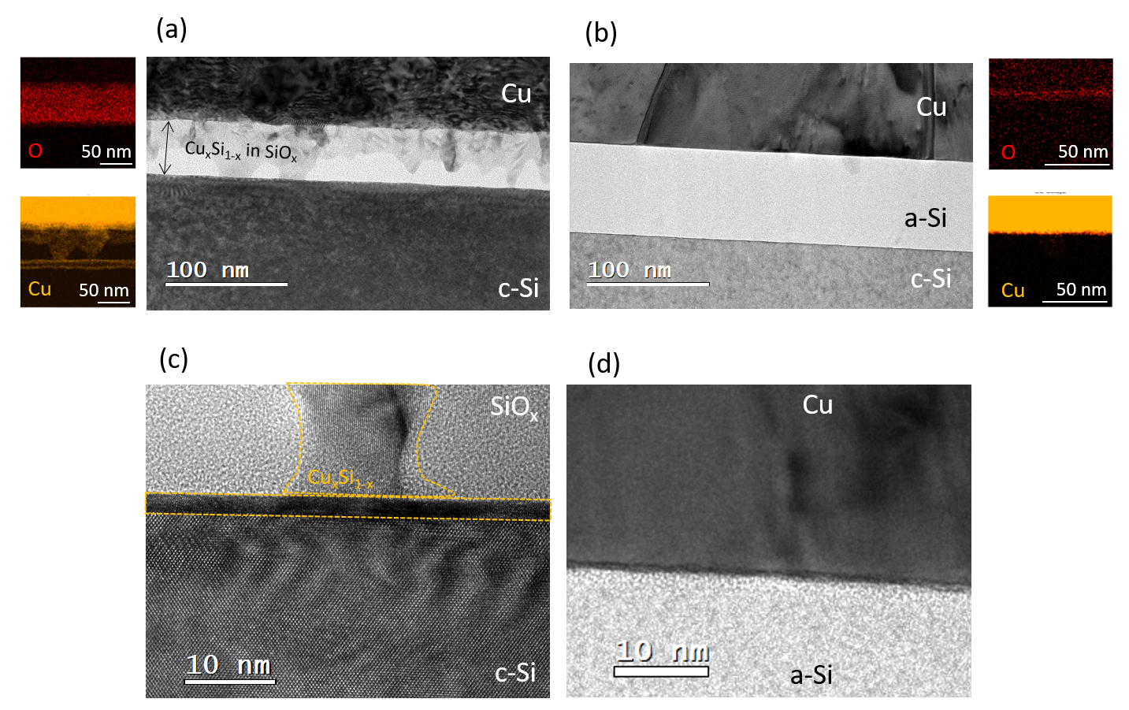
Figure S2 : (a) The cross-sectional XTEM image after annealing process of the Cu/c-Si structured sample is shown. The EDS mapping data of O and Cu elements is shown on the left side of the figure, and a high resolution image at the Cu/c-Si interface is shown in (c). (b) The same heat treatment was performed on a sample of the Cu/a-Si/c-Si structure, and its cross-sectional XTEM image is shown. The right figure is the EDS mapping data of the Cu/a-Si interface with O and Cu elements. The high resolution TEM image of the Cu/a-Si interface is shown in (d).

In Figures S3(a) and (b), the vacuum concentration formed by Ge ions injected into a 70 nm a-Si/c-Si sample is shown as a function of depth, as simulated by TRIM. When the ion implantation angle is fixed at 7° and the initial implantation amount is varied from 1×10¹⁴ to 1x10¹⁶ flux/cm², the vacancy concentration increases proportionally with the implantation. A c-Si thin film forms an amorphous phase when the vacancy exceeds 1 % ^{5,6}. Thus, the bottom c-Si substrate becomes amorphized when the injection volume exceeds 1×10¹⁵ flux/cm². However, as shown in Figure S3(b), when the ion implantation is performed with a fluence of 1×10¹⁵ or 1×10¹⁶ flux/cm², the vacuum concentration at the a-Si/c-Si interface is less than 1 %, and the bottom c-Si substrate remains crystalline. This was confirmed through TEM cross-sectional imaging and FFT analysis as shown in Figure S3(c).

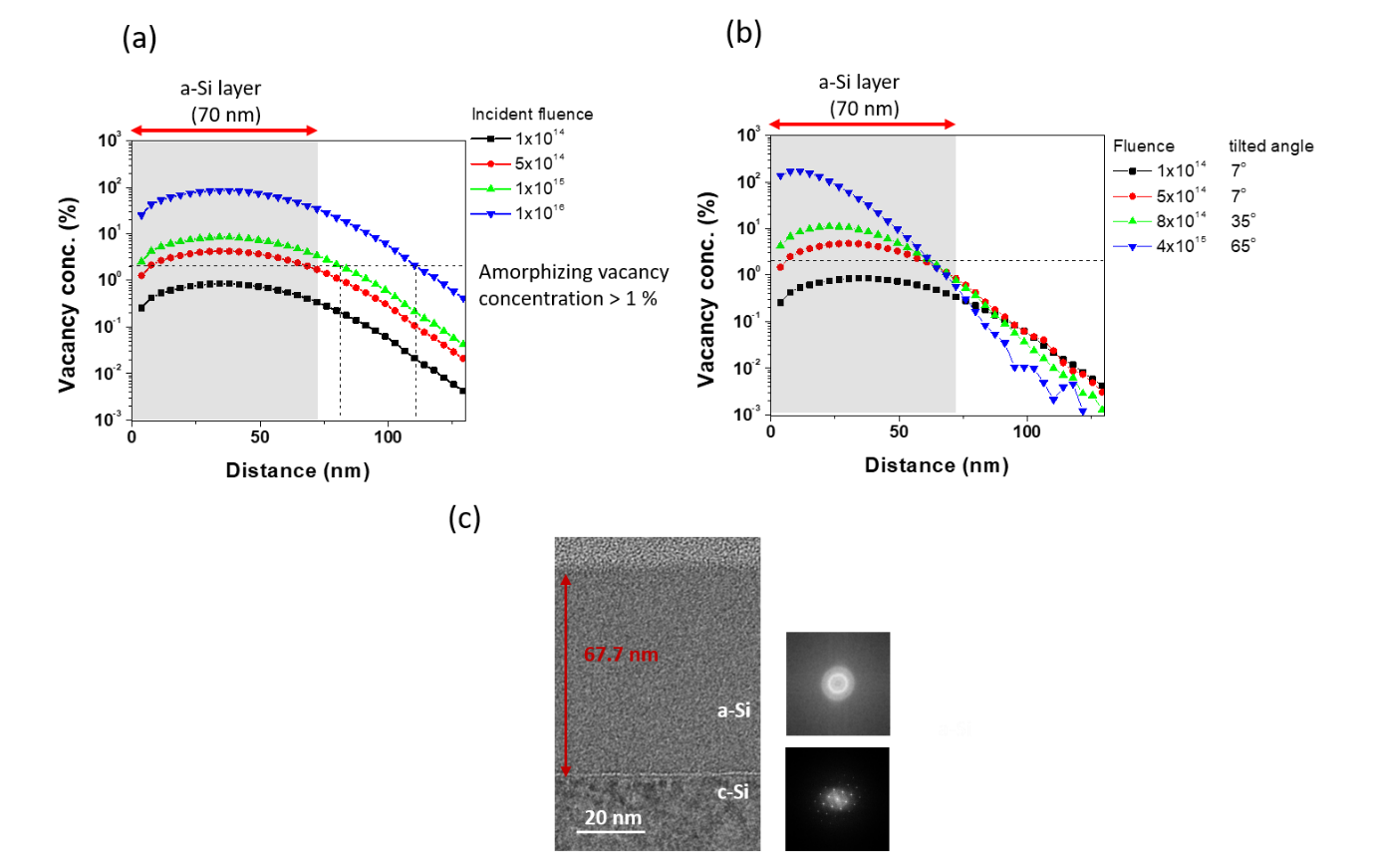
Figures S3. (a) and (b) show the results of a TRIM simulation of Ge ion implantation. In Figure S3(a), the distance versus vacancy concentration is plotted for fixed ion implantation angle of 7° and varying Ge fluences of 1×10¹⁴, 5×10¹⁴, 1×10¹⁵, and 1×10¹⁶ flux/cm². In Figure S3(b), the same Ge fluences are plotted as a function of distance, but with the ion implantation angle varied to 7°, 35°, and 65°. Finally, Figure S3(c) presents TEM cross-sectional imaging and FFT analysis of a sample implanted at a tilt angle of 65° and a final fluence of 4×10¹⁵ flux/cm².

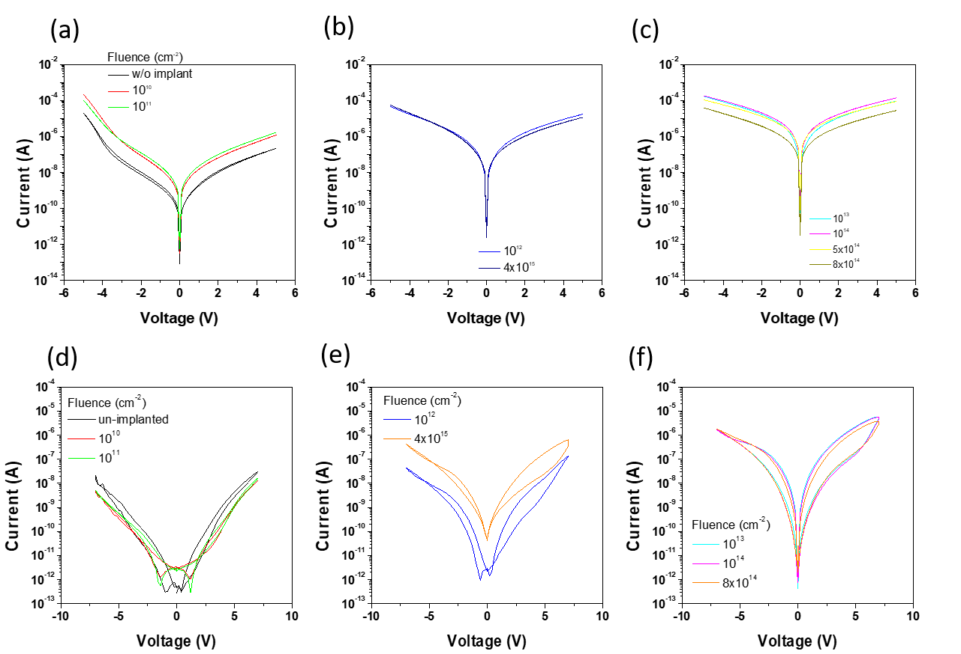
Figures S4 : (a), (b), and (c) show the current-voltage characteristics of a device with an Ag/a-SiGe_{x}/c-Si structure. The voltage was swept in the following manner: 0 V → +5 V → 0 V → -5 V → 0. (d), (e), and (f) show the current-voltage characteristics of a device with a Cu/SiO_{x}/a-SiGe_{x}/c-Si structure. The voltage was swept in the following manner: 0 V → +7 V → 0 V → -7 V → 0. (a) and (d) show the I-V characteristics in the LC region with the lowest conductance, where the implanted Ge ion fluence is (w/o implant, 10¹⁰, 10¹¹ flux/cm²). (b) and (e) show the I-V characteristics in the MC1 and MC2 regions, where the Ge ion fluence is 10¹² and 4×10¹⁵ flux/cm² and the conductance is intermediate. (c) and (f) show the I-V characteristics in the HC region with high conductance values where the implanted fluence is 10¹³, 10¹⁴, 8×10¹⁴ flux/cm² and the a-SiG_{x} film has a high conductance.

The role of the inserted a-SiGe_{x} layer was clarified by confirming the I-V characteristics based on the Cu/SiOx/c-Si structure. Figures S5 (a), (b), (c), and (d) show the I-V curve of the case where the resistor is inserted inside the device, the case where the ohmic resistance is connected in series, and the case where the Ag/a-SiGe_{x} (HC or LC)/c-Si structure of the device is connected in series. When a voltage is applied to the device, the voltage distribution occurs according to the resistance ratio of the switching layer and the resistance body or a-SiGe_{x} that is connected in series. As shown in (a), (c), and (d), a gradual forming process occurs when the Ag/a-SiGe_{x}/c-Si device is connected in series in a circuit. However, in the case of (b), since the resistor had same resistance as the voltage increased, it cannot perform its role effectively as a current limiting layer above a certain voltage. The I-V curve of the Ag/a-SiGe_{x}/c-Si device follows the schottky curve, so even if more voltage is applied to the a-SiGe_{x} layer, it can effectively suppress the current. However, the cases of (b), (c), and (d) where the external resistance was connected, unlike (a) which shows stable switching behavior, did not reset. This is since during the forming process, Cu moves to the SiO_{x}/c-Si surface and creates a second phase, preventing reset. Thus, the a-SiGe_{x} layer performs both the role of a current limiting layer and the role of preventing the formation of a second phase.
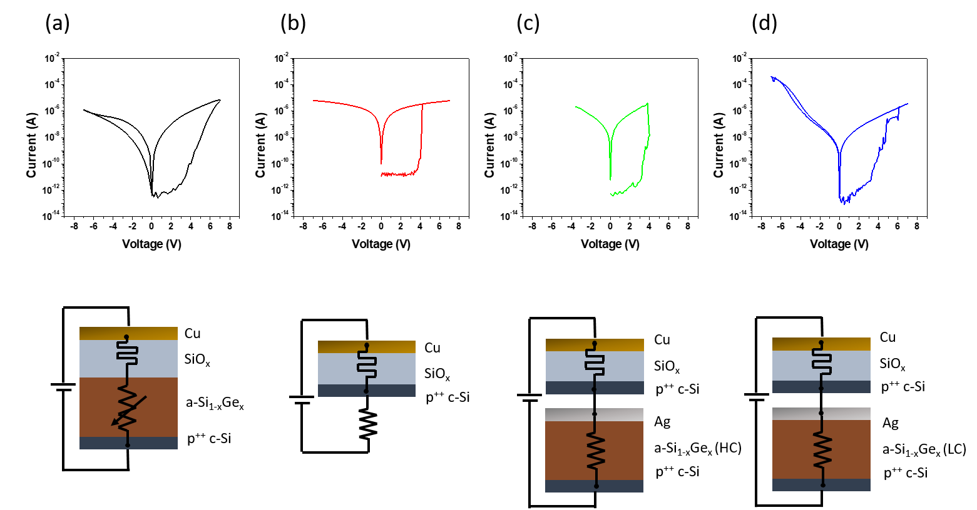
Figure S5 : (a) is the I-V curve of the device with the structure of Cu/SiO_{x}/a-SiGe_{x}/c-Si. (b), (c), and (d) are the I-V curves of the device with the structure of Cu/SiO_{x}/c-Si with a 1MΩ resistor in series, Ag/a-SiGe_{x} (HC)/c-Si in series, and Ag/a-SiGe_{x} (LC)/c-Si in series, respectively. The circuit diagram of each device measured is shown under each I-V curve.
The effect of the resistivity ratio at the interface on electric field was confirmed through COMSOL Multiphysics simulation. As seen in Figure 8(c), the Cu clusters in the SiOx switching layer have an elliptical sphere shape. Based on this, the Cu cluster was assumed to be in the form of a half-elliptical sphere located on the surface in the COMSOL simulation. A p-doped wafer with a resistivity of 0.005 Ω·cm was used, so the resistivity of c-Si was input as 0.005 Ω·cm. The conductance changes with Ge ion fluence in the a-Si layer, so the median average value of all fluences, 4×10⁷ Ω·cm, was utilized. In order to clearly show the distribution of the current with the resistivity ratio, the resistivity of SiOx was assumed to be 10⁸ Ω·cm. The resistivity ratio of SiOx and c-Si in Figure S6 (b) is approximately 10¹⁰ times, and the resistivity ratio of a-Si in (c) is 10 times. When the difference in resistivity is large, as in (b), the current distribution is not uniform around the Cu cluster, causing strong current concentration. On the other hand, in the case of (c) where the difference in resistivity is small, the current is distributed evenly around the Cu cluster. If the current is concentrated, it is difficult to obtain analog characteristics in the case of a current-dependent forming device because abrupt forming occurs. Therefore, by inserting an a-SiGe x layer with relatively large resistivity, gradual switching characteristics can be secured.

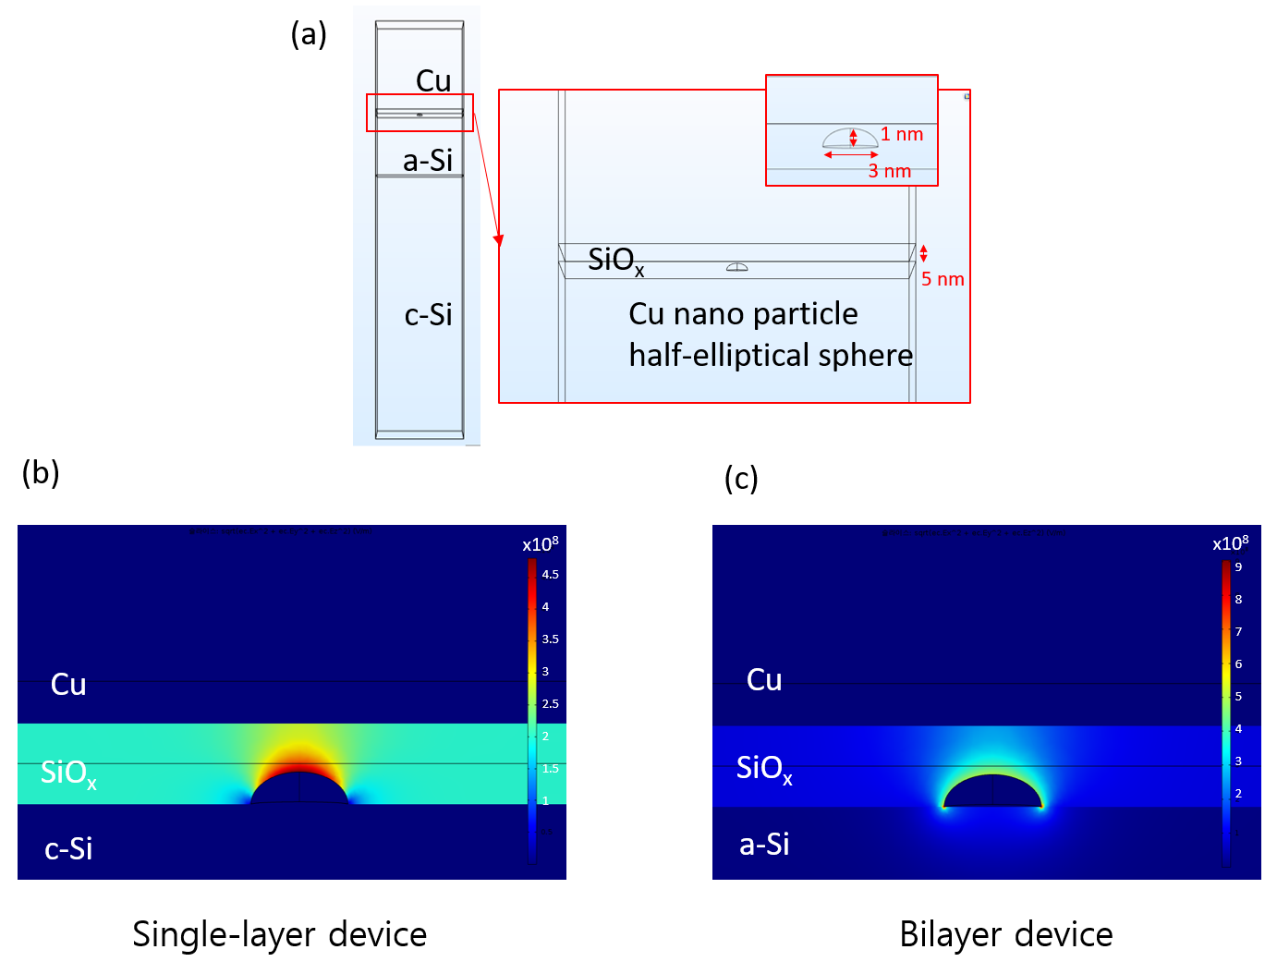
Figure S6 : The Cu/SiOx/Si structure was implemented in a COMSOL simulation. (a) SiOx was 5 nm and the embedded Cu cluster was simulated as an elliptical shape on the SiOx/Si surface with an axis length of 3 nm and a short axis length of 1 nm. (b) and (c) represent the electrical distribution of the Cu/SiOx/c-Si or Cu/SiOx/a-Si device, respectively. The resistivity of c-Si and a-Si were 0.005 and 107 Ω·cm, respectively, and the resistivity of SiOx was 108 Ω·cm.
References

1 Cemin, F. et al. Epitaxial growth of Cu(001) thin films onto Si(001) using a single-step HiPIMS process. Sci Rep 7, 1655 (2017). https://doi.org:10.1038/s41598-017-01755-8
2 Dodony, E., Radnóczi, G. Z. & Dódony, I. Low temperature formation of copper rich silicides. Intermetallics 107, 108-115 (2019). https://doi.org:10.1016/j.intermet.2019.01.010
3 Chiu, C. H. et al. Copper silicide/silicon nanowire heterostructures: in situ TEM observation of growth behaviors and electron transport properties. Nanoscale 5, 5086-5092 (2013). https://doi.org:10.1039/c3nr33302g
4 Li, S. et al. Controlled Synthesis of Copper-Silicide Nanostructures. Crystal Growth & Design 10, 2983-2989 (2010). https://doi.org:10.1021/cg1000232
5 J.F.Ziegler. High energy ion implantation. Nucl. Instrum. Methods. Phys. Res. B 6, 13 (1985). https://doi.org:https://doi.org/10.1016/0168-583X(85)90645-7
6 Pease, G. H. K. a. R. S. The displacement of atoms in solids by radiation. Vol. 18 (Rep. Prog. Phys., 1955).

