Supplementary Information

Copper sulfide in a vesicular basalt reveals aqueous liquid on the Moon
Yang Liu¹*, Chi Ma², Scott A. Eckley³
¹Jet Propulsion Laboratory, California Institute of Technology, Pasadena, CA, USA. Email: yang.liu@jpl.nasa.gov
²Division of Geological and Planetary Sciences, California Institute of Technology, Pasadena, CA, USA.
³Jacobs, NASA Johnson Space Center, Houston, TX, USA.

The PDF file includes:
Supplementary information 1
Supplementary information 2
Figs. S1 to S9
Table S1: EPMA analyses of troilite and Fe-metal in Apollo 15556
Table S2: EDS data of copper sulfide in Apollo 15556
Table S3: Comparison of EPMA and EDS data on Fe-metal and troilite
Table S4: Porosity and connectivity analyses of the main mass 15556,0

Other Supplementary Materials for this manuscript include the following:
Movies S1: Reconstructed 3D surface and interior view of a pristine chip (C3) of Apollo basalt 15556. The movie shows the surface of the chip, the distribution of irregular pore space (magenta) and sulfide (green) and metal (white) in the interior, and then a zoomed-in view from the surface to the interior of a round vesicle.

Supplementary information 1: Vesicles in Apollo 15556
- Vesicles, porosity, and connectivity
Apollo sample 15556 contains two types of open space, round gas vesicles and smaller, jagged pore space (Fig. 3, Figs. S6-S7). The rounded vesicles are clearly seen on exterior surfaces and the cut/chipped surfaces (Fig. S6). The round vesicle wall is made of interlocking silicates and Fe-Ti-Cr oxides forming a roughly smooth surface, see chip C1 as an example (Fig. S8). The spherical vesicles range in diameter from approximately 0.5 mm to 10 mm. Most of the larger rounded vesicles preserve evidence for gas bubble coalescence, forming dumb-bell shaped void spaces reaching a long axis of ~15 mm.
Abundance of void space in the main mass was measured in seven internal subvolumes (average volume = 36.3 cm³) within 15556,0. These subvolumes were picked to avoid large fractures. All non-rock voxels (i.e., air) were digitally segmented using a lower-Otsu global grayscale threshold unique to each subvolume. This analysis, which included both round vesicles and irregular pore space down to the resolution limits of the X-ray CT scan (i.e., 55.2 µm/voxel edge), is a minimum total porosity estimate since porosity exists below the resolution limits, which was shown with a higher resolution X-ray CT scan (3.49 µm/voxel edge) of a smaller chip (15556,290; Chip 3) revealing jagged pore spaces that are well below the resolution limits of the main mass scan (Fig. 3). However, sub-resolution void spaces do not contribute significantly to the total porosity measurements when using an Otsu or midpoint global grayscale threshold¹. The porosity of seven volume ranges from 31.8 vol% - 34.0 vol% with an average of 33.1 vol% (Table S4), which matches CT measurements of a 354 g sample of 15556,215², but smaller than that estimated in Ref.³⁹.
We used a similar approach as in Ref.³ to investigate the connectivity of vesicles. We measured the volume of every three-dimensionally contiguous component composed of voxels of air. This analysis was performed in Dragonfly™ using the “connected component analysis” tool. We used the 16-bit grayscale data and an Otsu threshold method to define the upper grayscale limit for vesicles (threshold from 0 to 12,127). This thresholding method uses a histogram-based approach to calculate the minimum between the histogram peaks for air and rock. Measurements were made in a 2.4 cm x 2.4 cm x 2.0 cm internal subvolume (Fig. S7A-D) that is free of resolvable fractures within 15556,0 that would artificially skew connectivity analysis. The degree of vesicle connectivity within the measured subvolume is quantified by dividing the volume of the single largest connected vesicle component by the total vesicle volume. In the measured subvolume, 43 % of the total porosity is comprised by one three-dimensionally connected void space component and 70 % of the total porosity is comprised by the ten largest three-dimensionally connected void space components (Table S4). This is a minimum estimate of vesicle connectivity since there are void spaces below the resolution limits (Fig. 3, Fig. S7, movie S1). All the rounded vesicles contain small openings protruding into the rock matrix seen in the CT data (Fig. S7, movie S1) and the SEM examination of all chips (e.g., Fig. 3B, Fig. S8). Therefore, we propose most, if not all, of the porosity in 15556 is connected, which is consistent with a previous study showing that almost all porosity is connected in basalt samples with total porosity >25 %⁴.
The irregular pore space with a jagged shape is pervasive but mostly smaller. Their presence is more easily seen in polished sections and the CT scan of the smaller chip (movie S1). The jagged pore space has straight edges and are framed by euhedral mineral grains. This is a result of the solidification of the melt as minerals occupy smaller volumes than that of the melt of the same mass. The relationship between jagged pore space and larger round vesicles is seen from the reconstructed 3D view of 15556, 290 chip C3 (Fig. 3, movie S1). All rounded vesicles in 15556,0 and 15556,290 chip C3 have jagged pore spaces protruding from their walls the rock matrix. However, not all jagged pore spaces are connected to larger vesicles. There is a small volume (0.24 vol. %) of jagged pore spaces in 15556, 290 chip C3 that appear to be three-dimensionally isolated from other void spaces (Fig. 3, movie S1). However, fractures or microfractures that are not included in our CT analyses could connect jagged pore spaces with round vesicles or each other.

- Minerals on vesicle walls
Fig. S8 shows a portion of the wall of a full vesicle as an example. The vesicle wall is made with relatively smooth interlocking silicates and Fe-Cr-Ti oxides of similar chemistry as those away from the vesicles. Troilite and metal grains are protruding from the smooth wall toward the empty space.
Wall troilite has well-formed outward surfaces (euhedral), is 20 to 100 μm in the largest dimension, and protrudes from the vesicle wall into empty space with a height of <20 μm. Multiple troilite grains are present in a single vesicle (Fig. 3, Fig. S8, movie S1). CT data of 15556, 290 C3 (6.1 mm in length and 3.9 mm wide) show no preferred distribution patterns of troilite grains on vesicle walls. Both CT data and examination of polished sections show some troilite grains have roots growing into the rock matrix (Fig. 3, Fig. S3). Different analytical methods also reveal the common presence of Fe metal in wall troilite (Fig. 1, Fig. S3, movie S1). Metal grains of 10 to 40 μm are not as common as troilite grains and less regular in shape (Figs. S1 and S9). In thin sections and CT data, some metal grains form a trail ending with a grain extruding into the vesicle (Fig. 3, Fig. S4, movie S1).

References
- Eckley, S. A. & Ketcham, R. A. 4D Imaging of Mineral Dissolution in Porous Carbonado Diamond: Implications for Acid Digestion and XCT Measurement of Porosity and Material Properties. Frontiers in Earth Science 7, 288, doi:10.3389/feart.2019.00288 (2019).
- McCubbin, F. M. et al. Endogenous lunar volatiles. In New Views of the Moon II, Reviews in Mineralogy & Geochemistry (in press) (2023).
- Eckley, S. A. Magmatic thermal histories and emplacement mechanisms of Martian shergottite meteorites. Ph.D. Thesis. University of Texas, Austin (2022).
- Zahasky, C., Thomas, D., Matter, J., Maher, K., & Benson, S. M. (2018). Multimodal imaging and stochastic percolation simulation for improved quantification of effective porosity and surface area in vesicular basalt. Advances in Water Resources, 121, 235-244.

Supplementary information 2: EDS data versus EPMA data
To assess SEM EDS analyses, we compared the same metal and troilite grains. The EDS Fe contents in metals differ from EPMA values by <1 % relative. The EDS molar Fe/S ratio of troilite is consistently higher than those from EPMA by 7% relative. For the rough samples, we use troilite to assess the EDS analysis. The EDS molar Fe/S ratios of troilite on vesicle walls are similar to EDS data of polished troilite on vesicle walls in the thin section but are consistently higher than those from EPMA by <8 % relative (Table S3). From this comparison, the EDS chemistry of copper sulfide (Cu_{1.5}S) would be Cu_{>1.38}S, like spionkopite (Cu₃₉S₂₈).

A
B
E
1C
C
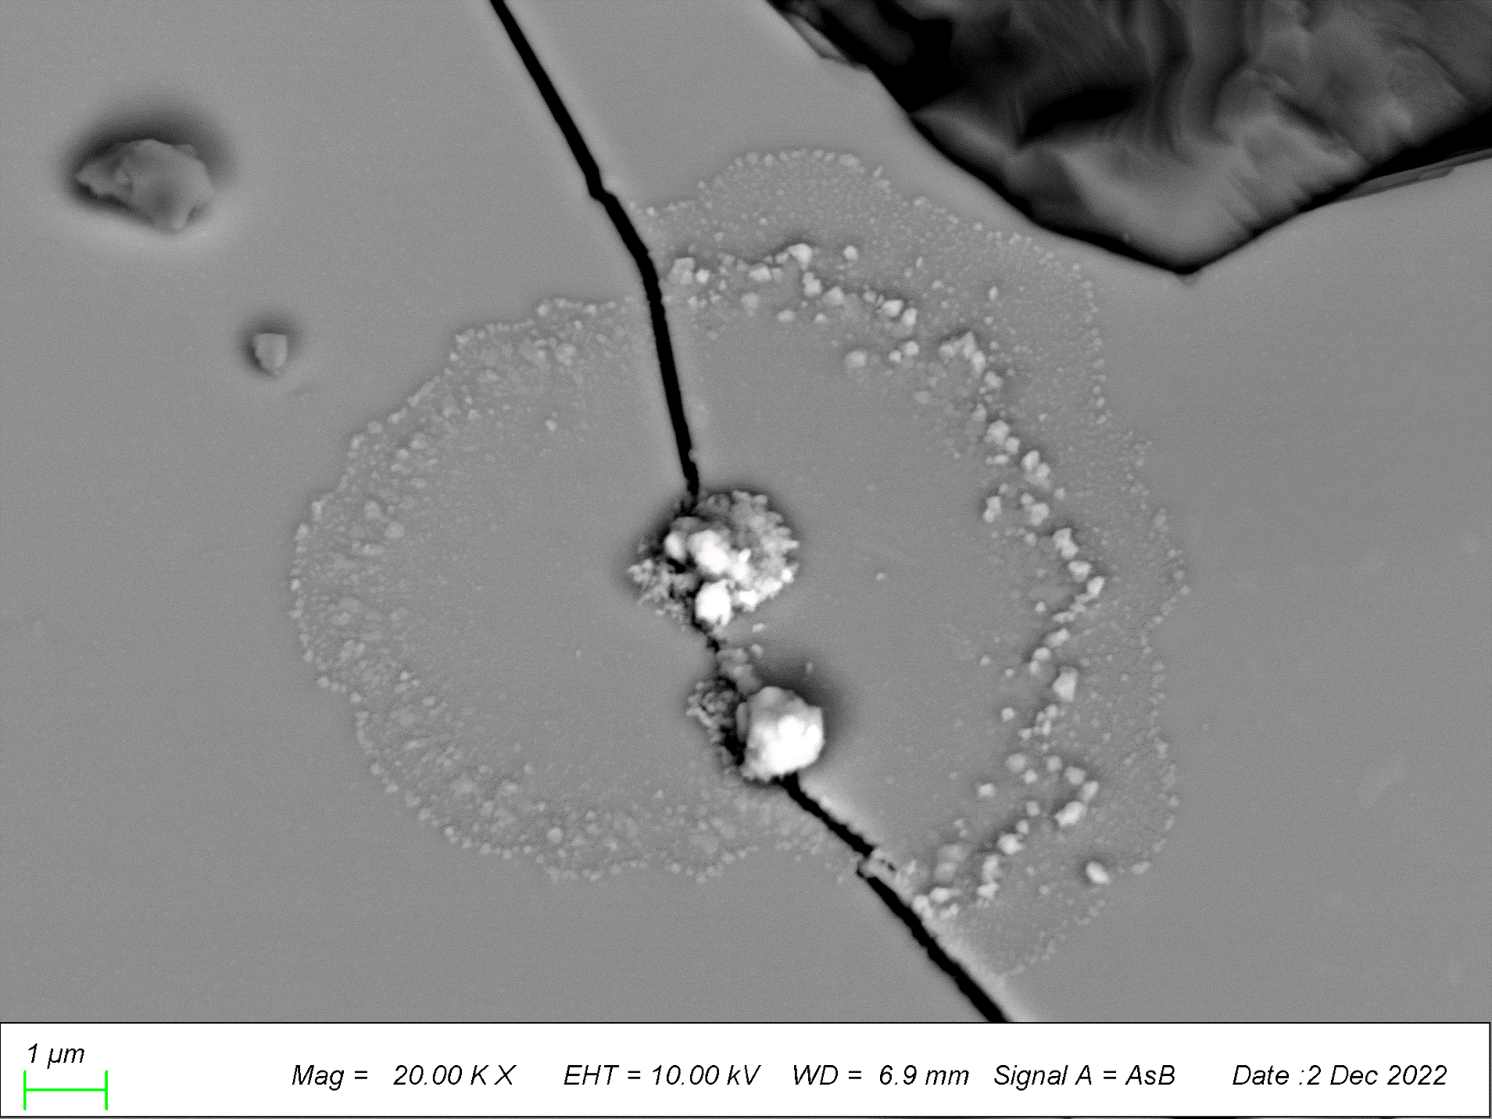
D
E
G
J
I
H
Fe
Fe
Uspl
Fa
F
wall
Base of Troilite
charging
G
Clean Troilite
Copper sulfide coated
H
No Ni
Ni
I
Copper sulfide coated
Copper sulfide coated
Clean Tro
Ni
Clean Tro
SE
Ni
Fe
J
M
L
Fe
K
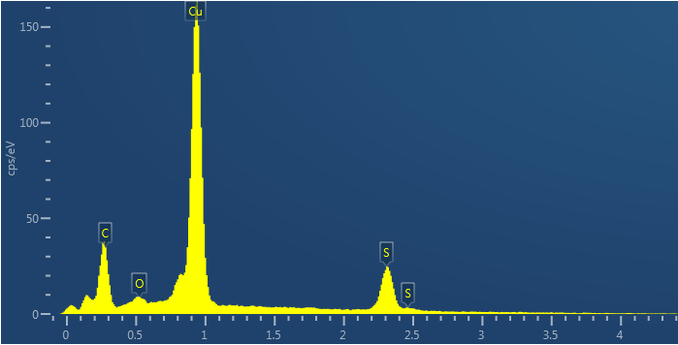
S Kα
Cu Lα
charging
SE
L
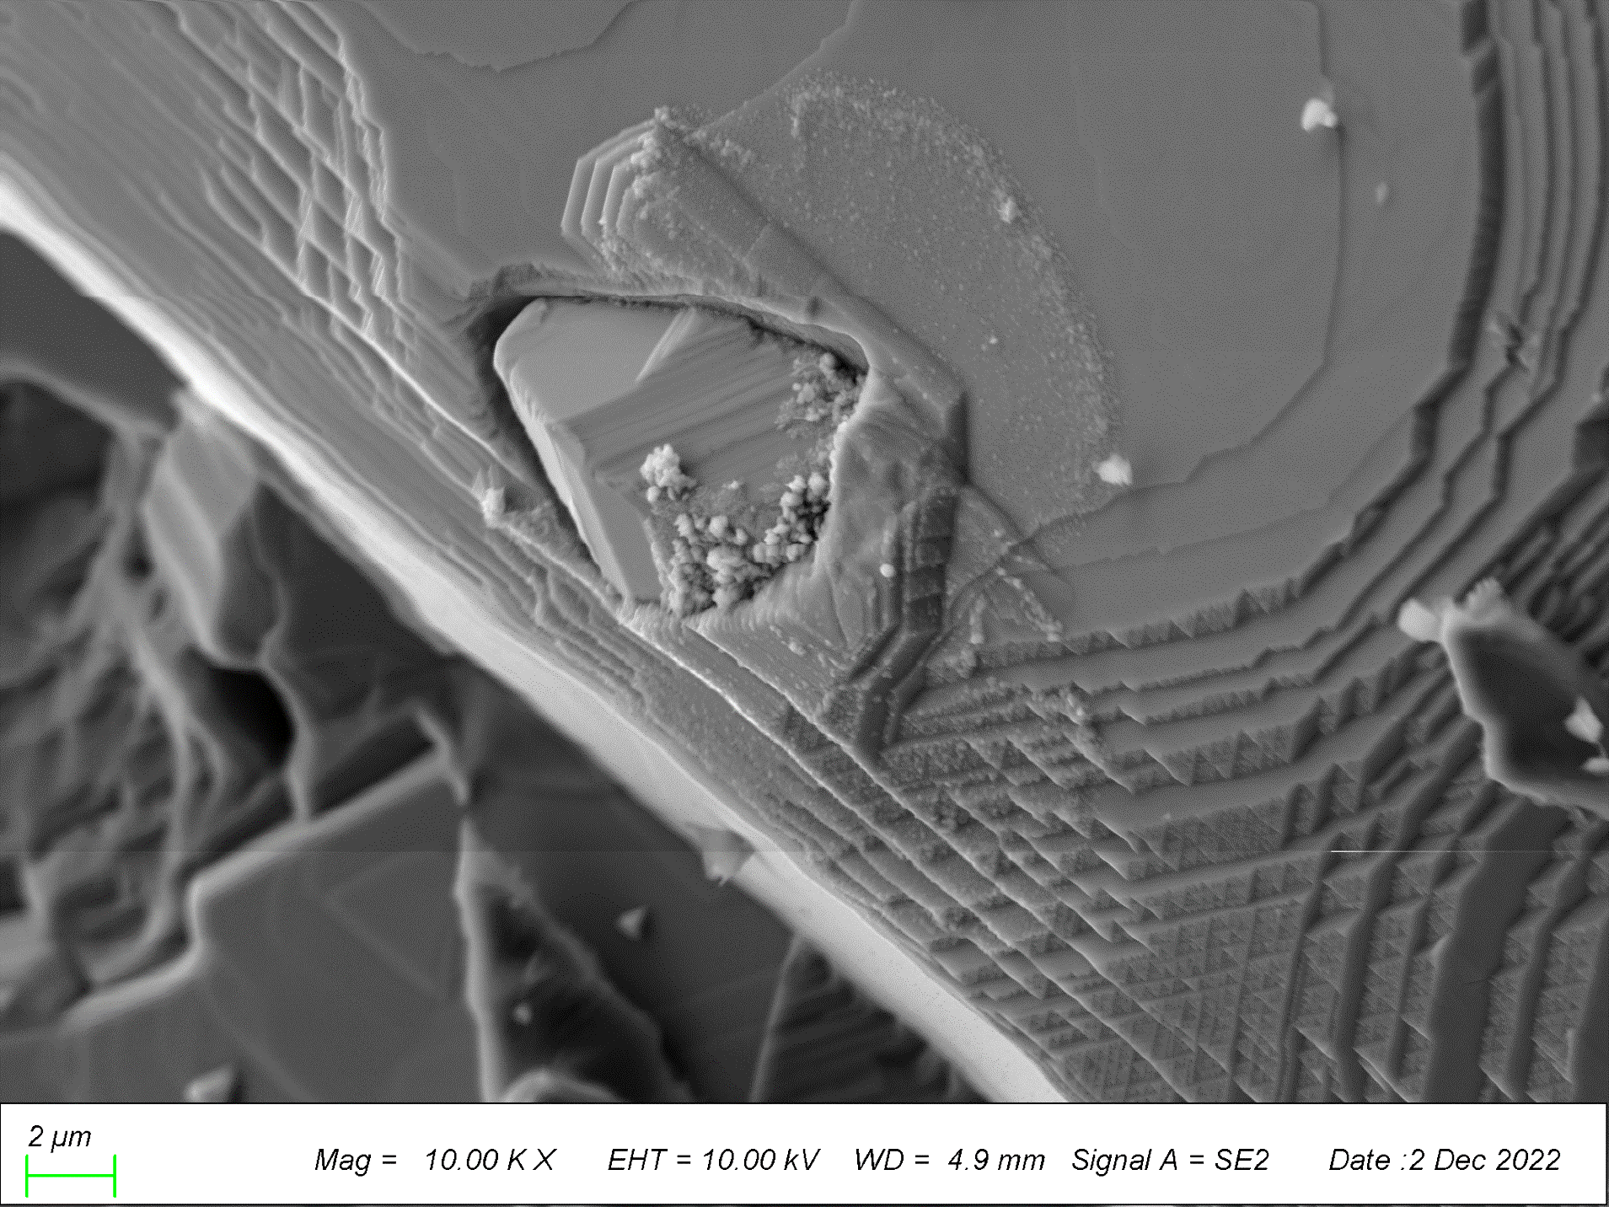
charging
SE
M
P
O
1F
vesicle
N
O
P
Ni
Fe
Tro
Fe
Q
Ni
Tro
Fe
R
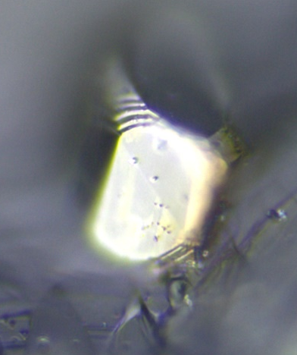
Ni
Tro
S
Tro
T
Fig. S1. Full sized images of troilite grains shown in Figure 1 and some additional examples. All images are BSE unless otherwise noted. (A-B) for Figure 1A & 1B from chip C4. (C-D) the grain in Figure 1C from chip C2. (E) Anther region in (C). (F) the grain in Figure 1D from chip C1. (G-J) Other regions with copper sulfide in (F). Ni, Ni-rich surface on troilite. (K-M) the grain in Figure 1E. The inset in (L) shows EDS spectrum of the cupper sulfide aggregate. (N) The troilite grain in Figure 1F from chip C3. (O-P) other regions of the grain in (N). (Q)-(R) Other troilite grains from the same vesicle wall in chip C1. Note the flow lobes of multiple coatings on both grains. (S-T) Another troilite in chip C4. Discrete copper sulfide mounds lie on top of a thin coating in (T). Yellow arrows point to the edge of the coating. Dark grains on the surface in some of the images are silicate dust. Fa, fayalite (Fe₂SiO₄); Uspl, ulvöspinel (Fe₂TiO₄).

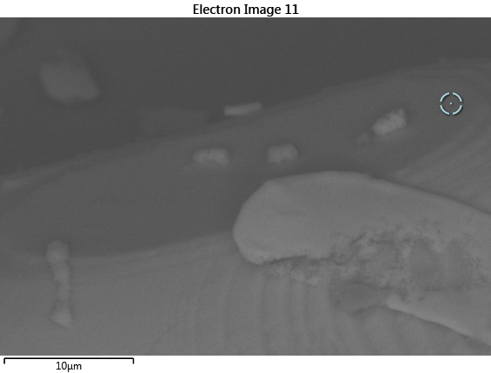
A
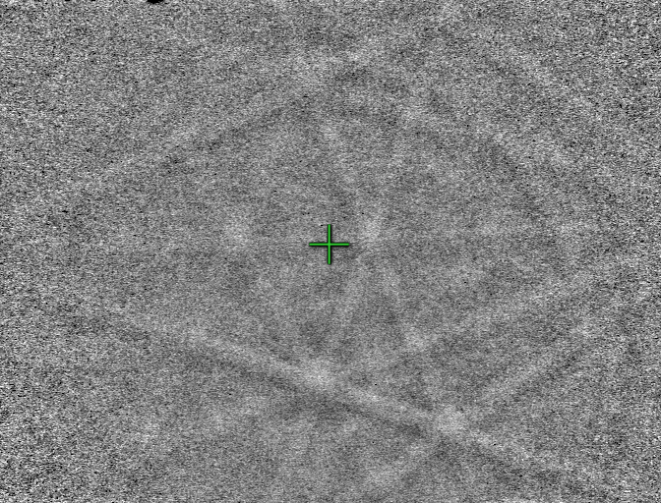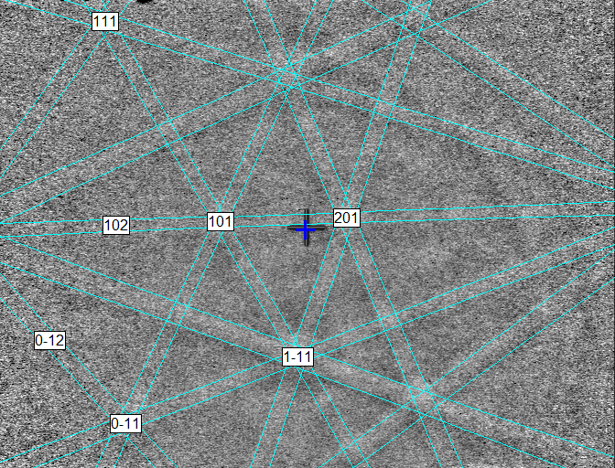
C
B
Fig. S2. EBSD pattern of the troilite crystal in Fig. 1D and fig. S1F. (A) BSE image of the grain with the location of the EBSD shown as a target point. (B) Raw EBSD pattern. (C) The EBSD pattern, indexed with the hexagonal P6₃/mmc structure.
Fig. S3. BSE images of wall troilite (Tro) grains with euhedral Fe metal inclusions in the polished sections. These troilite grains show roots intruding into the rock matrix (yellow ellipses). Chr, chromite (FeCr₂O₄); Uspl, ulvöspinel (Fe₂TiO₄).

Fig. S4. BSE images of troilite (Tro) and Fe metal grains in the rock matrix. (A) A mesostasis containing a significantly altered troilite grain. (B) An irregular troilite grain with small Fe metal inclusions (brightest regions). The grain is rimmed by fayalite (Fa, Fe₂SiO₄). (C) Large irregular Fe metal grains forming a trail extending toward the vesicle wall. An, anorthite (CaAl₂Si₂O₈); Fs, ferrosilite (Fe₂Si₂O₆), Gl, glass; Ilm, ilmenite (FeTiO₃); Hd, hedenbergite (CaFeSi₂O₆); Chr, chromite (FeCr₂O₄); Uspl, ulvöspinel (Fe₂TiO₄).
Liquid
Vapor
Fig. S5. The phase boundary between H₂S vapor and liquid, calculated using the Antoine equation using data compiled by U.S. Secretary of Commerce on behalf of the U.S.A. The horizontal bar at the bottom shows the hydrostatic pressure at the surface to 10 m depth of a lava flow on the Moon.

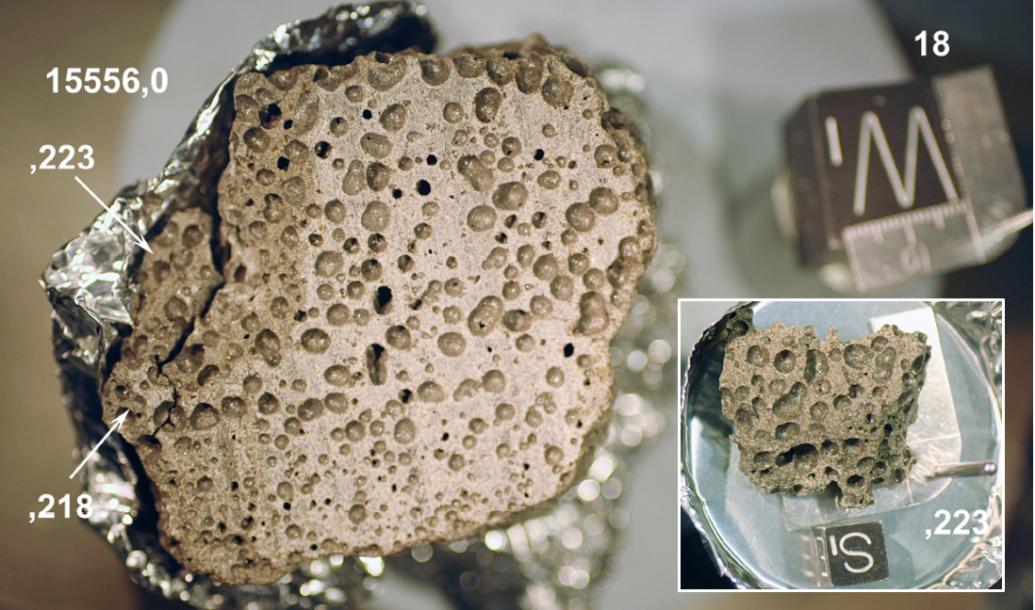
Fig. S6. Photographs showing the relationship between subsample 15556,223 and the main mass 15556,0. The cube shows the original orientation and the edge of the cube is 2.5 cm. The inset shows the south side of 15556,223 and the cube has a 1 cm edge. Image credit: NASA.
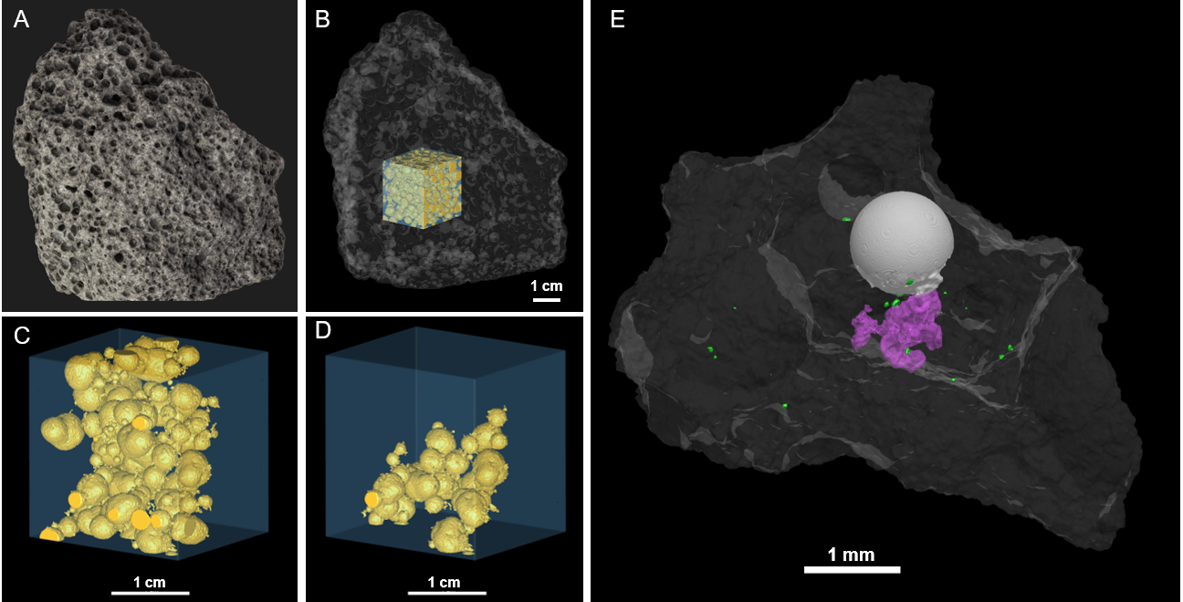
Fig. S7. Vesicle connectivity in sample 15556, 0 (A-D) and 15556, 290 C3 (E). (A) The exterior view of the sample. (B) 3D constructed view of the sample in the same orientation as in (A). the rock was rendered semi-transparent. The interior subvolume used for connectivity analysis is shown in transparent pale blue color and vesicles are highlighted in yellow. (C) Fewer vesicles to show their relationship. (D) Connectivity of the vesicles shown by even less vesicles. (C) and (D) show small opening on the wall of vesicles of different sizes, giving its spiky appearance. (E) Side view of Fig. 1A showing the connection between a large irregular pore with the vesicle. Green is troilite, light gray is round vesicle, magenta is irregular pore space.
Fig. S8. Images of the vesicle wall of 15556, 290 C1 examined in this study. Locations of troilites shown in Figs. 1 and S1 are shown. Yellow arrows point to additional wall troilite with copper sulfide coatings. An: anorthite.
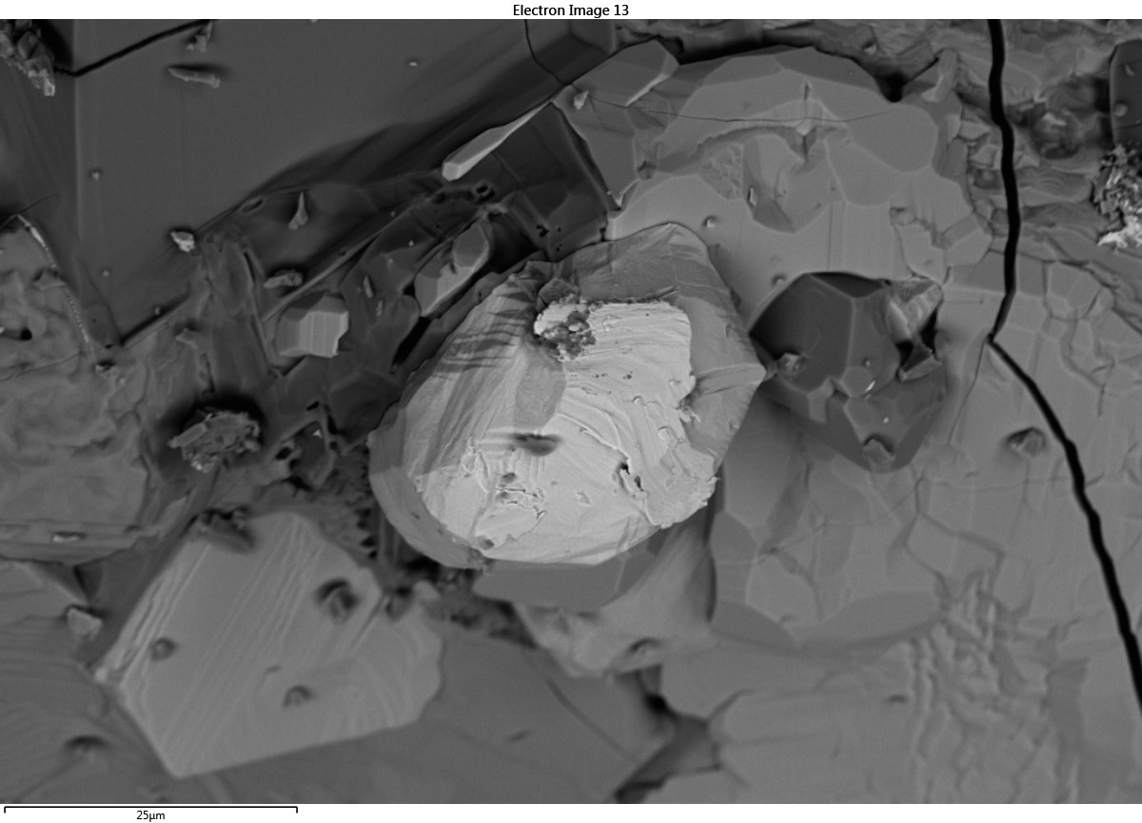
Uspl
Fa
Fe
Fe
Fig. S9. BSE image of Fe-metal (Fe) on the vesicle wall of 15556, 290 C3. Fa: fayalite. Uspl: Cr-bearing ulvöspinel.

