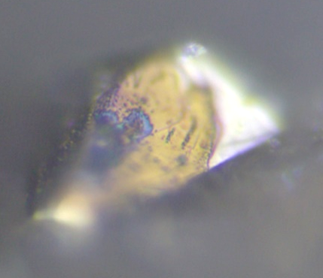
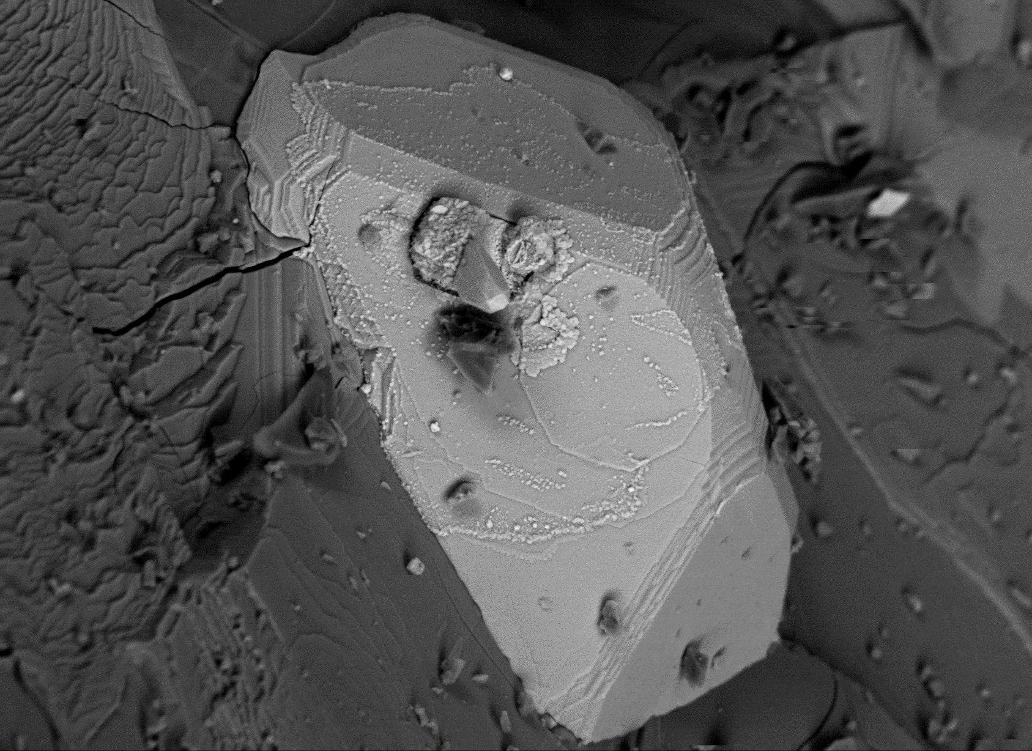
10 μm
Extended Data Figure 1. Full size image of Figure 1A with adjusted brightness and contrast.
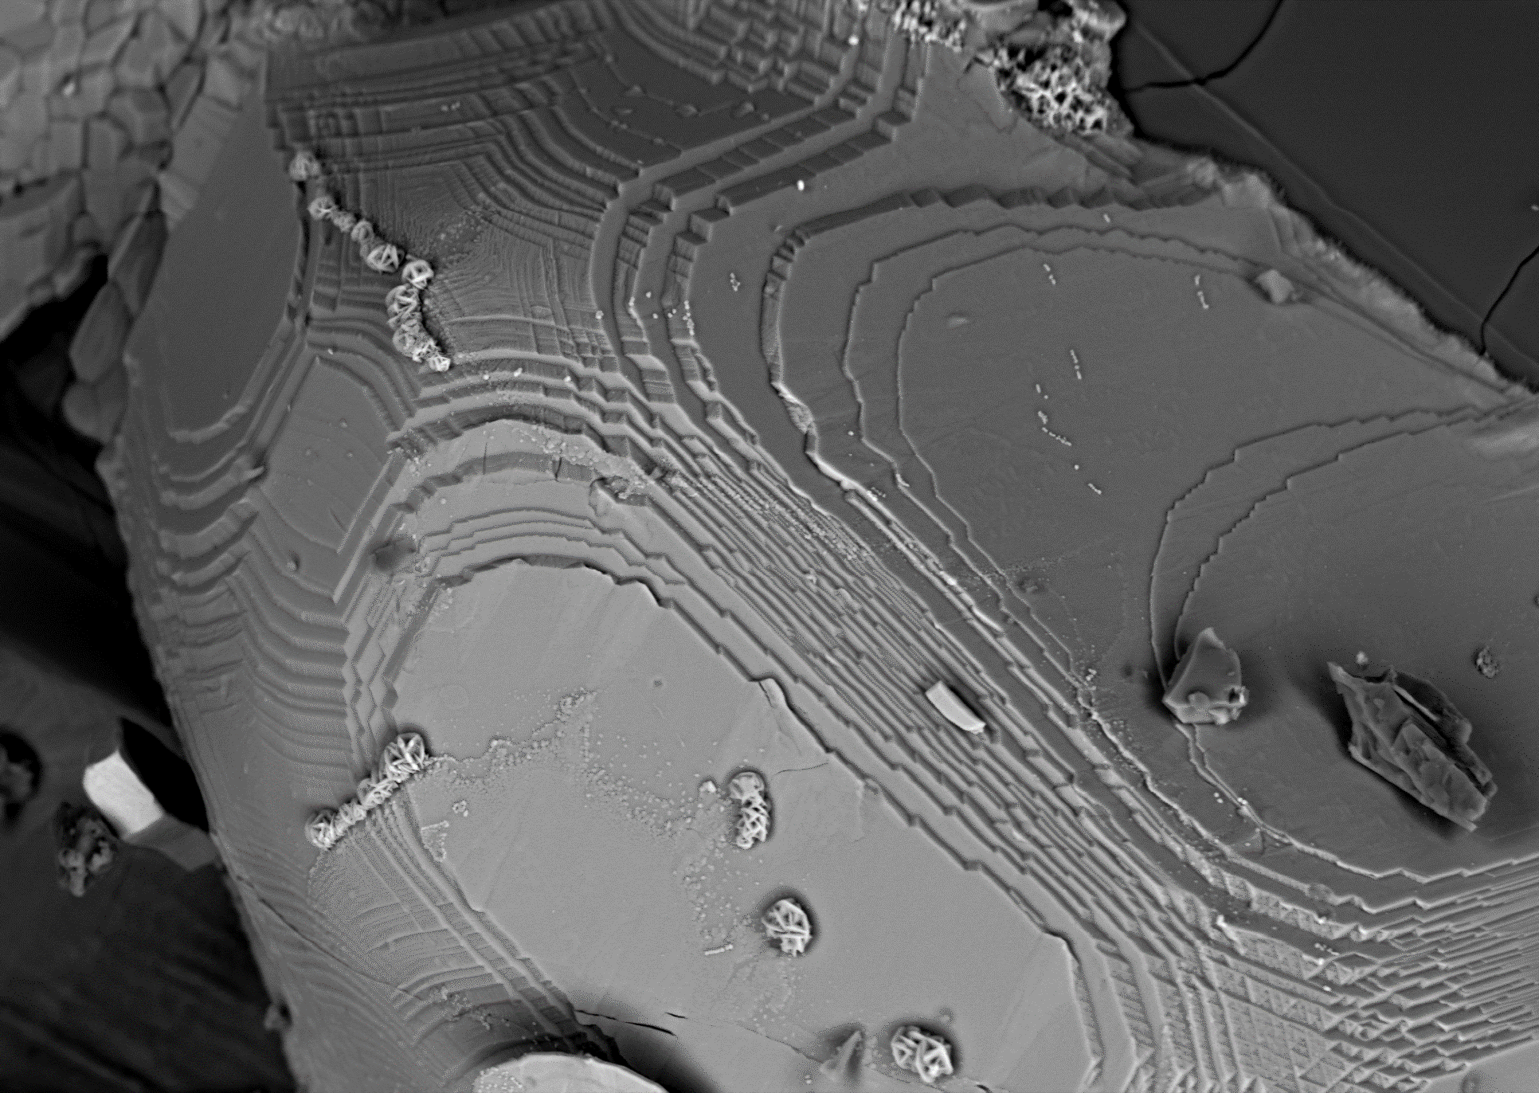
10 μm
Extended Data Figure 2. A slightly zoomed-out BSE image including the area in Fig. 1D.

